St. John’s Episcopal Church
Kingsville, Maryland
Welcomes You
Our Vision Statement

We believe that together we will transform
the world with love: Come on in!

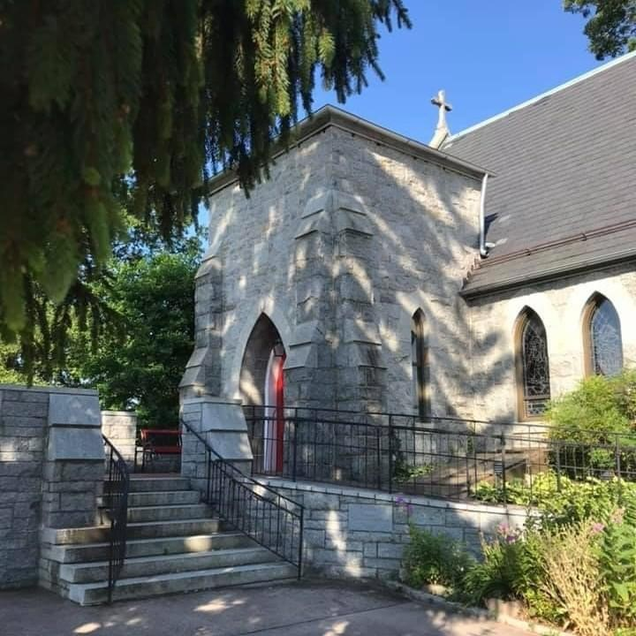

Pentecost Sunday
May 28, 2023
10:30 am

St. John’s Episcopal Church

11901 Belair Road, P. O. Box 187, Kingsville, MD 21087
FaceBook: St. John’s Episcopal, Kingsville, MD
Email: office@stjohnskingsville.org
Website: www.stjohnskingsville.org
Church Phone: 410-592-8570
For Pastoral Emergencies: Father Walter Burgess, 410-679-8000

Church Staff

Administrative Assistant: Angie Bosley
Organist/Choir Director: Nancy Heinold

The Vestry

Class of 2024 Class of 2025

Marguerite Lobb John Frost
Jacob Johnson Woodie Tingle

Officers
Ty Schwenk—Sr. Warden Terry Roe—Jr. Warden
Elizabeth Healey—Treasurer Anne Leland-Registrar

Parish Committee Chairpersons

Altar Guild: Elizabeth Healey
Organ Restoration Committee: Nancy Heinold

10:30 am Worship
Holy Eucharist, Rite Two

Prelude:
The Word of God

Processional hymn: Hail thee, festival day Hymnal #225

Worship begins BCP 355

Gloria Hymnal #S-278
Glory to God in the highest,
and peace to his people on earth.
Lord God, heavenly King,
almighty God and Father,
we worship you, we give you thanks,
we praise you for your glory.
Lord Jesus Christ, only Son of the Father,
Lord God, Lamb of God,
you take away the sin of the world:
have mercy on us;
you are seated at the right hand of the Father:
receive our prayer.
For you alone are the Holy One,
you alone are the Lord,
you alone are the Most High,
Jesus Christ,
with the Holy Spirit,
in the glory of God the Father. Amen.

Celebrant: The Lord be with you.
People: And also with you.
Celebrant: Let us pray.

The Collect of the Day Kneel or stand as able BCP 227
Almighty God, on this day you opened the way of eternal life to every race and nation by the promised gift of your Holy Spirit: Shed abroad this gift throughout the world by the preaching of the Gospel, that it may reach to the ends of the earth; through Jesus Christ our Lord, who lives and reigns with you, in the unity of the Holy Spirit, one God, for ever and ever. Amen.
The congregation is seated.

A Reading from the Acts of the Apostles 2:1-21
When the day of Pentecost had come, the disciples were all together in one place. And suddenly from heaven there came a sound like the rush of a violent wind, and it filled the entire house where they were sitting. Divided tongues, as of fire, appeared among them, and a tongue rested on each of them. All of them were filled with the Holy Spirit and began to speak in other languages, as the Spirit gave them ability.
Now there were devout Jews from every nation under heaven living in Jerusalem. And at this sound the crowd gathered and was bewildered, because each one heard them speaking in the native language of each. Amazed and astonished, they asked, "Are not all these who are speaking Galileans? And how is it that we hear, each of us, in our own native language? Parthians, Medes, Elamites, and residents of Mesopotamia, Judea and Cappadocia, Pontus and Asia, Phrygia and Pamphylia, Egypt and the parts of Libya belonging to Cyrene, and visitors from Rome, both Jews and proselytes, Cretans and Arabs-- in our own languages we hear them speaking about God's deeds of power." All were amazed and perplexed, saying to one another, "What does this mean?" But others sneered and said, "They are filled with new wine."
But Peter, standing with the eleven, raised his voice and addressed them, "Men of Judea and all who live in Jerusalem, let this be known to you, and listen to what I say. Indeed, these are not drunk, as you suppose, for it is only nine o'clock in the morning. No, this is what was spoken through the prophet Joel: `In the last days it will be, God declares, that I will pour out my Spirit upon all flesh, and your sons and your daughters shall prophesy, and your young men shall see visions, and your old men shall dream dreams. Even upon my slaves, both men and women, in those days I will pour out my Spirit; and they shall prophesy. And I will show portents in the heaven above and signs on the earth below, blood, and fire, and smoky mist. The sun shall be turned to darkness and the moon to blood, before the coming of the Lord's great and glorious day. Then everyone who calls on the name of the Lord shall be saved.' "

Reader: The Word of the Lord.
People: Thanks be to God.

Psalm 104:25-35, 37 (Prayed as directed.)
25 O Lord, how manifold are your works! *
in wisdom you have made them all;
the earth is full of your creatures.
26 Yonder is the great and wide sea
with its living things too many to number, *
creatures both small and great.
27 There move the ships,
and there is that Leviathan, *
which you have made for the sport of it.
28 All of them look to you *
to give them their food in due season.
29 You give it to them; they gather it; *
you open your hand, and they are filled with good things.
30 You hide your face, and they are terrified; *
you take away their breath,
and they die and return to their dust.
31 You send forth your Spirit, and they are created; *
and so you renew the face of the earth.
32 May the glory of the Lord endure for ever; *
may the Lord rejoice in all his works.
33 He looks at the earth and it trembles; *
he touches the mountains and they smoke.
34 I will sing to the Lord as long as I live; *
I will praise my God while I have my being.
35 May these words of mine please him; *
I will rejoice in the Lord.
37 Bless the Lord, O my soul. *
Hallelujah!

A Reading from the First Letter of of St. Paul to the Corinthians 12:3b-13
No one can say “Jesus is Lord” except by the Holy Spirit. Now there are varieties of gifts, but the same Spirit; and there are varieties of services, but the same Lord; and there are varieties of activities, but it is the same God who activates all of them in everyone. To each is given the manifestation of the Spirit for the common good. To one is given through the Spirit the utterance of wisdom, and to another the utterance of knowledge according to the same Spirit, to another faith by the same Spirit, to another gifts of healing by the one Spirit, to another the working of miracles, to another prophecy, to another the discernment of spirits, to another various kinds of tongues, to another the interpretation of tongues. All these are activated by one and the same Spirit, who allots to each one individually just as the Spirit chooses.
For just as the body is one and has many members, and all the members of the body, though many, are one body, so it is with Christ. For in the one Spirit we were all baptized into one body-- Jews or Greeks, slaves or free-- and we were all made to drink of one Spirit.

Reader: The Word of the Lord.
People: Thanks be to God.

Gradual hymn: Holy Spirit, font of light Hymnal #228

The Gospel
Priest: The Holy Gospel of our Lord Jesus Christ according to John 20:19-23

People: Glory to you, Lord Christ.
When it was evening on that day, the first day of the week, and the doors of the house where the disciples had met were locked for fear of the Jews, Jesus came and stood among them and said, “Peace be with you.” After he said this, he showed them his hands and his side. Then the disciples rejoiced when they saw the Lord. Jesus said to them again, “Peace be with you. As the Father has sent me, so I send you.” When he had said this, he breathed on them and said to them, “Receive the Holy Spirit. If you forgive the sins of any, they are forgiven them; if you retain the sins of any, they are retained.”

Priest: The Gospel of the Lord.
People: Praise to you, Lord Christ.

Sermon Rev. Mark Winward+

Nicene Creed Please stand as able BCP 358
We believe in one God,
the Father, the Almighty,
maker of heaven and earth,
of all that is, seen and unseen.
We believe in one Lord, Jesus Christ,
the only Son of God,
eternally begotten of the Father,
God from God, Light from Light,
true God from true God,
begotten, not made,
of one Being with the Father.
Through him all things were made.
For us and for our salvation
he came down from heaven:
by the power of the Holy Spirit
he became incarnate from the Virgin Mary,
and was made man.
For our sake he was crucified under Pontius Pilate;
he suffered death and was buried.
On the third day he rose again
in accordance with the Scriptures;
he ascended into heaven
and is seated at the right hand of the Father.
He will come again in glory to judge the living and the dead,
and his kingdom will have no end.
We believe in the Holy Spirit, the Lord, the giver of life,
who proceeds from the Father and the Son.
With the Father and the Son he is worshiped and glorified.
He has spoken through the Prophets.
We believe in one holy catholic and apostolic Church.
We acknowledge one baptism for the forgiveness of sins.
We look for the resurrection of the dead,
and the life of the world to come. Amen.

Prayers of the People Form III Kneel of stand as able BCP 387

Confession of Sin BCP 359

The Peace BCP 360

Welcome & Announcements The congregation is seated.

Offertory anthem: Wind of the Spirit (Choir)

Presentation Hymn Please stand as able Hymnal #43, vs. 4
Praise God, from whom all blessings flow; praise him, all creatures here below; praise him above, ye heavenly host: praise Father, Son, and Holy Ghost.

The Holy Communion

THE GREAT THANKSGIVING: Eucharistic Prayer B BCP 367

Sanctus Hymnal #S-128
Holy, Holy, Holy Lord, God of power and might,
heaven and earth are full of your glory.
Hosanna in the highest.
Blessed is he who comes in the name of the Lord.
Hosanna in the highest.

The Lord’s Prayer BCP 364

Invitation to Communion

The Breaking of the Bread

Communion hymn: Spirit divine, attend our prayers Hymnal #509

The Post Communion Prayer BCP 365

Blessing

Recessional hymn: Come down, O Love, divine Hymnal #516

The Dismissal

Serving Today

Guest Celebrant & Preacher: Rev. Mark Winward+
Old Testament: Michele Lozanski
Psalm: Anne Leland
New Testament: Tony Rising
Prayers of the People: John Frost
Server: Terry Roe
Music Director: Nancy Heinold
Altar Guild: Stephanie Duchacek and Sandy Roe
Choir: Anne Leland, Nancy Dellinger, Liz Healey, Camy Schwenk,
Karen Smith-Manar, Jacob Johnson, Ty Schwenk

Altar Flowers
Given to the Glory of God
by St. John’s Parish

St. John’s Parish Prayer List

Additions and corrections may be made to our Parish Prayer List at any time. All names will be automatically removed from the Parish Prayer List on the 1st Sunday of each month unless you request otherwise. Please contact Angie at <office@stjohnskingsville.org> or 410-592-8570 in the church office with all changes by 10 am Thursdays. Thank you.

We Pray for Those in Need:

Ivan, Lisa, Peter, Sarah Sutherland, Melissa Heaver, Liz Rawl, Ricky Carter, Marilyn Stephenson, Charlotte Williams (small child), Cleo Collins, Sid & Joan Pyle, Karen Sugden, DeMarino Family, Jenny, Lisa, Jennifer, Dylan, Gary, Barbara Goldsmith, Thelma, Paul Edwards, James Kneussl, Kim Collins-Appel, Ronnee Congleton (pancreatic cancer), Stephanie Payton, Jim & Chris Carden and family, Terry Barrett, Rev. Tony and Deacon Linda Hollis, Anne Leland, Peggie Dietz, Barnabas & Sarah, Stacey Bell, Thomas Proctor.

We Pray for our Homebound

Lily John, Barbara Miller, Nancy Barnhart, Robin Dilworth

We pray for the Church and the World:

For Most Rev’d. Justin Welby, Archbishop of Canterbury; for The Most Rev’d. Michael Curry, our Presiding Bishop; for Right Rev’d. Eugene Sutton, our Bishop; for the Rt. Rev’d Robert Ihloff, our Assisting Bishop, for our Bishop Co-Adjutor Elect, Carrie Schofield Broadbent, for the Wardens, Vestry, Staff, and all members and friends of St. John’s Church.

For the leaders of all nations, especially for Joseph, our President; for Wes, our Governor; for Brandon, Nick, John and Bob, who lead our City and Counties. We pray for all children and youth; for the homeless, the unemployed, and the hungry. We pray for the safety of our loved ones and friends serving in the Armed Forces at home and abroad, and for our enemies, that all our hearts may be turned toward peace throughout the world.

From the Treasurer
May ’23 Income vs. Expenses:

Projected May Expenses: $13,990
Monies Received as of 5/25: $15,653

THANK YOU!

A few dates to put in your calendar:
June 2nd – Bingo, 7 pm
July 4th - July 4th Parade
September 16th - Flea Market
November 18th - Christmas Bazaar
We have St. John’s shirts available for a nominal charge.
With so much going on, everyone’s help is needed to make things a success. Our volunteers make the Church function. The volunteering of time and talent is greatly appreciated.

We have a Potluck Luncheon on the first Sunday of the month and a Coffee Hour on all other Sundays after service.

BINGO AT ST. JOHN’S
FRIDAY, JUNE 2ND @ 7:00 PM

St. John’s wants YOU
….......To Volunteer..........
For the 4th of July Celebration !
Greeters, Set Up and Clean Up Helpers and other Support Folks Needed. Even an hour is greatly appreciated!
Contact: Karen
(410) 746-9813 (cell)
bikenbocal@verizon.net

