St. John’s Episcopal Church
Kingsville, Maryland
Welcomes You
Our Vision Statement

We believe that together we will transform
the world with love: Come on in!

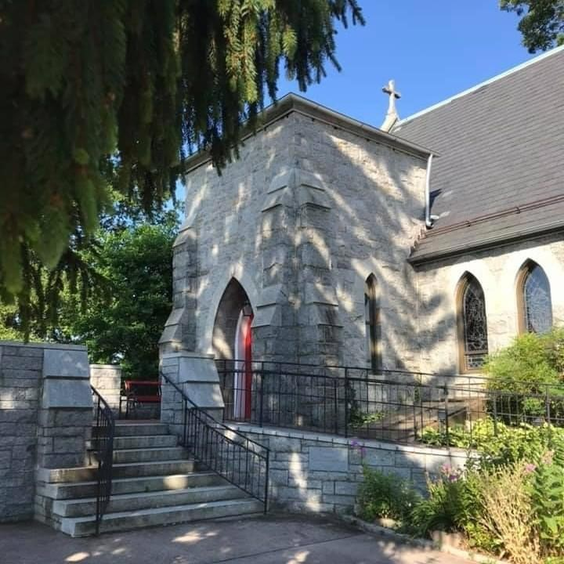

Second Sunday of Easter
April 16, 2023
10:30 am, Rite II

St. John’s Episcopal Church

11901 Belair Road, P. O. Box 187, Kingsville, MD 21087
FaceBook: St. John’s Episcopal, Kingsville, MD
Email: office@stjohnskingsville.org
Website: www.stjohnskingsville.org
Church Phone: 410-592-8570
Pastoral Emergencies: 410-698-5376

Church Staff

Rector: The Rev’d Elizabeth Sipos, M.Div.
Administrative Assistant: Angie Bosley
Organist/Choir Director: Nancy Heinold

The Vestry

Class of 2024 Class of 2025

Marguerite Lobb John Frost
Jacob Johnson Woodie Tingle

Officers
Ty Schwenk—Sr Warden Terry Roe—Jr. Warden
Elizabeth Healey—Treasurer Anne Leland-Registrar

Parish Committee Chairpersons

Altar Guild: Liz Healey
Organ Restoration Committee: Nancy Heinold

10:30 am Worship
Holy Eucharist, Rite Two

Prelude:
The Word of God

Processional hymn: This joyful Eastertide Hymnal #192

Worship begins BCP 355

Gloria Hymnal #S-278
Glory to God in the highest,
and peace to his people on earth.
Lord God, heavenly King,
almighty God and Father,
we worship you, we give you thanks,
we praise you for your glory.
Lord Jesus Christ, only Son of the Father,
Lord God, Lamb of God,
you take away the sin of the world:
have mercy on us;
you are seated at the right hand of the Father:
receive our prayer.
For you alone are the Holy One,
you alone are the Lord,
you alone are the Most High,
Jesus Christ,
with the Holy Spirit,
in the glory of God the Father. Amen.

The Collect of the Day Kneel or stand as able BCP 215
Almighty and everlasting God, who in the Paschal mystery established the new covenant of reconciliation: Grant that all who have been reborn into the fellowship of Christ's Body may show forth in their lives what they profess by their faith; through Jesus Christ our Lord, who lives and reigns with you and the Holy Spirit, one God, for ever and ever. Amen.

The congregation is seated.

A Reading from the Acts of the Apostles 2:14a, 22-32
Peter, standing with the eleven, raised his voice and addressed the crowd, “You that are Israelites, listen to what I have to say: Jesus of Nazareth, a man attested to you by God with deeds of power, wonders, and signs that God did through him among you, as you yourselves know— this man, handed over to you according to the definite plan and foreknowledge of God, you crucified and killed by the hands of those outside the law. But God raised him up, having freed him from death, because it was impossible for him to be held in its power. For David says concerning him, ‘I saw the Lord always before me, for he is at my right hand so that I will not be shaken; therefore my heart was glad, and my tongue rejoiced; moreover my flesh will live in hope. For you will not abandon my soul to Hades, or let your Holy One experience corruption. You have made known to me the ways of life; you will make me full of gladness with your presence.’ “Fellow Israelites, I may say to you confidently of our ancestor David that he both died and was buried, and his tomb is with us to this day. Since he was a prophet, he knew that God had sworn with an oath to him that he would put one of his
descendants on his throne. Foreseeing this, David spoke of the resurrection of the Messiah, saying, ‘He was not abandoned to Hades, nor did his flesh experience corruption.’ This Jesus God raised up, and of that all of us are witnesses.”

Reader: The Word of the Lord.
People: Thanks be to God.

Psalm 16 (Prayed as directed.)
1 Protect me, O God, for I take refuge in you; *
I have said to the Lord, "You are my Lord,
my good above all other."
2 All my delight is upon the godly that are in the land, *
upon those who are noble among the people.
3 But those who run after other gods *
shall have their troubles multiplied.
4 Their libations of blood I will not offer, *
nor take the names of their gods upon my lips.
5 O Lord, you are my portion and my cup; *
it is you who uphold my lot.
6 My boundaries enclose a pleasant land; *
indeed, I have a goodly heritage.
7 I will bless the Lord who gives me counsel; *
my heart teaches me, night after night.
8 I have set the Lord always before me; *
because he is at my right hand I shall not fall.
9 My heart, therefore, is glad, and my spirit rejoices; *
my body also shall rest in hope.
10 For you will not abandon me to the grave, *
nor let your holy one see the Pit.
11 You will show me the path of life; *
in your presence there is fullness of joy,
and in your right hand are pleasures for evermore.

A Reading from the First Letter of Peter 1:3-9
Blessed be the God and Father of our Lord Jesus Christ! By his great mercy he has given us a new birth into a living hope through the resurrection of Jesus Christ from the dead, and into an inheritance that is imperishable, undefiled, and unfading, kept in heaven for you, who are being protected by the power of God through faith for a salvation ready to be revealed in the last time. In this you rejoice, even if now for a little while you have had to suffer various trials, so that the genuineness of your faith-- being more precious than gold that, though perishable, is tested by fire-- may be found to result in praise and glory and honor when Jesus Christ is revealed. Although you have not seen him, you love him; and even though you do not see him now, you believe in him and rejoice with an indescribable and glorious joy, for you are receiving the outcome of your faith, the salvation of your souls.

Reader: The Word of the Lord.
People: Thanks be to God.

Gradual hymn: Alleluia, alleluia, alleluia! The strife is o’er Hymnal #208

The Gospel
Priest: The Holy Gospel of our Lord Jesus Christ according to John 20:19-31

People: Glory to you, Lord Christ.
When it was evening on that day, the first day of the week, and the doors of the house where the disciples had met were locked for fear of the Jews, Jesus came and stood among them and said, "Peace be with you." After he said this, he showed them his hands and his side. Then the disciples rejoiced when they saw the Lord. Jesus said to them again, "Peace be with you. As the Father has sent me, so I send you." When he had said this, he breathed on them and said to them, "Receive the Holy Spirit. If you forgive the sins of any, they are forgiven them; if you retain the sins of any, they are retained."
But Thomas (who was called the Twin), one of the twelve, was not with them when Jesus came. So the other disciples told him, "We have seen the Lord." But he said to them, "Unless I see the mark of the nails in his hands, and put my finger in the mark of the nails and my hand in his side, I will not believe."
A week later his disciples were again in the house, and Thomas was with them. Although the doors were shut, Jesus came and stood among them and said, "Peace be with you." Then he said to Thomas, "Put your finger here and see my hands. Reach out your hand and put it in my side. Do not doubt but believe." Thomas answered him, "My Lord and my God!" Jesus said to him, "Have you believed because you have seen me? Blessed are those who have not seen and yet have come to believe."
Now Jesus did many other signs in the presence of his disciples, which are not written in this book. But these are written so that you may come to believe that Jesus is the Messiah, the Son of God, and that through believing you may have life in his name.

Priest: The Gospel of the Lord.
People: Praise to you, Lord Christ.

Sermon Rev. Elizabeth Sipos+

Nicene Creed Please stand as able BCP 358

Prayers of the People Form III BCP 387

Confession of Sin BCP 359

The Peace BCP 360

Welcome & Announcements The congregation is seated.

Offertory anthem: Doubting Thomas (Choir)
Offertory hymn: That Easter day with joy was bright Hymnal #193

Presentation Hymn
Praise God, from whom all blessings flow; praise him, all creatures here below; praise him above, ye heavenly host: praise Father, Son, and Holy Ghost.

The Holy Communion

THE GREAT THANKSGIVING: Eucharistic Prayer B BCP 367

Sanctus Hymnal #S-128
Holy, Holy, Holy Lord, God of power and might,
heaven and earth are full of your glory.
Hosanna in the highest.
Blessed is he who comes in the name of the Lord.
Hosanna in the highest.

The Lord’s Prayer BCP 364

Invitation to Communion

The Breaking of the Bread

Communion hymn: Here, O my Lord, I see thee face to face Hymnal #318

The Post Communion Prayer BCP 365

Blessing BCP 366

Recessional hymn: Hosanna to the living Lord Hymnal #486

The Dismissal
Serving Today

Celebrant & Preacher: Rev. Elizabeth Sipos
Old Testament: Debbie Weaver
Psalm: John Stevens
New Testament: Jacob Johnson
Prayers of the People: Anne Leland
Server: Marguerite Lobb
Music Director: Nancy Heinold
Choir: Anne Leland, Rev. Elizabeth Sipos,
Liz Healey, Karen Smith-Manar, Jacob Johnson, Ty Schwenk
Altar Guild: Liz Healey & Marguerite Lobb

Altar Flowers

Given to the Glory of God by
The Healey Family
In Thanksgiving for Rev. Elizabeth

From the Treasurer
April ’23 Income vs. Expenses:

Projected April Expenses: $13,990
Monies Received as of 4/13: $10,330

Amount Needed to Meet Expenses: $3,660

St. John’s Parish Prayer List

Additions and corrections may be made to our Parish Prayer List at any time. All names will be automatically removed from the Parish Prayer List on the 1st Sunday of each month unless you request otherwise. Please contact Angie at <office@stjohnskingsville.org> or 410-592-8570 in the church office with all changes by 10 am Thursdays. Thank you.

We Pray for Those in Need:

Ivan, Lisa, Peter, Sarah Sutherland, Melissa Heaver, Liz Rawl, Ricky Carter, Marilyn Stephenson, Charlotte Williams (small child), Cleo Collins, Sid & Joan Pyle, Karen Sugden, DeMarino Family, Jenny, Lisa, Jennifer, Dylan, Gary, Barbara Goldsmith, Thelma, Paul Edwards, James Kneussl, Kim Collins-Appel, Ronnee Congleton (pancreatic cancer), Stephanie Payton, Jim & Chris Carden and family, Terry Barrett, Rev. Tony and Deacon Linda Hollis, Anne Leland, Peggie Dietz, Barnabas & Sarah, Stacey Bell, Thomas Proctor.

We Pray for our Homebound

Lily John, Barbara Miller, Nancy Barnhart, Robin Dilworth

We pray for the Church and the World:

For Most Rev’d. Justin Welby, Archbishop of Canterbury; for The Most Rev’d. Michael Curry, our Presiding Bishop; for Right Rev’d. Eugene Sutton, our Bishop; for the Rt. Rev’d Robert Ihloff, our Assisting Bishop, for our Bishop Co-Adjutor Elect, Carrie Schofield Broadbent, for our Rector, Rev. Elizabeth Sipos, for the Wardens, Vestry, Staff, and all members and friends of St. John’s Church.

For the leaders of all nations, especially for Joseph, our President; for Wes, our Governor; for Brandon, Nick, John and Barry, who lead our City and Counties. We pray for all children and youth; for the homeless, the unemployed, and the hungry. We pray for the safety of our loved ones and friends serving in the Armed Forces at home and abroad, and for our enemies, that all our hearts may be turned toward peace throughout the world.

Our monthly Vestry Meeting is this Tuesday, April 18th at 7:00 pm

Education for Ministry
Are you seeking to know more about Scripture, the church, and yourself? Then EfM is for you! Classes will officially begin in September, but you have an opportunity to explore what the class formats are like, as well as samples of discussion questions and reflections in which you will engage. If you know of anyone who might be interested in EfM, bring them along!
Below are the following dates and themes.
May EfM Meeting Format – May 2, 7 pm
Signing up for EfM
The Book of Common Prayer
Fall meeting format
A Theological Reflection

A few dates to put in your calendar:
Auxiliary Meeting after the 10:30 service
Church Pot Luck, May 7^{th,} everyone is invited. Come on in.
Auxiliary Meeting, May 7th after the 10:30 service
Flea Market, May 20th
Bingo, June 2nd
July 4th Parade, July 4th
Flea Market, September 16th
Christmas Bazaar, November 18th
We are also going to have St. John’s shirts available for a nominal charge.
As you can see, so much going on and everyone’s help is needed to make it a success. If you can any time/talent it is always appreciated.

The Potluck will be the first Sunday of the month with Coffee Hour on all other Sundays.

