St. John’s Episcopal Church
Kingsville, Maryland
Welcomes You
Our Vision Statement

We believe that together we will transform
the world with love: Come on in!

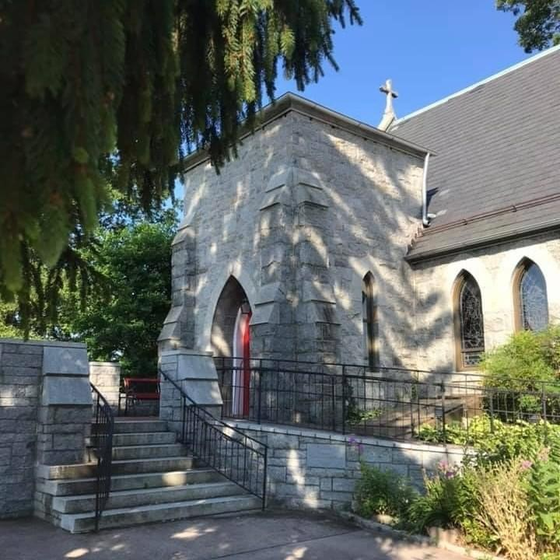

18th Sunday after Pentecost
October 9, 2022
10:30 am, Rite II

St. John’s Episcopal Church

11901 Belair Road, P. O. Box 187, Kingsville, MD 21087
FaceBook: St. John’s Episcopal, Kingsville, MD
Email: office@stjohnskingsville.org
Website: www.stjohnskingsville.org
Church Phone: 410-592-8570
Pastoral Emergencies: 410-698-5376

Church Staff

Rector: The Rev’d Elizabeth Sipos, M.Div.
Administrative Assistant: Angie Bosley
Organist/Choir Director: Nancy Heinold

The Vestry

Class of 2023 Class of 2024

Marguerite Lobb Terry Roe
Barb Daniel Ty Schwenk

Officers
Michele Lozanski—Sr Warden Jacob Johnson—Jr. Warden
Elizabeth Healey—Treasurer Anne Leland-Registrar

Parish Committee Chairpersons

Altar Guild: Liz Healey
Hospitality Hr. Coordinator: Barb Daniel
Outreach: Pat Carden
Organ Restoration Committee: Nancy Heinold
Chapel Restoration Committee: Jacob Johnson

10:30 am Worship
Holy Eucharist, Rite Two

10:25 am Church Bell is Rung

Prelude:
The Word of God

Processional hymn: Praise to the Lord, the Almighty Hymnal #390

Worship begins BCP 355

Gloria Hymnal #S-280
Glory to God in the highest,
and peace to his people on earth.
Lord God, heavenly King,
almighty God and Father,
we worship you, we give you thanks,
we praise you for your glory.
Lord Jesus Christ, only Son of the Father,
Lord God, Lamb of God,
you take away the sin of the world:
have mercy on us;
you are seated at the right hand of the Father:
receive our prayer.
For you alone are the Holy One,
you alone are the Lord,
you alone are the Most High,
Jesus Christ,
with the Holy Spirit,
in the glory of God the Father. Amen.

The Collect of the Day Kneel or stand as able BCP 225
Lord, we pray that your grace may always precede and follow us, that we may continually be given to good works; through Jesus Christ our Lord, who lives and reigns with you and the Holy Spirit, one God, now and for ever. Amen.

The congregation is seated.

A Reading from the Book of the Prophet Jeremiah 29:1, 4-7
These are the words of the letter that the prophet Jeremiah sent from Jerusalem to the remaining elders among the exiles, and to the priests, the prophets, and all the people, whom Nebuchadnezzar had taken into exile from Jerusalem to Babylon.
Thus says the Lord of hosts, the God of Israel, to all the exiles whom I have sent into exile from Jerusalem to Babylon: Build houses and live in them; plant gardens and eat what they produce. Take wives and have sons and daughters; take wives for your sons, and give your daughters in marriage, that they may bear sons and daughters; multiply there, and do not decrease. But seek the welfare of the city where I have sent you into exile, and pray to the Lord on its behalf, for in its welfare you will find your welfare.

Reader: The Word of the Lord.
People: Thanks be to God.

Psalm 66:1-11 (Prayed as directed.)
1 Be joyful in God, all you lands; *
sing the glory of his Name;
sing the glory of his praise.
2 Say to God, "How awesome are your deeds! *
because of your great strength your enemies cringe before you.
3 All the earth bows down before you, *
sings to you, sings out your Name."
4 Come now and see the works of God, *
how wonderful he is in his doing toward all people.
5 He turned the sea into dry land,
so that they went through the water on foot, *
and there we rejoiced in him.
6 In his might he rules for ever;
his eyes keep watch over the nations; *
let no rebel rise up against him.
7 Bless our God, you peoples; *
make the voice of his praise to be heard;
8 Who holds our souls in life, *
and will not allow our feet to slip.
9 For you, O God, have proved us; *
you have tried us just as silver is tried.
10 You brought us into the snare; *
you laid heavy burdens upon our backs.
11 You let enemies ride over our heads;
we went through fire and water; *
but you brought us out into a place of refreshment.

A Reading from the Second Letter of St. Paul to Timothy 2:8-15
Remember Jesus Christ, raised from the dead, a descendant of David-- that is my gospel, for which I suffer hardship, even to the point of being chained like a criminal. But the word of God is not chained. Therefore I endure everything for the sake of the elect, so that they may also obtain the salvation that is in Christ Jesus, with eternal glory. The saying is sure: If we have died with him, we will also live with him; if we endure, we will also reign with him; if we deny him, he will also deny us; if we are faithless, he remains faithful--for he cannot deny
himself.
Remind them of this, and warn them before God that they are to avoid wrangling over words, which does no good but only ruins those who are listening. Do your best to present yourself to God as one approved by him, a worker who has no need to be ashamed, rightly explaining the word of truth.

Reader: The Word of the Lord.
People: Thanks be to God.

Gradual hymn: Now thank we all our God Hymnal #397

The Gospel
Priest: The Holy Gospel of our Lord Jesus Christ according to Luke

People: Glory to you, Lord Christ. 17:11-19
On the way to Jerusalem Jesus was going through the region between Samaria and Galilee. As he entered a village, ten lepers approached him. Keeping their distance, they called out, saying, "Jesus, Master, have mercy on us!" When he saw them, he said to them, "Go and show yourselves to the priests." And as they went, they were made clean. Then one of them, when he saw that he was healed, turned back, praising God with a loud voice. He prostrated himself at Jesus' feet and thanked him. And he was a Samaritan. Then Jesus asked, "Were not ten made clean? But the other nine, where are they? Was none of them found to return and give praise to God except this foreigner?" Then he said to him, "Get up and go on your way; your faith has made you well."

Priest: The Gospel of the Lord.
People: Praise to you, Lord Christ.

Sermon Rev. Elizabeth Sipos+

Nicene Creed Please stand as able BCP 358

Prayers of the People Form III BCP 387

Confession of Sin BCP 359

The Peace BCP 360

Welcome & Announcements The congregation is seated.

Offertory anthem: Come Christians Join to Sing (BellChoir)
Offertory hymn: O for a thousand tongues to sing Hymnal #483

Presentation Hymn
Praise God, from whom all blessings flow; praise him, all creatures here below; praise him above, ye heavenly host: praise Father, Son, and Holy Ghost.

The Holy Communion

THE GREAT THANKSGIVING: Eucharistic Prayer B BCP 367

Sanctus Hymnal #S-129
Holy, Holy, Holy Lord, God of power and might,
heaven and earth are full of your glory.
Hosanna in the highest.
Blessed is he who comes in the name of the Lord.
Hosanna in the highest.

The Lord’s Prayer BCP 364

Invitation to Communion

The Breaking of the Bread

Communion hymn: Come with us, O blessed Jesus Hymnal #336

The Post Communion Prayer BCP 365

Blessing BCP 366

Recessional hymn: Praise my soul, the King of heaven Hymnal #410

The Dismissal

October is Clergy Appreciation Month!
Thank you Rev. Elizabeth. We appreciate you!

Serving Today

Celebrant & Preacher: Rev. Elizabeth Sipos
Old Testament: Charles Keenan
Psalm: Liz Healey
New Testament: Marguerite Lobb
Prayers of the People: John Stevens
Server: Terry Roe
Music Director: Nancy Heinold
Bell Choir: Ty Schwenk, Camy Schwenk, Janine Stevens, John Stevens
Liz Healey, Rev. Elizabeth, Karen Smith-Manar, Danette Moss, Nanci Rosendale
Altar Guild: Liz Healey & Marguerite Lobb

St. John’s Parish Prayer List

Additions and corrections may be made to our Parish Prayer List at any time. All names will be automatically removed from the Parish Prayer List on the 1st Sunday of each month unless you request otherwise. Please contact Angie at <office@stjohnskingsville.org> or 410-592-8570 in the church office with all changes by 10 am Thursdays. Thank you.

We Pray for Those in Need:

Ivan, Lisa, Peter, Sarah Sutherland, Melissa Heaver, Liz Rawl, Ricky Carter, Marilyn Stephenson, Charlotte Williams (small child), Cleo Collins, Sid & Joan Pyle, Karen Sugden, DeMarino Family, Jenny, Lisa, Jennifer, Dylan, Gary, Barbara Goldsmith, Thelma, Paul Edwards, James Kneussl, Kim Collins-Appel, Ronnee Congleton (pancreatic cancer), Stephanie Payton, Jim & Chris Carden and family, Terry Barrett, Rev. Tony and Deacon Linda Hollis, Anne Leland, Peggie Dietz.

We Pray for our Homebound

Lily John, Barbara Miller, Nancy Barnhart, Robin Dilworth

We pray for the Church and the World:

For Most Rev’d. Justin Welby, Archbishop of Canterbury; for The Most Rev’d. Michael Curry, our Presiding Bishop; for Right Rev’d. Eugene Sutton, our Bishop; for the Rt. Rev’d Robert Ihloff, our Assisting Bishop, for our Rector, Rev. Elizabeth Sipos, for the Wardens, Vestry, Staff, and all members and friends of St. John’s Church.

For the leaders of all nations, especially for Joseph, our President; for Larry, our Governor; for Brandon, Nick, John and Barry, who lead our City and Counties. We pray for all children and youth; for the homeless, the unemployed, and the hungry. We pray for the safety of our loved ones and friends serving in the Armed Forces at home and abroad, and for our enemies, that all our hearts may be turned toward peace throughout the world.

Congregational Vitality and Sustainability
Over the next year, St. John’s will begin to reflect and discern who we are at this moment in the life of St. John’s, what our mission is in our community, Outreach ministries, as well as taking a pulse check in
current ministries.

October 15th will be the first workshop about Vestry. To be clear, this is not a recruiting workshop! It is for me (the Rector) to Collect Data, from you, the congregation, about Vestry leadership.

It will be held on Saturday, October 15th, beginning at 9:00 am. Every voice counts and matters. Hope to see you there.

Altar Flowers
Given to the Glory of God
by Marie Dilworth
in memory of Gary Dilworth

From the Treasurer
October Income vs. Expenses:

Projected October Expenses: $12,540
Monies Received as of 10/6 $ 7,977

Amount Needed to Meet Expenses: $ 4,563

Stewardship Campaign—Our Path
Our path forward starts by looking at the journey we have been on together as a congregation. Together, we look back at our history and thank God for everything that has been provided to us. Today, I encourage you to think about how the church has played a meaningful role in your life.
In three weeks, we will be holding our stewardship commitment weekend. Please prayerfully consider how you will support our community and the ministries of our congregation.

Sunday School
We have an exciting year planned for them, with activities, singing, and learning about Jesus.
If you know anyone who might be looking for a Sunday School, invite them to check us out! The more the merrier.

“As a mother comforts her child, so I will comfort you;…” (Isaiah 66:13)
Beginning in October, there will be a healing service on the second Tuesday of every month at 7:00pm. All are welcome to come for support and healing. There will be a time for anointing, as well the Holy Eucharist - reminding us of God's promise of new life.
Education for Ministry (EfM )
What is EfM?
Education for Ministry (EfM) is a unique four-year distance learning certificate program in
theological education based upon small-group study and practice. Since its founding in 1975, this international program has assisted more than 120,000 participants in discovering and nurturing their call to Christian service. EfM helps the faithful encounter the breadth and depth of the Christian tradition and bring it into conversation with their experiences of the world as they study, worship, and engage in theological reflection together.
The program invites participants into small, mentored groups that provide the framework for
understanding life and shaping actions as Christian faith is deepened. EfM seminar groups meet in local settings and online, and provide a four-year curriculum that develops a theologically informed, reflective, and articulate laity
Is it for Me?
Yes! As disciples of Jesus, we have committed ourselves to live and grow in the Christian faith. The word disciple stems from the Latin word discipulus, meaning "learner."
Therefore, as disciples, we are called to be students of God's word and what it means to be a follower of Jesus.
If you are interested please contact Ty Schwenk at camyandty@aol.com. Details of time and place for EfM will be made available shortly.

Make a Joyful Noise!
Choir practice held Wednesdays at 7 pm

The Choir will begin rehearsals for a Christmas
Cantata to be presented at the Kingsville Tree
Lighting

All are welcome to join!

Bell choir practice Sundays after the 10:30 service

Dates to Remember

October 11th - Healing Services - 9:00 am & 7:00 pm
October 15th - Congregational Vitality Workshop: Vestry
(begins at 9:00 am, lunch included)
October 18th - Vestry Meeting - 7:00 pm
November 2nd - All Soul’s Service at 7:00 pm
November 8th - Healing Services - 9:00 am & 7:00 pm
November 12th - Christmas Bazaar, 9:00 am-1:00 pm
November 15th - Vestry Meeting - 7:00 pm
November 19th - Advent Candle Workshop - 9:30 am-12:00 pm
November 24th - Thanksgiving Day Service - 10:00 am
November 27th - Advent Study at 9:00 am (between the two services)

