St. John’s Episcopal Church
Kingsville, Maryland
Welcomes You
Our Vision Statement

We believe that together we will transform
the world with love: Come on in!

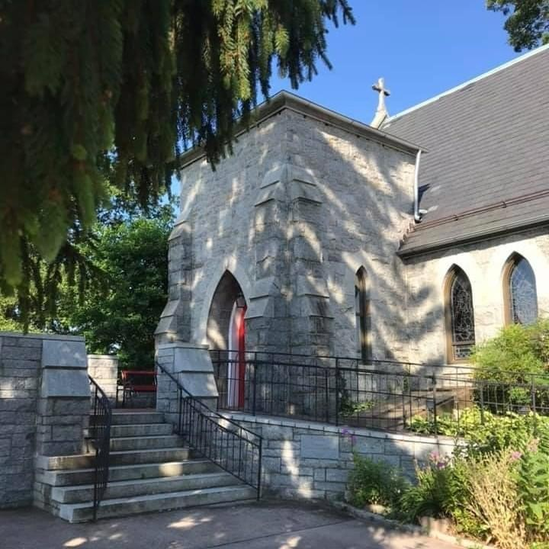

20th Sunday after Pentecost
October 23, 2022
10:30 am, Rite II

St. John’s Episcopal Church

11901 Belair Road, P. O. Box 187, Kingsville, MD 21087
FaceBook: St. John’s Episcopal, Kingsville, MD
Email: office@stjohnskingsville.org
Website: www.stjohnskingsville.org
Church Phone: 410-592-8570
Pastoral Emergencies: 410-698-5376

Church Staff

Rector: The Rev’d Elizabeth Sipos, M.Div.
Administrative Assistant: Angie Bosley
Organist/Choir Director: Nancy Heinold

The Vestry

Class of 2023 Class of 2024

Marguerite Lobb Terry Roe
Barb Daniel Ty Schwenk

Officers
Michele Lozanski—Sr Warden Jacob Johnson—Jr. Warden
Elizabeth Healey—Treasurer Anne Leland-Registrar

Parish Committee Chairpersons

Altar Guild: Liz Healey
Hospitality Hr. Coordinator: Barb Daniel
Outreach: Pat Carden
Organ Restoration Committee: Nancy Heinold
Chapel Restoration Committee: Jacob Johnson

10:30 am Worship
Holy Eucharist, Rite Two

10:25 am Church Bell is Rung

Prelude:
The Word of God

Processional hymn: I sing the almighty power of God Hymnal #398

Worship begins BCP 355

Gloria Hymnal #S-280
Glory to God in the highest,
and peace to his people on earth.
Lord God, heavenly King,
almighty God and Father,
we worship you, we give you thanks,
we praise you for your glory.
Lord Jesus Christ, only Son of the Father,
Lord God, Lamb of God,
you take away the sin of the world:
have mercy on us;
you are seated at the right hand of the Father:
receive our prayer.
For you alone are the Holy One,
you alone are the Lord,
you alone are the Most High,
Jesus Christ,
with the Holy Spirit,
in the glory of God the Father. Amen.

The Collect of the Day Kneel or stand as able BCP 225
Almighty and everlasting God, increase in us the gifts of faith, hope, and charity; and, that we may obtain what you promise, make us love what you command; through Jesus Christ our Lord, who lives and reigns with you and the Holy Spirit, one God, for ever and ever. Amen.

The congregation is seated.

A Reading from the Book of the Prophet Joel 2:23-32
O children of Zion, be glad and rejoice in the Lord your God; for he has given the early rain for your vindication, he has poured down for you abundant rain, the early and the later rain, as before. The threshing floors shall be full of grain, the vats shall overflow with wine and oil. I will repay you for the years that the swarming locust has eaten, the hopper, the destroyer, and the cutter, my great army, which I sent against you. You shall eat in plenty and be satisfied, and praise the name of the Lord your God, who has dealt wondrously with you. And my people shall never again be put to shame. You shall know that I am in the midst of Israel, and that I, the Lord, am your God and there is no other. And my people shall never again be put to shame. Then afterward I will pour out my spirit on all flesh; your sons and your daughters shall prophesy, your old men shall dream dreams, and your young men shall see visions. Even on the male and female slaves, in those days, I will pour out my spirit. I will show portents in the heavens and on the earth, blood and fire and columns of smoke. The sun shall be turned to darkness, and the moon to blood, before the great and terrible day of the Lord comes. Then everyone who calls on the name of the Lord shall be saved; for in Mount Zion and in Jerusalem there shall be those who escape, as the Lord has said, and among the survivors shall be those whom the Lord calls.

Reader: The Word of the Lord.
People: Thanks be to God.

Psalm 65 (Prayed as directed.)
1 You are to be praised, O God, in Zion; *
to you shall vows be performed in Jerusalem.
2 To you that hear prayer shall all flesh come, *
because of their transgressions.
3 Our sins are stronger than we are, *
but you will blot them out.
4 Happy are they whom you choose
and draw to your courts to dwell there! *
they will be satisfied by the beauty of your house,
by the holiness of your temple.
5 Awesome things will you show us in your righteousness,
O God of our salvation, *
O Hope of all the ends of the earth
and of the seas that are far away.
6 You make fast the mountains by your power; *
they are girded about with might.
7 You still the roaring of the seas, *
the roaring of their waves,
and the clamor of the peoples.
8 Those who dwell at the ends of the earth will tremble at your marvelous signs; *
you make the dawn and the dusk to sing for joy.
9 You visit the earth and water it abundantly;
you make it very plenteous; *
the river of God is full of water.
10 You prepare the grain, *
for so you provide for the earth.
11 You drench the furrows and smooth out the ridges; *
with heavy rain you soften the ground and bless its increase.
12 You crown the year with your goodness, *
and your paths overflow with plenty.
13 May the fields of the wilderness be rich for grazing, *
and the hills be clothed with joy.
14 May the meadows cover themselves with flocks,
and the valleys cloak themselves with grain; *
let them shout for joy and sing.

A Reading from the Second Letter of St. Paul to Timothy 4:6-8, 16-18
I am already being poured out as a libation, and the time of my departure has come. I have fought the good fight, I have finished the race, I have kept the faith. From now on there is reserved for me the crown of righteousness, which the Lord, the righteous judge, will give me on that day, and not only to me but also to all who have longed for his appearing.
At my first defense no one came to my support, but all deserted me. May it not be counted against them! But the Lord stood by me and gave me strength, so that through me the message might be fully proclaimed and all the Gentiles might hear it. So I was rescued from the lion's mouth. The Lord will rescue me from every evil attack and save me for his heavenly kingdom. To him be the glory
forever and ever. Amen.

Reader: The Word of the Lord.
People: Thanks be to God.

Gradual hymn: O God, our help in ages past Hymnal #680

The Gospel
Priest: The Holy Gospel of our Lord Jesus Christ according to Luke

People: Glory to you, Lord Christ. 18:9-14
Jesus told this parable to some who trusted in themselves that they were righteous and regarded others with contempt: "Two men went up to the temple to pray, one a Pharisee and the other a tax collector. The Pharisee, standing by himself, was praying thus, `God, I thank you that I am not like other people: thieves, rogues, adulterers, or even like this tax collector. I fast twice a week; I give a tenth of all my income.' But the tax collector, standing far off, would not even look up to heaven, but was beating his breast and saying, `God, be merciful to me, a sinner!' I tell you, this man went down to his home justified rather than the other; for all who exalt themselves will be humbled, but all who humble themselves will be
exalted."

Priest: The Gospel of the Lord.
People: Praise to you, Lord Christ.

Sermon Rev. Elizabeth Sipos+

Nicene Creed Please stand as able BCP 358

Prayers of the People Form III BCP 387

Confession of Sin BCP 359

The Peace BCP 360

Welcome & Announcements The congregation is seated.

Offertory anthem: Change My Heart to God (Choir)
Offertory hymn: Awake, my soul, stretch every nerve Hymnal #546

Presentation Hymn
Praise God, from whom all blessings flow; praise him, all creatures here below; praise him above, ye heavenly host: praise Father, Son, and Holy Ghost.

The Holy Communion

THE GREAT THANKSGIVING: Eucharistic Prayer B BCP 367

Sanctus Hymnal #S-129
Holy, Holy, Holy Lord, God of power and might,
heaven and earth are full of your glory.
Hosanna in the highest.
Blessed is he who comes in the name of the Lord.
Hosanna in the highest.

The Lord’s Prayer BCP 364

Invitation to Communion

The Breaking of the Bread

Communion hymn: Humbly I adore thee, Verity unseen Hymnal #314

The Post Communion Prayer BCP 365

Blessing BCP 366

Recessional hymn: How firm a foundation, ye saints of the Lord Hymnal #637

The Dismissal

October is Clergy Appreciation Month!
Thank you Rev. Elizabeth. We appreciate you!

St. John’s Parish Prayer List

Additions and corrections may be made to our Parish Prayer List at any time. All names will be
automatically removed from the Parish Prayer List on the 1st Sunday of each month unless you
request otherwise. Please contact Angie at <office@stjohnskingsville.org> or 410-592-8570 in the church office with all changes by 10 am Thursdays. Thank you.

We Pray for Those in Need:

Ivan, Lisa, Peter, Sarah Sutherland, Melissa Heaver, Liz Rawl, Ricky Carter, Marilyn Stephenson, Charlotte Williams (small child), Cleo Collins, Sid & Joan Pyle, Karen Sugden, DeMarino Family, Jenny, Lisa, Jennifer, Dylan, Gary, Barbara Goldsmith, Thelma, Paul Edwards, James Kneussl, Kim Collins-Appel, Ronnee Congleton (pancreatic cancer), Stephanie Payton, Jim & Chris Carden and family, Terry Barrett, Rev. Tony and Deacon Linda Hollis, Anne Leland, Peggie Dietz.

We Pray for our Homebound

Lily John, Barbara Miller, Nancy Barnhart, Robin Dilworth

We pray for the Church and the World:

For Most Rev’d. Justin Welby, Archbishop of Canterbury; for The Most Rev’d. Michael Curry, our Presiding Bishop; for Right Rev’d. Eugene Sutton, our Bishop; for the Rt. Rev’d Robert Ihloff, our Assisting Bishop, for our Rector, Rev. Elizabeth Sipos, for the Wardens, Vestry, Staff, and all
members and friends of St. John’s Church.

For the leaders of all nations, especially for Joseph, our President; for Larry, our Governor; for
Brandon, Nick, John and Barry, who lead our City and Counties. We pray for all children and youth; for the homeless, the unemployed, and the hungry. We pray for the safety of our loved ones and friends serving in the Armed Forces at home and abroad, and for our enemies, that all our hearts may be turned toward peace throughout the world.

Serving Today

Celebrant & Preacher: Rev. Elizabeth Sipos
Old Testament: Michele Lozanski
Psalm: Tony Rising
New Testament: John Frost
Prayers of the People: John Frost
Server: John Stevens
Music Director: Nancy Heinold
Choir: Nancy Dellinger, Janine Stevens, Liz Healey, Karen Smith-Manar,
Ty Schwenk, Jacob Johnson, Anne Leland
Altar Guild: Liz Healey & Marguerite Lobb

Altar Flowers
Given to the Glory of God
by Barb Daniel
in memory of Loved Ones

All Soul's Service
Our All Soul's Service will be held on Wednesday November 2nd at 7:00pm. If you have a loved one whom you would like to have remembered at this service, you can let us know by emailing us at office@stjohnskingsville.org or by clearly printing their name(s) on the Remember Loved Ones sheet provided at the back of the church.

Christmas Bazaar
Our Christmas is fast approaching and we are looking for chefs and bakers! There is a sign up sheet at the back of the church for volunteers, bake table and soup table contributions.
We are also looking for donations for our Christmas table. Any gently used Christmas items are welcomed. They can be dropped off during our office hours and/or brought to the parish hall on Sunday before or after services.

From the Treasurer
October Income vs. Expenses:

Projected October Expenses: $12,540
Monies Received as of 10/20 $14,565

Amount Needed to Meet Expenses:

Stewardship Campaign—Our People
We can all move forward on our spiritual path when we are supported and loved by our friends and family here in church. This week, please join me in reflecting on times where you have seen our community love one another. Next week we will be holding our stewardship commitment weekend. Please prayerfully consider how you will support our community and the ministries of our congregation.

Pot Luck Brunch after the 10:30 service on October 30th!

Education for Ministry (EfM )
What is EfM?
Education for Ministry (EfM) is a unique four-year distance learning certificate program in theological education based upon small-group study and practice. Since its founding in 1975, this international program has assisted more than 120,000 participants in discovering and nurturing their call to Christian service. EfM helps the faithful encounter the breadth and depth of the Christian tradition and bring it into conversation with their experiences of the world as they study, worship, and engage in theological reflection together.
The program invites participants into small, mentored groups that provide the framework for understanding life and shaping actions as Christian faith is deepened. EfM seminar groups meet in local settings and online, and provide a four-year curriculum that develops a theologically informed, reflective, and articulate laity.
If you are interested please contact Ty Schwenk at camyandty@aol.com.

Dates to Remember
November 2nd - All Soul’s Service at 7:00 pm
November 8th - Healing Services - 9:00 am & 7:00 pm
November 12th - Christmas Bazaar, 9:00 am-1:00 pm
November 15th - Vestry Meeting - 7:00 pm
November 19th - Advent Candle Workshop - 9:30 am-12:00 pm
November 24th - Thanksgiving Day Service - 10:00 am
November 27th - Advent Study at 9:00 am (between the two services) for the duration of Advent

