St. John’s Episcopal Church
Kingsville, Maryland
Welcomes You
Our Vision Statement

We believe that together we will transform
the world with love: Come on in!

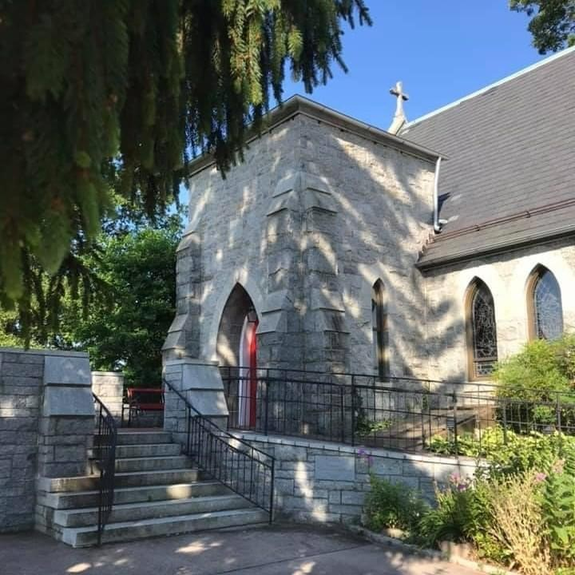

19th Sunday after Pentecost
October 16, 2022
10:30 am, Rite II

St. John’s Episcopal Church

11901 Belair Road, P. O. Box 187, Kingsville, MD 21087
FaceBook: St. John’s Episcopal, Kingsville, MD
Email: office@stjohnskingsville.org
Website: www.stjohnskingsville.org
Church Phone: 410-592-8570
Pastoral Emergencies: 410-698-5376

Church Staff

Rector: The Rev’d Elizabeth Sipos, M.Div.
Administrative Assistant: Angie Bosley
Organist/Choir Director: Nancy Heinold

The Vestry

Class of 2023 Class of 2024

Marguerite Lobb Terry Roe
Barb Daniel Ty Schwenk

Officers
Michele Lozanski—Sr Warden Jacob Johnson—Jr. Warden
Elizabeth Healey—Treasurer Anne Leland-Registrar

Parish Committee Chairpersons

Altar Guild: Liz Healey
Hospitality Hr. Coordinator: Barb Daniel
Outreach: Pat Carden
Organ Restoration Committee: Nancy Heinold
Chapel Restoration Committee: Jacob Johnson

10:30 am Worship
Holy Eucharist, Rite Two

10:25 am Church Bell is Rung

Prelude:
The Word of God

Processional hymn: Praise to the Living God Hymnal #372

Worship begins BCP 355

Gloria Hymnal #S-280
Glory to God in the highest,
and peace to his people on earth.
Lord God, heavenly King,
almighty God and Father,
we worship you, we give you thanks,
we praise you for your glory.
Lord Jesus Christ, only Son of the Father,
Lord God, Lamb of God,
you take away the sin of the world:
have mercy on us;
you are seated at the right hand of the Father:
receive our prayer.
For you alone are the Holy One,
you alone are the Lord,
you alone are the Most High,
Jesus Christ,
with the Holy Spirit,
in the glory of God the Father. Amen.

The Collect of the Day Kneel or stand as able BCP 225
Almighty and everlasting God, in Christ you have revealed your glory among the nations: Preserve the works of your mercy, that your Church throughout the world may persevere with steadfast faith in the confession of your Name; through Jesus Christ our Lord, who lives and reigns with you and the Holy Spirit, one God, for ever and ever. Amen.

The congregation is seated.

A Reading from the Book of the Prophet Jeremiah 31:27-34
The days are surely coming, says the Lord, when I will sow the house of Israel and the house of Judah with the seed of humans and the seed of animals. And just as I have watched over them to pluck up and break down, to overthrow, destroy, and bring evil, so I will watch over them to build and to plant, says the Lord. In those days they shall no longer say: "The parents have eaten sour grapes, and the children's teeth are set on edge."
But all shall die for their own sins; the teeth of everyone who eats sour grapes shall be set on edge.
The days are surely coming, says the Lord, when I will make a new covenant with the house of Israel and the house of Judah. It will not be like the covenant that I made with their ancestors when I took them by the hand to bring them out of the land of Egypt-- a covenant that they broke, though I was their husband, says the Lord. But this is the covenant that I will make with the house of Israel after those days, says the Lord: I will put my law within them, and I will write it on their hearts; and I will be their God, and they shall be my people. No longer shall they teach one another, or say to each other, "Know the Lord," for they shall all know me, from the least of them to the greatest, says the Lord; for I will forgive their iniquity, and remember their sin no more.

Reader: The Word of the Lord.
People: Thanks be to God.

Psalm 119:97-104 (Prayed as directed.)
97 Oh, how I love your law! *
all the day long it is in my mind.
98 Your commandment has made me wiser than my enemies, *
and it is always with me.
99 I have more understanding than all my teachers, *
for your decrees are my study.
100 I am wiser than the elders, *
because I observe your commandments.
101 I restrain my feet from every evil way, *
that I may keep your word.
102 I do not shrink from your judgments, *
because you yourself have taught me.
103 How sweet are your words to my taste! *
they are sweeter than honey to my mouth.
104 Through your commandments I gain understanding; *
therefore I hate every lying way.

A Reading from the Second Letter of St. Paul to Timothy 3:14-4:5
As for you, continue in what you have learned and firmly believed, knowing from whom you learned it, and how from childhood you have known the sacred writings that are able to instruct you for salvation through faith in Christ Jesus. All scripture is inspired by God and is useful for teaching, for reproof, for correction, and for training in righteousness, so that everyone who belongs to God may be proficient, equipped for every good work. In the presence of God and of Christ Jesus, who is to judge the living and the dead, and in view of his appearing and his kingdom, I solemnly urge you: proclaim the message; be persistent whether the time is favorable or unfavorable; convince, rebuke, and encourage, with the utmost patience in teaching. For the time is coming when people will not put up with sound
doctrine, but having itching ears, they will accumulate for themselves teachers to suit their own desires, and will turn away from listening to the truth and wander away to myths. As for you, always be sober, endure suffering, do the work of an evangelist, carry out your ministry fully.

Reader: The Word of the Lord.
People: Thanks be to God.

Gradual hymn: Book of books, our people’s strength Hymnal #631

The Gospel
Priest: The Holy Gospel of our Lord Jesus Christ according to Luke

People: Glory to you, Lord Christ. 18:1-8
Jesus told his disciples a parable about their need to pray always and not to lose heart. He said, "In a certain city there was a judge who neither feared God nor had respect for people. In that city there was a widow who kept coming to him and saying, `Grant me justice against my opponent.' For a while he refused; but later he said to himself, `Though I have no fear of God and no respect for anyone, yet because this widow keeps bothering me, I will grant her justice, so that she may not wear me out by continually coming.'" And the Lord said, "Listen to what the unjust judge says. And will not God grant justice to his chosen ones who cry to him day and night? Will he delay long in helping them? I tell you, he will quickly grant justice to them. And yet, when the Son of Man comes, will he find faith on earth?"

Priest: The Gospel of the Lord.
People: Praise to you, Lord Christ.

Sermon Rev. Elizabeth Sipos+

Nicene Creed Please stand as able BCP 358

Prayers of the People Form III BCP 387

Confession of Sin BCP 359

The Peace BCP 360

Welcome & Announcements The congregation is seated.

Offertory anthem: Was I Faithful (Choir)
Offertory hymn: Seek ye first the kingdom of God Hymnal #711

Presentation Hymn
Praise God, from whom all blessings flow; praise him, all creatures here below; praise him above, ye heavenly host: praise Father, Son, and Holy Ghost.

The Holy Communion

THE GREAT THANKSGIVING: Eucharistic Prayer B BCP 367

Sanctus Hymnal #S-129
Holy, Holy, Holy Lord, God of power and might,
heaven and earth are full of your glory.
Hosanna in the highest.
Blessed is he who comes in the name of the Lord.
Hosanna in the highest.

The Lord’s Prayer BCP 364

Invitation to Communion

The Breaking of the Bread

Communion hymn: And now, O Father, mindful of the love Hymnal #337

The Post Communion Prayer BCP 365

Blessing BCP 366

Recessional hymn: Spread, O spread, thou mighty word Hymnal #530

The Dismissal

October is Clergy Appreciation Month!
Thank you Rev. Elizabeth. We appreciate you!

Serving Today

Celebrant & Preacher: Rev. Elizabeth Sipos
Old Testament: Debbie Weaver
Psalm: John Stevens
New Testament: Jacob Johnson
Prayers of the People: John Frost
Server:
Music Director: Nancy Heinold
Choir: Nancy Dellinger, Janine Stevens, Liz Healey, Karen Smith-Manar,
Ty Schwenk, Jacob Johnson
Altar Guild: Liz Healey & Marguerite Lobb

St. John’s Parish Prayer List

Additions and corrections may be made to our Parish Prayer List at any time. All names will be
automatically removed from the Parish Prayer List on the 1st Sunday of each month unless you
request otherwise. Please contact Angie at <office@stjohnskingsville.org> or 410-592-8570 in the church office with all changes by 10 am Thursdays. Thank you.

We Pray for Those in Need:

Ivan, Lisa, Peter, Sarah Sutherland, Melissa Heaver, Liz Rawl, Ricky Carter, Marilyn Stephenson, Charlotte Williams (small child), Cleo Collins, Sid & Joan Pyle, Karen Sugden, DeMarino Family, Jenny, Lisa, Jennifer, Dylan, Gary, Barbara Goldsmith, Thelma, Paul Edwards, James Kneussl, Kim Collins-Appel, Ronnee Congleton (pancreatic cancer), Stephanie Payton, Jim & Chris Carden and family, Terry Barrett, Rev. Tony and Deacon Linda Hollis, Anne Leland, Peggie Dietz.

We Pray for our Homebound

Lily John, Barbara Miller, Nancy Barnhart, Robin Dilworth

We pray for the Church and the World:

For Most Rev’d. Justin Welby, Archbishop of Canterbury; for The Most Rev’d. Michael Curry, our Presiding Bishop; for Right Rev’d. Eugene Sutton, our Bishop; for the Rt. Rev’d Robert Ihloff, our Assisting Bishop, for our Rector, Rev. Elizabeth Sipos, for the Wardens, Vestry, Staff, and all
members and friends of St. John’s Church.

For the leaders of all nations, especially for Joseph, our President; for Larry, our Governor; for
Brandon, Nick, John and Barry, who lead our City and Counties. We pray for all children and youth; for the homeless, the unemployed, and the hungry. We pray for the safety of our loved ones and friends serving in the Armed Forces at home and abroad, and for our enemies, that all our hearts may be turned toward peace throughout the world.

Altar Flowers
Given to the Glory of God
by Frank & Stephanie Duchacek
in memory of Rose Duchacek

From the Treasurer
October Income vs. Expenses:

Projected October Expenses: $12,540
Monies Received as of 10/12 $8,872

Amount Needed to Meet Expenses: $3,668

Stewardship Campaign—Our Purpose
To move forward on our spiritual path, we must understand our purpose. This week I invite you to reflect on what you believe our mission is as a community of faith, and how you see your role in our spiritual family. In two weeks will be holding our stewardship commitment weekend. Please prayerful consider how you will support our community and the ministries of our congregation.

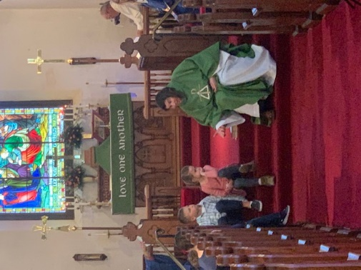

Sunday School
We have an exciting year planned for them, with activities, singing, and learning about Jesus.
If you know anyone who might be looking for a Sunday School, invite them to check us out! The more the merrier.

“As a mother comforts her child, so I will comfort you;…” (Isaiah 66:13)
Beginning in October, there will be a healing service on the second Tuesday of every month at 7:00pm. All are welcome to come for support and healing. There will be a time for anointing, as well the Holy Eucharist - reminding us of God's promise of new life.

Education for Ministry (EfM )
What is EfM?
Education for Ministry (EfM) is a unique four-year distance learning certificate program in theological education based upon small-group study and practice. Since its founding in 1975, this international program has assisted more than 120,000 participants in discovering and nurturing their call to Christian service. EfM helps the faithful encounter the breadth and depth of the Christian tradition and bring it into conversation with their experiences of the world as they study, worship, and engage in theological reflection together.
The program invites participants into small, mentored groups that provide the framework for
understanding life and shaping actions as Christian faith is deepened. EfM seminar groups meet in local settings and online, and provide a four-year curriculum that develops a theologically informed, reflective, and articulate laity
Is it for Me?
If you are interested please contact Ty Schwenk at camyandty@aol.com.

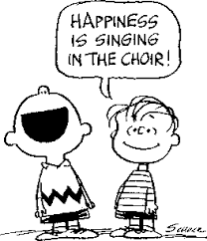
Make a Joyful Noise!
Choir practice held Wednesdays at 7 pm

The Choir will begin rehearsals for a Christmas
Cantata to be presented at the Kingsville Tree
Lighting

All are welcome to join!

Bell choir practice Sundays after the 10:30 service

Dates to Remember

October 18th - Vestry Meeting - 7:00 pm
November 2nd - All Soul’s Service at 7:00 pm
November 8th - Healing Services - 9:00 am & 7:00 pm
November 12th - Christmas Bazaar, 9:00 am-1:00 pm
November 15th - Vestry Meeting - 7:00 pm
November 19th - Advent Candle Workshop - 9:30 am-12:00 pm
November 24th - Thanksgiving Day Service - 10:00 am
November 27th - Advent Study at 9:00 am (between the two services) for the duration of Advent

