St. John’s Episcopal Church
Kingsville, Maryland
Welcomes You
Our Vision Statement

We believe that together we will transform
the world with love: Come on in!

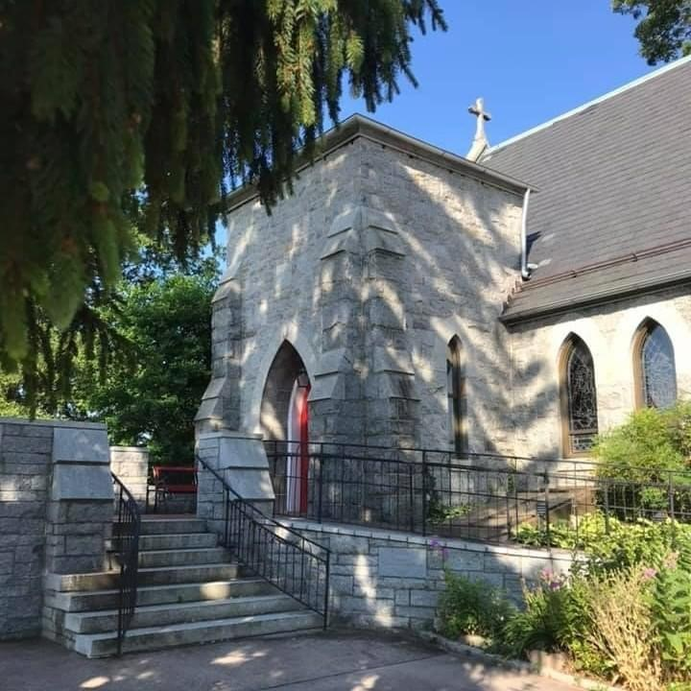

17th Sunday after Pentecost
October 2, 2022
10:30 am, Rite II

St. John’s Episcopal Church

11901 Belair Road, P. O. Box 187, Kingsville, MD 21087
FaceBook: St. John’s Episcopal, Kingsville, MD
Email: office@stjohnskingsville.org
Website: www.stjohnskingsville.org
Church Phone: 410-592-8570
Pastoral Emergencies: 410-698-5376

Church Staff

Rector: The Rev’d Elizabeth Sipos, M.Div.
Administrative Assistant: Angie Bosley
Organist/Choir Director: Nancy Heinold

The Vestry

Class of 2023 Class of 2024

Marguerite Lobb Terry Roe
Ty Schwenk Barb Daniel

Officers
Michele Lozanski—Sr Warden Jacob Johnson—Jr. Warden
Elizabeth Healey—Treasurer Anne Leland-Registrar

Parish Committee Chairpersons

Altar Guild: Liz Healey
Hospitality Hr. Coordinator: Barb Daniel
Outreach: Pat Carden
Organ Restoration Committee: Nancy Heinold
Chapel Restoration Committee: Jacob Johnson

10:30 am Worship
Holy Eucharist, Rite Two

10:25 am Church Bell is Rung

Prelude:
The Word of God

Processional hymn: Awake, my soul, and with the sun Hymnal #11

Worship begins BCP 355

Gloria Hymnal #S-280
Glory to God in the highest,
and peace to his people on earth.
Lord God, heavenly King,
almighty God and Father,
we worship you, we give you thanks,
we praise you for your glory.
Lord Jesus Christ, only Son of the Father,
Lord God, Lamb of God,
you take away the sin of the world:
have mercy on us;
you are seated at the right hand of the Father:
receive our prayer.
For you alone are the Holy One,
you alone are the Lord,
you alone are the Most High,
Jesus Christ,
with the Holy Spirit,
in the glory of God the Father. Amen.

The Collect of the Day Kneel or stand as able BCP 225
Almighty and everlasting God, you are always more ready to hear than we to pray, and to give more than we either desire or deserve: Pour upon us the abundance of your mercy, forgiving us those things of which our conscience is afraid, and giving us those good things for which we are not worthy to ask, except through the merits and mediation of Jesus Christ our Savior; who lives and reigns with you and the Holy Spirit, one God, for ever and ever. Amen.

The congregation is seated.

A Reading from the Book of Lamentations 1:1-6
How lonely sits the city that once was full of people! How like a widow she has become, she that was great among the nations! She that was a princess among the provinces has become a vassal. She weeps bitterly in the night, with tears on her cheeks; among all her lovers she has no one to comfort her; all her friends have dealt treacherously with her, they have become her enemies. Judah has gone into exile with suffering and hard servitude; she lives now among the nations, and finds no resting place; her pursuers have all overtaken her in the midst of her
distress. The roads to Zion mourn, for no one comes to the festivals; all her gates are desolate, her priests groan; her young girls grieve, and her lot is bitter. Her foes have become the masters, her enemies prosper, because the Lord has made her suffer for the multitude of her transgressions; her children have gone away, captives before the foe. From daughter Zion has departed all her majesty. Her princes have become like stags that find no pasture; they fled without strength before the pursuer.

Reader: The Word of the Lord.
People: Thanks be to God.

Psalm 137 (Prayed as directed.)
1 By the waters of Babylon we sat down and wept, *
when we remembered you, O Zion.
2 As for our harps, we hung them up *
on the trees in the midst of that land.
3 For those who led us away captive asked us for a song,
and our oppressors called for mirth: *
"Sing us one of the songs of Zion."
4 How shall we sing the Lord'S song *
upon an alien soil.
5 If I forget you, O Jerusalem, *
let my right hand forget its skill.
6 Let my tongue cleave to the roof of my mouth
if I do not remember you, *
if I do not set Jerusalem above my highest joy.
7 Remember the day of Jerusalem, O Lord,
against the people of Edom, *
who said, "Down with it! down with it!
even to the ground!"
8 O Daughter of Babylon, doomed to destruction, *
happy the one who pays you back
for what you have done to us!
9 Happy shall he be who takes your little ones, *
and dashes them against the rock!

A Reading from the Second Letter of St. Paul to Timothy 1:1-14
Paul, an apostle of Christ Jesus by the will of God, for the sake of the promise of life that is in Christ Jesus, To Timothy, my beloved child: Grace, mercy, and peace from God the Father and Christ Jesus our Lord.
I am grateful to God-- whom I worship with a clear conscience, as my ancestors did-- when I remember you constantly in my prayers night and day. Recalling your tears, I long to see you so that I may be filled with joy. I am reminded of your sincere faith, a faith that lived first in your grandmother Lois and your mother Eunice and now, I am sure, lives in you. For this reason I remind you to rekindle the gift of God that is within you through the laying on of my hands; for God did not give us a spirit of cowardice, but rather a spirit of power and of love and of self-discipline.
Do not be ashamed, then, of the testimony about our Lord or of me his prisoner, but join with me in suffering for the gospel, relying on the power of God, who saved us and called us with a holy calling, not according to our works but according to his own purpose and grace. This grace was given to us in Christ Jesus before the ages began, but it has now been revealed through the appearing of our Savior Christ Jesus, who abolished death and brought life and immortality to light through the gospel. For this gospel I was appointed a herald and an apostle and a teacher, and for this reason I suffer as I do. But I am not ashamed, for I know the one in whom I have put my trust, and I am sure that he is able to guard until that day what I have entrusted to him. Hold to the standard of sound teaching that you have heard from me, in the faith and love that are in Christ Jesus. Guard the good treasure entrusted to you, with the help of the Holy Spirit living in us.

Reader: The Word of the Lord.
People: Thanks be to God.

Gradual hymn: Come, labor on Hymnal #541

The Gospel
Priest: The Holy Gospel of our Lord Jesus Christ according to Luke

People: Glory to you, Lord Christ. 17:5-10
The apostles said to the Lord, "Increase our faith!" The Lord replied, "If you had faith the size of a mustard seed, you could say to this mulberry tree, `Be uprooted and planted in the sea,' and it would obey you. "Who among you would say to your slave who has just come in from plowing or tending sheep in the field, `Come here at once and take your place at the table'? Would you not rather say to him, `Prepare supper for me, put on your apron and serve me while I eat and drink; later you may eat and drink'? Do you thank the slave for doing what was commanded? So you also, when you have done all that you were ordered to do, say, `We are worthless slaves; we have done only what we ought to have done!'"

Priest: The Gospel of the Lord.
People: Praise to you, Lord Christ.

Sermon Rev. Elizabeth Sipos+

Nicene Creed Please stand as able BCP 358

Prayers of the People Form III BCP 387

Confession of Sin BCP 359

The Peace BCP 360

Welcome & Announcements The congregation is seated.

Offertory anthem: Prayer of St. Francis (Choir)
Offertory hymn: O Jesus, I have promised Hymnal #655

Presentation Hymn
Praise God, from whom all blessings flow; praise him, all creatures here below; praise him above, ye heavenly host: praise Father, Son, and Holy Ghost.

The Holy Communion

THE GREAT THANKSGIVING: Eucharistic Prayer B BCP 367

Sanctus Hymnal #S-129
Holy, Holy, Holy Lord, God of power and might,
heaven and earth are full of your glory.
Hosanna in the highest.
Blessed is he who comes in the name of the Lord.
Hosanna in the highest.

The Lord’s Prayer BCP 364

Invitation to Communion

The Breaking of the Bread

Communion hymn: O Master, let me walk with thee Hymnal #660

The Post Communion Prayer BCP 365

Blessing BCP 366

Recessional hymn: Ye servants of God, your Master proclaim Hymnal #535

The Dismissal

Serving Today

Celebrant & Preacher: Rev. Elizabeth Sipos
Old Testament: Barb Daniel
Psalm: Jacob Johnson
New Testament: Ty Schwenk
Prayers of the People: Ty Schwenk
Server: Terry Roe
Music Director: Nancy Heinold
Choir: Nancy Dellinger, Janine Stevens, Liz Healey, Karen Smith-Manar,
Ty Schwenk, Jacob Johnson
Altar Guild: Liz Healey & Marguerite Lobb

Congregational Vitality and Sustainability
Over the next year, St. John’s will begin to reflect and discern who we are at this moment in the life of St. John’s, what our mission is in our community, Outreach ministries, as well as taking a pulse check in current ministries.

October 15th will be the first workshop about Vestry. To be clear, this is not a recruiting workshop! It is for me (the Rector) to Collect Data, from you, the congregation, about Vestry leadership.

It will be held on Saturday, October 15th, beginning at 9:00 am. Every voice counts and matters. Hope to see you there.

Altar Flowers
Given to the Glory of God
by Frank Duchacek, in celebration
of the birthday of Stephanie Duchacek

From the Treasurer
September Recap:

September Expenses: $13,860
September Income: $13,300
Difference: ( $560)

Projected October Expenses: $12,540

Feast of St. Francis of Assisi - Pet Blessing
In his hand is the life of every creature and the breath of all mankind. ~ Job 12:10

Pet Blessing!
Join us on this Sunday (October 2nd) at 4:00pm for our Pet Blessing. If your wish to come but cannot because your pet is anxious travelling or around other pets, fell free to bring a picture, and we will bless them that way. Donations for the Human Society are welcome.

October is Clergy Appreciation Month!
Thank you Rev. Elizabeth. We appreciate you!
St. John’s Parish Prayer List

Additions and corrections may be made to our Parish Prayer List at any time. All names will be automatically removed from the Parish Prayer List on the 1st Sunday of each month unless you request otherwise. Please contact Angie at <office@stjohnskingsville.org> or 410-592-8570 in the church office with all changes by 10 am Thursdays. Thank you.

We Pray for Those in Need:

Ivan, Lisa, Peter, Sarah Sutherland, Melissa Heaver, Liz Rawl, Ricky Carter, Marilyn Stephenson, Charlotte Williams (small child), Cleo Collins, Sid & Joan Pyle, Karen Sugden, DeMarino Family, Jenny, Lisa, Jennifer, Dylan, Gary, Barbara Goldsmith, Thelma, Paul Edwards, James Kneussl, Kim Collins-Appel, Ronnee Congleton (pancreatic cancer), Stephanie Payton, Jim & Chris Carden and family, Terry Barrett, Rev. Tony and Deacon Linda Hollis, Anne Leland, Peggie Dietz.

We Pray for our Homebound

Lily John, Barbara Miller, Nancy Barnhart, Robin Dilworth

We pray for the Church and the World:

For Most Rev’d. Justin Welby, Archbishop of Canterbury; for The Most Rev’d. Michael Curry, our Presiding Bishop; for Right Rev’d. Eugene Sutton, our Bishop; for the Rt. Rev’d Robert Ihloff, our Assisting Bishop, for our Rector, Rev. Elizabeth Sipos, for the Wardens, Vestry, Staff, and all members and friends of St. John’s Church.

For the leaders of all nations, especially for Joseph, our President; for Larry, our Governor; for Brandon, Nick, John and Barry, who lead our City and Counties. We pray for all children and youth; for the homeless, the unemployed, and the hungry. We pray for the safety of our loved ones and friends serving in the Armed Forces at home and abroad, and for our enemies, that all our hearts may be turned toward peace throughout the world.
Sunday School Meet and Greet!
We have an exciting year planned for them, with activities, singing, and learning about Jesus.
If you know anyone who might be looking for a Sunday School, invite them to check us out! The more the merrier.

“As a mother comforts her child, so I will comfort you;…” (Isaiah 66:13)
Beginning in October, there will be a healing service on the second Tuesday of every month at 7:00pm. All are welcome to come for support and healing. There will be a time for anointing, as well the Holy Eucharist - reminding us of God's promise of new life.
"For I know the plans I have for you,” declares the Lord, “plans to prosper you and not to harm you, plans to give you hope and a future. ~ Jeremiah 29:11
Without a Spiritual foundation, your church is not sustainable, no matter the size or budget...Prayer is the key to cooperation with God, as well as sorting through many choices before you. These are wise words from the article The 5 "P's" of Sustainability for Small Churches by Rebekah Simon-Peter. If you feel called to be part of St. John's prayer group, we will meet on Monday evenings at 7:00pm. It will be hybrid, in that if you are unable to attend in person, you can join us online.
Our first gathering will be October 3, in the Parish Hall. If you can only join us online, please contact Rev. Elizabeth.

Education for Ministry (EfM )
What is EfM?
Education for Ministry (EfM) is a unique four-year distance learning certificate program in
theological education based upon small-group study and practice. Since its founding in 1975, this international program has assisted more than 120,000 participants in discovering and nurturing their call to Christian service. EfM helps the faithful encounter the breadth and depth of the Christian tradition and bring it into conversation with their experiences of the world as they study, worship, and engage in theological reflection together.
The program invites participants into small, mentored groups that provide the framework for understanding life and shaping actions as Christian faith is deepened. EfM seminar groups meet in local settings and online, and provide a four-year curriculum that develops a theologically informed, reflective, and articulate laity
Is it for Me?
Yes! As disciples of Jesus, we have committed ourselves to live and grow in the Christian faith. The word disciple stems from the Latin word discipulus, meaning "learner." Therefore, as disciples, we are called to be students of God's word and what it means to be a follower of Jesus.
If you are interested please contact Rev. Elizabeth at elizabethanne.sipos@yahoo.com Details of time and place for EfM will be made available shortly.

Make a Joyful Noise!
Choir practice Wednesdays at 7 pm
All are welcome to join!
Bell choir practice, after the 10:30 service

