St. John’s Episcopal Church
Kingsville, Maryland
Welcomes You
Our Vision Statement

We believe that together we will transform
the world with love: Come on in!

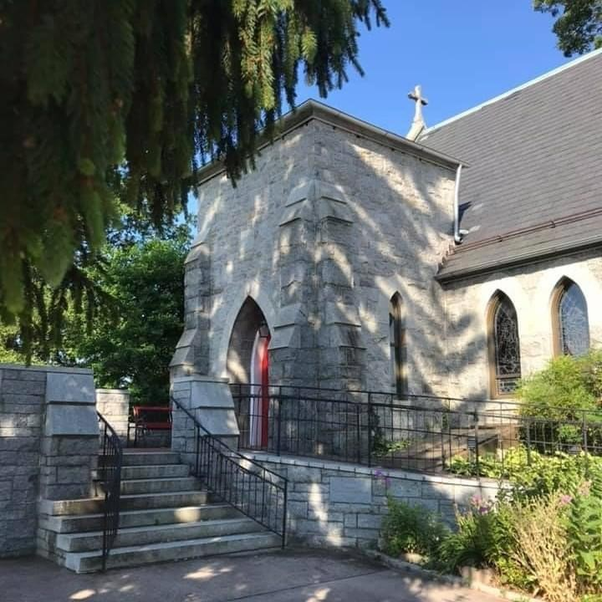

Third Sunday after Pentecost
June 26, 2022
10:30 am, Rite II

St. John’s Episcopal Church

11901 Belair Road, P. O. Box 187, Kingsville, MD 21087
FaceBook: St. John’s Episcopal, Kingsville, MD
Email: office@stjohnskingsville.org
Website: www.stjohnskingsville.org
Church Phone: 410-592-8570
Pastoral Emergencies: 410-698-5376

Church Staff

Rector: The Rev’d Elizabeth Sipos, M.Div.
Administrative Assistant: Angie Bosley
Organist/Choir Director: Nancy Heinold

The Vestry

Class of 2023 Class of 2024

Marguerite Lobb Terry Roe
Ty Schwenk Barb Daniel

Officers
Michele Lozanski—Sr Warden Jacob Johnson—Jr. Warden
Elizabeth Healey—Treasurer Anne Leland-Registrar

Parish Committee Chairpersons

Altar Guild: Liz Healey
Hospitality Hr. Coordinator: Barb Daniel
Outreach: Pat Carden
Organ Restoration Committee: Nancy Heinold
Chapel Restoration Committee: Jacob Johnson

10:30 am Worship
Holy Eucharist, Rite Two

*Please stand if you are able

10:25 am Church Bell is Rung

Prelude:
The Word of God

Processional hymn: The Church’s one foundation Hymnal #525

Worship begins BCP 355

Gloria Hymnal #S-280
Glory to God in the highest,
and peace to his people on earth.
Lord God, heavenly King,
almighty God and Father,
we worship you, we give you thanks,
we praise you for your glory.
Lord Jesus Christ, only Son of the Father,
Lord God, Lamb of God,
you take away the sin of the world:
have mercy on us;
you are seated at the right hand of the Father:
receive our prayer.
For you alone are the Holy One,
you alone are the Lord,
you alone are the Most High,
Jesus Christ,
with the Holy Spirit,
in the glory of God the Father. Amen.

The Collect of the Day Kneel or stand as able BCP 225
Almighty God, you have built your Church upon the foundation of the apostles and prophets, Jesus Christ himself being the chief cornerstone: Grant us so to be joined together in unity of spirit by their teaching, that we may be made a holy temple acceptable to you; through Jesus Christ our Lord, who lives and reigns with you and the Holy Spirit, one God, for ever and ever. Amen.

The congregation is seated.

A Reading from the Second Book of Kings 2:1-2, 6-14
When the Lord was about to take Elijah up to heaven by a whirlwind, Elijah and Elisha were on their way from Gilgal. Elijah said to Elisha, "Stay here; for the Lord has sent me as far as Bethel." But Elisha said, "As the Lord lives, and as you yourself live, I will not leave you." So they went down to Bethel.
Then Elijah said to him, "Stay here; for the Lord has sent me to the Jordan." But he said, "As the Lord lives, and as you yourself live, I will not leave you." So the two of them went on. Fifty men of the company of prophets also went, and stood at some distance from them, as they both were standing by the Jordan. Then Elijah took his mantle and rolled it up, and struck the water; the water was parted to the one side and to the other, until the two of them crossed on dry ground.
When they had crossed, Elijah said to Elisha, "Tell me what I may do for you,
before I am taken from you." Elisha said, "Please let me inherit a double share of your spirit." He responded, "You have asked a hard thing; yet, if you see me as I am being taken from you, it will be granted you; if not, it will not." As they
continued walking and talking, a chariot of fire and horses of fire separated the two of them, and Elijah ascended in a whirlwind into heaven. Elisha kept
watching and crying out, "Father, father! The chariots of Israel and its horsemen!" But when he could no longer see him, he grasped his own clothes and tore them in two pieces.
He picked up the mantle of Elijah that had fallen from him, and went back and stood on the bank of the Jordan. He took the mantle of Elijah that had fallen from him, and struck the water, saying, "Where is the Lord, the God of Elijah?" When he had struck the water, the water was parted to the one side and to the other, and Elisha went over.

Reader: The Word of the Lord.
People: Thanks be to God.

Psalm 77:1-2, 11-20 (Prayed as directed.)
1 I will cry aloud to God; *
I will cry aloud, and he will hear me.
2 In the day of my trouble I sought the Lord; *
my hands were stretched out by night and did not tire;
I refused to be comforted.
11 I will remember the works of the Lord, *
and call to mind your wonders of old time.
12 I will meditate on all your acts *
and ponder your mighty deeds.
13 Your way, O God, is holy; *
who is so great a god as our God?
14 You are the God who works wonders *
and have declared your power among the peoples.
15 By your strength you have redeemed your people, *
the children of Jacob and Joseph.
16 The waters saw you, O God;
the waters saw you and trembled; *
the very depths were shaken.
17 The clouds poured out water;
the skies thundered; *
your arrows flashed to and fro;
18 The sound of your thunder was in the whirlwind;
your lightnings lit up the world; *
the earth trembled and shook.
19 Your way was in the sea,
and your paths in the great waters, *
yet your footsteps were not seen.
20 You led your people like a flock *
by the hand of Moses and Aaron.

A Reading from the Letter of St. Paul to the Galatians 5:1, 13-25
For freedom Christ has set us free. Stand firm, therefore, and do not submit again to a yoke of slavery.
For you were called to freedom, brothers and sisters; only do not use your
freedom as an opportunity for self-indulgence, but through love become slaves to one another. For the whole law is summed up in a single commandment,
"You shall love your neighbor as yourself." If, however, you bite and devour one another, take care that you are not consumed by one another.
Live by the Spirit, I say, and do not gratify the desires of the flesh. For what the flesh desires is opposed to the Spirit, and what the Spirit desires is opposed to the flesh; for these are opposed to each other, to prevent you from doing what you want. But if you are led by the Spirit, you are not subject to the law. Now the works of the flesh are obvious: fornication, impurity, licentiousness, idolatry,
sorcery, enmities, strife, jealousy, anger, quarrels, dissensions, factions, envy, drunkenness, carousing, and things like these. I am warning you, as I warned you before: those who do such things will not inherit the kingdom of God.
By contrast, the fruit of the Spirit is love, joy, peace, patience, kindness,
generosity, faithfulness, gentleness, and self-control. There is no law against such things. And those who belong to Christ Jesus have crucified the flesh with its passions and desires. If we live by the Spirit, let us also be guided by the Spirit.

Reader: The Word of the Lord.
People: Thanks be to God.

Gradual hymn: Jesus calls us, o’er the tumult Hymnal #550

The Gospel
Priest: The Holy Gospel of our Lord Jesus Christ according to Luke

People: Glory to you, Lord Christ. 9:51-62
When the days drew near for Jesus to be taken up, he set his face to go to
Jerusalem. And he sent messengers ahead of him. On their way they entered a village of the Samaritans to make ready for him; but they did not receive him, because his face was set toward Jerusalem. When his disciples James and John saw it, they said, "Lord, do you want us to command fire to come down from heaven and consume them?" But he turned and rebuked them. Then they went on to another village.
As they were going along the road, someone said to him, "I will follow you wherever you go." And Jesus said to him, "Foxes have holes, and birds of the air have nests; but the Son of Man has nowhere to lay his head." To another he said, "Follow me." But he said, "Lord, first let me go and bury my father." But Jesus said to him, "Let the dead bury their own dead; but as for you, go and
proclaim the kingdom of God." Another said, "I will follow you, Lord; but let me first say farewell to those at my home." Jesus said to him, "No one who puts a hand to the plow and looks back is fit for the kingdom of God."

Priest: The Gospel of the Lord.
People: Praise to you, Lord Christ.

Sermon The Rev. Elizabeth Sipos+

Nicene Creed Please stand as able BCP 358

Prayers of the People Form III BCP 387

Confession of Sin BCP 359

The Peace BCP 360

Welcome & Announcements The congregation is seated.

Please stand as able

Offertory hymn: Christ is made the sure foundation Hymnal #518

Presentation Hymn
Praise God, from whom all blessings flow; praise him, all creatures here below; praise him above, ye heavenly host: praise Father, Son, and Holy Ghost.

The Holy Communion

THE GREAT THANKSGIVING: Eucharistic Prayer B BCP 367

Sanctus Hymnal #S-129
Holy, Holy, Holy Lord, God of power and might,
heaven and earth are full of your glory.
Hosanna in the highest.
Blessed is he who comes in the name of the Lord.
Hosanna in the highest.
The Lord’s Prayer (sung) S-149

Invitation to Communion

The Breaking of the Bread

Communion hymn: O Jesus, I have promised Hymnal #655

The Post Communion Prayer BCP 365

Blessing BCP 366

Recessional hymn: Lead us, heavenly Father, lead us Hymnal #559

The Dismissal (The Alleluias are back!)

Serving Today

Celebrant & Preacher: The Rev. Elizabeth Sipos
Old Testament: Michele Lozanski
Psalm: Michele Lozanski
New Testament: Tony Rising
Prayers of the People: John Frost
Server: John Stevens
Music Director: Nancy Heinold
Altar Guild: John Stevens & Woodie Tingle

Rev. Elizabeth begins her Sabbatical June 27th and will be unavailable to
respond to any emails or phone calls during her time away.

If there is a pastoral concern between June 28th and July 30th, please contact the Rev. Lynn Hade. She is the priest at Grace Memorial in Darlington. Her cell is 717-314-3913 and her email is gracerectordarlington@gmail.com.

Altar Flowers
Given to the Glory of God by Woodie Tingle
in Honor of and Thanksgiving for St. John’s
Kingsville Patriarchs, Past, Present and Future

St. John’s Parish Prayer List

Additions and corrections may be made to our Parish Prayer List at any time. All names will be
automatically removed from the Parish Prayer List on the 1st Sunday of each month unless you
request otherwise. Please contact Angie at <office@stjohnskingsville.org> or 410-592-8570 in the church office with all changes by 10 am Thursdays. Thank you.

We Pray for Those in Need:

Ivan, Lillian Jane (small child-Leukemia), Lisa, Peter, Sarah Sutherland, Melissa Heaver, Liz Rawl, Ricky Carter, Marilyn Stephenson, Charlotte Williams (small child), Dottie Atkin, Cleo Collins, Sid & Joan Pyle, Karen Sugden, DeMarino Family, Samantha, Jim, Christina, Pat, Jenny, Lisa, Jennifer, Dylan, Gary, Barbara Goldsmith, Thelma, Sam Hardwick, Paul Edwards, James Kneussl, Kim
Collins-Appel, Ronnee Congleton (pancreatic cancer), Elaine Jeffcoat, Stephanie Payton, Jim & Chris Carden and family, Terry Barrett.

We Pray for our Homebound

Lily John, Barbara Miller, Nancy Barnhart, Robin Dilworth

We pray for the Church and the World:

For Most Rev’d. Justin Welby, Archbishop of Canterbury; for The Most Rev’d. Michael Curry, our Presiding Bishop; for Right Rev’d. Eugene Sutton, our Bishop; for the Rt. Rev’d Robert Ihloff, our Assisting Bishop, for our Rector, Rev. Elizabeth Sipos, for the Wardens, Vestry, Staff, and all members and friends of St. John’s Church.

For the leaders of all nations, especially for Joseph, our President; for Larry, our Governor; for
Brandon, Nick, John and Barry, who lead our City and Counties. We pray for all children and youth; for the homeless, the unemployed, and the hungry. We pray for the safety of our loved ones and friends serving in the Armed Forces at home and abroad, and for our enemies, that all our hearts may be turned toward peace throughout the world.

Thank you to all who volunteered and donated to make our Flea Market a success.

There will be a meeting to finalize plans for July 4th next TUESDAY JUNE 28TH at 7:00pm in the Parish Hall.

Pastoral concerns, beginning June 27th will be directed to the Rev. Lynn Hade, Rector of Grace Memorial Church. If there is a pastoral concern, you can you reach her at 717-314-3913 or gracerector.darlington@gmail.com.

Beginning SUNDAY JULY 3RD (a week from Sunday), we will be
going down to ONE service for the months of JULY, AUGUST, AND THE FIRST TWO SUNDAYS IN SEPTEMBER (September 4th and 11th). The service time will be 9:30am.

From the Treasurer
June Income vs. Expenses

Projected Total Expenses for June $14,500
Monies Received as of 6/23 $13,583
Amount Needed to Meet Expenses $917

4TH OF JULY PARADE
The Kingsville July 4th Parade is fast approaching! We need volunteers to help with parking, church tours, hospitality in our parish hall, as well as to clean our parish hall and church on July 3rd. Part of our hospitality is to provide water and granola bars, as well as our washroom facilities. If you are able to commit to one part on the morning of July the 4th OR to clean our facilities OR to donate water and/or granola bars, we would be grateful. Let us show Kingsville, how we are able to serve our community.

MUSIC MINISTRY

ALL CHOIR REHEARSALS WILL RESUME IN THE FALL.

