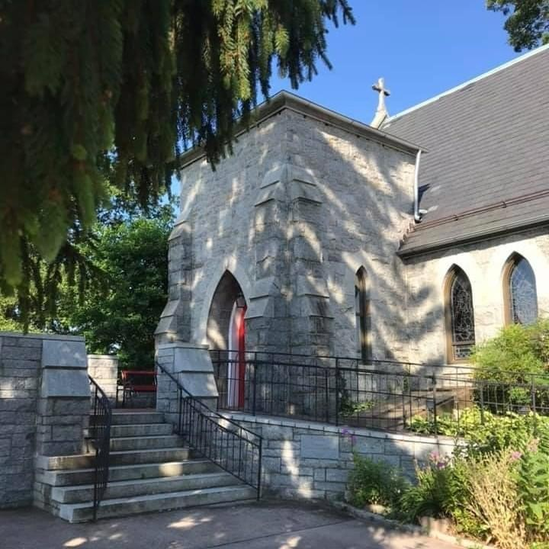
St. John’s Episcopal Church
Kingsville, Maryland
Welcomes You
Our Mission Statement

To go forth into the world in peace
to love one another, and serve the Lord.

Fourth Sunday of Easter
May 8, 2022
10:30 am, Rite II

St. John’s Episcopal Church

11901 Belair Road, P. O. Box 187, Kingsville, MD 21087
FaceBook: St. John’s Episcopal, Kingsville, MD
Email: office@stjohnskingsville.org
Website: www.stjohnskingsville.org
Church Phone: 410-592-8570
Pastoral Emergencies: 410-698-5376

Church Staff

Rector: The Rev’d Elizabeth Sipos, M.Div.
Administrative Assistant: Angie Bosley
Organist/Choir Director: Nancy Heinold

The Vestry

Class of 2023 Class of 2024

Marguerite Lobb Terry Roe
Ty Schwenk Barb Daniel

Officers
Michele Lozanski—Sr Warden Jacob Johnson—Jr. Warden
Elizabeth Healey—Treasurer Anne Leland-Registrar

Parish Committee Chairpersons

Altar Guild: Liz Healey
Hospitality Hr. Coordinator: Barb Daniel
Outreach: Pat Carden
Organ Restoration Committee: Nancy Heinold
Chapel Restoration Committee: Jacob Johnson

10:30 am Worship
Holy Eucharist, Rite Two

*Please stand if you are able

10:25 am Church Bell is Rung

Prelude:
The Word of God

Processional hymn: Glorious things of thee are spoken Hymnal #522

Worship begins BCP 355

Gloria Hymnal #S-280
Glory to God in the highest,
and peace to his people on earth.
Lord God, heavenly King,
almighty God and Father,
we worship you, we give you thanks,
we praise you for your glory.
Lord Jesus Christ, only Son of the Father,
Lord God, Lamb of God,
you take away the sin of the world:
have mercy on us;
you are seated at the right hand of the Father:
receive our prayer.
For you alone are the Holy One,
you alone are the Lord,
you alone are the Most High,
Jesus Christ,
with the Holy Spirit,
in the glory of God the Father. Amen.

The Collect of the Day Kneel or stand as able BCP 225
O God, whose Son Jesus is the good shepherd of your people: Grant that when we hear his voice we may know him who calls us each by name, and follow where he leads; who, with you and the Holy Spirit, lives and reigns, one God, for ever and ever. Amen.

The congregation is seated.

A Reading from the Acts of the Apostles 9:36-43
Now in Joppa there was a disciple whose name was Tabitha, which in Greek is Dorcas. She was devoted to good works and acts of charity. At that time she became ill and died. When they had washed her, they laid her in a room upstairs. Since Lydda was near Joppa, the disciples, who heard that Peter was there, sent two men to him with the request, "Please come to us without delay." So Peter got up and went with them; and when he arrived, they took him to the room upstairs. All the widows stood beside him, weeping and showing tunics and other clothing that Dorcas had made while she was with them. Peter put all of them outside, and then he knelt down and prayed. He turned to the body and said, "Tabitha, get up." Then she opened her eyes, and seeing Peter, she sat up. He gave her his hand and helped her up. Then calling the saints and widows, he showed her to be alive. This became known throughout Joppa, and many believed in the Lord. Meanwhile he stayed in Joppa for some time with a certain Simon, a tanner.

Reader: The Word of the Lord.
People: Thanks be to God.

Psalm 23 (Prayed as directed.)
1 The Lord is my shepherd; *
I shall not be in want.
2 He makes me lie down in green pastures *
and leads me beside still waters.
3 He revives my soul *
and guides me along right pathways for his Name's sake.
4 Though I walk through the valley of the shadow of death, I shall fear no evil; *
for you are with me;
your rod and your staff, they comfort me.
5 You spread a table before me in the presence of those who trouble me; *
you have anointed my head with oil,
and my cup is running over.
6 Surely your goodness and mercy shall follow me all the days of my life, *
and I will dwell in the house of the Lord for ever.

A Reading from the Book of Revelation 7:9-17
I looked, and there was a great multitude that no one could count, from every nation, from all tribes and peoples and languages, standing before the throne and before the Lamb, robed in white, with palm branches in their hands. They cried out in a loud voice, saying, “Salvation belongs to our God who is seated on the throne, and to the Lamb!” And all the angels stood around the throne and around the elders and the four living creatures, and they fell on their faces before the throne and worshiped God, singing, “Amen! Blessing and glory and wisdom
and thanksgiving and honor and power and might be to our God forever and ever! Amen.” Then one of the elders addressed me, saying, "Who are these, robed in white, and where have they come from?" I said to him, "Sir, you are the one that knows." Then he said to me, "These are they who have come out of the great ordeal; they have washed their robes and made them white in the blood of the Lamb. For this reason they are before the throne of God, and worship him day and night within his temple, and the one who is seated on the throne will shelter them. They will hunger no more, and thirst no more; the sun will not strike them, nor any scorching heat; for the Lamb at the center of the throne will be their shepherd, and he will guide them to springs of the water of life, and God will wipe away every tear from their eyes."

Reader: The Word of the Lord.
People: Thanks be to God.

Gradual hymn: My faith looks up to thee Hymnal #691

The Gospel
Priest: The Holy Gospel of our Lord Jesus Christ according to John 10:22-30

People: Glory to you, Lord Christ.
At that time the festival of the Dedication took place in Jerusalem. It was winter, and Jesus was walking in the temple, in the portico of Solomon. So the Jews gathered around him and said to him, "How long will you keep us in suspense? If you are the Messiah, tell us plainly." Jesus answered, "I have told you, and you do not believe. The works that I do in my Father's name testify to me; but you do not believe, because you do not belong to my sheep. My sheep hear my voice. I know them, and they follow me. I give them eternal life, and they will never perish. No one will snatch them out of my hand. What my Father has given me is greater than all else, and no one can snatch it out of the Father's hand. The Father and I are one."

Priest: The Gospel of the Lord.
People: Praise to you, Lord Christ.

Sermon The Rev. Elizabeth Sipos+

Nicene Creed Please stand as able BCP 358

Prayers of the People Form III BCP 387

Confession of Sin BCP 359

The Peace BCP 360

Welcome & Announcements The congregation is seated.

Please stand as able

Offertory hymn: My Shepherd will supply my need Hymnal #664

Presentation Hymn
Praise God, from whom all blessings flow; praise him, all creatures here below; praise him above, ye heavenly host: praise Father, Son, and Holy Ghost.

The Holy Communion

THE GREAT THANKSGIVING: Eucharistic Prayer B BCP 367

Sanctus Hymnal #S-129
Holy, Holy, Holy Lord, God of power and might,
heaven and earth are full of your glory.
Hosanna in the highest.
Blessed is he who comes in the name of the Lord.
Hosanna in the highest.

The Lord’s Prayer BCP 364

Invitation to Communion

The Breaking of the Bread

Communion hymn: The King of love my shepherd is Hymnal #646

The Post Communion Prayer BCP 365

Blessing BCP 366

Recessional hymn: Alleluia! The strife is o’er Hymnal #208

The Dismissal (The Alleluias are back!)

Serving Today

Celebrant and Preacher: The Rev. Elizabeth Sipos
Old Testament: Charles Keenan
Psalm: Liz Healey
New Testament: Tony Rising
Prayers of the People: Tony Rising
Server: Terry Roe

Altar Flowers
Given to the Glory of God
by Marguerite Lobb
in Thanksgiving for Mark’s graduation
from Seminary

St. John’s Parish Prayer List

Additions and corrections may be made to our Parish Prayer List at any time. All names will be
automatically removed from the Parish Prayer List on the 1st Sunday of each month unless you
request otherwise. Please contact Angie at <office@stjohnskingsville.org> or 410-592-8570 in the church office with all changes by 10 am Thursdays. Thank you.

We Pray for Those in Need:

Ivan, Lillian Jane (small child-Leukemia), Lisa, Peter, Sarah Sutherland, Melissa Heaver, Liz Rawl, Ricky Carter, Marilyn Stephenson, Charlotte Williams (small child), Dottie Atkin, Cleo Collins, Sid & Joan Pyle, Karen Sugden, DeMarino Family, Samantha, Jim, Christina, Pat, Jenny, Lisa, Jennifer, Dylan, Gary, Barbara Goldsmith, Thelma, Sam Hardwick, Paul Edwards, James Kneussl, Kim
Collins-Appel, Angela Baumeister, Ronnee Congleton (pancreatic cancer), Karen Smith-Manar.

We Pray for our Homebound

Lily John, Barbara Miller, Nancy Barnhart, Robin Dilworth

We pray for the Church and the World:

For Most Rev’d. Justin Welby, Archbishop of Canterbury; for The Most Rev’d. Michael Curry, our Presiding Bishop; for Right Rev’d. Eugene Sutton, our Bishop; for the Rt. Rev’d Robert Ihloff, our Assisting Bishop, for our Rector, Rev. Elizabeth Sipos, for the Wardens, Vestry, Staff, and all members and friends of St. John’s Church.

For the leaders of all nations, especially for Joseph, our President; for Larry, our Governor; for
Brandon, Nick, John and Barry, who lead our City and Counties. We pray for all children and youth; for the homeless, the unemployed, and the hungry. We pray for the safety of our loved ones and friends serving in the Armed Forces at home and abroad, and for our enemies, that all our hearts may be turned toward peace throughout the world.

From the Treasurer
May Income vs. Expenses

Projected Total Expenses for May $13,500
Monies Received as of 5/5 $8,732
Amount Needed to Meet Expenses $4,768

Come and See!
On Thursday May 19th, you are invited to 'come and see' how St. John's is revitalizing the Auxiliary. This work began in January 2020, but was cut short due to the pandemic. We are looking ahead with hope and excitement as we begin plans for a Flea Market, July 4th Celebration, Christmas Bazaar, as well as working towards
other fundraisers to repay the Church for its contribution in restoring our historic organ. We will also discern how we, as a community, live fully into our mission statement to go forth into the world in peace to love one another and serve the Lord.
Life is busy, to be sure. If you are only able to commit to one event, we are grateful that you are willing to do so. God has called us, as his church, in to fellowship and service. Are you willing to answer his call?
There are different gifts, but the same Spirit. There are different ministries, but the same Lord. There are different ways of working, but the same God works all things in all people. ~ 1 Corinthians 12:4

CHILDREN’S MINISTRY AT ST JOHN’S ACTIVITIES

Sunday School Classes have resumed on Tuesdays 7:00pm on zoom. If you are interested in participating, please contact our Sunday School Teacher John Stevens at jssok99@hotmail.com.

MUSIC MINISTRY

Bell Choir rehearsals, Sundays at 11:45 a.m.

Choir rehearsals, Wednesdays at 7:00 p.m.

