THE THIRTEENTH SUNDAY AFTER PENTECOST

AUGUST 23, 2026
HOLY EUCHARIST RITE I
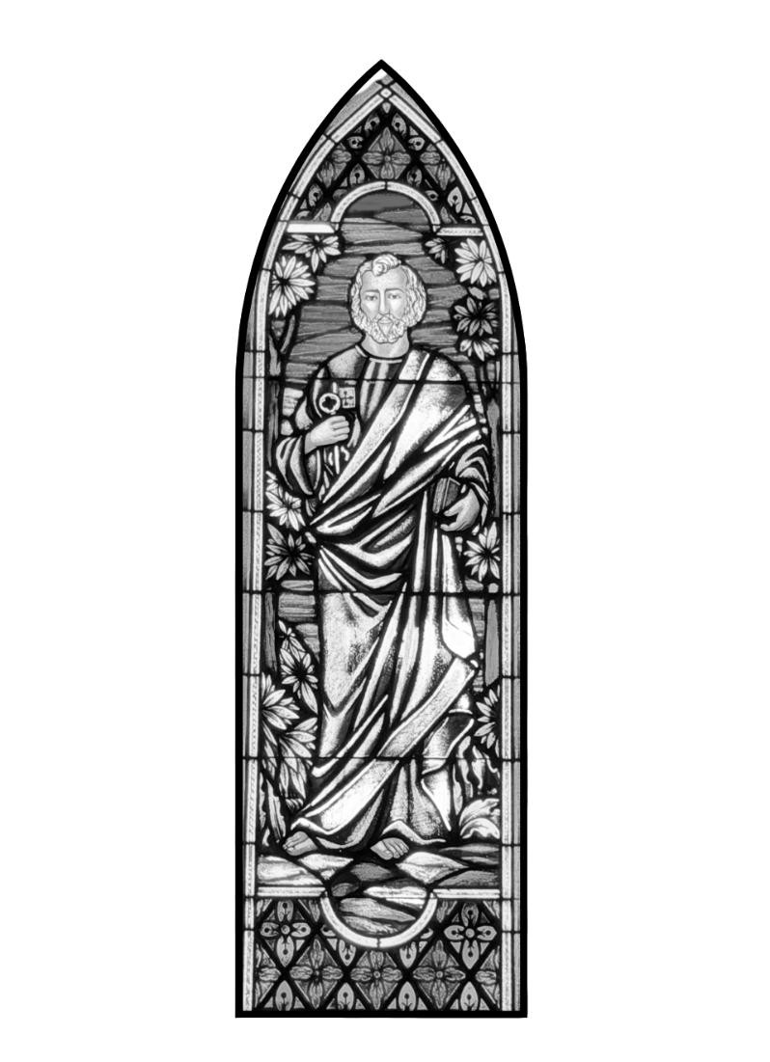
9
:
3
0

A
.
M
.

SAINT JOHN’S EPISCOPAL CHURCH 11901 BELAIR ROAD KINGSVILLE, MARYLAND 21087

Together we will transform the world with love.
Come on in!

ST. JOHN’S EPISCOPAL CHURCH
P.O. Box 187
Kingsville, MD 21087
410-592-8570
Email us at: stjohnskingsville@outlook.com
Visit our website at: www.stjohnskingsville.org
Follow us on Facebook at: https://www.facebook.com/stjohnsparish
In a pastoral emergency, please call Fr. Mark Lobb at: 443-690-9545

Welcome to worship today!
We are glad that you are with us and invite you to participate in all parts of the service as indicated in the red Book of Common Prayer and this service bulletin. If you have any questions, feel free to ask the ushers.

Restrooms are located in the Parish Hall, the brick building across the parking lot.

I was glad when they said to me, “Let us go to the house of the Lord.”
-- Psalm 122:1

About our worship—Episcopalians traditionally stand, kneel, and sit at different points in the service. While we appreciate active participation, please be kind to your body. It is OK to remain seated, if unable to stand or kneel.
The service is found in the red Book of Common Prayer (BCP), unless otherwise noted. Hymns and service music are found in the blue Hymnal, unless otherwise indicated.

THE WORD OF GOD
Please stand as you are able
Processional When morning guilds the skies Hymnal #427
Opening Acclamation BCP 323
The Collect for Purity
The Kyrie Hymnal S91
The Gloria BCP 324
The Collect of the Day
Celebrant: The Lord be with you.
People: And with thy spirit.
Celebrant: Let us pray.
Grant, O merciful God, that your Church, being gathered together in unity by your Holy
Spirit, may show forth your power among all peoples, to the glory of your Name; through Jesus Christ our Lord, who lives and reigns with you and the Holy Spirit, one God, for ever and ever. Amen.
Please be seated for the reading of the Lessons.

The First Lesson Exodus 1:8-2:10
Now a new king arose over Egypt, who did not know Joseph. He said to his people, “Look, the Israelite people are more numerous and more powerful than we. Come, let us deal shrewdly with them, or they will increase and, in the event of war, join our enemies and fight against us and escape from the land.” Therefore they set taskmasters over them to oppress them with forced labor. They built supply cities, Pithom and Rameses, for Pharaoh. But the more they were oppressed, the more they multiplied and spread, so that the Egyptians came to dread the Israelites. The Egyptians became ruthless in imposing tasks on the Israelites, and made their lives bitter with hard service in mortar and brick and in every kind of field labor. They were ruthless in all the tasks that they imposed on them.
The king of Egypt said to the Hebrew midwives, one of whom was named Shiphrah and the other Puah, “When you act as midwives to the Hebrew women, and see them on the birthstool, if it is a boy, kill him; but if it is a girl, she shall live.” But the midwives feared God; they did not do as the king of Egypt commanded them, but they let the boys live. So the king of Egypt summoned the midwives and said to them, “Why have you done this, and allowed the boys to live?” The midwives said to Pharaoh, “Because the Hebrew women are not like the Egyptian women; for they are vigorous and give birth before the midwife comes to them.” So God dealt well with the midwives; and the people multiplied and became very strong. And because the midwives feared God, he gave them families. Then Pharaoh commanded all his people, “Every boy that is born to the Hebrews you shall throw into the Nile, but you shall let every girl live.”
Now a man from the house of Levi went and married a Levite woman. The woman conceived and bore a son; and when she saw that he was a fine baby, she hid him three months. When she could hide him no longer she got a papyrus basket for him, and plastered it with bitumen and pitch; she put the child in it and placed it among the reeds on the bank of the river. His sister stood at a distance, to see what would happen to him.
The daughter of Pharaoh came down to bathe at the river, while her attendants walked beside the river. She saw the basket among the reeds and sent her maid to bring it. When she opened it, she saw the child. He was crying, and she took pity on him, “This must be one of the Hebrews’ children,” she said. Then his sister said to Pharaoh’s daughter, “Shall I go and get you a nurse from the Hebrew women to nurse the child for you?” Pharaoh’s daughter said to her, “Yes.” So the girl went and called the child’s mother. Pharaoh’s daughter said to her, “Take this child and nurse it for me, and I will give you your wages.” So the woman took the child and nursed it. When the child grew up, she brought him to Pharaoh’s daughter, and she took him as her son. She named him Moses, “because,” she said, “I drew him out of the water.”
Reader: The Word of the Lord.
People: Thanks be to God.

The Psalm Psalm 124
Nisi quia Dominus
- If the LORD had not been on our side, * let Israel now say;
- If the LORD had not been on our side, * when enemies rose up against us;
- Then would they have swallowed us up alive * in their fierce anger toward us;
- Then would the waters have overwhelmed us * and the torrent gone over us;
- Then would the raging waters * have gone right over us.
- Blessed be the LORD! * he has not given us over to be a prey for their teeth.
- We have escaped like a bird from the snare of the fowler; * the snare is broken, and we have escaped.
- Our help is in the Name of the LORD, * the maker of heaven and earth.

The Epistle Romans 12:1-8
I appeal to you therefore, brothers and sisters, by the mercies of God, to present your bodies as a living sacrifice, holy and acceptable to God, which is your spiritual worship. Do not be conformed to this world, but be transformed by the renewing of your minds, so that you may discern what is the will of God-- what is good and acceptable and perfect.
For by the grace given to me I say to everyone among you not to think of yourself more highly than you ought to think, but to think with sober judgment, each according to the measure of faith that God has assigned. For as in one body we have many members, and not all the members have the same function, so we, who are many, are one body in Christ, and individually we are members one of another. We have gifts that differ according to the grace given to us: prophecy, in proportion to faith; ministry, in ministering; the teacher, in teaching; the exhorter, in exhortation; the giver, in generosity; the leader, in diligence; the compassionate, in cheerfulness.
Reader: The Word of the Lord.
People: Thanks be to God.
Please stand as you are able.
Gradual Hymn The Church’s one foundation Hymnal #525
Priest: The Holy Gospel according to Matthew. Matthew 16: 13-20 People: Glory be to thee, O Lord.
When Jesus came into the district of Caesarea Philippi, he asked his disciples, “Who do people say that the Son of Man is?” And they said, “Some say John the Baptist, but others Elijah, and still others Jeremiah or one of the prophets.” He said to them, “But who do you say that I am?” Simon Peter answered, “You are the Messiah, the Son of the living God.” And Jesus answered him, “Blessed are you, Simon son of Jonah! For flesh and blood has not revealed this to you, but my Father in heaven. And I tell you, you are Peter, and on this rock I will build my church, and the gates of Hades will not prevail against it. I will give you the keys of the kingdom of heaven, and whatever you bind on earth will be bound in heaven, and whatever you loose on earth will be loosed in heaven.” Then he sternly ordered the disciples not to tell anyone that he was the Messiah.
Priest: The Gospel of the Lord.
People: Praise be to thee, O Christ.
Sermon The Reverend Mark Lobb Please be seated.

The Nicene Creed BCP 326
Please stand as you are able.
The Prayers of the People Please stand or kneel as you are able. BCP 328
See page 8 for prayer list.
Confession of Sin Celebrant and people. BCP 331
The Peace Please stand as you are able. BCP 332
Celebrant: The peace of the Lord be always with you.
People: And with thy spirit.
Announcements Please be seated.
THE HOLY COMMUNION – FORM I
Offertory The congregation remains seated while the elements are brought forward and offerings are collected. As offerings are presented, please stand as you are able.
Offertory Hymn He’s got the whole world See bulletin insert.
Doxology
Celebrant & People: Praise God, from whom all blessings flow; praise him, all creatures here below; praise him above, ye heavenly host: praise Father, Son, and Holy Ghost.
The Great Thanksgiving BCP 333
The Sanctus Hymnal S114 BCP 334
Please stand or kneel as you are able.
Celebrant: And now, as our Savior Christ hath taught us, we are bold to say,
The Lord’s Prayer In unison. BCP 336
The Breaking of the Bread
Celebrant: [Alleluia.] Christ our Passover is sacrificed for us; People: Therefore let us keep the feast. [Alleluia.]
Fraction Anthem Agnus Dei Hymnal S158 BCP 337
O Lamb of God, that takest away the sins of the world, have mercy upon us.
O Lamb of God, that takest away the sins of the world, have mercy upon us.
O Lamb of God, that takest away the sins of the world, grant us thy peace.
The People may join in saying The Prayer of Humble Access BCP 337
The Invitation to Communion
Celebrant: The Gifts of God for the People of God.
Take them in remembrance that Christ died for you, and feed on him in your hearts by faith, with thanksgiving.
The congregation is seated.
Communion Hymn I come with joy Hymnal #304
Post Communion Prayer Celebrant and people. BCP 339
The Blessing
Recessional Hymn Glorious things of thee are spoken Hymnal #522
Dismissal
Celebrant: Go in peace to love and serve the Lord.
People: Thanks be to God.

SERVING _{AT} 9:30  Presider: The Rev. Mark Lobb  Reader: Woodie Tingle  Prayers of the People: Chip Williams  Server: Jennifer Scepaniak  Organist: Nancy Heinold | License #A-719154
ST. JOHN’S PRAYER LIST

Please let Mark+ or a vestry member know if a name should be returned or added to or subtracted from the list. Thank you for remembering these persons in prayer.

We pray for those in need of healing, strength, and recovery: Mike Carden, Bill Hoffman and family, the family of Steven Rakas, the family of Joann Koch, Ed Thompson, Marsha DeMarino, Sheila Jones, Greg Sharp, Ione Leamer, Susan
Koch, Anna Marie Surdel, Maxine Rising, Tony Rising, Jacquelin Scepaniak, Rochelle Santoro, Larry Betzler, Skip Perouty, Catherine Ryland, Jeff Tomlinson and Debbie Tomlinson.

We pray for the homebound:
Lily John, Barbara Miller, Nancy Barnhart, Robin Dilworth, and David House.

We pray for the Church and the World:
For +Sean, our Presiding Bishop and +Carrie, our Bishop; for Mark+, our Priest-in-Charge; the Wardens, Vestry, Staff, and all members and friends of St. John’s Church.

We pray for the leaders of all nations, especially for Donald our President; for Wes, our Governor; for Brandon, Kathy, and Bob, who lead our City and Counties.

We pray for all children and youth; for the homeless, the unemployed, and the hungry. We pray for the safety of our loved ones and friends serving in the Armed Forces at home and abroad, and for our enemies, that all our hearts may be turned toward peace throughout the world.

The flowers on the altar are given to the Glory of God by the Dilworth Family-Hills Forest Fruit Farm in memory of Henry and Janice Dilworth.

WHAT’S HAPPENING AT ST. JOHN’S
Monday, August 24
12-1:00 pm AA Lunch Bunch (Parish Hall)
6:30 pm AA Big Book Meeting
Tuesday, August 25
10:00 am AA Book Group (Parish Hall) 12-1:00 pm AA Lunch Bunch (Parish Hall)
Wednesday, August 26
12-1:00 pm AA Lunch Bunch (Parish Hall) 7:30 pm AA (Parish Hall)
Thursday, August 27
12-1:00 pm AA Lunch Bunch (Parish Hall) 7:00 pm AA (Parish Hall)
Friday, August 28
12-1:00 pm AA Lunch Bunch (Parish Hall)
Saturday, August 29
8:30 pm AA (Parish Hall)
Sunday, August 30
9:30 am Morning Prayer, Rite II, with music (Church)


Thanks for your continued support! To make a donation, scan this qr code or go to:
www. stjohnskingsville.org
Or mail your donation to: St. John’s Episcopal Church
P.O. Box 187
Kingsville, MD 21087

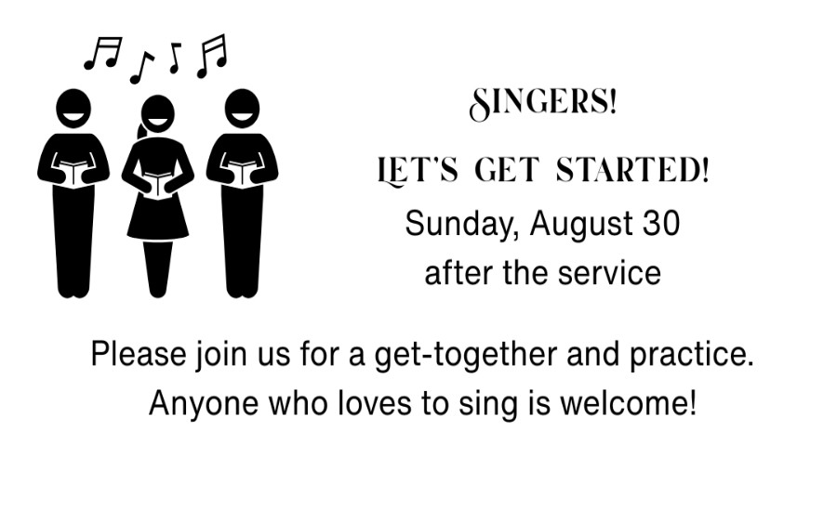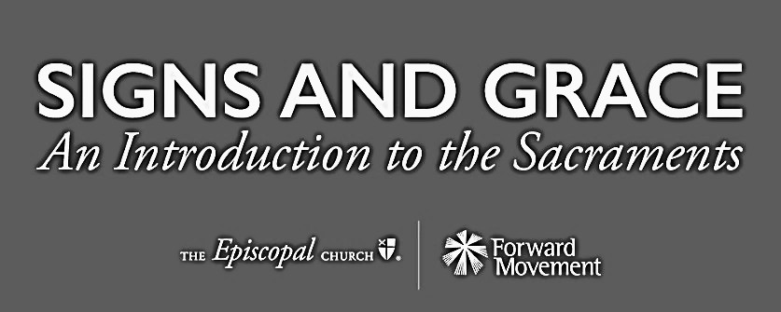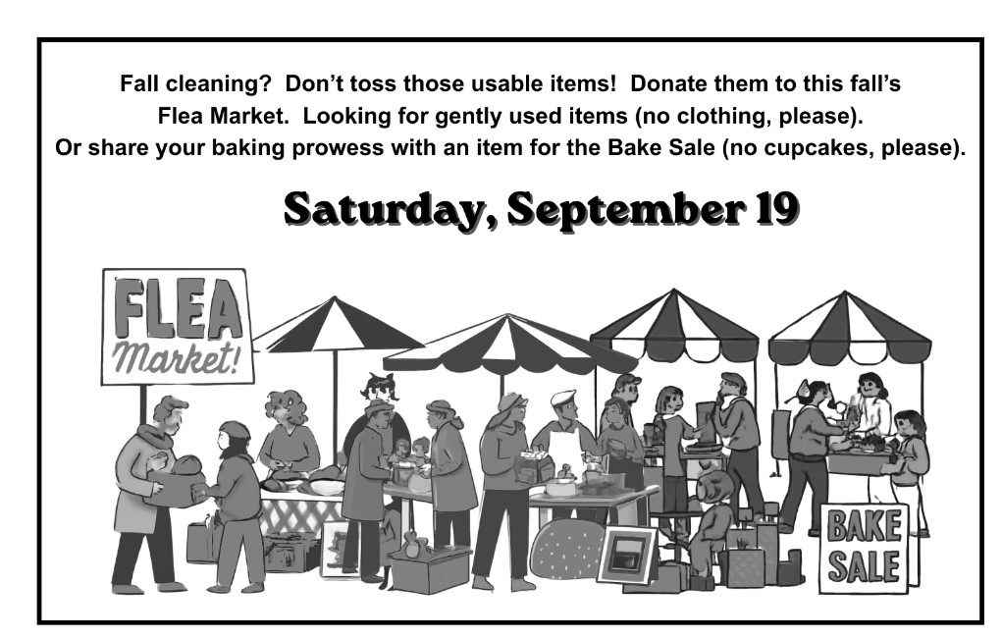

Coming September 20:

