The Eleventh Sunday after Pentecost
August 9, 2026
Morning Prayer - Rite I
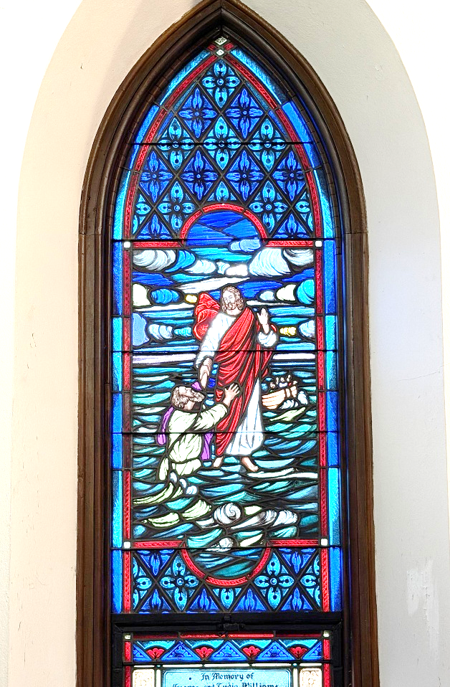
9:30 a.m.

Saint John’s Episcopal Church
11901 Belair Road
Kingsville, Maryland 21087

Together we will transform the world with love.
Come on in!

ST. JOHN’S EPISCOPAL CHURCH
P.O. Box 187
Kingsville, MD 21087
410-592-8570
Email us at: stjohnskingsville@outlook.com
Visit our website at: www.stjohnskingsville.org
Follow us on Facebook at: https://www.facebook.com/stjohnsparish
In a pastoral emergency, please call Fr. Mark Lobb at: 443-690-9545

Welcome to worship today!
We are glad that you are with us and invite you to participate in all parts of the service as indicated in the red Book of Common Prayer and this service bulletin.
If you have any questions, feel free to ask the ushers.

Restrooms are located in the Parish Hall, the brick building across the parking lot.

I was glad when they said to me, “Let us go to the house of the Lord.”
-- Psalm 122:1

About our worship—Episcopalians traditionally stand, kneel, and sit at different points in the service. While we appreciate active participation, please be kind to your body. It is OK to remain seated, if unable to stand or kneel.
The service is found in the red Book of Common Prayer (BCP), unless otherwise noted. Hymns and service music are found in the blue Hymnal, unless otherwise indicated.

Morning Prayer—Rite I
Opening Hymn #388 O, Worship the King

Opening Sentences
Officiant: Grace to you and peace from God our Father and the Lord Jesus Christ.
Philippians 1:2
Confession of Sin
The Officiant says to the people,
Dearly beloved, we have come together in the presence of Almighty God our heavenly Father, to render thanks for the great benefits that we have received at his hands, to set forth his most worthy praise, to hear his holy Word, and to ask, for ourselves and on behalf of others, those things that are necessary for our life and our salvation. And so that we may prepare ourselves in heart and mind to worship him, let us kneel in silence, and with penitent and obedient hearts confess our sins, that we may obtain forgiveness by his infinite goodness and mercy.
Let us humbly confess our sins unto Almighty God.
Silence may be kept.
Officiant and People together, all kneeling as you are able.
Almighty and most merciful Father, we have erred and strayed from thy ways like lost sheep, we have followed too much the devices and desires of our own hearts, we have offended against thy holy laws, we have left undone those things which we ought to have done, and we have done those things which we ought not to have done. But thou, O Lord, have mercy upon us, spare thou those who confess their faults, restore thou those who are penitent, according to thy promises declared unto mankind in Christ Jesus our Lord; and grant, O most merciful Father, for his sake, that we may hereafter live a godly, righteous, and sober life, to the glory of thy holy Name. Amen.
The Priest alone stands and says,
The Almighty and merciful Lord grant you absolution and remission of all your sins, true repentance, amendment of life, and the grace and consolation of his Holy Spirit. Amen.
The Invitatory and Psalter Please stand as you are able.
Officiant: O Lord, open thou our lips.
People: And our mouth shall show forth thy praise.

Officiant and People:
Glory to the Father, and to the Son, and to the Holy Spirit: as it was in the beginning, is now, and will be for ever. Amen.

Venite Psalm 95:1-7
O come, let us sing unto the Lord; *
let us heartily rejoice in the strength of our salvation.
Let us come before his presence with thanksgiving *
and show ourselves glad in him with psalms.
For the Lord is a great God, *
and a great King above all gods.
In his hand are all the corners of the earth, *
and the strength of the hills is his also.
The sea is his, and he made it, *
and his hands prepared the dry land.
O come, let us worship and fall down, *
and kneel before the Lord our Maker.
For he is the Lord our God, *
and we are the people of his pasture
and the sheep of his hand.
O worship the Lord in the beauty of holiness; *
let the whole earth stand in awe of him.
For he cometh, for he cometh to judge the earth, *
and with righteousness to judge the world
and the peoples with his truth.
Worship the Lord in the beauty of holiness: O come, let us adore him.
The Psalm Psalm 105, 1-6, 16-22, 45b
Confitemini Domino
1 Give thanks to the LORD and call upon his Name; * make known his deeds
among the peoples.
2 Sing to him, sing praises to him, * and speak of all his marvelous works.
3 Glory in his holy Name; * let the hearts of those who seek the LORD rejoice.
4 Search for the LORD and his strength; * continually seek his face.
5 Remember the marvels he has done, * his wonders and the judgments of his mouth,
6 O offspring of Abraham his servant, * O children of Jacob his chosen.
16 Then he called for a famine in the land * and destroyed the supply of bread.
17 He sent a man before them, * Joseph, who was sold as a slave.
18 They bruised his feet in fetters; * his neck they put in an iron collar.
19 Until his prediction came to pass, * the word of the LORD tested him.
20 The king sent and released him; * the ruler of the peoples set him free.
21 He set him as a master over his household, as a ruler over all his possessions,
22 To instruct his princes according to his will and to teach his elders wisdom.
45 Hallelujah!
Glory to the Father, and to the Son, and to the Holy Spirit: *
as it was in the beginning, is now, and will be for ever. Amen.
The Lessons
A Reading from Genesis Genesis 37:1-4, 12-28
Jacob settled in the land where his father had lived as an alien, the land of Canaan. This is the story of the family of Jacob.
Joseph, being seventeen years old, was shepherding the flock with his brothers; he was a helper to the sons of Bilhah and Zilpah, his father’s wives; and Joseph brought a bad report of them to their father. Now Israel loved Joseph more than any other of his children, because he was the son of his old age; and he had made him a long robe with sleeves. But when his brothers saw that their father loved him more than all his brothers, they hated him, and could not speak peaceably to him.
Now his brothers went to pasture their father’s flock near Shechem. And Israel said to Joseph, “Are not your brothers pasturing the flock at Shechem? Come, I will send you to them.” He answered, “Here I am.” So he said to him, “Go now, see if it is well with your brothers and with the flock; and bring word back to me.” So he sent him from the valley of Hebron.
He came to Shechem, and a man found him wandering in the fields; the man asked him, “What are you seeking?” “I am seeking my brothers,” he said; “tell me, please, where they are pasturing the flock.” The man said, “They have gone away, for I heard them say, ‘Let us go to Dothan.’“ So Joseph went after his brothers, and found them at Dothan. They saw him from a distance, and before he came near to them, they conspired to kill him. They said to one another, “Here comes this dreamer. Come now, let us kill him and throw him into one of the pits; then we shall say that a wild animal has devoured him, and we shall see what will become of his dreams.” But when Reuben heard it, he delivered him out of their hands, saying, “Let us not take his life.” Reuben said to them, “Shed no blood; throw him into this pit here in the wilderness, but lay no hand on him” —that he might rescue him out of their hand and restore him to his father. So when Joseph came to his brothers, they stripped him of his robe, the long robe with sleeves that he wore; and they took him and threw him into a pit. The pit was empty; there was no water in it.
Then they sat down to eat; and looking up they saw a caravan of Ishmaelites coming from Gilead, with their camels carrying gum, balm, and resin, on their way to carry it down to Egypt. Then Judah said to his brothers, “What profit is it if we kill our brother and conceal his blood? Come, let us sell him to the Ishmaelites, and not lay our hands on him, for he is our brother, our own flesh.” And his brothers agreed. When some Midianite traders passed by, they drew Joseph up, lifting him out of the pit, and sold him to the Ishmaelites for twenty pieces of silver. And they took Joseph to Egypt.
Reader: The Word of the Lord.
People: Thanks be to God.

4 The Song of Zechariah Benedictus Dominus Deus Luke 1:68-79
Blessed be the Lord God of Israel, *
for he hath visited and redeemed his people;
And hath raised up a mighty salvation for us *
in the house of his servant David,
As he spake by the mouth of his holy prophets, *
which have been since the world began:
That we should be saved from our enemies, *
and from the hand of all that hate us;
To perform the mercy promised to our forefathers, *
and to remember his holy covenant;
To perform the oath which he sware to our forefather Abraham, *
that he would give us,
That we being delivered out of the hand of our enemies *
might serve him without fear,
In holiness and righteousness before him, *
all the days of our life.
And thou, child, shalt be called the prophet of the Highest, *
for thou shalt go before the face of the Lord to prepare his ways;
To give knowledge of salvation unto his people *
for the remission of their sins,
Through the tender mercy of our God, *
whereby the dayspring from on high hath visited us;
To give light to them that sit in darkness
and in the shadow of death, *
and to guide our feet into the way of peace.
Glory to the Father, and to the Son, and to the Holy Spirit: *
as it was in the beginning, is now, and will be for ever. Amen.

A Reading from Romans Romans 10:5-15
Moses writes concerning the righteousness that comes from the law, that “the person who does these things will live by them.” But the righteousness that comes from faith says, “Do not say in your heart, ‘Who will ascend into heaven?’” (that is, to bring Christ down) “or ‘Who will descend into the abyss?’” (that is, to bring Christ up from the dead). But what does it say?
“The word is near you, on your lips and in your heart”

(that is, the word of faith that we proclaim); because if you confess with your lips that Jesus is Lord and believe in your heart that God raised him from the dead, you will be saved. For one believes with the heart and so is justified, and one confesses with the mouth and so is saved. The scripture says, “No one who believes in him will be put to shame.” For there is no distinction between Jew and Greek; the same Lord is Lord of all and is generous to all who call on him. For, “Everyone who calls on the name of the Lord shall be saved.”
But how are they to call on one in whom they have not believed? And how are they to believe in one of whom they have never heard? And how are they to hear without someone to proclaim him? And how are they to proclaim him unless they are sent? As it is written, “How beautiful are the feet of those who bring good news!”
Reader: The Word of the Lord.
People: Thanks be to God.

7 We Praise Thee Te Deum laudamus
We praise thee, O God; we acknowledge thee to be the Lord.
All the earth doth worship thee, the Father everlasting.
To thee all Angels cry aloud,
the Heavens and all the Powers therein.
To thee Cherubim and Seraphim continually do cry:
Holy, holy, holy, Lord God of Sabaoth;
Heaven and earth are full of the majesty of thy glory.
The glorious company of the apostles praise thee.
The goodly fellowship of the prophets praise thee.
The noble army of martyrs praise thee.
The holy Church throughout all the world doth acknowledge thee,
the Father, of an infinite majesty,
thine adorable, true, and only Son,
also the Holy Ghost the Comforter.
Thou art the King of glory, O Christ.
Thou art the everlasting Son of the Father.
When thou tookest upon thee to deliver man,
thou didst humble thyself to be born of a Virgin.
When thou hadst overcome the sharpness of death,
thou didst open the kingdom of heaven to all believers.
Thou sittest at the right hand of God, in the glory of the Father.
We believe that thou shalt come to be our judge.
We therefore pray thee, help thy servants,
whom thou hast redeemed with thy precious blood.
Make them to be numbered with thy saints,
in glory everlasting.
Gradual Hymn #637 How firm a foundation
The Gospel Matthew 14:22-33
Jesus made the disciples get into the boat and go on ahead to the other side, while he dismissed the crowds. And after he had dismissed the crowds, he went up the mountain by himself to pray. When evening came, he was there alone, but by this time the boat, battered by the waves, was far from the land, for the wind was against them. And early in the morning he came walking toward them on the sea. But when the disciples saw him walking on the sea, they were terrified, saying, “It is a ghost!” And they cried out in fear. But immediately Jesus spoke to them and said, “Take heart, it is I; do not be afraid.”
Peter answered him, “Lord, if it is you, command me to come to you on the water.” He said, “Come.” So Peter got out of the boat, started walking on the water, and came toward Jesus. But when he noticed the strong wind, he became frightened, and beginning to sink, he cried out, “Lord, save me!” Jesus immediately reached out his hand and caught him, saying to him, “You of little faith, why did you doubt?” When they got into the boat, the wind ceased. And those in the boat worshiped him, saying, “Truly you are the Son of God.”
Homily The Rev. Fain Webb

The Apostles' Creed
Officiant and People together, please stand as you are able:
I believe in God, the Father almighty,
maker of heaven and earth;
And in Jesus Christ his only Son our Lord;
who was conceived by the Holy Ghost,
born of the Virgin Mary,
suffered under Pontius Pilate,
was crucified, dead, and buried.
He descended into hell.
The third day he rose again from the dead.
He ascended into heaven,
and sitteth on the right hand of God the Father almighty.
From thence he shall come to judge the quick and the dead.
I believe in the Holy Ghost,
the holy catholic Church,
the communion of saints,
the forgiveness of sins,
the resurrection of the body,
and the life everlasting. Amen.

The Prayers Please stand or kneel as you are able.
Officiant: The Lord be with you.
People: And with thy spirit.
Officiant: Let us pray.

Officiant and People:
Our Father, who art in heaven, hallowed be thy Name,
thy kingdom come, thy will be done, on earth as it is in heaven.
Give us this day our daily bread.
And forgive us our trespasses, as we forgive those who trespass against us.
And lead us not into temptation, but deliver us from evil.
For thine is the kingdom, and the power, and the glory, for ever and ever. Amen.
Suffrages B
V. O Lord, save thy people and bless thine heritage;
R. Govern them and lift them up for ever.
V. Day by day we magnify thee;
R. And we worship thy Name ever, world without end.
V. Vouchsafe, O Lord, to keep us this day without sin;
R. O Lord, have mercy upon us, have mercy upon us.
V. O Lord, let thy mercy be upon us;
R. As our trust is in thee.
V. O Lord, in thee have I trusted;
R. Let me never be confounded.

The Collects
The Collect of the Day
Keep, O Lord, your household the Church in your steadfast faith and love, that through your grace we may proclaim your truth with boldness, and minister your justice with compassion; for the sake of our Savior Jesus Christ, who lives and reigns with you and the Holy Spirit, one God, now and for ever. Amen.

A Collect for Sundays
O God, who makest us glad with the weekly remembrance of the glorious resurrection of thy Son our Lord: Grant us this day such blessing through our worship of thee, that the days to come may be spent in thy favor; through the same Jesus Christ our Lord. Amen.
A Prayer for Mission
O God, who hast made of one blood all the peoples of the earth, and didst send thy blessed Son to preach peace to those who are far off and to those who are near: Grant that people everywhere may seek after thee and find thee; bring the nations into thy fold; pour out thy Spirit upon all flesh; and hasten the coming of thy kingdom; through the same thy Son Jesus Christ our Lord. Amen.
Offertory Hymn #410 Praise my Soul
OFFERTORY The Gifts of the People are now collected

The General Thanksgiving
Officiant and People together:
Almighty God, Father of all mercies,
we thine unworthy servants do give thee most humble and hearty thanks
for all thy goodness and loving-kindness to us and to all men.
We bless thee for our creation, preservation, and all the blessings of this life;
but above all for thine inestimable love in the redemption of the world by our Lord Jesus Christ; for the means of grace, and for the hope of glory.
And, we beseech thee, give us that due sense of all thy mercies, that our hearts may be unfeignedly thankful; and that we show forth thy praise, not only with our lips, but in our lives, by giving up our selves to thy service, and by walking before thee
in holiness and righteousness all our days; through Jesus Christ our Lord, to whom, with thee and the Holy Ghost, be all honor and glory, world without end. Amen.

A Prayer of St. Chrysostom
Almighty God, who hast given us grace at this time with one accord to make our common supplication unto thee, and hast promised through thy well-beloved Son that when two or three are gathered together in his Name thou wilt be in the
midst of them: Fulfill now, O Lord, the desires and petitions of thy servants as may be best for us; granting us in this world knowledge of thy truth, and in the world to come life everlasting. Amen.
Let us bless the Lord.
Thanks be to God.
The Officiant concludes with: The grace of our Lord Jesus Christ, and the love of God, and the fellowship of the Holy Ghost, be with us all evermore. Amen.
2 Corinthians 13:14
Closing Hymn #398 I sing the Almighty Power of God
Serving Today
Presider: The Reverend Fain Webb
Reader: Chip Williams
Prayers of the People: Chip Williams
Server: Jennifer Scepaniak
Priest in Charge: The Reverend Mark Lobb
Music Director: Nancy Heinold

License #A-719154
St. John’s Prayer List

Please let Mark+ or a vestry member know if a name should be returned or added to or subtracted from the list. Thank you for remembering these persons in prayer.

We pray for those in need of healing, strength, and recovery: Mike Carden, Bill Hoffman and family, the family of Steven Rakas, the family of Joann Koch, Ed Thompson, Andy Grau, Marsha DeMarino, Sheila Jones, Marisol Aubrey, Greg Sharp, Ione Leaner, Susan Koch, Anna Marie Surdel, Maxine Rising, Tony Rising, Jacquelin Scepaniak, Rochelle Santoro, Larry Betzler, Skip Perouty, Catherine Ryland, Jeff Tomlinson and Debbie Tomlinson.

We pray for the homebound:
Lily John, Barbara Miller, Nancy Barnhart, Robin Dilworth, and David House.

We pray for the Church and the World:
For +Sean, our Presiding Bishop and +Carrie, our Bishop; for Mark+, our Priest-in-Charge; the Wardens, Vestry, Staff, and all members and friends of St. John’s Church.

We pray for the leaders of all nations, especially for Donald our President; for Wes, our Governor; for Brandon, Kathy, and Bob, who lead our City and Counties.

We pray for all children and youth; for the homeless, the unemployed, and the hungry. We pray for the safety of our loved ones and friends serving in the Armed Forces at home and abroad, and for our enemies, that all our hearts may be turned toward peace throughout the world.

The flowers on the altar are given to the Glory of God by the Dilworth Family- Hills Forest Fruit Farm in memory of Henry & Janice Dilworth.

What’s Happening at St. John’s
Monday, August 10
12-1:00 pm AA Lunch Bunch (Parish Hall)
6:30 pm AA Big Book Meeting
Tuesday, August 11
10:00 am AA Book Group (Parish Hall)
12-1:00 pm AA Lunch Bunch (Parish Hall)
Wednesday, August 12
12-1:00 pm AA Lunch Bunch (Parish Hall)
7:30 pm AA (Parish Hall)
Thursday, August 13
12-1:00 pm AA Lunch Bunch (Parish Hall)
7:00 pm AA (Parish Hall)
Friday, August 14
12-1:00 pm AA Lunch Bunch (Parish Hall)
5:30 pm BINGO! Doors open. See below for more information.
7:00 pm Play starts.
Saturday, August 15
8:30 pm AA (Parish Hall)
Sunday, August 16
9:30 am Morning Prayer, Rite I, with music (Church)


Thanks for your continued support! To make a donation, scan this qr code or go to: www. stjohnskingsville.org
Or mail your donation to: St. John’s Episcopal Church
P.O. Box 187
Kingsville, MD 21087
August ‘26 Income vs. Expenses:

Projected July Expenses: $15,000
Monies Received as of 8/5: $ 6,929

Amount Needed to Meet Expenses: $ 8,071
Bingo this Friday:

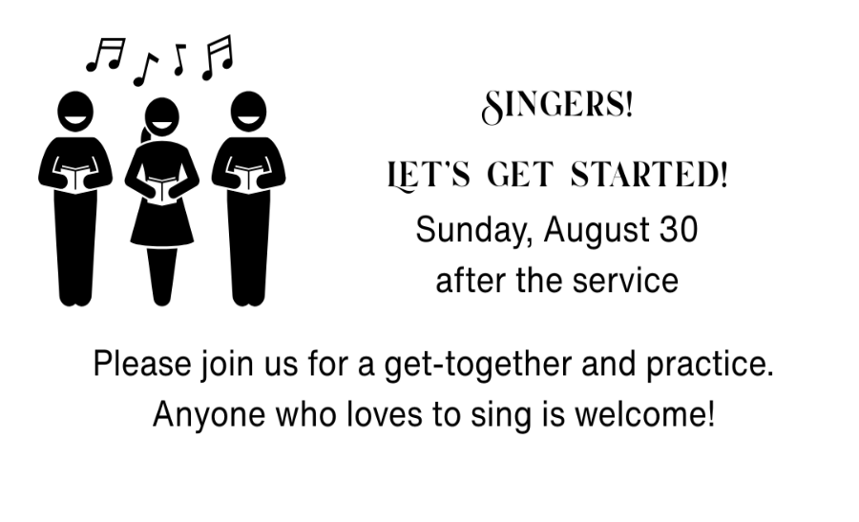

Celebrate our Colonial Roots!


Have questions about Scripture or the Church or becoming an Episcopalian?
Please give Fr. Mark your suggestions and thoughts by August 16.

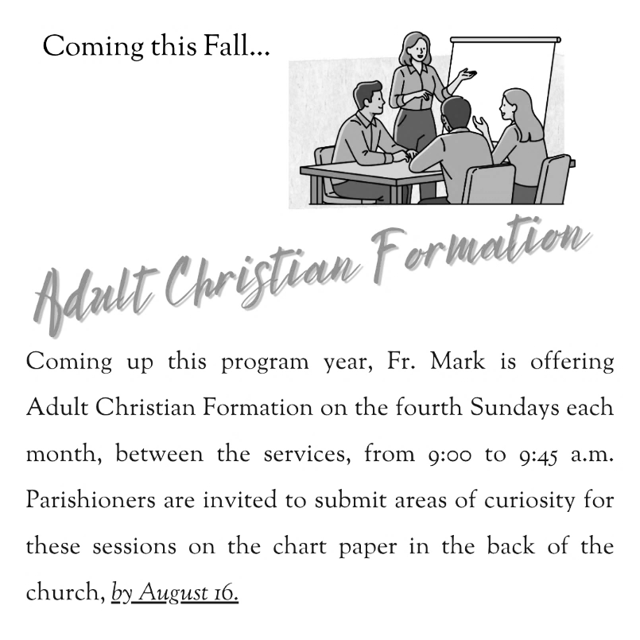
F

