The Celebration of the Life of
Tyrone Damon Schwenk
May 23, 1949 ~ May 29, 2026

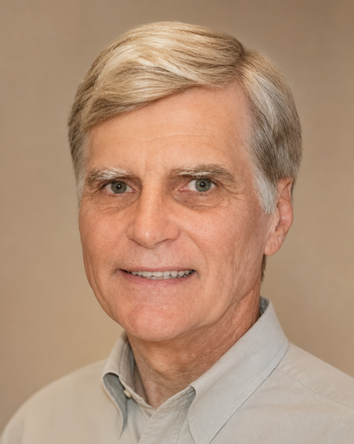

June 7, 2026
11:00 AM

St. John’s Episcopal Church
11901 Belair Road
Kingsville, MD 21087

The Reverend Mark Lobb, Celebrant
Nancy Heinold, Organist

The Celebration of the Life of
Tyrone Damon Schwenk

PRELUDE

All please stand while the following anthem is said: BCP p. 491
I am Resurrection and I am Life, says the Lord. Whoever has faith in me shall have life,
Even though he die.
And everyone who has life,
And has committed himself to me in faith, shall not die for ever.
As for me, I know that my Redeemer lives
And that at the last he will stand upon the earth. After my awaking, he will raise me up;
And in my body I shall see God.
I myself shall see, and my eyes behold him who is my friend and not a stranger.
For none of us has life in himself,
And none becomes his own master when he dies.
For if we have life, we are alive in the Lord, and if we die, we die in the Lord.
So, then, whether we live or die, we are the Lord's possession.
Happy from now on are those who die in the Lord! So it is, says the Spirit, for they rest from their labors.

OPENING HYMN 293 I sing a song of the saints of God
Celebrant: The Lord be with you.
People: And also with you.
Celebrant: Let us pray.
O God, who by the glorious resurrection of your Son Jesus Christ destroyed death, and brought life and immortality to light: Grant that your servant Ty, being raised with him, may know the strength of his presence, and rejoice in his eternal glory; who with you and the Holy Spirit lives and reigns, one God, for ever and ever. Amen.

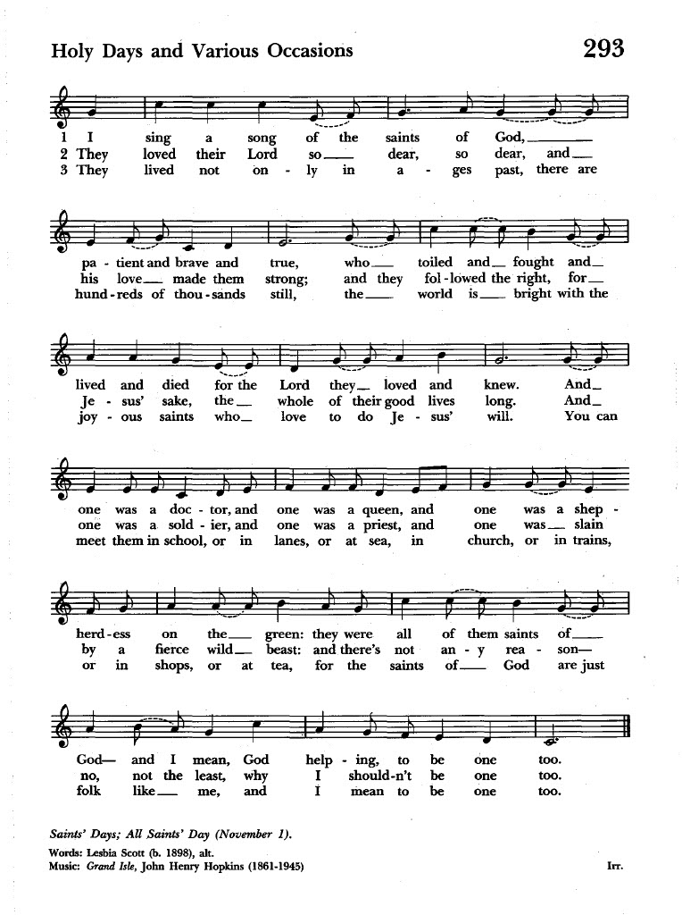

Most merciful God, whose wisdom is beyond our understanding: Deal graciously with Ty’s family and friends in their grief. Surround them with your love, that they may not be overwhelmed by their loss, but have confidence in your goodness, and strength to meet the days to come; through Jesus Christ our Lord. Amen.

The Liturgy of the Word

A Reading from Wisdom 3:1-5, 9 Anne Leland
But the souls of the righteous are in the hand of god, and no torment will ever touch them. In the eyes of the foolish they seemed to have died, and their departure was thought to be a disaster, and their going from us to be their destruction; but they are at peace. For though in the sight of others they were punished, their hope is full of immortality. Having been disciplined a little, they will receive great good, because god tested them and found them worthy of himself. Those who trust in him will understand truth, and the faithful will abide with him in love, because grace and mercy are upon his holy ones, and he watches over his elect.
Reader: The Word of the Lord.
People: Thanks be to God.

Psalm 42: 1-7 Read in unison John Stevens
1 As the deer longs for the water-brooks, *
so longs my soul for you, O God.
2 My soul is athirst for God, athirst for the living God; *
when shall I come to appear before the presence of God?
3 My tears have been my food day and night, *
while all day long they say to me, "Where now is your God?"
4 I pour out my soul when I think on these things: *
how I went with the multitude and led them into the house of God,
5 With the voice of praise and thanksgiving, *
among those who keep holy-day.
6 Why are you so full of heaviness, O my soul? *
and why are you so disquieted within me?
7 Put your trust in God; *
for I will yet give thanks to him, who is the help of my countenance, and my God.

A Reading from the Letter to the Romans 8:14-19, 34-35, 37-39 Liz Healey
All who are led by the Spirit of God are children of God. For you did not receive a spirit of slavery to fall back into fear, but you have received a spirit of adoption. When we cry, "Abba! Father!" it is that very Spirit bearing witness with our spirit that we are children of God, and if children, then heirs, heirs of God and joint heirs with Christ-- if, in fact, we suffer with him so that we may also be glorified with him.
I consider that the sufferings of this present time are not worth comparing with the glory about to be revealed to us. For the creation waits with eager longing for the revealing of the children of God.
Who is to condemn? It is Christ Jesus, who died, yes, who was raised, who is at the right hand of God, who indeed intercedes for us. Who will separate us from the love of Christ? Will hardship, or distress, or persecution, or famine, or nakedness, or peril, or sword?
No, in all these things we are more than conquerors through him who loved us. For I am convinced that neither death, nor life, nor angels, nor rulers, nor things present, nor things to come, nor powers, nor height, nor depth, nor anything else in all creation, will be able to separate us from the love of God in Christ Jesus our Lord.
Reader: The Word of the Lord.
People: Thanks be to God.
SEQUENCE HYMN 482 Lord of all hopefulness

The Gospel The Reverend Mark Lobb
Gospeler: The Holy Gospel of our Lord Jesus Christ according to John 14:1-6.
People: Glory to you Lord Christ.
Jesus said to his disciples, “Do not let your hearts be troubled. Believe in God, believe also in me. In my Father’s house there are many dwelling places. If it were not so, would I have told you that I go to prepare a place for you? And if I go and prepare a place for you, I will come again and will take you to myself, so that where I am, there you may be also. And you know the way to the place where I am going.” Thomas said to him, “Lord, we do not know where you are going. How can we know the way?”
Jesus said to him, “I am the way, and the truth, and the life. No one comes to the Father except through me.”
Gospeler: The Gospel of the Lord.
People: Praise be to you, Lord Christ.

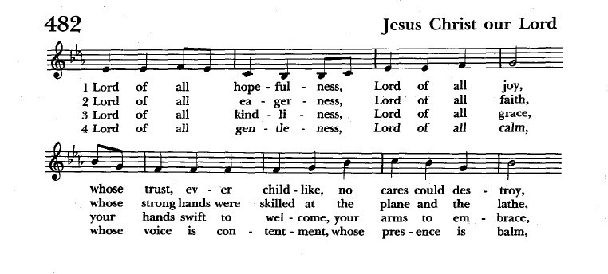

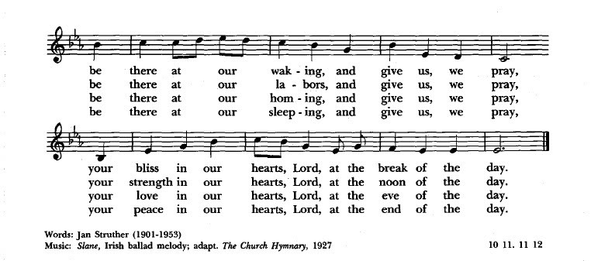

Homily The Reverend Mark Lobb

After the Homily the Celebrant says: BCP p. 496
In the assurance of eternal life given at Baptism, let us proclaim our faith and say,

Celebrant and People
I believe in God, the Father almighty, Creator of heaven and earth.
I believe in Jesus Christ, his only Son, our Lord.
He was conceived by the Holy Spirit
And born of the Virgin Mary.
He suffered under Pontius Pilate,
was crucified, died, and was buried.
He descended to the dead.
On the third day he rose again.
He ascended into heaven and is seated at the right hand of the Father. He will come again to judge the living and the dead.
I believe in the Holy Spirit,
the holy catholic Church,
the communion of saints,
the forgiveness of sins,
the resurrection of the body,
and the life everlasting. Amen.

The Lord’s Prayer
And now, as our Savior Christ has taught us, we are bold to say,
People and Celebrant:
Our Father, who art in heaven, hallowed be thy Name. Thy kingdom come, thy will be done, on earth as it is in heaven. Give us this day our daily bread. And forgive us our trespasses, as we forgive those who trespass against us. And lead us not into temptation, but deliver us from evil. For thine is the kingdom, and the power, and the glory, for ever and ever. Amen.

The Prayers of the People BCP p. 497
For our brother Ty, let us pray to our Lord Jesus Christ who said, "I am the Resurrection and I am Life."
Lord, you consoled Martha and Mary in their distress; draw near to us who mourn for Ty; and dry the tears of those who weep.

Hear us, Lord.
You wept at the grave of Lazarus, your friend; comfort us in our sorrow.

Hear us, Lord.
You raised the dead to life; give to our brother eternal life.

Hear us, Lord.
You promised paradise to the thief who repented; bring our brother to the joys of heaven.

Hear us, Lord.
Comfort us in our sorrows at the death of our brother; let our faith be our consolation, and eternal life our hope.
Celebrant: Father of all, we pray to you for Ty, and for all those whom we love but see no longer. Grant to them eternal rest. Let light perpetual shine upon them.
May his soul and the souls of all the departed, through the mercy of God, rest in peace. Amen.

The Peace
Celebrant: The peace of the Lord be always with you.
People: And also with you.
The People and Ministers greet each other in the name of the Lord.
Closing Hymn 208 The strife is o’er, the battle done

The Dismissal
Celebrant: Let us go forth in the name of Christ.
People: Thanks be to God.
Postlude
Please join the family in the Parish Hall for a reception following the service.
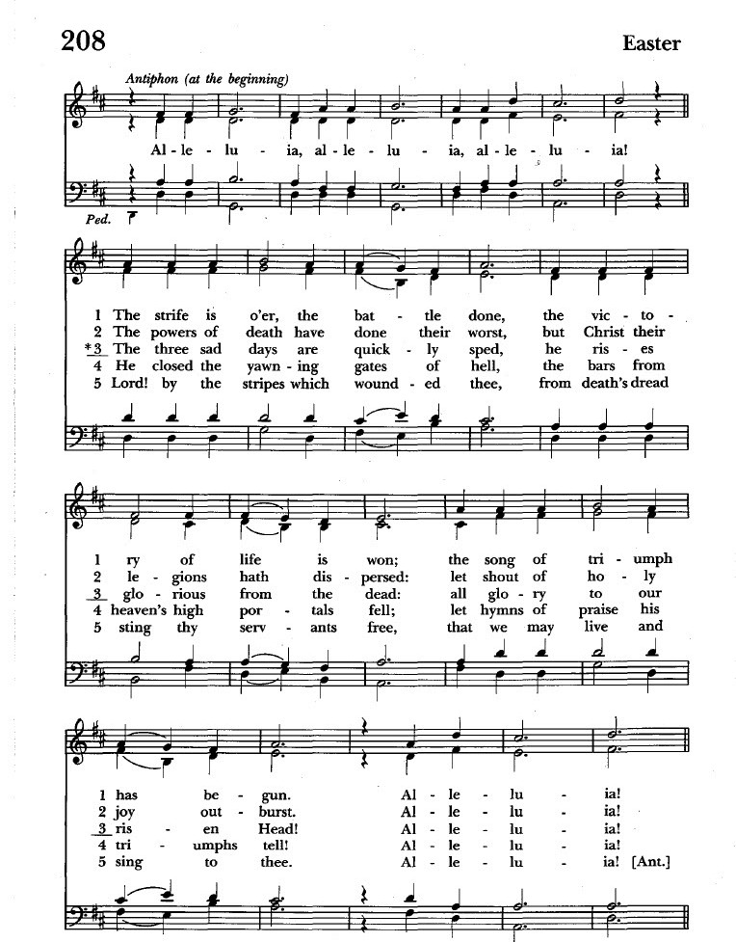

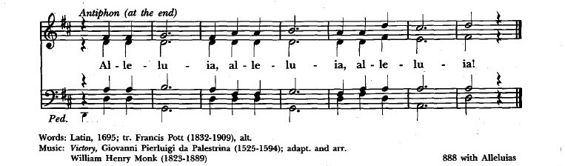

Tyrone Damon Schwenk lived a life rich in accomplishments, service, and devotion to those he loved. Ty was the beloved husband of 56 years to his cherished wife, Camilla “Camy” Sue (née Viste) Schwenk, devoted and loving father to Regina and Christopher, and is also survived by his sister-in-law Marta Wall and her husband Dennis, nephew Nathan Wall, and niece Megan Brogger. He will be lovingly remembered by his faithful feline companion, Miss Mustache, who brought him great comfort and companionship. Ty was preceded in death by his parents, Jack Burton Schwenk and Jesse Kathleen (née Stockwell) Schwenk.
A man of unwavering dedication, Ty honorably served in the U.S. Army during the Vietnam War and pursued knowledge with passion and determination, earning a Doctorate, two Master’s degrees, and two Bachelor’s degrees. As a Mechanical and Electrical Engineer whose remarkable intellect, creativity, and dedication to advancing technology left an impact not only on those fields but on those with whom he worked. Ty held a patent for one of his engineering creations, an achievement that brought him great pride when it was later adopted and utilized by the U.S. Navy.
Embracing a healthy and active lifestyle, Ty was an accomplished 5K runner, competing well into his seventies, frequently placing in the winners’ circle. His adventurous spirit led him to raft down the Colorado River, creating cherished memories and experiences, and his creativity extended to the kitchen, where he earned awards in the Johns Hopkins Keto Food Challenge for two consecutive years.
A lifelong student of history, Tyrone was an active member of an archaeological club and had a deep appreciation for land preservation and historical homes, especially his beloved Victorian house and barn, where he enjoyed quiet moments relaxing with Miss Mustache.
Faith was an important cornerstone of Tyrone's life, devotedly serving as Senior Warden of St. John's parish, generously giving of his time, talents, and leadership. He was always willing to lend a helping hand, was deeply respected for his kindness, friendliness, and wisdom, and will be remembered for his wonderful sense of humor, love of storytelling, and ability to bring smiles and laughter wherever he went. His warmth, generosity, and joyful spirit touched countless lives and created memories that will be treasured forever.
Tyrone will be dearly missed by his family, friends, church community, and all who had the privilege of knowing him. The family sincerely appreciates the outpouring of love, prayers, kindness, and support extended to them during this difficult time.
Ty will be interred at Arlington National Cemetery at a future date.

ST. JOHN’S EPISCOPAL CHURCH
P.O. Box 187
11901 Belair Road
Kingsville, MD 21087
410-592-8570

Sunday Services
Rite I – 8:00 a.m.
Rite II with music – 10:30 a.m.

July & August Sunday Services
9:30 a.m.

Priest in Charge: Fr. Mark Lobb
Email us at: stjohnskingsville@outlook.com
Visit our website at: www.stjohnskingsville.org
Follow us on Facebook at: https://www.facebook.com/stjohnsparish
In a pastoral emergency, please call Fr. Mark Lobb at: 443-690-9545



