St. John’s Episcopal Church
Kingsville, Maryland
Welcomes You
Our Vision Statement

We believe that together we will transform
the world with love: Come on in!



3rd Sunday after the Epiphany
January 25, 2026

St. John’s Episcopal Church

11901 Belair Road, P. O. Box 187, Kingsville, MD 21087
Facebook: St. John’s Episcopal, Kingsville, MD
Email: office@stjohnskingsville.org
Website: www.stjohnskingsville.org
Church Phone: 410-592-8570
For Pastoral Emergencies: Fr. Mark Lobb+ 443-690-9545

Welcome to worship today! We are glad that you are with us. You are invited to participate in all parts of the service as indicated in the red Book of Common Prayer and this service bulletin. If you have any questions, feel free to ask the ushers. Restrooms are located in the Parish Hall, the brick building across the parking lot.

I was glad when they said to me, “Let us go to the house of the Lord.” Psalm 122:1

Church Staff

Priest in Charge: Father Mark Lobb
Administrative Assistant: Angie Bosley
Organist/Choir Director: Nancy Heinold

The Vestry

Class of 2026 Class of 2027

John Stevens John Frost
Paul Johnson Stephanie White

Officers
Ty Schwenk—Sr. Warden Terry Roe—Jr. Warden
Elizabeth Healey—Treasurer Anne Leland-Registrar

Parish Committee Chairpersons

Altar Guild: Elizabeth Healey
Auxiliary Committee: Michele Lozanski
Cemetery Committee: Karen Smith-Manar

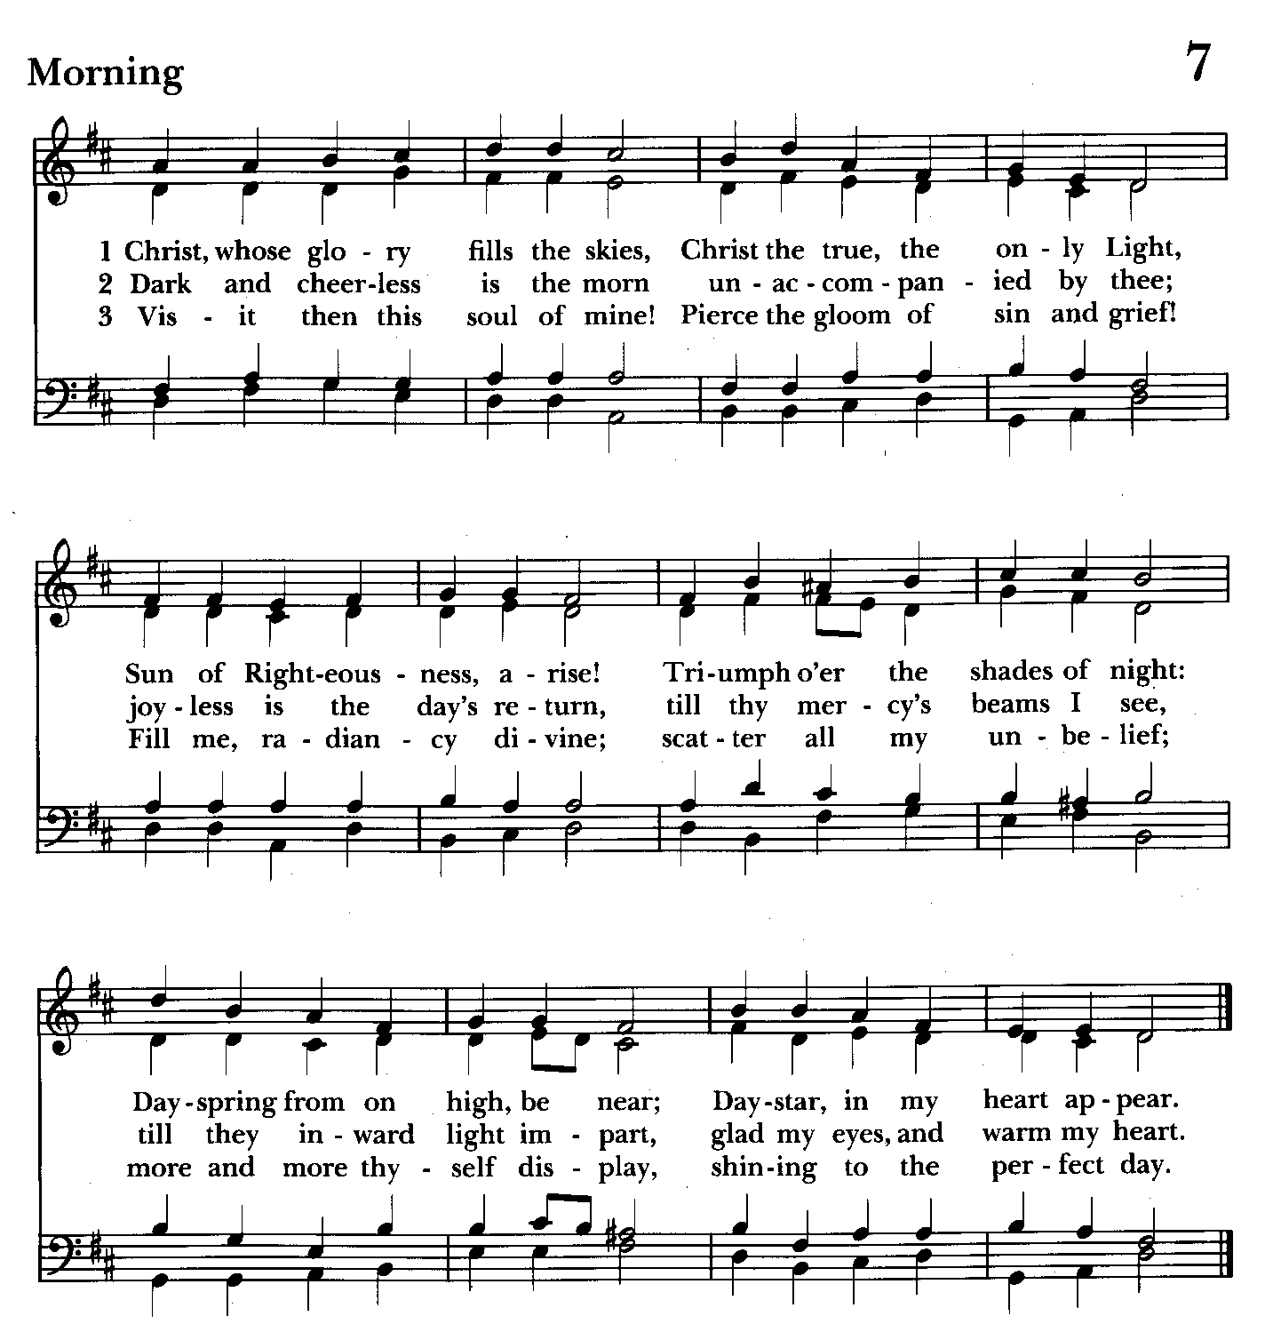

10:30 am Worship
Holy Eucharist, Rite Two
“LIVESTREAM”

Prelude:
The Word of God

Please stand as able
Opening hymn: Christ, whose glory fills the skies Hymnal #7
(see previous page)

Worship begins BCP 355

Gloria Hymnal #S-280
Glory to God in the highest,
and peace to his people on earth.
Lord God, heavenly King,
almighty God and Father,
we worship you, we give you thanks,
we praise you for your glory.
Lord Jesus Christ, only Son of the Father,
Lord God, Lamb of God,
you take away the sin of the world:
have mercy on us;
you are seated at the right hand of the Father:
receive our prayer.
For you alone are the Holy One,
you alone are the Lord,
you alone are the Most High,
Jesus Christ,
with the Holy Spirit,
in the glory of God the Father. Amen.

Celebrant: The Lord be with you.
People: And also with you.
Celebrant: Let us pray.

The Collect of the Day BCP 215
Give us grace, O Lord, to answer readily the call of our Savior Jesus Christ and proclaim to all people the Good News of his salvation, that we and the whole world may perceive the glory of his marvelous works; who lives and reigns with you and the Holy Spirit, one God, for ever and ever. Amen.

The congregation is seated.
A Reading from the Book of the Prophet Isaiah 9:1-4
There will be no gloom for those who were in anguish. In the former time he brought into contempt the land of Zebulun and the land of Naphtali, but in the latter time he will make glorious the way of the sea, the land beyond the Jordan, Galilee of the nations.
The people who walked in darkness
have seen a great light;
those who lived in a land of deep darkness--
on them light has shined.
You have multiplied the nation,
you have increased its joy;
they rejoice before you
as with joy at the harvest,
as people exult when dividing plunder.
For the yoke of their burden,
and the bar across their shoulders,
the rod of their oppressor,
you have broken as on the day of Midian.

Reader: The Word of the Lord.
People: Thanks be to God.

Psalm 27:1, 5-13 (Prayed as directed.)
1 The Lord is my light and my salvation;
whom then shall I fear? *
the Lord is the strength of my life;
of whom then shall I be afraid?
5 One thing have I asked of the Lord;
one thing I seek; *
that I may dwell in the house of the Lord all the days of my life;
6 To behold the fair beauty of the Lord *
and to seek him in his temple.
7 For in the day of trouble he shall keep me safe in his shelter; *
he shall hide me in the secrecy of his dwelling
and set me high upon a rock.
8 Even now he lifts up my head *
above my enemies round about me.
9 Therefore I will offer in his dwelling an oblation
with sounds of great gladness; *
I will sing and make music to the Lord.
10 Hearken to my voice, O Lord, when I call; *
have mercy on me and answer me.
11 You speak in my heart and say, "Seek my face." *
Your face, Lord, will I seek.
12 Hide not your face from me, *
nor turn away your servant in displeasure.
13 You have been my helper;
cast me not away; *
do not forsake me, O God of my salvation.

A Reading from the First Letter of St. Paul to the Corinthians 1:10-18
Now I appeal to you, brothers and sisters, by the name of our Lord Jesus Christ, that all of you be in agreement and that there be no divisions among you, but that you be united in the same mind and the same purpose. For it has been reported to me by Chloe’s people that there are quarrels among you, my brothers and sisters. What I mean is that each of you says, “I belong to Paul,” or “I belong to Apollos,” or “I belong to Cephas,” or “I belong to Christ.” Has Christ been divided? Was Paul crucified for you? Or were you baptized in the name of Paul? I thank God that I baptized none of you except Crispus and Gaius, so that no one can say that you were baptized in my name. (I did baptize also the household of Stephanas; beyond that, I do not know whether I baptized anyone else.) For Christ did not send me to baptize but to proclaim the gospel, and not with eloquent wisdom, so that the cross of Christ might not be emptied of its power.
For the message about the cross is foolishness to those who are perishing, but to us who are being saved it is the power of God.
Please stand as able

Gradual hymn: The people who in darkness walked Hymnal #126
(see next page)

The Gospel The congregation remains standing
Priest: The Holy Gospel of our Lord Jesus Christ according to Matthew 4:12-23

People: Glory to you, Lord Christ.
When Jesus heard that John had been arrested, he withdrew to Galilee. He left Nazareth and made his home in Capernaum by the sea, in the territory of Zebulun and Naphtali, so that what had been spoken through the prophet Isaiah might be fulfilled:

“Land of Zebulun, land of Naphtali,
on the road by the sea, across the Jordan, Galilee of the Gentiles—
the people who sat in darkness
have seen a great light,
and for those who sat in the region and shadow of death
light has dawned.”

From that time Jesus began to proclaim, “Repent, for the kingdom of heaven has come near.”
As he walked by the Sea of Galilee, he saw two brothers, Simon, who is called Peter, and Andrew his brother, casting a net into the sea—for they were fishermen. And he said to them, “Follow me, and I will make you fish for people.” Immediately they left their nets and followed him. As he went from there, he saw two other brothers, James son of Zebedee and his brother John, in the boat with their father Zebedee, mending their nets, and he called them. Immediately they left the boat and their father, and followed him.
Jesus went throughout Galilee, teaching in their synagogues and proclaiming the good news of the kingdom and curing every disease and every sickness among the people.

Priest: The Gospel of the Lord.
People: Praise to you, Lord Christ.

Sermon Please be seated Rev. Mark Lobb+

Nicene Creed Please stand as able BCP 358
We believe in one God,
the Father, the Almighty,
maker of heaven and earth,
of all that is, seen and unseen.
We believe in one Lord, Jesus Christ,
the only Son of God,
eternally begotten of the Father,
God from God, Light from Light,
true God from true God,
begotten, not made,
of one Being with the Father.
Through him all things were made.
For us and for our salvation
he came down from heaven:
by the power of the Holy Spirit
he became incarnate from the Virgin Mary,
and was made man.
For our sake he was crucified under Pontius Pilate;
he suffered death and was buried.
On the third day he rose again
in accordance with the Scriptures;
he ascended into heaven
and is seated at the right hand of the Father.
He will come again in glory to judge the living and the dead,
and his kingdom will have no end.
We believe in the Holy Spirit, the Lord, the giver of life,
who proceeds from the Father and the Son.
With the Father and the Son he is worshiped and glorified.
He has spoken through the Prophets.
We believe in one holy catholic and apostolic Church.
We acknowledge one baptism for the forgiveness of sins.
We look for the resurrection of the dead,
and the life of the world to come. Amen.

Prayers of the People Form III Please remain standing BCP 387
Celebrant: Father, we pray for your holy Catholic Church;
People: That we all may be one.

Celebrant: Grant that every member of the Church may truly and humbly serve you;
People: That your Name may be glorified by all people.

Celebrant: We pray for all bishops, priests, and deacons;
People: That they may be faithful ministers of your Word and Sacraments.

Celebrant: We pray for all who govern and hold authority in the nations of the world;
People: That there may be justice and peace on the earth.

Celebrant: Give us grace to do your will in all that we undertake;
People: That our works may find favor in your sight.

Celebrant: Have compassion on those who suffer from any grief or trouble;
People: That they may be delivered from their distress.

Celebrant: Give to the departed eternal rest;
People: Let light perpetual shine upon them.
Celebrant: We praise you for your saints who have entered into joy;
People: May we also come to share in your heavenly kingdom.

Celebrant: Let us pray for our own needs and those of others Especially remember in our prayers, Mike Carden, Bill Hoffman & Family, Family of Steven Rakas, Family of Joann Koch, Phillip Harris, Ed Thompson, Riley Terrill, Andy Grau, Jim Peeling, Tom Baumeister, Marsha DeMarino, Iona Leamer, Susan Koch, Ty Schwenk, Anna Marie Surdel, Maxine Rising, Tony Rising, Angelina DeMarino Grandel, Jacquelin Scepaniak.

We pray for the repose of the soul of Fey Robertson.

We pray for the Church and the World:

For +Sean, our Presiding Bishop, for +Carrie, our Bishop, for Mark+, our Priest in Charge, for the Wardens, Vestry, Staff, and all members and friends of St. John’s Church.

For the leaders of all nations, especially for Donald, our President; for Wes, our Governor; for Brandon, Kathy and Bob, who lead our City and Counties. We pray for all children and youth; for the homeless, the unemployed, and the hungry. We pray for the safety of our loved ones and friends serving in the Armed Forces at home and abroad, and for our enemies, that all our hearts may be turned toward peace throughout the world.

For Peace Among the Nations BCP 816
Almighty God our heavenly Father, guide the nations of the world into the way of justice and truth, and establish among them that peace which is the fruit of
righteousness, that they may become the kingdom of our Lord and Savior Jesus Christ. Amen.
The priest adds a concluding collect.

Confession of Sin BCP 359
Most merciful God, we confess that we have sinned against you in thought, word, and deed, by what we have done, and by what we have left undone. We have not loved you with our whole heart; we have not loved our neighbors as ourselves. We are truly sorry and we humbly repent. For the sake of your Son Jesus Christ, have mercy on us and forgive us; that we may delight in your will, and walk in your ways, to the glory of your Name. Amen.

The Peace BCP 360
Celebrant: The peace of the Lord be always with you.
People: And also with you.

Welcome & Announcements The congregation is seated.

Offertory anthem: They’ll know we are Christians by our love(Choir)

Offertory hymn: I come with joy to meet my Lord Hymnal #304 vs. 1&2
(see next page)

All remain seated during the hymn and collection of the offering

Please stand as able
Presentation Hymn Hymnal #43, vs. 4
Praise God, from whom all blessings flow; praise him, all creatures here below; praise him above, ye heavenly host: praise Father, Son, and Holy Ghost.

The Holy Communion

THE GREAT THANKSGIVING: Eucharistic Prayer A BCP 361
Celebrant: The Lord be with you.
People: And also with you.
Celebrant: Lift up your hearts.
People: We lift them to the Lord.
Celebrant: Let us give thanks to the Lord our God.
People: It is right to give him thanks and praise.
Celebrant: It is right, and a good and joyful thing, always and everywhere to give thanks to you, Father Almighty, Creator of heaven and earth.

Therefore we praise you, joining our voices with Angels and Archangels and with all the company of heaven, who for ever sing this hymn to proclaim the glory of your Name:

Sanctus Hymnal #S-129
Holy, Holy, Holy Lord, God of power and might,
heaven and earth are full of your glory.
Hosanna in the highest.
Blessed is he who comes in the name of the Lord.
Hosanna in the highest.

Celebrant: Holy and gracious Father: In your infinite love you made us for yourself; and, when we had fallen into sin and become subject to evil and death, you, in your mercy, sent Jesus Christ, your only and eternal Son, to share our human
nature, to live and die as one of us, to reconcile us to you, the God and Father of all.

He stretched out his arms upon the cross, and offered himself, in obedience to your will, a perfect sacrifice for the whole world.

On the night he was handed over to suffering and death, our Lord Jesus Christ took bread; and when he had given thanks to you, he broke it, and gave it to his disciples, and said, “Take, eat: This is my Body, which is given for you. Do this for the remembrance of me.”

After supper he took the cup of wine; and when he had given thanks, he gave it to them, and said, “Drink this, all of you: This is my Blood of the new Covenant, which is shed for you and for many for the forgiveness of sins. Whenever you drink it, do this for the remembrance of me.”

Therefore we proclaim the mystery of faith.

Christ has died.
Christ is risen.
Christ will come again.

We celebrate the memorial of our redemption, O Father, in this sacrifice of praise and thanksgiving. Recalling his death, resurrection, and ascension, we offer you these gifts.

Sanctify them by your Holy Spirit to be for your people the Body and Blood of your Son, the holy food and drink of new and unending life in him. Sanctify us also that we may faithfully receive this holy Sacrament, and serve you in unity,
constancy, and peace; and at the last day bring us with all your saints into the joy of your eternal kingdom.

All this we ask through your Son Jesus Christ. By him, and with him, and in him, in the unity of the Holy Spirit all honor and glory is yours, Almighty Father, now and for ever. Amen.

And now, as our Savior Christ has taught us, we are bold to say,

The Lord’s Prayer Please stand as able BCP 364
Our Father, who art in heaven, hallowed be thy Name, thy kingdom come, thy will be done, on earth as it is in heaven. Give us this day our daily bread. And forgive us our trespasses, as we forgive those who trespass against us. And lead us not into temptation, but deliver us from evil. For thine is the kingdom, and the power, and the glory, for ever and ever. Amen.

Invitation to Communion

The Breaking of the Bread
Celebrant: Alleluia. Christ our Passover is sacrificed for us;
People: Therefore let us keep the feast. Alleluia.

Celebrant: The Gifts of God for the People of God.

The Body and Blood of our Lord Jesus Christ keep you in everlasting life. Amen.

The Holy Communion is an “outward and visible sign” that we encounter Christ. Although some reserve this sacrament only for the baptized, at St. John’s we invite all who know Christ, seek to know Christ, or are simply curious to the altar at the Invitation. Receive the bread in cupped hands. Receive the wine by gently grasping the base of the chalice with two fingers, assisting the chalice bearer in guiding the cup to your lips. Intinction (dipping the bread in the wine) is strongly discouraged. If you do not wish to receive one or both kinds, please cross your arms in front of your chest to receive a blessing from the minister. Gluten-free wafers are available. Please indicate your desire for gluten-free sacrament by holding your hands palm down. Those participating online or otherwise unable to be present are considered to be fully engaged and receive the full benefit of the blessings of this gathering.
The congregation remains seated

Communion hymn: I come with joy to meet my Lord Hymnal #304 vs. 3-5
(see page 11)

The Post Communion Prayer BCP 365
Celebrant and People: Eternal God, heavenly Father, you have graciously accepted us as living members of your Son our Savior Jesus Christ, and you have fed us with spiritual food in the Sacrament of his Body and Blood. Send us now into the world in peace, and grant us strength and courage to love and serve you with gladness and singleness of heart; through Christ our Lord. Amen.

Blessing

The people stand as able

Closing hymn: Christ for the world we sing Hymnal #537
(see next page)

The Dismissal
Celebrant: Let us go forth in the name of Christ.
People: Thanks be to God.

St. John’s Parish Prayer List

As is our established practice, some names have been removed from the parish prayer list. Please let Mark+, a vestry member, or Angie know if a name should be returned, added, or subtracted from the list. Thank you for remembering these persons in prayer.

---------------------------------------------------------------------------------------------------------
Pray for healing, strength, and recovery:
Mike Carden, Bill Hoffman & Family, Family of Steven Rakas, Family of Joann Koch, Phillip Harris, Ed Thompson, Riley Terrill, Andy Grau, Jim Peeling, Tom Baumeister, Marsha DeMarino, Sheila Jones, Marisol Aubrey, Greg Sharp, Ione Leamer, Susan Koch, Ty Schwenk, Anna Marie Surdel, Maxine Rising, Tony Rising, Pat Thomas, Angelina DeMarino Grandel, Jacquelin Scepaniak, Lester Mosko (cancer) and family.

We pray for the repose of the soul of Fey Robertson.

We pray for our homebound: Lily John, Barbara Miller, Nancy Barnhart, Robin Dilworth, David House

We pray for the Church and the World:

For +Sean, our Presiding Bishop, for +Carrie, our Bishop, for Mark+, our Priest in Charge, for the Wardens, Vestry, Staff, and all members and friends of St. John’s Church.

For the leaders of all nations, especially for Donald, our President; for Wes, our Governor; for Brandon, Kathy and Bob, who lead our City and Counties. We pray for all children and youth; for the homeless, the unemployed, and the hungry. We pray for the safety of our loved ones and friends serving in the Armed Forces at home and abroad, and for our enemies, that all our hearts may be turned toward peace throughout the world.


We pray for Birthdays this week:
January 26 Benjamin Grau, Cameron Sandora
January 28 Anne Leland

From the Treasurer
January ‘26 Income vs. Expenses:

Projected January Expenses: $14,500
Monies Received as of 1/22: $9,733

Amount Needed to Meet Expenses: $4,767

If you would like to mail your contribution, our address is:
St. John’s Episcopal Church
P.O. Box 187
Kingsville, Maryland 21087


If you’d like to make a donation to St. John’s you can scan this QR code with your phone’s camera or tap on the link that comes up to make a contribution with either a credit or debit card, Apple Pay or Google Pay. This is a secure site provided by Clover which is a service of PNC Bank.

HAPPENINGS

Calendar Updates
February 6 – BINGO, to benefit the Harford County Hope for the Homeless Alliance

Calendars are living documents. Every effort will be made to keep the members of the parish and community aware of any changes.



CHOIR/BELL CHOIR
Choir rehearsal – Wednesdays at 7 pm
Bell Choir rehearsal – Sundays at 11:45 am

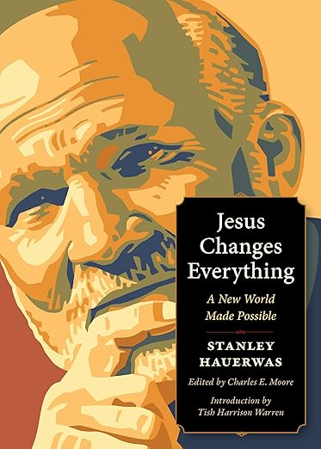
BOOK GROUP
https://a.co/d/4clvIHs
The eagerly awaited Epiphany book study is revealed! Chock full of theology and scripture, this will be fun.
Book Group starts on Thursday, January 22, 2026 at 9:00.
Let us know if you need assistance in obtaining a copy.


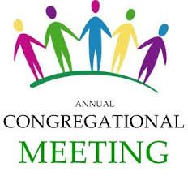
ANNUAL MEETING & POTLUCK NEXT SUNDAY- FEBRUARY 1ST @ 9:30 AM

"Have a Heart Potluck" – Sunday, February 1
Join us for a “Have a Heart” Potluck on Sunday, February 1, immediately following the 9:30 a.m. service and Annual Meeting. In the spirit of love and fellowship, everyone is invited to share a meal and enjoy time together as a church family. Consider bringing a heart-themed dish—think heart-shaped sandwiches, pasta or pizza, red or pink salads, soups made with love, or sweet treats like cookies, cupcakes, or chocolate desserts. Bring a dish if you’re able, and most importantly, bring your appetite and your loving hearts.

What’s Happening This Week at St. John’s

Sunday, January 25—3rd Sunday after Epiphany
10:30am: Holy Eucharist Rite II, LIVESTREAM

Monday, January 26
12:00-1:00pm: AA Lunch Bunch (Parish Hall)
AA Big Book Meeting

Tuesday, January 27
12:00-1:00pm: AA Lunch Bunch (Parish Hall)

Wednesday, January 28
12:00-1:00pm: AA Lunch Bunch (Parish Hall)
7.00pm: Choir Rehearsal (Church)
7:30pm: AA (Parish Hall)

Thursday, January 29
12:00-1:00pm: AA Lunch Bunch (Parish Hall)
7:00pm: AA (Parish Hall)

Friday, January 30
12:00-1:00pm: AA Lunch Bunch (Parish Hall)

Saturday, January 31
8:30pm: AA (Parish Hall)

Sunday, February 1—4th Sunday after Epiphany
9:30am: Holy Eucharist Rite II, with Music (Parish Hall)
followed by the Annual Meeting and Brunch
11:30am: Bell Choir Rehearsal (Church)

Parish Office is open Monday and Thursday, 9:00am-2:00pm.
Potluck Luncheon on the first Sunday of the month and Coffee Hour on all other Sundays after the 10:30 service.

