St. John’s Episcopal Church
in Kingsville, Maryland
Welcomes You

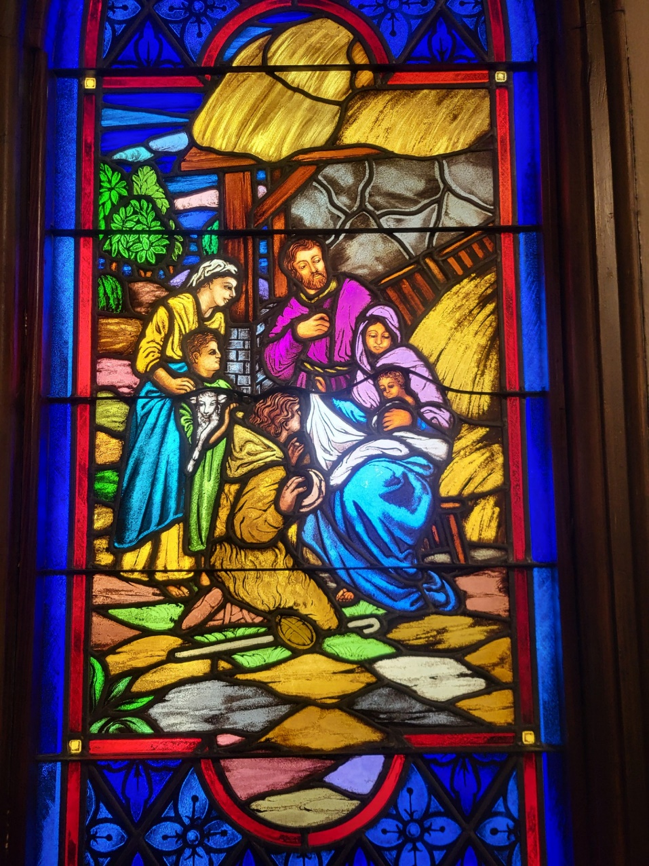

The First Sunday in the Christmas Season
with Lessons & Carols at 10:30 a.m.
December 28, 2025

St. John’s Episcopal Church

11901 Belair Road, P. O. Box 187, Kingsville, MD 21087
Facebook: St. John’s Episcopal, Kingsville, MD
Email: office@stjohnskingsville.org
Website: www.stjohnskingsville.org
Church Phone: 410-592-8570
For Pastoral Emergencies: Fr. Mark Lobb+ 443-690-9545

Welcome to worship today! We are glad that you are with us. You are invited to participate in all parts of the service as indicated in the red Book of Common Prayer and this service bulletin. If you have any questions, feel free to ask the ushers. Restrooms are located in the Parish hall, the brick building across the parking lot.

I was glad when they said to me, “Let us go to the house of the Lord.” Psalm 122:1

Church Staff

Priest in Charge: Father Mark Lobb
Administrative Assistant: Angie Bosley
Organist/Choir Director: Nancy Heinold

The Vestry

Class of 2026 Class of 2027

John Stevens John Frost
Paul Johnson Stephanie White

Officers
Ty Schwenk—Sr. Warden Terry Roe—Jr. Warden
Elizabeth Healey—Treasurer Anne Leland-Registrar

Parish Committee Chairpersons

Altar Guild: Elizabeth Healey
Auxiliary Committee: Michele Lozanski
Cemetery Committee: Karen Smith-Manar
A Christmas Service of Lessons & Carols
December 28, 2025 at 10:30 AM

Prelude

Processional Hymn: Once in Royal David’s City Hymnal #102
Please stand as able

The Collect of the Day
Almighty God, you have poured upon us the new light of your incarnate Word: Grant that this light, enkindled in our hearts, may shine forth in our lives; through Jesus Christ our Lord, who lives and reigns with you, in the unity of the Holy Spirit, one God, now and for ever. Amen.

Lessons & Carols
The congregation is seated

1st Lesson: Genesis 3:1-23
Now the serpent was more crafty than any other wild animal that the Lord God had made. He said to the woman, "Did God say, `You shall not eat from any tree in the garden'?" The woman said to the serpent, "We may eat of the fruit of the trees in the garden; but God said, `You shall not eat of the fruit of the tree that is in the middle of the garden, nor shall you touch it, or you shall die.'" But the serpent said to the woman, "You will not die; for God knows that when you eat of it your eyes will be opened, and you will be like God, knowing good and evil." So when the woman saw that the tree was good for food, and that it was a delight to the eyes, and that the tree was to be desired to make one wise, she took of its fruit and ate; and she also gave some to her husband, who was with her, and he ate. Then the eyes of both were opened, and they knew that they were naked; and they sewed fig leaves together and made loincloths for themselves.

They heard the sound of the Lord God walking in the garden at the time of the evening breeze, and the man and his wife hid themselves from the presence of the Lord God among the trees of the garden. But the Lord God called to the man, and said to him, "Where are you?" He said, "I heard the sound of you in the garden, and I was afraid, because I was naked; and I hid myself." He said, "Who told you that you were naked? Have you eaten from the tree of which I commanded you not to eat?" The man said, "The woman whom you gave to be with me, she gave me fruit from the tree, and I ate." Then the Lord God said to the woman, "What is this that you have done?" The woman said, "The serpent tricked me, and I ate." The Lord God said to the serpent,

"Because you have done this,
cursed are you among all animals
and among all wild creatures;
upon your belly you shall go,
and dust you shall eat
all the days of your life.
I will put enmity between you and the woman,
and between your offspring and hers;
he will strike your head,
and you will strike his heel."
[To the woman he said,
"I will greatly increase your pangs in childbearing;
in pain you shall bring forth children,
yet your desire shall be for your husband,
and he shall rule over you."
And to the man he said,
"Because you have listened to the voice of your wife,
and have eaten of the tree
about which I commanded you,
`You shall not eat of it,'
cursed is the ground because of you;
in toil you shall eat of it all the days of your life;
thorns and thistles it shall bring forth for you;
and you shall eat the plants of the field.
By the sweat of your face
you shall eat bread
until you return to the ground,
for out of it you were taken;
you are dust,
and to dust you shall return."

The man named his wife Eve, because she was the mother of all living. And the Lord God made garments of skins for the man and for his wife, and clothed them. Then the Lord God said, “See, the man has become like one of us, knowing good and evil; and now, he might reach out his hand and take also from the tree of life, and eat, and live forever”—therefore the Lord God sent him forth from the garden of Eden, to till the ground from which he was taken.]

“Creator of the stars of night” # 60

2nd Lesson: Isaiah 40:1-11
Comfort, O comfort my people,
says your God.
Speak tenderly to Jerusalem,
and cry to her
that she has served her term,
that her penalty is paid,
that she has received from the Lord's hand
double for all her sins.
A voice cries out:
"In the wilderness prepare the way of the Lord,
make straight in the desert a highway for our God.
Every valley shall be lifted up,
and every mountain and hill be made low;
the uneven ground shall become level,
and the rough places a plain.
Then the glory of the Lord shall be revealed,
and all people shall see it together,
for the mouth of the Lord has spoken."
A voice says, "Cry out!"
And I said, "What shall I cry?"
All people are grass,
their constancy is like the flower of the field.
The grass withers, the flower fades,
when the breath of the Lord blows upon it;
surely the people are grass.
The grass withers, the flower fades;
but the word of our God will stand forever.
Get you up to a high mountain,
O Zion, herald of good tidings;
lift up your voice with strength,
O Jerusalem, herald of good tidings,
lift it up, do not fear;
say to the cities of Judah,
"Here is your God!"
See, the Lord GOD comes with might,
and his arm rules for him;
his reward is with him,
and his recompense before him.
He will feed his flock like a shepherd;
he will gather the lambs in his arms,
and carry them in his bosom,
and gently lead the mother sheep.

“Rejoice, rejoice” # 68

3rd Lesson: Luke 1:26-38
In the sixth month the angel Gabriel was sent by God to a town in Galilee called Nazareth, to a virgin engaged to a man whose name was Joseph, of the house of David. The virgin's name was Mary. And he came to her and said, "Greetings, favored one! The Lord is with you." But she was much perplexed by his words and pondered what sort of greeting this might be. The angel said to her, "Do not be afraid, Mary, for you have found favor with God. And now, you will conceive in your womb and bear a son, and you will name him Jesus. He will be great, and will be called the Son of the Most High, and the Lord God will give to him the throne of his ancestor David. He will reign over the house of Jacob forever, and of his kingdom there will be no end." Mary said to the angel, "How can this be, since I am a virgin?" The angel said to her, "The Holy Spirit will come upon you, and the power of the Most High will overshadow you; therefore the child to be born will be holy; he will be called Son of God. And now, your relative Elizabeth in her old age has also conceived a son; and this is the sixth month for her who was said to be barren. For nothing will be impossible with God." Then Mary said, "Here am I, the servant of the Lord; let it be with me according to your word." Then the angel departed from her. “The angel Gabriel salutes the Blessed Virgin Mary.”

“The Angel Gabriel” # 265
4th Lesson: Luke 2:1-20
In those days a decree went out from Emperor Augustus that all the world should be registered. This was the first registration and was taken while Quirinius was governor of Syria. All went to their own towns to be registered. Joseph also went from the town of Nazareth in Galilee to Judea, to the city of David called Bethlehem, because he was descended from the house and family of David. He went to be registered with Mary, to whom he was engaged and who was expecting a child. While they were there, the time came for her to deliver her child. And she gave birth to her firstborn son and wrapped him in bands of cloth, and laid him in a manger, because there was no place for them in the inn.
In that region there were shepherds living in the fields, keeping watch over their flock by night. Then an angel of the Lord stood before them, and the glory of the Lord shone around them, and they were terrified. But the angel said to them, "Do not be afraid; for see-- I am bringing you good news of great joy for all the people: to you is born this day in the city of David a Savior, who is the Messiah, the Lord. This will be a sign for you: you will find a child wrapped in bands of cloth and lying in a manger." And suddenly there was with the angel a multitude of the heavenly host, praising God and saying,
"Glory to God in the highest heaven,
and on earth peace among those whom he favors!"
[When the angels had left them and gone into heaven, the shepherds said to one another, "Let us go now to Bethlehem and see this thing that has taken place, which the Lord has made known to us." So they went with haste and found Mary and Joseph, and the child lying in the manger. When they saw this, they made known what had been told them about this child; and all who heard it were amazed at what the shepherds told them. But Mary treasured all these words and pondered them in her heart. The shepherds returned, glorifying and praising God for all they had heard and seen, as it had been told them.]
The Holy Gospel according to John 1:1-18 Rev. Mark Lobb+
In the beginning was the Word, and the Word was with God, and the Word was God. He was in the beginning with God. All things came into being through him, and without him not one thing came into being. What has come into being in him was life, and the life was the light of all people. The light shines in the darkness, and the darkness did not overcome it.
There was a man sent from God, whose name was John. He came as a witness to testify to the light, so that all might believe through him. He himself was not the light, but he came to testify to the light. The true light, which enlightens everyone, was coming into the world.
He was in the world, and the world came into being through him; yet the world did not know him. He came to what was his own, and his own people did not accept him. But to all who received him, who believed in his name, he gave power to become children of God, who were born, not of blood or of the will of the flesh or of the will of man, but of God.
And the Word became flesh and lived among us, and we have seen his glory, the glory as of a father's only son, full of grace and truth. (John testified to him and cried out, “This was he of whom I said, ‘He who comes after me ranks ahead of me because he was before me.’”) From his fullness we have all received, grace upon grace. The law indeed was given through Moses; grace and truth came through Jesus Christ. No one has ever seen God. It is God the only Son, who is close to the Father’s heart, who has made him known.
Gradual Hymn: O Come All Ye Faithful Hymnal # 83
Please stand as able
The Gospel: John 1:1-14 Rev. Mark Lobb+
“St. John unfolds the great mystery of the Incarnation.”

“Of the Father’s love begotten” The people are seated Hymnal # 82

Homily Rev. Mark Lobb+

The Nicene Creed Please stand as able BCP 358
We believe in one God,
the Father, the Almighty,
maker of heaven and earth,
of all that is, seen and unseen.

We believe in one Lord, Jesus Christ,
the only Son of God,
eternally begotten of the Father,
God from God, Light from Light,
true God from true God,
begotten, not made,
of one Being with the Father;
through him all things were made.
For us and for our salvation
he came down from heaven,
was incarnate of the Holy Spirit and the Virgin Mary
and became truly human.
For our sake he was crucified under Pontius Pilate;
he suffered death and was buried.
On the third day he rose again
in accordance with the Scriptures;
he ascended into heaven
and is seated at the right hand of the Father.
He will come again in glory to judge the living and the dead,
and his kingdom will have no end.

We believe in the Holy Spirit, the Lord, the giver of life,
who proceeds from the Father,
who with the Father and the Son is worshiped and glorified,
who has spoken through the prophets.

We believe in one holy catholic and apostolic Church.
We acknowledge one baptism for the forgiveness of sins.
We look for the resurrection of the dead,
and the life of the world to come. Amen.

Prayers of the People Form III Kneel or stand as able BCP 387
Celebrant: Father, we pray for your holy Catholic Church;
People: That we all may be one.

Celebrant: Grant that every member of the Church may truly and humbly serve you;
People: That your Name may be glorified by all people.

Celebrant: We pray for all bishops, priests, and deacons;
People: That they may be faithful ministers of your Word and Sacraments.

Celebrant: We pray for all who govern and hold authority in the nations of the world;
People: That there may be justice and peace on the earth.

Celebrant: Give us grace to do your will in all that we undertake;
People: That our works may find favor in your sight.

Celebrant: Have compassion on those who suffer from any grief or trouble;
People: That they may be delivered from their distress.

Celebrant: Give to the departed eternal rest;
People: Let light perpetual shine upon them.

Celebrant: We praise you for your saints who have entered into joy;
People: May we also come to share in your heavenly kingdom.

Celebrant: Let us pray for our own needs and those of others.

Celebrant: Heavenly Father, you have promised to hear what we ask in the Name of your Son: Accept and fulfill our petitions, we pray, not as we ask in our ignorance, nor as we deserve in our sinfulness, but as you know and love us in your Son Jesus Christ our Lord. Amen.

Confession of Sin BCP 359
Let us confess our sins against God and our neighbor.

Silence may be kept.
Minister and People
Most merciful God,
we confess that we have sinned against you
in thought, word, and deed,
by what we have done,
and by what we have left undone.
We have not loved you with our whole heart;
we have not loved our neighbors as ourselves.
We are truly sorry and we humbly repent.
For the sake of your Son Jesus Christ,
have mercy on us and forgive us;
that we may delight in your will,
and walk in your ways,
to the glory of your Name. Amen.

The Peace of Christ Please stand as able

Announcements The congregation is seated

Offertory Hymn: O little town of Bethlehem Hymnal #79
Please remain seated during the collection of the offertory

Presentation Hymn: Offerings are presented Please stand as able Hymnal #43, vs. 4

THE GREAT THANKSGIVING: Eucharistic Prayer B BCP 367
Celebrant: The Lord be with you.
People: And also with you.
Celebrant: Lift up your hearts.
People: We lift them to the Lord.
Celebrant: Let us give thanks to the Lord our God.
People: It is right to give him thanks and praise.
Celebrant: It is right, and a good and joyful thing, always and everywhere to give thanks to you, Father Almighty, Creator of heaven and earth.

Proper Preface

Therefore we praise you, joining our voices with Angels and Archangels and with all the company of heaven, who for ever sing this hymn to proclaim the glory of your Name:

Sanctus Hymnal # S –129
Holy, holy, holy Lord, God of power and might,
heaven and earth are full, full of your glory.
Hosanna in the highest.
Blessed is he who comes in the name of the Lord.
Hosanna in the highest.

The congregation stands or kneels
Celebrant: We give thanks to you, O God, for the goodness and love which you have made known to us in creation; in the calling of Israel to be your people; in your Word spoken through the prophets; and above all in the Word made flesh, Jesus, your Son. For in these last days you sent him to be incarnate from the Virgin Mary, to be the Savior and Redeemer of the world. In him, you have delivered us from evil, and made us worthy to stand before you. In him, you have brought us out of error into truth, out of sin into righteousness, out of death into life.

On the night before he died for us, our Lord Jesus Christ took bread; and when he had given thanks to you, he broke it, and gave it to his disciples, and said, “Take, eat: This is my Body, which is given for you. Do this for the remembrance of me.”

After supper he took the cup of wine; and when he had given thanks, he gave it to them, and said, “Drink this, all of you: This is my Blood of the new Covenant, which is shed for you and for many for the forgiveness of sins. Whenever you drink it, do this for the remembrance of me.”

Therefore, according to his command, O Father,

Celebrant and People: We remember his death, We proclaim his resurrection, We await his coming in glory;

Celebrant: And we offer our sacrifice of praise and thanksgiving to you, O Lord of all; presenting to you, from your creation, this bread and this wine.

We pray you, gracious God, to send your Holy Spirit upon these gifts that they may be the Sacrament of the Body of Christ and his Blood of the new Covenant. Unite us to your Son in his sacrifice, that we may be acceptable through him, being sanctified by the Holy Spirit. In the fullness of time put all things in subjection under your Christ, and bring us to that heavenly country where, with St. John and all your saints, we may enter the everlasting heritage of your sons and daughters; through Jesus Christ our Lord, the firstborn of all creation, the head of the Church, and the author of our salvation.

By him, and with him, and in him, in the unity of the Holy Spirit all honor and glory is yours, Almighty Father, now and for ever. Amen.

And now, as our Savior Christ has taught us, we are bold to say,

Our Father, who art in heaven, BCP 364
hallowed be thy Name,
thy kingdom come,
thy will be done,
on earth as it is in heaven.
Give us this day our daily bread.
And forgive us our trespasses,
as we forgive those
who trespass against us.
And lead us not into temptation,
but deliver us from evil.
For thine is the kingdom,
and the power, and the glory,
for ever and ever. Amen.

The Breaking of the Bread BCP 364
Celebrant: Alleluia. Christ our Passover is sacrificed for us;
People: Therefore let us keep the feast. Alleluia.

Agnus Dei Hymnal #S-163
Lamb of God, you take away the sins of the world: have mercy on us.
Lamb of God, you take away the sins of the world: have mercy on us.
Lamb of God, you take away the sins of the world: grant us peace.

Celebrant: The Gifts of God for the people of God.

Invitation to Communion BCP 364
All baptized Christians are welcome to receive Holy Communion with us. If you do not wish to receive Holy Communion, you may come to the altar rail for a blessing. Cross your arms over your heart as a sign to the priest.

Communion hymn: Let all mortal flesh keep silence Hymnal #324
The people kneel or sit

Post Communion Prayer BCP 365
Eternal God, heavenly Father, you have graciously accepted us as living members of your Son our Savior Jesus Christ, and you have fed us with spiritual food in the Sacrament of his Body and Blood. Send us now into the world in peace, and grant us strength and courage to love and serve you with gladness and singleness of heart; through Christ our Lord. Amen.

A Christmas Blessing
Celebrant: May Christ, who by his Incarnation gathered into one things earthly and heavenly, fill you with his joy and peace; and the blessing of God Almighty, the Father, the Son, and the Holy Spirit, be among you, and remain with you always.
All: Amen.

Recessional Hymn: Angels we have heard on high Hymnal # 96
Please stand as able

Dismissal
Celebrant: Let us bless the Lord.
People: Thanks be to God.

Serving Today
Celebrant & Preacher: The Rev. Mark Lobb
Readers: John Webb, Michele Lozanski, Tony Rising, Anne Leland
Prayers of the People: John Frost
Server: Ty Schwenk

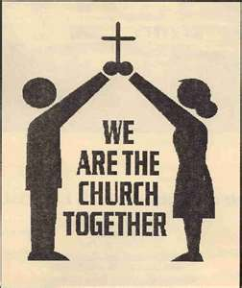

Join us for the Annual Meeting on
January 25, 2026. There will be ONE SERVICE at 9:30 am in the Parish Hall

St. John’s Prayer List

As is our established practice, some names have been removed from the parish prayer list. Please let Mark+, a vestry member, or Angie know if a name should be returned, added, or subtracted from the list. Thank you for remembering these persons in prayer.

----------------------------------------------------------------------------------------------------

Pray for healing, strength, and recovery:
Mike Carden, Bill Hoffman & Family, Family of Steven Rakas, Family of Joann Koch, Debra Sudano-Perouty, Phillip Harris, Ed Thompson, Riley Terrill, Andy Grau, Jim Peeling, Tom Baumeister, Marsha DeMarino, Sheila Jones, Marisol Aubrey, Greg Sharp, Ione Leamer, Susan Koch, Ty Schwenk, Anna Marie Surdel, Maxine Rising, Tony Rising, Pat Thomas, Angelina DeMarino Grandel, Jacquelin Scepaniak, Pat McCall Paquin.

We pray for our homebound: Lily John, Barbara Miller, Nancy Barnhart, Robin Dilworth, David House

We pray for Dennis Mally, for whom the altar flowers are given.

We pray for the Church and the World:

For +Sean, our Presiding Bishop, for +Carrie, our Bishop, for Mark+, our Priest in Charge, for the Wardens, Vestry, Staff, and all members and friends of St. John’s Church.

For the leaders of all nations, especially for Donald, our President; for Wes, our Governor; for Brandon, Kathy and Bob, who lead our City and Counties. We pray for all children and youth; for the homeless, the unemployed, and the hungry. We pray for the safety of our loved ones and friends serving in the Armed Forces at home and abroad, and for our enemies, that all our hearts may be turned toward peace throughout the world.



2025 Poinsettias
Peggie & Sonny Dietz in memory of Karie Dietz
Sharon Lobb in memory of Robert Kellogg, Michael Kellogg, Susan Kellogg, Donald Thomas Sr.
Marguerite Lobb in memory of Thomas Lobb
Joan Salmon in memory of Capt. Walter W. Salmon, Jr, Scott Keyser
Joan Salmon in honor of her parents
Darlene & Ross Strickler in memory of their mothers, fathers & siblings
Stephanie & Frank Duchacek in memory of Loved Ones
Chip Williams & Nanci Rosendale in memory of Eleanor & Arnold Gebler
Barbara Richardson in memory of Bertha & Arthur Howard
Woodie Tingle in honor of Dennis Mally, in honor of Jane White, in honor of Angie Bosley, in honor of Nancy Heinold, in memory of Mary & Woodie Tingle and Helen & Gus Mally
Laura Spadone in memory of Charles Keenan
Barbara Daniel in memory of Loved Ones Passed
Liz Healey in memory of John & Lorraine Healey, Earl & May Banks, Norman & Peggy Banks and in thanksgiving for The Holland Family

Altar Flowers
Given to the Glory of God
by Woodie Tingle
in celebration of Dennis Mally—HAPPY BIRTHDAY XOXOXO


We pray for Birthdays this week:
December 29 Allen Rawl
January 1 Bart Dellinger
January 2 Susan Peeling


Donations can be made to St. John’s you can scan this QR code with your phone’s camera or tap on the link that comes up to make a contribution with either a credit or debit card, Apple Pay or Google Pay. This is a secure site provided by Clover which is a service of PNC Bank.

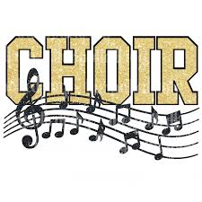
CHOIR/BELL CHOIR
Choir rehearsal – Wednesdays at 7 pm
Bell Choir rehearsal – Sundays at 11:45 am

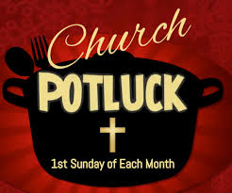
4 January 2026: Healthy Beginnings Potluck Sunday

Potluck will be immediately after the 10:30 service on 4 January 2026.

For Sunday, 4 January 2026, the first Sunday of the New Year, the Potluck theme is “Healthy Beginnings.” We will have a list of items to help make sure there are a variety of options at the back of the church as suggestions only. Do you have low calorie side dish, lean meat or meatless casserole, or favorite fruit dessert that you want to bring? Thank you!!!


INCLEMENT WEATHER—Be careful coming to church in inclement weather. If you don’t feel safe coming out—stay home. God will understand. You can also participate on line.

What’s Happening This Week at St. John’s

Sunday, December 28—First Sunday after Christmas
10:30am: Christmas Lessons & Carols (Church)
11:30am: Coffee Hour (Parish Hall)

Monday, December 29
12:00pm-1:00pm: AA Lunch Bunch (Parish Hall)

Tuesday, December 30
12:00pm-1:00pm: AA Lunch Bunch (Parish Hall)

Wednesday, December 31
12:00pm-1:00pm: AA Lunch Bunch (Parish Hall)
7:30pm: AA (Parish Hall)

Thursday, January 1 -- OFFICE CLOSED
12:00pm-1:00pm: AA Lunch Bunch (Parish Hall)
7:00pm: AA (Parish Hall)

Friday, January 2
12:00pm-1:00pm: AA Lunch Bunch (Parish Hall)

Saturday, January 3
8:30pm: AA (Parish Hall)

Sunday, January 4—Second Sunday after Christmas
8:00am: Holy Eucharist Rite I (Church)
10:30am: Holy Eucharist Rite II (Church)
11:30am: Potluck (Parish Hall)

Parish Office is open Monday and Thursday, 9:00am-2:00pm.

Potluck Luncheon on the first Sunday of the month and a Coffee Hour on all other Sundays after the 10:30 service.

