St. John’s Episcopal Church
Kingsville, Maryland
Welcomes You

Our Mission Statement

We believe that together we will transform
the world with love: Come on in!

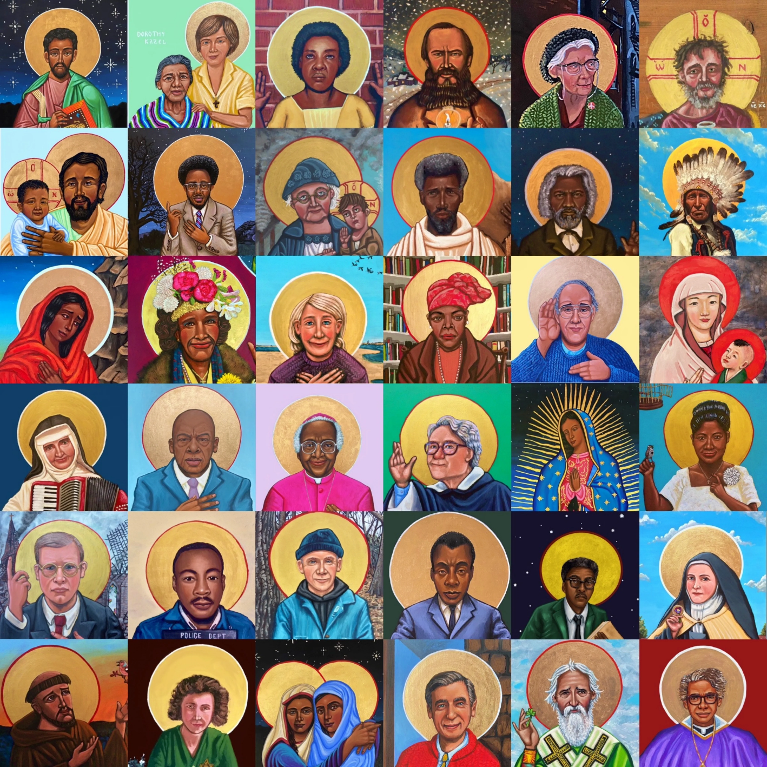

All Saints Sunday
November 2, 2025
10:30 am, Rite II

St. John’s Episcopal Church

11901 Belair Road, P. O. Box 187, Kingsville, MD 21087
Facebook: St. John’s Episcopal, Kingsville, MD
Email: office@stjohnskingsville.org
Website: www.stjohnskingsville.org
Church Phone: 410-592-8570
For Pastoral Emergencies: Fr. Mark Lobb+ 443-690-9545

Welcome to worship today! We are glad that you are with us. You are invited to participate in all parts of the service as indicated in red the Book of Common Prayer and this service bulletin. If you have any questions, feel free to ask the ushers. Restrooms are located in the Parish hall, the brick building across the parking lot.

I was glad when they said to me, “Let us go to the house of the Lord.” Psalm 122:1

Church Staff

Priest in Charge: Father Mark Lobb
Administrative Assistant: Angie Bosley
Organist/Choir Director: Nancy Heinold

The Vestry

Class of 2026 Class of 2027

John Stevens John Frost
Paul Johnson Stephanie White

Officers
Ty Schwenk—Sr. Warden Terry Roe—Jr. Warden
Elizabeth Healey—Treasurer Anne Leland-Registrar

Parish Committee Chairpersons

Altar Guild: Elizabeth Healey
Auxiliary Committee: Michele Lozanski
Cemetery Committee: Karen Smith-Manar

A note about our worship—Episcopalians traditionally stand, kneel, and sit at different points in the service. While we appreciate active participation, please be kind to your body. It is OK to remain seated if unable to stand or kneel.

The service is found in the red Book of Common Prayer (BCP) unless otherwise noted. Hymns and service music are found in the blue Hymnal, unless otherwise noted.

10:30 am Worship
The Holy Eucharist, Rite Two and
A Service of Holy Baptism

The congregation stands as able.
Processional Hymn: For all the saints, who from their labors rest Hymnal #287
(see previous 2 pages)

The Word of God
Remain standing as able

Celebrant: Blessed be God: Father, Son, and Holy Spirit. BCP 355
People: And blessed be his kingdom, now and for ever. Amen.

Celebrant: There is one Body and one Spirit;
People: There is one hope in God’s call to us;
Celebrant: One Lord, one Faith, one Baptism;
People: One God and Father of all.

Gloria Please remain standing as able Hymnal #S-278
Glory to God in the highest,
and peace to his people on earth.
Lord God, heavenly King,
almighty God and Father,
we worship you, we give you thanks,
we praise you for your glory.
Lord Jesus Christ, only Son of the Father,
Lord God, Lamb of God,
you take away the sin of the world:
have mercy on us;
you are seated at the right hand of the Father:
receive our prayer.
For you alone are the Holy One,
you alone are the Lord,
you alone are the Most High,
Jesus Christ,
with the Holy Spirit,
in the glory of God the Father. Amen.

Celebrant: The Lord be with you.
People: And also with you.
Celebrant: Let us pray.

The congregation is seated

The Collect of the Day BCP 245
Almighty God, you have knit together your elect in one communion and fellowship in the mystical body of your Son Christ our Lord: Give us grace so to follow your blessed saints in all virtuous and godly living, that we may come to those ineffable joys that you have prepared for those who truly love you; through Jesus Christ our Lord, who with you and the Holy Spirit lives and reigns, one God, in glory everlasting. Amen.

The congregation is seated
The Lessons
A Reading from the Book of the Prophet Daniel 7:1-3, 15-18
In the first year of King Belshazzar of Babylon, Daniel had a dream and visions of his head as he lay in bed. Then he wrote down the dream: I, Daniel, saw in my vision by night the four winds of heaven stirring up the great sea, and four great beasts came up out of the sea, different from one another.
As for me, Daniel, my spirit was troubled within me, and the visions of my head terrified me. I approached one of the attendants to ask him the truth concerning all this. So he said that he would disclose to me the interpretation of the matter: "As for these four great beasts, four kings shall arise out of the earth. But the holy ones of the Most High shall receive the kingdom and possess the kingdom for ever—for ever and ever."
Reader: The Word of the Lord.
People: Thanks be to God.
Psalm 149 Pray as directed BCP 807
1 Hallelujah!
Sing to the Lord a new song; *
sing his praise in the congregation of the faithful.
2 Let Israel rejoice in his Maker; *
let the children of Zion be joyful in their King.
3 Let them praise his Name in the dance; *
let them sing praise to him with timbrel and harp.
4 For the Lord takes pleasure in his people *
and adorns the poor with victory.
5 Let the faithful rejoice in triumph; *
let them be joyful on their beds.
6 Let the praises of God be in their throat *
and a two-edged sword in their hand;
7 To wreak vengeance on the nations *
and punishment on the peoples;
8 To bind their kings in chains *
and their nobles with links of iron;
9 To inflict on them the judgment decreed; *
this is glory for all his faithful people.
Hallelujah!

A Reading from the Letter of St. Paul to the Ephesians 1:11-23
In Christ we have also obtained an inheritance, having been destined according to the purpose of him who accomplishes all things according to his counsel and will, so that we, who were the first to set our hope on Christ, might live for the praise of his glory. In him you also, when you had heard the word of truth, the gospel of your salvation, and had believed in him, were marked with the seal of the promised Holy Spirit; this is the pledge of our inheritance toward redemption as God's own people, to the praise of his glory.
I have heard of your faith in the Lord Jesus and your love toward all the saints, and for this reason I do not cease to give thanks for you as I remember you in my prayers. I pray that the God of our Lord Jesus Christ, the Father of glory, may give you a spirit of wisdom and revelation as you come to know him, so that, with the eyes of your heart enlightened, you may know what is the hope to which he has called you, what are the riches of his glorious inheritance among the saints, and what is the immeasurable greatness of his power for us who believe, according to the working of his great power. God put this power to work in Christ when he raised him from the dead and seated him at his right hand in the heavenly places, far above all rule and authority and power and dominion, and above every name that is named, not only in this age but also in the age to come. And he has put all things under his feet and has made him the head over all things for the church, which is his body, the fullness of him who fills all in all.
Reader: The Word of the Lord.
People: Thanks be to God.

Please stand as able
Gradual Hymn: Rejoice, ye pure in heart Hymnal #556
(see next page)

The Gospel Please remain standing as able
The Holy Gospel of Our Lord Jesus Christ according to Luke 6:20-31
People: Glory to you Lord Christ.
Jesus looked up at his disciples and said:

“Blessed are you who are poor,
for yours is the kingdom of God.
“Blessed are you who are hungry now,
for you will be filled.
“Blessed are you who weep now,
for you will laugh.
“Blessed are you when people hate you, and when they exclude you, revile you, and defame you on account of the Son of Man. Rejoice in that day and leap for joy, for surely your reward is great in heaven; for that is what their ancestors did to the prophets."
"But woe to you who are rich,
for you have received your consolation.
"Woe to you who are full now,
for you will be hungry.
"Woe to you who are laughing now,
for you will mourn and weep.
"Woe to you when all speak well of you, for that is what their ancestors did to the false prophets.

"But I say to you that listen, Love your enemies, do good to those who hate you, bless those who curse you, pray for those who abuse you. If anyone strikes you on the cheek, offer the other also; and from anyone who takes away your coat do not withhold even your shirt. Give to everyone who begs from you; and if anyone takes away your goods, do not ask for them again. Do to others as you would have them do to you.

Priest: The Gospel of the Lord.
People: Praise to you, Lord Christ.

Sermon The congregation is seated Rev. Mark Lobb+

The Baptismal Covenant Please stand as able BCP 304
Presentation and Examination of the Candidates
The candidates for Holy Baptism will now be presented.

Parents and Godparents: I present Alicegeorgettemarie and Cynthiaparaskevi to receive the
Sacrament of Baptism.

Celebrant: Will you be responsible for seeing that the children you present are brought up in the Christian faith and life?
Parents and Godparents: I will, with God’s help.

Celebrant: Will you by your prayers and witness help them to grow into the full stature of Christ?
Parents and Godparents: I will, with God’s help.

Celebrant: Do you renounce Satan and all the spiritual forces of wickedness that rebel against God?
Parents and Godparents: I renounce them.

Celebrant: Do you renounce the evil powers of this world which corrupt and
destroy the creatures of God?
Parents and Godparents: I renounce them.

Celebrant: Do you renounce all sinful desires that draw you from the love of God?
Parents and Godparents: I renounce them.

Celebrant: Do you turn to Jesus Christ and accept him as your Savior?
Parents and Godparents: I do.

Celebrant: Do you put your whole trust in his grace and love?
Parents and Godparents: I do.

Celebrant: Do you promise to follow and obey him as your Lord?
Parents and Godparents: I do.

Turning to the Congregation
Celebrant: Will you who witness these vows do all in your power to support these persons in their life in Christ?
Congregation: We will.

Celebrant: Let us join with those who are committing themselves to Christ and renew our own baptismal covenant.

Celebrant: Do you believe in God the Father?
People: I believe in God, the Father almighty, creator of heaven and earth.

Celebrant: Do you believe in Jesus Christ, the Son of God?
People: I believe in Jesus Christ, his only Son, our Lord. He was conceived by the power of the Holy Spirit and born of the Virgin Mary. He suffered under Pontius Pilate, was crucified, died, and was buried. He descended to the dead. On the third day he rose again. He ascended into heaven, and is seated at the right hand of the Father. He will come again to judge the living and the dead.

Celebrant: Do you believe in God the Holy Spirit?
People: I believe in the Holy Spirit, the holy catholic Church, the communion of saints, the forgiveness of sins, the resurrection of the body, and the life everlasting.

Celebrant: Will you continue in the apostles’ teaching and fellowship, in the breaking of bread, and in the prayers ?
People: I will, with God’s help.

Celebrant: Will you persevere in resisting evil, and, whenever you fall into sin, repent and return to the Lord?
People: I will, with God’s help.

Celebrant: Will you proclaim by word and example the Good News of God in Christ?
People: I will, with God’s help.

Celebrant: Will you seek and serve Christ in all persons, loving your neighbor as yourself?
People: I will, with God’s help.

Celebrant: Will you strive for justice and peace among all people, and respect the dignity of every human being?
People: I will, with God’s help.

Prayers for the Candidates BCP 305
Celebrant: Let us now pray for Alicegeorgettemarie and Cynthiaparaskevi who are to receive the
Sacrament of new birth.

Leader: Deliver them, O Lord, from the way of sin and death.
People: Lord, hear our prayer.

Leader: Open their hearts to your grace and truth.
People: Lord, hear our prayer.

Leader: Fill them with your holy and life-giving Spirit.
People: Lord, hear our prayer.

Leader: Keep them in the faith and communion of your holy Church.
People: Lord, hear our prayer.

Leader: Teach them to love others in the power of the Spirit.
People: Lord, hear our prayer.

Leader: Send them into the world in witness to your love.
People: Lord, hear our prayer.

Leader: Bring them to the fullness of your peace and glory.
People: Lord, hear our prayer.

Celebrant: Grant, O Lord, that all who are baptized into the death of Jesus Christ your Son may live in the power of his resurrection and look for him to come again in glory; who lives and reigns now and for ever. Amen.

Thanksgiving over the water BCP 306
Celebrant: The Lord be with you.
People: And also with you.

Celebrant: Let us give thanks to the Lord our God.
People: It is right to give him thanks and praise.

Celebrant: We thank you, Almighty God, for the gift of water. Over it the Holy Spirit moved in the beginning of creation. Through it you led the children of Israel out of their bondage in Egypt into the land of promise. In it your Son Jesus received the baptism of John and was anointed by the Holy Spirit as the Messiah, the Christ, to lead us, through his death and resurrection, from the bondage of sin into everlasting life.

We thank you, Father, for the water of Baptism. In it we are buried with Christ in his death. By it we share in his resurrection. Through it we are reborn by the Holy Spirit. Therefore, in joyful obedience to your Son, we bring into his fellowship those who come to him in faith, baptizing them in the Name of the Father, and of the Son, and of the Holy Spirit.

Now sanctify this water, we pray you, by the power of your Holy Spirit, that those who here are cleansed from sin and born again may continue for ever in the risen life of Jesus Christ our Savior.

To him, to you, and to the Holy Spirit, be all honor and glory, now and for ever. Amen.

The Baptism BCP 307
Celebrant: Alicegeorgettemarie and Cynthiaparaskevi, I baptize you in the Name of the Father, and of the Son, and of the Holy Spirit. Amen.

Let us pray.

Heavenly Father, we thank you that by water and the Holy Spirit you have bestowed upon these your servants the forgiveness of sin, and have raised them to the new life of grace. Sustain them, O Lord, in your Holy Spirit. Give them an inquiring and discerning heart, the courage to will and to persevere, a spirit to know and to love you, and the gift of joy and wonder in all your works. Amen.

Celebrant: Alicegeorgettemarie and Cynthiaparaskevi you are sealed by the Holy Spirit in Baptism and marked as Christ’s own for ever. Amen.

Celebrant: Receive the light of Christ as a sign that you have passed from darkness into life.

Celebrant: Let us welcome the newly baptized.

Celebrant and People: We receive you into the household of God. Confess the faith of Christ crucified, proclaim his resurrection, and share with us in his eternal priesthood.

Celebrant: The peace of the Lord be always with you. BCP 360
People: And also with you.

The Peace Please stand as able BCP 360

Welcome & Announcements The congregation is seated

The Holy Communion
Offertory anthem: Song of Joy (Bell Choir)

The congregation remains seated during the hymn while elements are brought forward
and the offering is collected

Offertory hymn: I sing a song of the saints of God Hymnal #293
(see next page)

Doxology Offerings are presented Please stand as able Hymnal #43, vs. 4
Praise God, from whom all blessings flow; praise him, all creatures here below; praise him above, ye heavenly host: praise Father, Son and Holy Ghost.
THE GREAT THANKSGIVING: Eucharistic Prayer A BCP 361
Celebrant: The Lord be with you.
People: And also with you.
Celebrant: Lift up your hearts.
People: We lift them to the Lord.
Celebrant: Let us give thanks to the Lord our God.
People: It is right to give him thanks and praise.

Celebrant: It is right, and a good and joyful thing, always and everywhere to give thanks to you, Father Almighty, Creator of heaven and earth.
Celebrant: Therefore we praise you, joining our voices with Angels and Archangels and with all the company of heaven, who for ever sing this hymn to proclaim the glory of your Name:

Sanctus Hymnal #S-124
Holy, holy, holy Lord, God of power and might,
heaven and earth are full of your glory.
Hosanna in the highest.
Blessed is he who comes in the name of the Lord.
Hosanna in the highest.

Please stand or kneel as able
Celebrant: Holy and gracious Father: In your infinite love you made us for yourself; and, when we had fallen into sin and become subject to evil and death, you, in your mercy, sent Jesus Christ your only and eternal Son, to share our human nature, to live and die as one of us, to reconcile us to you, the God and Father of all.

He stretched out his arms upon the cross, and offered himself, in obedience to your will, a perfect sacrifice for the whole world.

On the night he was handed over to suffering and death, our Lord Jesus Christ took bread; and when he had given thanks to you, he broke it, and gave it to his disciples, and said, “Take, eat: This is my Body, which is given for you. Do this for the remembrance of me.”

After supper he took the cup of wine; and when he had given thanks, he gave it to them, and said, “Drink this, all of you: This is my Blood of the new Covenant, which is shed for you and for many for the forgiveness of sins. Whenever you drink it, do this for the remembrance of me.”

Therefore we proclaim the mystery of faith:

Celebrant and People: Christ has died.
Christ is risen.
Christ will come again.

Celebrant: We celebrate the memorial of our redemption, O Father, in this sacrifice of praise and thanksgiving. Recalling his death, resurrection, and ascension, we offer you these gifts.

Sanctify them by your Holy Spirit to be for your people the Body and Blood of your Son, the holy food and drink of new and unending life in him. Sanctify us also that we may faithfully receive this holy Sacrament, and serve you in unity, constancy, and peace; and at the last day bring us with all your saints into the joy of your eternal kingdom.

All this we ask through your Son Jesus Christ. By him, and with him, and in him, in the unity of the Holy Spirit, all honor and glory is yours, Almighty Father, now and for ever. Amen.

And now as our Savior Christ has taught us, we are bold to say.
Our Father, who art in heaven,
hallowed be thy Name,
thy kingdom come,
thy will be done,
on earth as it is in heaven.
Give us this day our daily bread.
And forgive us our trespasses,
as we forgive those
who trespass against us.
And lead us not into temptation,
but deliver us from evil.
For thine is the kingdom,
and the power, and the glory,
for ever and ever. Amen.

Celebrant: Alleluia. Christ our Passover is sacrificed for us;
People: Therefore let us keep the feast. Alleluia

Fraction Anthem Agnus Dei S-161
Lamb of God, you take away the sins of the world: have mercy on us.
Lamb of God, you take away the sins of the world: have mercy on us.
Lamb of God, you take away the sins of the world: grant us peace.

Invitation to Communion
Celebrant: The Gifts of God for the People of God.
Please remain seated during the following hymn

Communion Hymn: Here, O my Lord, I see thee face to face Hymnal #318
(see next page)

The Post Communion Prayer BCP 365
Eternal God, heavenly Father, you have graciously accepted us as living members of your Son our Savior Jesus Christ, and you have fed us with spiritual food in the Sacrament of his Body and Blood. Send us now into the world in peace, and grant us strength and courage to love and serve you with gladness and singleness of heart; through Christ our Lord. Amen.

The Blessing

Closing Hymn: Praise my soul, the King of heaven Hymnal #410
(see next page)

The congregation stands as able

The Dismissal BCP 366
Celebrant: Go in peace to love and serve the Lord. Alleluia, Alleluia.
People: Thanks be to God. Alleluia. Alleluia.

License #A-719154

Serving Today:
Celebrant & Preacher: Rev. Mark Lobb+
Old Testament: Barbara Daniel
Psalm: John Frost
New Testament: Anne Leland
Prayers of the People: John Frost
Server: Terry Roe
Organist/Choir Director: Nancy Heinold
Bell Choir: Nanci Rosendale, Melissa Vandergriff, Karen Smith-Manar,
Liz Healey, John Stevens, Cami Schwenk, Ty Schwenk, Liam Vandergriff
Altar Guild: Stephanie Duchacek & Sandy Roe
Head Usher: John Stevens

St. John’s Parish Prayer List

As is our established practice, some names have been removed from the parish prayer list. Please let Mark+, a vestry member, or Angie know if a name should be returned, added, or subtracted from the list. Thank you for remembering these persons in prayer.
----------------------------------------------------------------------------------------------------------
Pray for healing, strength, and recovery:
Mike Carden, Bill Hoffman & Family, Family of Steven Rakas, Family of Joann Koch, Debra Sudano-Perouty, Phillip Harris, Ed Thompson, Riley Terrill, Andy Grau, Jim Peeling, Tom Baumeister, Marsha DeMarino, Steve, Sheila Jones, Marisol Aubrey, Greg Sharp, Ione Leamer, Debbie Weaver, Barbara Richardson, Susan Koch, Dewey Howard, Ty Schwenk. Anna Marie Surdel, Maxine Rising.

We pray for our homebound: Lily John, Barbara Miller, Nancy Barnhart, Robin Dilworth, David House

We pray for all saints, for whom the altar flowers are given.

We pray for the Church and the World:

For +Sean, our Presiding Bishop, for +Carrie, our Bishop, for Mark+, our Priest in Charge, for the Wardens, Vestry, Staff, and all members and friends of St. John’s Church.


For the leaders of all nations, especially for Donald, our President; for Wes, our Governor; for Brandon, Kathy and Bob, who lead our City and Counties. We pray for all children and youth; for the homeless, the unemployed, and the hungry. We pray for the safety of our loved ones and friends serving in the Armed Forces at home and abroad, and for our enemies, that all our hearts may be turned toward peace throughout the world.
Altar Flowers
Given to the Glory of God
by a generous parishioner
in thanksgiving for all saints

We pray for birthdays & anniversaries


November 1 Debbie Weaver
Emma Serp
November 4 Alyson Deitz
November 8 Morgan White

From the Treasurer
October ‘25 Income vs. Expenses:

Projected October Expenses: $14,500
Monies Received as of 10/30: $16,899
Additional Monies from 10/17 Bingo: $ 2,170

Projected November expenses: $14,500


If you’d like to make a donation to St. John’s you can scan this QR code with your phone’s camera or tap on the link that comes up to make a contribution with either a credit or debit card, Apple Pay or Google Pay. This is a secure site provided by Clover which is a service of PNC Bank.

Calendar Updates
November 2 – All Souls Service, 7 pm in the Chapel
November 9 – St. John’s Spaghetti Dinner, 3 pm
November 22 – Christmas Bazaar, 9 am-1 pm

Calendars are living documents. Every effort will be made to keep the members of the parish and community aware of any changes.


For the next twelve months we plan to have a potluck theme for the St. John's First Sunday of the month potluck gathering. For Sunday, 2 November 2025, the Potluck theme is “Fall Harvest.” We will have a list of items to help make sure there are a variety of options, but the items are general in nature and are intended to be a guide or recommendation, not a recipe for any specific dish. This list of Fall themed dishes will be at the back of the church on 26 October for you to fill in your name and take a tag/tab by the item you wish to bring. If you plan to contribute but will not be present on 26 Oct to sign up on the sheet in the back of the church, please contact Jennifer at 410-937-7707 or Jenniferfain8677@gmail.com. Of course, this list is not complete with all Fall Favorites, so if you have a recipe you love that reminds you of the Fall Harvest, please bring it!!!


ALL SOULS SERVICE
NOVEMBER 2ND AT 7 PM IN THE CHAPEL


St John's Spaghetti Dinner
Sunday November 9 @ 3pm
We want to share with everyone what your auxiliary has achieved so far this year and what is planned for November and December. What could/should our plans be for next year.

What would you like to see next year?
How can each of us make a difference?
What are you passionate about how can you make that difference?

Come join us for fellowship and fun.
Everyone Is invited, Everyone in the parish is part of the Auxiliary! Anyone in our community is welcome and also invited to come.

A sign-up sheet will be available in the back of the church.

CHOIR/BELL CHOIR
Choir rehearsal – Wednesdays at 7 pm
Bell Choir rehearsal – Sundays at 11:45 am

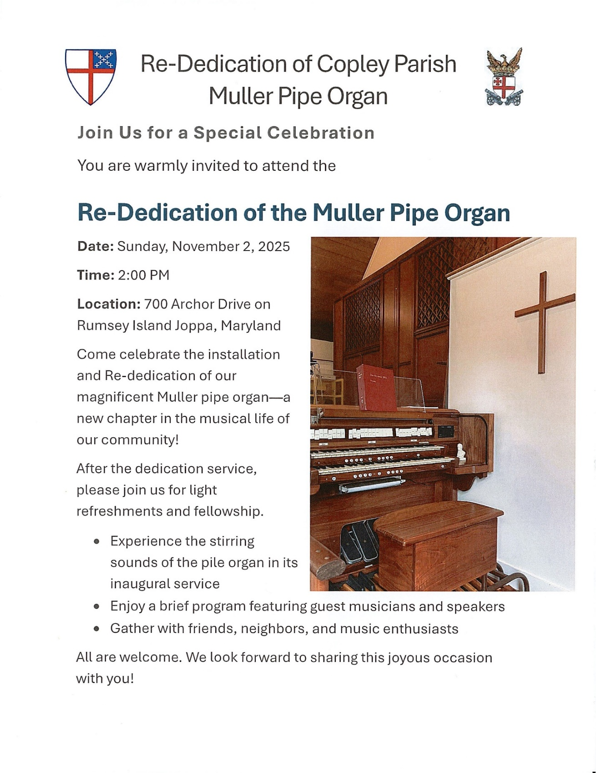

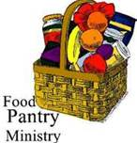
FOOD PANTRY
They could really use pasta sauce and canned corn right now.

What’s Happening This Week at St. John’s

Sunday, November 2nd—All Saints Sunday
8:00am: Holy Eucharist Rite I, Said Service (Church)
10:30am: Holy Eucharist Rite II, with Music (Church)
11:30am: Potluck (Parish Hall)
7:00pm: All Souls Service (Chapel)

Monday, November 3
12:00-1:00pm: AA Lunch Bunch (Parish Hall)
AA Big Book Meeting

Tuesday, November 4
12:00-1:00pm: AA Lunch Bunch (Parish Hall)

Wednesday, November 5
12:00-1:00pm: AA Lunch Bunch (Parish Hall)
7:00pm: Choir Rehearsal (Church)
7:30pm: AA (Parish Hall)

Thursday, November 6
9:00am-10:00am: Book Study (Parish Hall)
12:00-1:00pm: AA Lunch Bunch (Parish Hall)
7:00pm: AA (Parish Hall)

Friday, November 7
12:00-1:00pm: AA Lunch Bunch (Parish Hall)

Saturday, November 8
8:30pm: AA (Parish Hall)

Sunday, November 9—22nd Sunday after Pentecost
8:00am: Holy Eucharist Rite I, Said Service (Church)
10:30am: Holy Eucharist Rite II, with Music (Church)
11:45am: Bell Rehearsal (Church)
3:00pm: Spaghetti Dinner (Parish Hall)

Parish Office is open Monday and Thursday, 9:00am-2:00pm.
Potluck Luncheon on the first Sunday of the month and Coffee Hour on all other Sundays after the 10:30 service.

