St. John’s Episcopal Church
Kingsville, Maryland
Welcomes You

Our Mission Statement

We believe that together we will transform
the world with love: Come on in!



Third Sunday of Easter
May 4, 2025
10:30 am, Rite II

St. John’s Episcopal Church

11901 Belair Road, P. O. Box 187, Kingsville, MD 21087
Facebook: St. John’s Episcopal, Kingsville, MD
Email: office@stjohnskingsville.org
Website: www.stjohnskingsville.org
Church Phone: 410-592-8570
For Pastoral Emergencies: Fr. Mark Lobb+ 443-690-9545

Welcome to worship today! We are glad that you are with us. You are invited to participate in all parts of the service as indicated in the Book of Common Prayer and this service bulletin. If you have any questions, feel free to ask the ushers. Restrooms are located in the Parish hall, the brick building across the parking lot.

I was glad when they said to me, “Let us go to the house of the Lord.” Psalm 122:1

Church Staff

Priest in Charge: Father Mark Lobb
Administrative Assistant: Angie Bosley
Organist/Choir Director: Nancy Heinold

The Vestry

Class of 2026 Class of 2027

John Stevens John Frost
Jacob Johnson Stephanie White

Officers
Ty Schwenk—Sr. Warden Terry Roe—Jr. Warden
Elizabeth Healey—Treasurer Anne Leland-Registrar

Parish Committee Chairpersons

Altar Guild: Elizabeth Healey
Auxiliary Committee: Michele Lozanski
Cemetery Committee: Karen Smith-Manar

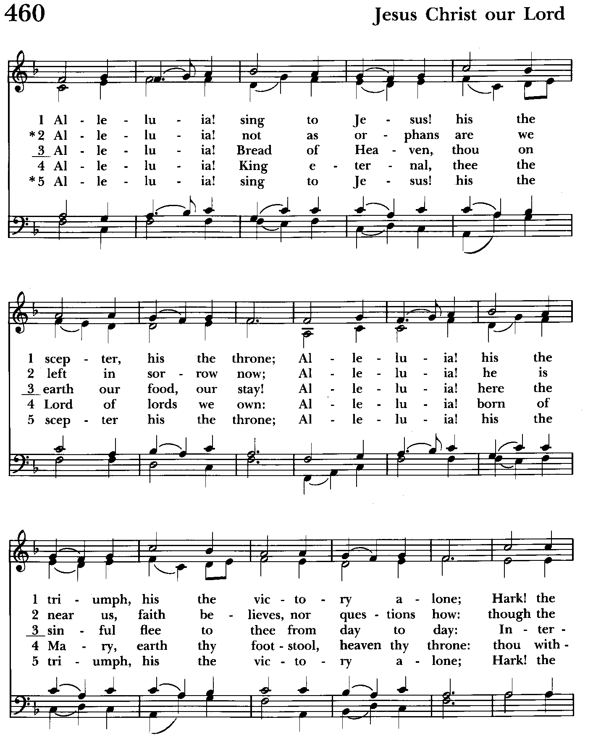

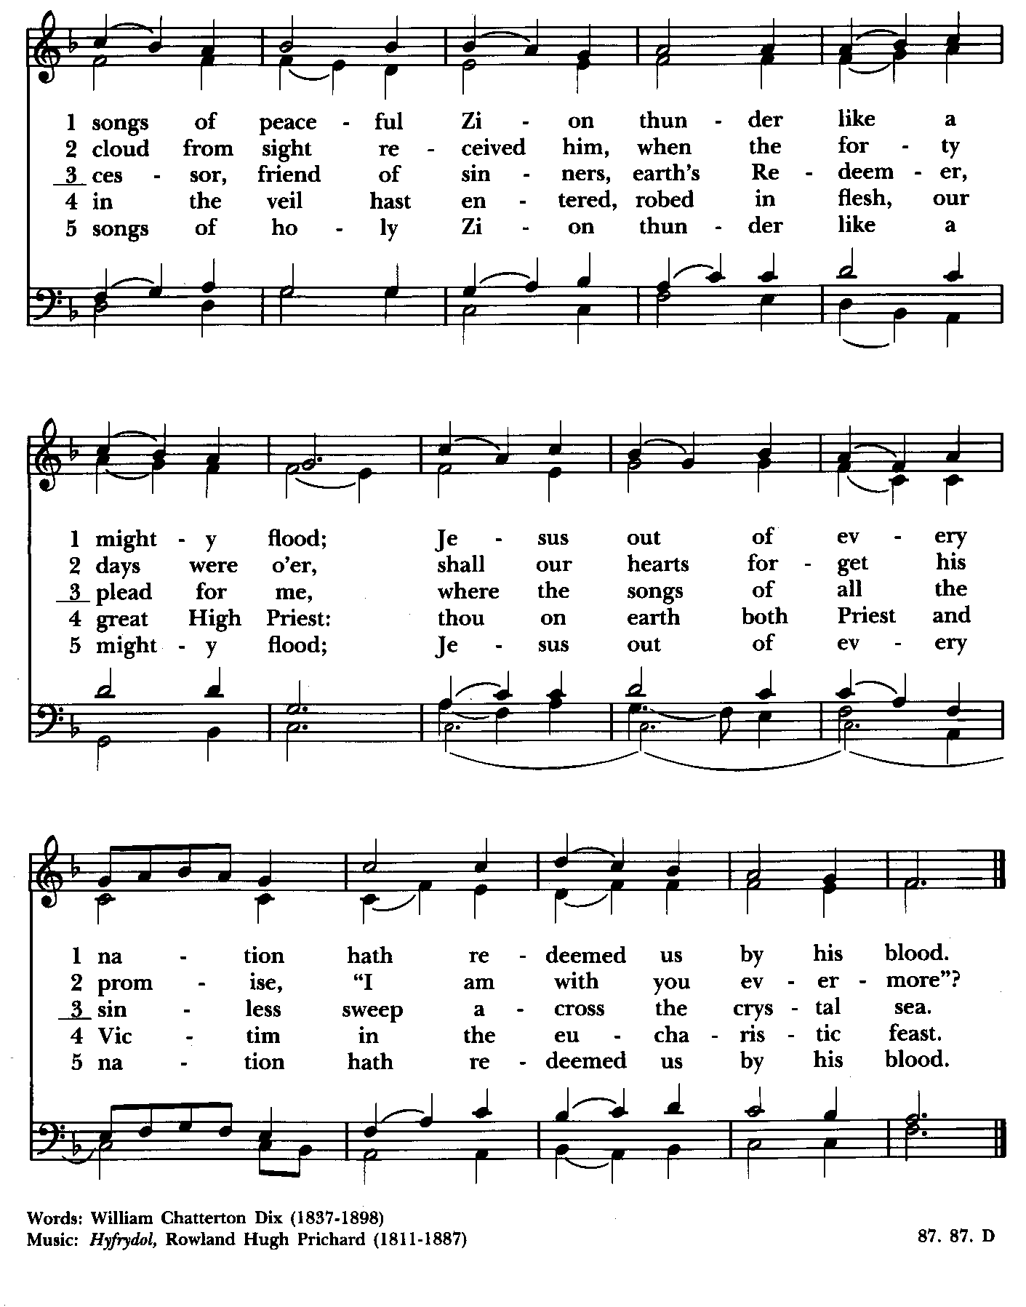

10:30 am Worship
The Holy Eucharist, Rite Two

Processional Hymn: Alleluia sing to Jesus Hymnal #460
(see previous 2 pages)

The Word of God

Celebrant: Alleluia Christ is risen.
People: The Lord is risen indeed. Alleluia.

Gloria Hymnal #S-278
Glory to God in the highest,
and peace to his people on earth.
Lord God, heavenly King,
almighty God and Father,
we worship you, we give you thanks,
we praise you for your glory.
Lord Jesus Christ, only Son of the Father,
Lord God, Lamb of God,
you take away the sin of the world:
have mercy on us;
you are seated at the right hand of the Father:
receive our prayer.
For you alone are the Holy One,
you alone are the Lord,
you alone are the Most High,
Jesus Christ,
with the Holy Spirit,
in the glory of God the Father. Amen.

The Collect of the Day BCP 224
O God, whose blessed Son made himself known to his disciples in the breaking of bread: Open the eyes of our faith, that we may behold him in all his redeeming work; who lives and reigns with you, in the unity of the Holy Spirit, one God, now and for ever. Amen.

The congregation is seated

A Reading from the Acts of the Apostles 9:1-6 (7-20)
Saul, still breathing threats and murder against the disciples of the Lord, went to the high priest and asked him for letters to the synagogues at Damascus, so that if he found any who belonged to the Way, men or women, he might bring them bound to Jerusalem. Now as he was going along and approaching Damascus, suddenly a light from heaven flashed around him. He fell to the ground and heard a voice saying to him, "Saul, Saul, why do you persecute me?" He asked, "Who are you, Lord?" The reply came, "I am Jesus, whom you are persecuting. But get up and enter the city, and you will be told what you are to do." [The men who were traveling with him stood speechless because they heard the voice but saw no one. Saul got up from the ground, and though his eyes were open, he could see nothing; so they led him by the hand and brought him into Damascus. For three days he was without sight, and neither ate nor drank.

Now there was a disciple in Damascus named Ananias. The Lord said to him in a vision, "Ananias." He answered, "Here I am, Lord." The Lord said to him, "Get up and go to the street called Straight, and at the house of Judas look for a man of Tarsus named Saul. At this moment he is praying, and he has seen in a vision a man named Ananias come in and lay his hands on him so that he might regain his sight." But Ananias answered, "Lord, I have heard from many about this man, how much evil he has done to your saints in Jerusalem; and here he has authority from the chief priests to bind all who invoke your name." But the Lord said to him, "Go, for he is an instrument whom I have chosen to bring my name before Gentiles and kings and before the people of Israel; I myself will show him how much he must suffer for the sake of my name." So Ananias went and entered the house. He laid his hands on Saul and said, "Brother Saul, the Lord Jesus, who appeared to you on your way here, has sent me so that you may regain your sight and be filled with the Holy Spirit." And immediately something like scales fell from his eyes, and his sight was restored. Then he got up and was baptized, and after taking some food, he regained his strength.

For several days he was with the disciples in Damascus, and immediately he began to proclaim Jesus in the synagogues, saying, "He is the Son of God."]

Reader: The Word of the Lord.
People: Thanks be to God.

Psalm 30 (Pray as directed) BCP 623
1 I will exalt you, O Lord,
because you have lifted me up *
and have not let my enemies triumph over me.
2 O Lord my God, I cried out to you, *
and you restored me to health.
3 You brought me up, O Lord, from the dead; *
you restored my life as I was going down to the grave.
4 Sing to the Lord, you servants of his; *
give thanks for the remembrance of his holiness.
5 For his wrath endures but the twinkling of an eye, *
his favor for a lifetime.
6 Weeping may spend the night, *
but joy comes in the morning.
7 While I felt secure, I said,
"I shall never be disturbed. *
You, Lord, with your favor, made me as strong as the mountains."
8 Then you hid your face, *
and I was filled with fear.
9 I cried to you, O Lord; *
I pleaded with the Lord, saying,
10 ”What profit is there in my blood, if I go down to the Pit? *
will the dust praise you or declare your faithfulness?
11 Hear, O Lord, and have mercy upon me; *
O Lord, be my helper."
12 You have turned my wailing into dancing; *
you have put off my sack-cloth and clothed me with joy.
13 Therefore my heart sings to you without ceasing; *
O Lord my God, I will give you thanks for ever.
I have said, "You are my God.
15 My times are in your hand; *
rescue me from the hand of my enemies,
and from those who persecute me.
16 Make your face to shine upon your servant, *
and in your loving-kindness save me."

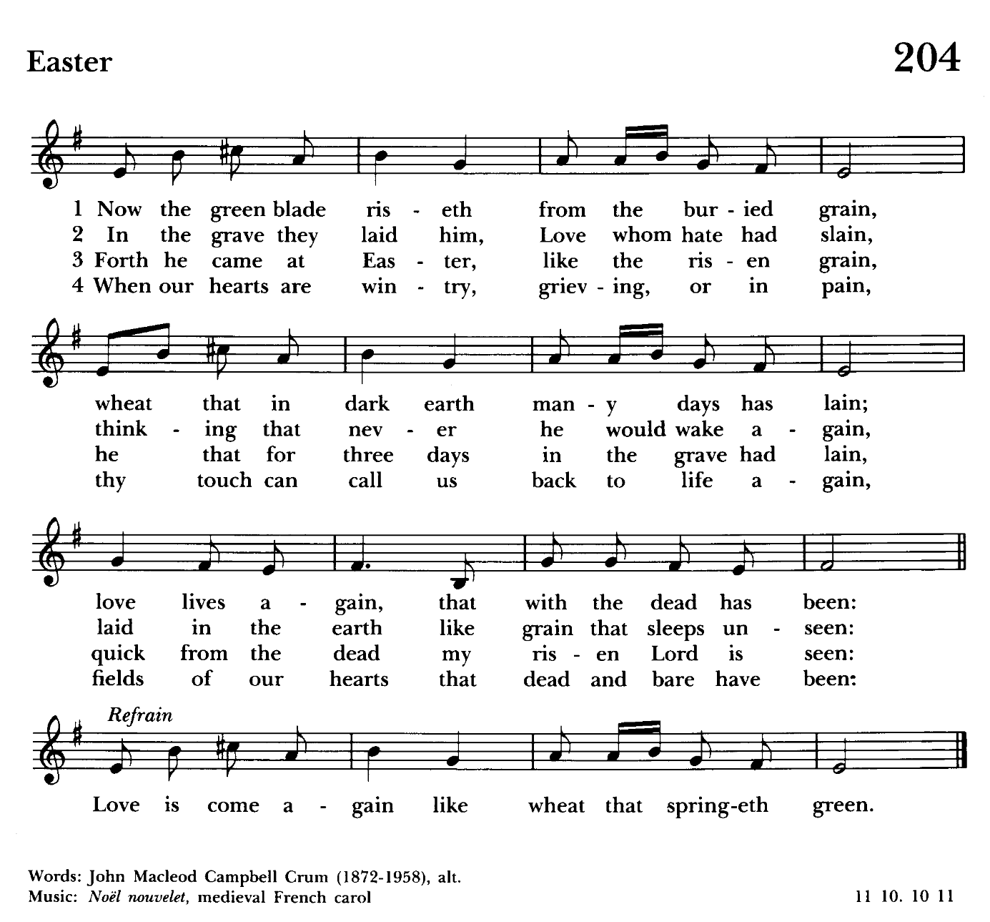

A Reading from the Book of Revelation 5:11-14
I looked, and I heard the voice of many angels surrounding the throne and the living creatures and the elders; they numbered myriads of myriads and thousands of thousands, singing with full voice,
"Worthy is the Lamb that was slaughtered
to receive power and wealth and wisdom and might
and honor and glory and blessing!"
Then I heard every creature in heaven and on earth and under the earth and in the sea, and all that is in them, singing,
"To the one seated on the throne and to the Lamb
be blessing and honor and glory and might forever and ever!"
And the four living creatures said, "Amen!" And the elders fell down and
worshiped.

Reader: The Word of the Lord.
People: Thanks be to God.

Gradual Hymn: Now the green blade riseth from the buried grain Hymnal #204
(see previous page)
The congregation remains standing

The Holy Gospel of Our Lord Jesus Christ according to John 21:1-19
People: Glory to you Lord Christ.
Jesus showed himself again to the disciples by the Sea of Tiberias; and he showed himself in this way. Gathered there together were Simon Peter, Thomas called the Twin, Nathanael of Cana in Galilee, the sons of Zebedee, and two others of his disciples. Simon Peter said to them, "I am going fishing." They said to him, "We will go with you." They went out and got into the boat, but that night they caught nothing.
Just after daybreak, Jesus stood on the beach; but the disciples did not know that it was Jesus. Jesus said to them, "Children, you have no fish, have you?" They answered him, "No." He said to them, "Cast the net to the right side of the boat, and you will find some." So they cast it, and now they were not able to haul it in because there were so many fish. That disciple whom Jesus loved said to Peter, "It is the Lord!" When Simon Peter heard that it was the Lord, he put on some clothes, for he was naked, and jumped into the sea. But the other disciples came in the boat, dragging the net full of fish, for they were not far from the land, only about a hundred yards off.
When they had gone ashore, they saw a charcoal fire there, with fish on it, and bread. Jesus said to them, "Bring some of the fish that you have just caught." So Simon Peter went aboard and hauled the net ashore, full of large fish, a hundred fifty-three of them; and though there were so many, the net was not torn. Jesus said to them, "Come and have breakfast." Now none of the disciples dared to ask him, "Who are you?" because they knew it was the Lord. Jesus came and took the bread and gave it to them, and did the same with the fish. This was now the third time that Jesus appeared to the disciples after he was raised from the dead.
When they had finished breakfast, Jesus said to Simon Peter, "Simon son of John, do you love me more than these?" He said to him, "Yes, Lord; you know that I love you." Jesus said to him, "Feed my lambs." A second time he said to him, "Simon son of John, do you love me?" He said to him, "Yes, Lord; you know that I love you." Jesus said to him, "Tend my sheep." He said to him the third time, "Simon son of John, do you love me?" Peter felt hurt because he said to him the third time, "Do you love me?" And he said to him, "Lord, you know everything; you know that I love you." Jesus said to him, "Feed my sheep. Very truly, I tell you, when you were younger, you used to fasten your own belt and to go wherever you wished. But when you grow old, you will stretch out your hands, and
someone else will fasten a belt around you and take you where you do not wish to go." (He said this to indicate the kind of death by which he would glorify God.) After this he said to him, "Follow me."

Celebrant: The Gospel of the Lord.
People: Praise to you, Lord Christ.

Sermon The people are seated Rev. Mark Lobb+

The Prayers of the People Form IV The people kneel or stand as able BCP 388
Litanist:: Let us pray for the Church and for the world. Grant, Almighty God, that all who confess your Name may be united in your truth, live together in your love, and reveal your glory in the world.

Silence

Litanist: Lord, in your mercy
People: Hear our prayer.

Litanist: Guide the people of this land, and of all the nations, in the ways of justice and peace; that we may honor one another and serve the common good.
Silence

Litanist: Lord, in your mercy
People: Hear our prayer.

Litanist: Give us all a reverence for the earth as your own creation, that we may use its resources rightly in the service of others and to your honor and glory.

Silence
Litanist: Lord, in your mercy
People: Hear our prayer.

Litanist: Bless all whose lives are closely linked with ours, and grant that we may serve Christ in them, and love one another as he loves us.

Silence

Litanist: Lord, in your mercy
People: Hear our prayer.

Litanist: Comfort and heal all those who suffer in body, mind, or spirit; give them courage and hope in their troubles, and bring them the joy of your salvation.

Silence

Litanist: Lord, in your mercy
People: Hear our prayer.

Litanist: We commend to your mercy all who have died, that your will for them may be fulfilled; and we pray that we may share with all your saints in your eternal kingdom.

Silence

Litanist: Lord, in your mercy
People: Hear our prayer.

For the leaders of all nations, especially for Donald, our President; for Wes, our Governor; for Brandon, Kathy and Bob, who lead our City and Counties. We pray for all children and youth; for the homeless, the unemployed, and the hungry. We pray for the safety of our loved ones and friends serving in the Armed Forces at home and abroad, and for our enemies, that all our hearts may be turned toward peace throughout the world.

Litanist: For the special needs and concerns of this congregation. Especially
remember in our prayers, DeMarino Family, Jim & Chris Carden and family,
Peggie Dietz, Mike Carden, Pat Carden, Gail Landers, Sheila Jones, Gloria Millar, Marisol Aubrey, Ross Strickler, Jim & Janice Sieracki, James Daniel Jr., Larry Betzler, Camy Schwenk, Dennis Mally, Zach Walsh, Lily John,
Barbara Miller, Nancy Barnhart, Robin Dilworth, Linda Posten, Bill Hoffman & Family, Deb Melcher, Emily Lobb, Bri Del Pilar, Paul Leamer,
Janine Stevens, Dawn Wilson, Family of Steven Rakas, Family of Joann Koch, Debra Sudano-Perouty, Phillip Harris, Chip Williams.

The People may add their own petitions

Litanist: Hear us, Lord;
People: For your mercy is great.
Litanist: We thank you, Lord, for all the blessings of this life.

The People may add their own thanksgivings

Litanist: We will exalt you, O God our King;
People: And praise your Name for ever and ever.

The People may add their own petitions

Celebrant: O Lord our God, accept the fervent prayers of your people; in the multitude of your mercies, look with compassion upon us and all who turn to you for help; for you are gracious, O lover of souls, and to you we give glory, Father, Son, and Holy Spirit, now and for ever. Amen.

The Peace Please stand as able BCP 360

Welcome & Announcements The congregation is seated

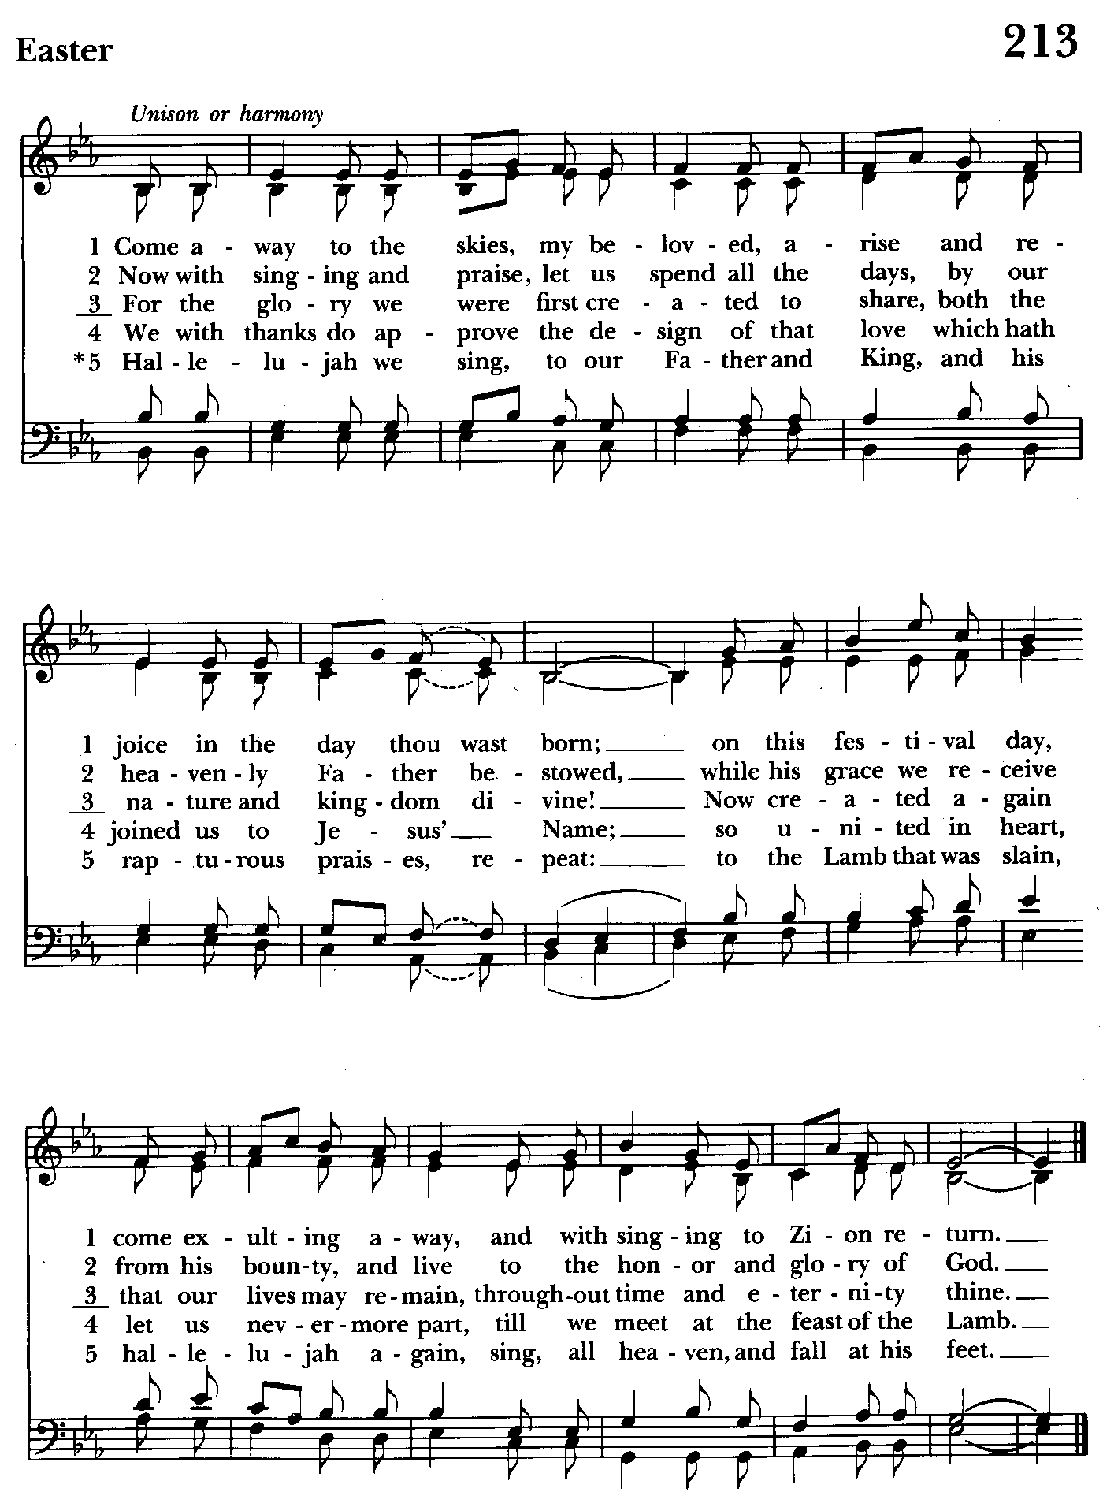

The Holy Communion
Offertory anthem: Lamb of God (Choir)
Offertory hymn: Come away to the skies Hymnal #213
(see previous page)
The congregation remains seated while the offering is collected

Doxology Please stand as able Hymnal #43, vs. 4
Praise God, from whom all blessings flow; praise him, all creatures here
below; praise him above, ye heavenly host: praise Father, Son and Holy Ghost.

THE GREAT THANKSGIVING: Eucharistic Prayer A BCP 361
Celebrant: The Lord be with you.
People: And also with you.
Celebrant: Lift up your hearts.
People: We lift them to the Lord.
Celebrant: Let us give thanks to the Lord our God.
People: It is right to give him thanks and praise.

Celebrant: It is right, and a good and joyful thing, always and everywhere to give thanks to you, Father Almighty, Creator of heaven and earth.
Celebrant: Therefore we praise you, joining our voices with Angels and
Archangels and with all the company of heaven, who for ever sing this hymn to proclaim the glory of your Name:

Sanctus Hymnal #S-124

Holy, holy, holy Lord, God of power and might,
heaven and earth are full of your glory.
Hosanna in the highest.
Blessed is he who comes in the name of the Lord.
Hosanna in the highest.

Please stand or kneel as able

Celebrant: Holy and gracious Father: In your infinite love you made us for
yourself; and, when we had fallen into sin and become subject to evil and death, you, in your mercy, sent Jesus Christ your only and eternal Son, to share our
human nature, to live and die as one of us, to reconcile us to you, the God and Father of all.

He stretched out his arms upon the cross, and offered himself, in obedience to your will, a perfect sacrifice for the whole world.

On the night he was handed over to suffering and death, our Lord Jesus Christ took bread; and when he had given thanks to you, he broke it, and gave it to his disciples, and said, “Take, eat: This is my Body, which is given for you. Do this for the remembrance of me.”

After supper he took the cup of wine; and when he had given thanks, he gave it to them, and said, “Drink this, all of you: This is my Blood of the new
Covenant, which is shed for you and for many for the forgiveness of sins.
Whenever you drink it, do this for the remembrance of me.”

Therefore we proclaim the mystery of faith:

Celebrant and People: Christ has died.
Christ is risen.
Christ will come again.

Celebrant: We celebrate the memorial of our redemption, O Father, in this
sacrifice of praise and thanksgiving. Recalling his death, resurrection, and
ascension, we offer you these gifts.

Sanctify them by your Holy Spirit to be for your people the Body and Blood of your Son, the holy food and drink of new and unending life in him. Sanctify us also that we may faithfully receive this holy Sacrament, and serve you in unity, constancy, and peace; and at the last day bring us with all your saints into the joy of your eternal kingdom.

All this we ask through your Son Jesus Christ. By him, and with him, and in him, in the unity of the Holy Spirit, all honor and glory is yours, Almighty Father, now and for ever. Amen.

And now as our Savior Christ has taught us, we are bold to say.

Our Father, who art in heaven,
hallowed be thy Name,
thy kingdom come,
thy will be done,
on earth as it is in heaven.
Give us this day our daily bread.
And forgive us our trespasses,
as we forgive those
who trespass against us.
And lead us not into temptation,
but deliver us from evil.
For thine is the kingdom,
and the power, and the glory,
for ever and ever. Amen.

Celebrant: Alleluia. Christ our Passover is sacrificed for us;
People: Therefore let us keep the feast. Alleluia

Fraction Anthem Agnus Dei S-161
Lamb of God, you take away the sins of the world: have mercy on us.
Lamb of God, you take away the sins of the world: have mercy on us.
Lamb of God, you take away the sins of the world: grant us peace.

Invitation to Communion
Celebrant: The Gifts of God for the People of God.

Communion Hymn: Shepherd of souls, refresh and bless Hymnal #343
(see next page)

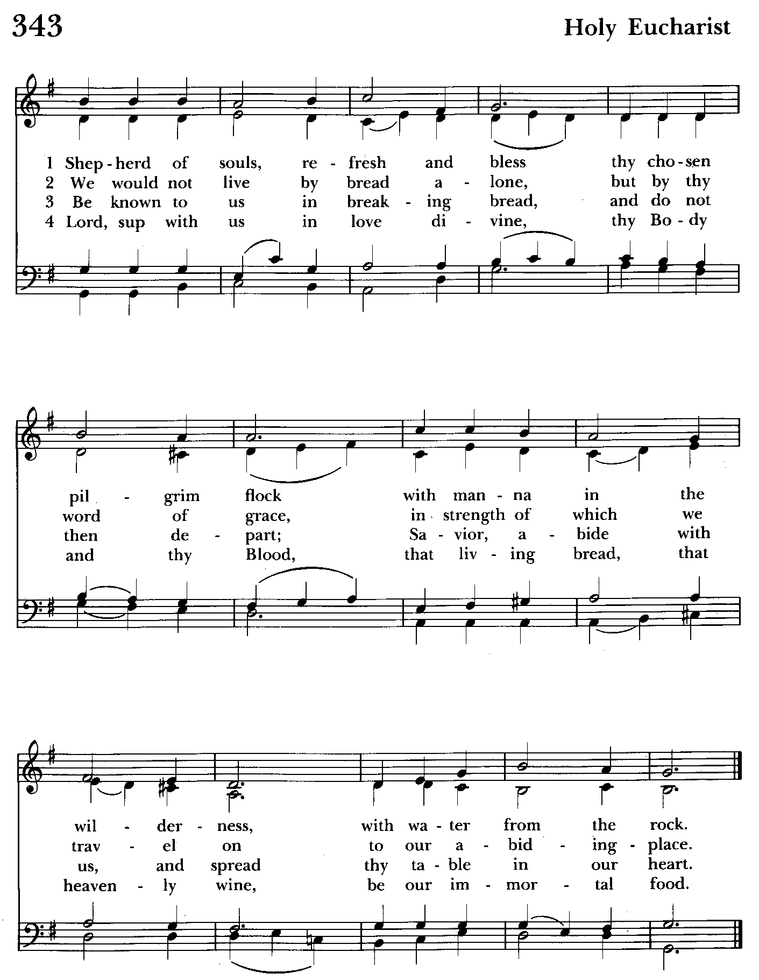

The Post Communion Prayer BCP 365
Eternal God, heavenly Father, you have graciously accepted us as living members of your Son our Savior Jesus Christ, and you have fed us with spiritual food in the Sacrament of his Body and Blood. Send us now into the world in peace, and grant us strength and courage to love and serve you with gladness and singleness of heart; through Christ our Lord. Amen.

The Solemn Prayer over the People
Almighty God, we pray you graciously to behold this your family, for whom our Lord Jesus Christ was willing to be betrayed, and given into the hands of
sinners, and to suffer death upon the cross; who lives and reigns for ever and
ever. Amen.

Closing Hymn: Ye servants of God, your Master proclaim Hymnal #535
(see next page)

The Dismissal BCP 366
Celebrant: Go in peace to love and serve the Lord. Alleluia, Alleluia.
People: Thanks be to God. Alleluia. Alleluia.

License #A-719154

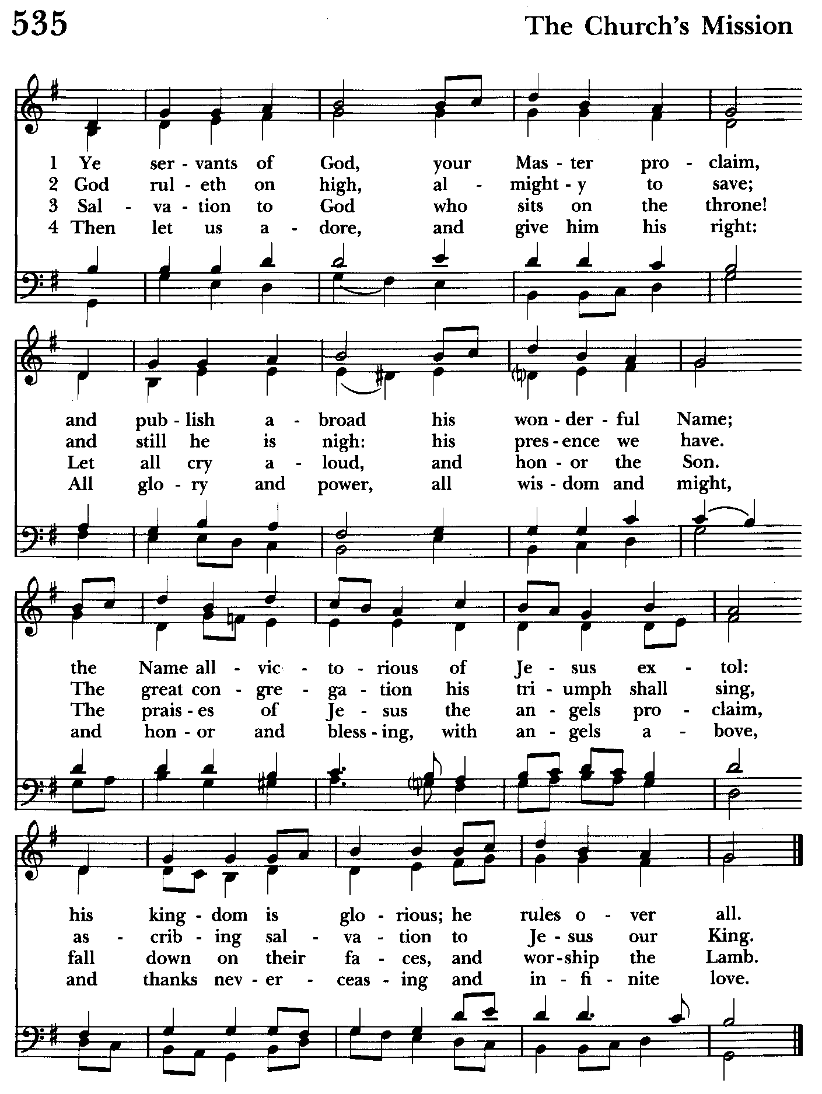

St. John’s Parish Prayer List

Additions and corrections may be made to our Parish Prayer List at any time. All names will be automatically removed from the Parish Prayer List on the 1st Sunday of each month unless you request otherwise. Please contact Angie at <office@stjohnskingsville.org> or 410-592-8570 in the church office with all changes by 10 am Thursdays. Thank you.

We Pray for Those in Need:
Names in BOLD read aloud by all.

DeMarino Family, Jim & Chris Carden and family, Peggie Dietz, Mike Carden, Pat Carden, Gail Landers, Sheila Jones, Gloria Millar, Marisol Aubrey, Ross Strickler, James Daniel Jr, Larry Betzler, Camy Schwenk, Dennis Mally, Zach Walsh, Linda Posten, Bill Hoffman & Family, Deb Melcher, Emily Lobb, Bri Del Pilar, Paul Leamer, Janine Stevens, Dawn Wilson, Family of
Steven Rakas, Family of Joann Koch, Debra Sudano-Perouty, Phillip Harris, Chip Williams.

We Pray for our Homebound

Lily John, Barbara Miller, Nancy Barnhart, Robin Dilworth

We pray for the Church and the World:

For +Sean, our Presiding Bishop; for +Carrie, our Bishop, for Mark+, our Priest in Charge, for the Wardens, Vestry, Staff, and all members and friends of St. John’s Church.

For the leaders of all nations, especially for Donald, our President; for Wes, our Governor; for Brandon, Kathy and Bob, who lead our City and Counties. We pray for all children and youth; for the homeless, the unemployed, and the hungry. We pray for the safety of our loved ones and friends serving in the Armed Forces at home and abroad, and for our enemies, that all our hearts may be turned toward peace throughout the world.

Serving Today:
Celebrant & Preacher: Rev. Mark Lobb+
Old Testament: Barbara Daniel
Psalm: John Frost
New Testament: Anne Leland
Prayers of the People: John Frost
Server: Marguerite Lobb
Organist/Choir Director: Nancy Heinold
Choir: Nancy Dellinger, Anne Leland,
Liz Healey, Ty Schwenk
Altar Guild: Stephanie Duchacek & Sandy Roe

Altar Flowers

Given to the Glory of God
by Frank & Stephanie Duchacek
in memory of Stephen Slitzer

From the Treasurer
April ‘25 Income vs. Expenses:

Projected April Expenses: $14,000
Monies Received as of 4/30: $19,016

Amount Needed to Meet Expenses: + $5,016

Projected May Expenses: $14,500


If you’d like to make a donation to St. John’s you can scan this QR code with your phone’s camera or tap on the link that comes up to make a contribution with either a credit or debit card, Apple Pay or Google Pay. This is a secure site provided by Clover which is a service of PNC Bank.


SUNDAY SCHOOL
10:30: Kids Sunday School- Begin in the church, ring the bell, then process over to the parish hall for a fun lesson with Mr. John and Ms. Stephanie.
Note: Please seriously consider regular attendance at Sunday School so that Mr. John and Ms. Stephanie can plan good stuff.


ChoiR
Choir rehearsal, Wednesdays at 7:00 pm

If anyone is interested in joining, see Nancy Heinold, our Choir Director.

We pray for birthdays this week

May 8 Susan Koch


God’s Grace Gardens
A collaboration of St. John’s, Hill and Stream Garden Club and AA is beginning an “Adopt-A-Garden” program for the various garden plots on St. John’s Campus.

So grab your gloves as 16 garden areas (some quite small) are up for “Adoption”. GGG will take care of shrub and tree trimming and provide mulch. Most gardens
only require weeding and mulching, not planting.

If you enjoy working with your hands, or just want to learn how to tend God’s good earth, see Karen or Anne.

Let’s make St. John’s campus a place of beauty and peace for the Kingsville community!

Wish List: Large watering cans.

God’s Grace Gardens is thankful for the generous donation of a wagon by a faithful parishioner!


FLEA MARKET!
On Saturday May 17th. from 8am to 1pm St. John’s will be hosting a community flea market. If you have any gently used items (no clothes), feel free to drop them off after 4/21/25 during office hours or on Sundays. If you know of anyone who might be interested in participating, invite them to contact the church for details. The office Number is 410-592-8570 email is office@stjohnskingsville.org

Calling all Bakers!
If you can, please bake cookies or brownies to sell at the flea market.
Please package 4 cookies to a bag and 2 brownies to a bag please label so we know what the item is and if it has nuts. They can be dropped off on Friday 5/16 after 1pm till 8pm. Best Cookies are Chocolate Chip.

Please consider signing up to help with the flea market event. Sign up sheets in the back of the church. Just give us a call and let us know if you are available, any time would be helpful. Michele 443-463-6333 or Angie 410-592-8570.

Barb Daniel would like help to set up after 2 on Friday 5/16 and the Day of the flea market. You can call Barb at 410-877-2962

Please let us know if you need a flyer for the event and we will send you one.




Yoga classes on the third Saturday of the month, 9 to 10 am in the Chapel. All experience levels are welcome.

Calendar Updates

May 13—Vestry Meeting, 7 pm
May 17—Flea Market, 8am-1pm

Calendars are living documents. Every effort will be made to keep the members of the parish and community aware of any changes.

What’s Happening This Week at St. John’s

Sunday, May 4—3rd Sunday of Easter
8:00am: Holy Eucharist Rite I, Said Service (Church)
10:30am: Holy Eucharist Rite II, with Music
11:30am: Potluck

Monday, May 5
12:00-1:00pm: AA Lunch Bunch (Parish Hall)

Tuesday, May 6
12:00-1:00pm: AA Lunch Bunch (Parish Hall)

Wednesday, May 7
12:00-1:00pm: AA Lunch Bunch (Parish Hall)
7:00-8:30pm: Choir Rehearsal (Church)
7:30pm: AA (Parish Hall)

Thursday, May 8
12:00-1:00pm: AA Lunch Bunch (Parish Hall)
7:00pm: AA (Parish Hall)

Friday, May 9
12:00-1:00pm: AA Lunch Bunch (Parish Hall)

Saturday, May 10
9:00am-10:00am: Yoga (Chapel)
8:30pm: AA (Parish Hall)

Sunday, May 11—4th Sunday of Easter—Mother’s Day
8:00am: Holy Eucharist Rite I, Said Service (Church)
10:30am: Holy Eucharist Rite II, with Music (Church)
11:30am: Coffee Hour

Parish Office is open Monday, Wednesday and Thursday, 9:30am-1:30pm.

Potluck Luncheon on the first Sunday of the month and a Coffee Hour on all other Sundays after the 10:30 service.

