St. John’s Episcopal Church
Kingsville, Maryland
Welcomes You

OUR VISION STATEMENT
We believe that together we will transform the world with love: Come on in!

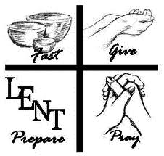

Fifth Sunday in Lent
April 6, 2025
10:30 am, Rite II

St. John’s Episcopal Church

11901 Belair Road, P. O. Box 187, Kingsville, MD 21087
Facebook: St. John’s Episcopal, Kingsville, MD
Email: office@stjohnskingsville.org
Website: www.stjohnskingsville.org
Church Phone: 410-592-8570
For Pastoral Emergencies: Fr. Mark Lobb+ 443-690-9545

Welcome to worship today! We are glad that you are with us. You are invited to participate in all parts of the service as indicated in the Book of Common Prayer and this service bulletin. If you have any questions, feel free to ask the ushers. Restrooms are located in the Parish hall, the brick building across the parking lot.

I was glad when they said to me, “Let us go to the house of the Lord.” Psalm 122:1

Church Staff

Priest in Charge: Father Mark Lobb
Administrative Assistant: Angie Bosley
Organist/Choir Director: Nancy Heinold

The Vestry

Class of 2026 Class of 2027

John Stevens John Frost
Jacob Johnson Stephanie White

Officers
Ty Schwenk—Sr. Warden Terry Roe—Jr. Warden
Elizabeth Healey—Treasurer Anne Leland-Registrar

Parish Committee Chairpersons

Altar Guild: Elizabeth Healey
Auxiliary Committee: Michele Lozanski
Cemetery Committee: Karen Smith-Manar

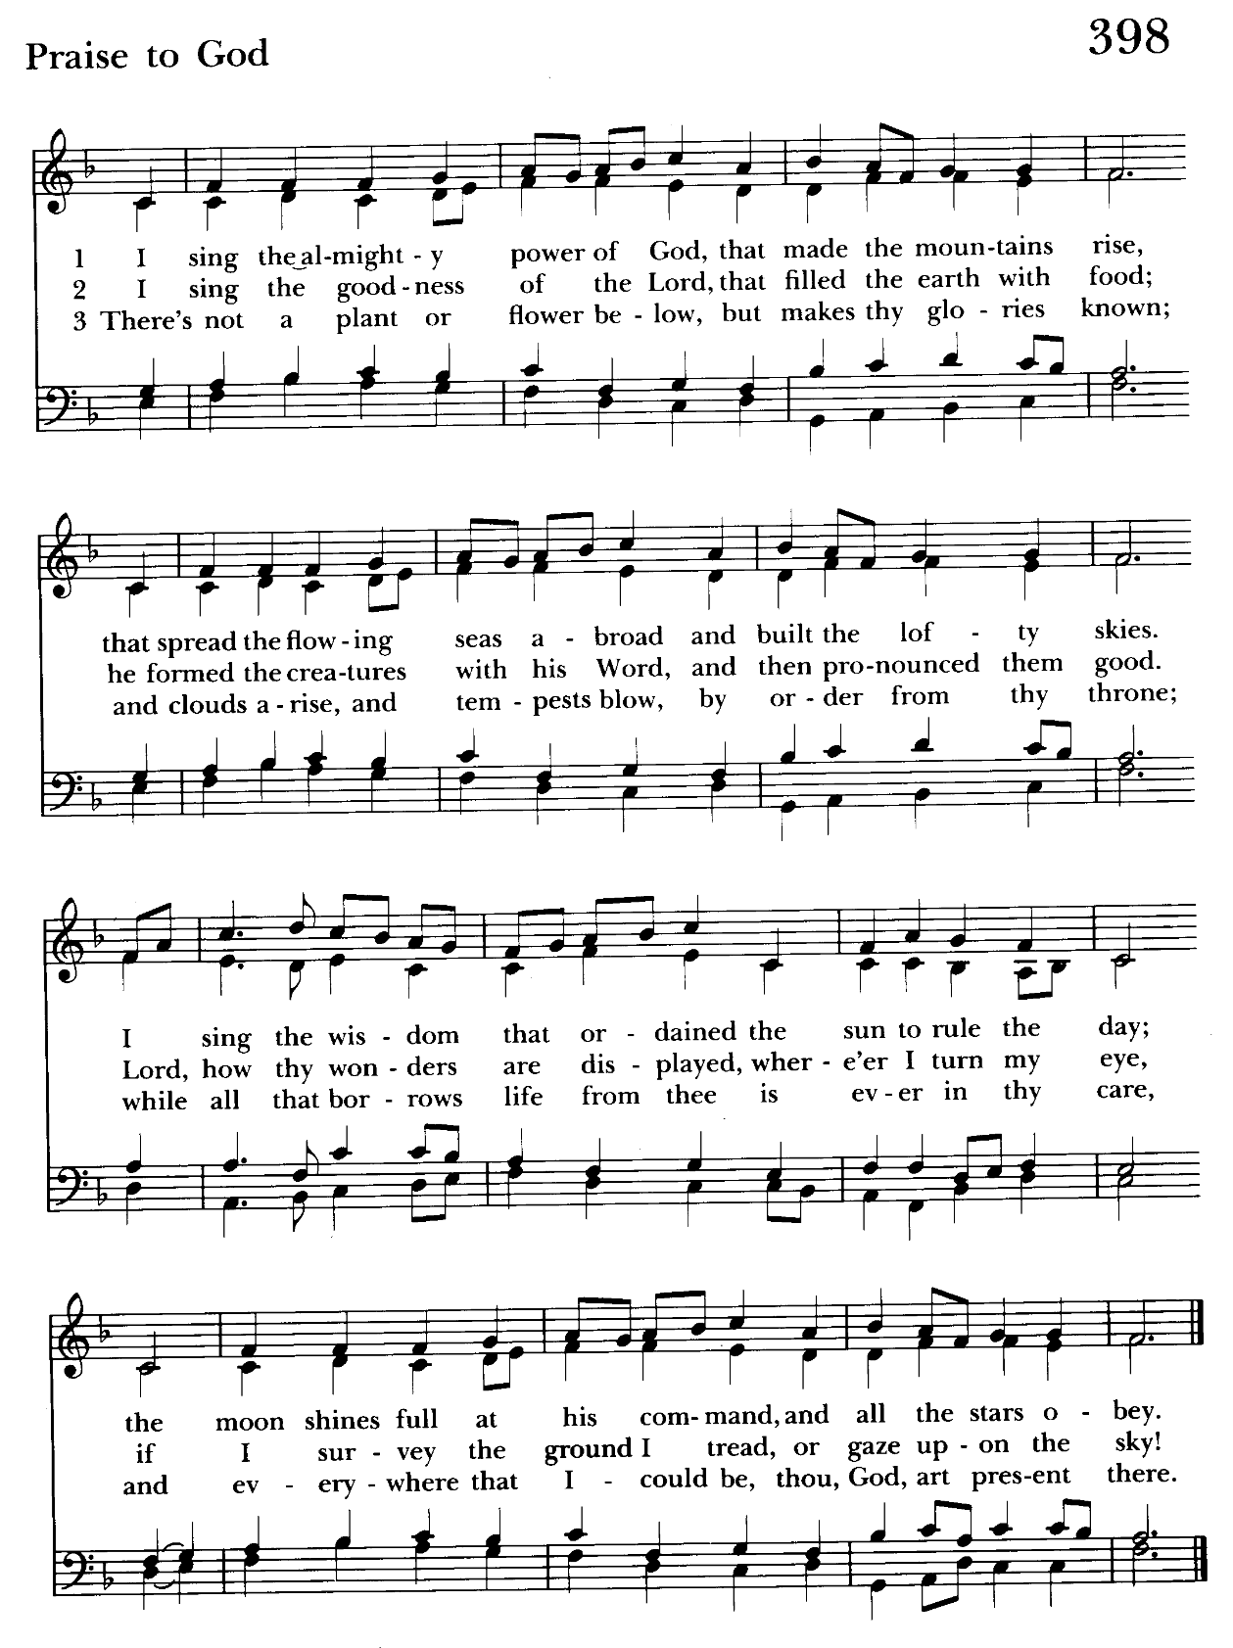

10:30 am Worship
Holy Eucharist, Rite Two

Prelude:
The Word of God

Processional hymn: I sing the almighty power of God Hymnal #398
(see previous page)

The congregation remains standing as able

Celebrant: Bless the Lord who forgives all our sins.
People: His mercy endures for ever.

The Decalogue Please kneel or stand as able BCP 350
Celebrant: Hear the commandments of God to his people: I am the Lord your God who brought you out of bondage. You shall have no other gods but me.
People: Amen. Lord have mercy.

Celebrant: You shall not make for yourself any idol.
People: Amen. Lord have mercy.

Celebrant: You shall not invoke with malice the Name of the Lord your God.
People: Amen. Lord have mercy.

Celebrant: Remember the Sabbath day and keep it holy.
People: Amen. Lord have mercy.

Celebrant: Honor your father and your mother.
People: Amen. Lord have mercy.

Celebrant: You shall not commit murder.
People: Amen. Lord have mercy.

Celebrant: You shall not commit adultery.
People: Amen. Lord have mercy.

Celebrant: You shall not steal.
People: Amen. Lord have mercy.

Celebrant: You shall not be a false witness.
People: Amen. Lord have mercy.

Celebrant: You shall not covet anything that belongs to your neighbor.
People: Amen. Lord have mercy.

A Penitential Order - Rite II BCP 352

Celebrant: If we say that we have no sin, we deceive ourselves, and the truth is not in us; but if we confess our sins, God is faithful and just to forgive us our sins, and to cleanse us from all unrighteousness. 1 John 1:8, 9

Let us confess our sins against God and our neighbor.

Celebrant and People: Most merciful God, we confess that we have sinned against you in thought, word, and deed, by what we have done, and by what we have left undone. We have not loved you with our whole heart; we have not loved our neighbors as ourselves. We are truly sorry and we humbly repent. For the sake of your Son Jesus Christ, have mercy on us and forgive us; that we may delight in your will, and walk in your ways, to the glory of your Name. Amen.

Celebrant: Almighty God have mercy on you, forgive you all your sins through our Lord Jesus Christ, strengthen you in all goodness, and by the power of the Holy Spirit keep you in eternal life. Amen.

Kyrie Eleison Hymnal #S-86
Kyrie eleison. Kyrie eleison. Kyrie eleison.
Christe eleison. Christe eleison. Christe eleison.
Kyrie eleison Kyrie eleison. Kyrie eleison..

Celebrant: The Lord be with you.
People: And also with you.
Celebrant: Let us pray.

The Collect of the Day BCP 219
Almighty God, you alone can bring into order the unruly wills and affections of sinners: Grant your people grace to love what you command and desire what you promise; that, among the swift and varied changes of the world, our hearts may surely there be fixed where true joys are to be found; through Jesus Christ our Lord, who lives and reigns with you and the Holy Spirit, one God, now and for ever.
Amen.

The congregation is seated.

A Reading from the Book of the Prophet Isaiah 43:16-21
Thus says the Lord, who makes a way in the sea, a path in the mighty waters, who brings out chariot and horse, army and warrior; they lie down, they cannot rise, they are extinguished, quenched like a wick: Do not remember the former things, or consider the things of old. I am about to do a new thing; now it springs forth, do you not perceive it? I will make a way in the wilderness and rivers in the desert.
The wild animals will honor me, the jackals and the ostriches; for I give water in the wilderness, rivers in the desert, to give drink to my chosen people, the people whom I formed for myself so that they might declare my praise.

Reader: The Word of the Lord.
People: Thanks be to God.

Psalm 126 (Pray as directed) BCP 782
1 When the Lord restored the fortunes of Zion, *
then were we like those who dream.
2 Then was our mouth filled with laughter, *
and our tongue with shouts of joy.
3 Then they said among the nations, *
"The Lord has done great things for them."
4 The Lord has done great things for us, *
and we are glad indeed.
5 Restore our fortunes, O Lord, *
like the watercourses of the Negev.
6 Those who sowed with tears *
will reap with songs of joy.
7 Those who go out weeping, carrying the seed, *
will come again with joy, shouldering their sheaves.

A Reading from the Letter of St. Paul to the Philippians 3:4b-14
If anyone else has reason to be confident in the flesh, I have more: circumcised on the eighth day, a member of the people of Israel, of the tribe of Benjamin, a Hebrew born of Hebrews; as to the law, a Pharisee; as to zeal, a persecutor of the church; as to righteousness under the law, blameless.
Yet whatever gains I had, these I have come to regard as loss because of Christ. More than that, I regard everything as loss because of the surpassing value of knowing Christ Jesus my Lord. For his sake I have suffered the loss of all things, and I regard them as rubbish, in order that I may gain Christ and be found in him, not having a righteousness of my own that comes from the law, but one that comes through faith in Christ, the righteousness from God based on faith. I want to know Christ and the power of his resurrection and the sharing of his sufferings by becoming like him in his death, if somehow I may attain the resurrection from the dead.
Not that I have already obtained this or have already reached the goal; but I press on to make it my own, because Christ Jesus has made me his own. Beloved, I do not consider that I have made it my own; but this one thing I do: forgetting what lies behind and straining forward to what lies ahead, I press on toward the goal for the prize of the heavenly call of God in Christ Jesus.

Reader: The Word of the Lord.
People: Thanks be to God.

Gradual hymn: When I survey the wondrous cross Hymnal #474
(see next page)

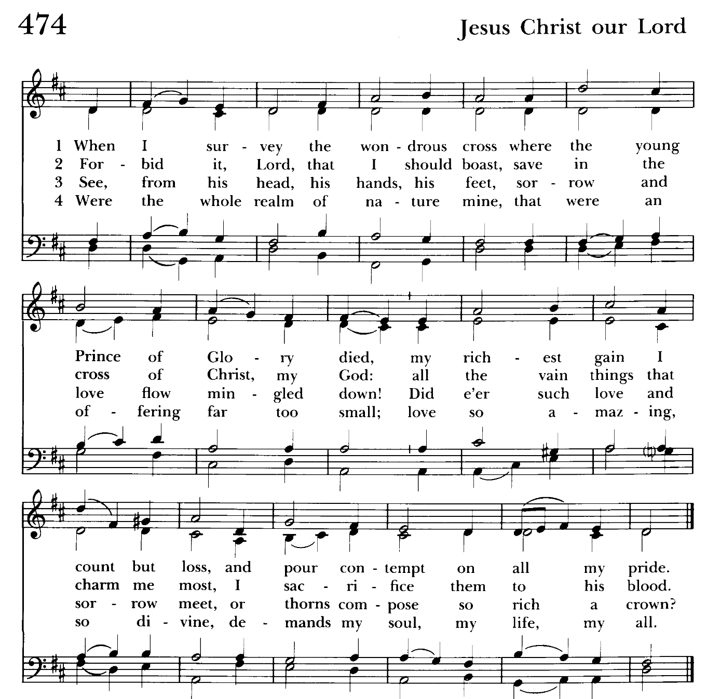

The congregation remains standing as able
The Gospel
Priest: The Holy Gospel of our Lord Jesus Christ according to John 12:1-8
People: Glory to you, Lord Christ.
Six days before the Passover Jesus came to Bethany, the home of Lazarus, whom he had raised from the dead. There they gave a dinner for him. Martha served, and Lazarus was one of those at the table with him. Mary took a pound of costly perfume made of pure nard, anointed Jesus' feet, and wiped them with her hair. The house was filled with the fragrance of the perfume. But Judas Iscariot, one of his disciples (the one who was about to betray him), said, "Why was this perfume not sold for three hundred denarii and the money given to the poor?" (He said this not because he cared about the poor, but because he was a thief; he kept the common purse and used to steal what was put into it.) Jesus said, "Leave her alone. She bought it so that she might keep it for the day of my burial. You always have the poor with you, but you do not always have me."

Priest: The Gospel of the Lord.
People: Praise to you, Lord Christ.

Sermon The congregation is seated Rev. Mark Lobb

The Nicene Creed Please stand as able BCP 358
We believe in one God,
the Father, the Almighty,
maker of heaven and earth,
of all that is, seen and unseen.
We believe in one Lord, Jesus Christ,
the only Son of God,
eternally begotten of the Father,
God from God, Light from Light,
true God from true God,
begotten, not made,
of one Being with the Father.
Through him all things were made.
For us and for our salvation
he came down from heaven:
by the power of the Holy Spirit
he became incarnate from the Virgin Mary,
and was made man.
For our sake he was crucified under Pontius Pilate;
he suffered death and was buried.
On the third day he rose again
in accordance with the Scriptures;
he ascended into heaven
and is seated at the right hand of the Father.
He will come again in glory to judge the living and the dead,
and his kingdom will have no end.
We believe in the Holy Spirit, the Lord, the giver of life,
who proceeds from the Father and the Son.
With the Father and the Son he is worshiped and glorified.
He has spoken through the Prophets.
We believe in one holy catholic and apostolic Church.
We acknowledge one baptism for the forgiveness of sins.
We look for the resurrection of the dead,
and the life of the world to come. Amen.

The Prayers of the People Form IV Kneel or stand as able BCP 388
Litanist:: Let us pray for the Church and for the world. Grant, Almighty God, that all who confess your Name may be united in your truth, live together in your love, and reveal your glory in the world.

Silence

Litanist: Lord, in your mercy
People: Hear our prayer.

Litanist: Guide the people of this land, and of all the nations, in the ways of justice and peace; that we may honor one another and serve the common good.

Silence

Litanist: Lord, in your mercy
People: Hear our prayer.

Litanist: Give us all a reverence for the earth as your own creation, that we may use its resources rightly in the service of others and to your honor and glory.

Silence
Litanist: Lord, in your mercy
People: Hear our prayer.

Litanist: Bless all whose lives are closely linked with ours, and grant that we may serve Christ in them, and love one another as he loves us.

Silence

Litanist: Lord, in your mercy
People: Hear our prayer.

Litanist: Comfort and heal all those who suffer in body, mind, or spirit; give them courage and hope in their troubles, and bring them the joy of your salvation.

Silence

Litanist: Lord, in your mercy
People: Hear our prayer.

Litanist: We commend to your mercy all who have died, that your will for them may be fulfilled; and we pray that we may share with all your saints in your eternal kingdom.

Silence

Litanist: Lord, in your mercy
People: Hear our prayer.

For the leaders of all nations, especially for Donald, our President; for Wes, our Governor; for Brandon, Kathy and Bob, who lead our City and Counties. We pray for all children and youth; for the homeless, the unemployed, and the hungry. We pray for the safety of our loved ones and friends serving in the Armed Forces at home and abroad, and for our enemies, that all our hearts may be turned toward peace throughout the world.

Litanist: For the special needs and concerns of this congregation. Especially remember in our prayers, DeMarino Family, Jim & Chris Carden and family, Peggie Dietz, Mike Carden, Pat Carden, Gail Landers, Sheila Jones, Gloria Millar, Marisol Aubrey, Ross Strickler, Jim & Janice Sieracki, James Daniel Jr., Larry Betzler, Camy Schwenk, Dennis Mally, Zach Walsh, Lily John, Barbara Miller, Nancy Barnhart, Robin Dilworth, Eileen Weimer, David Harris, Linda Posten, Bill Hoffman & Family, Deb Melcher, Emily Lobb, Bri Del Pilar, Paul Leamer, Janine Stevens.

The People may add their own petitions

Litanist: Hear us, Lord;
People: For your mercy is great.
Litanist: We thank you, Lord, for all the blessings of this life.

The People may add their own thanksgivings

We give thanks for the upcoming marriage of Matthew Johnson and Rachel Thompson.

Litanist: We will exalt you, O God our King;
People: And praise your Name for ever and ever.

The People may add their own petitions

Celebrant: O Lord our God, accept the fervent prayers of your people; in the multitude of your mercies, look with compassion upon us and all who turn to you for help; for you are gracious, O lover of souls, and to you we give glory, Father, Son, and Holy Spirit, now and for ever. Amen.

The Peace Please stand as able BCP 360

Welcome & Announcements The congregation is seated.

Offertory Anthem: At the Cross (Choir)

The people remain seated while offerings are collected.

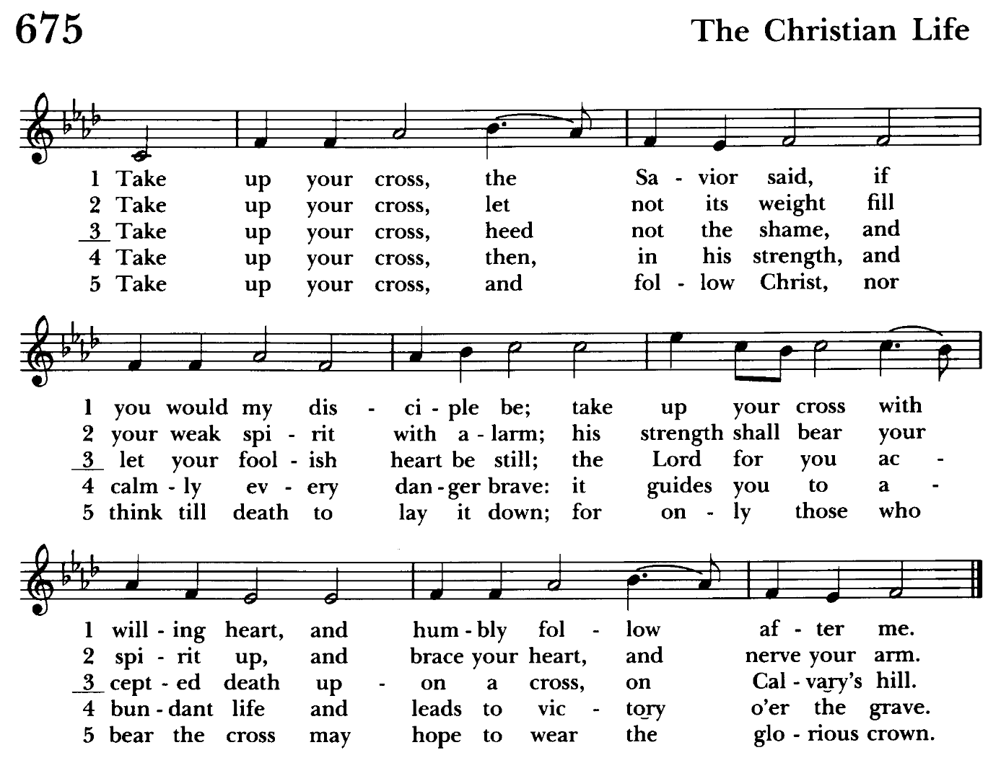

Presentation Hymn Offerings are presented Please stand as able Hymnal #43, vs. 4

Praise God, from whom all blessings flow; praise him, all creatures here below; praise him above, ye heavenly host: praise Father, Son, and Holy Ghost.

Offertory hymn: Take up your cross, the Savior said Hymnal #675
(see above)

The Holy Communion

THE GREAT THANKSGIVING: Eucharistic Prayer A BCP 361
The people remain standing.
Celebrant: The Lord be with you.
People: And also with you.
Celebrant: Lift up your hearts.
People: We lift them to the Lord.
Celebrant: Let us give thanks to the Lord our God.
People: It is right to give him thanks and praise.

Celebrant: It is right, and a good and joyful thing, always and everywhere to give thanks to you, Father Almighty, Creator of heaven and earth.

Therefore we praise you, joining our voices with Angels and Archangels and with all the company of heaven, who for ever sing this hymn to proclaim the glory of your Name:

Celebrant and People
Holy, holy, holy Lord, God of power and might, Hymnal #S-124
heaven and earth are full of your glory.
Hosanna in the highest. Hosanna in the highest.
Blessed is he who comes in the name of the Lord.
Hosanna in the highest. Hosanna in the highest.

The people stand or kneel.
Celebrant: Holy and gracious Father: In your infinite love you made us for yourself; and, when we had fallen into sin and become subject to evil and death, you, in your mercy, sent Jesus Christ, your only and eternal Son, to share our human nature, to live and die as one of us, to reconcile us to you, the God and Father of all. He stretched out his arms upon the cross, and offered himself in obedience to your will, a perfect sacrifice for the whole world.
On the night he was handed over to suffering and death, our Lord Jesus Christ took bread; and when he had given thanks to you, he broke it, and gave it to his disciples, and said, “Take, eat: This is my Body, which is given for you. Do this for the remembrance of me.”

After supper he took the cup of wine; and when he had given thanks, he gave it to them, and said, “Drink this, all of you: This is my Blood of the new Covenant, which is shed for you and for many for the forgiveness of sins. Whenever you drink it, do this for the remembrance of me.”

Therefore we proclaim the mystery of faith:

Celebrant and People
Christ has died.
Christ is risen.
Christ will come again.

Celebrant: We celebrate the memorial of our redemption, O Father, in this sacrifice of praise and thanksgiving. Recalling his death, resurrection, and ascension, we
offer you these gifts.

Sanctify them by your Holy Spirit to be for your people the Body and Blood of your Son, the holy food and drink of new and unending life in him. Sanctify us also that we may faithfully receive this holy Sacrament, and serve you in unity, constancy, and peace; and at the last day bring us with all your saints into the joy of your eternal kingdom.

All this we ask through your Son Jesus Christ. By him, and with him, and in him, in the unity of the Holy Spirit all honor and glory is yours,
Almighty Father, now and for ever. Amen.

And now, as our Savior As our Savior Christ has taught us, we are bold to say,
Celebrant and People
Our Father, who art in heaven, Our Father in heaven,
hallowed be thy Name, hallowed be your Name,
thy kingdom come, your kingdom come,
thy will be done, your will be done,
on earth as it is in heaven. on earth as in heaven.
Give us this day our daily bread. Give us today our daily bread.
And forgive us our trespasses, Forgive us our sins
as we forgive those as we forgive those
who trespass against us. who sin against us.
And lead us not into temptation, Save us from the time of trial,
but deliver us from evil. and deliver us from evil.
For thine is the kingdom, For the kingdom, the power,
and the power, and the glory, and the glory are yours,
for ever and ever. Amen. now and for ever. Amen.

The Breaking of the Bread
Celebrant: Christ our Passover is sacrificed for us;
People: Therefore let us keep the feast.

Celebrant: The Gifts of God for the People of God.
The Body (Blood) of our Lord Jesus Christ keep you in everlasting life. Amen.

Communion hymn: Jesus, all my gladness Hymnal #701
(see next page)

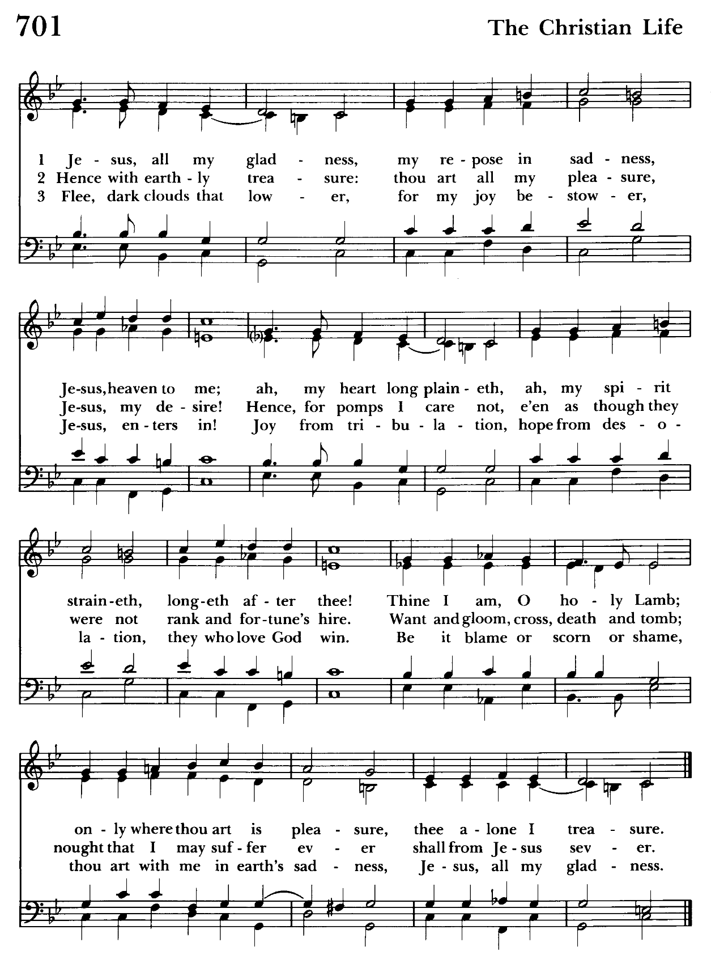

Post Communion Prayer BCP 365
Let us pray.

Celebrant and People
Eternal God, heavenly Father, you have graciously accepted us as living members of your Son our Savior Jesus Christ, and you have fed us with spiritual food in the Sacrament of his Body and Blood. Send us now into the world in peace, and grant us strength and courage to love and serve you with gladness and singleness of heart; through Christ our Lord. Amen.

Recessional hymn: In the cross of Christ I glory Hymnal #441
(see below)

The Dismissal
Celebrant: Go in peace to love and serve the Lord.
People: Thanks be to God.

Postlude:

License #A-719154

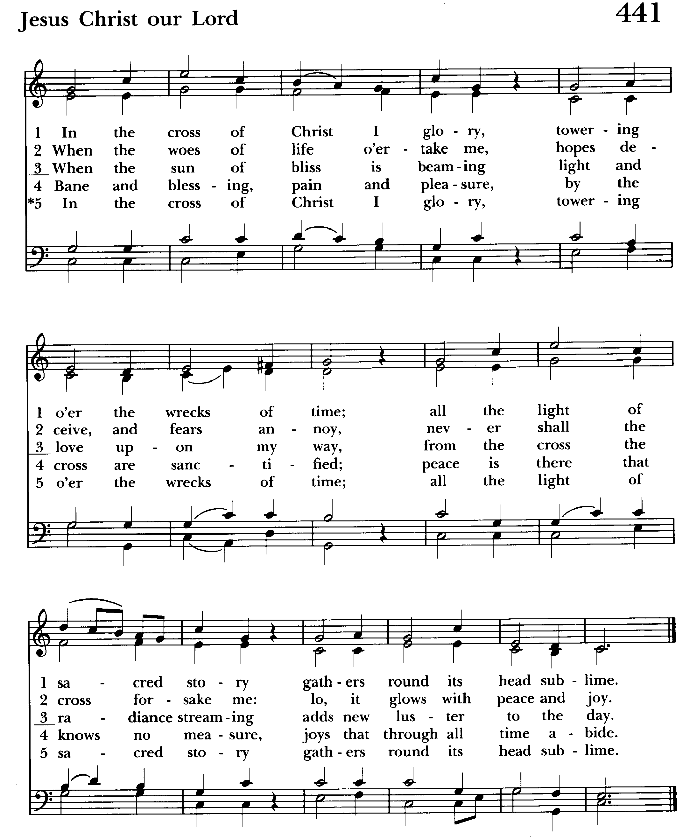

Serving Today

Celebrant and Preacher: Rev. Mark Lobb
Old Testament: Barb Daniel
Psalm: John Frost
New Testament: Anne Leland
Prayers of the People: John Frost
Server: Terry Roe
Music Director: Nancy Heinold
Choir: Anne Leland, Nancy Dellinger, Liz Healey,
Karen Smith-Manar, Ty Schwenk,
Altar Guild: Liz Healey & Marguerite Lobb

St. John’s Parish Prayer List

Additions and corrections may be made to our Parish Prayer List at any time. All names will be automatically removed from the Parish Prayer List on the 1st Sunday of each month unless you request otherwise. Please contact Angie at <office@stjohnskingsville.org> or 410-592-8570 in the church office with all changes by 10 am Thursdays. Thank you.

We Pray for Those in Need:
Names in BOLD read aloud by all.

DeMarino Family, Jim & Chris Carden and family, Peggie Dietz, Mike Carden, Pat Carden, Gail Landers, Sheila Jones, Gloria Millar, Marisol Aubrey, Ross Strickler, Jim and Janice Sieracki, James Daniel Jr, Larry Betzler, Camy Schwenk, Dennis Mally, Zach Walsh, Eileen Weimer, David Harris, Linda Posten, Bill Hoffman & Family, Deb Melcher, Emily Lobb, Bri Del Pilar, Paul Leamer, Janine Stevens.

We Pray for our Homebound

Lily John, Barbara Miller, Nancy Barnhart, Robin Dilworth

We pray for the Church and the World:

For +Sean, our Presiding Bishop; for +Carrie, our Bishop, for Mark+, our Priest in Charge, for the Wardens, Vestry, Staff, and all members and friends of St. John’s Church.

For the leaders of all nations, especially for Donald, our President; for Wes, our Governor; for Brandon, Kathy and Bob, who lead our City and Counties. We pray for all children and youth; for the homeless, the unemployed, and the hungry. We pray for the safety of our loved ones and friends serving in the Armed Forces at home and abroad, and for our enemies, that all our hearts may be turned toward peace throughout the world.

From the Treasurer
March ‘25 Income vs. Expenses:
Projected March Expenses: $15,000
Monies Received as of 3/31: $20,183
Amount Needed to Meet Expenses: $0
THANK YOU!

If you’d like to make a donation to St. John’s you can scan this QR code with your phone’s camera or tap on the link that comes up to make a contribution with either a credit or debit card, Apple Pay or Google Pay. This is a secure site provided by Clover which is a service of PNC Bank.


POTLUCK
Today after the 10:30 service.
Bring a dish to share.

Calendar Updates

April 8 – Vestry Meeting, moved to this night, will evaluate based on volume of business
April 13 - Palm Sunday, 8 & 10:30 services
April 17 - Maundy Thursday, 7 pm service
April 18 - Good Friday Crosswalk, 1 pm
All are welcome to join the Kingsville/Upper Falls area churches for our annual Community Crosswalk. Walk begins at Franklinville Presbyterian Church (11846 Franklinville Rd, Kingsville) proceeds along Franklinville Rd to Bradshaw Rd.
Parking is available at Salem UMC, 7901 Bradshaw Rd or St. Stephen, 8030 Bradshaw Rd.
April 18 - Good Friday , 7 pm service
April 20 - Easter Sunday, 8 & 10:30 services

Calendars are living documents. Every effort will be made to keep the members of the parish and community aware of any changes.

God’s Grace Gardens

A collaboration of St. John’s, Hill and Stream Garden Club and AA is beginning an “Adopt-A-Garden” program for the various garden plots on St. John’s Campus.

So grab your gloves as 16 garden areas (some quite small) are up for “Adoption”. GGG will take care of shrub and tree trimming and provide mulch. Most gardens
only require weeding and mulching, not planting.

If you enjoy working with your hands, or just want to learn how to tend God’s good earth, see Karen or Anne.

Let’s make St. John’s campus a place of beauty and peace for the Kingsville community!


Choir
Choir rehearsals Wednesdays at 7:00. If anyone is interested in joining, see Nancy Heinold, our Choir Director.

SUNDAY SCHOOL

10:30: Kids Sunday School- Begin in the church, ring the bell, then process over to the parish hall for a fun lesson with Mr. John and Ms. Stephanie.
Note: Please seriously consider regular attendance at Sunday School so that Mr. John and Ms. Stephanie can plan good stuff.

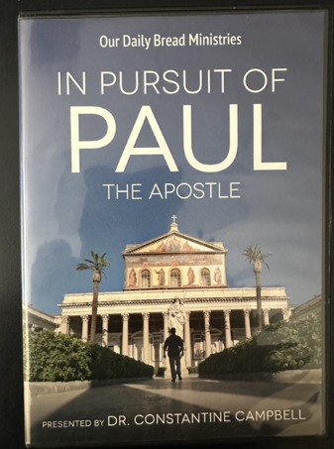
Friday Nights in Lent

Friday nights in Lent have been a good time, however Fr. Mark is asking that if you plan to attend that you RSVP by end of business the Thursday before.

After a light supper and fellowship at 6:30, we will view this contemporary look at the travels of St. Paul. Begins Friday March 7.

Let Us Bake Bread Together!

If you are interested in serving the St. John’s
community with a new Lenten opportunity, join us in baking unleavened bread for our communion service.

No experience necessary! We will provide the recipe and ingredients for our Baking Fellowship get togethers in the Parish Hall Kitchen. You can also bake at home if you prefer.

Contact Karen at (410) 746-9813 to arrange a time that’s
convenient for you.

Then we will

“Break Bread Together on our Knees!”

Yoga classes on Saturday mornings 9 to 10 am in the Chapel. All experience levels are welcome.


RECYCLING!

Our recycling can is getting dry and lonely. Please send him a friend.

In our Community
Bible Studies in our area. If interested, please contact these churches to confirm.
St. Mary’s, Abingdon, (410)569-0180- Wednesdays at noon. Bring lunch. Zoom available.
Emmanuel, Bel Air, (410)838-7699- Fridays at 9:30- Zoom Available.
Holy Trinity, Churchville, (410)914-5531- Wednesdays 11:30- Zoom may be available.

What’s Happening This Week at St. John’s

Sunday, April 6—5th Sunday in Lent
8:00am: Holy Eucharist Rite I, Said Service (Church)
10:30am: Holy Eucharist Rite II, with Music (Church)
11:30am: Coffee Hour

Monday, April 7
12:00-1:00pm: AA Lunch Bunch (Parish Hall)

Tuesday, April 8
12:00-1:00pm: AA Lunch Bunch (Parish Hall)

Wednesday, April 9
12:00-1:00pm: AA Lunch Bunch (Parish Hall)
7:00-8:30pm: Choir Rehearsal (Church)
7:30pm: AA (Parish Hall)

Thursday, April 10
12:00-1:00pm: AA Lunch Bunch (Parish Hall)
7:00pm: AA (Parish Hall)

Friday, April 11
12:00-1:00pm: AA Lunch Bunch (Parish Hall)
6:30pm: Friday Nights in Lent with Light Supper

Saturday, April 12
9:00am-10:00am: Yoga (Chapel)
8:30pm: AA (Parish Hall)

Sunday, April 13—Palm Sunday
8:00am: Holy Eucharist Rite I, Said Service (Church)
10:30am: Holy Eucharist Rite II, with Music (begins in Parish Hall)
11:30am: Coffee Hour

Parish Office is open Monday, Wednesday and Thursday, 9:30am-1:30pm.

Potluck Luncheon on the first Sunday of the month and a Coffee Hour on all other Sundays after the 10:30 service.

