St. John’s Episcopal Church
Kingsville, Maryland
Welcomes You

OUR VISION STATEMENT
We believe that together we will transform the world with love: Come on in!


Christ is
Risen
Indeed!
Alleluia!

Easter Sunday
April 20, 2025
10:30 am, Rite II

St. John’s Episcopal Church

11901 Belair Road, P. O. Box 187, Kingsville, MD 21087
Facebook: St. John’s Episcopal, Kingsville, MD
Email: office@stjohnskingsville.org
Website: www.stjohnskingsville.org
Church Phone: 410-592-8570
For Pastoral Emergencies: Fr. Mark Lobb+ 443-690-9545

Welcome to worship today! We are glad that you are with us. You are invited to participate in all parts of the service as indicated in the Book of Common Prayer and this service bulletin. If you have any questions, feel free to ask the ushers. Restrooms are located in the Parish hall, the brick building across the parking lot.

I was glad when they said to me, “Let us go to the house of the Lord.” Psalm 122:1

Church Staff

Interim Rector: Father Mark Lobb
Administrative Assistant: Angie Bosley
Organist/Choir Director: Nancy Heinold

The Vestry

Class of 2025 Class of 2026

John Frost John Stevens
Woodie Tingle
Jacob Johnson

Officers
Ty Schwenk—Sr. Warden Terry Roe—Jr. Warden
Elizabeth Healey—Treasurer Anne Leland-Registrar

Parish Committee Chairpersons

Altar Guild: Elizabeth Healey
Auxiliary Committee: Michele Lozanski
Cemetery Committee: Terry Roe

10:30 am Worship
Holy Eucharist, Rite Two

Prelude:
The Word of God

Processional hymn: Jesus Christ is Risen Today Hymnal #207
(see next pages)

The congregation remains standing as able
Celebrant: Alleluia. Christ is risen. BCP 355
People: The Lord is risen indeed. Alleluia.

Celebrant: Almighty God, to you all hearts are open, all desires known, and from you no secrets are hid: Cleanse the thoughts of our hearts by the inspiration of your Holy Spirit, that we may perfectly love you, and worthily magnify your holy Name; through Christ our Lord. Amen.

Gloria Hymnal #S-278
Glory to God in the highest,
and peace to his people on earth.
Lord God, heavenly King,
almighty God and Father,
we worship you, we give you thanks,
we praise you for your glory.
Lord Jesus Christ, only Son of the Father,
Lord God, Lamb of God,
you take away the sin of the world:
have mercy on us;
you are seated at the right hand of the Father:
receive our prayer.
For you alone are the Holy One,
you alone are the Lord,
you alone are the Most High,
Jesus Christ,
with the Holy Spirit,
in the glory of God the Father. Amen.

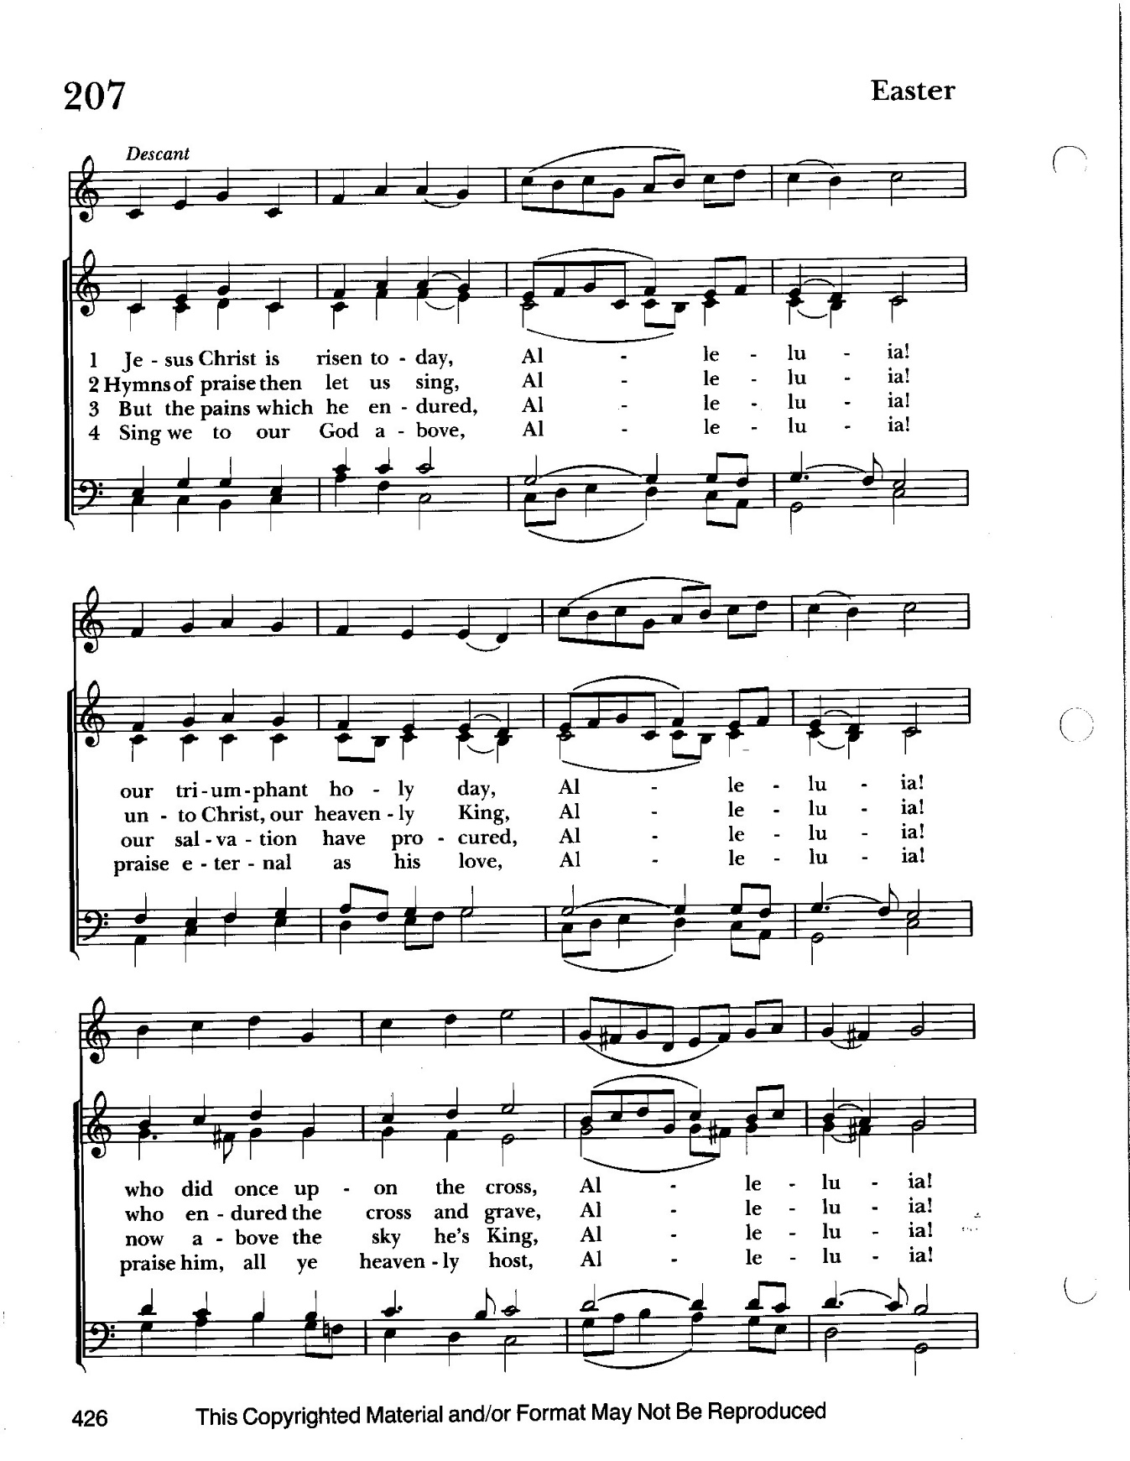

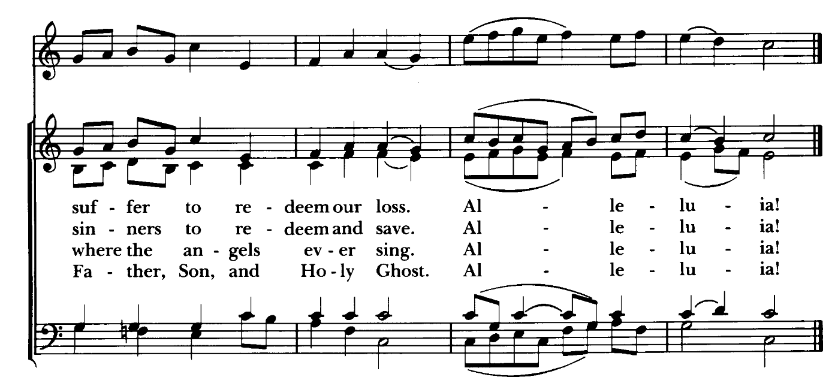

Words: Latin, 14th cent.; tr. Lyra Davidica, 1708, alt. St. 4, Charles Wesley &1707-1788)

Music: Easter Hymn, from Lyra Davidica, 1708; adapt. The Compleat Psalmodist, 1749, alt.;
desc. Hymns Ancient and Modern, Revised, 1950 77. 77 with Alleluias

Celebrant: The Lord be with you.
People: And also with you.
Celebrant: Let us pray.

The Collect of the Day Kneel or stand as able BCP 222
O God, who for our redemption gave your only-begotten Son to the death of the cross, and by his glorious resurrection delivered us from the power of our enemy: Grant us so to die daily to sin, that we may evermore live with him in the joy of his resurrection; through Jesus Christ your Son our Lord, who lives and reigns with you and the Holy Spirit, one God, now and for ever. Amen.

The congregation is seated.

A Reading from the Acts of the Apostles 10:34-43
Peter began to speak to Cornelius and the other Gentiles: "I truly understand that God shows no partiality, but in every nation anyone who fears him and does what is right is acceptable to him. You know the message he sent to the people of Israel, preaching peace by Jesus Christ--he is Lord of all. That message spread throughout Judea, beginning in Galilee after the baptism that John announced: how God anointed Jesus of Nazareth with the Holy Spirit and with power; how he went about doing good and healing all who were oppressed by the devil, for God was with him. We are witnesses to all that he did both in Judea and in Jerusalem. They put him to death by hanging him on a tree; but God raised him on the third day and allowed him to appear, not to all the people but to us who were chosen by God as witnesses, and who ate and drank with him after he rose from the dead. He commanded us to preach to the people and to testify that he is the one ordained by God as judge of the living and the dead. All the prophets testify about him that everyone who believes in him receives forgiveness of sins through his name."

Reader: The Word of the Lord.
People: Thanks be to God.

Psalm 118:1-2, 14-24 (Prayed as directed.)
1 Give thanks to the Lord, for he is good; *
his mercy endures for ever.
2 Let Israel now proclaim, *
"His mercy endures for ever."
14 The Lord is my strength and my song, *
and he has become my salvation.
15 There is a sound of exultation and victory *
in the tents of the righteous:
16 "The right hand of the Lord has triumphed! *
the right hand of the Lord is exalted!
the right hand of the Lord has triumphed!"
17 I shall not die, but live, *
and declare the works of the Lord.
18 The Lord has punished me sorely, *
but he did not hand me over to death.
19 Open for me the gates of righteousness; *
I will enter them;
I will offer thanks to the Lord.
20 "This is the gate of the Lord; *
he who is righteous may enter."
21 I will give thanks to you, for you answered me *
and have become my salvation.
22 The same stone which the builders rejected *
has become the chief cornerstone.
23 This is the Lord's doing, *
and it is marvelous in our eyes.
24 On this day the Lord has acted; *
we will rejoice and be glad in it.

A Reading from the 1st Letter of St. Paul to the Corinthians 15:19-26
If for this life only we have hoped in Christ, we are of all people most to be pitied.
But in fact Christ has been raised from the dead, the first fruits of those who have died. For since death came through a human being, the resurrection of the dead has also come through a human being; for as all die in Adam, so all will be made alive in Christ. But each in his own order: Christ the first fruits, then at his coming those who belong to Christ. Then comes the end, when he hands over the kingdom to God the Father, after he has destroyed every ruler and every authority and power. For he must reign until he has put all his enemies under his feet. The last enemy to be destroyed is death.

Reader: The Word of the Lord.
People: Thanks be to God.
Gradual hymn: He is risen, he is risen Hymnal #180

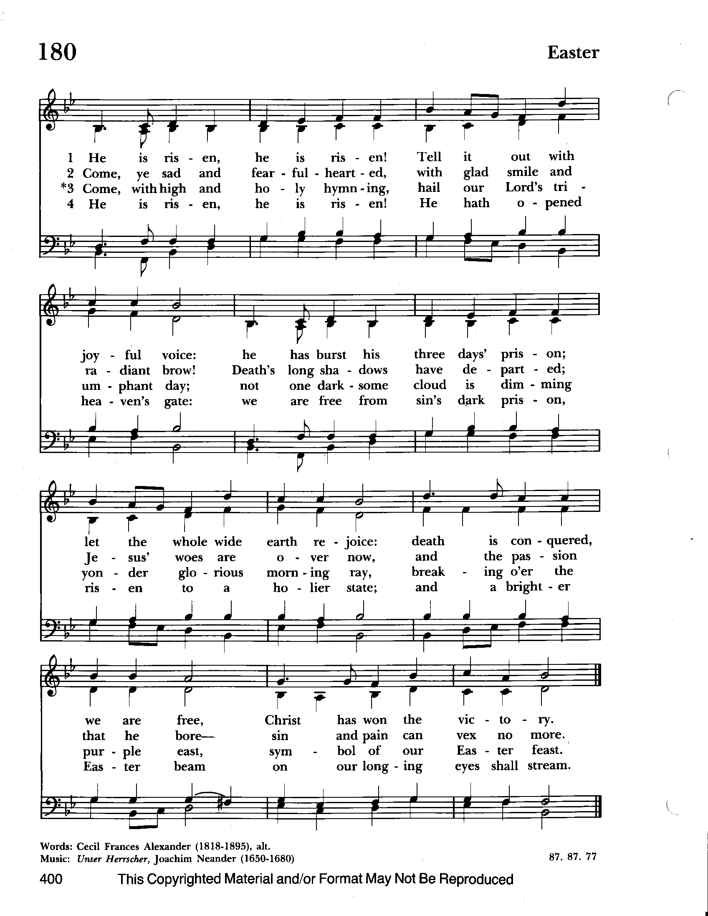

The Gospel The congregation remains standing as able
Priest: The Holy Gospel of our Lord Jesus Christ according to Luke 24:1-12

People: Glory to you, Lord Christ.
When the sabbath was over, Mary Magdalene, and Mary the mother of James, On the first day of the week, at early dawn, the women who had come with Jesus from Galilee came to the tomb, taking the spices that they had prepared. They found the stone rolled away from the tomb, but when they went in, they did not find the body. While they were perplexed about this, suddenly two men in dazzling clothes stood beside them. The women were terrified and bowed their faces to the ground, but the men said to them, "Why do you look for the living among the dead? He is not here, but has risen. Remember how he told you, while he was still in Galilee, that the Son of Man must be handed over to sinners, and be crucified, and on the third day rise again." Then they remembered his words, and returning from the tomb, they told all this to the eleven and to all the rest. Now it was Mary Magdalene, Joanna, Mary the mother of James, and the other women with them who told this to the apostles. But these words seemed to them an idle tale, and they did not believe them. But Peter got up and ran to the tomb; stooping and looking in, he saw the linen cloths by themselves; then he went home, amazed at what had happened.

Priest: The Gospel of the Lord.
People: Praise to you, Lord Christ.

Sermon The Rev. Mark Lobb+

The Baptismal Covenant Please stand as able BCP 304
Celebrant: Through the Paschal mystery, dear friends, we are buried with Christ by Baptism into his death, and raised with him to newness of life. I call upon you, therefore, now that our Lenten observance is ended, to renew the solemn promises and vows of Holy Baptism, by which we once renounced Satan and all his works, and promised to serve God faithfully in his holy Catholic Church.

Celebrant: Do you believe in God the Father?
People: I believe in God, the Father almighty, creator of heaven and earth.

Celebrant: Do you believe in Jesus Christ, the Son of God?
People: I believe in Jesus Christ, his only Son, our Lord. He was conceived by the power of the Holy Spirit and born of the Virgin Mary. He suffered under Pontius Pilate, was crucified, died, and was buried. He descended to the dead. On the third day he rose again. He ascended into heaven, and is seated at the right hand of the Father. He will come again to judge the living and the dead.

Celebrant: Do you believe in God the Holy Spirit?
People: I believe in the Holy Spirit, the holy catholic Church, the
communion of saints, the forgiveness of sins, the resurrection of the body, and the life everlasting.

Celebrant: Will you continue in the apostles’ teaching and fellowship, in the breaking of bread, and in the prayers?
People: I will, with God’s help.

Celebrant: Will you persevere in resisting evil, and, whenever you fall into sin, repent and return to the Lord?
People: I will, with God’s help.

Celebrant: Will you proclaim by word and example the Good News of God in Christ?
People: I will, with God’s help.

Celebrant: Will you seek and serve Christ in all persons, loving your neighbor as yourself?
People: I will, with God’s help.
Celebrant: Will you strive for justice and peace among all people, and respect the dignity of every human being?
People: I will, with God’s help.

The Prayers of the People Form VI BCP 392
Litanist: In peace, we pray to you, Lord God.

Litanist: For all people in their daily life and work;
People: For our families, friends, and neighbors, and for those who are alone.

Litanist: For this community, the nation, and the world;
People: For all who work for justice, freedom, and peace.

Litanist: For the just and proper use of your creation;
People: For the victims of hunger, fear, injustice, and oppression.

Litanist: For all who are in danger, sorrow, or any kind of trouble;
People: For those who minister to the sick, the friendless, and the needy.

Litanist: For the peace and unity of the Church of God;
People: For all who proclaim the Gospel, and all who seek the Truth.

Litanist: For +Sean, our Presiding Bishop; for +Carrie, our Bishop, for Mark+, our Priest in Charge, for the Wardens, Vestry, Staff, and all members and friends of St. John’s Church.
People: For all who serve God in his Church.

Litanist: For the special needs and concerns of this congregation. Especially remember in our prayers, DeMarino Family, Jim & Chris Carden and family, Peggie Dietz, Mike Carden, Pat Carden, Gail Landers, Sheila Jones, Gloria Millar, Marisol Aubrey, Ross Strickler, Jim & Janice Sieracki, James Daniel Jr., Larry Betzler, Camy Schwenk, Dennis Mally, Zach Walsh, Lily John, Barbara Miller, Nancy Barnhart, Robin Dilworth, Eileen Weimer, David Harris, Linda Posten, Bill Hoffman & Family, Deb Melcher, Emily Lobb, Bri Del Pilar, Paul Leamer, Janine Stevens.

The People may add their own petitions

Litanist: Hear us, Lord;
People: For your mercy is great.

Litanist: We thank you, Lord, for all the blessings of this life.

The People may add their own thanksgivings

Litanist: We will exalt you, O God our King;
People: And praise your Name for ever and ever.
Litanist: We pray for all who have died, that they may have a place in your eternal kingdom.

The People may add their own petitions
Litanist: Lord, let your loving-kindness be upon them;
People: Who put their trust in you.

Litanist: We pray to you also for the forgiveness of our sins.
People: Have mercy upon us, most merciful Father; in your compassion forgive us our sins, known and unknown, things done and left undone; and so uphold us by your Spirit that we may live and serve you in newness of life, to the honor and glory of your Name; through Jesus Christ our Lord. Amen.

The Celebrant gives the absolution.

The Peace BCP 360

Welcome & Announcements The congregation is seated.

Offertory Anthem : Alleluia (Bells, Choir & Congregation)

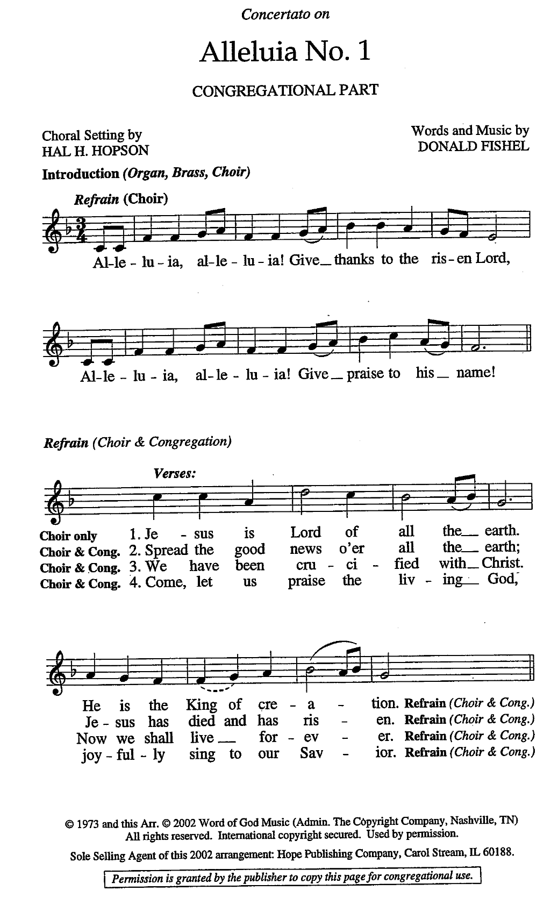

Offertory Hymn: Jesus Lives Hymnal #194
(see next page)

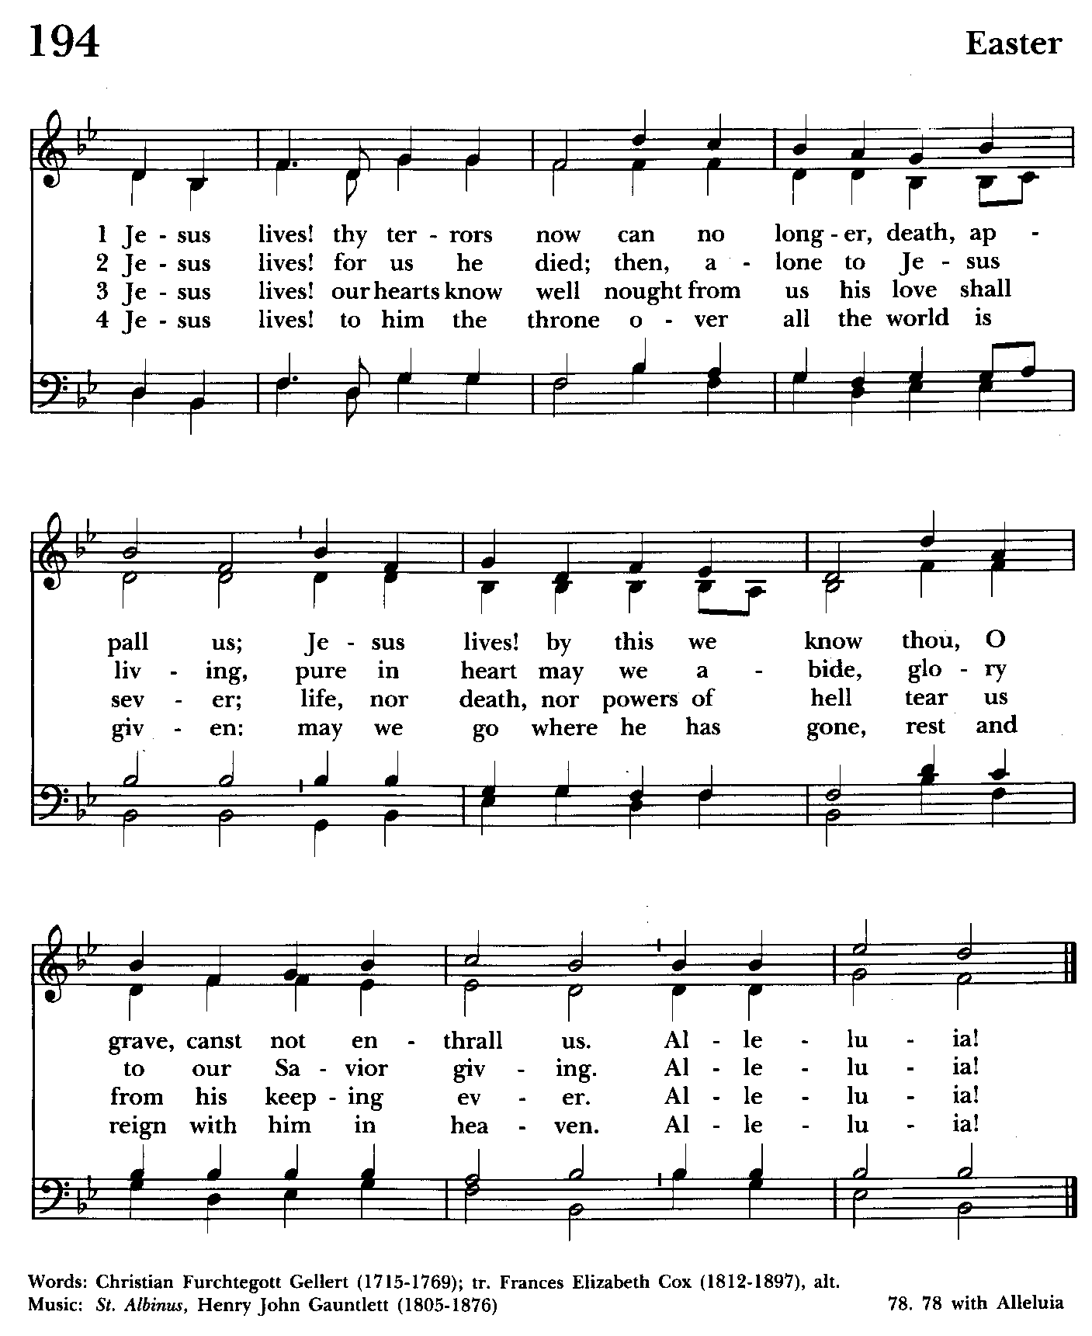

Offertory: Offerings are collected

Presentation Hymn Offerings are presented Please stand as able Hymnal #43, vs. 4
Praise God, from whom all blessings flow; praise him, all creatures here below; praise him above, ye heavenly host: praise Father, Son, and Holy Ghost.

The Holy Communion

THE GREAT THANKSGIVING: Eucharistic Prayer A BCP 361
Celebrant: The Lord be with you.
People: And also with you.

Celebrant: Lift up your hearts.
People: We lift them to the Lord.
Celebrant: Let us give thanks to the Lord our God.
People: It is right to give him thanks and praise.
Celebrant: It is right, and a good and joyful thing, always and everywhere to give thanks to you, Father Almighty, Creator of heaven and earth.

Celebrant: Therefore we praise you, joining our voices with Angels and Archangels and with all the company of heaven, who for ever sing this hymn to proclaim the glory of your Name:

Sanctus Hymnal #S-124

Holy, holy, holy Lord, God of power and might,
heaven and earth are full of your glory.
Hosanna in the highest.
Blessed is he who comes in the name of the Lord.
Hosanna in the highest.

Please stand or kneel as able

Celebrant: Holy and gracious Father: In your infinite love you made us for yourself; and, when we had fallen into sin and become subject to evil and death, you, in your mercy, sent Jesus Christ your only and eternal Son, to share our human nature, to live and die as one of us, to reconcile us to you, the God and Father of all.

He stretched out his arms upon the cross, and offered himself, in obedience to your will, a perfect sacrifice for the whole world.

On the night he was handed over to suffering and death, our Lord Jesus Christ took bread; and when he had given thanks to you, he broke it, and gave it to his disciples, and said, “Take, eat: This is my Body, which is given for you. Do this for the remembrance of me.”

After supper he took the cup of wine; and when he had given thanks, he gave it to them, and said, “Drink this, all of you: This is my Blood of the new Covenant, which is shed for you and for many for the forgiveness of sins.

Whenever you drink it, do this for the remembrance of me.”

Therefore we proclaim the mystery of faith:

Celebrant and People: Christ has risen.
Christ is risen.
Christ will come again.

Celebrant: We celebrate the memorial of our redemption, O Father, in this sacrifice of praise and thanksgiving. Recalling his death, resurrection, and ascension, we offer you these gifts.

Sanctify them by your Holy Spirit to be for your people the Body and Blood of your Son, the holy food and drink of new and unending life in him. Sanctify us also that we may faithfully receive this holy Sacrament, and serve you in unity, constancy, and peace; and at the last day bring us with all your saints into the joy of your eternal kingdom.

All this we ask through your Son Jesus Christ. By him, and with him, and in him, in the unity of the Holy Spirit, all honor and glory is yours, Almighty Father, now and for ever. Amen.

And now as our Savior Christ has taught us, we are bold to say.

Our Father, who art in heaven,
hallowed be thy Name,
thy kingdom come,
thy will be done,
on earth as in heaven.
Give us this day our daily bread.
And forgive us our sins,
as we forgive those
who sin against us.
Save us from the time of trial,
and deliver us from evil.
For the kingdom,
the power, and the glory are yours,
now and for ever. Amen.

Celebrant and People: Alleluia, Alleluia, Alleluia.
Christ our Passover is sacrificed for us;
Therefore let us keep the feast.
Alleluia, Alleluia, Alleluia.

Fraction Anthem Agnus Dei S-161
Lamb of God, you take away the sins of the world: have mercy on us.
Lamb of God, you take away the sins of the world: have mercy on us.
Lamb of God, you take away the sins of the world: grant us peace.

Invitation to Communion
Celebrant: The Gifts of God for the People of God.

Communion Hymn: I am the bread of life Hymnal #335
(see below and next page)

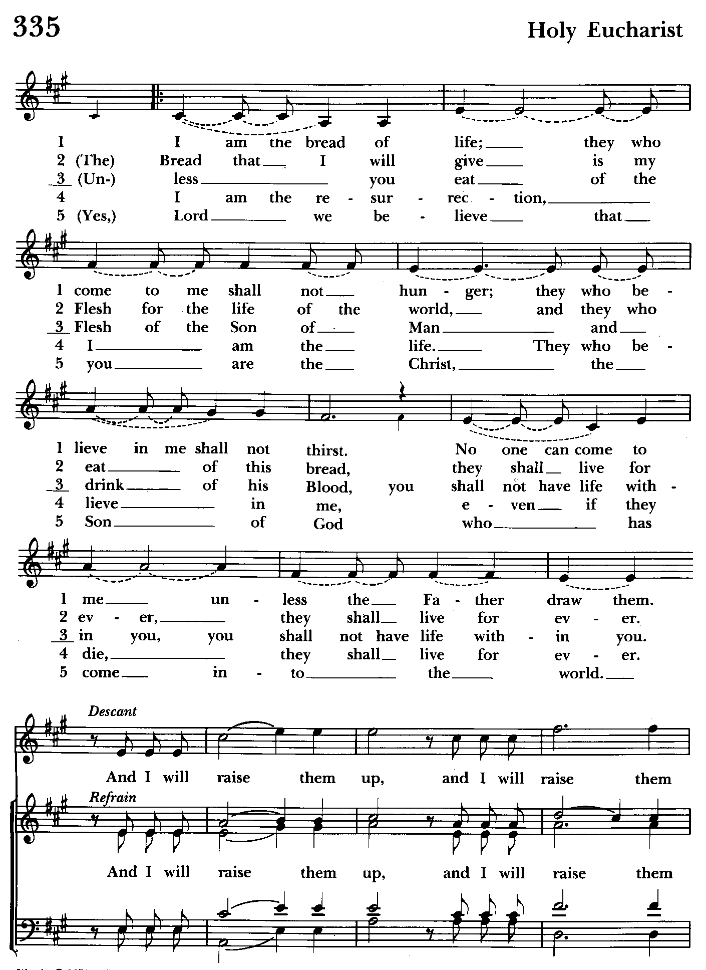

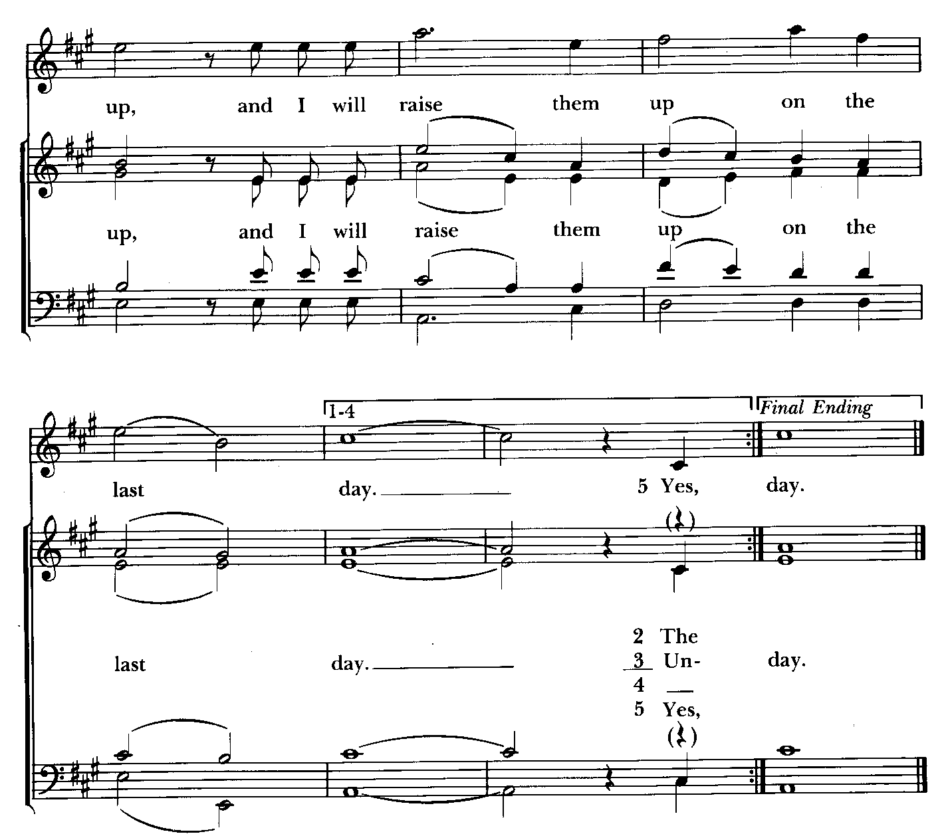

Post Communion Prayer
Let us pray.

Celebrant and People BCP 365
Eternal God, heavenly Father, you have graciously accepted us as living members of your Son our Savior Jesus Christ, and you have fed us with spiritual food in the Sacrament of his Body and Blood. Send us now into the world in peace, and grant us strength and courage to love and serve you with gladness and singleness of heart; through Christ our Lord. Amen.

Easter Blessing
May Almighty God, who has redeemed us and made us his children through the Resurrection of his Son our Lord, bestow upon you the riches of his blessing. Amen.

Recessional hymn: Come ye faithful, raise the strain Hymnal #199

The Dismissal (The Alleluias are back!)

Celebrant: Let us go forth in the name of the risen Lord. Alleluia! alleluia!
People: Thanks be to God. Alleluia, alleluia!

License #A-719154

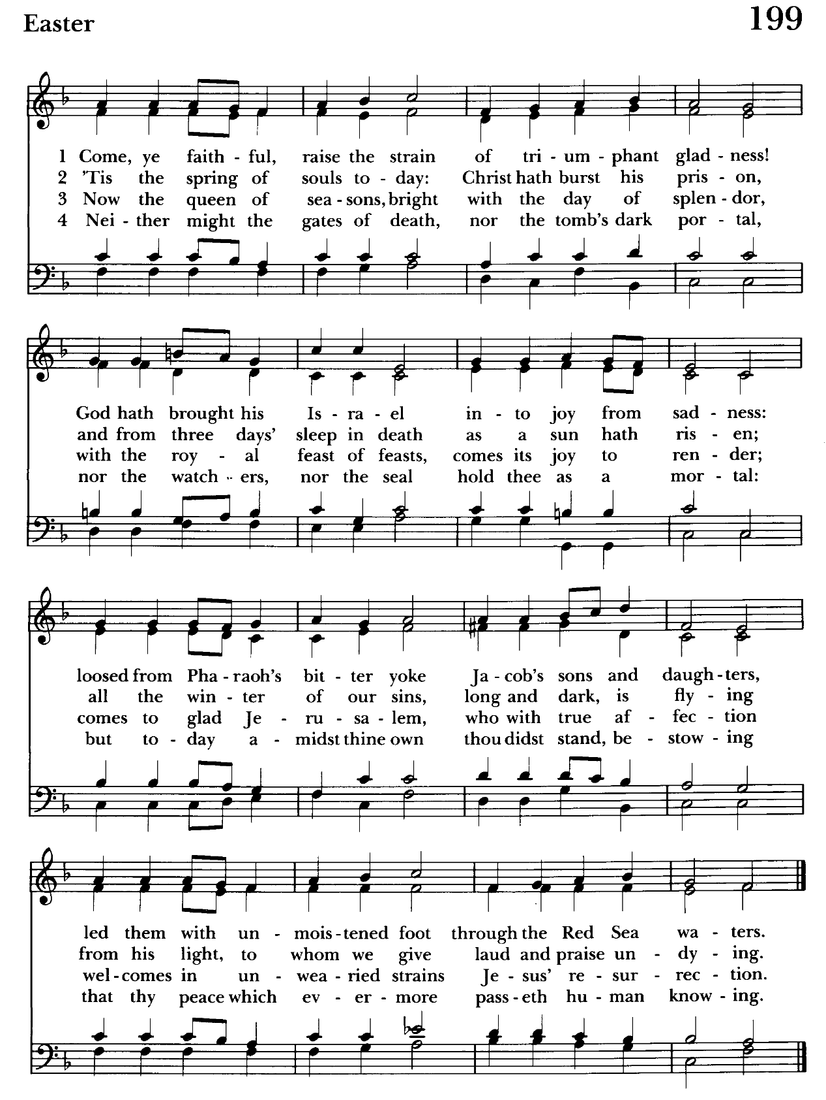

Serving Today

Celebrant and Preacher: The Rev. Mark Lobb+
Old Testament: Debbie Weaver
Psalm: John Stevens
New Testament: Anne Leland
Prayers of the People: Debbie Weaver
Server: Marguerite Lobb
Choir: Nancy Dellinger, Anne Leland, Liz Healey,
Karen Smith-Manar, Jacob Johnson, Ty Schwenk
Bells: Nanci Rosendale, John Stevens
Music Director: Nancy Heinold
Altar Guild: Liz Healey & Marguerite Lobb


Easter Egg Hunt Today
after the 10:30 service.


We pray for birthdays this week

April 21 Emily Dilworth

From the Treasurer
April ‘25 Income vs. Expenses:

Projected April Expenses: $14,000
Monies Received as of 4/16: $ 8,089

Amount Needed to Meet Expenses: $ 5,911


If you’d like to make a donation to St. John’s you can scan this QR code with your phone’s camera or tap on the link that comes up to make a contribution with either a credit or debit card, Apple Pay or Google Pay. This is a secure site provided by Clover which is a service of PNC Bank.

Calendar Updates

April 20 - Easter Sunday, 8 & 10:30 services
Easter Egg Hunt—after the 10:30 service
April 27 - Auxiliary Meeting after 10:30 service
May 17 - Flea Market, 8 am-1 pm

Calendars are living documents. Every effort will be made to keep the members of the parish and community aware of any changes.

St. John’s Parish Prayer List

Additions and corrections may be made to our Parish Prayer List at any time. All names will be automatically removed from the Parish Prayer List on the 1st Sunday of each month unless you request otherwise. Please contact Angie at <office@stjohnskingsville.org> or 410-592-8570 in the church office with all changes by 10 am Thursdays. Thank you.

We Pray for Those in Need:
Names in BOLD read aloud by all.

DeMarino Family, Jim & Chris Carden and family, Peggie Dietz, Mike Carden, Pat Carden, Gail Landers, Sheila Jones, Gloria Millar, Marisol Aubrey, Ross Strickler, Jim and Janice Sieracki, James Daniel Jr, Larry Betzler, Camy Schwenk, Dennis Mally, Zach Walsh, Eileen Weimer, David Harris, Linda Posten, Bill Hoffman & Family, Deb Melcher, Emily Lobb,
Bri Del Pilar, Paul Leamer, Janine Stevens.

We Pray for our Homebound

Lily John, Barbara Miller, Nancy Barnhart, Robin Dilworth

We pray for the Church and the World:

For +Sean, our Presiding Bishop; for +Carrie, our Bishop, for Mark+, our Priest in Charge, for the Wardens, Vestry, Staff, and all members and friends of St. John’s Church.

For the leaders of all nations, especially for Donald, our President; for Wes, our Governor; for Brandon, Kathy and Bob, who lead our City and Counties. We pray for all children and youth; for the homeless, the unemployed, and the hungry. We pray for the safety of our loved ones and friends serving in the Armed Forces at home and abroad, and for our enemies, that all our hearts may be turned toward peace throughout the world.


Easter Flowers 2025

Sharon Lobb in memory of Michael Kellogg, Robert Kellogg, Susan Kellogg, Thomas Lobb
Liz Healey in memory of John & Lorraine Healey, Earl & May Banks, Norman & Peggy Banks, The Holland Family
Woodie Tingle in honor of Dennis Mally, Rev. Mark & Sharon, Angie Bosley, Jane White, Nancy Heinold, Marsha DeMarino
Woodie Tingle in memory of Mary & Woodie Tingle and Helen & Gus Mally
Frank & Stephanie Duchacek in memory of Loved Ones
Ross & Darlene Strickler in memory of Gustav A. & Ethel D. Ay,
Thomas E. & Kathleen Ay (sister) McKelvey, Morris & Katherine S. Lowman
Duane & Debbie Weaver in memory of Loved Ones
Debbie Grau in memory of Grau Family members
Joan Salmon in memory of Capt. Walter W. Salmon, Jr./USN
Barbara Daniel in honor of family and friends that have passed on

AUXILIARY NOTES
Starting Monday April 21 please bring your gently used items to donate for the flea market no clothes please.
Tables will be set up in the back of the hall.
Mark your calendars Auxiliary meeting on Sunday April 27 after the 10:30 service.
We need everyone's help. We will be discussing the flea market on Saturday May 17 and the next bingos. If you want to help and you can't make the meeting please call Michele at 443-463-6333.


Choir and Bell Choir

Choir practice, Wednesdays at 7:00 pm

Bell Choir practice, Sundays after the 10:30 service.


SUNDAY SCHOOL
10:30: Kids Sunday School- Begin in the church, ring the bell, then process over to the parish hall for a fun lesson with Mr. John and Ms. Stephanie.

Note: Please seriously consider regular attendance at Sunday School so that Mr. John and Ms. Stephanie can plan good stuff.


God’s Grace Gardens
A collaboration of St. John’s, Hill and Stream Garden Club and AA is beginning an “Adopt-A-Garden” program for the various garden plots on St. John’s Campus.

So grab your gloves as 16 garden areas (some quite small) are up for “Adoption”. GGG will take care of shrub and tree trimming and provide mulch. Most gardens only require weeding and mulching, not planting.

If you enjoy working with your hands, or just want to learn how to tend God’s good earth, see Karen or Anne.

Let’s make St. John’s campus a place of beauty and peace for the Kingsville community!

Wish List: Large watering cans

God’s Grace Gardens is thankful for the generous donation of a wagon by a faithful parishioner!


Yoga classes on Saturday mornings 9 to 10 am in the Chapel.

All experience levels are welcome.

What’s Happening This Week at St. John’s

Sunday, April 20—Easter Sunday
8:00am: Holy Eucharist, Rite I (Church)
10:30am: Holy Eucharist, Rite II (Church)
11:30: Easter Egg Hunt (Outside-Weather Permitting)

Monday, April 21
OFFICE IS CLOSED
12:00-1:00pm: AA Lunch Bunch (Parish Hall)

Tuesday, April 22
12:00-1:00pm: AA Lunch Bunch (Parish Hall)

Wednesday, April 23
12:00-1:00pm: AA Lunch Bunch (Parish Hall)
7:00pm: Choir Rehearsal (Church)
7:30pm: AA (Parish Hall)

Thursday, April 24
12:00-1:00pm: AA Lunch Bunch (Parish Hall)
7:00pm: AA (Parish Hall)

Friday, April 25
12:00-1:00pm: AA Lunch Bunch (Parish Hall)

Saturday, April 26
9:00am-10:00am: Yoga (Chapel)
8:30pm: AA (Parish Hall)

Sunday, April 27-Second Sunday of Easter
8:00am: Holy Eucharist, Rite I (Church)
10:30am: Holy Eucharist, Rite II (Church)
10:30am-11:00am: Sunday School
11:30am: Coffee Hour (Parish Hall)
11:45am: Bell Choir Rehearsal (Church)

Parish Office is open Monday, Wednesday and Thursday, 9:30am-1:30pm.

Potluck Luncheon on the first Sunday of the month and a Coffee Hour on all other Sundays after the 10:30 service.

