St. John’s Episcopal Church
Kingsville, Maryland
Welcomes You



The Sunday of the Passion: Palm Sunday
April 13, 2025
10:30 am, Rite II

St. John’s Episcopal Church

11901 Belair Road, P. O. Box 187, Kingsville, MD 21087
Facebook: St. John’s Episcopal, Kingsville, MD
Email: office@stjohnskingsville.org
Website: www.stjohnskingsville.org
Church Phone: 410-592-8570
For Pastoral Emergencies: Fr. Mark Lobb+ 443-690-9545

Welcome to worship today! We are glad that you are with us. You are invited to participate in all parts of the service as indicated in the Book of Common Prayer and this service bulletin. If you have any questions, feel free to ask the ushers. Restrooms are located in the Parish hall, the brick building across the parking lot.

I was glad when they said to me, “Let us go to the house of the Lord.” Psalm 122:1

Church Staff

Priest in Charge: Father Mark Lobb
Administrative Assistant: Angie Bosley
Organist/Choir Director: Nancy Heinold

The Vestry

Class of 2026 Class of 2027

John Stevens John Frost
Jacob Johnson Stephanie White

Officers
Ty Schwenk—Sr. Warden Terry Roe—Jr. Warden
Elizabeth Healey—Treasurer Anne Leland-Registrar

Parish Committee Chairpersons

Altar Guild: Elizabeth Healey
Auxiliary Committee: Michele Lozanski
Cemetery Committee: Karen Smith-Manar

10:30 am Worship
The Holy Eucharist, Rite Two

Please stand as able
The Liturgy of the Palms

Celebrant: Blessed is the King who comes in the name of the Lord! BCP 270
People: Peace in heaven and glory in the highest!

Celebrant: Let us pray.
Assist us mercifully with your help, O Lord God of our salvation, that we may enter with joy upon the contemplation of those mighty acts, whereby you have given us life and immortality; through Jesus Christ our Lord. Amen.

A Reading from the Holy Gospel according to Luke 19:28-40
After telling a parable to the crowd at Jericho, Jesus went on ahead, going up to Jerusalem. When he had come near Bethphage and Bethany, at the place called the Mount of Olives, he sent two of the disciples, saying, "Go into the village ahead of you, and as you enter it you will find tied there a colt that has never been ridden. Untie it and bring it here. If anyone asks you, 'Why are you untying it?' just say this, 'The Lord needs it.'" So those who were sent departed and found it as he had told them. As they were untying the colt, its owners asked them, "Why are you untying the colt?" They said, "The Lord needs it." Then they brought it to Jesus; and after throwing their cloaks on the colt, they set Jesus on it. As he rode along, people kept spreading their cloaks on the road. As he was now approaching the path down from the Mount of Olives, the whole multitude of the disciples began to praise God joyfully with a loud voice for all the deeds of power that they had seen, saying,
"Blessed is the king
who comes in the name of the Lord!
Peace in heaven,
and glory in the highest heaven!"
Some of the Pharisees in the crowd said to him, "Teacher, order your disciples to stop." He answered, "I tell you, if these were silent, the stones would shout out."

The Blessing of the Palms BCP 271
Celebrant: The Lord be with you.
People: And also with you.
Celebrant: Let us give thanks to the Lord our God.
People: It is right to give him thanks and praise.

Celebrant: It is right to praise you, Almighty God, for the acts of love by which you have redeemed us through your Son Jesus Christ our Lord. On this day he entered the holy city of Jerusalem in triumph, and was proclaimed as King of kings by those who spread their garments and branches of palm along his way. Let these branches be for us signs of his victory, and grant that we who bear them in his name may ever hail him as our King, and follow him in the way that leads to eternal life; who lives and reigns in glory with you and the Holy Spirit, now and for ever. Amen.

Celebrant: Blessed is he who comes in the name of the Lord!
People: Hosanna in the highest!

Celebrant: Let us go forth in peace.
People: In the name of Christ. Amen.
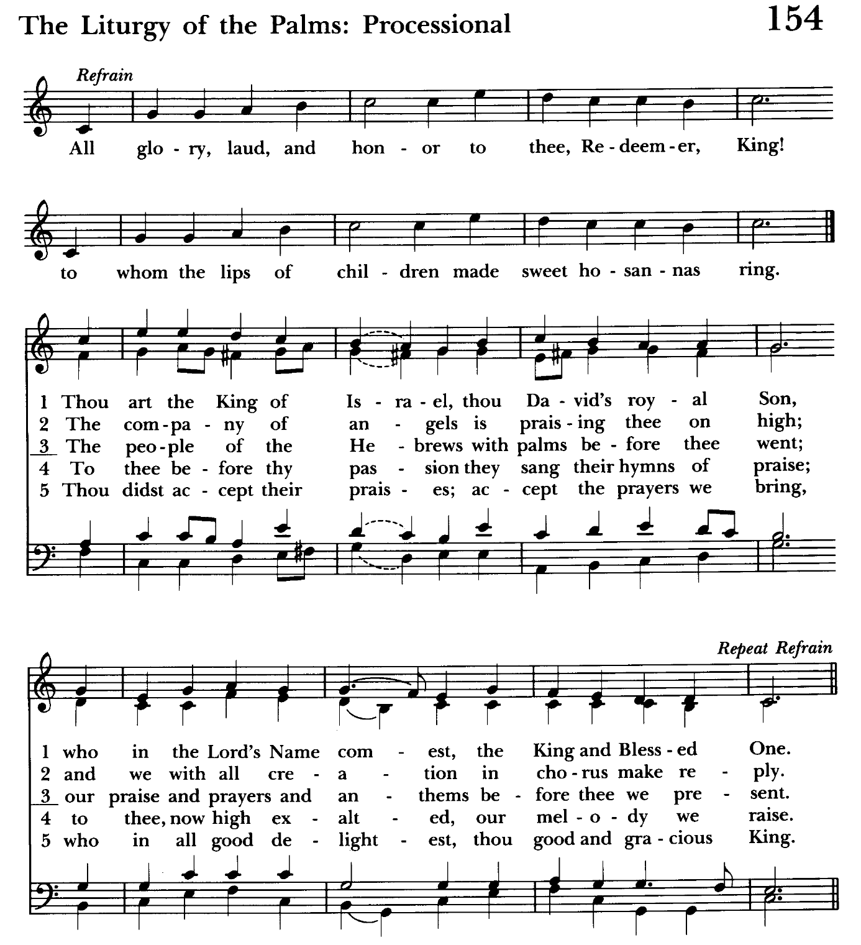

Procession from the Parish Hall Begins (weather permitting)
As we process psalm verses and hymn verses will be said/sung at each station.
Psalm 118:19-29 - said together while walking
1 Give thanks to the Lord, for he is good; *
his mercy endures for ever.
2 Let Israel now proclaim, *
"His mercy endures for ever.”

Hymn: All glory laud and honor Hymnal #154, vs. 1

19 Open for me the gates of righteousness; *
I will enter them;
I will offer thanks to the Lord.
20 "This is the gate of the Lord; *
he who is righteous may enter."

Hymn: All glory laud and honor Hymnal #154, vs. 2

21 I will give thanks to you, for you answered me *
and have become my salvation.
22 The same stone which the builders rejected *
has become the chief cornerstone.

Hymn: All glory laud and honor Hymnal #154. vs. 3

23 This is the Lord's doing, *
and it is marvelous in our eyes.
24 On this day the Lord has acted; *
we will rejoice and be glad in it.

Hymn: All glory laud and honor Hymnal #154, vs. 4

25 Hosannah, Lord, hosannah! *
Lord, send us now success.
26 Blessed is he who comes in the name of the Lord; *
we bless you from the house of the Lord.
Hymn: All glory laud and honor Hymnal #154, vs. 5

28 "You are my God, and I will thank you; *
you are my God, and I will exalt you."

29 Give thanks to the Lord, for he is good; *
his mercy endures for ever.

Hymn: All glory laud and honor Hymnal #154
(see next page)

Celebrant: Let us pray. Please kneel or stand as able BCP 272
Almighty God, whose most dear Son went not up to joy but first he suffered pain, and entered not into glory before he was crucified: Mercifully grant that we, walking in the way of the cross, may find it none other than the way of life and peace; through Jesus Christ our Lord. Amen.

The Word of God

Celebrant: Bless the Lord who forgives all our sins.
People: His mercy endures for ever.

The Collect of the Day BCP 219
Almighty and everliving God, in your tender love for the human race you sent your Son our Savior Jesus Christ to take upon him our nature, and to suffer death upon the cross, giving us the example of his great humility: Mercifully grant that we may walk in the way of his suffering, and also share in his resurrection; through Jesus Christ our Lord, who lives and reigns with you and the Holy Spirit, one God, for ever and ever. Amen.

The congregation is seated

A Reading from the Book of the Prophet Isaiah 50:4-9a
The Lord God has given me the tongue of a teacher, that I may know how to sustain the weary with a word. Morning by morning he wakens--wakens my ear to listen as those who are taught. The Lord God has opened my ear, and I was not rebellious, I did not turn backward. I gave my back to those who struck me, and my cheeks to those who pulled out the beard; I did not hide my face from insult and spitting. The Lord God helps me; therefore I have not been disgraced; therefore I have set my face like flint, and I know that I shall not be put to shame; he who vindicates me is near. Who will contend with me? Let us stand up together. Who are my adversaries? Let them confront me. It is the Lord God who helps me; who will declare me guilty?

Reader: The Word of the Lord.
People: Thanks be to God.

Psalm 31:9-16 (Pray as directed) BCP 623
9 Have mercy on me, O Lord, for I am in trouble; *
my eye is consumed with sorrow,
and also my throat and my belly.
10 For my life is wasted with grief,
and my years with sighing; *
my strength fails me because of affliction,
and my bones are consumed.
11 I have become a reproach to all my enemies and even to my neighbors,
a dismay to those of my acquaintance; *
when they see me in the street they avoid me.
12 I am forgotten like a dead man, out of mind; *
I am as useless as a broken pot.
13 For I have heard the whispering of the crowd;
fear is all around; *
they put their heads together against me;
they plot to take my life.
14 But as for me, I have trusted in you, O Lord. *
I have said, "You are my God.
15 My times are in your hand; *
rescue me from the hand of my enemies,
and from those who persecute me.
16 Make your face to shine upon your servant, *
and in your loving-kindness save me."

A Reading from the Letter of St. Paul to the Philippians 2:5-11
Let the same mind be in you that was in Christ Jesus, who, though he was in the form of God, did not regard equality with God as something to be exploited, but emptied himself, taking the form of a slave, being born in human likeness.
And being found in human form, he humbled himself and became obedient to the point of death--even death on a cross. Therefore God also highly exalted him and gave him the name that is above every name, so that at the name of Jesus every knee should bend, in heaven and on earth and under the earth, and every tongue should confess that Jesus Christ is Lord, to the glory of God the Father.

Reader: The Word of the Lord.
People: Thanks be to God.

Gradual Hymn: O sacred head, sore wounded Hymnal #168, vs 1-3

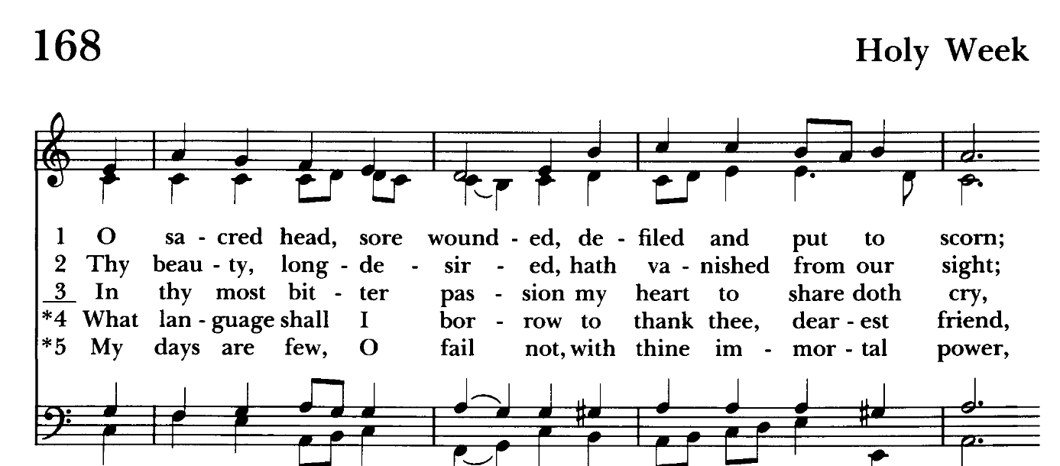

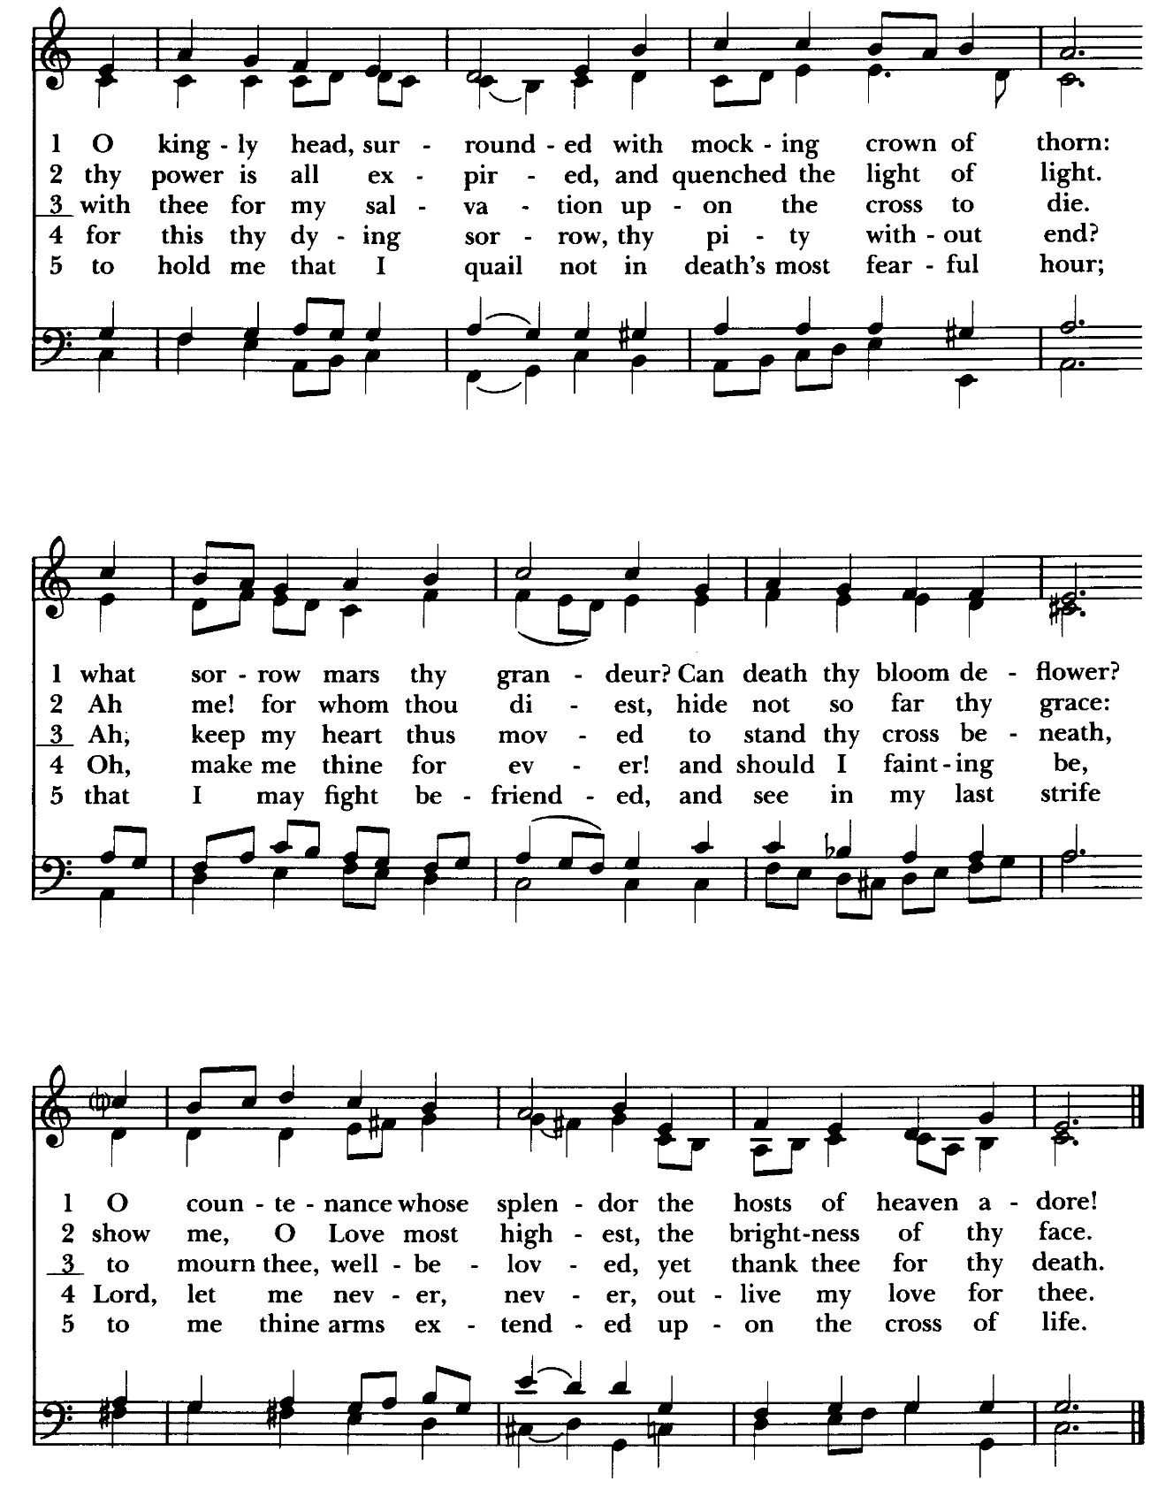

The Passion of Our Lord Jesus Christ according to Luke
(SEE INSERT) The people are seated

Sermon Rev. Mark Lobb+

The Prayers of the People Form IV The people kneel as able BCP 388
Litanist:: Let us pray for the Church and for the world. Grant, Almighty God, that all who confess your Name may be united in your truth, live together in your love, and reveal your glory in the world.

Silence

Litanist: Lord, in your mercy
People: Hear our prayer.

Litanist: Guide the people of this land, and of all the nations, in the ways of justice and peace; that we may honor one another and serve the common good.

Silence

Litanist: Lord, in your mercy
People: Hear our prayer.

Litanist: Give us all a reverence for the earth as your own creation, that we may use its resources rightly in the service of others and to your honor and glory.

Silence
Litanist: Lord, in your mercy
People: Hear our prayer.

Litanist: Bless all whose lives are closely linked with ours, and grant that we may serve Christ in them, and love one another as he loves us.

Silence

Litanist: Lord, in your mercy
People: Hear our prayer.

Litanist: Comfort and heal all those who suffer in body, mind, or spirit; give them courage and hope in their troubles, and bring them the joy of your salvation.

Silence

Litanist: Lord, in your mercy
People: Hear our prayer.

Litanist: We commend to your mercy all who have died, that your will for them may be fulfilled; and we pray that we may share with all your saints in your eternal kingdom.

Silence

Litanist: Lord, in your mercy
People: Hear our prayer.

For the leaders of all nations, especially for Donald, our President; for Wes, our Governor; for Brandon, Kathy and Bob, who lead our City and Counties. We pray for all children and youth; for the homeless, the unemployed, and the hungry. We pray for the safety of our loved ones and friends serving in the Armed Forces at home and abroad, and for our enemies, that all our hearts may be turned toward peace throughout the world.

Litanist: For the special needs and concerns of this congregation. Especially remember in our prayers, DeMarino Family, Jim & Chris Carden and family, Peggie Dietz, Mike Carden, Pat Carden, Gail Landers, Sheila Jones, Gloria Millar, Marisol Aubrey, Ross Strickler, Jim & Janice Sieracki, James Daniel Jr., Larry Betzler, Camy Schwenk, Dennis Mally, Zach Walsh, Lily John, Barbara Miller, Nancy Barnhart, Robin Dilworth, Eileen Weimer, David Harris, Linda Posten, Bill Hoffman & Family, Deb Melcher, Emily Lobb, Bri Del Pilar, Paul Leamer, Janine Stevens.

The People may add their own petitions

Litanist: Hear us, Lord;
People: For your mercy is great.
Litanist: We thank you, Lord, for all the blessings of this life.

The People may add their own thanksgivings

Litanist: We will exalt you, O God our King;
People: And praise your Name for ever and ever.

The People may add their own petitions

Celebrant: O Lord our God, accept the fervent prayers of your people; in the multitude of your mercies, look with compassion upon us and all who turn to you for help; for you are gracious, O lover of souls, and to you we give glory, Father, Son, and Holy Spirit, now and for ever. Amen.

The Peace The congregation is seated BCP 360

Welcome & Announcements

The Holy Communion
Offertory anthem: Hosanna in the Highest (Choir & Bells)
Offertory hymn: At the Name of Jesus Hymnal #435
(see next page)

The congregation remains seated while the offering is collected

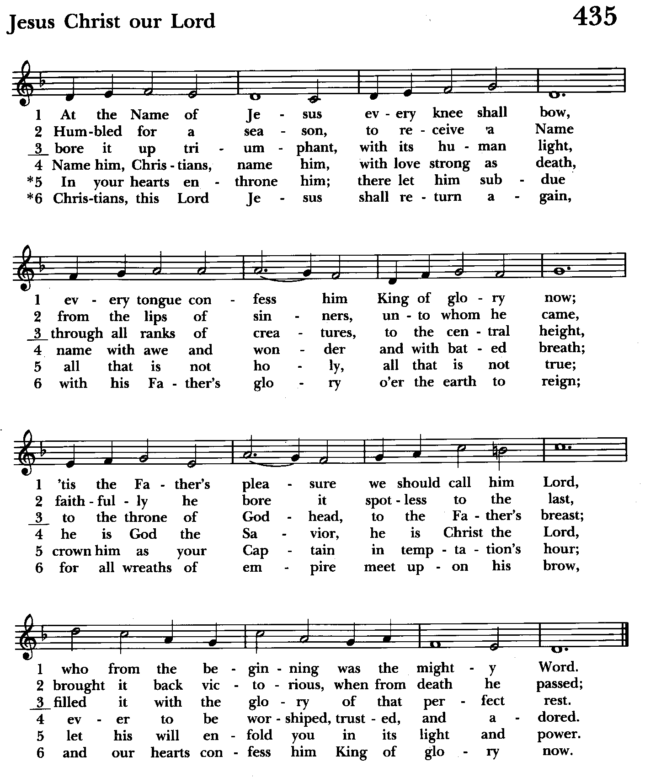

Doxology Please stand as able Hymnal #43, vs. 4
Praise God, from whom all blessings flow; praise him, all creatures here
below; praise him above, ye heavenly host: praise Father, Son and Holy Ghost.

THE GREAT THANKSGIVING: Eucharistic Prayer A BCP 361
Celebrant: The Lord be with you.
People: And also with you.
Celebrant: Lift up your hearts.
People: We lift them to the Lord.
Celebrant: Let us give thanks to the Lord our God.
People: It is right to give him thanks and praise.

Celebrant: It is right, and a good and joyful thing, always and everywhere to give thanks to you, Father Almighty, Creator of heaven and earth.
Celebrant: Therefore we praise you, joining our voices with Angels and Archangels and with all the company of heaven, who for ever sing this hymn to proclaim the glory of your Name:

Sanctus Hymnal #S-124

Holy, holy, holy Lord, God of power and might,
heaven and earth are full of your glory.
Hosanna in the highest.
Blessed is he who comes in the name of the Lord.
Hosanna in the highest.

Please stand or kneel as able

Celebrant: Holy and gracious Father: In your infinite love you made us for yourself; and, when we had fallen into sin and become subject to evil and death, you, in your mercy, sent Jesus Christ your only and eternal Son, to share our human nature, to live and die as one of us, to reconcile us to you, the God and Father of all.

He stretched out his arms upon the cross, and offered himself, in obedience to your will, a perfect sacrifice for the whole world.

On the night he was handed over to suffering and death, our Lord Jesus Christ took bread; and when he had given thanks to you, he broke it, and gave it to his disciples, and said, “Take, eat: This is my Body, which is given for you. Do this for the remembrance of me.”

After supper he took the cup of wine; and when he had given thanks, he gave it to them, and said, “Drink this, all of you: This is my Blood of the new Covenant, which is shed for you and for many for the forgiveness of sins. Whenever you drink it, do this for the remembrance of me.”

Therefore we proclaim the mystery of faith:

Celebrant and People: We remember his death,
We proclaim his resurrection,
We await his coming in glory;

Celebrant: We celebrate the memorial of our redemption, O Father, in this sacrifice of praise and thanksgiving. Recalling his death, resurrection, and ascension, we offer you these gifts.

Sanctify them by your Holy Spirit to be for your people the Body and Blood of your Son, the holy food and drink of new and unending life in him. Sanctify us also that we may faithfully receive this holy Sacrament, and serve you in unity, constancy, and peace; and at the last day bring us with all your saints into the joy of your eternal kingdom.

All this we ask through your Son Jesus Christ. By him, and with him, and in him, in the unity of the Holy Spirit, all honor and glory is yours, Almighty Father, now and for ever. Amen.

And now as our Savior Christ has taught us, we are bold to say.

Our Father, who art in heaven,
hallowed be thy Name,
thy kingdom come,
thy will be done,
on earth as it is in heaven.
Give us this day our daily bread.
And forgive us our trespasses,
as we forgive those
who trespass against us.
And lead us not into temptation,
but deliver us from evil.
For thine is the kingdom,
and the power, and the glory,
for ever and ever. Amen.

Celebrant: Christ our Passover is sacrificed for us;
People: Therefore let us keep the feast.

Fraction Anthem Agnus Dei S-161
Lamb of God, you take away the sins of the world: have mercy on us.
Lamb of God, you take away the sins of the world: have mercy on us.
Lamb of God, you take away the sins of the world: grant us peace.

Invitation to Communion
Celebrant: The Gifts of God for the People of God.

Communion Hymn: And now, O Father, mindful of the love Hymnal #337
(see next 2 pages)

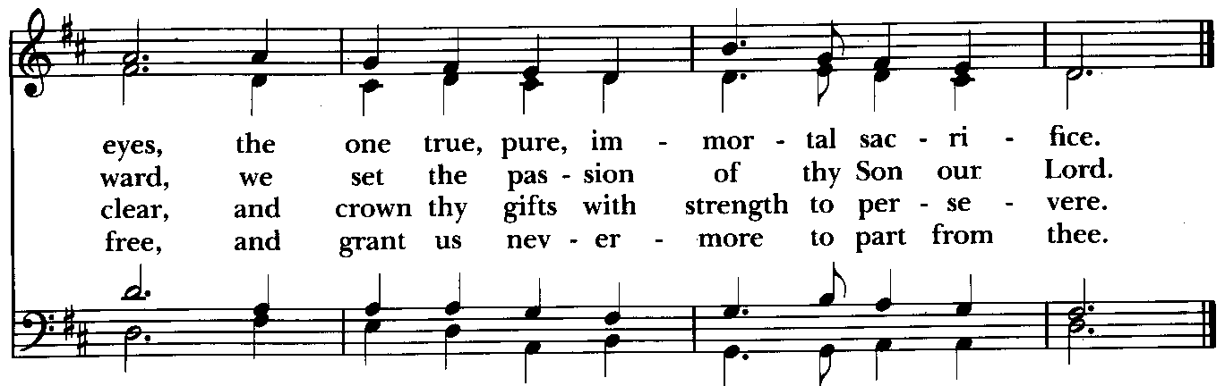

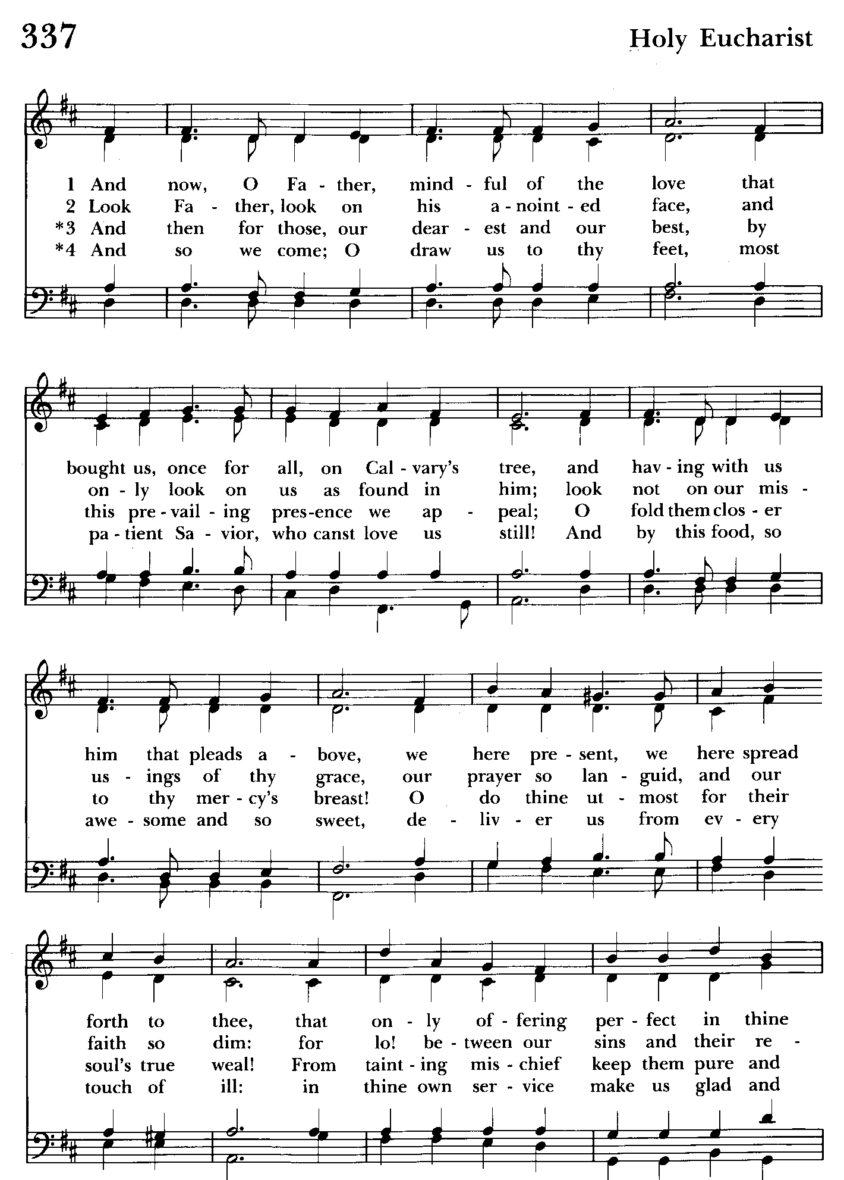

The Post Communion Prayer BCP 365
Eternal God, heavenly Father, you have graciously accepted us as living members of your Son our Savior Jesus Christ, and you have fed us with spiritual food in the Sacrament of his Body and Blood. Send us now into the world in peace, and grant us strength and courage to love and serve you with gladness and singleness of heart; through Christ our Lord. Amen.

The Solemn Prayer over the People
Almighty God, we pray you graciously to behold this your family, for whom our Lord Jesus Christ was willing to be betrayed, and given into the hands of sinners, and to suffer death upon the cross; who lives and reigns for ever and ever. Amen.

Closing Hymn: Ride on, ride on in majesty Hymnal #156
(see next page)

The Dismissal

License #A-719154
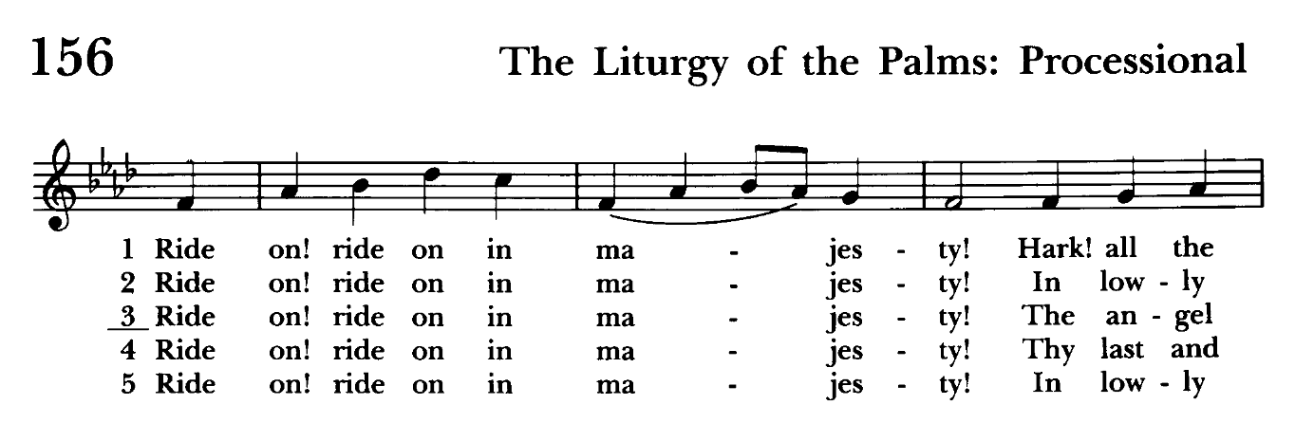

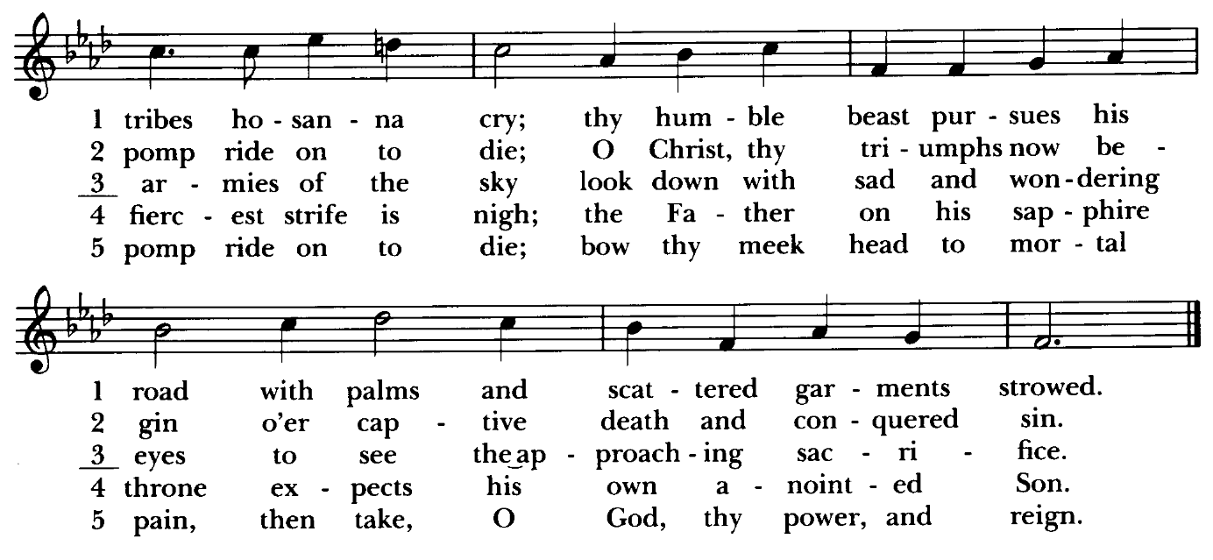

Serving Today:
Celebrant & Preacher: Rev. Mark Lobb+
Old Testament: John Stevens
Psalm: John Stevens
New Testament: Anne Leland
Narrative Readers: Prayers of the People: John Frost
Server: Marguerite Lobb
Organist/Choir Director: Nancy Heinold
Choir: Nancy Dellinger, Anne Leland, Liz Healey,
Karen Smith-Manar, Ty Schwenk
Bells: Nanci Rosendale, John Stevens
Altar Guild: Liz Healey & Marguerite Lobb

St. John’s Parish Prayer List

Additions and corrections may be made to our Parish Prayer List at any time. All names will be automatically removed from the Parish Prayer List on the 1st Sunday of each month unless you request otherwise. Please contact Angie at <office@stjohnskingsville.org> or 410-592-8570 in the church office with all changes by 10 am Thursdays. Thank you.

We Pray for Those in Need:
Names in BOLD read aloud by all.

DeMarino Family, Jim & Chris Carden and family, Peggie Dietz, Mike Carden, Pat Carden, Gail Landers, Sheila Jones, Gloria Millar, Marisol Aubrey, Ross Strickler, Jim and Janice Sieracki, James Daniel Jr, Larry Betzler, Camy Schwenk, Dennis Mally, Zach Walsh, Eileen Weimer, David Harris, Linda Posten, Bill Hoffman & Family, Deb Melcher, Emily Lobb, Bri Del Pilar, Paul Leamer, Janine Stevens.

We Pray for our Homebound

Lily John, Barbara Miller, Nancy Barnhart, Robin Dilworth

We pray for the Church and the World:

For +Sean, our Presiding Bishop; for +Carrie, our Bishop, for Mark+, our Priest in Charge, for the Wardens, Vestry, Staff, and all members and friends of St. John’s Church.

For the leaders of all nations, especially for Donald, our President; for Wes, our Governor; for Brandon, Kathy and Bob, who lead our City and Counties. We pray for all children and youth; for the homeless, the unemployed, and the hungry. We pray for the safety of our loved ones and friends serving in the Armed Forces at home and abroad, and for our enemies, that all our hearts may be turned toward peace throughout the world.

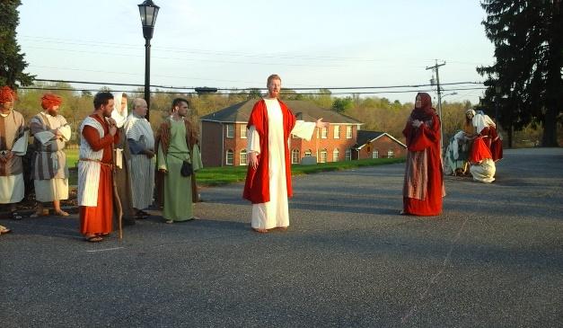

Good News! The Passion Play of years ago is back again! The play is today at dusk. We need folks to participate.

From the Treasurer
April ‘25 Income vs. Expenses:

Projected April Expenses: $14,000
Monies Received as of 4/10: $ 6,588

Amount Needed to Meet Expenses: $ 7,412

March Income Vs. Expenses Recap:
Total March Income: $16,068

2/28 Bingo Proceeds: $ 3,957


If you’d like to make a donation to St. John’s you can scan this QR code with your phone’s camera or tap on the link that comes up to make a contribution with either a credit or debit card, Apple Pay or Google Pay. This is a secure site provided by Clover which is a service of PNC Bank.

Community Good Friday Cross Walk


Friday, April 18, 2025 1:00 P.M.
All are welcome to join the Kingsville/Upper Falls area churches for our annual Community Crosswalk. Walk begins at Franklinville Presbyterian Church (11846 Franklinville Rd, Kingsville) proceeds along Franklinville Rd to
Bradshaw Rd.

Parking is available at Salem UMC, 7901 Bradshaw Rd or St. Stephen, 8030 Bradshaw Rd.

ChoiR
Choir practice, Wednesdays at 7:00 pm
If anyone is interested in joining, see Nancy Heinold, our Choir Director.

Yoga classes on Saturday mornings 9 to 10 am in the Chapel.
All experience levels are welcome.


SUNDAY SCHOOL
10:30: Kids Sunday School- Begin in the church, ring the bell, then process over to the parish hall for a fun lesson with Mr. John and Ms. Stephanie.
Note: Please seriously consider regular attendance at Sunday School so that Mr. John and Ms. Stephanie can plan good stuff.

Calendar Updates

HOLY WEEK
April 13 - Palm Sunday, 8 & 10:30 services
April 17 - Maundy Thursday, 7 pm service
April 18 - Good Friday Crosswalk, 1 pm
All are welcome to join the Kingsville/Upper Falls area churches for our annual Community Crosswalk. Walk begins at Franklinville Presbyterian Church (11846 Franklinville Rd, Kingsville) proceeds along Franklinville Rd to Bradshaw Rd.
Parking is available at Salem UMC, 7901 Bradshaw Rd or St. Stephen, 8030 Bradshaw Rd.
April 18 - Good Friday , 7 pm service
April 20 - Easter Sunday, 8 & 10:30 services
Easter Egg Hunt after the 10:30 service

Calendars are living documents. Every effort will be made to keep the members of the parish and community aware of any changes.


Easter Egg Hunt
Easter Sunday
after the 10:30 service.


God’s Grace Gardens
A collaboration of St. John’s, Hill and Stream Garden Club and AA is beginning an “Adopt-A-Garden” program for the various garden plots on St. John’s Campus.

So grab your gloves as 16 garden areas (some quite small) are up for “Adoption”. GGG will take care of shrub and tree trimming and provide mulch. Most gardens
only require weeding and mulching, not planting.

If you enjoy working with your hands, or just want to learn how to tend God’s good earth, see Karen or Anne.

Let’s make St. John’s campus a place of beauty and peace for the Kingsville community!

Wish List: Large watering cans.
God’s Grace Gardens is thankful for the generous donation of a wagon by a faithful parishioner!

AUXILIARY NOTES
Starting Monday April 21 please bring your gently used items to donate for the flea market no clothes please.
Tables will be set up in the back of the hall.
Mark your calendars Auxiliary meeting on Sunday April 27 after the 10:30 service.
We need everyone's help. We will be discussing the flea market on Saturday May 17 and the next bingos. If you want to help and you can't make the meeting please call Michele at 443-463-6333.

What’s Happening This Week at St. John’s

Sunday, April 13—PALM SUNDAY
8:00am: Holy Eucharist Rite I, Said Service (Church)
10:30am: Holy Eucharist Rite II, with Music
((begins in Parish Hall-weather permitting)
11:30am: Coffee Hour

Monday, April 14
12:00-1:00pm: AA Lunch Bunch (Parish Hall)

Tuesday, April 15
12:00-1:00pm: AA Lunch Bunch (Parish Hall)

Wednesday, April 16
12:00-1:00pm: AA Lunch Bunch (Parish Hall)
7:00-8:30pm: Choir Rehearsal (Church)
7:30pm: AA (Parish Hall)

Thursday, April 17
12:00-1:00pm: AA Lunch Bunch (Parish Hall)
7:00pm: Maundy Thursday Service (Church)
7:00pm: AA (Parish Hall)

Friday, April 18
12:00-1:00pm: AA Lunch Bunch (Parish Hall)
1:00pm: Good Friday Community Crosswalk
7:00pm: Good Friday Service (Church)

Saturday, April 19
9:00am-10:00am: Yoga (Chapel)
8:30pm: AA (Parish Hall)

Sunday, April 20—EASTER SUNDAY
8:00am: Holy Eucharist Rite I, Said Service (Church)
10:30am: Holy Eucharist Rite II, with Music (Church)
11:30am: EASTER EGG HUNT

Parish Office is open Monday, Wednesday and Thursday, 9:30am-1:30pm.

Potluck Luncheon on the first Sunday of the month and a Coffee Hour on all other Sundays after the 10:30 service.

