St. John’s Episcopal Church
Kingsville, Maryland
Welcomes You

OUR VISION STATEMENT
We believe that together we will transform the world with love: Come on in!

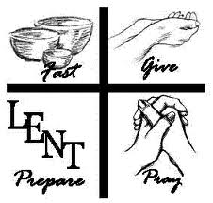

Third Sunday in Lent
March 23, 2025
10:30 am, Rite II

St. John’s Episcopal Church

11901 Belair Road, P. O. Box 187, Kingsville, MD 21087
Facebook: St. John’s Episcopal, Kingsville, MD
Email: office@stjohnskingsville.org
Website: www.stjohnskingsville.org
Church Phone: 410-592-8570
For Pastoral Emergencies: Fr. Mark Lobb+ 443-690-9545

Welcome to worship today! We are glad that you are with us. You are invited to participate in all parts of the service as indicated in the Book of Common Prayer and this service bulletin. If you have any questions, feel free to ask the ushers. Restrooms are located in the Parish hall, the brick building across the parking lot.

I was glad when they said to me, “Let us go to the house of the Lord.” Psalm 122:1

Church Staff

Priest in Charge: Father Mark Lobb
Administrative Assistant: Angie Bosley
Organist/Choir Director: Nancy Heinold

The Vestry

Class of 2026 Class of 2027

John Stevens John Frost
Jacob Johnson Stephanie White

Officers
Ty Schwenk—Sr. Warden Terry Roe—Jr. Warden
Elizabeth Healey—Treasurer Anne Leland-Registrar

Parish Committee Chairpersons

Altar Guild: Elizabeth Healey
Auxiliary Committee: Michele Lozanski
Cemetery Committee: Karen Smith-Manar

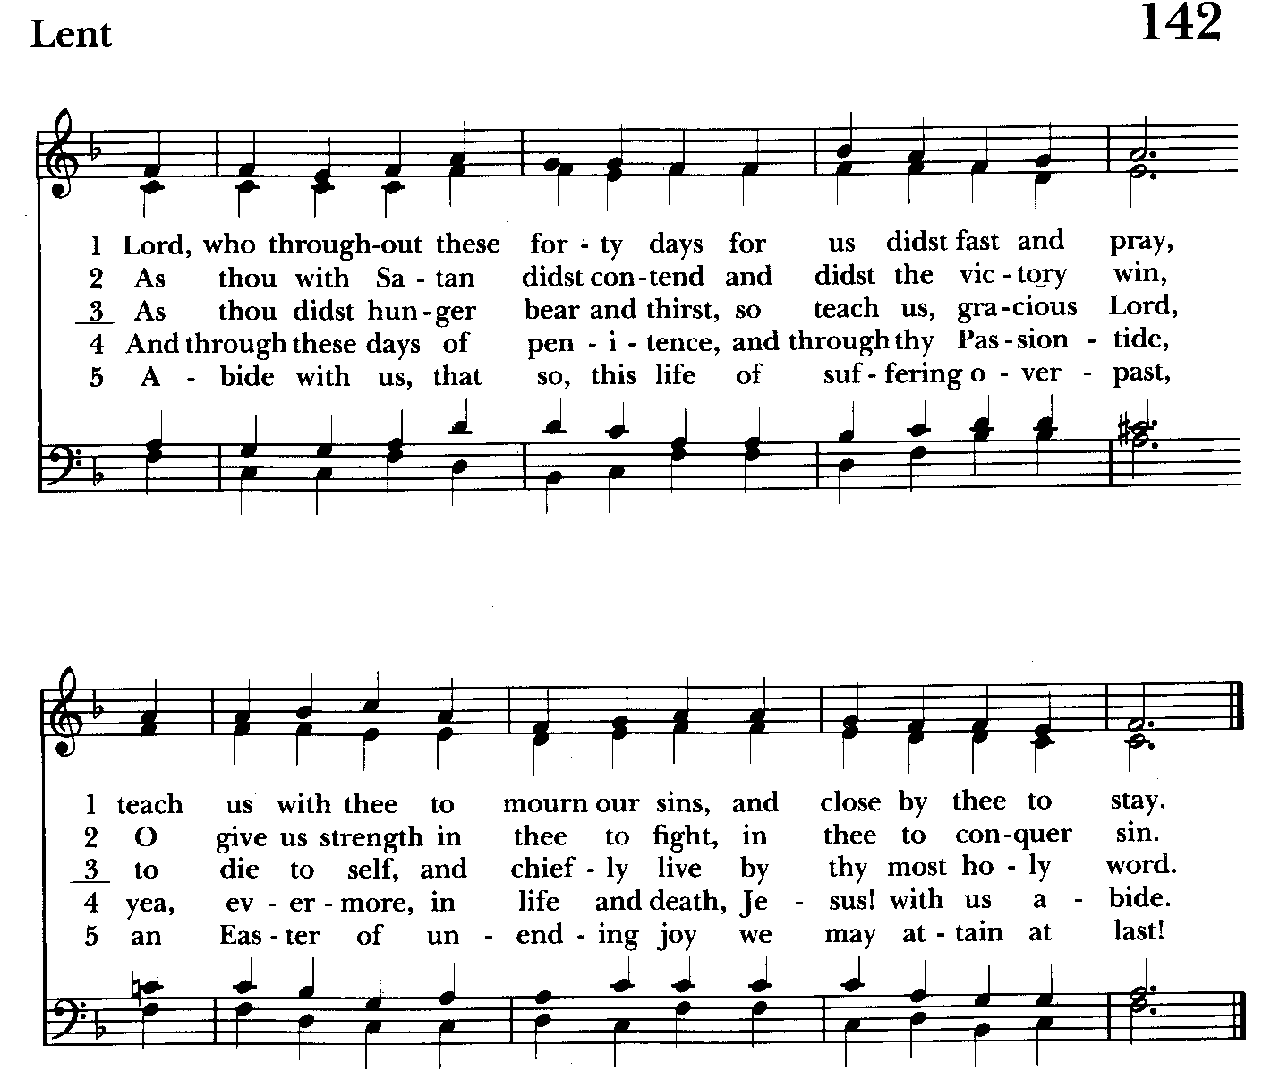

10:30 am Worship
Holy Eucharist, Rite Two

Prelude:
The Word of God

Processional hymn: Lord, who throughout these forty days Hymnal #142
(see previous page)

The congregation remains standing as able

Celebrant: Bless the Lord who forgives all our sins.
People: His mercy endures for ever.

The Decalogue Please kneel or stand as able BCP 350
Celebrant: Hear the commandments of God to his people: I am the Lord your God who brought you out of bondage. You shall have no other gods but me.
People: Amen. Lord have mercy.

Celebrant: You shall not make for yourself any idol.
People: Amen. Lord have mercy.

Celebrant: You shall not invoke with malice the Name of the Lord your God.
People: Amen. Lord have mercy.

Celebrant: Remember the Sabbath day and keep it holy.
People: Amen. Lord have mercy.

Celebrant: Honor your father and your mother.
People: Amen. Lord have mercy.

Celebrant: You shall not commit murder.
People: Amen. Lord have mercy.

Celebrant: You shall not commit adultery.
People: Amen. Lord have mercy.

Celebrant: You shall not steal.
People: Amen. Lord have mercy.

Celebrant: You shall not be a false witness.
People: Amen. Lord have mercy.

Celebrant: You shall not covet anything that belongs to your neighbor.
People: Amen. Lord have mercy.

A Penitential Order - Rite II BCP 352

Celebrant: If we say that we have no sin, we deceive ourselves, and the truth is not in us; but if we confess our sins, God is faithful and just to forgive us our sins, and to cleanse us from all unrighteousness. 1 John 1:8, 9

Let us confess our sins against God and our neighbor.

Celebrant and People: Most merciful God, we confess that we have sinned against you in thought, word, and deed, by what we have done, and by what we have left undone. We have not loved you with our whole heart; we have not loved our neighbors as ourselves. We are truly sorry and we humbly repent. For the sake of your Son Jesus Christ, have mercy on us and forgive us; that we may delight in your will, and walk in your ways, to the glory of your Name. Amen.

Celebrant: Almighty God have mercy on you, forgive you all your sins through our Lord Jesus Christ, strengthen you in all goodness, and by the power of the Holy Spirit keep you in eternal life. Amen.

Kyrie Eleison Hymnal #S-86
Kyrie eleison. Kyrie eleison. Kyrie eleison.
Christe eleison. Christe eleison. Christe eleison.
Kyrie eleison Kyrie eleison. Kyrie eleison..

Celebrant: The Lord be with you.
People: And also with you.
Celebrant: Let us pray.

The Collect of the Day BCP 218
Almighty God, you know that we have no power in ourselves to help ourselves: Keep us both outwardly in our bodies and inwardly in our souls, that we may be defended from all adversities which may happen to the body, and from all evil thoughts which may assault and hurt the soul; through Jesus Christ our Lord, who lives and reigns with you and the Holy Spirit, one God, for ever and ever. Amen.

The congregation is seated.

A Reading from the Book of Exodus 3:1-15
Moses was keeping the flock of his father-in-law Jethro, the priest of Midian; he led his flock beyond the wilderness, and came to Horeb, the mountain of God. There the angel of the Lord appeared to him in a flame of fire out of a bush; he looked, and the bush was blazing, yet it was not consumed. Then Moses said, “I must turn aside and look at this great sight, and see why the bush is not burned up.” When the Lord saw that he had turned aside to see, God called to him out of the bush, “Moses, Moses!” And he said, “Here I am.” Then he said, “Come no closer! Remove the sandals from your feet, for the place on which you are standing is holy ground.” He said further, “I am the God of your father, the God of Abraham, the God of Isaac, and the God of Jacob.” And Moses hid his face, for he was afraid to look at God.
Then the Lord said, “I have observed the misery of my people who are in Egypt; I have heard their cry on account of their taskmasters. Indeed, I know their sufferings, and I have come down to deliver them from the Egyptians, and to bring them up out of that land to a good and broad land, a land flowing with milk and honey, to the country of the Canaanites, the Hittites, the Amorites, the Perizzites, the Hivites, and the Jebusites. The cry of the Israelites has now come to me; I have also seen how the Egyptians oppress them. So come, I will send you to Pharaoh to bring my people, the Israelites, out of Egypt.” But Moses said to God, “Who am I that I should go to Pharaoh, and bring the Israelites out of Egypt?” He said, “I will be with you; and this shall be the sign for you that it is I who sent you: when you have brought the people out of Egypt, you shall worship God on this mountain.”
But Moses said to God, “If I come to the Israelites and say to them, 'The God of your ancestors has sent me to you,' and they ask me, 'What is his name?' what shall I say to them?” God said to Moses, “I am who I am.” He said further, “Thus you shall say to the Israelites, 'I am has sent me to you.'” God also said to Moses, “Thus you shall say to the Israelites, 'The Lord, the God of your ancestors, the God of Abraham, the God of Isaac, and the God of Jacob, has sent me to you':
This is my name forever,
and this my title for all generations.”
Reader: The Word of the Lord.
People: Thanks be to God.

Psalm 63:1-8 (Pray as directed) BCP 670
1 O God, you are my God; eagerly I seek you; *
my soul thirsts for you, my flesh faints for you,
as in a barren and dry land where there is no water.
2 Therefore I have gazed upon you in your holy place, *
that I might behold your power and your glory.
3 For your loving-kindness is better than life itself; *
my lips shall give you praise.
4 So will I bless you as long as I live *
and lift up my hands in your Name.
5 My soul is content, as with marrow and fatness, *
and my mouth praises you with joyful lips,
6 When I remember you upon my bed, *
and meditate on you in the night watches.
7 For you have been my helper, *
and under the shadow of your wings I will rejoice.
8 My soul clings to you; *
your right hand holds me fast.

A Reading from the First Letter of St. Paul to the Corinthians 10:1-13
I do not want you to be unaware, brothers and sisters, that our ancestors were all under the cloud, and all passed through the sea, and all were baptized into Moses in the cloud and in the sea, and all ate the same spiritual food, and all drank the same spiritual drink. For they drank from the spiritual rock that followed them, and the rock was Christ. Nevertheless, God was not pleased with most of them, and they were struck down in the wilderness.
Now these things occurred as examples for us, so that we might not desire evil as they did. Do not become idolaters as some of them did; as it is written, "The people sat down to eat and drink, and they rose up to play." We must not indulge in sexual immorality as some of them did, and twenty-three thousand fell in a single day. We must not put Christ to the test, as some of them did, and were destroyed by serpents. And do not complain as some of them did, and were destroyed by the destroyer. These things happened to them to serve as an example, and they were written down to instruct us, on whom the ends of the ages have come. So if you think you are standing, watch out that you do not fall. No testing has overtaken you that is not common to everyone. God is faithful, and he will not let you be tested beyond your strength, but with the testing he will also provide the way out so that you may be able to endure it.

Reader: The Word of the Lord.
People: Thanks be to God.

Gradual hymn: When Israel was in Egypt’s land Hymnal #648
(see next page)
The congregation remains standing as able

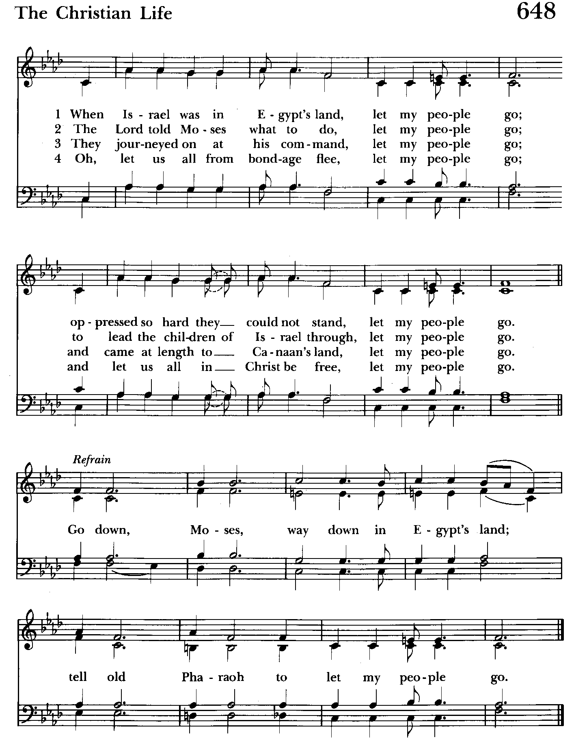

Priest: The Holy Gospel of our Lord Jesus Christ according to Luke 13:1-9
People: Glory to you, Lord Christ.
At that very time there were some present who told Jesus about the Galileans whose blood Pilate had mingled with their sacrifices. He asked them, "Do you think that because these Galileans suffered in this way they were worse sinners than all other Galileans? No, I tell you; but unless you repent, you will all perish as they did. Or those eighteen who were killed when the tower of Siloam fell on them--do you think that they were worse offenders than all the others living in Jerusalem? No, I tell you; but unless you repent, you will all perish just as they did."
Then he told this parable: "A man had a fig tree planted in his vineyard; and he came looking for fruit on it and found none. So he said to the gardener, 'See here! For three years I have come looking for fruit on this fig tree, and still I find none. Cut it down! Why should it be wasting the soil?' He replied, 'Sir, let it alone for one more year, until I dig around it and put manure on it. If it bears fruit next year, well and good; but if not, you can cut it down.'"

Priest: The Gospel of the Lord.
People: Praise to you, Lord Christ.

Sermon The congregation is seated Rev. Mark Lobb

The Nicene Creed Please stand as able BCP 358
We believe in one God,
the Father, the Almighty,
maker of heaven and earth,
of all that is, seen and unseen.
We believe in one Lord, Jesus Christ,
the only Son of God,
eternally begotten of the Father,
God from God, Light from Light,
true God from true God,
begotten, not made,
of one Being with the Father.
Through him all things were made.
For us and for our salvation
he came down from heaven:
by the power of the Holy Spirit
he became incarnate from the Virgin Mary,
and was made man.
For our sake he was crucified under Pontius Pilate;
he suffered death and was buried.
On the third day he rose again
in accordance with the Scriptures;
he ascended into heaven
and is seated at the right hand of the Father.
He will come again in glory to judge the living and the dead,
and his kingdom will have no end.
We believe in the Holy Spirit, the Lord, the giver of life,
who proceeds from the Father and the Son.
With the Father and the Son he is worshiped and glorified.
He has spoken through the Prophets.
We believe in one holy catholic and apostolic Church.
We acknowledge one baptism for the forgiveness of sins.
We look for the resurrection of the dead,
and the life of the world to come. Amen.

The Prayers of the People Form IV Kneel or stand as able BCP 388
Litanist:: Let us pray for the Church and for the world. Grant, Almighty God, that all who confess your Name may be united in your truth, live together in your love, and reveal your glory in the world.

Silence

Litanist: Lord, in your mercy
People: Hear our prayer.

Litanist: Guide the people of this land, and of all the nations, in the ways of justice and peace; that we may honor one another and serve the common good.

Silence

Litanist: Lord, in your mercy
People: Hear our prayer.

Litanist: Give us all a reverence for the earth as your own creation, that we may use its resources rightly in the service of others and to your honor and glory.

Silence
Litanist: Lord, in your mercy
People: Hear our prayer.

Litanist: Bless all whose lives are closely linked with ours, and grant that we may serve Christ in them, and love one another as he loves us.

Silence

Litanist: Lord, in your mercy
People: Hear our prayer.

Litanist: Comfort and heal all those who suffer in body, mind, or spirit; give them courage and hope in their troubles, and bring them the joy of your salvation.

Silence

Litanist: Lord, in your mercy
People: Hear our prayer.

Litanist: We commend to your mercy all who have died, that your will for them may be fulfilled; and we pray that we may share with all your saints in your eternal kingdom.

Silence

Litanist: Lord, in your mercy
People: Hear our prayer.

Celebrant: O Lord our God, accept the fervent prayers of your people; in the multitude of your mercies, look with compassion upon us and all who turn to you for help; for you are gracious, O lover of souls, and to you we give glory, Father, Son, and Holy Spirit, now and for ever. Amen.

For the leaders of all nations, especially for Donald, our President; for Wes, our Governor; for Brandon, Kathy and Bob, who lead our City and Counties. We pray for all children and youth; for the homeless, the unemployed, and the hungry. We pray for the safety of our loved ones and friends serving in the Armed Forces at home and abroad, and for our enemies, that all our hearts may be turned toward peace throughout the world.

Litanist: For the special needs and concerns of this congregation. Especially remember in our prayers, DeMarino Family, Jim & Chris Carden and family, Peggie Dietz, Mike Carden, Pat Carden, Gail Landers, Sheila Jones, Gloria Millar, Marisol Aubrey, Ross Strickler, Jim & Janice Sieracki, James Daniel Jr., Larry Betzler, Camy Schwenk, Dennis Mally, Zach Walsh, Lily John, Barbara Miller, Nancy Barnhart, Robin Dilworth, Eileen Weimer, David Harris, Linda Posten, Bill Hoffman & Family, Deb Melcher, Emily Lobb, Bri Del Pilar, Paul Leamer, Janine Stevens.

The People may add their own petitions

Litanist: Hear us, Lord;
People: For your mercy is great.
Litanist: We thank you, Lord, for all the blessings of this life.

The People may add their own thanksgivings

Litanist: We will exalt you, O God our King;
People: And praise your Name for ever and ever.

The People may add their own petitions

The Peace Please stand as able BCP 360

Welcome & Announcements The congregation is seated.

Offertory Anthem: As You Will (Choir)

Offertory hymn: What wondrous love is this Hymnal #439
(see next 2 pages)

The people remain seated while offerings are collected.

Presentation Hymn Offerings are presented Please stand as able Hymnal #43, vs. 4
Praise God, from whom all blessings flow; praise him, all creatures here below; praise him above, ye heavenly host: praise Father, Son, and Holy Ghost.

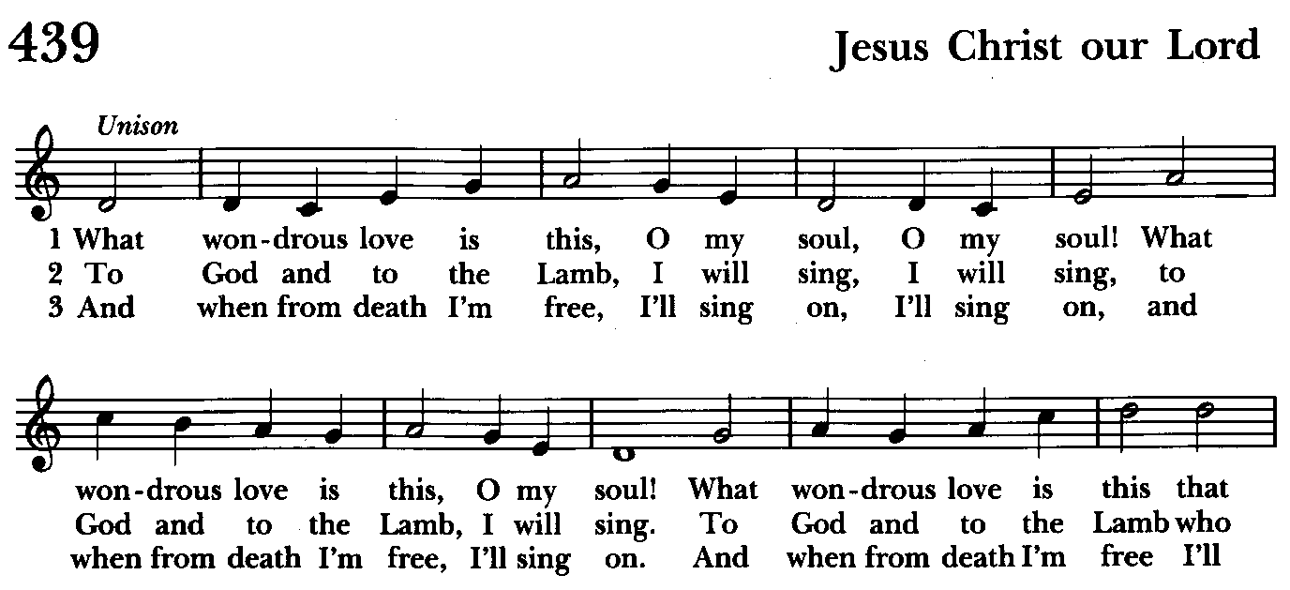

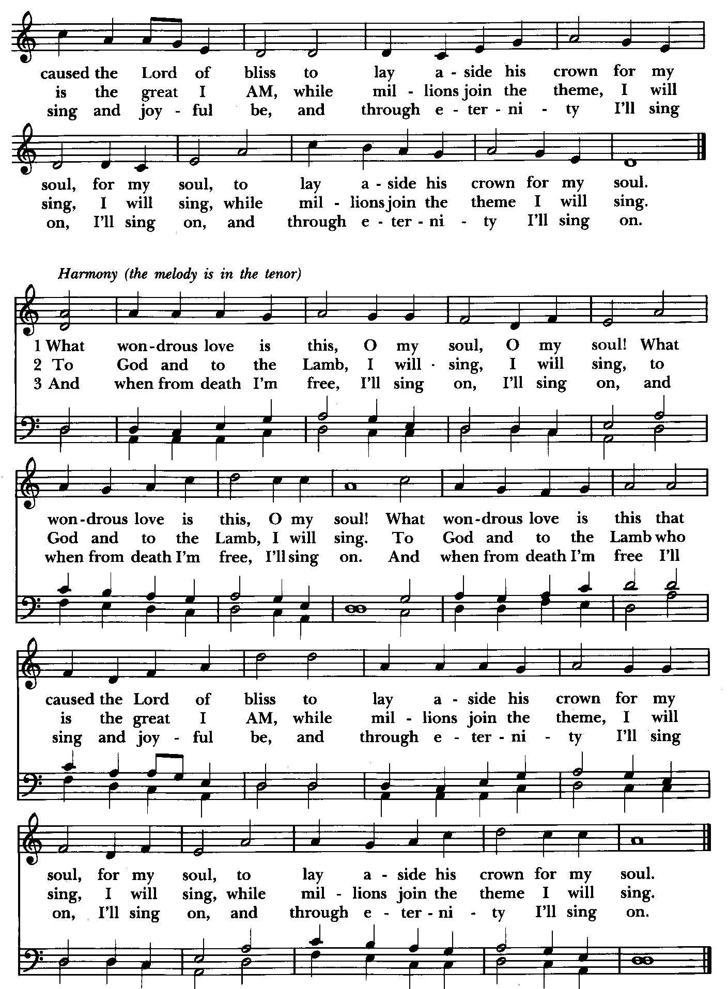

The Holy Communion

THE GREAT THANKSGIVING: Eucharistic Prayer A BCP 361
The people remain standing.
Celebrant: The Lord be with you.
People: And also with you.
Celebrant: Lift up your hearts.
People: We lift them to the Lord.
Celebrant: Let us give thanks to the Lord our God.
People: It is right to give him thanks and praise.

Celebrant: It is right, and a good and joyful thing, always and everywhere to give thanks to you, Father Almighty, Creator of heaven and earth.

Therefore we praise you, joining our voices with Angels and Archangels and with all the company of heaven, who for ever sing this hymn to proclaim the glory of your Name:

Celebrant and People
Holy, holy, holy Lord, God of power and might, Hymnal #S-124
heaven and earth are full of your glory.
Hosanna in the highest. Hosanna in the highest.
Blessed is he who comes in the name of the Lord.
Hosanna in the highest. Hosanna in the highest.

The people stand or kneel.
Celebrant: Holy and gracious Father: In your infinite love you made us for yourself; and, when we had fallen into sin and become subject to evil and death, you, in your mercy, sent Jesus Christ, your only and eternal Son, to share our human nature, to live and die as one of us, to reconcile us to you, the God and Father of all. He stretched out his arms upon the cross, and offered himself in obedience to your will, a perfect sacrifice for the whole world.
On the night he was handed over to suffering and death, our Lord Jesus Christ took bread; and when he had given thanks to you, he broke it, and gave it to his disciples, and said, “Take, eat: This is my Body, which is given for you. Do this for the remembrance of me.”

After supper he took the cup of wine; and when he had given thanks, he gave it to them, and said, “Drink this, all of you: This is my Blood of the new Covenant, which is shed for you and for many for the forgiveness of sins. Whenever you drink it, do this for the remembrance of me.”

Therefore we proclaim the mystery of faith:

Celebrant and People
Christ has died.
Christ is risen.
Christ will come again.

Celebrant: We celebrate the memorial of our redemption, O Father, in this sacrifice of praise and thanksgiving. Recalling his death, resurrection, and ascension, we offer you these gifts. Sanctify them by your Holy Spirit to be for your people the Body and Blood of your Son, the holy food and drink of new and unending life in him. Sanctify us also that we may faithfully receive this holy Sacrament, and serve you in unity, constancy, and peace; and at the last day bring us with all your saints into the joy of your eternal kingdom. All this we ask through your Son Jesus Christ. By him, and with him, and in him, in the unity of the Holy Spirit all honor and glory is yours, Almighty Father, now and for ever. Amen.

And now, as our Savior As our Savior Christ has taught us, we are bold to say,
Celebrant and People
Our Father, who art in heaven, Our Father in heaven,
hallowed be thy Name, hallowed be your Name,
thy kingdom come, your kingdom come,
thy will be done, your will be done,
on earth as it is in heaven. on earth as in heaven.
Give us this day our daily bread. Give us today our daily bread.
And forgive us our trespasses, Forgive us our sins
as we forgive those as we forgive those
who trespass against us. who sin against us.
And lead us not into temptation, Save us from the time of trial,
but deliver us from evil. and deliver us from evil.
For thine is the kingdom, For the kingdom, the power,
and the power, and the glory, and the glory are yours,
for ever and ever. Amen. now and for ever. Amen.

The Breaking of the Bread
Celebrant: Christ our Passover is sacrificed for us;
People: Therefore let us keep the feast.

Celebrant: The Gifts of God for the People of God.
The Body (Blood) of our Lord Jesus Christ keep you in everlasting life. [Amen.]

Communion hymn: Rock of ages, cleft for me Hymnal #685
(see next page)

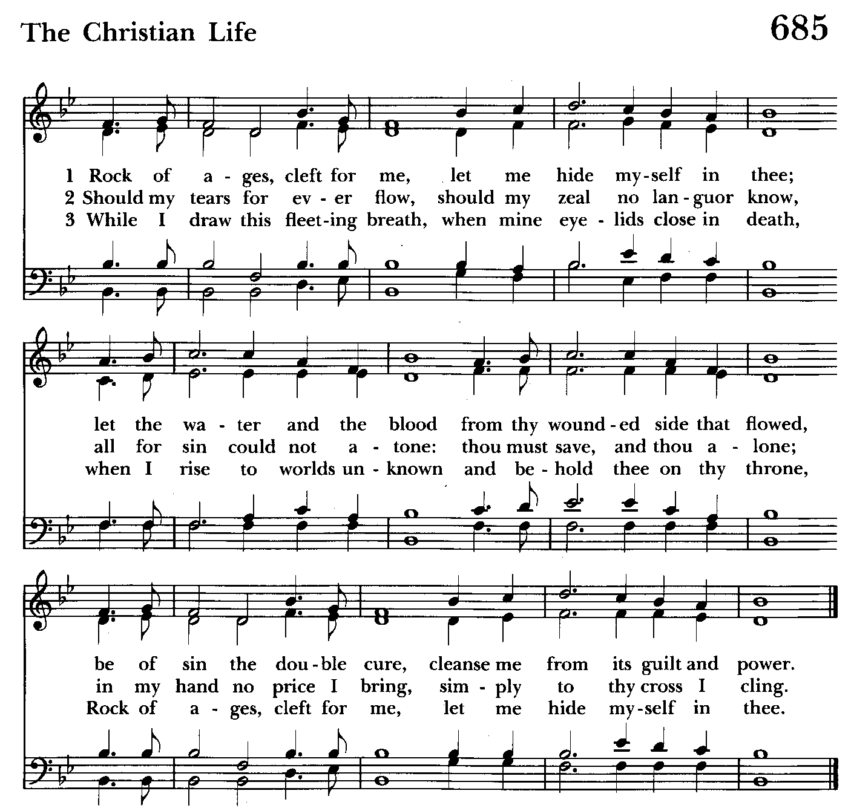

Post Communion Prayer BCP 365
Let us pray.
Celebrant and People
Eternal God, heavenly Father, you have graciously accepted us as living members of your Son our Savior Jesus Christ, and you have fed us with spiritual food in the Sacrament of his Body and Blood. Send us now into the world in peace, and grant us strength and courage to love and serve you with gladness and singleness of heart; through Christ our Lord. Amen.

Recessional hymn: Lord, dismiss us with thy blessing Hymnal #344
(see next page)

The Dismissal
Celebrant: Go in peace to love and serve the Lord.
People: Thanks be to God.

Postlude:

License #A-719154

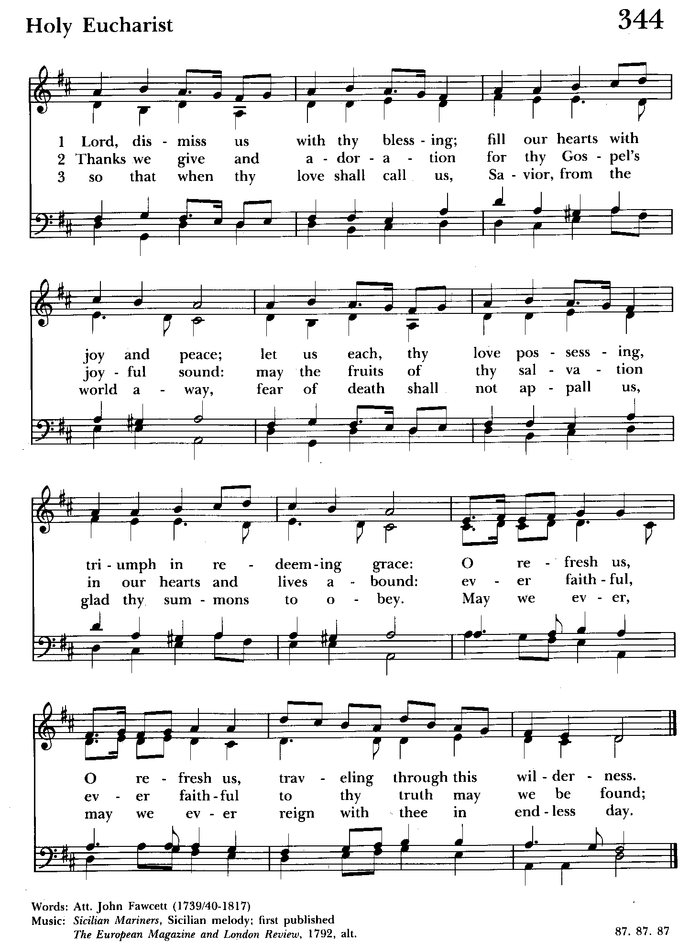

Serving Today

Celebrant and Preacher: Rev. Mark Lobb
Old Testament: Michele Lozanski
Psalm: Michele Lozanski
New Testament: Tony Rising
Prayers of the People: John Frost
Server: Marguerite Lobb
Music Director: Nancy Heinold
Choir: Anne Leland, Nancy Dellinger, Liz Healey,
Karen Smith-Manar, Ty Schwenk,
Altar Guild: John Stevens & Woodie Tingle

St. John’s Parish Prayer List

Additions and corrections may be made to our Parish Prayer List at any time. All names will be automatically removed from the Parish Prayer List on the 1st Sunday of each month unless you request otherwise. Please contact Angie at <office@stjohnskingsville.org> or 410-592-8570 in the church office with all changes by 10 am Thursdays. Thank you.

We Pray for Those in Need:
Names in BOLD read aloud by all.

DeMarino Family, Jim & Chris Carden and family, Peggie Dietz, Mike Carden, Pat Carden, Gail Landers, Sheila Jones, Gloria Millar, Marisol Aubrey, Ross Strickler, Jim and Janice Sieracki, James Daniel Jr, Larry Betzler, Camy Schwenk, Dennis Mally, Zach Walsh, Eileen Weimer, David Harris, Linda Posten, Bill Hoffman & Family, Deb Melcher, Emily Lobb, Bri Del Pilar, Paul Leamer, Janine Stevens.

We Pray for our Homebound

Lily John, Barbara Miller, Nancy Barnhart, Robin Dilworth

We pray for the Church and the World:

For +Sean, our Presiding Bishop; for +Carrie, our Bishop, for Mark+, our Priest in Charge, for the Wardens, Vestry, Staff, and all members and friends of St. John’s Church.

For the leaders of all nations, especially for Donald, our President; for Wes, our Governor; for Brandon, Kathy and Bob, who lead our City and Counties. We pray for all children and youth; for the homeless, the unemployed, and the hungry. We pray for the safety of our loved ones and friends serving in the Armed Forces at home and abroad, and for our enemies, that all our hearts may be turned toward peace throughout the world.

From the Treasurer
March ‘25 Income vs. Expenses:
Projected March Expenses: $15,000
Monies Received as of 3/20: $12,283
Amount Needed to Meet Expenses: $2,717

If you’d like to make a donation to St. John’s you can scan this QR code with your phone’s camera or tap on the link that comes up to make a contribution with either a credit or debit card, Apple Pay or Google Pay. This is a secure site provided by Clover which is a service of PNC Bank.

Calendar Updates

March 27 - Johnson/Thompson Wedding at St. John’s, 2 pm
April 5 - Church Clean Up, 9 am
April 13 - Palm Sunday, 8 & 10:30 services
April 17 - Maundy Thursday, 7 pm service
April 18 - Good Friday Crosswalk, 1 pm (more details to follow)
April 18 - Good Friday , 7 pm service
April 20 - Easter Sunday, 8 & 10:30 services

Calendars are living documents. Every effort will be made to keep the members of the parish and community aware of any changes.


With so much going on, everyone’s help is needed to make events a success. Our volunteers make the Church function. The volunteering of time and talent is greatly appreciated.

RECYCLING!

Our recycling can is getting dry and lonely. Please send him a friend.

By popular demand, we are recycling. Some parishioners take printed paper home where they have recycling pickup. We now have a blue container located in the Parish Hall. This will be collected and taken for recycling. Aluminum cans will be saved and taken to a recycling center for cash. The proceeds will be donated to the Outreach fund. Each recycled aluminum can also save on the electricity needed to make new aluminum from bauxite.


Choral Choir
Choir rehearsals Wednesdays at 7:00. If anyone is interested in joining, see Nancy Heinold, our Choir Director.

SUNDAY SCHOOL

10:30: Kids Sunday School- Begin in the church, ring the bell, then process over to the parish hall for a fun lesson with Mr. John and Ms. Stephanie.
Note: Please seriously consider regular attendance at Sunday School so that Mr. John and Ms. Stephanie can plan good stuff.


Yoga classes on Wednesday evenings 6 to 7 pm and Saturday mornings 9 to 10 am in the Chapel. All experience levels are welcome.



You are invited to join us for our next Book Study. Wednesday mornings at 9:00 in the Library through Lent. If you need assistance in obtaining a book, contact Fr. Mark or the office.

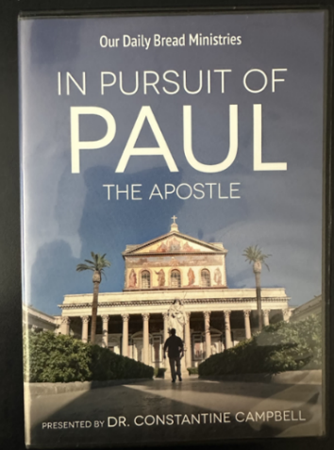
Friday Nights in Lent
Friday nights in Lent have been a good time, however Fr. Mark is asking that if you plan to attend that you RSVP by end of business the Thursday before.

After a light supper and fellowship at 6:30, we will view this contemporary look at the travels of St. Paul. Begins Friday March 7.

Let Us Bake Bread Together!

If you are interested in serving the St. John’s
community with a new Lenten opportunity, join us in baking unleavened bread for our communion service.

No experience necessary! We will provide the recipe and ingredients for our Baking Fellowship get togethers in the Parish Hall Kitchen. You can also bake at home if you prefer.

Contact Karen at (410) 746-9813 to arrange a time that’s
convenient for you.

Then we will


“Break Bread Together on our Knees!”

In our Community
Bible Studies in our area. If interested, please contact these churches to confirm.
St. Mary’s, Abingdon, (410)569-0180- Wednesdays at noon. Bring lunch. Zoom available.
Emmanuel, Bel Air, (410)838-7699- Fridays at 9:30- Zoom Available.
Holy Trinity, Churchville, (410)914-5531- Wednesdays 11:30- Zoom may be available.

What’s Happening This Week at St. John’s

Sunday, March 23—3rd Sunday in Lent
8:00am: Holy Eucharist Rite I, Said Service (Church)
10:30am: Holy Eucharist Rite II, with Music (Church)
11:30am: Coffee Hour
1:00pm: BRIGHTVIEW

Monday, March 24
12:00-1:00pm: AA Lunch Bunch (Parish Hall)

Tuesday, March 25
12:00-1:00pm: AA Lunch Bunch (Parish Hall)

Wednesday, March 26
9:00am: Book Study (Parish Hall)
12:00-1:00pm: AA Lunch Bunch (Parish Hall)
6:00-7:00pm: Yoga (Chapel)
7:00-8:30pm: Choir Rehearsal (Church)
7:30pm: AA (Parish Hall)

Thursday, March 27
12:00-1:00pm: AA Lunch Bunch (Parish Hall)
7:00pm: AA (Parish Hall)

Friday, March 28
12:00-1:00pm: AA Lunch Bunch (Parish Hall)

Saturday, March 29
9:00am-10:00am: Yoga (Chapel)
8:30pm: AA (Parish Hall)

Sunday, March 30—4th Sunday in Lent—MORNING PRAYER
8:00am: Holy Eucharist Rite I, Said Service (Church)
10:30am: Holy Eucharist Rite II, with Music (Church)
11:30am: Coffee Hour

Parish Office is open Monday, Wednesday and Thursday, 9:30am-1:30pm.

Potluck Luncheon on the first Sunday of the month and a Coffee Hour on all other Sundays after the 10:30 service.

