St. John’s Episcopal Church
Kingsville, Maryland
Welcomes You

Our Vision Statement

We believe that together we will transform
the world with love: Come on in!

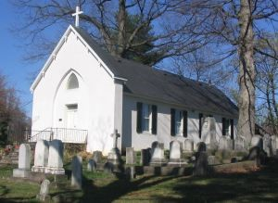

5th Sunday after Epiphany
Morning Prayer Rite II
February 9, 2025—10:30 am

St. John’s Episcopal Church

11901 Belair Road, P. O. Box 187, Kingsville, MD 21087
Facebook: St. John’s Episcopal, Kingsville, MD
Email: office@stjohnskingsville.org
Website: www.stjohnskingsville.org
Church Phone: 410-592-8570
For Pastoral Emergencies: Fr. Mark Lobb+ 443-690-9545

Welcome to worship today! We are glad that you are with us. You are invited to participate in all parts of the service as indicated in the Book of Common Prayer and this service bulletin. If you have any questions, feel free to ask the ushers. Restrooms are located in the Parish Hall, the brick building across the parking lot.

I was glad when they said to me, “Let us go to the house of the Lord.” Psalm 122:1

Church Staff

Priest in Charge: Father Mark Lobb
Administrative Assistant: Angie Bosley
Organist/Choir Director: Nancy Heinold

The Vestry

Class of 2025 Class of 2026

John Frost John Stevens
Jacob Johnson Woodie Tingle

Officers
Ty Schwenk—Sr. Warden Terry Roe—Jr. Warden
Elizabeth Healey—Treasurer Anne Leland-Registrar

Parish Committee Chairpersons

Altar Guild: Elizabeth Healey
Auxiliary Committee: Michele Lozanski
Cemetery Committee: Karen Smith-Manar

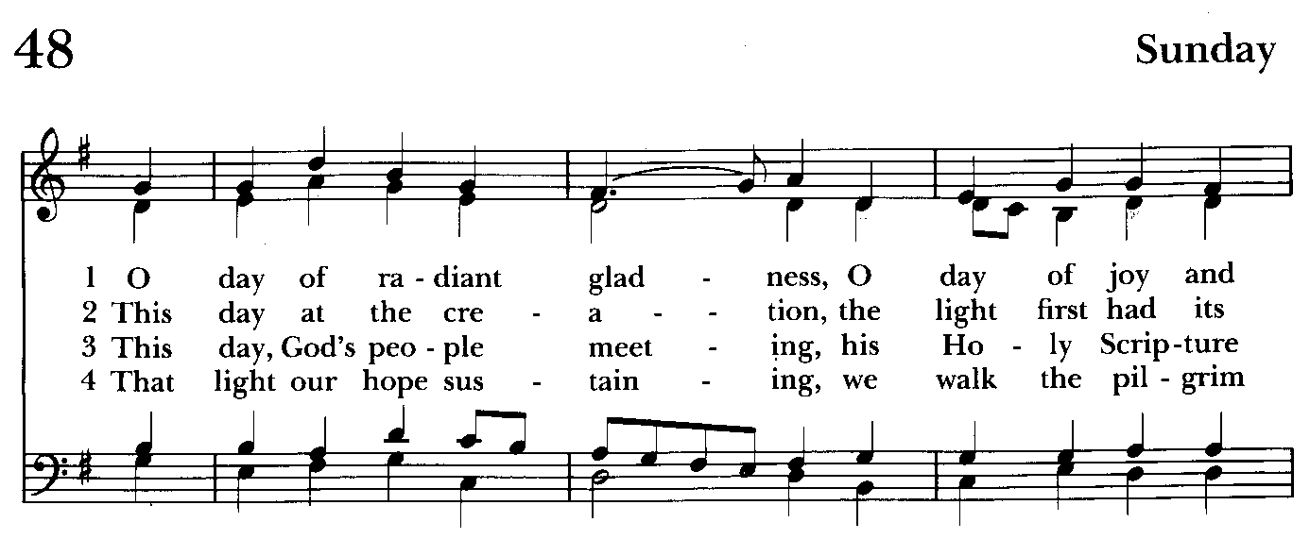

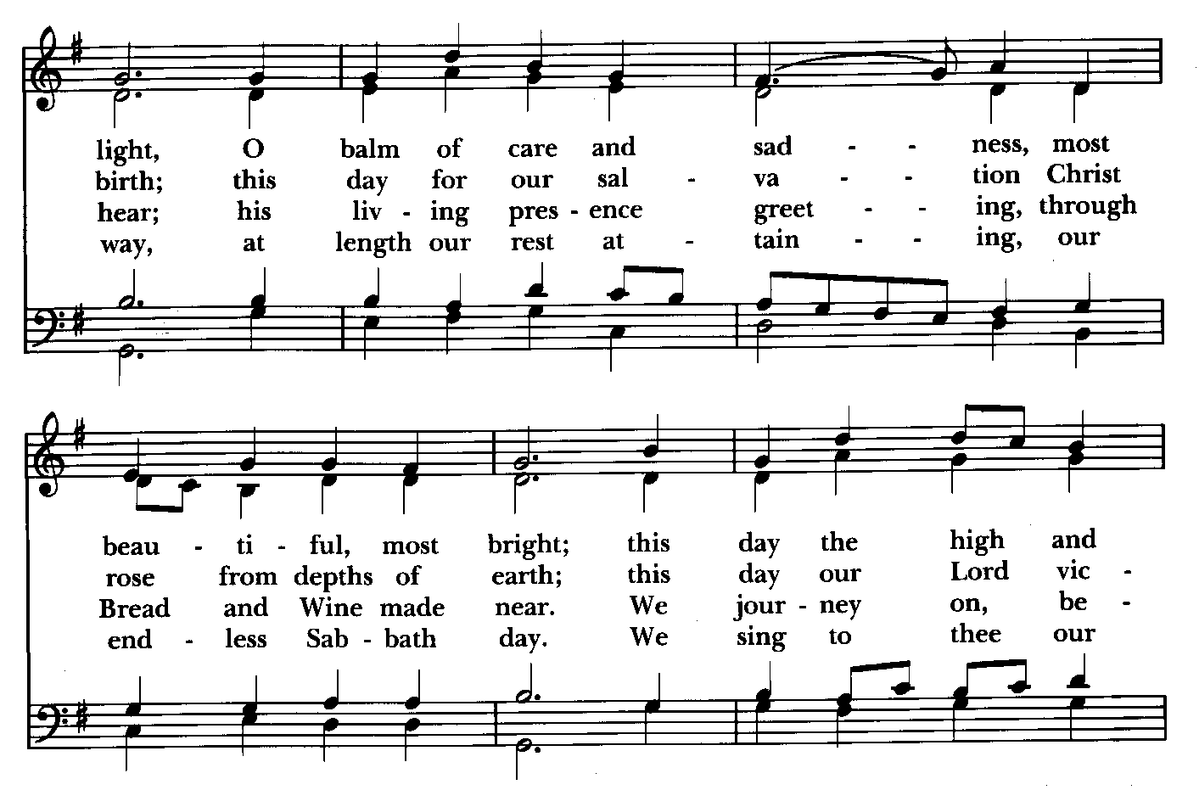

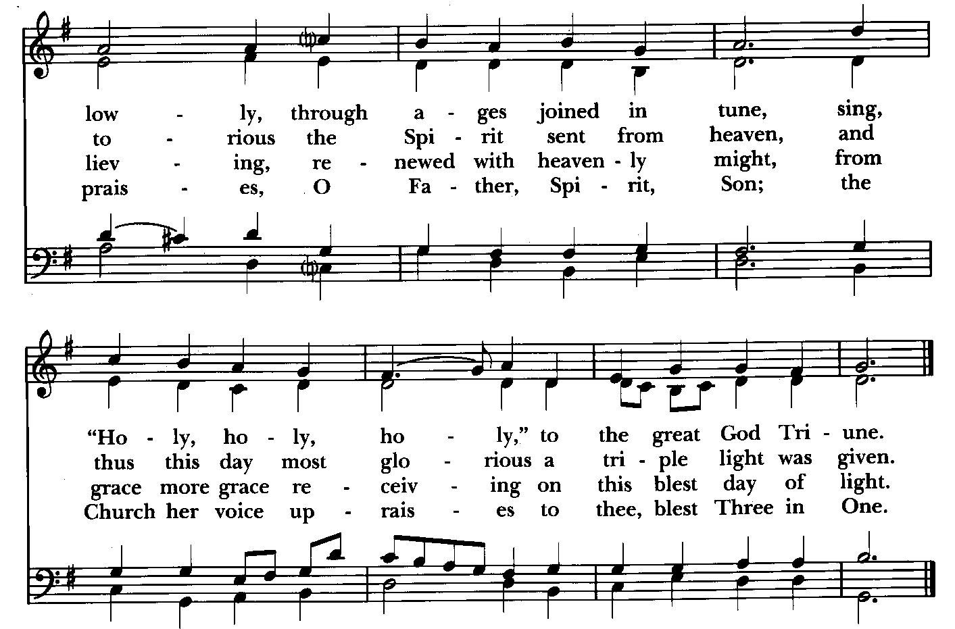

Morning Prayer—Rite II

Prelude

Gathering hymn: O day of radiant gladness Hymnal #48
(see previous page)

OPENING SENTENCES BCP p. 78

Officiant: Grace to you and peace from God our Father and the Lord Jesus Christ.
Philippians 1:2

CONFESSION OF SIN BCP p. 79
Dearly beloved, we have come together in the presence of Almighty God our heavenly Father, to set forth his praise, to hear his holy Word, and to ask, for ourselves and on behalf of others, those things that are necessary for our life and our salvation. And so that we may prepare ourselves in heart and mind to worship him, let us kneel in silence, and with penitent and obedient hearts confess our sins, that we may obtain forgiveness by his infinite goodness and mercy.

Officiant and People please stand or kneel as able
Most merciful God, we confess that we have sinned against you in thought, word, and deed, by what we have done, and by what we have left undone. We have not loved you with our whole heart; we have not loved our neighbors as
ourselves. We are truly sorry and we humbly repent. For the sake of your Son
Jesus Christ, have mercy on us and forgive us; that we may delight in your will, and walk in your ways, to the glory of your Name. Amen.

Officiant: Almighty God have mercy on us, forgive us all our sins through our Lord Jesus Christ, strengthen you in all goodness, and by the power of the Holy Spirit keep us in eternal life. Amen.

The Invitatory and Psalter BCP pg. 80

All stand
Officiant: Lord, open our lips.
People: And our mouth shall proclaim your praise.

Officiant and People
Glory to the Father, and to the Son, and to the Holy Spirit: as it was in the
beginning, is now, and will be for ever. Amen.

The mercy of the Lord is everlasting: Come let us adore him. BCP pg. 81

Venite Psalm 95:1-7 BCP. pg. 82
Come, let us sing to the Lord;*
let us shout for joy to the Rock of our salvation.
Let us come before his presence with thanksgiving*
and raise a loud shout to him with psalms.

For the Lord is a great God,*
and a great King above all gods.
In his hands are the caverns of the earth,*
and the heights of the hills are his also.
The sea is his, for he made it.*
and his hands have molded the dry land.
Come, let us bow down, and bend the knee,*
and kneel before the Lord our Maker.

For he is our God,
and we are the people of his pasture and the sheep of his hand.*
Oh, that today you would hearken to his voice!

Psalm 138
Officiant and People Please be seated
1 I will give thanks to you, O Lord, with my whole heart; *
before the gods I will sing your praise.
2 I will bow down toward your holy temple
and praise your Name, *
because of your love and faithfulness;
3 For you have glorified your Name *
and your word above all things.
4 When I called, you answered me; *
you increased my strength within me.
5 All the kings of the earth will praise you, O Lord, *
when they have heard the words of your mouth.
6 They will sing of the ways of the Lord, *
that great is the glory of the Lord.
7 Though the Lord be high, he cares for the lowly; *
he perceives the haughty from afar.
8 Though I walk in the midst of trouble, you keep me safe; *
you stretch forth your hand against the fury of my enemies;
your right hand shall save me.
9 The Lord will make good his purpose for me; *
O Lord, your love endures for ever;
do not abandon the works of your hands.

THE FIRST READING Isaiah 6:1-8, [9-13]
In the year that King Uzziah died, I saw the Lord sitting on a throne, high and lofty; and the hem of his robe filled the temple. Seraphs were in attendance above him; each had six wings: with two they covered their faces, and with two they covered their feet, and with two they flew. And one called to another and said:
"Holy, holy, holy is the Lord of hosts;
the whole earth is full of his glory."
The pivots on the thresholds shook at the voices of those who called, and the house filled with smoke. And I said: "Woe is me! I am lost, for I am a man of unclean lips, and I live among a people of unclean lips; yet my eyes have seen the King, the Lord of hosts!"
Then one of the seraphs flew to me, holding a live coal that had been taken from the altar with a pair of tongs. The seraph touched my mouth with it and said: "Now that this has touched your lips, your guilt has departed and your sin is blotted out." Then I heard the voice of the Lord saying, "Whom shall I send, and who will go for us?" And I said, "Here am I; send me!" [And he said, "Go and say to this people:
`Keep listening, but do not comprehend;
keep looking, but do not understand.'
Make the mind of this people dull,
and stop their ears,
and shut their eyes,
so that they may not look with their eyes,
and listen with their ears,
and comprehend with their minds,
and turn and be healed."
Then I said, "How long, O Lord?" And he said:
"Until cities lie waste
without inhabitant,
and houses without people,
and the land is utterly desolate;
until the Lord sends everyone far away,
and vast is the emptiness in the midst of the land.
Even if a tenth part remain in it,
it will be burned again,
like a terebinth or an oak
whose stump remains standing
when it is felled."
The holy seed is its stump.]

The Word of the Lord.
Thanks be to God.

Canticle 16 The Song of Zechariah Benedictus Dominus Deus BCP pg. 92
Luke 1: 68-79
Blessed be the Lord, the God of Israel; *
he has come to his people and set them free.
He has raised up for us a mighty savior, *
born of the house of his servant David.
Through his holy prophets he promised of old,
that he would save us from our enemies, *
from the hands of all who hate us.
He promised to show mercy to our fathers *
and to remember his holy covenant.
This was the oath he swore to our father Abraham, *
to set us free from the hands of our enemies,
Free to worship him without fear, *
holy and righteous in his sight
all the days of our life.
You, my child, shall be called the prophet of the Most High, *
for you will go before the Lord to prepare his way,
To give his people knowledge of salvation *
by the forgiveness of their sins.
In the tender compassion of our God *
the dawn from on high shall break upon us,
To shine on those who dwell in darkness and the
shadow of death, *
and to guide our feet into the way of peace.
Glory to the Father, and to the Son, and to the Holy Spirit: *
as it was in the beginning, is now, and will be for ever. Amen.

THE SECOND READING 1 Corinthians 15:1-11
I would remind you, brothers and sisters, of the good news that I proclaimed to you, which you in turn received, in which also you stand, through which also you are being saved, if you hold firmly to the message that I proclaimed to you--unless you have come to believe in vain.
For I handed on to you as of first importance what I in turn had received: that Christ died for our sins in accordance with the scriptures, and that he was buried, and that he was raised on the third day in accordance with the scriptures, and that he appeared to Cephas, then to the twelve. Then he appeared to more than five hundred brothers and sisters at one time, most of whom are still alive, though some have died. Then he appeared to James, then to all the apostles. Last of all, as to one untimely born, he appeared also to me. For I am the least of the apostles, unfit to be called an apostle, because I persecuted the church of God. But by the grace of God I am what I am, and his grace toward me has not been in vain. On the contrary, I worked harder than any of them--though it was not I, but the grace of God that is with me. Whether then it was I or they, so we proclaim and so you have come to believe.

The Word of the Lord.
Thanks be to God.

Canticle 21 You are God Te Deum laudamus BCP pg. 95
You are the Lord; we acclaim you;
You are the eternal Father:
All creation worships you.
To you all angels, all the powers of heaven,
Cherubim and Seraphim, sing in endless praise:
Holy, holy, holy Lord, God of power and might,
heaven and earth are full of your glory.
The glorious company of apostles praise you.
The noble fellowship of prophets praise you.
The white-robed army of martyrs praise you.
Throughout the world the holy Church acclaims you;
Father, of majesty unbounded,
your true and only Son, worthy of all worship,
and the Holy Spirit, advocate and guide.
You, Christ, are the king of glory,
the eternal Son of the Father.
When you became man to set us free
you did not shun the Virgin's womb.
You overcame the sting of death
and opened the kingdom of heaven to all believers.
You are seated at God's right hand in glory.
We believe that you will come and be our judge.
Come then, Lord, and help your people,
bought with the price of your own blood,
and bring us with your saints
to glory everlasting.

Gradual hymn: Holy, holy, holy Lord God Almighty Hymnal #362
(see next page)

The people remain standing

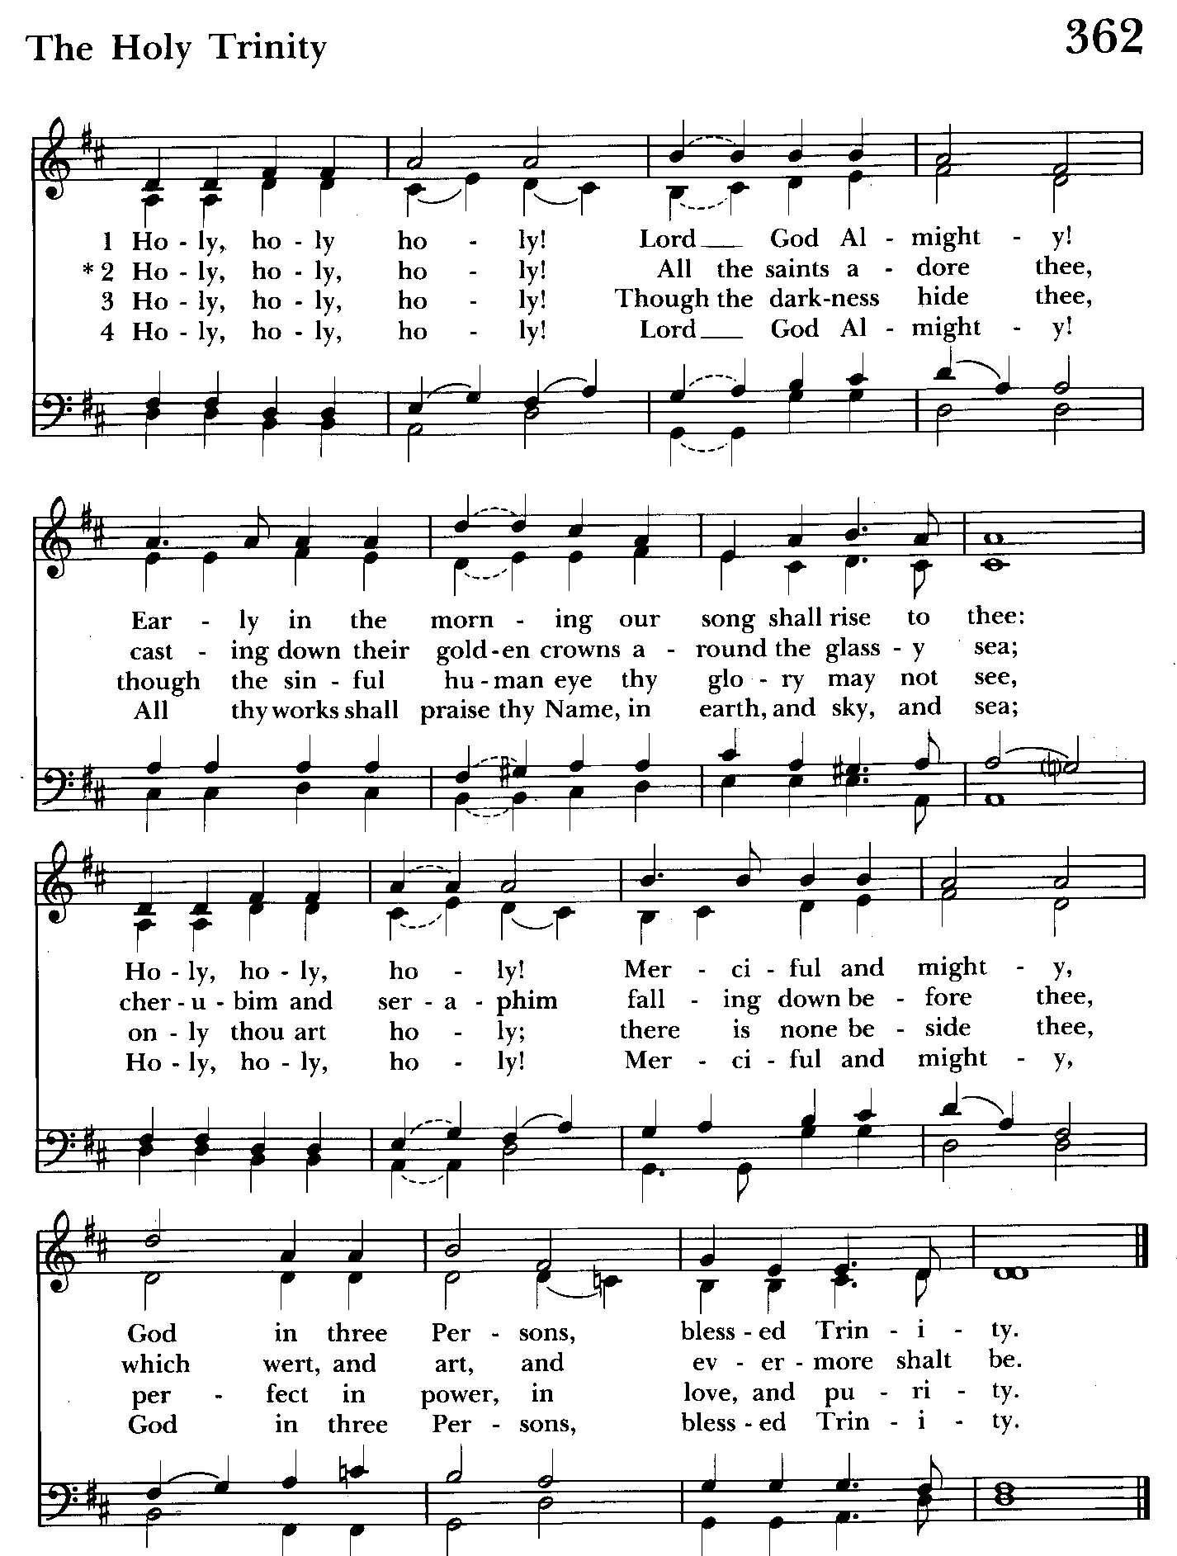

A READING FROM THE GOSPEL OF LUKE 5:1-11
Once while Jesus was standing beside the lake of Gennesaret, and the crowd was pressing in on him to hear the word of God, he saw two boats there at the shore of the lake; the fishermen had gone out of them and were washing their nets. He got into one of the boats, the one belonging to Simon, and asked him to put out a little way from the shore. Then he sat down and taught the crowds from the boat. When he had finished speaking, he said to Simon, "Put out into the deep water and let down your nets for a catch." Simon answered, "Master, we have worked all night long but have caught nothing. Yet if you say so, I will let down the nets." When they had done this, they caught so many fish that their nets were beginning to break. So they signaled their partners in the other boat to come and help them. And they came and filled both boats, so that they began to sink. But when Simon Peter saw it, he fell down at Jesus' knees, saying, "Go away from me, Lord, for I am a sinful man!" For he and all who were with him were amazed at the catch of fish that they had taken; and so also were James and John, sons of Zebedee, who were partners with Simon. Then Jesus said to Simon, "Do not be afraid; from now on you will be catching people." When they had brought their boats to shore, they left everything and followed him.

The Word of the Lord.
Thanks be to God.

The Homily The congregation is seated Ty Schwenk

The Peace The congregation stands as able

Announcements The people are seated

THE APOSTLES CREED BCP pg. 96
Said by all, standing as you are able.
I believe in God, the Father almighty,
creator of heaven and earth;
I believe in Jesus Christ, his only Son, our Lord.
He was conceived by the power of the Holy Spirit
and born of the Virgin Mary.
He suffered under Pontius Pilate,
was crucified, died, and was buried.
He descended to the dead.
On the third day he rose again.
He ascended into heaven,
and is seated at the right hand of the Father.
He will come again to judge the living and the dead.
I believe in the Holy Spirit,
the holy catholic Church,
the communion of saints,
the forgiveness of sins
the resurrection of the body,
and the life everlasting. Amen.
Celebrant: The Lord be with you.
People: And also with you.
Celebrant: Let us pray.
THE LORD’S PRAYER Stand or kneel as able. BCP pg. 97
Our Father, who art in heaven, hallowed be thy Name, thy kingdom come, thy will be done, on earth as it is in heaven. Give us this day our daily bread. And forgive us our trespasses, as we forgive those who trespass against us. And lead us not into temptation, but deliver us from evil. For thine is the kingdom, and the power, and the glory, for ever and ever. Amen.
People and Officiant
SUFFRAGES B BCP pg. 98
V. Save your people, Lord, and bless your inheritance;
R. Govern and uphold them, now and always.
V. Day by day we bless you;
R. We praise your Name for ever.
V. Lord, keep us from all sin today;
R. Have mercy on us, Lord, have mercy.
V. Lord, show us your love and mercy;
R. For we put our trust in you.
V. In you, Lord, is our hope;
R. And we shall never hope in vain.

THE COLLECT OF THE DAY BCP pg. 216
Set us free, O God, from the bondage of our sins, and give us the liberty of that abundant life which you have made known to us in your Son our Savior Jesus Christ; who lives and reigns with you, in the unity of the Holy Spirit, one God, now and for ever. Amen.
A COLLECT FOR SUNDAYS BCP pg. 98
O God, you make us glad with the weekly remembrance of the glorious resurrection of your Son our Lord: Give us this day such blessing through our worship of you, that the week to come may be spent in your favor; through Jesus Christ our Lord. Amen.

Officiant: Let us pray for our own needs and those of others.

Silence

PRAYER FOR MISSION BCP pg. 100
Almighty and everlasting God, by whose Spirit the whole body of your faithful people is governed and sanctified: Receive our supplications and prayers which we offer
may show forth your praise, not only with our lips, but in our lives, by giving

before you for all members of your holy Church, that in their vocation and ministry they may truly and devoutly serve you; through Lord and Savior Jesus Christ. Amen.

The people are seated.
OFFERTORY ANTHEM: Carol of the Fisherman (Choir)

OFFERTORY HYMN: Ye servants of God Hymnal #535
(see next page)
Please remain while the offering is collected

THE OFFERTORY The offering is brought forward

DOXOLOGY Please stand as able Hymnal #43, vs. 4
Praise God, from whom all blessings flow; praise him, all creatures here below; praise him above, ye heavenly host: praise Father, Son, and Holy Ghost.

Please kneel or stand as able

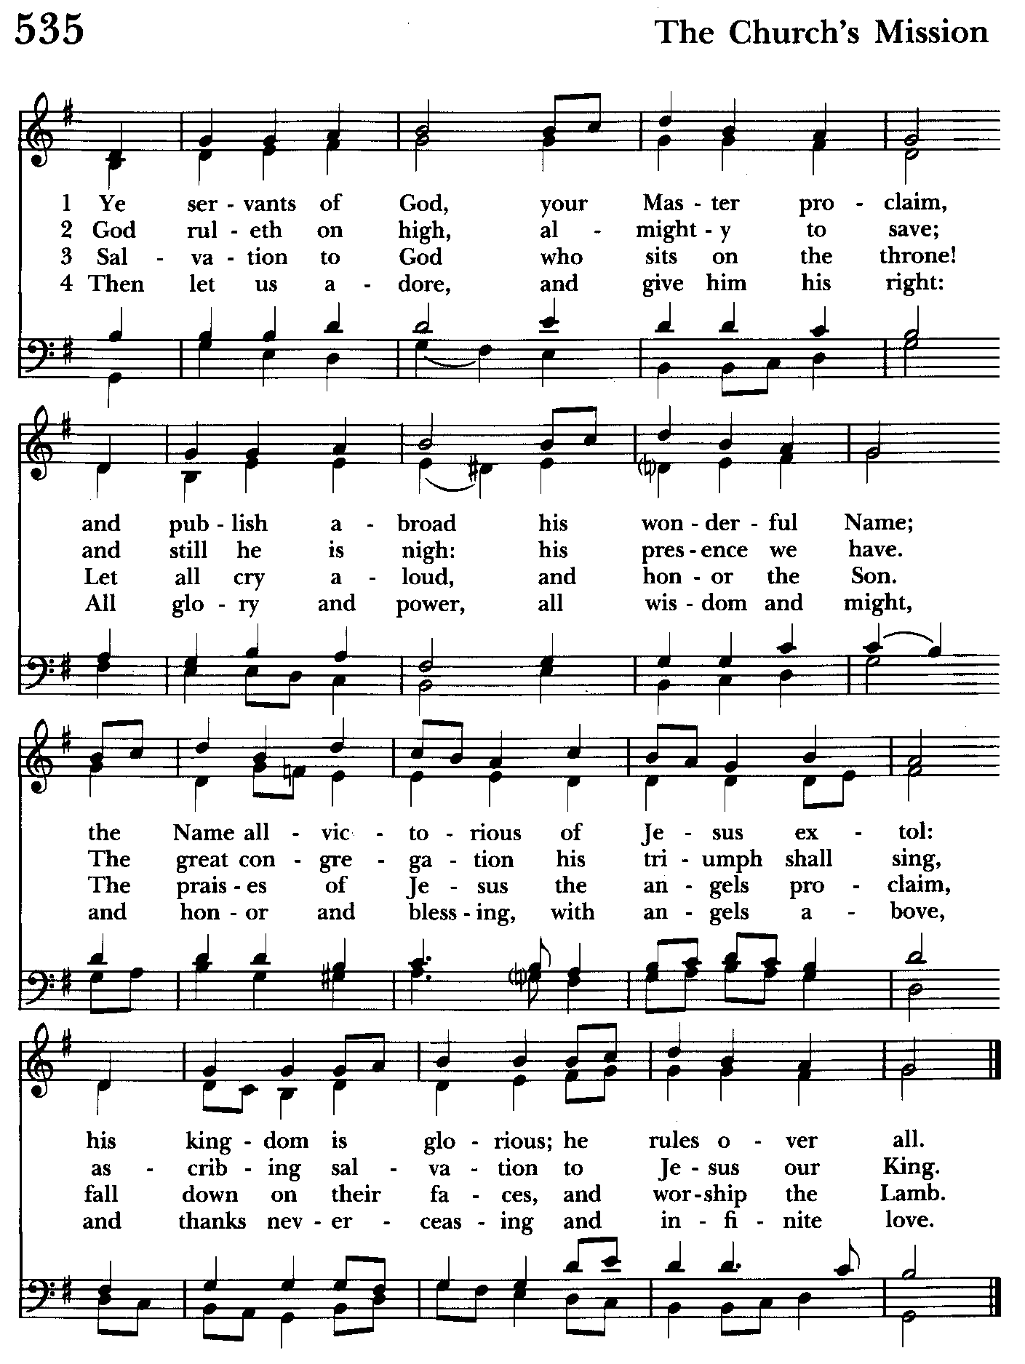

THE PRAYERS OF THE PEOPLE – Form III BCP pg. 387
Father, we pray for your holy Catholic Church;
That we all may be one.

Grant that every member of the Church may truly and humbly serve you;
That your Name may be glorified by all people.

We pray for all bishops, priests, and deacons;
That they may be faithful ministers of your Word and Sacraments.

We pray for all who govern and hold authority in the nations of the world;
That there may be justice and peace on the earth.

Give us grace to do your will in all that we undertake;
That our works may find favor in your sight.

Have compassion on those who suffer from any grief or trouble;
That they may be delivered from their distress.

Give to the departed eternal rest;
Let light perpetual shine upon them.
.
We praise you for your saints who have entered into joy;
May we also come to share in your heavenly kingdom.
.
Let us pray for our own needs and those of others.

We Pray for Those in Need:
DeMarino Family, Jim & Chris Carden and family, Peggie Dietz, Mike Carden, Pat Carden, Gail Landers, Sheila Jones, Gloria Millar, Marisol Aubrey, Ross Strickler, Jim & Janice Sieracki, James Daniel Jr., Larry Betzler, Camy Schwenk, Dennis Mally, Zach Walsh, Helen Johnson, Eileen Weimer, David Harris, Bill Hoffman & Family, Deb Melcher, Emily Lobb, Lily John, Barbara Miller, Nancy Barnhart, Robin Dilworth

We pray for the Church and the World:

For +Sean, our Presiding Bishop, for +Carrie, our Bishop, for Mark+, our Priest in Charge, for the Wardens, Vestry, Staff, and all members and friends of St. John’s Church.

For the leaders of all nations, especially for Donald, our President; for Wes, our Governor; for Brandon, Zeke, Kathy and Bob, who lead our City and Counties. We pray for all children and youth; for the homeless, the unemployed, and the hungry. We pray for the safety of our loved ones and friends serving in the Armed Forces at home and abroad, and for our enemies, that all our hearts may be turned toward peace throughout the world.

THE GENERAL THANKSGIVING
Let us pray.
Officiant and people BCP pg. 101
Almighty God, Father of all mercies, we your unworthy servants give you humble thanks for all your goodness and loving-kindness to us and to all whom you have made. We bless you for our creation, preservation, and all the blessings of this life; but above all for your immeasurable love in the redemption of the world by our Lord Jesus Christ; for the means of grace, and for the hope of glory. And, we pray, give us such an awareness of your mercies, that with truly thankful hearts we up our selves to your service, and by walking before you in holiness and righteousness all our days; through Jesus Christ our Lord, to whom, with you and the Holy Spirit, be honor and glory throughout all ages. Amen.

Closing hymn: The God of Abraham praise Hymnal #401
(see next 2 pages)

THE DISMISSAL BCP pg. 102
Officiant: The grace of our Lord Jesus Christ, and the Love of God, and the
fellowship of the Holy Spirit, be with us all evermore.
People: Thanks be to God.

License #A-719154

Serving Today
Officiant: Ty Schwenk
Old Testament: John Stevens
Psalm: John Stevens
New Testament: Anne Leland
Prayers of the People: John Frost
Music Director: Nancy Heinold
Choir: Anne Leland, Nancy Dellinger, Janine Stevens, Liz Healey
Karen Smith-Manar, Ty Schwenk
Altar Guild: Stephanie Duchacek & Sandy Roe



Altar Flowers

Given to the Glory of God
by Karen Smith-Manar
in memory of Hugh Manar

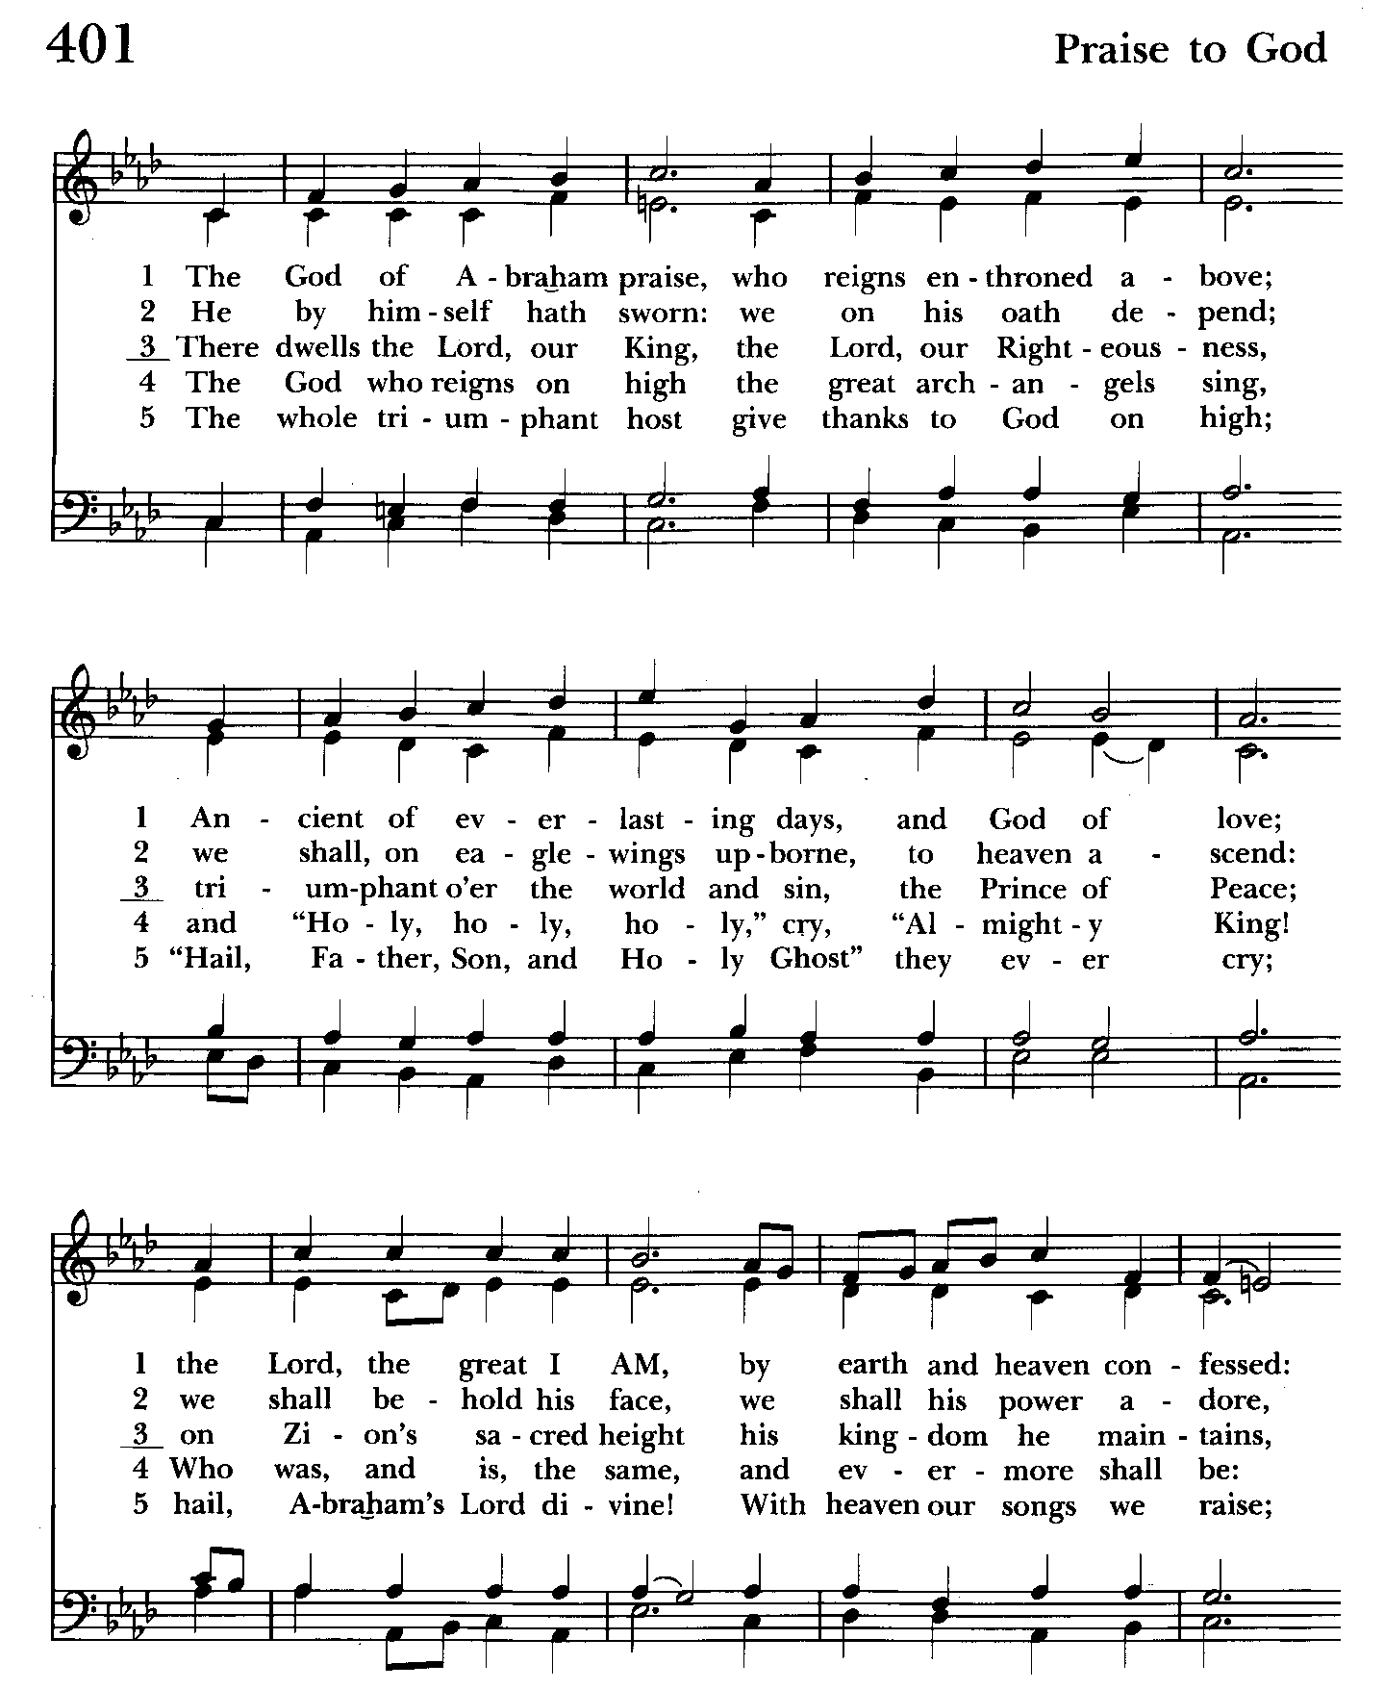

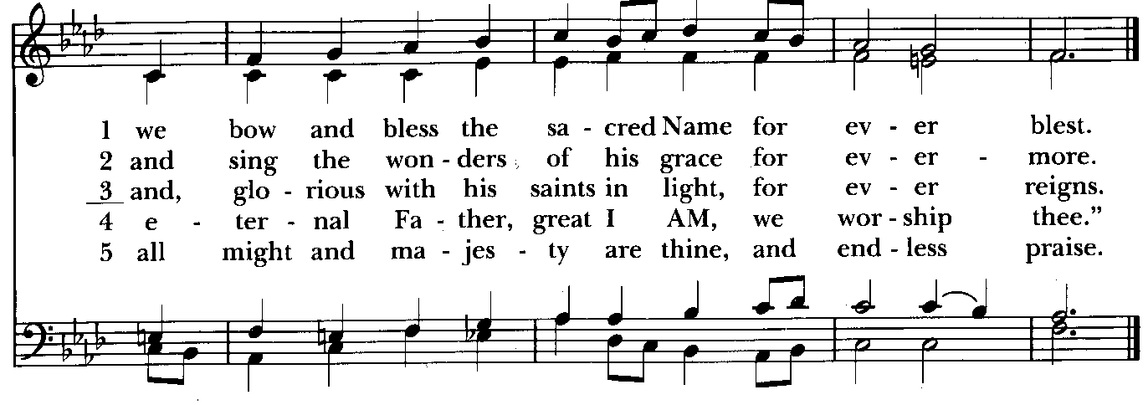

St. John’s Parish Prayer List

Additions and corrections may be made to our Parish Prayer List at any time. All names will be automatically removed from the Parish Prayer List on the 1st Sunday of each month unless you request otherwise. Please contact Angie at <office@stjohnskingsville.org> or 410-592-8570 in the church office with all changes by 10 am Thursdays. Thank you.

We Pray for Those in Need:
Names in BOLD read aloud by all.

DeMarino Family, Jim & Chris Carden and family, Peggie Dietz, Mike Carden, Pat Carden, Gail Landers, Sheila Jones, Gloria Millar, Marisol Aubrey, Ross Strickler, Jim and Janice Sieracki, James Daniel Jr, Larry Betzler, Camy Schwenk, Dennis Mally, Zach Walsh, Helen Johnson, Eileen Weimer, David Harris, Bill Hoffman & Family, Deb Melcher, Emily Lobb.

We pray for the repose of the soul of Henry Dilworth. Viewing at Lassahn-Kingsville on Sunday, 2 to 4 pm and 6 to 8 pm. Funeral on Monday, February 10th at 10 am.

We Pray for our Homebound

Lily John, Barbara Miller, Nancy Barnhart, Robin Dilworth

We pray for the Church and the World:

For +Sean, our Presiding Bishop; for +Carrie, our Bishop, for Mark+, our Priest in Charge, for the Wardens, Vestry, Staff, and all members and friends of St. John’s Church.

For the leaders of all nations, especially for Donald, our President; for Wes, our Governor; for Brandon, Zeke, Kathy and Bob, who lead our City and Counties. We pray for all children and youth; for the homeless, the unemployed, and the hungry. We pray for the safety of our loved ones and friends serving in the Armed Forces at home and abroad, and for our enemies, that all our hearts may be turned toward peace throughout the world.

Calendar Updates

February 28th - BINGO, Doors open at 5:30 pm. Bingo starts at 7 pm
March 2nd - Organ Dedication, Chapel, 10:30 am
March 4th - Shrove Tuesday Pancake Supper, 5 to 7 pm
March 5th - Ash Wednesday Services - Noon and 7 pm
Ashes to Go—7 to 9 am and 4 to 6 pm

Calendars are living documents. Every effort will be made to keep the members of the parish and community aware of any changes.


Friday, February 28th
Doors open at 5:30 pm and the games begin at 7 pm!
Tickets are $25 each which includes a 24 game starter pack PLUS specials.
Cash and basket prizes, 50/50 raffles, special bingos
Jumbo hot dogs, pulled pork, tuna salad, sodas, fresh baked goodies and snacks for sale.
To reserve a ticket in advance call Michele at 443-463-6333.
All proceeds benefit St. John's.

From the Treasurer
February ‘25 Income vs. Expenses:

Projected February Expenses: $15,000
Monies Received as of 2/6: $8,015
Amount Needed to Meet Expenses: $6,985


If you’d like to make a donation to St. John’s you can scan this QR code with your phone’s camera or tap on the link that comes up to make a contribution with either a credit or debit card, Apple Pay or Google Pay. This is a secure site provided by Clover which is a service of PNC Bank.


SUNDAY SCHOOL
10:30: Kids Sunday School- Begin in the church, ring the bell, then process over to the parish hall for a fun lesson with Mr. John and Ms. Stephanie.
Note: Please seriously consider regular attendance at Sunday School so that Mr. John and Ms. Stephanie can plan good stuff


Yoga is on Wednesday and Friday evenings 6 to 7 pm and Saturday mornings 9 to 10 am in the Chapel. All experience levels are welcome.


RECYCLING!
It takes approximately 15 kilowatt-hours (kWh) of electricity to make one aluminum can when produced from virgin ore, as the process of converting aluminum from bauxite is very energy intensive. Recycling aluminum cans requires significantly less energy, with the ability to produce 20 new cans with the same energy used to make one can from bauxite.

By popular demand, we are recycling. Some parishioners take printed paper home where they have recycling pickup. We now have a blue container located in the Parish Hall. This will be collected and taken for recycling. Aluminum cans will be saved and taken to a recycling center for cash. The proceeds will be donated to the Outreach fund. Each recycled aluminum can also save on the electricity needed to make new aluminum from bauxite.


You are invited to join us for our next Book Study. We begin on Wednesday
February 19 at 9:00 in the Library and will run through Lent. We will meet with the author by zoom on March 12. If you need assistance in obtaining a book,
contact Fr. Mark or the office.

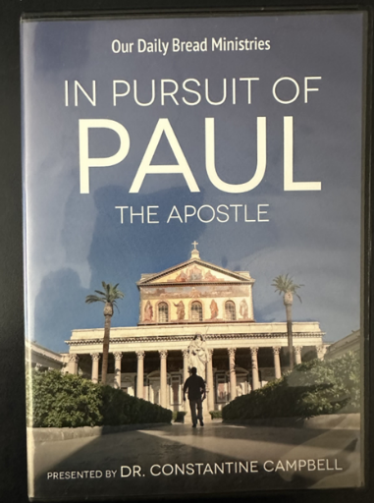

Friday Nights in Lent
After a light supper and fellowship at 6:30, we will view this contemporary look at the travels of St. Paul.
Begins Friday March 7.

In our Community

Bible Studies in our area. If interested, please contact these churches to confirm.
St. Mary’s, Abingdon, (410)569-0180- Wednesdays at noon. Bring lunch. Zoom available.
Emmanuel, Bel Air, (410)838-7699- Fridays at 9:30- Zoom Available.
Holy Trinity, Churchville, (410)914-5531- Wednesdays 11:30- Zoom may be available.
What’s Happening This Week at St. John’s

Sunday, February 9—5th Sunday after Epiphany
8:00am: Morning Prayer, Rite I (Church)
10:30am: Morning Prayer, Rite II (Church)
11:30am: Coffee Hour (Parish Hall)

Monday, February 10
12:00-1:00pm: AA Lunch Bunch (Parish Hall)

Tuesday, February 11
12:00-1:00pm: AA Lunch Bunch (Parish Hall)

Wednesday, February 12
12:00-1:00pm: AA Lunch Bunch (Parish Hall)
6:00-7:00pm: Yoga (Chapel)
7:00pm: Choir Rehearsal (Parish Hall)
7:30pm: AA (Parish Hall)

Thursday, February 13
12:00-1:00pm: AA Lunch Bunch (Parish Hall)
7:00pm: AA (Parish Hall)

Friday, February 14
12:00-1:00pm: AA Lunch Bunch (Parish Hall)
6:00pm -7:00pm: Yoga (Chapel)

Saturday, February 15
9:00am-10:00am: Yoga (Chapel)
8:30pm: AA (Parish Hall)

Sunday, February 16—6th Sunday after Epiphany
8:00am: Holy Eucharist, Said Service (Church)
10:30am: Holy Eucharist, with Music (Church)
11:30am: Coffee Hour (Parish Hall)

Parish Office is open Monday, Wednesday and Thursday, 9:30am-1:30pm.

Potluck Luncheon on the first Sunday of the month and a Coffee Hour on all other Sundays after the 10:30 service.

