St. John’s Episcopal Church
Kingsville, Maryland
Welcomes You

OUR VISION STATEMENT
We believe that together we will transform the world with love: Come on in!



7th Sunday after Epiphany
February 23, 2025
10:30 am, Rite II

St. John’s Episcopal Church

11901 Belair Road, P. O. Box 187, Kingsville, MD 21087
Facebook: St. John’s Episcopal, Kingsville, MD
Email: office@stjohnskingsville.org
Website: www.stjohnskingsville.org
Church Phone: 410-592-8570
For Pastoral Emergencies: Fr. Mark Lobb+ 443-690-9545

Welcome to worship today! We are glad that you are with us. You are invited to participate in all parts of the service as indicated in the Book of Common Prayer and this service bulletin. If you have any questions, feel free to ask the ushers. Restrooms are located in the Parish hall, the brick building across the parking lot.

I was glad when they said to me, “Let us go to the house of the Lord.” Psalm 122:1

Church Staff

Priest in Charge: Father Mark Lobb
Administrative Assistant: Angie Bosley
Organist/Choir Director: Nancy Heinold

The Vestry

Class of 2026 Class of 2027

John Stevens John Frost
Jacob Johnson Stephanie White

Officers
Ty Schwenk—Sr. Warden Terry Roe—Jr. Warden
Elizabeth Healey—Treasurer Anne Leland-Registrar

Parish Committee Chairpersons

Altar Guild: Elizabeth Healey
Auxiliary Committee: Michele Lozanski
Cemetery Committee: Karen Smith-Manar

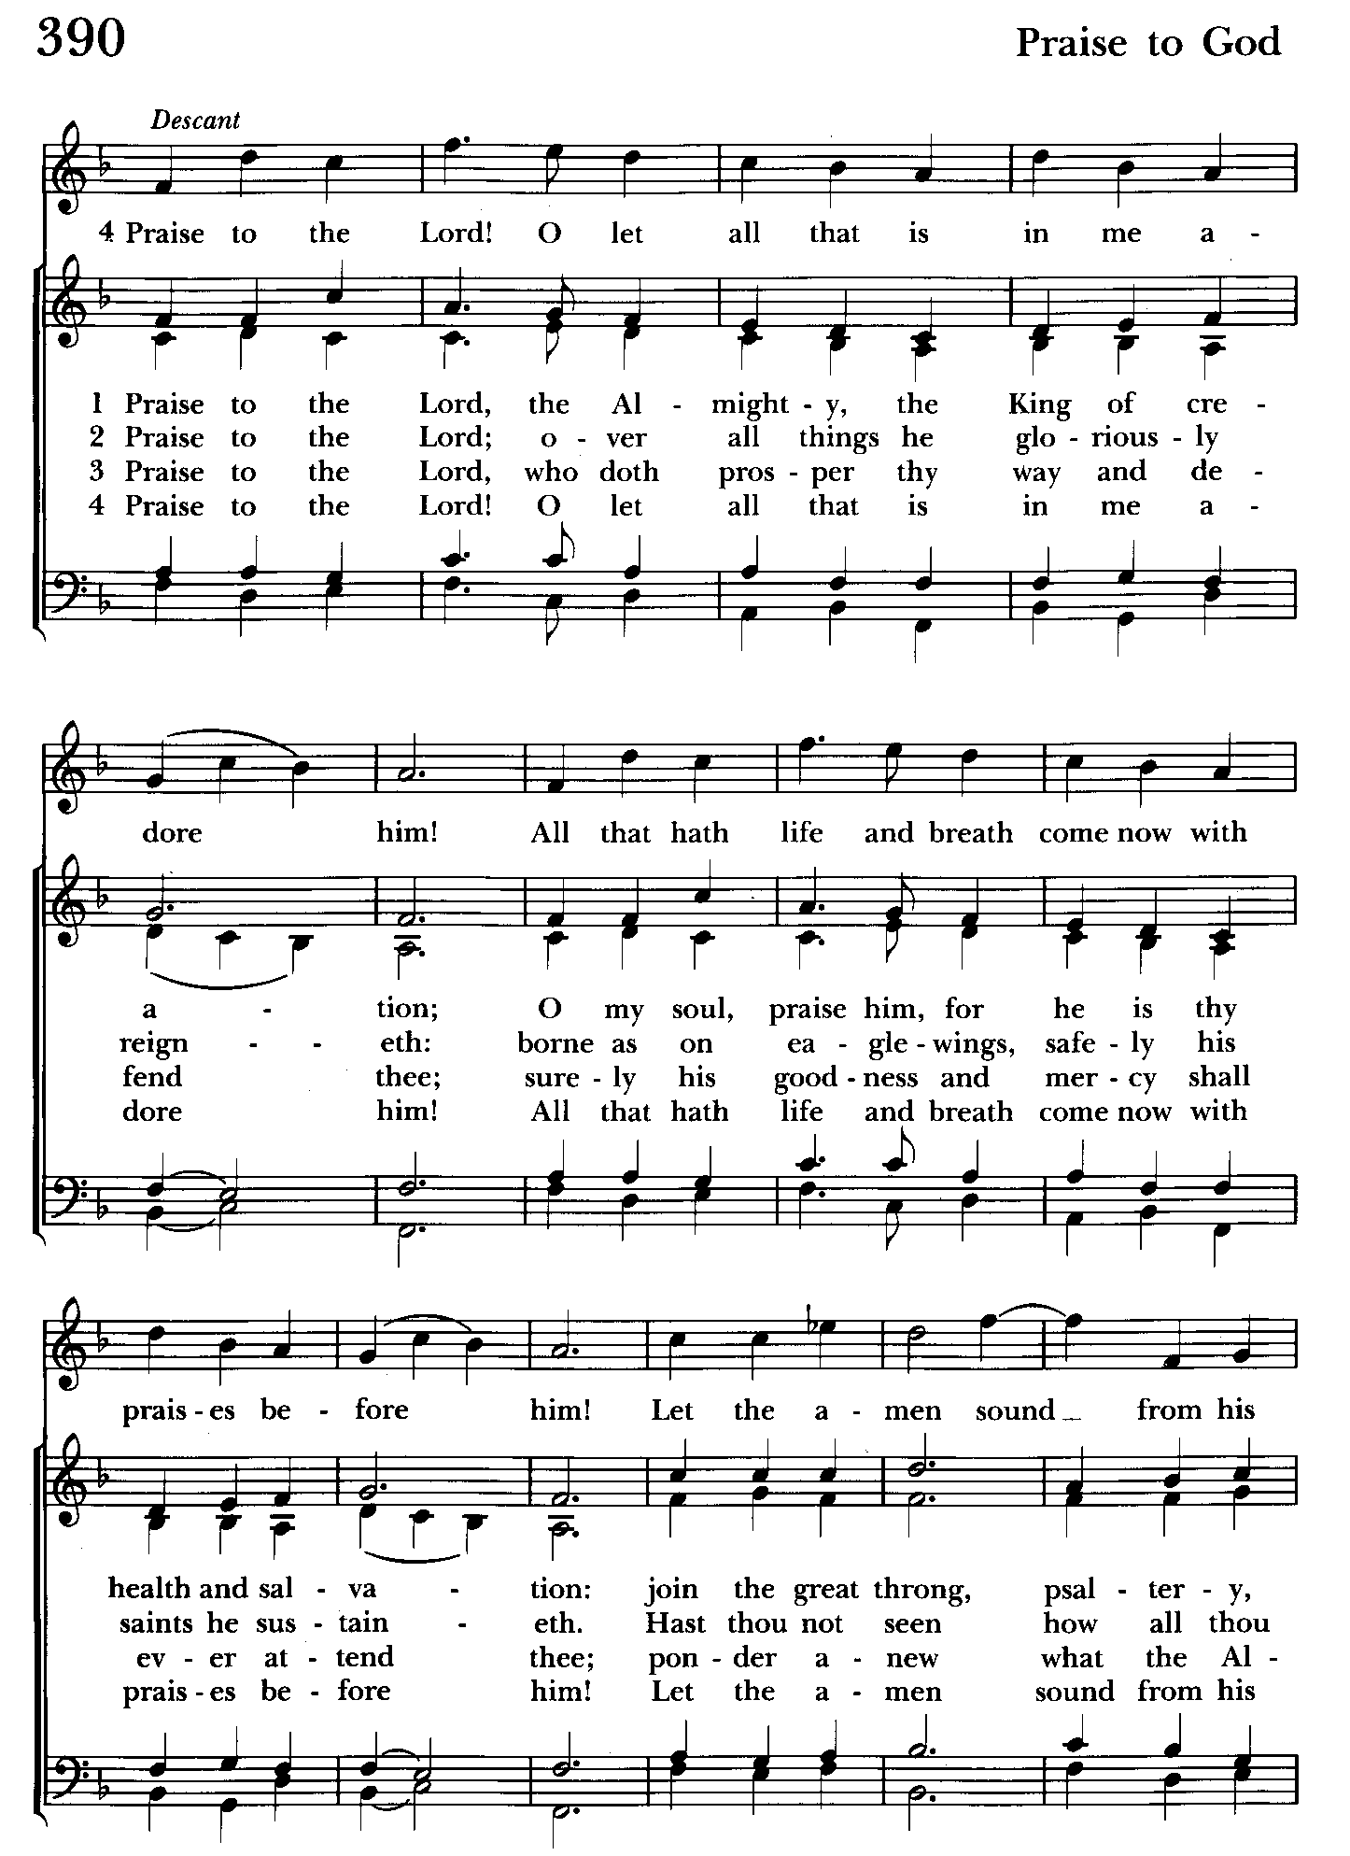

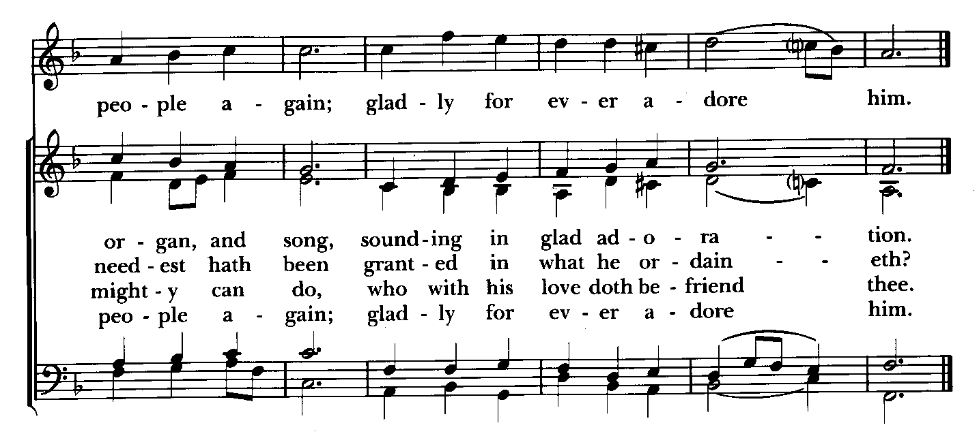

10:30 am Worship
Holy Eucharist, Rite Two

Prelude

The Word of God

Processional hymn: Praise to the Lord, the Almighty Hymnal #390
(see previous page and above)

The congregation remains standing as able

Celebrant: Blessed be God: Father, Son, and Holy Spirit. BCP 355
People: And blessed be his kingdom, now and for ever. Amen.

Celebrant: Almighty God, to you all hearts are open, all desires known, and from you no secrets are hid: Cleanse the thoughts of our hearts by the inspiration of your Holy Spirit, that we may perfectly love you, and worthily magnify your holy Name; through Christ our Lord. Amen.

Gloria Hymnal #S-280
Glory to God in the highest,
and peace to his people on earth.
Lord God, heavenly King,
almighty God and Father,
we worship you, we give you thanks,
we praise you for your glory.
Lord Jesus Christ, only Son of the Father,
Lord God, Lamb of God,
you take away the sin of the world:
have mercy on us;
you are seated at the right hand of the Father:
receive our prayer.
For you alone are the Holy One,
you alone are the Lord,
you alone are the Most High,
Jesus Christ,
with the Holy Spirit,
in the glory of God the Father. Amen.

Celebrant: The Lord be with you.
People: And also with you.
Celebrant: Let us pray.

The Collect of the Day Kneel or stand as able BCP 216
O Lord, you have taught us that without love whatever we do is worth nothing: Send your Holy Spirit and pour into our hearts your greatest gift, which is love, the true bond of peace and of all virtue, without which whoever lives is accounted dead before you. Grant this for the sake of your only Son Jesus Christ, who lives and reigns with you and the Holy Spirit, one God, now and for ever. Amen.

The congregation is seated.

A Reading from the Book of Genesis 45:3-11, 15
Thus says the Lord:
Joseph said to his brothers, "I am Joseph. Is my father still alive?" But his brothers could not answer him, so dismayed were they at his presence.
Then Joseph said to his brothers, "Come closer to me." And they came closer. He said, "I am your brother, Joseph, whom you sold into Egypt. And now do not be distressed, or angry with yourselves, because you sold me here; for God sent me before you to preserve life. For the famine has been in the land these two years; and there are five more years in which there will be neither plowing nor harvest. God sent me before you to preserve for you a remnant on earth, and to keep alive for you many survivors. So it was not you who sent me here, but God; he has made me a father to Pharaoh, and lord of all his house and ruler over all the land of Egypt. Hurry and go up to my father and say to him, 'Thus says your son Joseph, God has made me lord of all Egypt; come down to me, do not delay. You shall settle in the land of Goshen, and you shall be near me, you and your children and your children's children, as well as your flocks, your herds, and all that you have. I will provide for you there--since there are five more years of famine to come--so that you and your household, and all that you have, will not come to poverty.'"
And he kissed all his brothers and wept upon them; and after that his brothers talked with him.

Reader: The Word of the Lord.
People: Thanks be to God.

Psalm 37:1-12, 41-42 (Pray as directed)
1 Do not fret yourself because of evildoers; *
do not be jealous of those who do wrong.
2 For they shall soon wither like the grass, *
and like the green grass fade away.
3 Put your trust in the Lord and do good; *
dwell in the land and feed on its riches.
4 Take delight in the Lord, *
and he shall give you your heart's desire.
5 Commit your way to the Lord and put your trust in him, *
and he will bring it to pass.

6 He will make your righteousness as clear as the light *
and your just dealing as the noonday.
7 Be still before the Lord *
and wait patiently for him.
8 Do not fret yourself over the one who prospers, *
the one who succeeds in evil schemes.
9 Refrain from anger, leave rage alone; *
do not fret yourself; it leads only to evil.
10 For evildoers shall be cut off, *
but those who wait upon the Lord shall possess the land.
11 In a little while the wicked shall be no more; *
you shall search out their place, but they will not be there.
12 But the lowly shall possess the land; *
they will delight in abundance of peace.
41 But the deliverance of the righteous comes from the Lord; *
he is their stronghold in time of trouble.
42 The Lord will help them and rescue them; *
he will rescue them from the wicked and deliver them,
because they seek refuge in him.

A Reading from the First Letter of St. Paul to the Corinthians 15:35-38,42-50
Someone will ask, "How are the dead raised? With what kind of body do they come?" Fool! What you sow does not come to life unless it dies. And as for what you sow, you do not sow the body that is to be, but a bare seed, perhaps of wheat or of some other grain. But God gives it a body as he has chosen, and to each kind of seed its own body.
So it is with the resurrection of the dead. What is sown is perishable, what is raised is imperishable. It is sown in dishonor, it is raised in glory. It is sown in weakness, it is raised in power. It is sown a physical body, it is raised a spiritual body. If there is a physical body, there is also a spiritual body. Thus it is written, "The first man, Adam, became a living being"; the last Adam became a life-giving spirit. But it is not the spiritual that is first, but the physical, and then the spiritual. The first man was from the earth, a man of dust; the second man is from heaven. As was the man of dust, so are those who are of the dust; and as is the man of heaven, so are those who are of heaven. Just as we have borne the image of the man of dust, we will also bear the image of the man of heaven.
What I am saying, brothers and sisters, is this: flesh and blood cannot inherit the kingdom of God, nor does the perishable inherit the imperishable.

Reader: The Word of the Lord.
People: Thanks be to God.

Gradual hymn: Lord make us servants of your peace Hymnal #593
(see next page)
The congregation remains standing as able

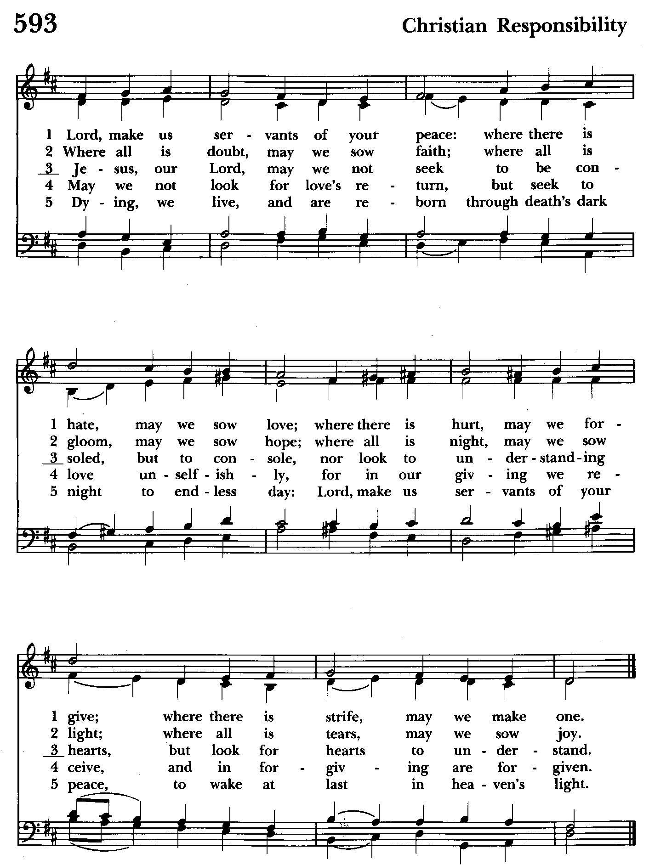

Priest: The Holy Gospel of our Lord Jesus Christ according to Luke 6:27-38
People: Glory to you, Lord Christ.
Jesus said, "I say to you that listen, Love your enemies, do good to those who hate you, bless those who curse you, pray for those who abuse you. If anyone strikes you on the cheek, offer the other also; and from anyone who takes away your coat do not withhold even your shirt. Give to everyone who begs from you; and if anyone takes away your goods, do not ask for them again. Do to others as you would have them do to you.
"If you love those who love you, what credit is that to you? For even sinners love those who love them. If you do good to those who do good to you, what credit is that to you? For even sinners do the same. If you lend to those from whom you hope to receive, what credit is that to you? Even sinners lend to sinners, to receive as much again. But love your enemies, do good, and lend, expecting nothing in return. Your reward will be great, and you will be children of the Most High; for he is kind to the ungrateful and the wicked. Be merciful, just as your Father is merciful.
"Do not judge, and you will not be judged; do not condemn, and you will not be condemned. Forgive, and you will be forgiven; give, and it will be given to you. A good measure, pressed down, shaken together, running over, will be put into your lap; for the measure you give will be the measure you get back."

Priest: The Gospel of the Lord.
People: Praise to you, Lord Christ.

Sermon The congregation is seated Rev. Mark Lobb

The Nicene Creed Please stand as able BCP 358
We believe in one God,
the Father, the Almighty,
maker of heaven and earth,
of all that is, seen and unseen.
We believe in one Lord, Jesus Christ,
the only Son of God,
eternally begotten of the Father,
God from God, Light from Light,
true God from true God,
begotten, not made,
of one Being with the Father.
Through him all things were made.
For us and for our salvation
he came down from heaven:
by the power of the Holy Spirit
he became incarnate from the Virgin Mary,
and was made man.
For our sake he was crucified under Pontius Pilate;
he suffered death and was buried.
On the third day he rose again
in accordance with the Scriptures;
he ascended into heaven
and is seated at the right hand of the Father.
He will come again in glory to judge the living and the dead,
and his kingdom will have no end.
We believe in the Holy Spirit, the Lord, the giver of life,
who proceeds from the Father and the Son.
With the Father and the Son he is worshiped and glorified.
He has spoken through the Prophets.
We believe in one holy catholic and apostolic Church.
We acknowledge one baptism for the forgiveness of sins.
We look for the resurrection of the dead,
and the life of the world to come. Amen.

The Prayers of the People Form VI Kneel or stand as able BCP 392
Litanist: In peace, we pray to you, Lord God.

Litanist: For all people in their daily life and work;
People: For our families, friends, and neighbors, and for those who are alone.

Litanist: For this community, the nation, and the world;
People: For all who work for justice, freedom, and peace.

Litanist: For the just and proper use of your creation;
People: For the victims of hunger, fear, injustice, and oppression.

Litanist: For all who are in danger, sorrow, or any kind of trouble;
People: For those who minister to the sick, the friendless, and the needy.

Litanist: For the peace and unity of the Church of God;
People: For all who proclaim the Gospel, and all who seek the Truth.

Litanist: For +Sean, our Presiding Bishop; +Carrie, our Bishop, Mark+ our Priest in Charge, for the Wardens, Vestry, Staff, and all members and friends of St. John’s Church.
People: For all who serve God in his Church.

For the leaders of all nations, especially for Donald, our President; for Wes, our Governor; for Brandon, Zeke, Kathy and Bob, who lead our City and Counties. We pray for all children and youth; for the homeless, the unemployed, and the hungry. We pray for the safety of our loved ones and friends serving in the Armed Forces at home and abroad, and for our enemies, that all our hearts may be turned toward peace throughout the world.

Litanist: For the special needs and concerns of this congregation. Especially
remember in our prayers, DeMarino Family, Jim & Chris Carden and family,
Peggie Dietz, Mike Carden, Pat Carden, Gail Landers, Sheila Jones, Gloria Millar, Marisol Aubrey, Ross Strickler, Jim & Janice Sieracki, James Daniel Jr., Larry Betzler, Camy Schwenk, Dennis Mally, Zach Walsh, Lily John, Barbara Miller, Nancy Barnhart, Robin Dilworth, Helen Johnson, Eileen Weimer, David Harris, Linda Posten, Bill Hoffman & Family, Deb Melcher, Emily Lobb, de Wit family (who lost a 1 year old child), Bri Del Pilar.

The People may add their own petitions

Litanist: Hear us, Lord;
People: For your mercy is great.

Litanist: We thank you, Lord, for all the blessings of this life.

The People may add their own thanksgivings

Litanist: We will exalt you, O God our King;
People: And praise your Name for ever and ever.

Litanist: We pray for all who have died, that they may have a place in your
eternal kingdom. And especially in honor of Black History month whom the altar flowers are given.

The People may add their own petitions
Litanist: Lord, let your loving-kindness be upon them;
People: Who put their trust in you.

Litanist: We pray to you also for the forgiveness of our sins.
People: Have mercy upon us, most merciful Father; in your compassion
forgive us our sins, known and unknown, things done and left undone;
and so uphold us by your Spirit that we may live and serve you in
newness of life, to the honor and glory of your Name; through Jesus Christ our Lord. Amen.

The Celebrant gives the absolution.

The Peace Please stand as able BCP 360

Welcome & Announcements The congregation is seated.

Offertory Anthem: Peace Be With You (Choir)

Offertory Hymn: God is Love, and where true love is Hymnal #577
(see next 2 pages)

The people remain seated while offerings are collected.

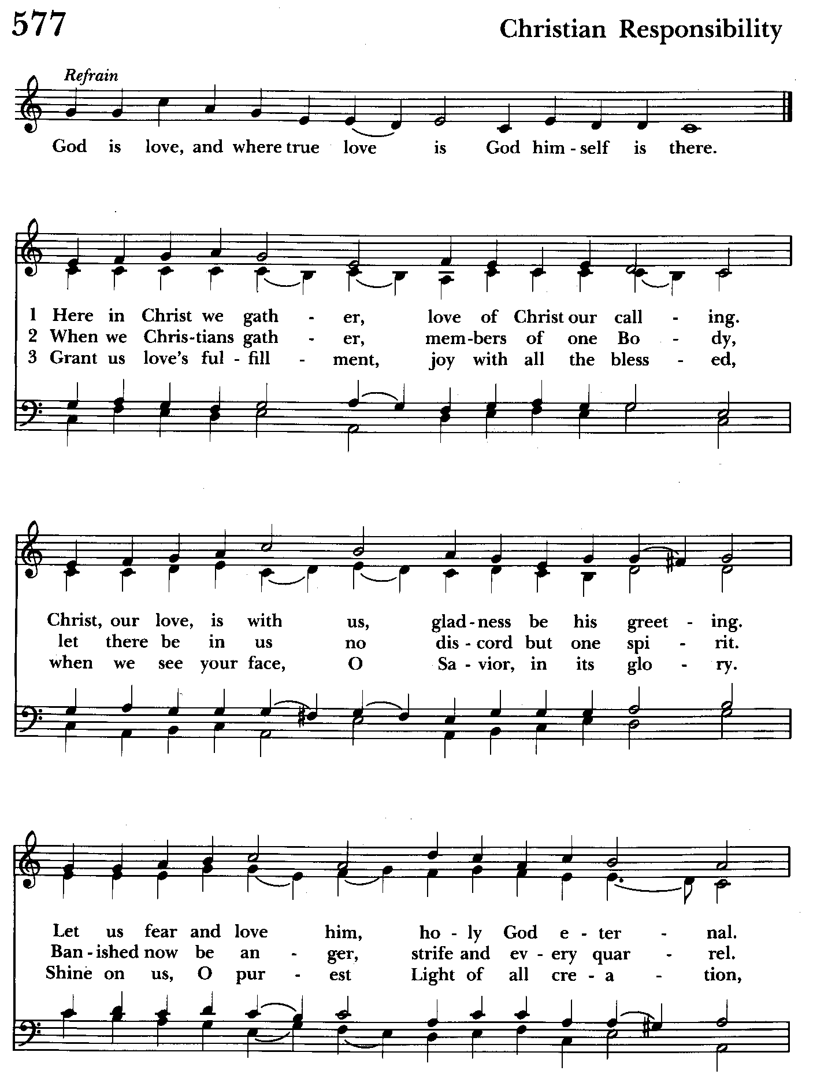

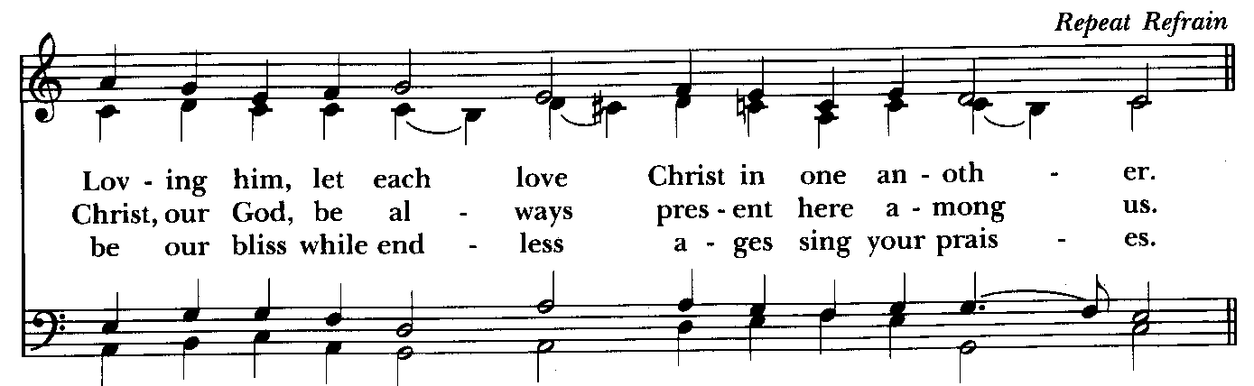

Presentation Hymn Offerings are presented Please stand as able Hymnal #43, vs. 4
Praise God, from whom all blessings flow; praise him, all creatures here below; praise him above, ye heavenly host: praise Father, Son, and Holy Ghost.

The Holy Communion

THE GREAT THANKSGIVING: Eucharistic Prayer B BCP 367
Celebrant: The Lord be with you.
People: And also with you.
Celebrant: Lift up your hearts.
People: We lift them to the Lord.
Celebrant: Let us give thanks to the Lord our God.
People: It is right to give him thanks and praise.

Then, facing the Holy Table, the Celebrant proceeds
It is right, and a good and joyful thing, always and everywhere to give thanks to you, Father Almighty, Creator of heaven and earth.

Therefore we praise you, joining our voices with Angels and Archangels and with all the company of heaven, who for ever sing this hymn to proclaim the glory of your Name:

Celebrant and People:
Holy, Holy, Holy Lord, God of power and might, Hymnal #S-129
heaven and earth are full of your glory.
Hosanna in the highest.
Blessed is he who comes in the name of the Lord.
Hosanna in the highest.

Please kneel or stand as able
Then the Celebrant continues BCP 368
We give thanks to you, O God, for the goodness and love which you have made known to us in creation; in the calling of Israel to be your people; in your Word spoken through the prophets; and above all in the Word made flesh, Jesus, your Son. For in these last days you sent him to be incarnate from the Virgin Mary, to be the Savior and Redeemer of the world. In him, you have delivered us from evil, and made us worthy to stand before you. In him, you have brought us out of error into truth, out of sin into righteousness, out of death into life.

At the following words concerning the bread, the Celebrant is to hold it, or to lay a hand upon it; and at the words concerning the cup, to hold or place a hand upon the cup and any other vessel containing wine to be consecrated.

On the night before he died for us, our Lord Jesus Christ took bread; and when he had given thanks to you, he broke it, and gave it to his disciples, and said, "Take, eat: This is my Body, which is given for you. Do this for the remembrance of me."

After supper he took the cup of wine; and when he had given thanks, he gave it to them, and said, "Drink this, all of you: This is my Blood of the new Covenant, which is shed for you and for many for the forgiveness of sins. Whenever you drink it, do this for the remembrance of me."

Therefore, according to his command, O Father,

Celebrant and People:
We remember his death,
We proclaim his resurrection,
We await his coming in glory;

The Celebrant continues
And we offer our sacrifice of praise and thanksgiving to you, O Lord of all; presenting to you, from your creation, this bread and this wine. We pray you, gracious God, to send your Holy Spirit upon these gifts that they may be the Sacrament of the Body of Christ and his Blood of the new Covenant. Unite us to your Son in his sacrifice, that we may be acceptable through him, being sanctified by the Holy Spirit. In the fullness of time, put all things in subjection under your Christ, and bring us to that heavenly country where, with St. John and the Blessed Virgin Mary and all your saints, we may enter the everlasting heritage of your sons and daughters; through Jesus Christ our Lord, the firstborn of all creation, the head of the Church, and the author of our salvation.

By him, and with him, and in him, in the unity of the Holy Spirit all honor and
glory is yours, Almighty Father, now and for ever. Amen.

And now, as our Savior Christ has taught us, we are bold to say,

Our Father, who art in heaven, BCP p. 364
hallowed be thy Name,
thy kingdom come,
thy will be done,
on earth as in heaven.
Give us this day our daily bread.
And forgive us our trespasses,
as we forgive those
who trespass against us.
And lead us not into temptation,
but deliver us from evil.
For thine is the kingdom,
and the power, and the glory,
for ever and ever. Amen.
Invitation to Communion

The Breaking of the Bread
Celebrant: Alleluia. Christ our Passover is sacrificed for us;
People: Therefore let us keep the feast. Alleluia.
Celebrant: The Gifts of God for the people of God.

The congregation is seated

Communion hymn: Jesu, Jesu, fill us with your love Hymnal #602
(see below)

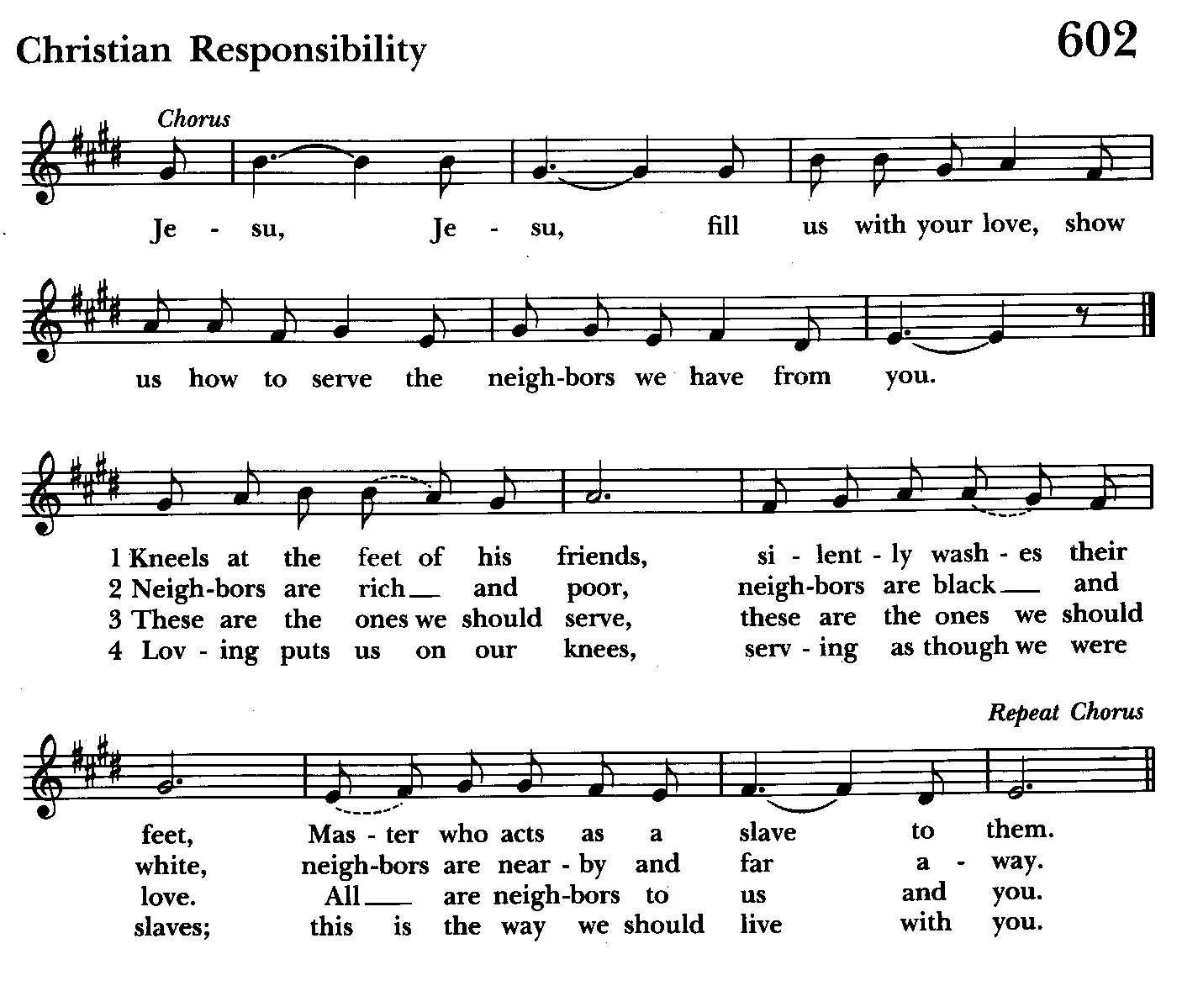

The Post Communion Prayer BCP p. 365
Eternal God, heavenly Father, you have graciously accepted us as living members of your Son our Savior Jesus Christ, and you have fed us with spiritual food in the Sacrament of his Body and Blood. Send us now into the world in peace, and grant us strength and courage to love and serve you with gladness and singleness of heart; through Christ our Lord. Amen.

Blessing

Recessional hymn: Love divine, all loves excelling Hymnal #657
(see next 2 pages)

The Dismissal
Celebrant: Let us go forth in the name of the risen Lord.
People: Thanks be to God.
Postlude:

License #A-719154

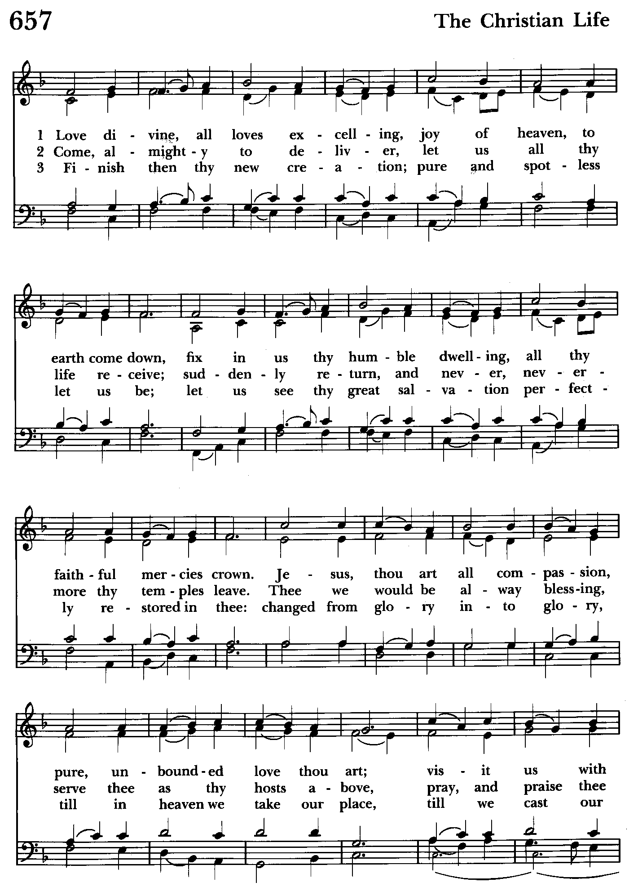

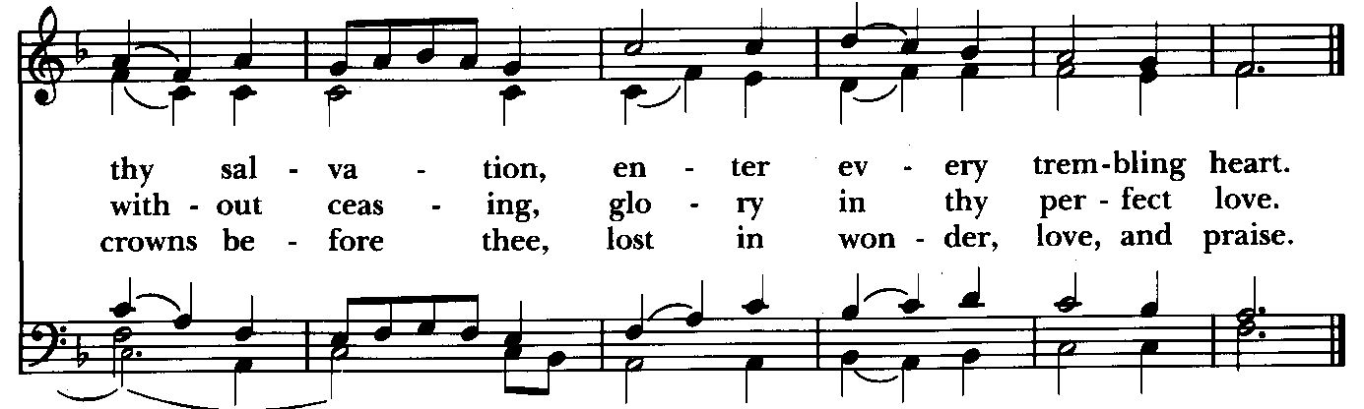

Serving Today

Celebrant and Preacher: Rev. Mark Lobb
Old Testament: Michele Lozanski
Psalm: John Webb
New Testament: Tony Rising
Prayers of the People: John Frost
Server: Marguerite Lobb
Music Director: Nancy Heinold
Choir: Anne Leland, Nancy Dellinger, Janine Stevens, Liz Healey,
Karen Smith-Manar, Ty Schwenk
Altar Guild: Stephanie Duchacek & Sandy Roe

St. John’s Parish Prayer List

Additions and corrections may be made to our Parish Prayer List at any time. All names will be automatically removed from the Parish Prayer List on the 1st Sunday of each month unless you request otherwise. Please contact Angie at <office@stjohnskingsville.org> or 410-592-8570 in the church office with all changes by 10 am Thursdays. Thank you.

We Pray for Those in Need:
Names in BOLD read aloud by all.

DeMarino Family, Jim & Chris Carden and family, Peggie Dietz, Mike Carden, Pat Carden, Gail Landers, Sheila Jones, Gloria Millar, Marisol Aubrey, Ross Strickler, Jim and Janice Sieracki, James Daniel Jr, Larry Betzler, Camy Schwenk, Dennis Mally, Zach Walsh, Helen Johnson, Eileen Weimer, David Harris, Linda Posten, Bill Hoffman & Family, Deb Melcher, Emily Lobb, de Wit family (who lost a 1 year old child), Bri Del Pilar.

We Pray for our Homebound

Lily John, Barbara Miller, Nancy Barnhart, Robin Dilworth

We pray for the Church and the World:

For +Sean, our Presiding Bishop; for +Carrie, our Bishop, for Mark+, our Priest in Charge, for the Wardens, Vestry, Staff, and all members and friends of St. John’s Church.

For the leaders of all nations, especially for Donald, our President; for Wes, our Governor; for Brandon, Zeke, Kathy and Bob, who lead our City and Counties. We pray for all children and youth; for the homeless, the unemployed, and the hungry. We pray for the safety of our loved ones and friends serving in the Armed Forces at home and abroad, and for our enemies, that all our hearts may be turned toward peace throughout the world.

From the Treasurer
February ‘25 Income vs. Expenses:

Projected February Expenses: $15,000
Monies Received as of 2/20: $10,668
Amount Needed to Meet Expenses: $4,332


If you’d like to make a donation to St. John’s you can scan this QR code with your phone’s camera or tap on the link that comes up to make a contribution with either a credit or debit card, Apple Pay or Google Pay. This is a secure site provided by Clover which is a service of PNC Bank.

Calendar Updates

February 28th - Bingo, Doors open at 5:30 pm. Bingo starts at 7 pm
March 2nd - Organ Dedication. Chapel, 8 & 10:30 am
March 4th - Shrove Tuesday Pancake Supper, 5 to 7 pm
March 5th - Ash Wednesday Services, Noon and 7 pm
Ashes to Go—7 to 9 and 4 to 6

Calendars are living documents. Every effort will be made to keep the members of the parish and community aware of any changes.


Altar Flowers
Given to the Glory of God
by a generous parishioner
in honor of Black History Month


With so much going on, everyone’s help is needed to make events a success. Our volunteers make the Church function. The volunteering of time and talent is greatly appreciated.


Friday, February 28th
Doors open at 5:30 pm and the games begin at 7 pm!
Tickets are $25 each which includes a 24 game starter pack PLUS specials.
Cash and basket prizes, 50/50 raffles, special bingos
Jumbo hot dogs, pulled pork, tuna salad, sodas, fresh baked goodies and snacks for sale.
To reserve a ticket in advance call Michele at 443-463-6333.
All proceeds benefit St. John's.


Choral Choir and Bell Choir
Choir rehearsals Wednesdays at 7:00 pm and Bell Choir Rehearsal, Sundays after the 10:30 service. If anyone is interested in joining, see Nancy Heinold, our Music Director.

SUNDAY SCHOOL

10:30: Kids Sunday School- Begin in the church, ring the bell, then process over to the parish hall for a fun lesson with Mr. John and Ms. Stephanie.
Note: Please seriously consider regular attendance at Sunday School so that Mr. John and Ms. Stephanie can plan good stuff.


Yoga classes on Wednesday and Friday evenings 6 to 7 pm and Saturday mornings 9 to 10 am in the Chapel. All experience levels are welcome.


You are invited to join us for our next Book Study. We begin on Wednesday February 19 at 9:00 in the Library and will run through Lent. We will meet with the author by zoom on March 12. If you need assistance in obtaining a book,
contact Fr. Mark or the office.

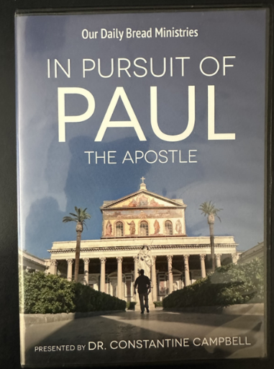

Friday Nights in Lent
After a light supper and fellowship at 6:30, we will view this contemporary look at the travels of St. Paul.
Begins Friday March 7.

Chapel Organ Dedication
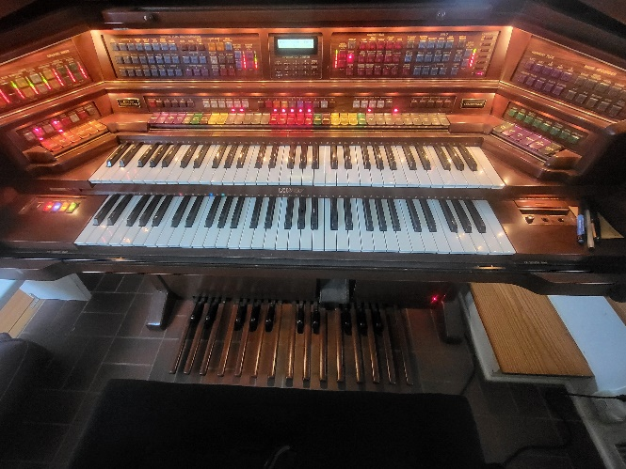
March 2, 2025 - 8 and 10:30
Join us for Sunday services in our historic chapel to dedicate our newly donated organ to God’s use.

Potluck in the Parish Hall to follow.

Please come celebrate this generous gift to St. John’s and meet the Tubbs family that made it possible.


Come to St. John’s
Shrove Tuesday pancake dinner
March 4, 2025
5:00 pm in the parish hall

Join us for pancakes, sausage, bacon and all the fixins!
Celebrate Mardi Gras the night before Lent begins

Laissez les bons temps rouler!!!!!!!

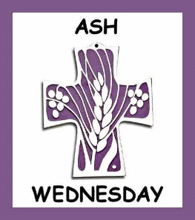
Ash Wednesday Services
Noon and 7 pm
Ashes to Go
7 to 9 and 4 to 6

RECYCLING!

It takes approximately 15 kilowatt-hours (kWh) of electricity to make one aluminum can when produced from virgin ore, as the process of converting aluminum from bauxite is very energy intensive. Recycling aluminum cans requires significantly less energy, with the ability to produce 20 new cans with the same energy used to make one can from bauxite.

By popular demand, we are recycling. Some parishioners take printed paper home where they have recycling pickup. We now have a blue container located in the Parish Hall. This will be collected and taken for recycling. Aluminum cans will be saved and taken to a recycling center for cash. The proceeds will be donated to the Outreach fund. Each recycled aluminum can also save on the electricity needed to make new aluminum from bauxite.

In our Community
Bible Studies in our area. If interested, please contact these churches to confirm.
St. Mary’s, Abingdon, (410)569-0180- Wednesdays at noon. Bring lunch. Zoom available.
Emmanuel, Bel Air, (410)838-7699- Fridays at 9:30- Zoom Available.
Holy Trinity, Churchville, (410)914-5531- Wednesdays 11:30- Zoom may be available.

What’s Happening This Week at St. John’s

Sunday, February 23—7th Sunday after Epiphany
8:00am: Holy Eucharist Rite I, Said Service (Church)
10:30am: Holy Eucharist Rite II, with Music (Church)
11:30am: Coffee Hour (Parish Hall)

Monday, February 24
12:00-1:00pm: AA Lunch Bunch (Parish Hall)

Tuesday, February 25
12:00-1:00pm: AA Lunch Bunch (Parish Hall)

Wednesday, February 26
9:00am: Book Study (Parish Hall)
12:00-1:00pm: AA Lunch Bunch (Parish Hall)
6:00-7:00pm: Yoga (Chapel)
7:00pm: Choir Rehearsal (Church)
7:30pm: AA (Parish Hall)

Thursday, February 27
12:00-1:00pm: AA Lunch Bunch (Parish Hall)
7:00pm: AA (Parish Hall)

Friday, February 28
12:00-1:00pm: AA Lunch Bunch (Parish Hall)
6:00pm -7:00pm: Yoga (Chapel)

Saturday, March 1
9:00am-10:00am: Yoga (Chapel)
8:30pm: AA (Parish Hall)

Sunday, March 2—Last Sunday after Epiphany
8:00am: Holy Eucharist Rite I, Said Service (Church)
10:30am: Holy Eucharist Rite II, with Music (Church)
11:30am: Potluck
11:45am: Bell Choir Rehearsal (Church)

Parish Office is open Monday, Wednesday and Thursday, 9:30am-1:30pm.

Potluck Luncheon on the first Sunday of the month and a Coffee Hour on all other Sundays after the 10:30 service.

