St. John’s Episcopal Church
Kingsville, Maryland
Welcomes You

OUR VISION STATEMENT
We believe that together we will transform the world with love: Come on in!



2nd Sunday after Christmas
January 5, 2025
10:30 am, Rite II

St. John’s Episcopal Church

11901 Belair Road, P. O. Box 187, Kingsville, MD 21087
Facebook: St. John’s Episcopal, Kingsville, MD
Email: office@stjohnskingsville.org
Website: www.stjohnskingsville.org
Church Phone: 410-592-8570
For Pastoral Emergencies: Fr. Mark Lobb+ 443-690-9545

Welcome to worship today! We are glad that you are with us. You are invited to participate in all parts of the service as indicated in the Book of Common Prayer and this service bulletin. If you have any questions, feel free to ask the ushers. Restrooms are located in the Parish hall, the brick building across the parking lot.

I was glad when they said to me, “Let us go to the house of the Lord.” Psalm 122:1

Church Staff

Priest in Charge: Father Mark Lobb
Administrative Assistant: Angie Bosley
Organist/Choir Director: Nancy Heinold

The Vestry

Class of 2025 Class of 2026

John Frost John Stevens
Woodie Tingle
Jacob Johnson

Officers
Ty Schwenk—Sr. Warden Terry Roe—Jr. Warden
Elizabeth Healey—Treasurer Anne Leland-Registrar

Parish Committee Chairpersons

Altar Guild: Elizabeth Healey
Auxiliary Committee: Michele Lozanski
Cemetery Committee: Karen Smith-Manar

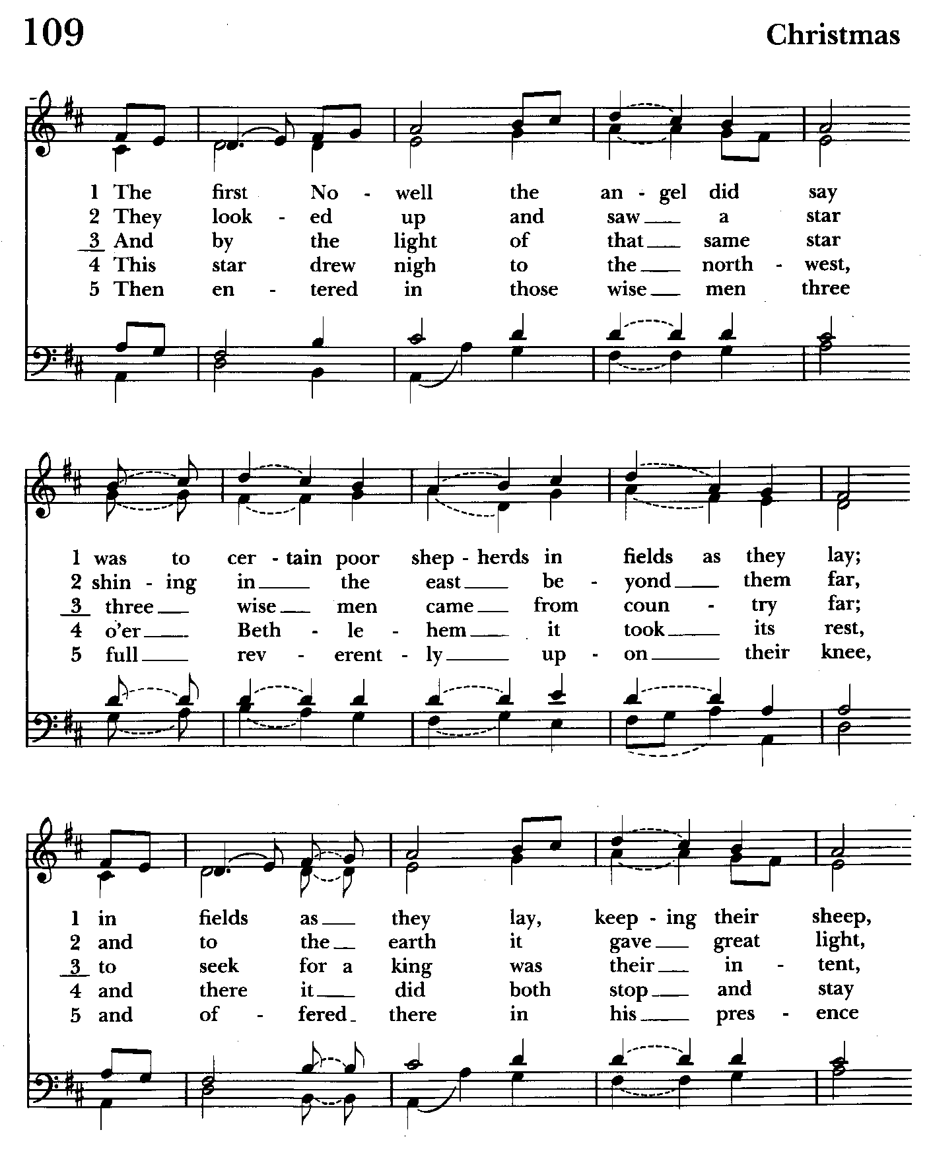

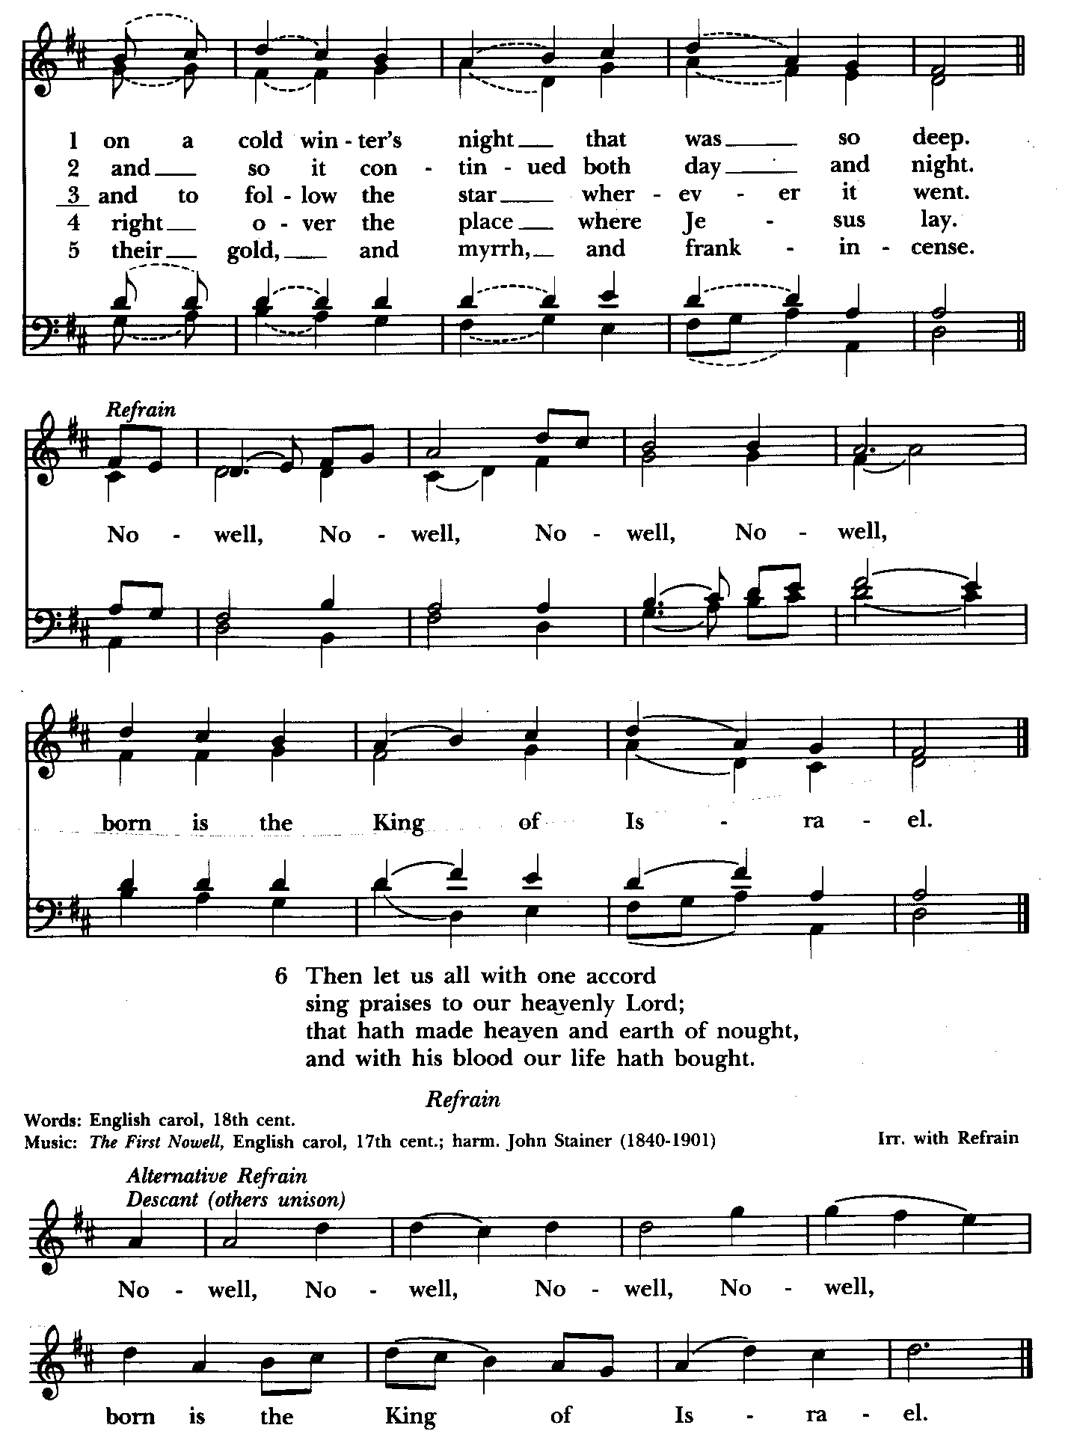

10:30 am Worship
Holy Eucharist, Rite Two

Prelude

The Word of God

Processional hymn: The first Nowell the angel did say Hymnal #109
(see previous 2 pages)

The congregation remains standing as able

Celebrant: Blessed be God: Father, Son, and Holy Spirit. BCP 355
People: And blessed be his kingdom, now and for ever. Amen.

Celebrant: Almighty God, to you all hearts are open, all desires known, and from you no secrets are hid: Cleanse the thoughts of our hearts by the inspiration of your Holy Spirit, that we may perfectly love you, and worthily magnify your holy Name; through Christ our Lord. Amen.

Gloria Hymnal #S-278
Glory to God in the highest,
and peace to his people on earth.
Lord God, heavenly King,
almighty God and Father,
we worship you, we give you thanks,
we praise you for your glory.
Lord Jesus Christ, only Son of the Father,
Lord God, Lamb of God,
you take away the sin of the world:
have mercy on us;
you are seated at the right hand of the Father:
receive our prayer.
For you alone are the Holy One,
you alone are the Lord,
you alone are the Most High,
Jesus Christ,
with the Holy Spirit,
in the glory of God the Father. Amen.

Celebrant: The Lord be with you.
People: And also with you.
Celebrant: Let us pray.

The Collect of the Day Kneel or stand as able BCP 236
O God, who wonderfully created, and yet more wonderfully restored, the dignity of human nature: Grant that we may share the divine life of him who humbled himself to share our humanity, your Son Jesus Christ; who lives and reigns with you, in the unity of the Holy Spirit, one God, for ever and ever. Amen.

The congregation is seated.

A Reading from the Prophet Jeremiah 31:7-14
Thus says the Lord:
Sing aloud with gladness for Jacob,
and raise shouts for the chief of the nations;
proclaim, give praise, and say,
"Save, O Lord, your people,
the remnant of Israel."
See, I am going to bring them from the land of the north,
and gather them from the farthest parts of the earth,
among them the blind and the lame, those with child and
those in labor, together;
a great company, they shall return here.
With weeping they shall come,
and with consolations I will lead them back,
I will let them walk by brooks of water,
in a straight path in which they shall not stumble;
for I have become a father to Israel,
and Ephraim is my firstborn.
Hear the word of the Lord, O nations,
and declare it in the coastlands far away;
say, "He who scattered Israel will gather him,
and will keep him as a shepherd a flock."
For the Lord has ransomed Jacob,
and has redeemed him from hands too strong for him.
They shall come and sing aloud on the height of Zion,
and they shall be radiant over the goodness of the Lord,
over the grain, the wine, and the oil,
and over the young of the flock and the herd;
their life shall become like a watered garden,
and they shall never languish again.
Then shall the young women rejoice in the dance,
and the young men and the old shall be merry.
I will turn their mourning into joy,
I will comfort them, and give them gladness for sorrow.
I will give the priests their fill of fatness,
and my people shall be satisfied with my bounty,
says the Lord.

Reader: The Word of the Lord.
People: Thanks be to God.

Psalm 84 (Pray as directed)
1 How dear to me is your dwelling, O Lord of hosts! *
My soul has a desire and longing for the courts of the Lord;
my heart and my flesh rejoice in the living God.
2 The sparrow has found her a house
and the swallow a nest where she may lay her young; *
by the side of your altars, O Lord of hosts,
my King and my God.
3 Happy are they who dwell in your house! *
they will always be praising you.
4 Happy are the people whose strength is in you! *
whose hearts are set on the pilgrims' way.
5 Those who go through the desolate valley will find it a place of springs, *
for the early rains have covered it with pools of water.
6 They will climb from height to height, *
and the God of gods will reveal himself in Zion.
7 Lord God of hosts, hear my prayer; *
hearken, O God of Jacob.
8 Behold our defender, O God; *
and look upon the face of your Anointed.
[9 For one day in your courts is better than a thousand in my own room, *
and to stand at the threshold of the house of my God
than to dwell in the tents of the wicked.
10 For the Lord God is both sun and shield; *
he will give grace and glory;
11 No good thing will the Lord withhold *
from those who walk with integrity.
12 O Lord of hosts, *
happy are they who put their trust in you!]

A Reading from the Letter of St. Paul to the Ephesians 1:3-6,15-19a
Blessed be the God and Father of our Lord Jesus Christ, who has blessed us in Christ with every spiritual blessing in the heavenly places, just as he chose us in Christ before the foundation of the world to be holy and blameless before him in love. He destined us for adoption as his children through Jesus Christ, according to the good pleasure of his will, to the praise of his glorious grace that he freely bestowed on us in the Beloved.
I have heard of your faith in the Lord Jesus and your love toward all the saints, and for this reason I do not cease to give thanks for you as I remember you in my prayers. I pray that the God of our Lord Jesus Christ, the Father of glory, may give you a spirit of wisdom and revelation as you come to know him, so that, with the eyes of your heart enlightened, you may know what is the hope to which he has called you, what are the riches of his glorious inheritance among the saints, and what is the immeasurable greatness of his power for us who believe.

Reader: The Word of the Lord.
People: Thanks be to God.

Gradual hymn: What star is this, with beams so bright Hymnal #124
(see next page)
The congregation remains standing as able

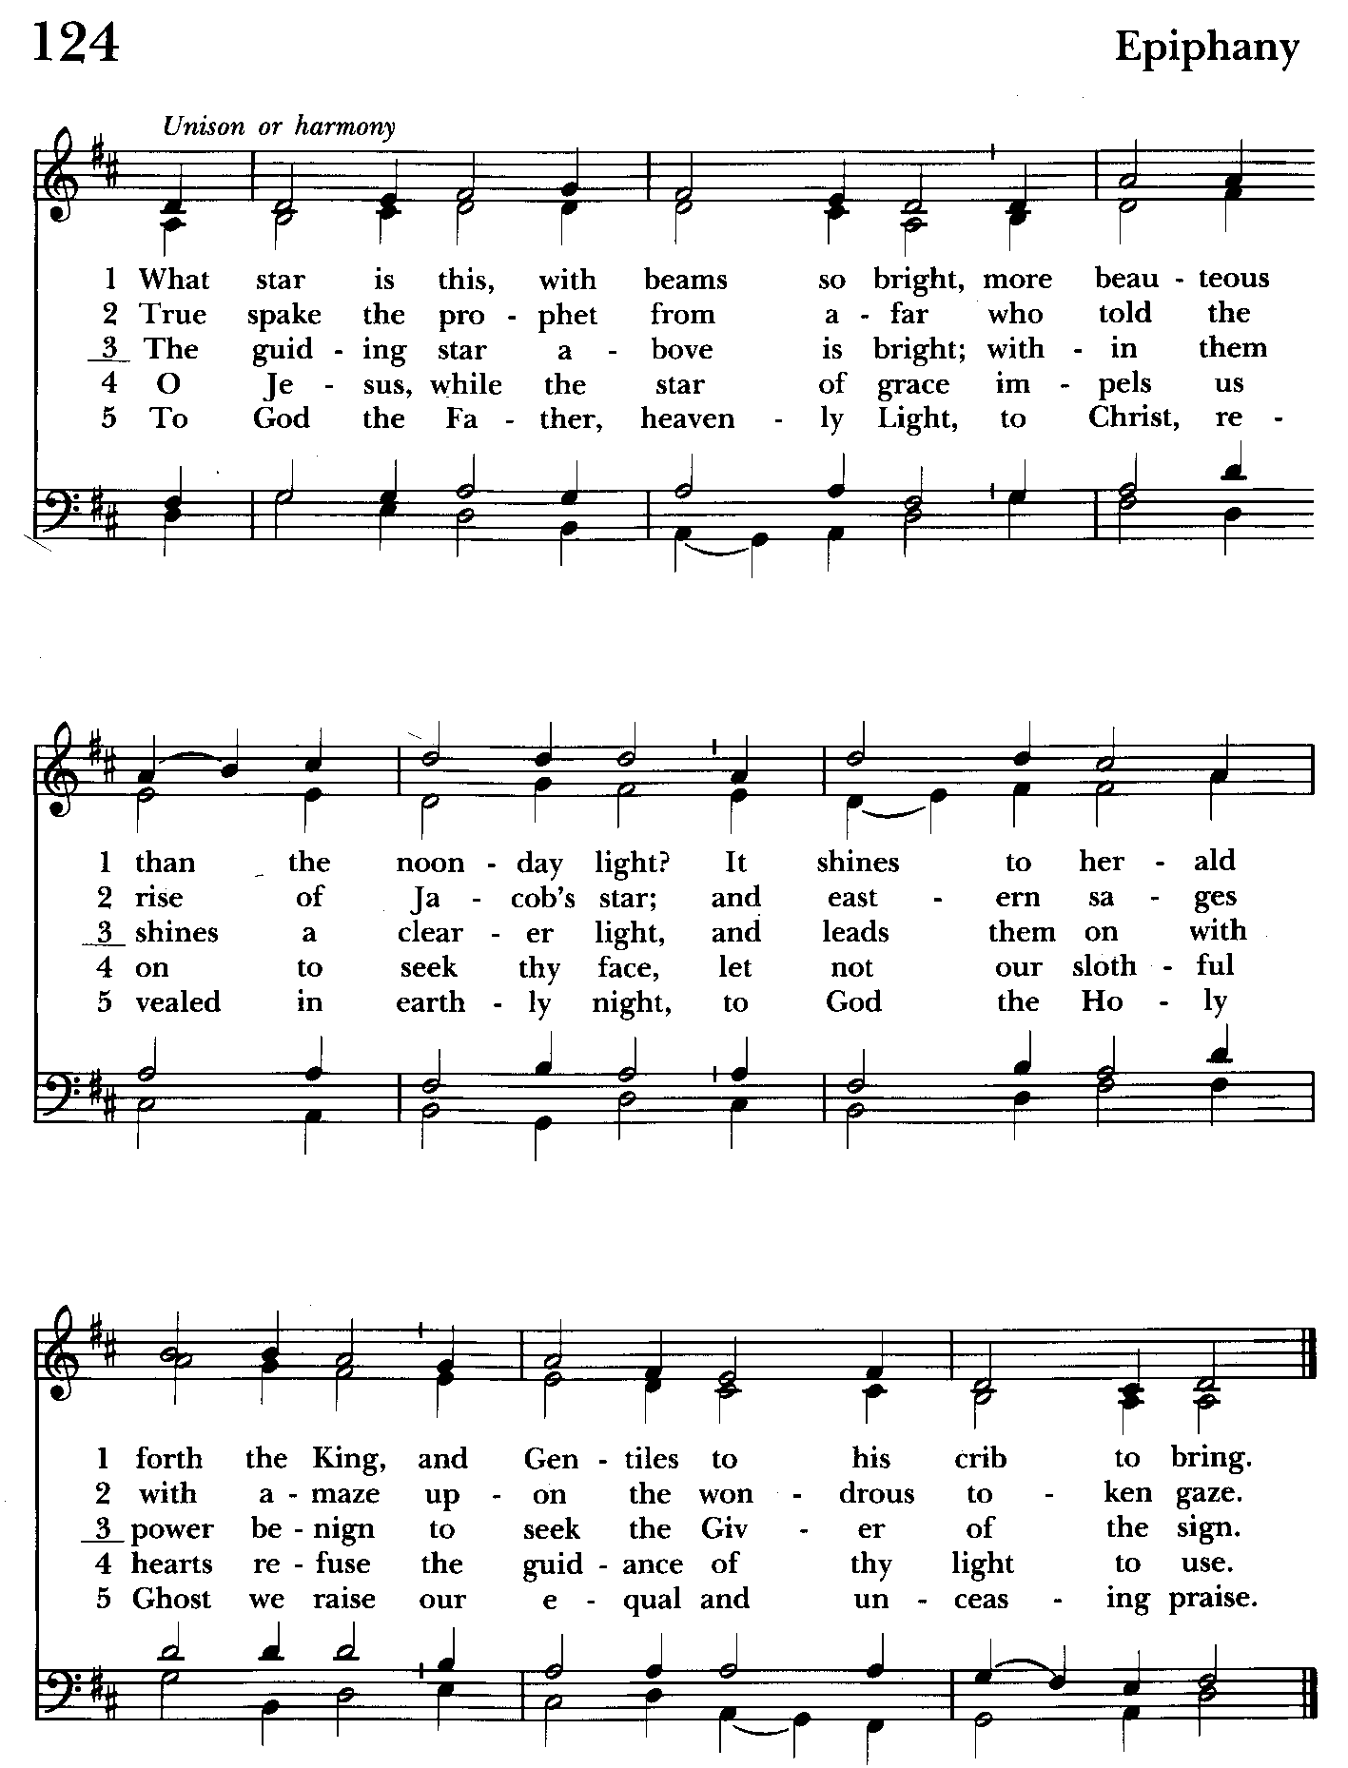

Priest: The Holy Gospel of our Lord Jesus Christ according to Matthew 2:1-12
People: Glory to you, Lord Christ.
In the time of King Herod, after Jesus was born in Bethlehem of Judea, wise men from the East came to Jerusalem, asking, "Where is the child who has been born king of the Jews? For we observed his star at its rising, and have come to pay him homage." When King Herod heard this, he was frightened, and all Jerusalem with him; and calling together all the chief priests and scribes of the people, he
inquired of them where the Messiah was to be born. They told him, "In
Bethlehem of Judea; for so it has been written by the prophet:
`And you, Bethlehem, in the land of Judah,
are by no means least among the rulers of Judah;
for from you shall come a ruler
who is to shepherd my people Israel.'"
Then Herod secretly called for the wise men and learned from them the exact time when the star had appeared. Then he sent them to Bethlehem, saying, "Go and search diligently for the child; and when you have found him, bring me word so that I may also go and pay him homage." When they had heard the king, they set out; and there, ahead of them, went the star that they had seen at its rising,
until it stopped over the place where the child was. When they saw that the star had stopped, they were overwhelmed with joy. On entering the house, they saw the child with Mary his mother; and they knelt down and paid him homage. Then, opening their treasure chests, they offered him gifts of gold, frankincense, and myrrh. And having been warned in a dream not to return to Herod, they left for their own country by another road.

Priest: The Gospel of the Lord.
People: Praise to you, Lord Christ.

Sermon The congregation is seated Rev. Mark Lobb

The Nicene Creed Please stand as able BCP 358
We believe in one God,
the Father, the Almighty,
maker of heaven and earth,
of all that is, seen and unseen.
We believe in one Lord, Jesus Christ,
the only Son of God,
eternally begotten of the Father,
God from God, Light from Light,
true God from true God,
begotten, not made,
of one Being with the Father.
Through him all things were made.
For us and for our salvation
he came down from heaven:
by the power of the Holy Spirit
he became incarnate from the Virgin Mary,
and was made man.
For our sake he was crucified under Pontius Pilate;
he suffered death and was buried.
On the third day he rose again
in accordance with the Scriptures;
he ascended into heaven
and is seated at the right hand of the Father.
He will come again in glory to judge the living and the dead,
and his kingdom will have no end.
We believe in the Holy Spirit, the Lord, the giver of life,
who proceeds from the Father and the Son.
With the Father and the Son he is worshiped and glorified.
He has spoken through the Prophets.
We believe in one holy catholic and apostolic Church.
We acknowledge one baptism for the forgiveness of sins.
We look for the resurrection of the dead,
and the life of the world to come. Amen.

The Prayers of the People Form VI Kneel or stand as able BCP 392
Litanist: In peace, we pray to you, Lord God.

Litanist: For all people in their daily life and work;
People: For our families, friends, and neighbors, and for those who are alone.

Litanist: For this community, the nation, and the world;
People: For all who work for justice, freedom, and peace.

Litanist: For the just and proper use of your creation;
People: For the victims of hunger, fear, injustice, and oppression.

Litanist: For all who are in danger, sorrow, or any kind of trouble;
People: For those who minister to the sick, the friendless, and the needy.

Litanist: For the peace and unity of the Church of God;
People: For all who proclaim the Gospel, and all who seek the Truth.

Litanist: For +Justin, Archbishop of Canterbury; +Sean, our Presiding Bishop; +Carrie, our Bishop, Mark+ our Priest in Charge, for the Wardens, Vestry, Staff, and all members and friends of St. John’s Church.
People: For all who serve God in his Church.
Litanist: For the special needs and concerns of this congregation. Especially
remember in our prayers, DeMarino Family, Jim & Chris Carden and family,
Peggie Dietz, Mike Carden, Pat Carden, Gail Landers, Sheila Jones, Gloria Millar, Marisol Aubrey, Ross Strickler, Jim & Janice Sieracki, James Daniel Jr., Larry Betzler, Camy Schwenk, Dennis Mally, Zach Walsh, Lily John, Barbara Miller, Nancy Barnhart, Robin Dilworth, Helen Johnson, Eileen Weimer, David Harris.
The People may add their own petitions

Litanist: Hear us, Lord;
People: For your mercy is great.
Litanist: We thank you, Lord, for all the blessings of this life.

The People may add their own thanksgivings

Litanist: We will exalt you, O God our King;
People: And praise your Name for ever and ever.

Litanist: We pray for all who have died, that they may have a place in your eternal kingdom. And especially for those of blessed memory in the Peeling Family for whom the altar flowers are given.

We pray for healing for all those injured in the tragic events that took place in New Orleans and Las Vegas, especially those injured in the performance of their duty.

We also pray for the repose of the souls of those who died due to the evil perpetrated in New Orleans and Las Vegas.
For the Human Family
O God, you made us in your own image and redeemed us through Jesus your Son: Look with compassion on the whole human family; take away the arrogance and hatred which infect our hearts; break down the walls that separate us; unite us in bonds of love; and work through our struggle and confusion to accomplish your purposes on earth; that, in your good time, all nations and races may serve you in
harmony around your heavenly throne; through Jesus Christ our Lord. Amen.

The People may add their own petitions
Litanist: Lord, let your loving-kindness be upon them;
People: Who put their trust in you.

Litanist: We pray to you also for the forgiveness of our sins.
People: Have mercy upon us, most merciful Father; in your compassion forgive us our sins, known and unknown, things done and left undone; and so uphold us by your Spirit that we may live and serve you in newness of life, to the honor and glory of your Name; through Jesus Christ our Lord. Amen.

The Celebrant gives the absolution.

The Peace Please stand as able BCP 360

Welcome & Announcements The congregation is seated.

Offertory Hymn: How bright appears the Morning Star Hymnal #497
(see next 2 pages)
The people remain seated while offerings are collected.
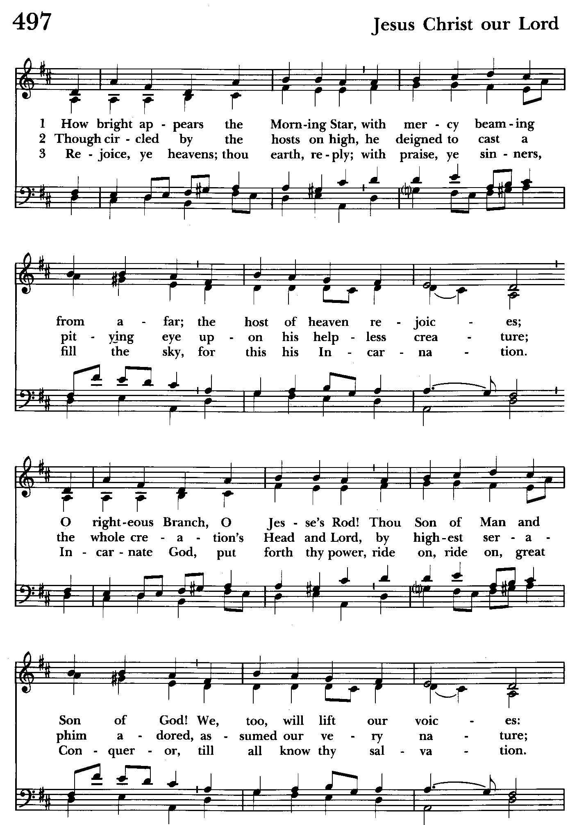

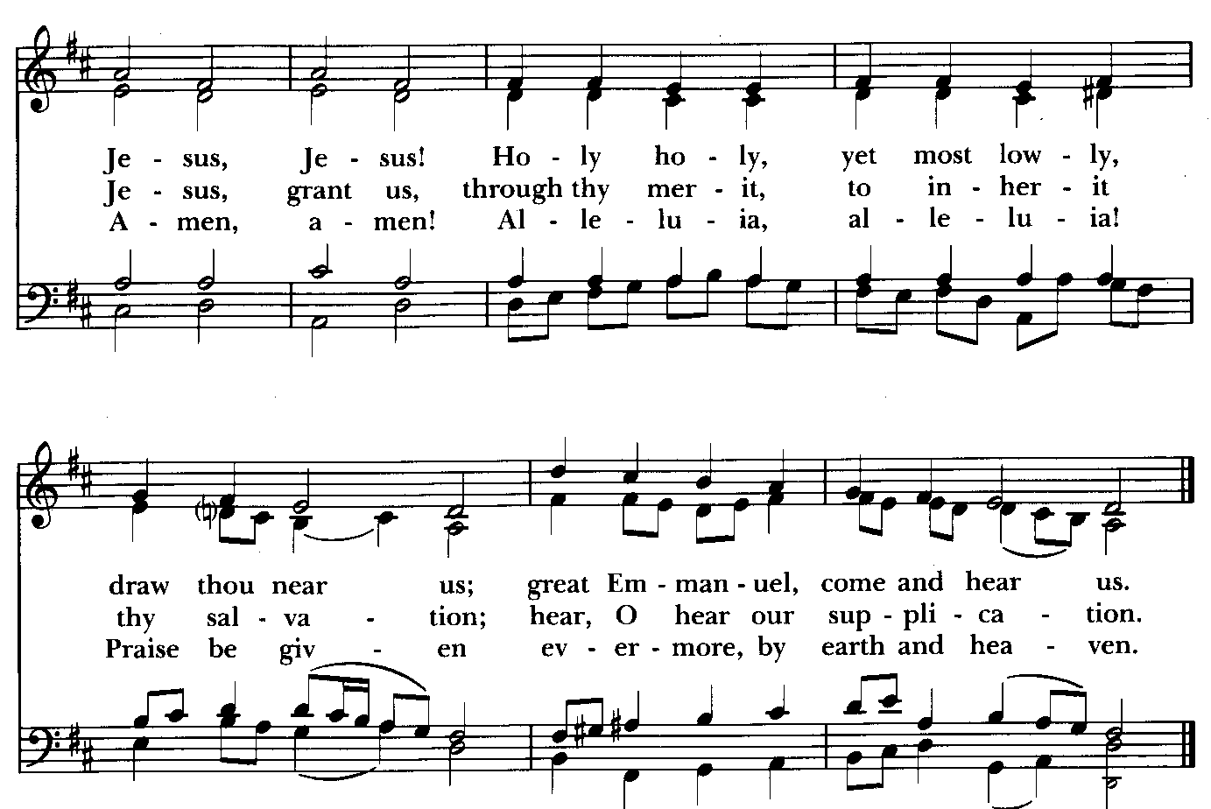

Presentation Hymn Offerings are presented Please stand as able Hymnal #43, vs. 4
Praise God, from whom all blessings flow; praise him, all creatures here below; praise him above, ye heavenly host: praise Father, Son, and Holy Ghost.

The Holy Communion

THE GREAT THANKSGIVING: Eucharistic Prayer B BCP 367
Celebrant: The Lord be with you.
People: And also with you.
Celebrant: Lift up your hearts.
People: We lift them to the Lord.
Celebrant: Let us give thanks to the Lord our God.
People: It is right to give him thanks and praise.

Then, facing the Holy Table, the Celebrant proceeds
It is right, and a good and joyful thing, always and everywhere to give thanks to you, Father Almighty, Creator of heaven and earth.

Therefore we praise you, joining our voices with Angels and Archangels and with all the company of heaven, who for ever sing this hymn to proclaim the glory of your Name:

Celebrant and People:
Holy, Holy, Holy Lord, God of power and might, Hymnal #S-129
heaven and earth are full of your glory.
Hosanna in the highest.
Blessed is he who comes in the name of the Lord.
Hosanna in the highest.
Please kneel or stand as able
Then the Celebrant continues BCP 368
We give thanks to you, O God, for the goodness and love which you have made known to us in creation; in the calling of Israel to be your people; in your Word spoken through the prophets; and above all in the Word made flesh, Jesus, your
Son. For in these last days you sent him to be incarnate from the Virgin Mary, to be the Savior and Redeemer of the world. In him, you have delivered us from evil, and made us worthy to stand before you. In him, you have brought us out of error into truth, out of sin into righteousness, out of death into life.

At the following words concerning the bread, the Celebrant is to hold it, or to lay a hand upon it; and at the words concerning the cup, to hold or place a hand upon the cup and any other vessel
containing wine to be consecrated.

On the night before he died for us, our Lord Jesus Christ took bread; and when he had given thanks to you, he broke it, and gave it to his disciples, and said, "Take, eat: This is my Body, which is given for you. Do this for the remembrance of me."

After supper he took the cup of wine; and when he had given thanks, he gave it to them, and said, "Drink this, all of you: This is my Blood of the new Covenant, which is shed for you and for many for the forgiveness of sins. Whenever you drink it, do this for the remembrance of me."
Therefore, according to his command, O Father,

Celebrant and People:
We remember his death,
We proclaim his resurrection,
We await his coming in glory;

The Celebrant continues
And we offer our sacrifice of praise and thanksgiving to you, O Lord of all;
presenting to you, from your creation, this bread and this wine. We pray you,
gracious God, to send your Holy Spirit upon these gifts that they may be the
Sacrament of the Body of Christ and his Blood of the new Covenant. Unite us to your Son in his sacrifice, that we may be acceptable through him, being sanctified by the Holy Spirit. In the fullness of time, put all things in subjection under your Christ, and bring us to that heavenly country where, with St. John and the Blessed Virgin Mary and all your saints, we may enter the everlasting heritage of your sons and daughters; through Jesus Christ our Lord, the firstborn of all creation, the head of the Church, and the author of our salvation.

By him, and with him, and in him, in the unity of the Holy Spirit all honor and
glory is yours, Almighty Father, now and for ever. Amen.

And now, as our Savior Christ has taught us, we are bold to say,

Our Father, who art in heaven, BCP p. 364
hallowed be thy Name,
thy kingdom come,
thy will be done,
on earth as in heaven.
Give us this day our daily bread.
And forgive us our trespasses,
as we forgive those
who trespass against us.
And lead us not into temptation,
but deliver us from evil.
For thine is the kingdom,
and the power, and the glory,
for ever and ever. Amen.

Invitation to Communion

The Breaking of the Bread
Celebrant: Alleluia. Christ our Passover is sacrificed for us;
People: Therefore let us keep the feast. Alleluia.
Celebrant: The Gifts of God for the people of God.

The congregation is seated

Communion hymn: Love came down at Christmas Hymnal #84
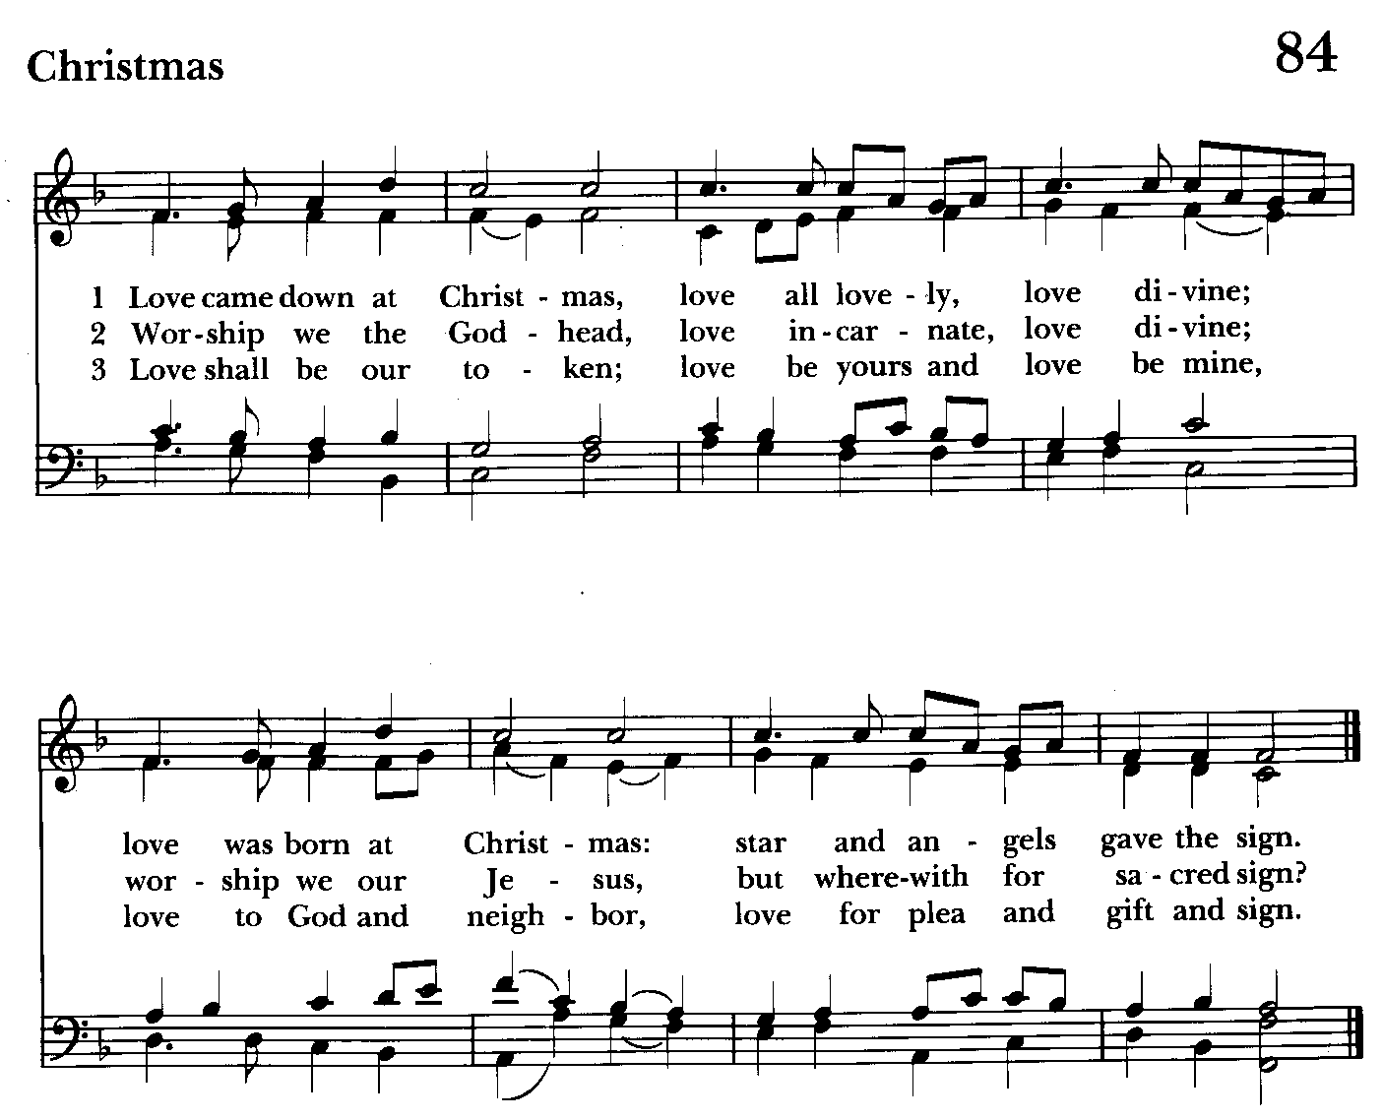

The Post Communion Prayer BCP p. 365
Eternal God, heavenly Father, you have graciously accepted us as living
members of your Son our Savior Jesus Christ, and you have fed us with
spiritual food in the Sacrament of his Body and Blood. Send us now into the world in peace, and grant us strength and courage to love and serve you with gladness and singleness of heart; through Christ our Lord. Amen.

Blessing

Recessional hymn: Angels, from the realms of glory Hymnal #93
(see next page)

The Dismissal
Celebrant: Let us go forth in the name of the risen Lord.
People: Thanks be to God.

Postlude:

License #A-719154

Serving Today

Celebrant and Preacher: Rev. Mark Lobb
Old Testament: Barb Daniel
Psalm: John Frost
New Testament: Anne Leland
Prayers of the People: John Frost
Server: Terry Roe
Music Director: Nancy Heinold
Altar Guild: Li Healey & Marguerite Lobb

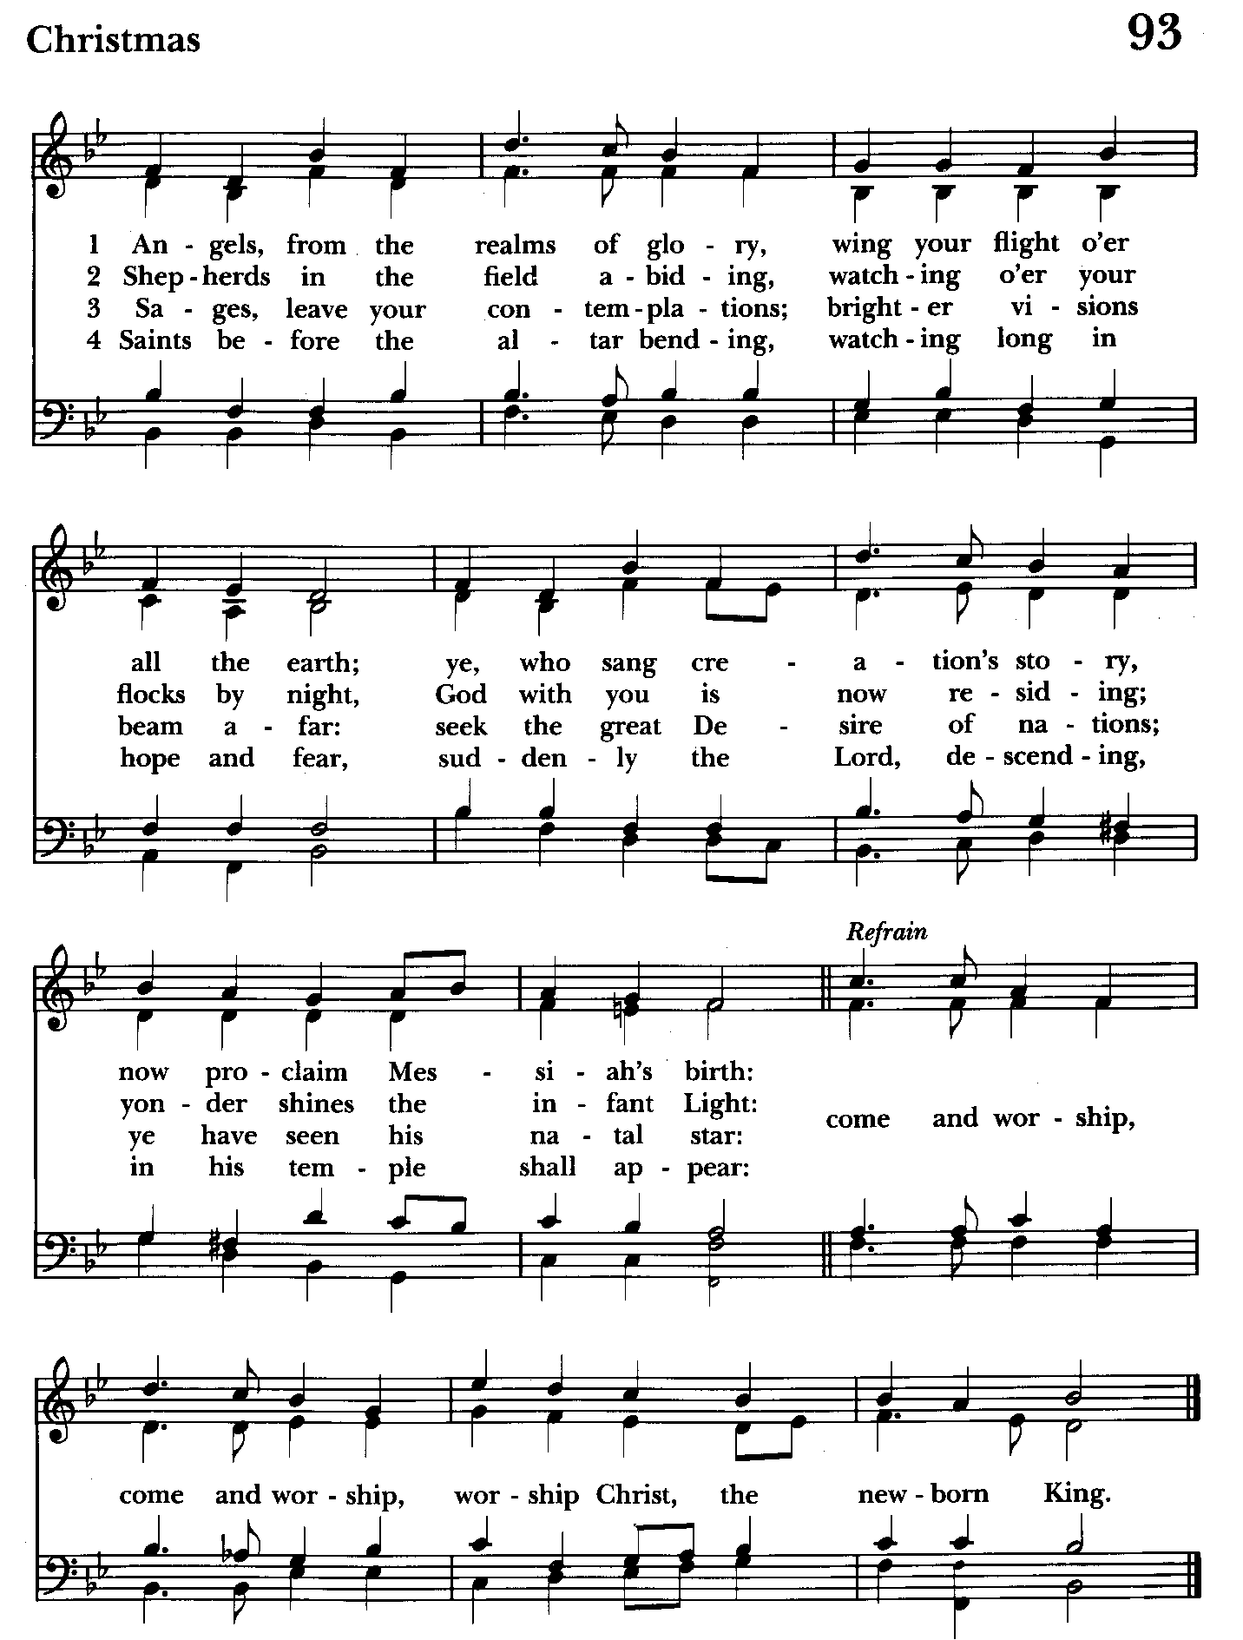

St. John’s Parish Prayer List

Additions and corrections may be made to our Parish Prayer List at any time. All names will be automatically removed from the Parish Prayer List on the 1st Sunday of each month unless you request otherwise. Please contact Angie at <office@stjohnskingsville.org> or 410-592-8570 in the church office with all changes by 10 am Thursdays. Thank you.

We Pray for Those in Need:
Names in BOLD read aloud by all.

DeMarino Family, Jim & Chris Carden and family, Peggie Dietz, Mike Carden, Pat Carden, Gail Landers, Sheila Jones, Gloria Millar, Marisol Aubrey, Ross Strickler, Jim and Janice Sieracki, James Daniel Jr, Larry Betzler, Camy Schwenk, Dennis Mally, Zach Walsh, Helen Johnson, Eileen Weimer, David Harris.

We Pray for our Homebound

Lily John, Barbara Miller, Nancy Barnhart, Robin Dilworth

We pray for the Church and the World:

For +Justin, Archbishop of Canterbury; for +Sean, our Presiding Bishop; for +Carrie, our Bishop, for Mark+, our Priest in Charge, for the Wardens, Vestry, Staff, and all members and friends of St. John’s Church.

We pray for the repose of the soul of our 39th President of the United States, Jimmy Carter.

For the leaders of all nations, especially for Joseph, our President; for Wes, our Governor; for Brandon, Zeke, John and Bob, who lead our City and Counties. We pray for all children and youth; for the homeless, the unemployed, and the hungry. We pray for the safety of our loved ones and friends serving in the Armed Forces at home and abroad, and for our enemies, that all our hearts may be turned toward peace throughout the world.

From the Treasurer
December ‘24 Income vs. Expenses:

Projected December Expenses: $14,500
Monies Received as of 12/31: $18,483
Amount Needed to Meet Expenses: Thank You!

January ’25 Projected Expenses: $14,250


If you’d like to make a donation to St. John’s you can scan this QR code with your phone’s camera or tap on the link that comes up to make a contribution with either a credit or debit card, Apple Pay or Google Pay. This is a secure site provided by Clover which is a service of PNC Bank.


Altar Flowers
Given to the Glory of God
by The Peeling Family in memory of Loved Ones


SUNDAY SCHOOL
10:30: Kids Sunday School- Begin in the church, ring the bell, then process over to the parish hall for a fun lesson with Mr. John and Ms. Stephanie.
Note: Please seriously consider regular attendance at Sunday School so that Mr. John and Ms. Stephanie can plan good stuff.


Choral Choir and Bell Choir
Choir rehearsals Wednesdays at 7:00 pm and Bell Choir Rehearsal, Sundays after the 10:30 service. If anyone is interested in joining, see Nancy Heinold, our Music Director.


Yoga classes on Wednesday and Friday evenings 6 to 7 pm and Saturday mornings 9 to 10 am in the Chapel. All experience levels are welcome.

Calendar Updates
Potluck Today
January 12th - Morning Prayer
February 2nd - Annual Meeting (Proposed)

Calendars are living documents. Every effort will be made to keep the members of the parish and community aware of any changes.


With so much going on, everyone’s help is needed to make things a success. Our volunteers make the Church function. The volunteering of time and talent is greatly appreciated.

RECYCLING!

Did you know that cat food cans are aluminum? How can you tell if a can is aluminum? Try a magnet.

By popular demand, we are recycling. Some parishioners take printed paper home where they have recycling pickup. We now have a blue container located in the Parish Hall. This will be collected and taken for recycling. Aluminum cans will be saved and taken to a recycling center for cash. The proceeds will be donated to the Outreach fund. Each recycled aluminum can also save on the electricity needed to make new aluminum from bauxite.

In our Community
Bible Studies in our area. If interested, please contact these churches to confirm.
St. Mary’s, Abingdon, (410)569-0180- Wednesdays at noon. Bring lunch. Zoom available.
Emmanuel, Bel Air, (410)838-7699- Fridays at 9:30- Zoom Available.
Holy Trinity, Churchville, (410)914-5531- Wednesdays 11:30- Zoom may be available.

What’s Happening This Week at St. John’s

Sunday, January 5—2nd Sunday after Christmas
8:00am: Holy Eucharist, Rite I (Church)
10:30am: Holy Eucharist, Rite II (Church)
11:30am: Potluck (Parish Hall)

Monday, January 6
12:00-1:00pm: AA Lunch Bunch (Parish Hall)

Tuesday, January 7
12:00-1:00pm: AA Lunch Bunch (Parish Hall)

Wednesday, January 8
12:00-1:00pm: AA Lunch Bunch (Parish Hall)
6:00-7:00pm: Yoga (Chapel)
7:30pm: AA (Parish Hall)

Thursday, January 9
12:00-1:00pm: AA Lunch Bunch (Parish Hall)
7:00pm: AA (Parish Hall)

Friday, January 10
12:00-1:00pm: AA Lunch Bunch (Parish Hall)
6:00pm -7:00pm: Yoga (Chapel)

Saturday, January 11
9:00am-10:00am: Yoga (Chapel)
8:30pm: AA (Parish Hall)

Sunday, January 12—1st Sunday after Epiphany
8:00am: Holy Eucharist, Said Service (Church)
10:30am: Holy Eucharist, with Music (Church)
11:30am: Coffee Hour (Parish Hall)

Parish Office is open Monday, Wednesday and Thursday, 9:30am-1:30pm.
Potluck Luncheon on the first Sunday of the month and a Coffee Hour on all other Sundays after the 10:30 service.

