St. John’s Episcopal Church
Kingsville, Maryland
Welcomes You

OUR VISION STATEMENT
We believe that together we will transform the world with love: Come on in!



2nd Sunday after Epiphany
January 19, 2025
10:30 am, Rite II

St. John’s Episcopal Church

11901 Belair Road, P. O. Box 187, Kingsville, MD 21087
Facebook: St. John’s Episcopal, Kingsville, MD
Email: office@stjohnskingsville.org
Website: www.stjohnskingsville.org
Church Phone: 410-592-8570
For Pastoral Emergencies: Fr. Mark Lobb+ 443-690-9545

Welcome to worship today! We are glad that you are with us. You are invited to participate in all parts of the service as indicated in the Book of Common Prayer and this service bulletin. If you have any questions, feel free to ask the ushers. Restrooms are located in the Parish hall, the brick building across the parking lot.

I was glad when they said to me, “Let us go to the house of the Lord.” Psalm 122:1

Church Staff

Priest in Charge: Father Mark Lobb
Administrative Assistant: Angie Bosley
Organist/Choir Director: Nancy Heinold

The Vestry

Class of 2025 Class of 2026

John Frost John Stevens
Jacob Johnson Woodie Tingle

Officers
Ty Schwenk—Sr. Warden Terry Roe—Jr. Warden
Elizabeth Healey—Treasurer Anne Leland-Registrar

Parish Committee Chairpersons

Altar Guild: Elizabeth Healey
Auxiliary Committee: Michele Lozanski
Cemetery Committee: Karen Smith-Manar

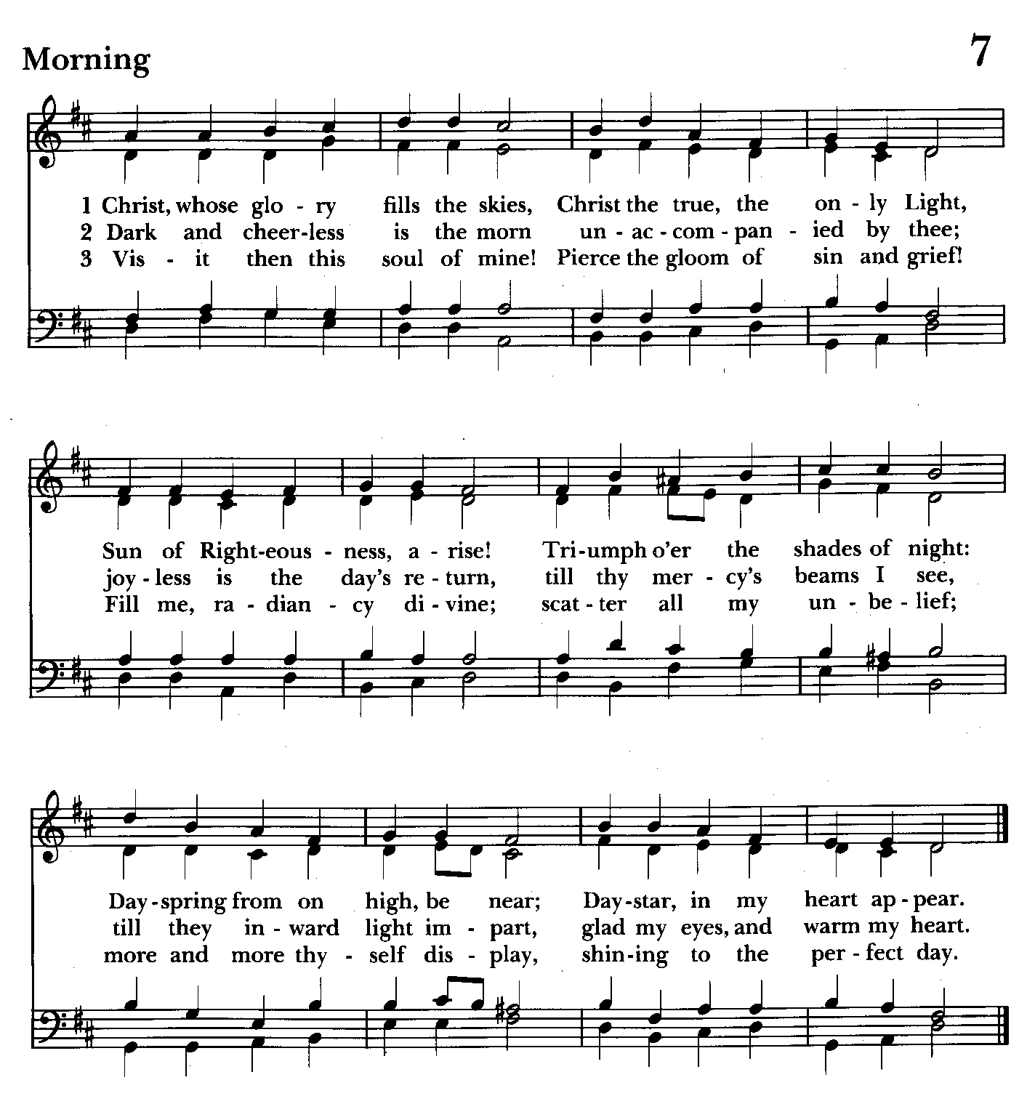

10:30 am Worship
Holy Eucharist, Rite Two

Prelude

The Word of God

Processional hymn: Christ, whose glory fills the skies Hymnal #7
(see above)

The congregation remains standing as able

Celebrant: Blessed be God: Father, Son, and Holy Spirit. BCP 355
People: And blessed be his kingdom, now and for ever. Amen.

Celebrant: Almighty God, to you all hearts are open, all desires known, and from you no secrets are hid: Cleanse the thoughts of our hearts by the inspiration of your Holy Spirit, that we may perfectly love you, and worthily magnify your holy Name; through Christ our Lord. Amen.

Gloria Hymnal #S-280
Glory to God in the highest,
and peace to his people on earth.
Lord God, heavenly King,
almighty God and Father,
we worship you, we give you thanks,
we praise you for your glory.
Lord Jesus Christ, only Son of the Father,
Lord God, Lamb of God,
you take away the sin of the world:
have mercy on us;
you are seated at the right hand of the Father:
receive our prayer.
For you alone are the Holy One,
you alone are the Lord,
you alone are the Most High,
Jesus Christ,
with the Holy Spirit,
in the glory of God the Father. Amen.

Celebrant: The Lord be with you.
People: And also with you.
Celebrant: Let us pray.

The Collect of the Day Kneel or stand as able BCP 215
Almighty God, whose Son our Savior Jesus Christ is the light of the world: Grant that your people, illumined by your Word and Sacraments, may shine with the radiance of Christ's glory, that he may be known, worshipped, and obeyed to the ends of the earth; through Jesus Christ our Lord, who with you and the Holy Spirit lives and reigns, one God, now and for ever. Amen.

The congregation is seated.

A Reading from the Prophet Isaiah 62:1-5
For Zion's sake I will not keep silent,
and for Jerusalem's sake I will not rest,
until her vindication shines out like the dawn,
and her salvation like a burning torch.
The nations shall see your vindication,
and all the kings your glory;
and you shall be called by a new name
that the mouth of the Lord will give.
You shall be a crown of beauty in the hand of the Lord,
and a royal diadem in the hand of your God.
You shall no more be termed Forsaken,
and your land shall no more be termed Desolate;
but you shall be called My Delight Is in Her,
and your land Married;
for the Lord delights in you,
and your land shall be married.
For as a young man marries a young woman,
so shall your builder marry you,
and as the bridegroom rejoices over the bride,
so shall your God rejoice over you.

Reader: The Word of the Lord.
People: Thanks be to God.

Psalm 36:5-10 (Pray as directed)
5 Your love, O Lord, reaches to the heavens, *
and your faithfulness to the clouds.
6 Your righteousness is like the strong mountains,
your justice like the great deep; *
you save both man and beast, O Lord.
7 How priceless is your love, O God! *
your people take refuge under the shadow of your wings.
8 They feast upon the abundance of your house; *
you give them drink from the river of your delights.
9 For with you is the well of life, *
and in your light we see light.
10 Continue your loving-kindness to those who know you, *
and your favor to those who are true of heart.

A Reading from the First Letter of St. Paul to the Corinthians 12:1-11
Now concerning spiritual gifts, brothers and sisters, I do not want you to be uninformed. You know that when you were pagans, you were enticed and led astray to idols that could not speak. Therefore I want you to understand that no one speaking by the Spirit of God ever says "Let Jesus be cursed!" and no one can say "Jesus is Lord" except by the Holy Spirit.
Now there are varieties of gifts, but the same Spirit; and there are varieties of services, but the same Lord; and there are varieties of activities, but it is the same God who activates all of them in everyone. To each is given the manifestation of the Spirit for the common good. To one is given through the Spirit the utterance of wisdom, and to another the utterance of knowledge according to the same Spirit, to another faith by the same Spirit, to another gifts of healing by the one Spirit, to another the working of miracles, to another prophecy, to another the discernment of spirits, to another various kinds of tongues, to another the interpretation of tongues. All these are activated by one and the same Spirit, who allots to each one individually just as the Spirit chooses.

Reader: The Word of the Lord.
People: Thanks be to God.

Gradual hymn: The people who in darkness walked Hymnal #126
(see below)
The congregation remains standing as able

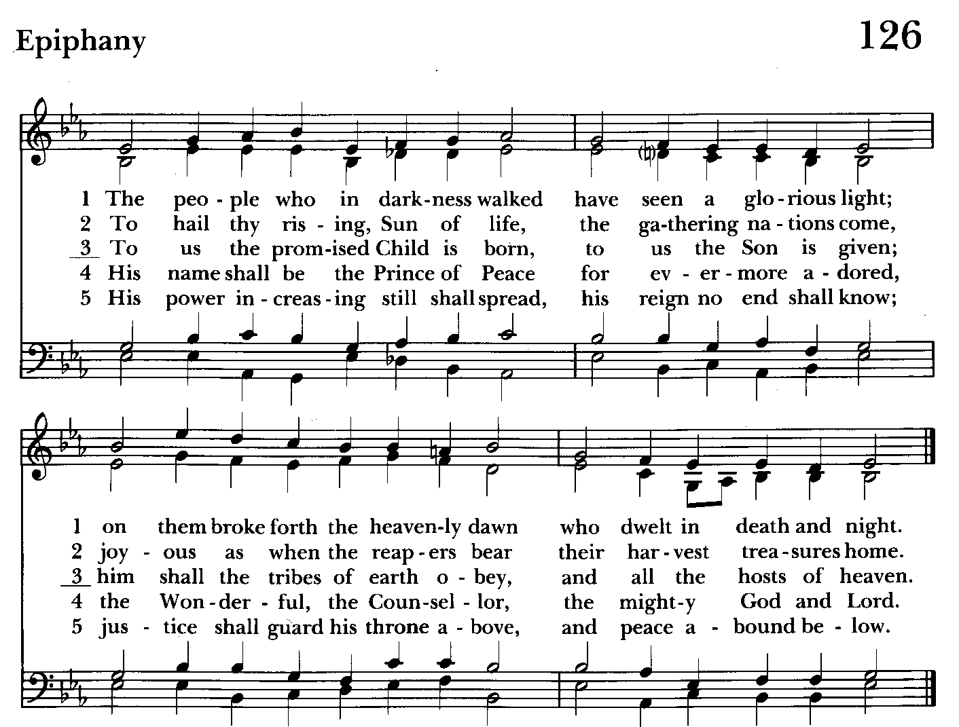

Priest: The Holy Gospel of our Lord Jesus Christ according to John 2:1-11
People: Glory to you, Lord Christ.
On the third day there was a wedding in Cana of Galilee, and the mother of Jesus was there. Jesus and his disciples had also been invited to the wedding. When the wine gave out, the mother of Jesus said to him, "They have no wine." And Jesus said to her, "Woman, what concern is that to you and to me? My hour has not yet come." His mother said to the servants, "Do whatever he tells you." Now standing there were six stone water jars for the Jewish rites of purification, each holding twenty or thirty gallons. Jesus said to them, "Fill the jars with water." And they filled them up to the brim. He said to them, "Now draw some out, and take it to the chief steward." So they took it. When the steward tasted the water that had become wine, and did not know where it came from (though the servants who had drawn the water knew), the steward called the bridegroom and said to him, "Everyone serves the good wine first, and then the inferior wine after the guests have become drunk. But you have kept the good wine until now." Jesus did this, the first of his signs, in Cana of Galilee, and revealed his glory; and his disciples believed in him.

Priest: The Gospel of the Lord.
People: Praise to you, Lord Christ.

Sermon The congregation is seated Rev. Mark Lobb

The Nicene Creed Please stand as able BCP 358
We believe in one God,
the Father, the Almighty,
maker of heaven and earth,
of all that is, seen and unseen.
We believe in one Lord, Jesus Christ,
the only Son of God,
eternally begotten of the Father,
God from God, Light from Light,
true God from true God,
begotten, not made,
of one Being with the Father.
Through him all things were made.
For us and for our salvation
he came down from heaven:
by the power of the Holy Spirit
he became incarnate from the Virgin Mary,
and was made man.
For our sake he was crucified under Pontius Pilate;
he suffered death and was buried.
On the third day he rose again
in accordance with the Scriptures;
he ascended into heaven
and is seated at the right hand of the Father.
He will come again in glory to judge the living and the dead,
and his kingdom will have no end.
We believe in the Holy Spirit, the Lord, the giver of life,
who proceeds from the Father and the Son.
With the Father and the Son he is worshiped and glorified.
He has spoken through the Prophets.
We believe in one holy catholic and apostolic Church.
We acknowledge one baptism for the forgiveness of sins.
We look for the resurrection of the dead,
and the life of the world to come. Amen.

The Prayers of the People Form VI Kneel or stand as able BCP 392
Litanist: In peace, we pray to you, Lord God.

Litanist: For all people in their daily life and work;
People: For our families, friends, and neighbors, and for those who are alone.

Litanist: For this community, the nation, and the world;
People: For all who work for justice, freedom, and peace.

Litanist: For the just and proper use of your creation;
People: For the victims of hunger, fear, injustice, and oppression.

Litanist: For all who are in danger, sorrow, or any kind of trouble;
People: For those who minister to the sick, the friendless, and the needy.

Litanist: For the peace and unity of the Church of God;
People: For all who proclaim the Gospel, and all who seek the Truth.

Litanist: For +Sean, our Presiding Bishop; +Carrie, our Bishop, Mark+ our Priest in Charge, for the Wardens, Vestry, Staff, and all members and friends of St. John’s Church.
People: For all who serve God in his Church.

Litanist: For the special needs and concerns of this congregation. Especially remember in our prayers, DeMarino Family, Jim & Chris Carden and family, Peggie Dietz, Mike Carden, Pat Carden, Gail Landers, Sheila Jones, Gloria Millar, Marisol Aubrey, Ross Strickler, Jim & Janice Sieracki, James Daniel Jr., Larry Betzler, Camy Schwenk, Dennis Mally, Zach Walsh, Lily John, Barbara Miller, Nancy Barnhart, Robin Dilworth, Helen Johnson, Eileen Weimer, David Harris.

The People may add their own petitions

Litanist: Hear us, Lord;
People: For your mercy is great.
Litanist: We thank you, Lord, for all the blessings of this life.

The People may add their own thanksgivings

Litanist: We will exalt you, O God our King;
People: And praise your Name for ever and ever.

Litanist: We pray for all who have died, that they may have a place in your eternal kingdom. And especially for those in need for whom the altar flowers are given.

The People may add their own petitions
Litanist: Lord, let your loving-kindness be upon them;
People: Who put their trust in you.

Litanist: We pray to you also for the forgiveness of our sins.
People: Have mercy upon us, most merciful Father; in your compassion forgive us our sins, known and unknown, things done and left undone; and so uphold us by your Spirit that we may live and serve you in newness of life, to the honor and glory of your Name; through Jesus Christ our Lord. Amen.

The Celebrant gives the absolution.

The Peace Please stand as able BCP 360

Welcome & Announcements The congregation is seated.

Offertory Anthem: Winter Canon (Choir)
Offertory Hymn: Immortal, invisible, God only wise Hymnal #423
(see next page)

The people remain seated while offerings are collected.

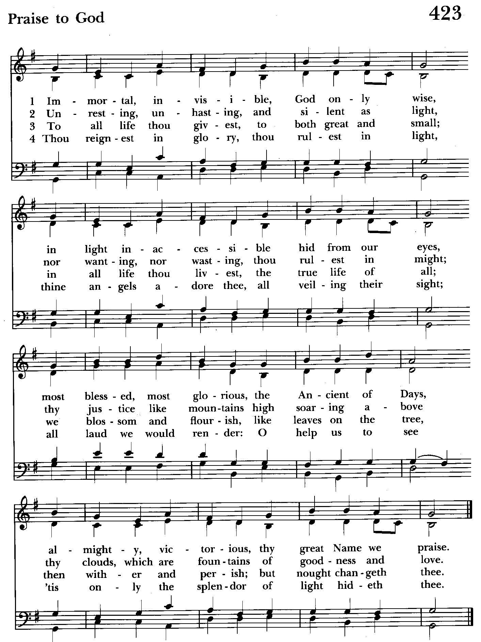

Presentation Hymn Offerings are presented Please stand as able Hymnal #43, vs. 4
Praise God, from whom all blessings flow; praise him, all creatures here below; praise him above, ye heavenly host: praise Father, Son, and Holy Ghost.

The Holy Communion

THE GREAT THANKSGIVING: Eucharistic Prayer B BCP 367
Celebrant: The Lord be with you.
People: And also with you.
Celebrant: Lift up your hearts.
People: We lift them to the Lord.
Celebrant: Let us give thanks to the Lord our God.
People: It is right to give him thanks and praise.

Then, facing the Holy Table, the Celebrant proceeds
It is right, and a good and joyful thing, always and everywhere to give thanks to you, Father Almighty, Creator of heaven and earth.

Therefore we praise you, joining our voices with Angels and Archangels and with all the company of heaven, who for ever sing this hymn to proclaim the glory of your Name:

Celebrant and People:
Holy, Holy, Holy Lord, God of power and might, Hymnal #S-129
heaven and earth are full of your glory.
Hosanna in the highest.
Blessed is he who comes in the name of the Lord.
Hosanna in the highest.

Please kneel or stand as able
Then the Celebrant continues BCP 368
We give thanks to you, O God, for the goodness and love which you have made known to us in creation; in the calling of Israel to be your people; in your Word spoken through the prophets; and above all in the Word made flesh, Jesus, your Son. For in these last days you sent him to be incarnate from the Virgin Mary, to be the Savior and Redeemer of the world. In him, you have delivered us from evil, and made us worthy to stand before you. In him, you have brought us out of error into truth, out of sin into righteousness, out of death into life.

At the following words concerning the bread, the Celebrant is to hold it, or to lay a hand upon it; and at the words concerning the cup, to hold or place a hand upon the cup and any other vessel
containing wine to be consecrated.

On the night before he died for us, our Lord Jesus Christ took bread; and when he had given thanks to you, he broke it, and gave it to his disciples, and said, "Take, eat: This is my Body, which is given for you. Do this for the remembrance of me."

After supper he took the cup of wine; and when he had given thanks, he gave it to them, and said, "Drink this, all of you: This is my Blood of the new Covenant, which is shed for you and for many for the forgiveness of sins. Whenever you drink it, do this for the remembrance of me."

Therefore, according to his command, O Father,

Celebrant and People:
We remember his death,
We proclaim his resurrection,
We await his coming in glory;

The Celebrant continues
And we offer our sacrifice of praise and thanksgiving to you, O Lord of all; presenting to you, from your creation, this bread and this wine. We pray you, gracious God, to send your Holy Spirit upon these gifts that they may be the Sacrament of the Body of Christ and his Blood of the new Covenant. Unite us to your Son in his sacrifice, that we may be acceptable through him, being sanctified by the Holy Spirit. In the fullness of time, put all things in subjection under your Christ, and bring us to that heavenly country where, with St. John and the Blessed Virgin Mary and all your saints, we may enter the everlasting heritage of your sons and daughters; through Jesus Christ our Lord, the firstborn of all creation, the head of the Church, and the author of our salvation.

By him, and with him, and in him, in the unity of the Holy Spirit all honor and glory is yours, Almighty Father, now and for ever. Amen.

And now, as our Savior Christ has taught us, we are bold to say,

Our Father, who art in heaven, BCP p. 364
hallowed be thy Name,
thy kingdom come,
thy will be done,
on earth as in heaven.
Give us this day our daily bread.
And forgive us our trespasses,
as we forgive those
who trespass against us.
And lead us not into temptation,
but deliver us from evil.
For thine is the kingdom,
and the power, and the glory,
for ever and ever. Amen.
Invitation to Communion

The Breaking of the Bread
Celebrant: Alleluia. Christ our Passover is sacrificed for us;
People: Therefore let us keep the feast. Alleluia.
Celebrant: The Gifts of God for the people of God.

The congregation is seated

Communion hymn: Let all mortal flesh keep silence Hymnal #324
(see next page)

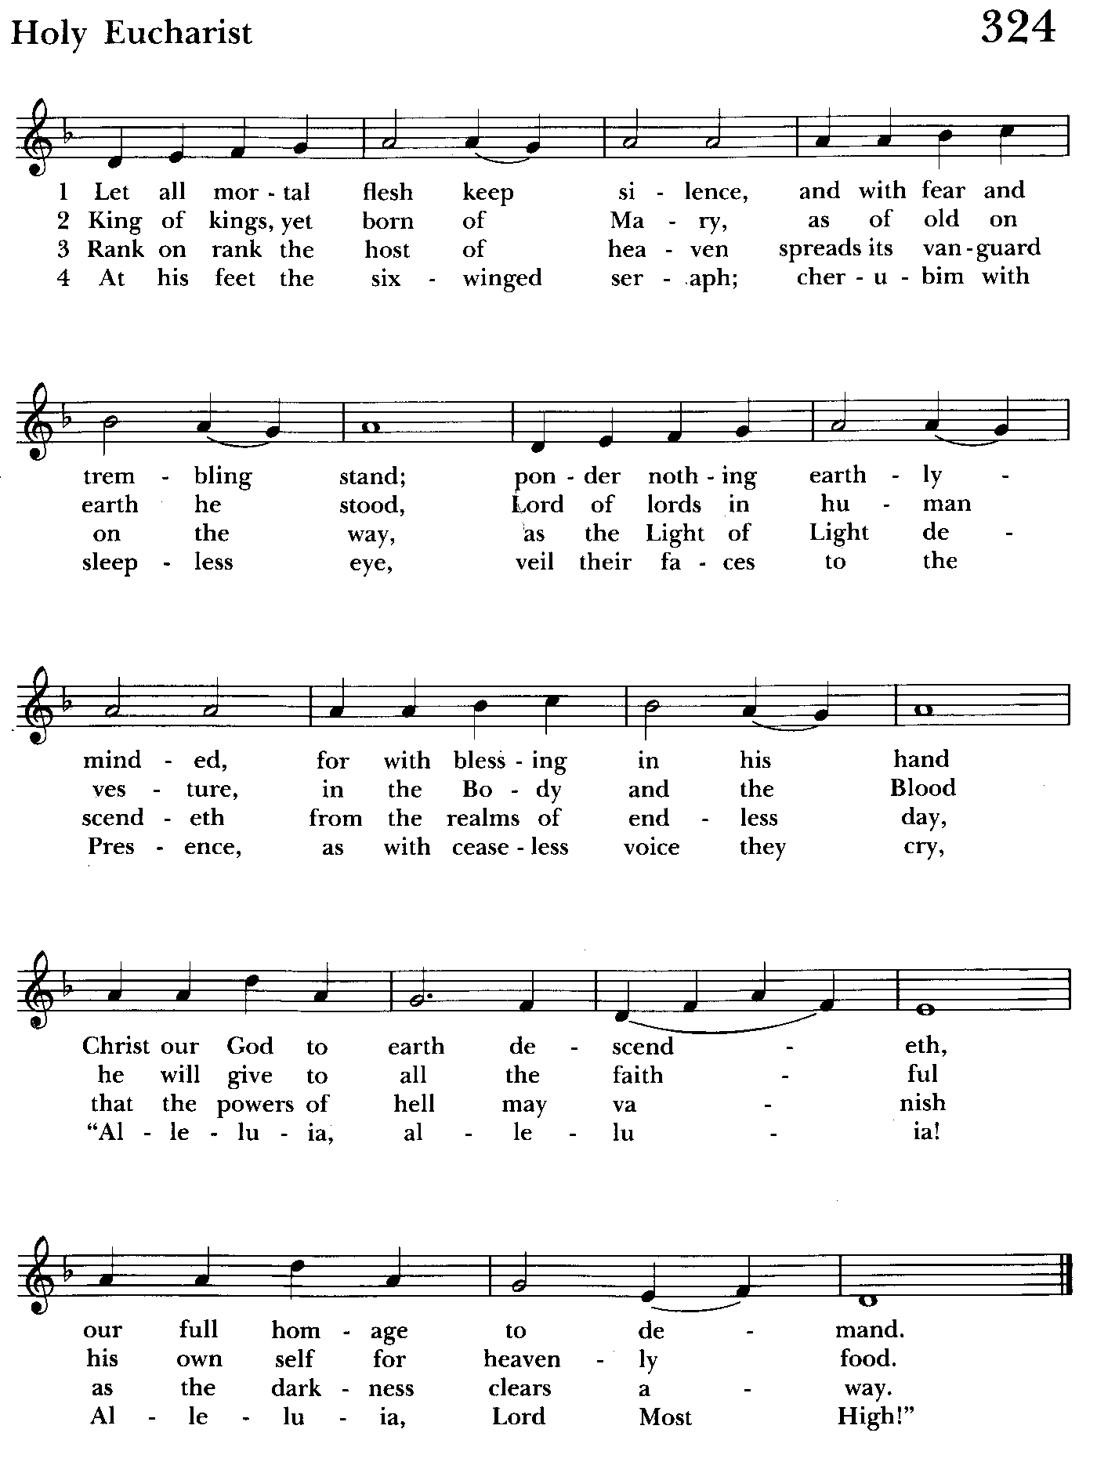

The Post Communion Prayer BCP p. 365
Eternal God, heavenly Father, you have graciously accepted us as living members of your Son our Savior Jesus Christ, and you have fed us with spiritual food in the Sacrament of his Body and Blood. Send us now into the world in peace, and grant us strength and courage to love and serve you with gladness and singleness of heart; through Christ our Lord. Amen.

Blessing
Recessional hymn: O Zion, haste, thy mission high fulfilling Hymnal #539
The Dismissal
Celebrant: Let us go forth in the name of the risen Lord.
People: Thanks be to God.

Postlude:

License #A-719154

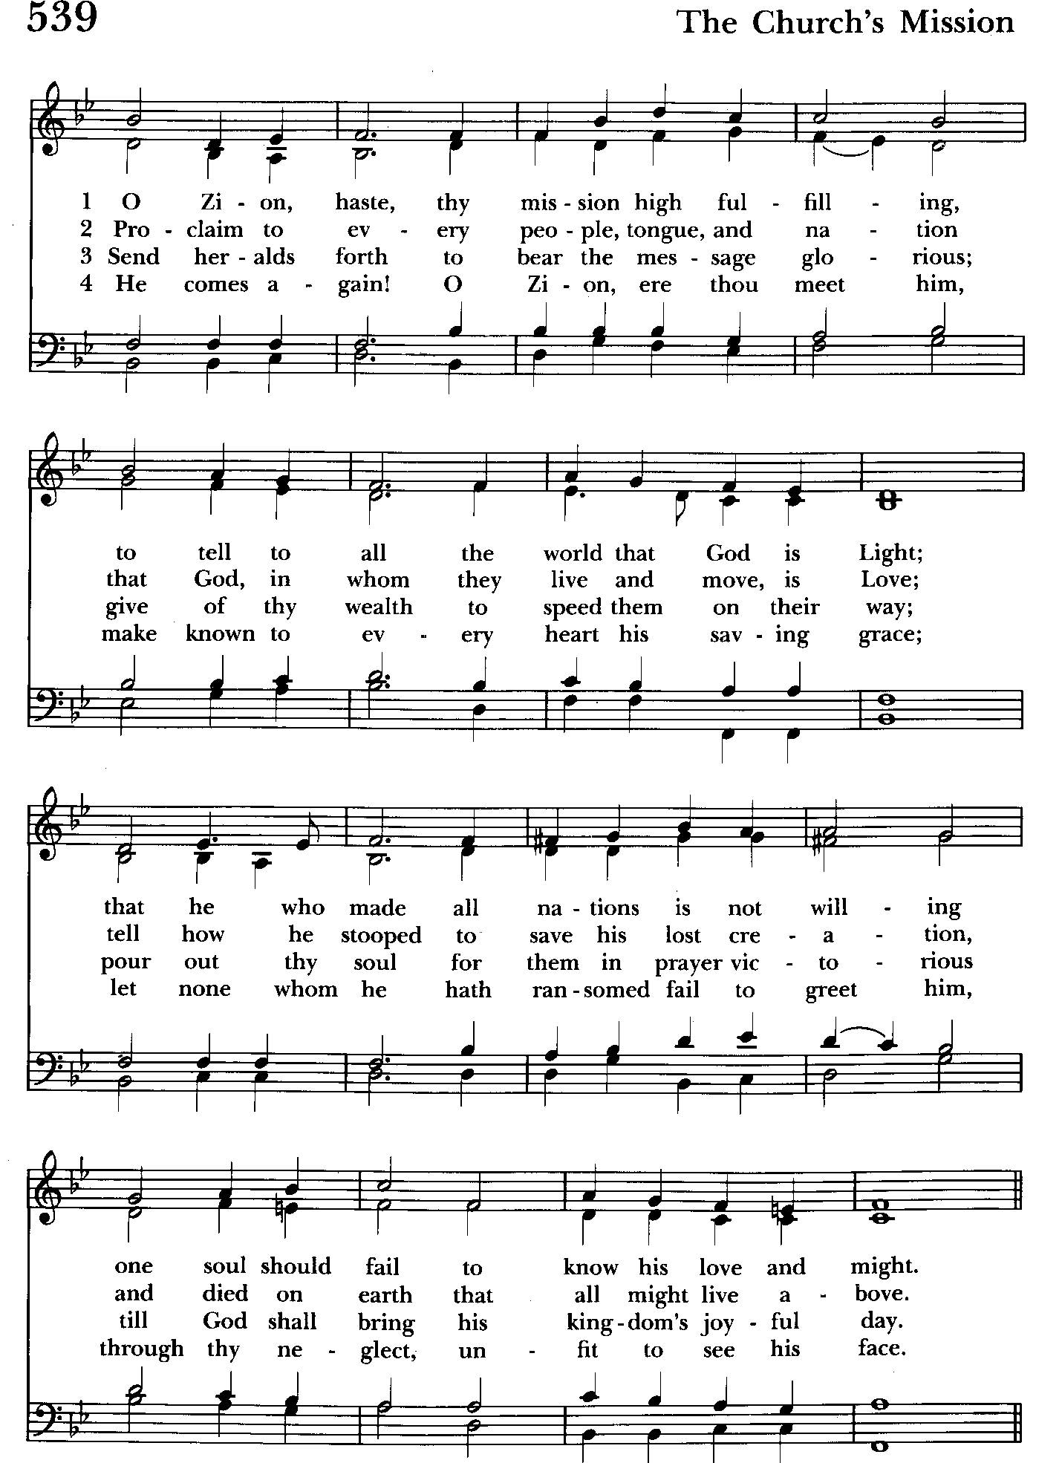

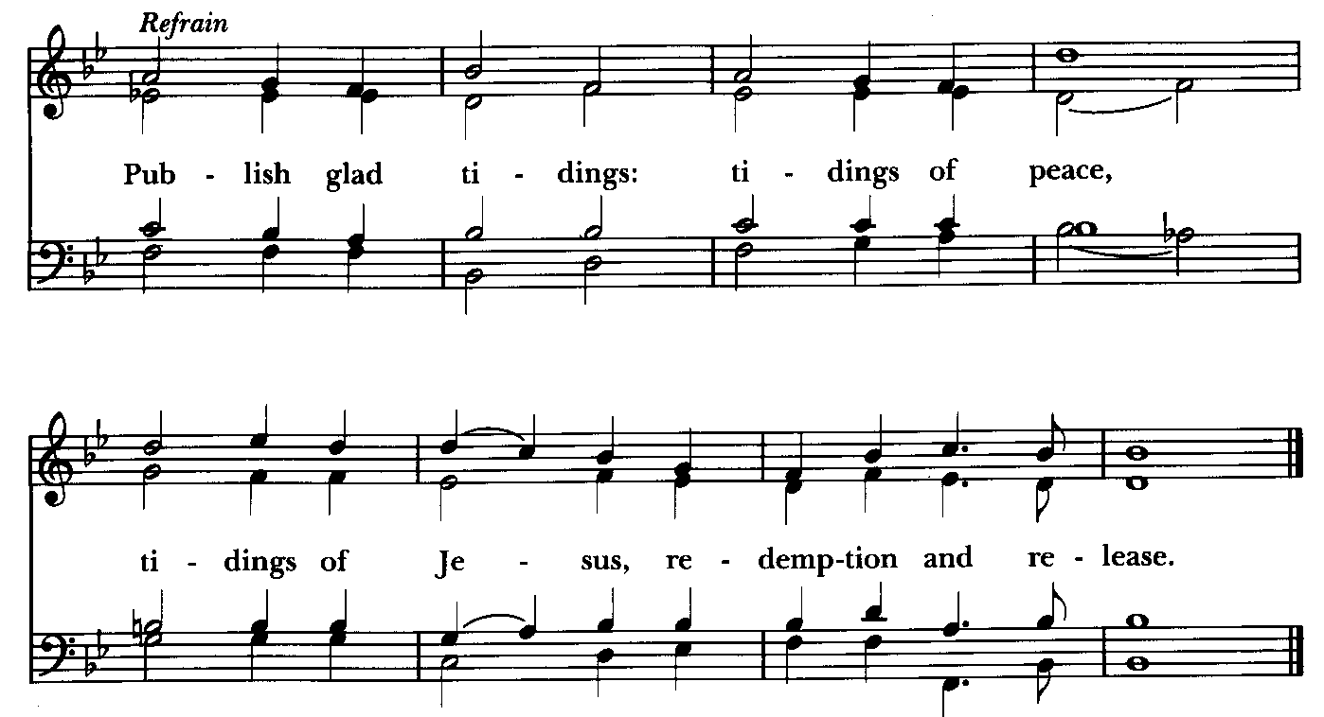
Serving Today

Celebrant and Preacher: Rev. Mark Lobb
Old Testament: Debbie Weaver
Psalm: John Stevens
New Testament: Anne Leland
Prayers of the People: Debbie Weaver
Server: Terry Roe
Music Director: Nancy Heinold
Choir: Anne Leland, Nancy Dellinger, Janine Stevens, Liz Healey,
Karen Smith-Manar, Jacob Johnson, Ty Schwenk
Altar Guild: Li Healey & Marguerite Lobb

St. John’s Parish Prayer List

Additions and corrections may be made to our Parish Prayer List at any time. All names will be automatically removed from the Parish Prayer List on the 1st Sunday of each month unless you request otherwise. Please contact Angie at <office@stjohnskingsville.org> or 410-592-8570 in the church office with all changes by 10 am Thursdays. Thank you.

We Pray for Those in Need:
Names in BOLD read aloud by all.

DeMarino Family, Jim & Chris Carden and family, Peggie Dietz, Mike Carden, Pat Carden, Gail Landers, Sheila Jones, Gloria Millar, Marisol Aubrey, Ross Strickler, Jim and Janice Sieracki, James Daniel Jr, Larry Betzler, Camy Schwenk, Dennis Mally, Zach Walsh, Helen Johnson, Eileen Weimer, David Harris.

We Pray for our Homebound

Lily John, Barbara Miller, Nancy Barnhart, Robin Dilworth

We pray for the Church and the World:

For +Sean, our Presiding Bishop; for +Carrie, our Bishop, for Mark+, our Priest in Charge, for the Wardens, Vestry, Staff, and all members and friends of St. John’s Church.

For the leaders of all nations, especially for Joseph, our President; for Wes, our Governor; for Brandon, Zeke, Kathy and Bob, who lead our City and Counties. We pray for all children and youth; for the homeless, the unemployed, and the hungry. We pray for the safety of our loved ones and friends serving in the Armed Forces at home and abroad, and for our enemies, that all our hearts may be turned toward peace throughout the world.

From the Treasurer
January ‘25 Income vs. Expenses:

Projected January Expenses: $14,250
Monies Received as of 1/9: $ 9,855
Amount Needed to Meet Expenses: $ 4,395


If you’d like to make a donation to St. John’s you can scan this QR code with your phone’s camera or tap on the link that comes up to make a contribution with either a credit or debit card, Apple Pay or Google Pay. This is a secure site provided by Clover which is a service of PNC Bank.


Altar Flowers
Given to the Glory of God
by the Ministry of St. John’s
for those in need

SUNDAY SCHOOL

10:30: Kids Sunday School- Begin in the church, ring the bell, then process over to the parish hall for a fun lesson with Mr. John and Ms. Stephanie.
Note: Please seriously consider regular attendance at Sunday School so that Mr. John and Ms. Stephanie can plan good stuff.


Choral Choir and Bell Choir
Choir rehearsals Wednesdays at 7:00 pm and Bell Choir Rehearsal, Sundays after the 10:30 service. If anyone is interested in joining, see Nancy Heinold, our Music Director.


Yoga classes on Wednesday and Friday evenings 6 to 7 pm and Saturday mornings 9 to 10 am in the Chapel. All experience levels are welcome.

Calendar Updates

January 19th - Server/Acolyte Training Meeting, 11:45 am in the Church
January 21st - Vestry Meeting, 7 pm
February 2nd - Annual Meeting (Proposed)

Calendars are living documents. Every effort will be made to keep the members of the parish and community aware of any changes.


With so much going on, everyone’s help is needed to make things a success. Our volunteers make the Church function. The volunteering of time and talent is greatly appreciated.

RECYCLING!

It takes approximately 15 kilowatt-hours (kWh) of electricity to make one aluminum can when produced from virgin ore, as the process of converting aluminum from bauxite is very energy intensive. Recycling aluminum cans requires significantly less energy, with the ability to produce 20 new cans with the same energy used to make one can from bauxite.

By popular demand, we are recycling. Some parishioners take printed paper home where they have recycling pickup. We now have a blue container located in the Parish Hall. This will be collected and taken for recycling. Aluminum cans will be saved and taken to a recycling center for cash. The proceeds will be donated to the Outreach fund. Each recycled aluminum can also save on the electricity needed to make new aluminum from bauxite.

In our Community
Bible Studies in our area. If interested, please contact these churches to confirm.
St. Mary’s, Abingdon, (410)569-0180- Wednesdays at noon. Bring lunch. Zoom available.
Emmanuel, Bel Air, (410)838-7699- Fridays at 9:30- Zoom Available.
Holy Trinity, Churchville, (410)914-5531- Wednesdays 11:30- Zoom may be available.

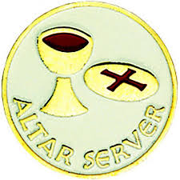
Server/Acolyte Training Meeting today at 11:45 am in the Church for anyone interested in serving.


Backpacks for the Homeless

As part of our continuing Outreach efforts, St. John’s will be providing approximately 50 backpacks for the homeless.
In partnership with Christ’s Church, Rock Spring and Harford County Hope for the Homeless Alliance (www.hchha.com), we will be delivering backpacks to families, including some children, on January 20th and again in early February.
“Friendly reminder that we’ll need the supplies for the backpacks returned by Sunday, 1/19. We’ll be putting everything together after the 10:30 service so if you are able to lend a hand for a few minutes that would be much appreciated. Shouldn’t take very long.”
Also, if you would like to help distribute the backpacks on the 20th, please let Liz Healey know (410-599-2759 or ehealey@hhladv.com). We’ll be traveling to either Aberdeen or Edgewood and will need to leave St. John’s by approximately 4pm.

Thank you all for your continued generosity. St. John’s is an amazing congregation!

The Auxiliary

If you’d like to make a donation to those in need. These are organizations who are helping victims of the California wildfires and other disasters.

https://www.redcross.org/donate/donation.html/

https://www.episcopalrelief.org/

https://wck.org/

What’s Happening This Week at St. John’s

Sunday, January 19—2nd Sunday after Epiphany
8:00am: Holy Eucharist Rite I, Said Service (Church)
10:30am: Holy Eucharist Rite II, with Music( Church)
11:30am: Coffee Hour (Parish Hall)
11:45am: Server/Acolyte Training Meeting (Church)
11:45am: Backpack packing

Monday, January 20
12:00-1:00pm: AA Lunch Bunch (Parish Hall)

Tuesday, January 21
12:00-1:00pm: AA Lunch Bunch (Parish Hall)
7:00pm: Vestry Meeting (Parish Hall)

Wednesday, January 22
12:00-1:00pm: AA Lunch Bunch (Parish Hall)
6:00-7:00pm: Yoga (Chapel)
7:00pm: Choir Rehearsal (Church)
7:30pm: AA (Parish Hall)

Thursday, January 23
12:00-1:00pm: AA Lunch Bunch (Parish Hall)
7:00pm: AA (Parish Hall)

Friday, January 24
12:00-1:00pm: AA Lunch Bunch (Parish Hall)
6:00pm -7:00pm: Yoga (Chapel)

Saturday, January 25
9:00am-10:00am: Yoga (Chapel)
8:30pm: AA (Parish Hall)

Sunday, January 26—3rd Sunday after Epiphany
8:00am: Holy Eucharist Rite I, Said Service (Church)
10:30am: Holy Eucharist Rite II, with Music (Church)
11:30am: Coffee Hour (Parish Hall)
11:45am: Bell Choir Rehearsal (Church)

Parish Office is open Monday, Wednesday and Thursday, 9:30am-1:30pm.

Potluck Luncheon on the first Sunday of the month and a Coffee Hour on all other Sundays after the 10:30 service.

