St. John’s Episcopal Church
Kingsville, Maryland
Welcomes You

Our Vision Statement

We believe that together we will transform
the world with love: Come on in!

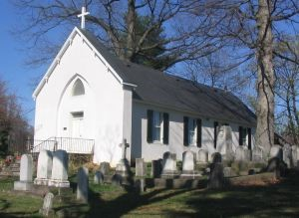

First Sunday after Epiphany-The Baptism of Our Lord
Morning Prayer Rite II
January 12, 2025—10:30 am

St. John’s Episcopal Church

11901 Belair Road, P. O. Box 187, Kingsville, MD 21087
Facebook: St. John’s Episcopal, Kingsville, MD
Email: office@stjohnskingsville.org
Website: www.stjohnskingsville.org
Church Phone: 410-592-8570
For Pastoral Emergencies: Fr. Mark Lobb+ 443-690-9545

Welcome to worship today! We are glad that you are with us. You are invited to participate in all parts of the service as indicated in the Book of Common Prayer and this service bulletin. If you have any questions, feel free to ask the ushers. Restrooms are located in the Parish Hall, the brick building across the parking lot.

I was glad when they said to me, “Let us go to the house of the Lord.” Psalm 122:1

Church Staff

Priest in Charge: Father Mark Lobb
Administrative Assistant: Angie Bosley
Organist/Choir Director: Nancy Heinold

The Vestry

Class of 2025 Class of 2026

John Frost John Stevens
Woodie Tingle
Jacob Johnson

Officers
Ty Schwenk—Sr. Warden Terry Roe—Jr. Warden
Elizabeth Healey—Treasurer Anne Leland-Registrar

Parish Committee Chairpersons

Altar Guild: Elizabeth Healey
Auxiliary Committee: Michele Lozanski
Cemetery Committee: Karen Smith-Manar

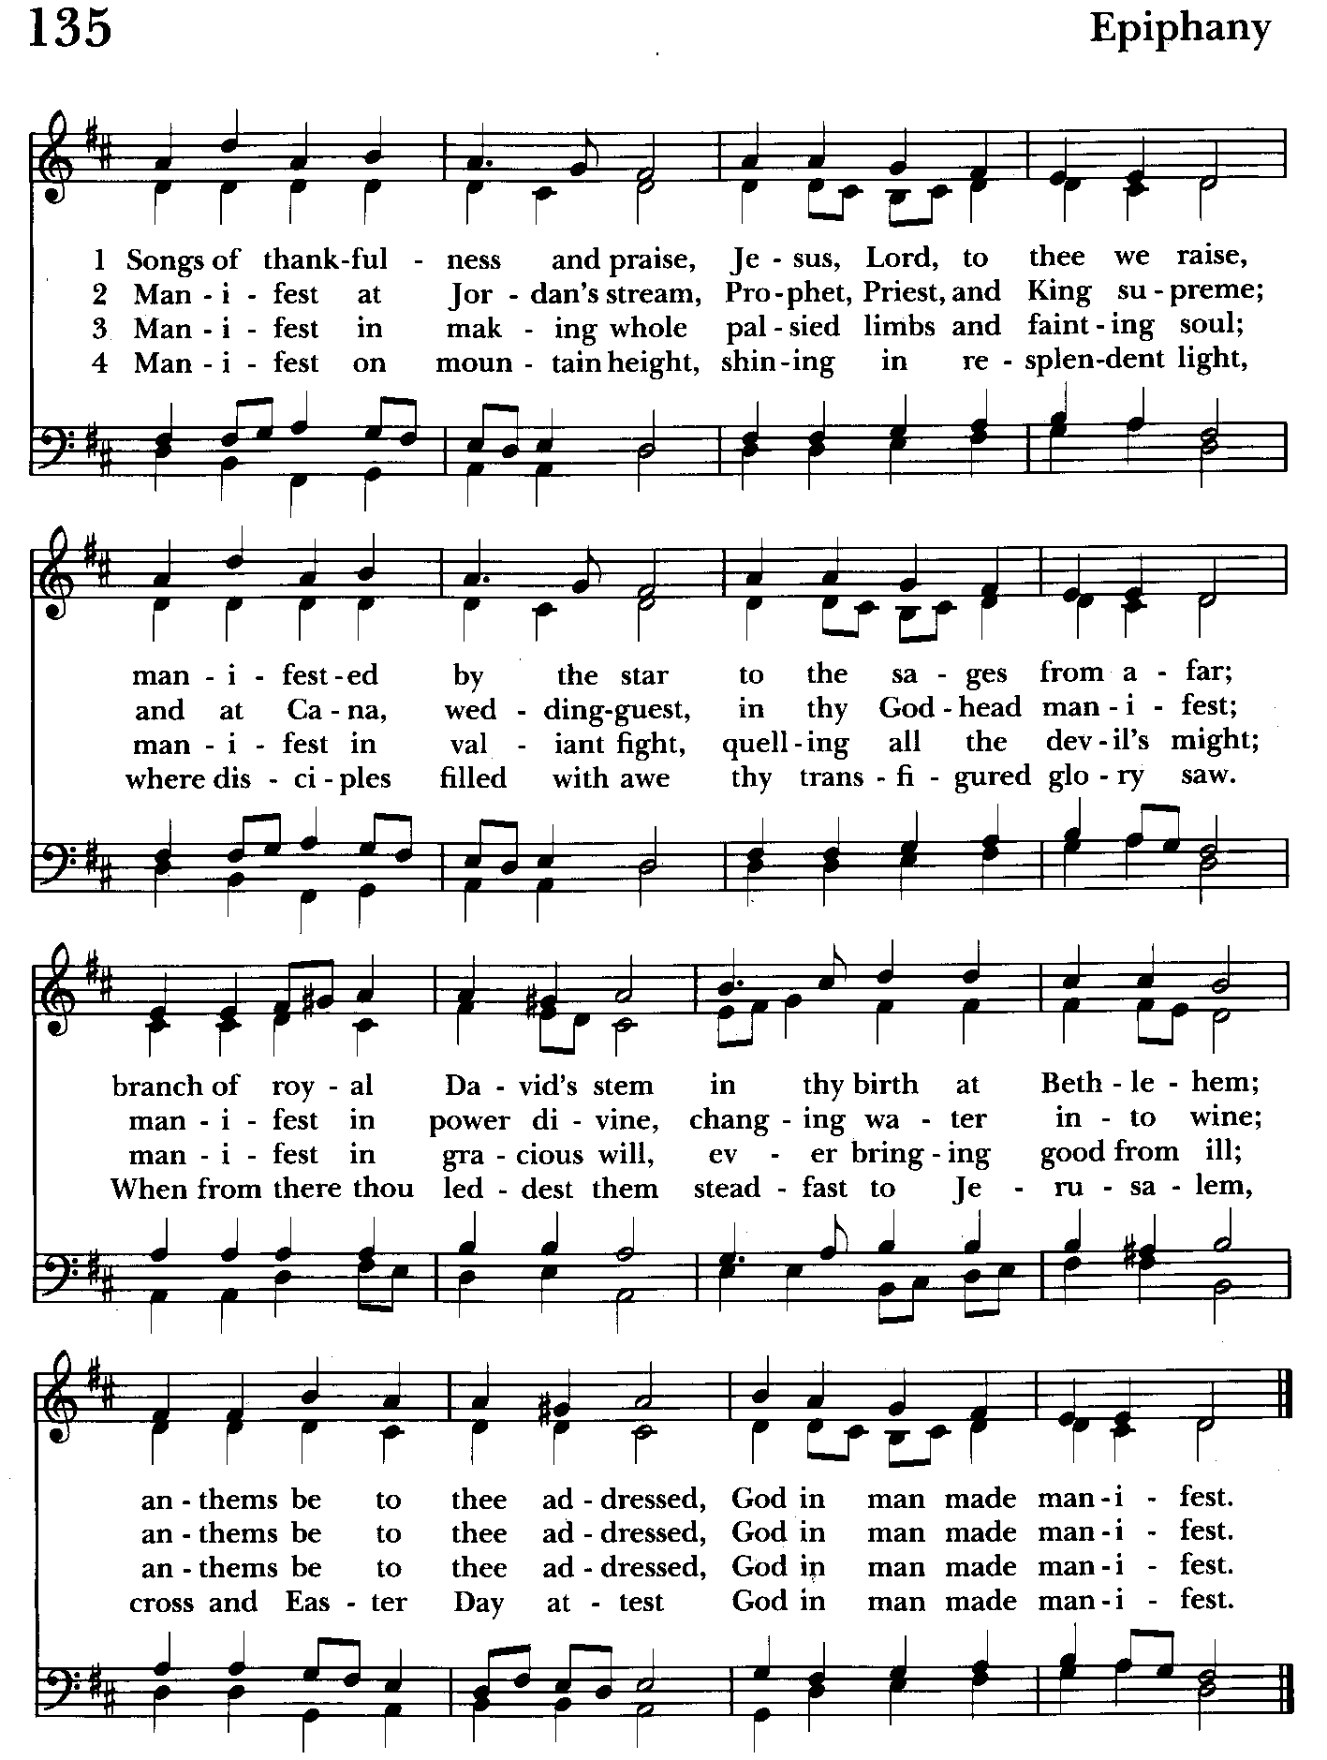

Morning Prayer—Rite II
Note:
Please feel free to remain seated during the service if unable to stand or kneel. ‘BCP’ refers to the Book of Common Prayer. The people’s responses are in bold.

Prelude

Gathering hymn: Songs of thankfulness and praise Hymnal #135
(see previous page)

OPENING SENTENCES BCP p. 78

Officiant: Grace to you and peace from God our Father and the Lord Jesus Christ.
Philippians 1:2

CONFESSION OF SIN BCP p. 79
Dearly beloved, we have come together in the presence of Almighty God our heavenly Father, to set forth his praise, to hear his holy Word, and to ask, for ourselves and on behalf of others, those things that are necessary for our life and our salvation. And so that we may prepare ourselves in heart and mind to worship him, let us kneel in silence, and with penitent and obedient hearts confess our sins, that we may obtain forgiveness by his infinite goodness and mercy.

Officiant and People please stand or kneel as able
Most merciful God, we confess that we have sinned against you in thought, word, and deed, by what we have done, and by what we have left undone. We have not loved you with our whole heart; we have not loved our neighbors as
ourselves. We are truly sorry and we humbly repent. For the sake of your Son
Jesus Christ, have mercy on us and forgive us; that we may delight in your will, and walk in your ways, to the glory of your Name. Amen.

Officiant: Almighty God have mercy on us, forgive us all our sins through our Lord Jesus Christ, strengthen you in all goodness, and by the power of the Holy Spirit keep us in eternal life. Amen.

The Invitatory and Psalter BCP pg. 80

All stand
Officiant: Lord, open our lips.
People: And our mouth shall proclaim your praise.

Officiant and People
Glory to the Father, and to the Son, and to the Holy Spirit: as it was in the
beginning, is now, and will be for ever. Amen.

The mercy of the Lord is everlasting: Come let us adore him. BCP pg. 81

Venite Psalm 95:1-7 BCP. pg. 82
Come, let us sing to the Lord;*
let us shout for joy to the Rock of our salvation.
Let us come before his presence with thakisgiving*
and raise a loud shout to him with psalms.

For the Lord is a great God,*
and a great King above all gods.
In his hands are the caverns of the earth,*
and the heights of the hills are his also.
The sea is his, for he made it.*
and his hands have molded the dry land.

Come, let us bow down, and bend the knee,*
and kneel before the Lord our Maker.
For he is our God,
and we are the people of his pasture and the sheep of his hand.*
Oh, that today you would hearken to his voice!

Psalm 29
Officiant and People Please be seated
1 Ascribe to the Lord, you gods, *
ascribe to the Lord glory and strength.
2 Ascribe to the Lord the glory due his Name; *
worship the Lord in the beauty of holiness.
3 The voice of the Lord is upon the waters;
the God of glory thunders; *
the Lord is upon the mighty waters.
4 The voice of the Lord is a powerful voice; *
the voice of the Lord is a voice of splendor.
5 The voice of the Lord breaks the cedar trees; *
the Lord breaks the cedars of Lebanon;
6 He makes Lebanon skip like a calf, *
and Mount Hermon like a young wild ox.
7 The voice of the Lord splits the flames of fire;
the voice of the Lord shakes the wilderness; *
the Lord shakes the wilderness of Kadesh.
8 The voice of the Lord makes the oak trees writhe *
and strips the forests bare.
9 And in the temple of the Lord *
all are crying, "Glory!"
10 The Lord sits enthroned above the flood; *
the Lord sits enthroned as King for evermore.
11 The Lord shall give strength to his people; *
the Lord shall give his people the blessing of peace.

THE FIRST READING Isaiah 43:1-7
Thus says the Lord,
he who created you, O Jacob,
he who formed you, O Israel:
Do not fear, for I have redeemed you;
I have called you by name, you are mine.
When you pass through the waters, I will be with you;
and through the rivers, they shall not overwhelm you;
when you walk through fire you shall not be burned,
and the flame shall not consume you.
For I am the Lord your God,
the Holy One of Israel, your Savior.
I give Egypt as your ransom,
Ethiopia and Seba in exchange for you.
Because you are precious in my sight,
and honored, and I love you,
I give people in return for you,
nations in exchange for your life.
Do not fear, for I am with you;
I will bring your offspring from the east,
and from the west I will gather you;
I will say to the north, "Give them up,"
and to the south, "Do not withhold;
bring my sons from far away
and my daughters from the end of the earth--
everyone who is called by my name,
whom I created for my glory,
whom I formed and made."

The Word of the Lord.
Thanks be to God.

Canticle 16 The Song of Zechariah Benedictus Dominus Deus BCP pg. 92
Luke 1: 68-79
Blessed be the Lord, the God of Israel; *
he has come to his people and set them free.
He has raised up for us a mighty savior, *
born of the house of his servant David.
Through his holy prophets he promised of old,
that he would save us from our enemies, *
from the hands of all who hate us.
He promised to show mercy to our fathers *
and to remember his holy covenant.
This was the oath he swore to our father Abraham, *
to set us free from the hands of our enemies,
Free to worship him without fear, *
holy and righteous in his sight
all the days of our life.
You, my child, shall be called the prophet of the Most High, *
for you will go before the Lord to prepare his way,
To give his people knowledge of salvation *
by the forgiveness of their sins.
In the tender compassion of our God *
the dawn from on high shall break upon us,
To shine on those who dwell in darkness and the
shadow of death, *
and to guide our feet into the way of peace.
Glory to the Father, and to the Son, and to the Holy Spirit: *
as it was in the beginning, is now, and will be for ever. Amen.

THE SECOND READING Acts of the Apostles 8:14-17
When the apostles at Jerusalem heard that Samaria had accepted the word of God, they sent Peter and John to them. The two went down and prayed for them that they might receive the Holy Spirit (for as yet the Spirit had not come upon any of them; they had
only been baptized in the name of the Lord Jesus). Then Peter and John laid their hands on them, and they received the Holy Spirit

The Word of the Lord.
Thanks be to God.

Canticle 21 You are God Te Deum laudamus BCP pg. 95
You are the Lord; we acclaim you;
You are the eternal Father:
All creation worships you.
To you all angels, all the powers of heaven,
Cherubim and Seraphim, sing in endless praise:
Holy, holy, holy Lord, God of power and might,
heaven and earth are full of your glory.
The glorious company of apostles praise you.
The noble fellowship of prophets praise you.
The white-robed army of martyrs praise you.
Throughout the world the holy Church acclaims you;
Father, of majesty unbounded,
your true and only Son, worthy of all worship,
and the Holy Spirit, advocate and guide.
You, Christ, are the king of glory,
the eternal Son of the Father.
When you became man to set us free
you did not shun the Virgin's womb.
You overcame the sting of death
and opened the kingdom of heaven to all believers.
You are seated at God's right hand in glory.
We believe that you will come and be our judge.
Come then, Lord, and help your people,
bought with the price of your own blood,
and bring us with your saints
to glory everlasting.

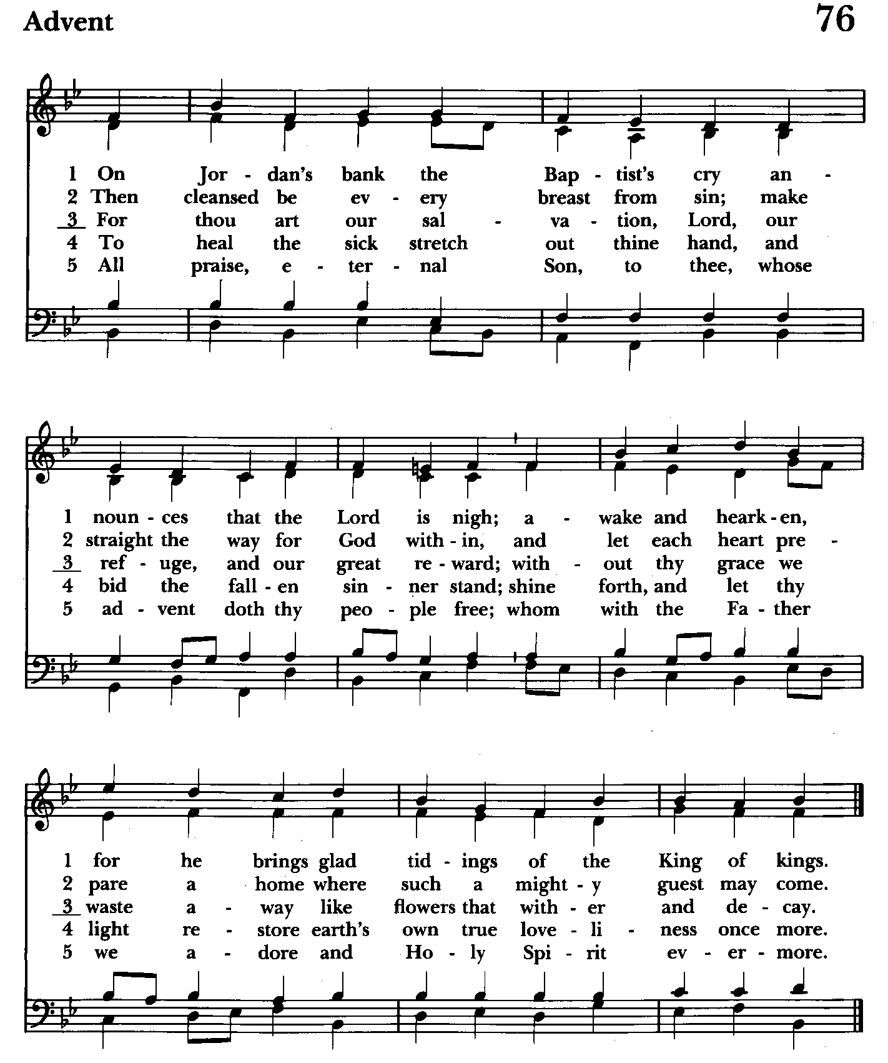

Gradual hymn: On Jordan’s bank the Baptist’s cry Hymnal #76
(see above)

The people remain standing
A READING FROM THE GOSPEL OF LUKE 3:15-17, 21-22
As the people were filled with expectation, and all were questioning in their hearts concerning John, whether he might be the Messiah, John answered all of them by saying, "I baptize you with water; but one who is more powerful than I is coming; I am not worthy to untie the thong of his sandals. He will baptize you with the Holy Spirit and fire. His winnowing fork is in his hand, to clear his threshing floor and to gather the wheat into his granary; but the chaff he will burn with unquenchable fire."
Now when all the people were baptized, and when Jesus also had been baptized and was praying, the heaven was opened, and the Holy Spirit descended upon him in bodily form like a dove. And a voice came from heaven, "You are my Son, the Beloved; with you I am well pleased."

The Word of the Lord.
Thanks be to God.

The Homily The congregation is seated Ty Schwenk

The Peace The congregation stands as able

Announcements The people are seated

THE APOSTLES CREED BCP pg. 96
Said by all, standing as you are able.
I believe in God, the Father almighty,
creator of heaven and earth;
I believe in Jesus Christ, his only Son, our Lord.
He was conceived by the power of the Holy Spirit
and born of the Virgin Mary.
He suffered under Pontius Pilate,
was crucified, died, and was buried.
He descended to the dead.
On the third day he rose again.
He ascended into heaven,
and is seated at the right hand of the Father.
He will come again to judge the living and the dead.
I believe in the Holy Spirit,
the holy catholic Church,
the communion of saints,
the forgiveness of sins
the resurrection of the body,
and the life everlasting. Amen.
Celebrant: The Lord be with you.
People: And also with you.
Celebrant: Let us pray.
THE LORD’S PRAYER Stand or kneel as able. BCP pg. 97
Our Father, who art in heaven, hallowed be thy Name, thy kingdom come, thy will be done, on earth as it is in heaven. Give us this day our daily bread. And forgive us our trespasses, as we forgive those who trespass against us. And lead us not into temptation, but deliver us from evil. For thine is the kingdom, and the power, and the glory, for ever and ever. Amen.
People and Officiant
SUFFRAGES B BCP pg. 98
V. Save your people, Lord, and bless your inheritance;
R. Govern and uphold them, now and always.
V. Day by day we bless you;
R. We praise your Name for ever.
V. Lord, keep us from all sin today;
R. Have mercy on us, Lord, have mercy.
V. Lord, show us your love and mercy;
R. For we put our trust in you.
V. In you, Lord, is our hope;
R. And we shall never hope in vain.

THE COLLECT OF THE DAY BCP pg. 214
Father in heaven, who at the baptism of Jesus in the River Jordan proclaimed him your beloved Son and anointed him with the Holy Spirit: Grant that all who are baptized into his Name may keep the covenant they have made, and boldly confess him as Lord and Savior; who with you and the Holy Spirit lives and reigns, one God, in glory everlasting. Amen.

A COLLECT FOR SUNDAYS BCP pg. 98
O God, you make us glad with the weekly remembrance of the glorious resurrection of your Son our Lord: Give us this day such blessing through our worship of you, that the week to come may be spent in your favor; through Jesus Christ our Lord. Amen.

Officiant: Let us pray for our own needs and those of others.

Silence

PRAYER FOR MISSION BCP pg. 100
Almighty and everlasting God, by whose Spirit the whole body of your faithful people is governed and sanctified: Receive our supplications and prayers which we offer
before you for all members of your holy Church, that in their vocation and ministry they may truly and devoutly serve you; through Lord and Savior Jesus Christ. Amen.

The people are seated.

OFFERTORY HYMN: Baptized in water Hymnal #294
(see next page)

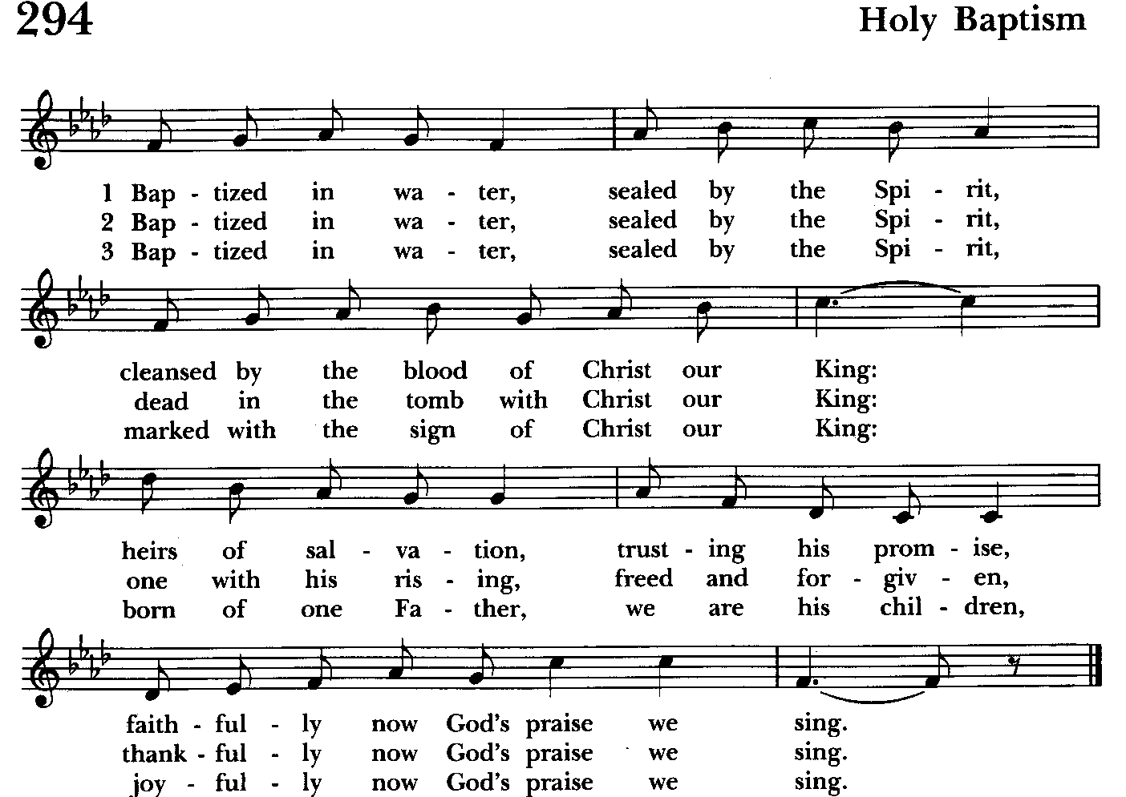

THE OFFERTORY The offering is collected The offering is brought forward

DOXOLOGY Please stand as able Hymnal #43, vs. 4
Praise God, from whom all blessings flow; praise him, all creatures here below; praise him above, ye heavenly host: praise Father, Son, and Holy Ghost.

Please kneel or stand as able

THE PRAYERS OF THE PEOPLE – Form III BCP pg. 387
Father, we pray for your holy Catholic Church;
That we all may be one.

Grant that every member of the Church may truly and humbly serve you;
That your Name may be glorified by all people.

We pray for all bishops, priests, and deacons;
That they may be faithful ministers of your Word and Sacraments.

We pray for all who govern and hold authority in the nations of the world;
That there may be justice and peace on the earth.

Give us grace to do your will in all that we undertake;
That our works may find favor in your sight.

Have compassion on those who suffer from any grief or trouble;
That they may be delivered from their distress.

Give to the departed eternal rest;
Let light perpetual shine upon them.
.
We praise you for your saints who have entered into joy;
May we also come to share in your heavenly kingdom.
.
Let us pray for our own needs and those of others.

For those affected or in the path of the wildfires in California
Compassionate God… Draw near to us in this time of sorrow and anguish, comfort those who mourn, strengthen those who are weary, encourage those in despair, and lead us all to fullness of life; through the same Jesus Christ, our Savior and Redeemer, who lives and reigns with you, in the unity of the Holy Spirit, God for ever and ever. Amen
– Holy Women, Holy Men: Celebrating the Saints (Church Publishing: New York), page 733

We Pray for Those in Need:
DeMarino Family, Jim & Chris Carden and family, Peggie Dietz, Mike Carden, Pat Carden, Gail Landers, Sheila Jones, Gloria Millar, Marisol Aubrey, Ross Strickler, Jim & Janice Sieracki, James Daniel Jr., Larry Betzler, Camy Schwenk, Dennis Mally, Zach Walsh, Helen Johnson, Eileen Weimer, David Harris, Lily John, Barbara Miller, Nancy Barnhart, Robin Dilworth

We pray for the Church and the World:

For +Sean, our Presiding Bishop, for +Carrie, our Bishop, for Mark+, our Priest in Charge, for the Wardens, Vestry, Staff, and all members and friends of St. John’s Church.

For the leaders of all nations, especially for Joseph, our President; for Wes, our Governor; for Brandon, Zeke, John and Bob, who lead our City and Counties. We pray for all children and youth; for the homeless, the unemployed, and the hungry. We pray for the safety of our loved ones and friends serving in the Armed Forces at home and abroad, and for our enemies, that all our hearts may be turned toward peace throughout the world.

THE GENERAL THANKSGIVING
Let us pray.
Officiant and people BCP pg. 101
Almighty God, Father of all mercies, we your unworthy servants give you
humble thanks for all your goodness and loving-kindness to us and to all whom you have made. We bless you for our creation, preservation, and all the blessings of this life; but above all for your immeasurable love in the redemption of the world by our Lord Jesus Christ; for the means of grace, and for the hope of glory. And, we pray, give us such an awareness of your mercies, that with truly thankful hearts we may show forth your praise, not only with our lips, but in our lives, by giving up our selves to your service, and by walking before you in holiness and righteousness all our days; through Jesus Christ our Lord, to whom, with you and the Holy Spirit, be honor and glory throughout all ages. Amen.
Closing hymn: Hail to the Lord’s Anointed Hymnal #616
(see below and next page)

THE DISMISSAL BCP pg. 102
Officiant: The grace of our Lord Jesus Christ, and the Love of God, and the
fellowship of the Holy Spirit, be with us all evermore.
People: Thanks be to God.

License #A-719154

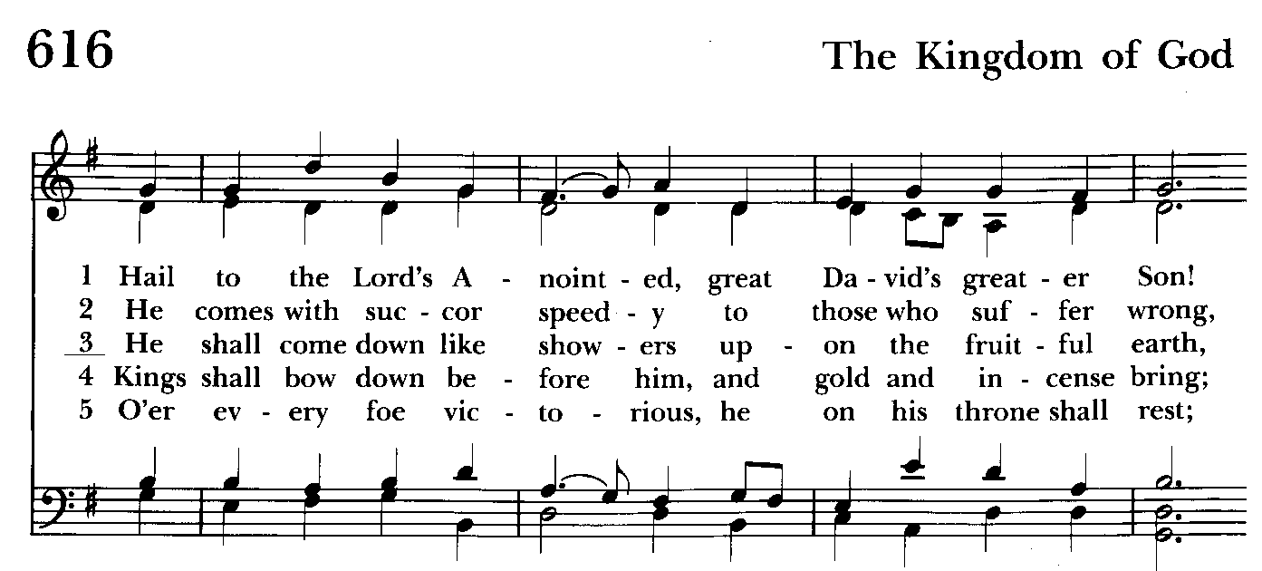

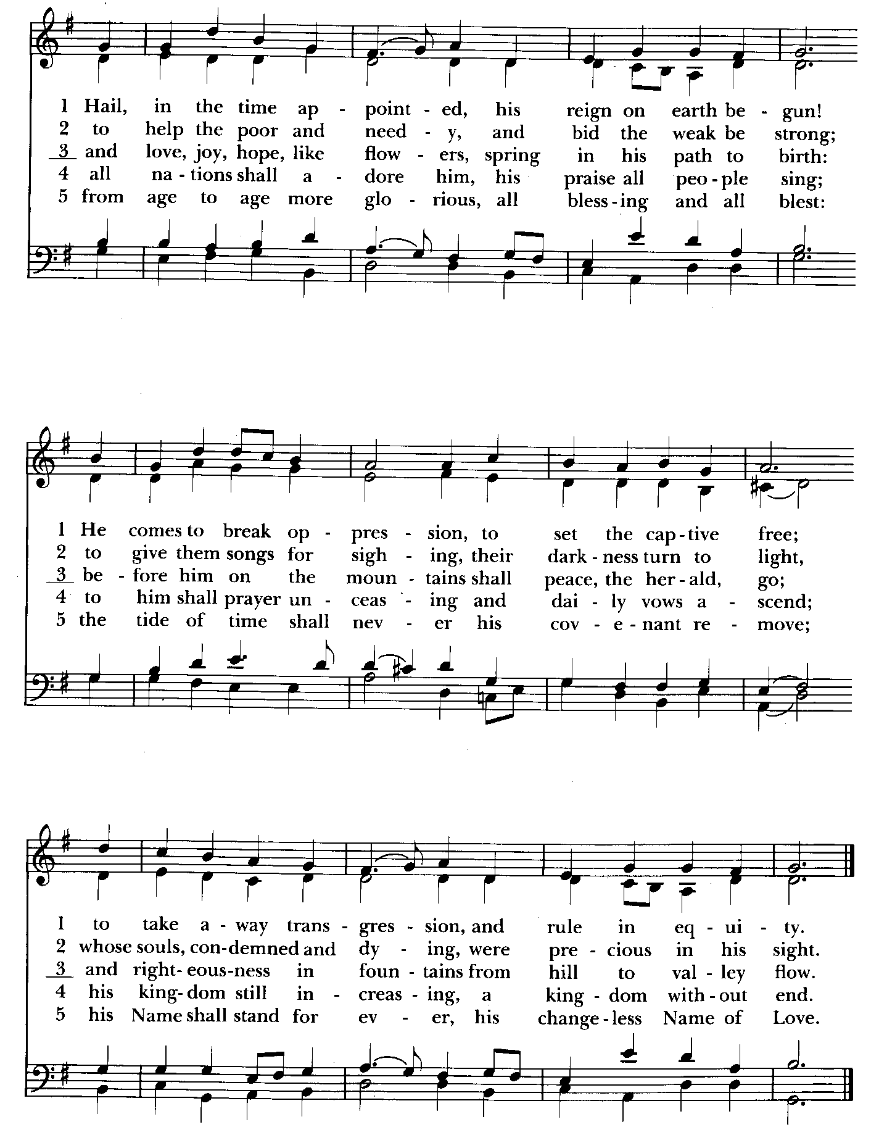

Serving Today
Officiant: Ty Schwenk
Old Testament: John Stevens
Psalm: John Stevens
New Testament: Anne Leland
Prayers of the People: John Frost
Music Director: Nancy Heinold
Altar Guild: Liz Healey & Marguerite Lobb


With so much going on, everyone’s help is needed to make things a success. Our volunteers make the Church function. The volunteering of time and talent is greatly appreciated.

St. John’s Parish Prayer List

Additions and corrections may be made to our Parish Prayer List at any time. All names will be
automatically removed from the Parish Prayer List on the 1st Sunday of each month unless you
request otherwise. Please contact Angie at <office@stjohnskingsville.org> or 410-592-8570 in the church office with all changes by 10 am Thursdays. Thank you.

We Pray for Those in Need:
Names in BOLD read aloud by all.

DeMarino Family, Jim & Chris Carden and family, Peggie Dietz, Mike Carden, Pat Carden, Gail Landers, Sheila Jones, Gloria Millar, Marisol Aubrey, Ross Strickler, Jim and Janice Sieracki, James Daniel Jr, Larry Betzler, Camy Schwenk, Dennis Mally, Zach Walsh, Helen Johnson, Eileen Weimer, David Harris.

We Pray for our Homebound

Lily John, Barbara Miller, Nancy Barnhart, Robin Dilworth

We pray for the Church and the World:

For +Sean, our Presiding Bishop; for +Carrie, our Bishop, for Mark+, our Priest in Charge, for the Wardens, Vestry, Staff, and all members and friends of St. John’s Church.

For the leaders of all nations, especially for Joseph, our President; for Wes, our Governor; for Brandon, Zeke, John and Bob, who lead our City and Counties. We pray for all children and youth; for the homeless, the unemployed, and the hungry. We pray for the safety of our loved ones and friends serving in the Armed Forces at home and abroad, and for our enemies, that all our hearts may be turned toward peace throughout the world.


Altar Flowers

Given to the Glory of God
by a Generous Parishioner
in memory of those lost to violence

From the Treasurer
January ‘25 Income vs. Expenses:

Projected January Expenses: $14,250
Monies Received as of 1/9: $ 7,440
Amount Needed to Meet Expenses: $ 6,810


If you’d like to make a donation to St. John’s you can scan this QR code with your phone’s camera or tap on the link that comes up to make a contribution with either a credit or debit card, Apple Pay or Google Pay. This is a secure site provided by Clover which is a service of PNC Bank.


Choral Choir and Bell Choir
Choir rehearsals Wednesdays at 7:00 pm and Bell Choir Rehearsal will be after the 10:30 service. If anyone is interested in joining, see Nancy Heinold, our Music Director.

SUNDAY SCHOOL

10:30: Kids Sunday School- Begin in the church, ring the bell, then process over to the parish hall for a fun lesson with Mr. John and Ms. Stephanie.
Note: Please seriously consider regular attendance at Sunday School so that Mr. John and Ms. Stephanie can plan good stuff.


Yoga is on Wednesday and Friday evenings 6 to 7 pm and Saturday mornings 9 to 10 am in the Chapel. All experience levels are welcome.

Calendar Updates

January 19th - Server/Acolyte Training Meeting, 11:45 am
January 19th - Packing of the Backpacks after the 10:30 service
January 21st - Vestry Meeting (Parish Hall)
February 2nd - Annual Meeting (Proposed)

Calendars are living documents. Every effort will be made to keep the members of the parish and community aware of any changes.

RECYCLING!

It takes approximately 15 kilowatt-hours (kWh) of electricity to make one aluminum can when produced from virgin ore, as the process of converting aluminum from bauxite is very energy intensive. Recycling aluminum cans requires significantly less energy, with the ability to produce 20 new cans with the same energy used to make one can from bauxite.
By popular demand, we are recycling. Some parishioners take printed paper home where they have recycling pickup. We now have a blue container located in the Parish Hall. This will be collected and taken for recycling. Aluminum cans will be saved and taken to a recycling center for cash. The proceeds will be donated to the Outreach fund. Each recycled aluminum can also save on the electricity needed to make new aluminum from bauxite.

In our Community

Bible Studies in our area. If interested, please contact these churches to confirm.
St. Mary’s, Abingdon, (410)569-0180- Wednesdays at noon. Bring lunch. Zoom available.
Emmanuel, Bel Air, (410)838-7699- Fridays at 9:30- Zoom Available.
Holy Trinity, Churchville, (410)914-5531- Wednesdays 11:30- Zoom may be available.

What’s Happening This Week at St. John’s

Sunday, January 12—1st Sunday after Epiphany
8:00am: Morning Prayer, Rite I (Church)
10:30am: Morning Prayer, Rite II (Church)
11:30am: Coffee Hour (Parish Hall)

Monday, January 13
12:00-1:00pm: AA Lunch Bunch (Parish Hall)

Tuesday, January 14
12:00-1:00pm: AA Lunch Bunch (Parish Hall)

Wednesday, January 15
12:00-1:00pm: AA Lunch Bunch (Parish Hall)
6:00-7:00pm: Yoga (Chapel)
7:00pm: Choir Rehearsal (Parish Hall)
7:30pm: AA (Parish Hall)

Thursday, January 16
12:00-1:00pm: AA Lunch Bunch (Parish Hall)
7:00pm: AA (Parish Hall)

Friday, January 17
12:00-1:00pm: AA Lunch Bunch (Parish Hall)
6:00pm -7:00pm: Yoga (Chapel)

Saturday, January 18
9:00am-10:00am: Yoga (Chapel)
8:30pm: AA (Parish Hall)

Sunday, January 19—2nd Sunday after Epiphany
8:00am: Holy Eucharist, Said Service (Church)
10:30am: Holy Eucharist, with Music (Church)
11:30am: Coffee Hour (Parish Hall)
11:45am: Server/Acolyte Training Meeting (Church)
11:45am: Packing of the Backpacks

Parish Office is open Monday, Wednesday and Thursday, 9:30am-1:30pm.

Potluck Luncheon on the first Sunday of the month and a Coffee Hour on all other Sundays after the 10:30 service.

