St. John’s Episcopal Church
Kingsville, Maryland
Welcomes You
Our Vision Statement

We believe that together we will transform
the world with love: Come on in!

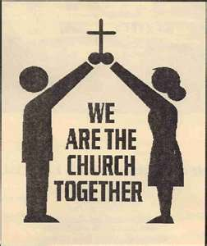

4th Sunday after the Epiphany
Presentation of Jesus in the Temple
February 2, 2025
ANNUAL CONGREGATION MEETING

St. John’s Episcopal Church

11901 Belair Road, P. O. Box 187, Kingsville, MD 21087
Facebook: St. John’s Episcopal, Kingsville, MD
Email: office@stjohnskingsville.org
Website: www.stjohnskingsville.org
Church Phone: 410-592-8570
For Pastoral Emergencies: Fr. Mark Lobb+ 443-690-9545

Welcome to worship today! We are glad that you are with us. You are invited to participate in all parts of the service as indicated in the Book of Common Prayer and this service bulletin. If you have any questions, feel free to ask the ushers. Restrooms are located in the Parish hall, the brick building across the parking lot.

I was glad when they said to me, “Let us go to the house of the Lord.” Psalm 122:1

Church Staff

Priest in Charge: Father Mark Lobb
Administrative Assistant: Angie Bosley
Organist/Choir Director: Nancy Heinold

The Vestry

Class of 2025 Class of 2026

John Frost John Stevens
Jacob Johnson Woodie Tingle

Officers
Ty Schwenk—Sr. Warden Terry Roe—Jr. Warden
Elizabeth Healey—Treasurer Anne Leland-Registrar

Parish Committee Chairpersons

Altar Guild: Elizabeth Healey
Auxiliary Committee: Michele Lozanski
Cemetery Committee: Karen Smith-Manar

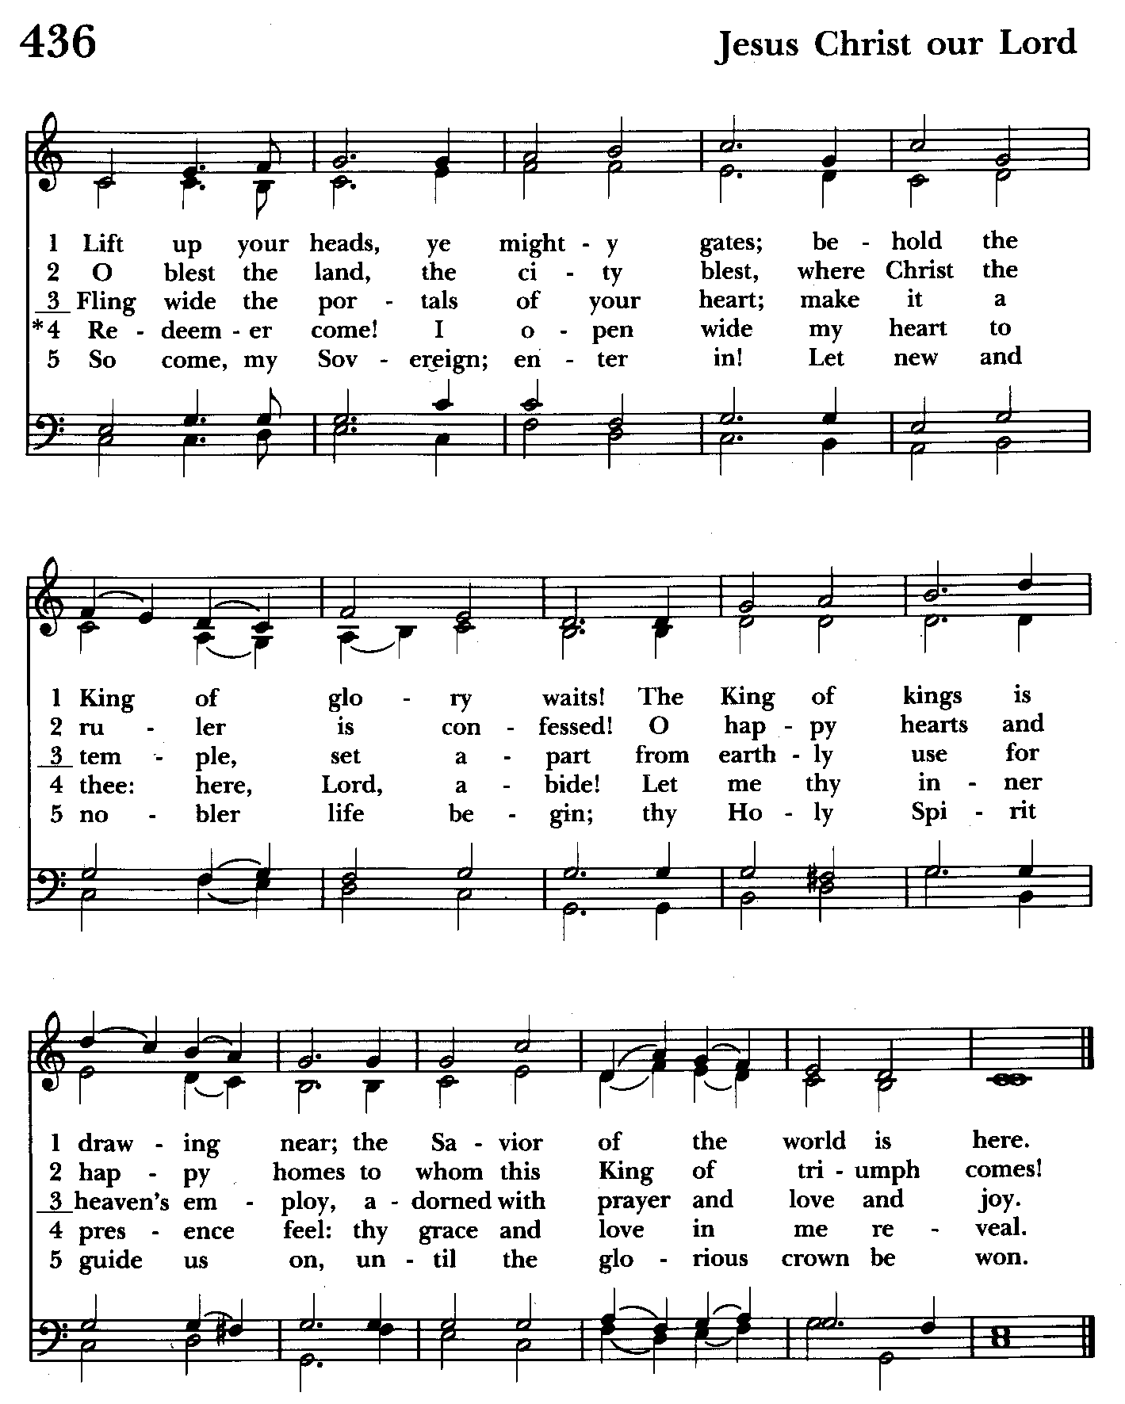

9:30 am Worship
Holy Eucharist, Rite Two

Prelude:
The Word of God

Opening hymn: Lift up your heads, ye mighty gates Hymnal #436
(see previous page)

Worship begins BCP 355

Gloria Hymnal #S-280
Glory to God in the highest,
and peace to his people on earth.
Lord God, heavenly King,
almighty God and Father,
we worship you, we give you thanks,
we praise you for your glory.
Lord Jesus Christ, only Son of the Father,
Lord God, Lamb of God,
you take away the sin of the world:
have mercy on us;
you are seated at the right hand of the Father:
receive our prayer.
For you alone are the Holy One,
you alone are the Lord,
you alone are the Most High,
Jesus Christ,
with the Holy Spirit,
in the glory of God the Father. Amen.

Celebrant: The Lord be with you.
People: And also with you.
Celebrant: Let us pray.

The Collect of the Day BCP 2
Almighty and everliving God, we humbly pray that, as your only-begotten Son was this day presented in the temple, so we may be presented to you with pure and clean hearts by Jesus Christ our Lord; who lives and reigns with you and the Holy Spirit, one God, now and for ever. Amen.

The congregation is seated.

A Reading from the Book of the Prophet Malachi 3:1-4
Thus says the Lord, See, I am sending my messenger to prepare the way before me, and the Lord whom you seek will suddenly come to his temple. The messenger of the covenant in whom you delight-- indeed, he is coming, says the Lord of hosts. But who can endure the day of his coming, and who can stand when he appears?
For he is like a refiner's fire and like fullers' soap; he will sit as a refiner and purifier of silver, and he will purify the descendants of Levi and refine them like gold and silver, until they present offerings to the Lord in righteousness. Then the offering of Judah and Jerusalem will be pleasing to the Lord as in the days of old and as in former years.

Reader: The Word of the Lord.
People: Thanks be to God.

Psalm 84 (Prayed as directed.)
1 How dear to me is your dwelling, O Lord of hosts! *
My soul has a desire and longing for the courts of the Lord;
my heart and my flesh rejoice in the living God.
2 The sparrow has found her a house
and the swallow a nest where she may lay her young; *
by the side of your altars, O Lord of hosts,
my King and my God.
3 Happy are they who dwell in your house! *
they will always be praising you.
4 Happy are the people whose strength is in you! *
whose hearts are set on the pilgrims' way.
5 Those who go through the desolate valley will find it a place of springs, *
for the early rains have covered it with pools of water.
6 They will climb from height to height, *
and the God of gods will reveal himself in Zion.
7 Lord God of hosts, hear my prayer; *
hearken, O God of Jacob.
8 Behold our defender, O God; *
and look upon the face of your Anointed.
9 For one day in your courts is better than a thousand in my own room, *
and to stand at the threshold of the house of my God
than to dwell in the tents of the wicked.
10 For the Lord God is both sun and shield; *
he will give grace and glory;
11 No good thing will the Lord withhold *
from those who walk with integrity.
12 O Lord of hosts, *
happy are they who put their trust in you!
Gradual hymn: O gracious Light, Lord Jesus Christ Hymnal #25
(see next page)

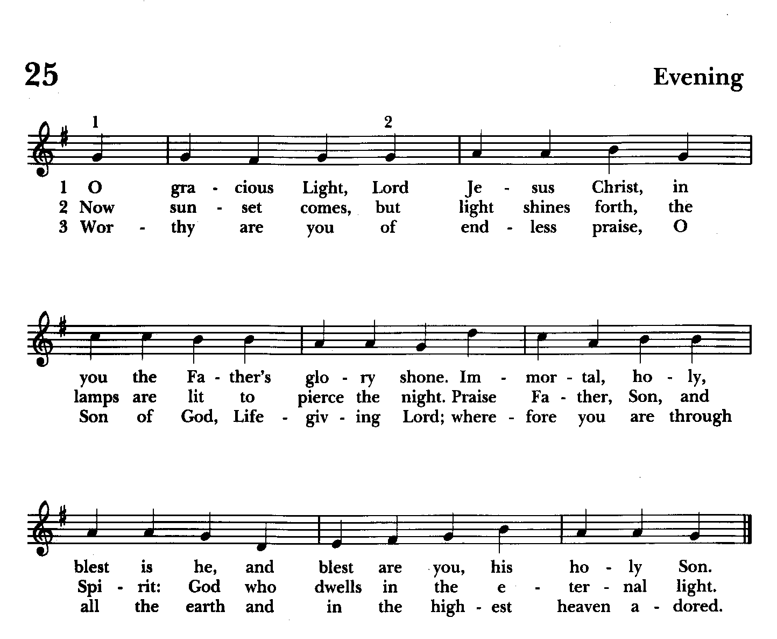

The Gospel The congregation remains standing
Priest: The Holy Gospel of our Lord Jesus Christ according to Luke 2:22-40

People: Glory to you, Lord Christ.
When the time came for their purification according to the law of Moses, the parents of Jesus brought him up to Jerusalem to present him to the Lord (as it is written in the law of the Lord, "Every firstborn male shall be designated as holy to the Lord"), and they offered a sacrifice according to what is stated in the law of the Lord, "a pair of turtledoves or two young pigeons."
Now there was a man in Jerusalem whose name was Simeon; this man was righteous and devout, looking forward to the consolation of Israel, and the Holy Spirit rested on him. It had been revealed to him by the Holy Spirit that he would not see death before he had seen the Lord's Messiah. Guided by the Spirit, Simeon came into the temple; and when the parents brought in the child Jesus, to do for him what was customary under the law, Simeon took him in his arms and praised God, saying,
"Master, now you are dismissing your servant in peace,
according to your word;
for my eyes have seen your salvation,
which you have prepared in the presence of all peoples,
a light for revelation to the Gentiles
and for glory to your people Israel."
And the child's father and mother were amazed at what was being said about him. Then Simeon blessed them and said to his mother Mary, "This child is destined for the falling and the rising of many in Israel, and to be a sign that will be opposed so that the inner thoughts of many will be revealed-- and a sword will pierce your own soul too."
There was also a prophet, Anna the daughter of Phanuel, of the tribe of Asher. She was of a great age, having lived with her husband seven years after her marriage, then as a widow to the age of eighty-four. She never left the temple but worshiped there with fasting and prayer night and day. At that moment she came, and began to praise God and to speak about the child to all who were looking for the redemption of Jerusalem.
When they had finished everything required by the law of the Lord, they returned to Galilee, to their own town of Nazareth. The child grew and became strong, filled with wisdom; and the favor of God was upon him.
Priest: The Gospel of the Lord.
People: Praise to you, Lord Christ.

Sermon Please be seated Rev. Mark Lobb+

Nicene Creed Please stand as able BCP 358
We believe in one God,
the Father, the Almighty,
maker of heaven and earth,
of all that is, seen and unseen.
We believe in one Lord, Jesus Christ,
the only Son of God,
eternally begotten of the Father,
God from God, Light from Light,
true God from true God,
begotten, not made,
of one Being with the Father.
Through him all things were made.
For us and for our salvation
he came down from heaven:
by the power of the Holy Spirit
he became incarnate from the Virgin Mary,
and was made man.
For our sake he was crucified under Pontius Pilate;
he suffered death and was buried.
On the third day he rose again
in accordance with the Scriptures;
he ascended into heaven
and is seated at the right hand of the Father.
He will come again in glory to judge the living and the dead,
and his kingdom will have no end.
We believe in the Holy Spirit, the Lord, the giver of life,
who proceeds from the Father and the Son.
With the Father and the Son he is worshiped and glorified.
He has spoken through the Prophets.
We believe in one holy catholic and apostolic Church.
We acknowledge one baptism for the forgiveness of sins.
We look for the resurrection of the dead,
and the life of the world to come. Amen.

Prayers of the People Form III Please remain standing BCP 387
Celebrant: Father, we pray for your holy Catholic Church;
People: That we all may be one.

Celebrant: Grant that every member of the Church may truly and humbly serve you;
People: That your Name may be glorified by all people.

Celebrant: We pray for all bishops, priests, and deacons;
People: That they may be faithful ministers of your Word and Sacraments.

Celebrant: We pray for all who govern and hold authority in the nations of the world;
People: That there may be justice and peace on the earth.

Celebrant: Give us grace to do your will in all that we undertake;
People: That our works may find favor in your sight.

Celebrant: Have compassion on those who suffer from any grief or trouble;
People: That they may be delivered from their distress.

Celebrant: Give to the departed eternal rest;
People: Let light perpetual shine upon them.
Celebrant: We praise you for your saints who have entered into joy;
People: May we also come to share in your heavenly kingdom.

Celebrant: Let us pray for our own needs and those of others; Especially
remember in our prayers, DeMarino Family, Jim & Chris Carden and family, Peggie Dietz, Mike Carden, Pat Carden, Gail Landers, Sheila Jones, Gloria Millar, Marisol Aubrey, Ross Strickler, Jim & Janice Sieracki, James Daniel Jr., Larry Betzler, Camy Schwenk, Dennis Mally, Zach Walsh, Lily John, Barbara Miller, Nancy Barnhart, Robin Dilworth, Helen Johnson, Eileen Weimer, David Harris, Bill Hoffman and family.

For Peace Among the Nations BCP 816
Almighty God our heavenly Father, guide the nations of the world into the way of justice and truth, and establish among them that peace which is the fruit of righteousness, that they may become the kingdom of our Lord and Savior Jesus Christ. Amen.
The priest adds a concluding collect.

Confession of Sin BCP 359
Most merciful God, we confess that we have sinned against you in thought, word, and deed, by what we have done, and by what we have left undone. We have not loved you with our whole heart; we have not loved our neighbors as ourselves. We are truly sorry and we humbly repent. For the sake of your Son Jesus Christ, have mercy on us and forgive us; that we may delight in your will, and walk in your ways, to the glory of your Name. Amen.

The Peace Please stand as able BCP 360
Celebrant: The peace of the Lord be always with you.
People: And also with you.

Welcome & Announcements The congregation is seated.

Please remain standing as the offering is collected
Offertory anthem: Come Bless the Lord (Choir)
Offertory hymn: How bright appears the Morning Star Hymnal #497
(see next page)

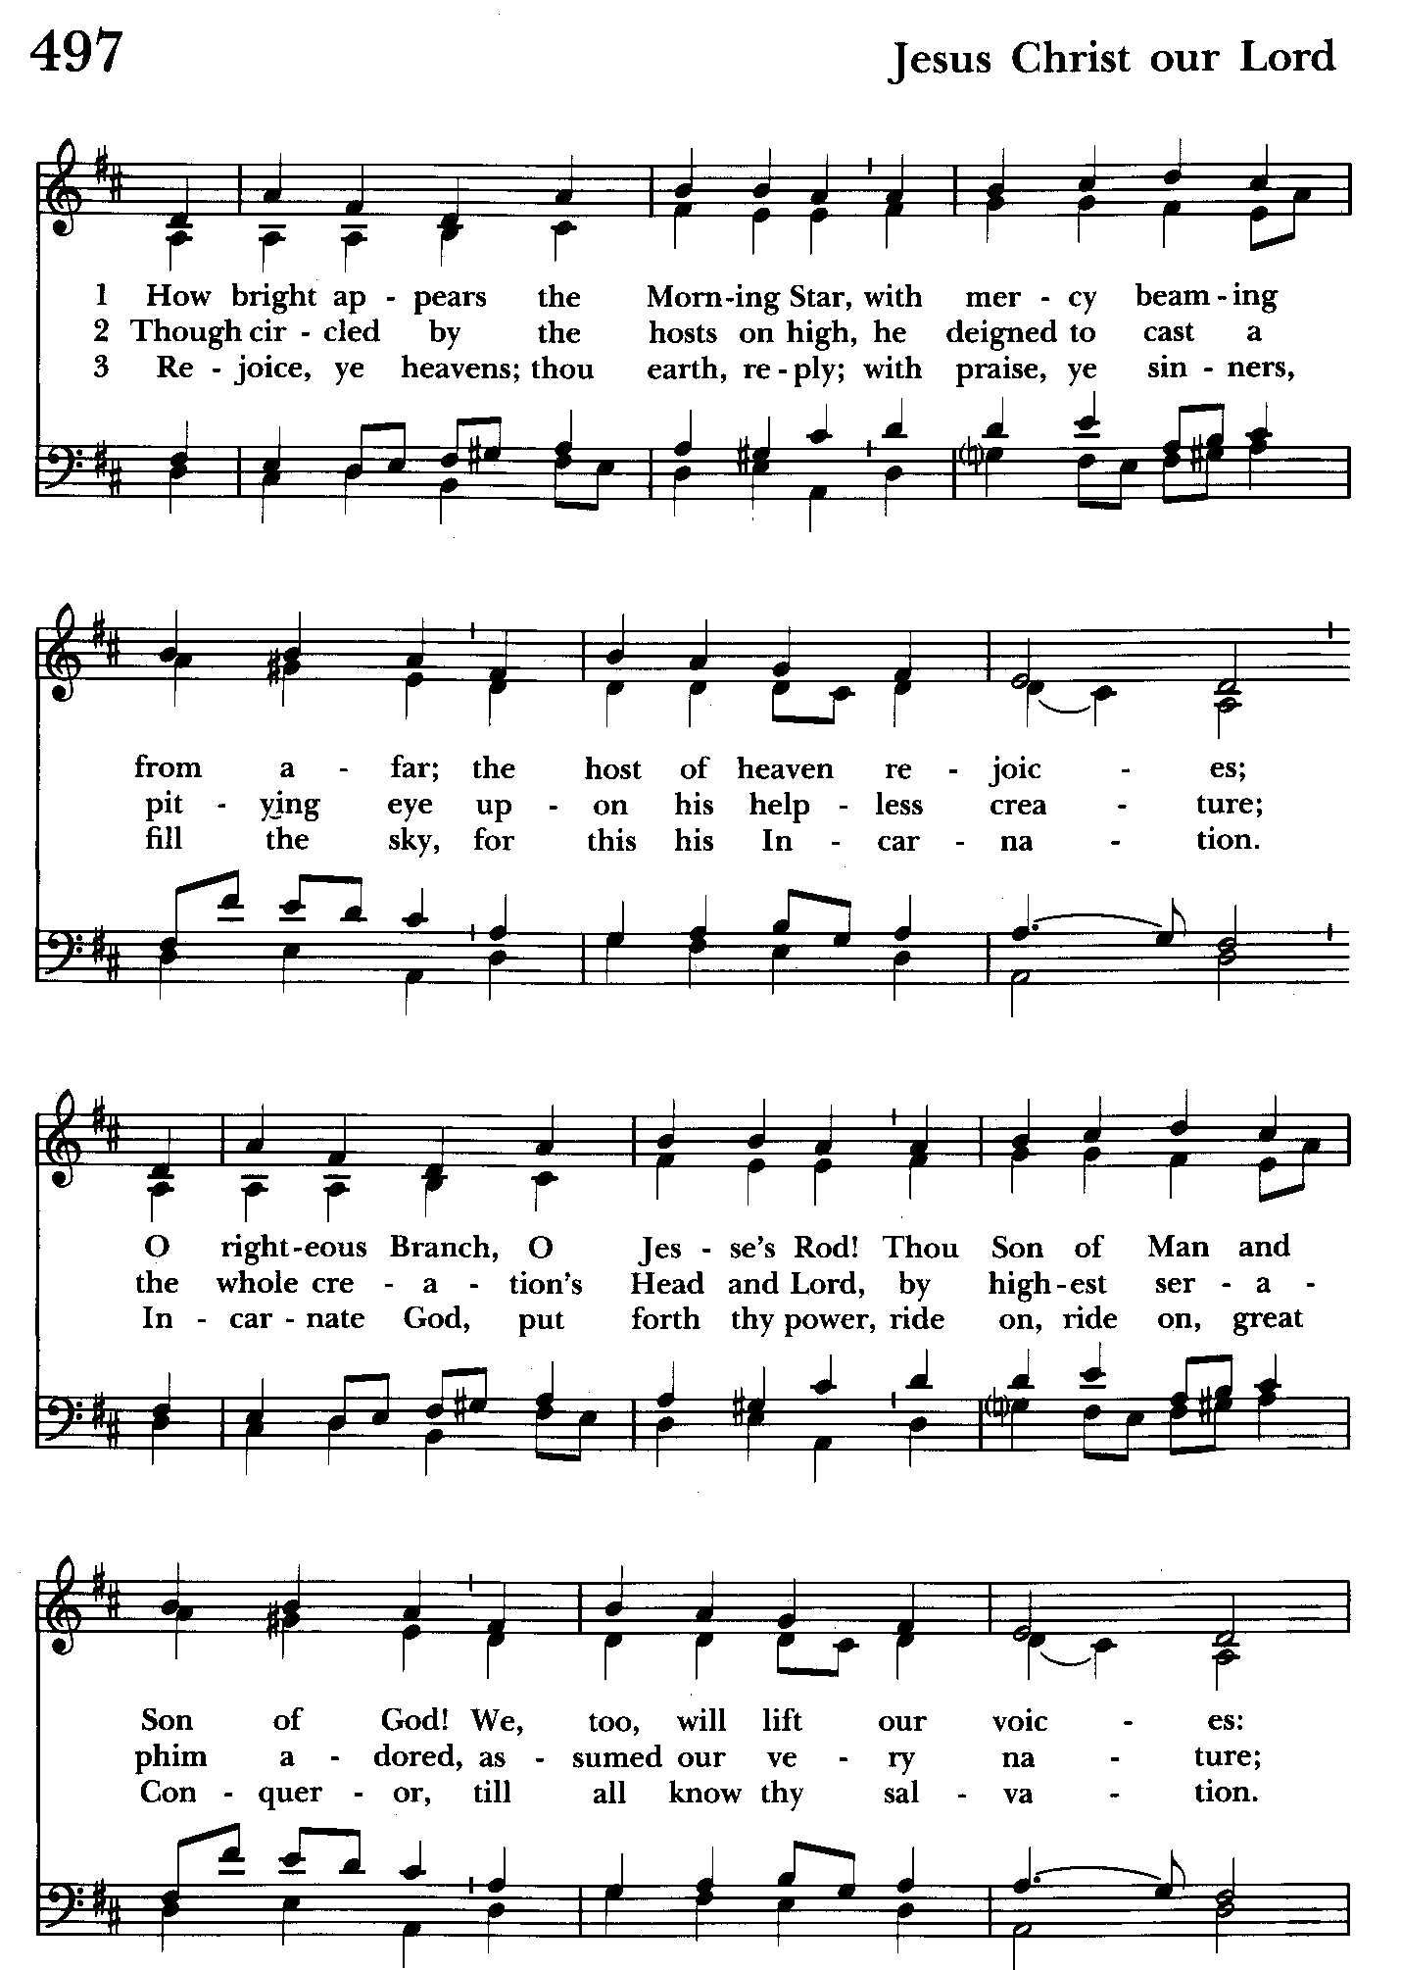

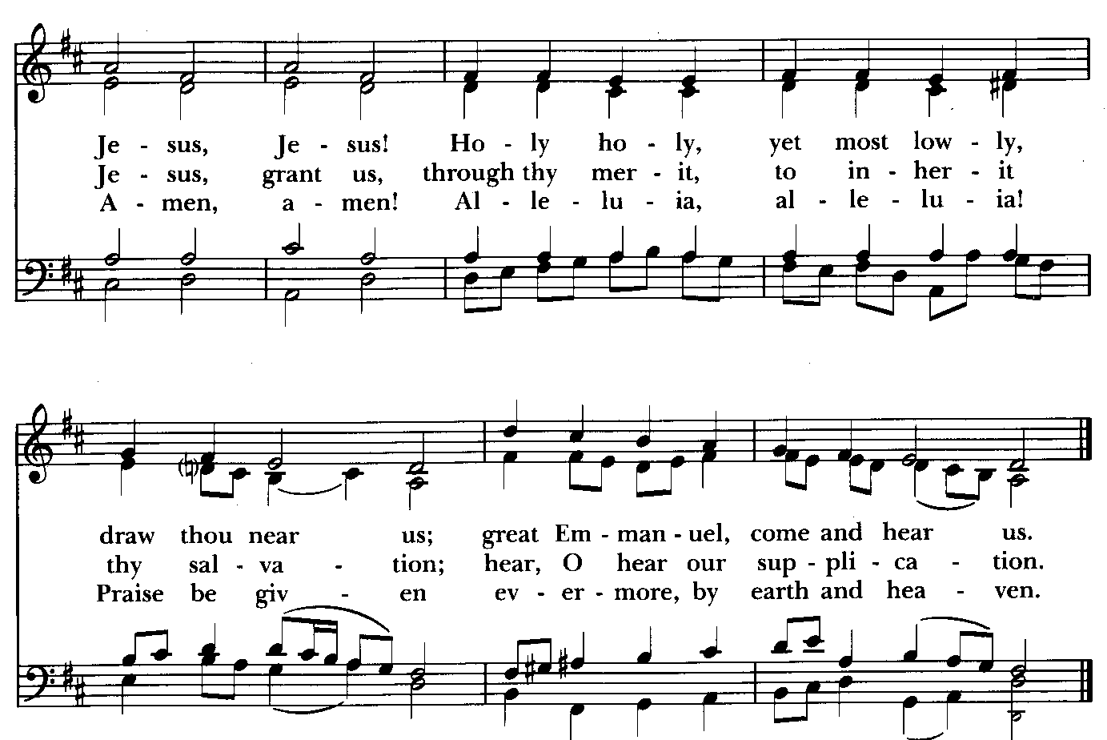

Please stand as able
Presentation Hymn Hymnal #43, vs. 4
Praise God, from whom all blessings flow; praise him, all creatures here below; praise him above, ye heavenly host: praise Father, Son, and Holy Ghost.

The Holy Communion

THE GREAT THANKSGIVING: Eucharistic Prayer A BCP 361
Celebrant: The Lord be with you.
People: And also with you.
Celebrant: Lift up your hearts.
People: We lift them to the Lord.
Celebrant: Let us give thanks to the Lord our God.
People: It is right to give him thanks and praise.
Celebrant: It is right, and a good and joyful thing, always and everywhere to give thanks to you, Father Almighty, Creator of heaven and earth.

Therefore we praise you, joining our voices with Angels and Archangels and with all the company of heaven, who for ever sing this hymn to proclaim the glory of your Name:

Sanctus Hymnal #S-129
Holy, Holy, Holy Lord, God of power and might,
heaven and earth are full of your glory.
Hosanna in the highest.
Blessed is he who comes in the name of the Lord.
Hosanna in the highest.

Celebrant: Holy and gracious Father: In your infinite love you made us for yourself; and, when we had fallen into sin and become subject to evil and death, you, in your mercy, sent Jesus Christ, your only and eternal Son, to share our human nature, to live and die as one of us, to reconcile us to you, the God and Father of all.

He stretched out his arms upon the cross, and offered himself, in obedience to your will, a perfect sacrifice for the whole world.

On the night he was handed over to suffering and death, our Lord Jesus Christ took bread; and when he had given thanks to you, he broke it, and gave it to his disciples, and said, “Take, eat: This is my Body, which is given for you. Do this for the remembrance of me.”

After supper he took the cup of wine; and when he had given thanks, he gave it to them, and said, “Drink this, all of you: This is my Blood of the new Covenant, which is shed for you and for many for the forgiveness of sins. Whenever you drink it, do this for the remembrance of me.”

Therefore we proclaim the mystery of faith.

Christ has died.
Christ is risen.
Christ will come again.

We celebrate the memorial of our redemption, O Father, in this sacrifice of praise and thanksgiving. Recalling his death, resurrection, and ascension, we offer you these gifts.

Sanctify them by your Holy Spirit to be for your people the Body and Blood of your Son, the holy food and drink of new and unending life in him. Sanctify us also that we may faithfully receive this holy Sacrament, and serve you in unity, constancy, and peace; and at the last day bring us with all your saints into the joy of your eternal kingdom.

All this we ask through your Son Jesus Christ. By him, and with him, and in him, in the unity of the Holy Spirit all honor and glory is yours, Almighty Father, now and for ever. Amen.

And now, as our Savior Christ has taught us, we are bold to say,

The Lord’s Prayer Please stand as able BCP 364
Our Father, who art in heaven, hallowed be thy Name, thy kingdom come, thy will be done, on earth as it is in heaven. Give us this day our daily bread. And forgive us our trespasses, as we forgive those who trespass against us. And lead us not into temptation, but deliver us from evil. For thine is the kingdom, and the power, and the glory, for ever and ever. Amen.

Invitation to Communion

The Breaking of the Bread
Celebrant: Alleluia. Christ our Passover is sacrificed for us;
People: Therefore let us keep the feast. Alleluia.

Celebrant: The Gifts of God for the People of God.

The Body and Blood of our Lord Jesus Christ keep you in everlasting life. Amen.

The Holy Communion is an “outward and visible sign” that we encounter Christ. Although some reserve this sacrament only for the baptized, at St. John’s we invite all who know Christ, seek to know Christ, or are simply curious to the altar at the Invitation. Receive the bread in cupped hands. Receive the wine by gently grasping the base of the chalice with two fingers, assisting the chalice bearer in guiding the cup to your lips. Intinction (dipping the bread in the wine) is strongly discouraged. If you do not wish to receive one or both kinds, please cross your arms in front of your chest to receive a blessing from the minister. Gluten-free wafers are available. Please indicate your desire for gluten-free sacrament by holding your hands palm down. Those participating online or otherwise unable to be present are considered to be fully engaged and receive the full benefit of the blessings of this gathering.

The congregation remains seated

Communion hymn: Let all mortal flesh keep silence Hymnal #324
(see next page)

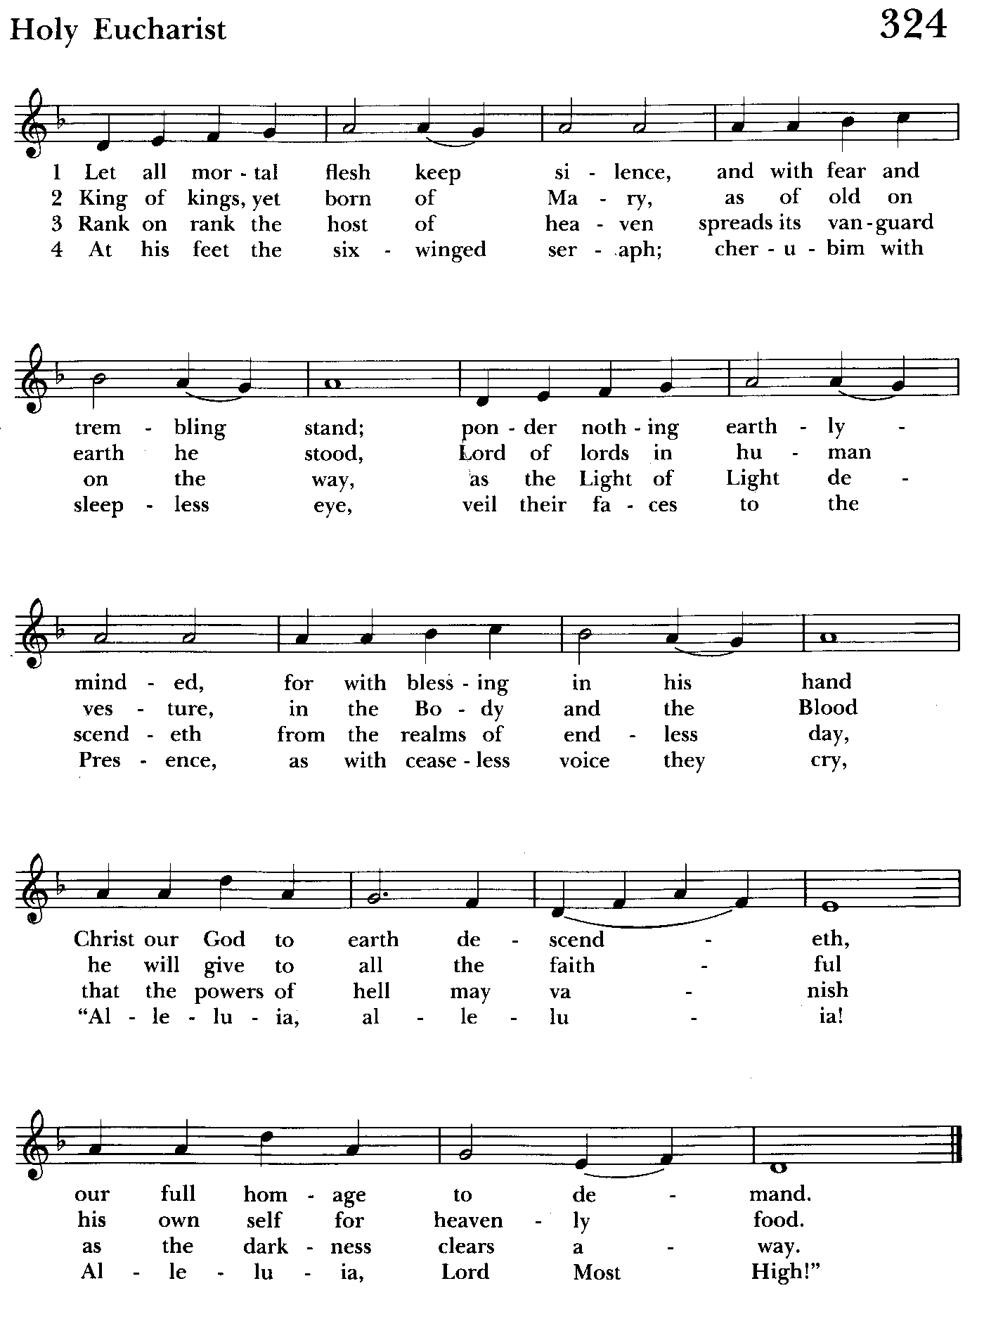

The Post Communion Prayer BCP 365
Celebrant and People: Eternal God, heavenly Father, you have graciously accepted us as living members of your Son our Savior Jesus Christ, and you have fed us with spiritual food in the Sacrament of his Body and Blood. Send us now into the world in peace, and grant us strength and courage to love and serve you with gladness and singleness of heart; through Christ our Lord. Amen.

Blessing

Closing hymn: How lovely is thy dwelling place Hymnal #517
(see next page)

The Dismissal
Celebrant: Let us go forth in the name of Christ.
People: Thanks be to God.

Annual Congregational Meeting begins—Brunch 30 min. meeting
continues as eating is finishing up

1) Opening Prayer
2) Appointment of Registrar
• Senior Warden Report
• Junior Warden Report
• Treasurer Report
• Music Ministry Report
• Priest in Charge Report
3) Nomination
4) Oath of Vestry Members
5) Closing Prayer for Annual Congregational Meeting

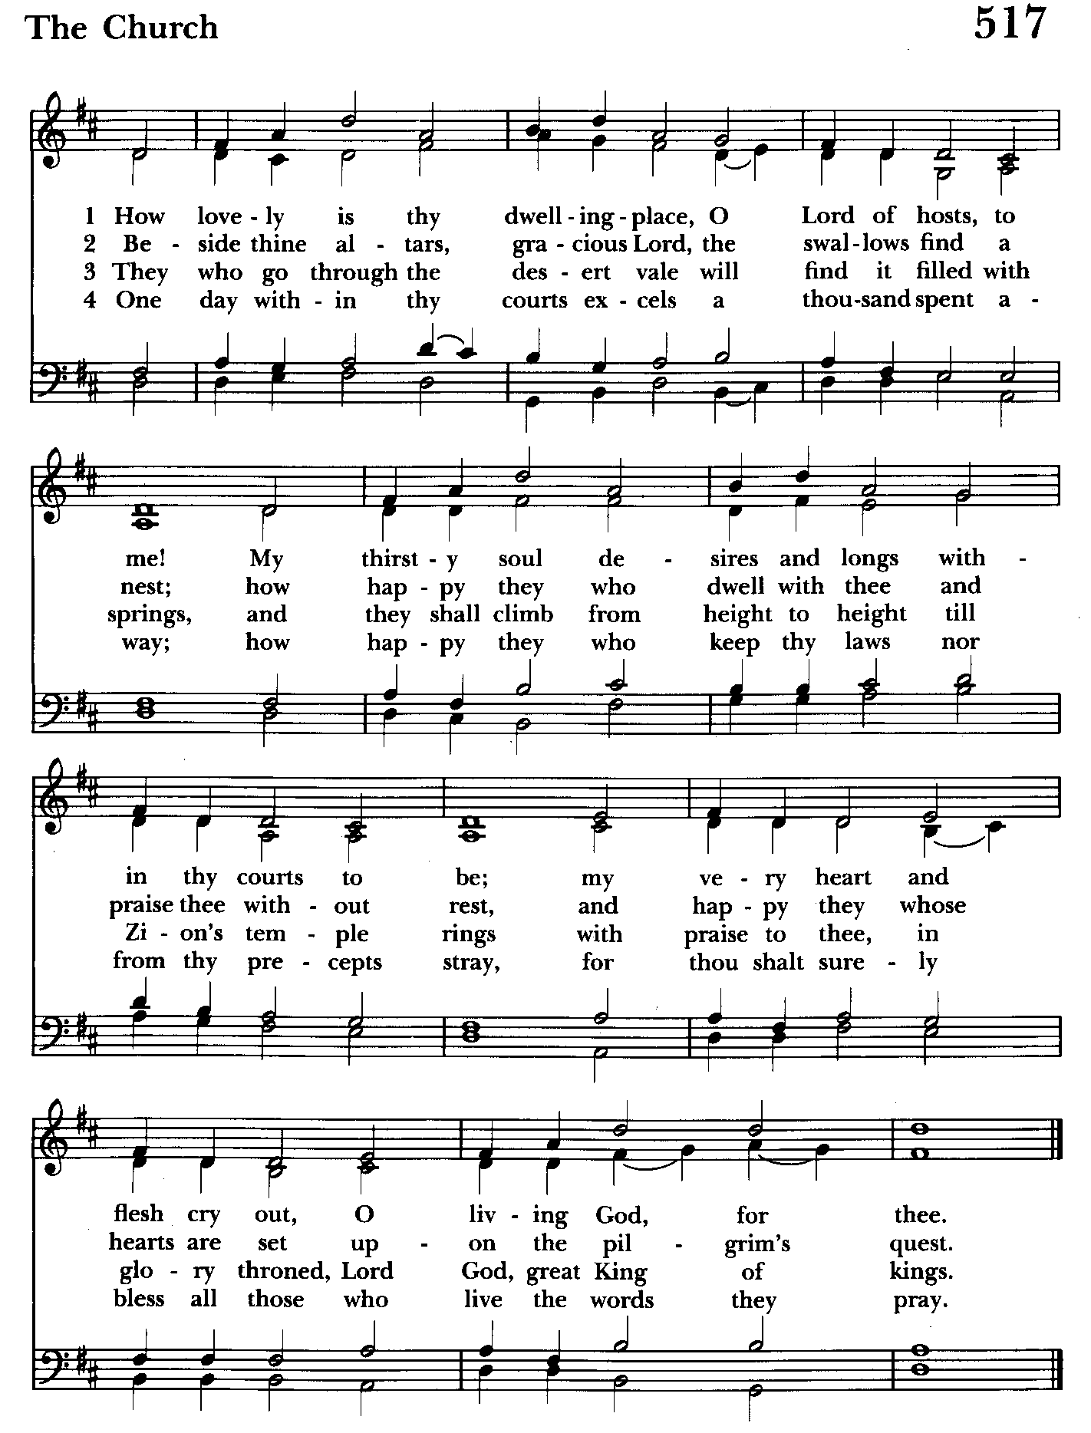
Serving Today

Celebrant & Preacher: The Rev. Mark Lobb
Old Testament: Woodie Tingle
Psalm: Liz Healey
Prayers of the People: John Frost
Server: Terry Roe
Music Director: Nancy Heinold
Choir: Anne Leland, Nancy Dellinger, Janine Stevens, Liz Healey
Karen Smith-Manar, Ty Schwenk
Altar Guild: Stephanie Duchacek & Sandy Roe


Altar Flowers
Given to the Glory of God
by a generous donor in gratitude
for the hard work of the people of this parish

St. John’s Parish Prayer List

Additions and corrections may be made to our Parish Prayer List at any time. All names will be automatically removed from the Parish Prayer List on the 1st Sunday of each month unless you request otherwise. Please contact Angie at <office@stjohnskingsville.org> or 410-592-8570 in the church office with all changes by 10 am Thursdays. Thank you.

We Pray for Those in Need:
Names in BOLD read aloud by all.

DeMarino Family, Jim & Chris Carden and family, Peggie Dietz, Mike Carden (recovery from back surgery), Pat Carden, Gail Landers, Sheila Jones, Gloria Millar, Marisol Aubrey, Ross Strickler, Jim and Janice Sieracki, James Daniel Jr, Larry Betzler, Camy Schwenk, Dennis Mally, Zach Walsh, Helen Johnson, Eileen Weimer, David Harris, Bill Hoffman and family.

We Pray for our Homebound

Lily John, Barbara Miller, Nancy Barnhart, Robin Dilworth

We pray for the Church and the World:

For +Sean, our Presiding Bishop; for +Carrie, our Bishop, for Mark+, our Priest in Charge, for the Wardens, Vestry, Staff, and all members and friends of St. John’s Church.

For the leaders of all nations, especially for Donald, our President; for Wes, our Governor; for Brandon, Zeke, Kathy and Bob, who lead our City and Counties. We pray for all children and youth; for the homeless, the unemployed, and the hungry. We pray for the safety of our loved ones and friends serving in the Armed Forces at home and abroad, and for our enemies, that all our hearts may be turned toward peace throughout the world.

From the Treasurer
January ‘25 Income vs. Expenses:

Projected January Expenses: $15,000
Monies Received as of 1/30: $11,687
Amount Needed to Meet Expenses: $ 3,313


If you’d like to make a donation to St. John’s you can scan this QR code with your phone’s camera or tap on the link that comes up to make a contribution with either a credit or debit card, Apple Pay or Google Pay. This is a secure site provided by Clover which is a service of PNC Bank.


SUNDAY SCHOOL
10:30: Kids Sunday School- Begin in the church, ring the bell, then process over to the parish hall for a fun lesson with Mr. John and Ms. Stephanie.
Note: Please seriously consider regular attendance at Sunday School so that Mr. John and Ms. Stephanie can plan good stuff.


Choral Choir and Bell Choir
Choir rehearsals Wednesdays at 7:00 pm and Bell Choir Rehearsal, Sundays after the 10:30 service.
If anyone is interested in joining, see Nancy Heinold, our Music Director.


Yoga classes on Wednesday and Friday evenings 6 to 7 pm and Saturday mornings 9 to 10 am in the Chapel.

All experience levels are welcome.


INCLEMENT WEATHER—Be careful coming to church in inclement weather. If you don’t feel safe coming out—stay home. God will understand. You can also participate on line. Follow Baltimore County Public Schools when appropriate.

Calendar Updates

February 2nd - Annual Meeting, 9:30 am
February 7th - Souper Supper, 5-7 pm
March 2nd - Organ Dedication
March 4th - Shrove Tuesday Pancake Supper, 5 pm
March 5th - Ash Wednesday Services - Noon and 7 pm
Ashes to Go—7 to 9 am and 4 to 6 pm

Calendars are living documents. Every effort will be made to keep the members of the parish and community aware of any changes.

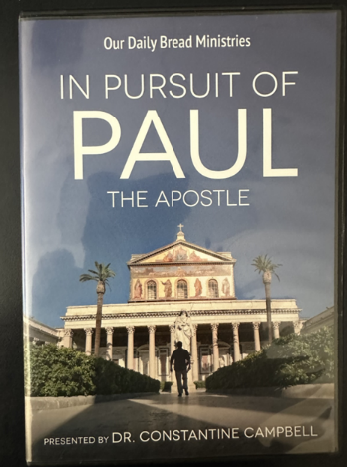

Friday Nights in Lent
After a light supper and fellowship at 6:30, we will view this contemporary look at the travels of St. Paul. Begins Friday March 7.


You are invited to join us for our next Book Study. We begin on Wednesday February 19 at 9:00 in the Library and will run through Lent. We will meet with the author by zoom on March 12. If you need assistance in obtaining a book, contact Fr. Mark or the office.


RECYCLING!
It takes approximately 15 kilowatt-hours (kWh) of electricity to make one aluminum can when produced from virgin ore, as the process of converting aluminum from bauxite is very energy intensive. Recycling aluminum cans requires significantly less energy, with the ability to produce 20 new cans with the same energy used to make one can from bauxite.

By popular demand, we are recycling. Some parishioners take printed paper home where they have recycling pickup. We now have a blue container located in the Parish Hall. This will be collected and taken for recycling. Aluminum cans will be saved and taken to a recycling center for cash. The proceeds will be donated to the Outreach fund. Each recycled aluminum can also save on the electricity needed to make new aluminum from bauxite.

In our Community
Bible Studies in our area. If interested, please contact these churches to confirm.
St. Mary’s, Abingdon, (410)569-0180- Wednesdays at noon. Bring lunch. Zoom available.
Emmanuel, Bel Air, (410)838-7699- Fridays at 9:30- Zoom Available.
Holy Trinity, Churchville, (410)914-5531- Wednesdays 11:30- Zoom may be available.


IT'S TIME FOR A
ST. JOHN’S EPISCOPAL CHURCH, KINGSVILLE
FRIDAY, FEBRUARY 7TH
5-7PM ONLY $15 PER PERSON

Your ticket will include – a large bowl of soup, bread, salad, and drink. Homemade desserts available for just $2!
Choose from Vegetable Beef, Bean and Ham, Chili, Split Pea & Ham, Seafood Chowder, Chicken Noodle,
Can’t decide? Order a “flight” of soups - 3 small servings of your choice.
Reserve your ticket in advance and receive a FREE dessert! Call 410-592-8570 to reserve your spot today!
Eat in or carry out. Come on in! There’s plenty of free parking. We look forward to seeing you.
Proceeds benefit our Outreach Fund.

FEBRUARY BIRTHDAYS THIS WEEK
February 2nd Nancy Barnhart
February 4th Carolyn Reeder, James Daniel,
Susan Dilworth
February 6th Marguerite Lobb

What’s Happening This Week at St. John’s

Sunday, February 2nd—4th Sunday after the Epiphany-ANNUAL MEETING
9:30am: Annual Congregational Meeting/Eucharist/Brunch (Hall)
No Sunday School

Monday, February 3rd
12:00-1:00pm: AA Lunch Bunch (Parish Hall)

Tuesday, February 4th
12:00-1:00pm: AA Lunch Bunch (Parish Hall)

Wednesday, February 5th
12:00-1:00pm: AA Lunch Bunch (Parish Hall)
6:00pm-7:00pm: Yoga (Chapel)
7:00pm: Choir Rehearsal (Church)
7:30pm: AA (Parish Hall)

Thursday, February 6th
12:00-1:00pm: AA Lunch Bunch (Parish Hall)
7:00pm: AA (Parish Hall)

Friday, February 7th
12:00-1:00pm: AA Lunch Bunch (Parish Hall)
6:00pm-7:00pm: Yoga (Chapel)

Saturday, February 8th
9:00am-10:00am: Yoga (Chapel)
8:30pm: AA (Parish Hall)

Sunday, February 9th-5th Sunday after Epiphany
8:00am: Holy Eucharist, Rite I, Said Service (Church)
10:30am: Holy Eucharist, Rite II, with Music (Church)
10:30am-11:00am: Sunday School
11:30am: Coffee Hour (Parish Hall)

Parish Office is open Monday, Wednesday and Thursday, 9:30am-1:30pm.

Potluck Luncheon on the first Sunday of the month and a Coffee Hour on all other Sundays after the 10:30 service.

