St. John’s Episcopal Church
In Kingsville, Maryland
welcomes you

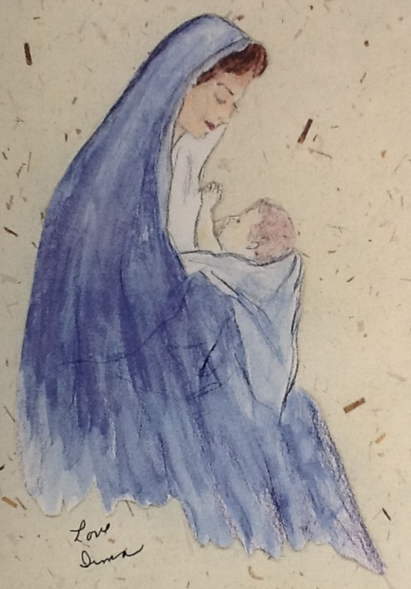

5:00 p.m. Family Christmas Eve Worship
December 24, 2024

St. John’s Episcopal Church

11901 Belair Road, P. O. Box 187, Kingsville, MD 21087
Facebook: St. John’s Episcopal, Kingsville, MD
Email: office@stjohnskingsville.org
Website: www.stjohnskingsville.org
Church Phone: 410-592-8570
For Pastoral Emergencies: Fr. Mark Lobb+ 443-690-9545

Welcome to worship today! We are glad that you are with us. You are invited to participate in all parts of the service as indicated in the Book of Common Prayer and this service bulletin. If you have any questions, feel free to ask the ushers. Restrooms are located in the Parish Hall, the brick building across the parking lot.

I was glad when they said to me, “Let us go to the house of the Lord.” Psalm 122:1

Church Staff

Priest in Charge: Father Mark Lobb
Administrative Assistant: Angie Bosley
Organist/Choir Director: Nancy Heinold

The Vestry

Class of 2024 Class of 2025

Marguerite Lobb John Frost
Jacob Johnson Woodie Tingle

Officers
Ty Schwenk—Sr. Warden Terry Roe—Jr. Warden
Elizabeth Healey—Treasurer Anne Leland-Registrar

Parish Committee Chairpersons

Altar Guild: Elizabeth Healey
Auxiliary Committee: Michele Lozanski
Cemetery Committee: Karen Smith-Manar

Cover artwork by Irma Black, a past parishioner.

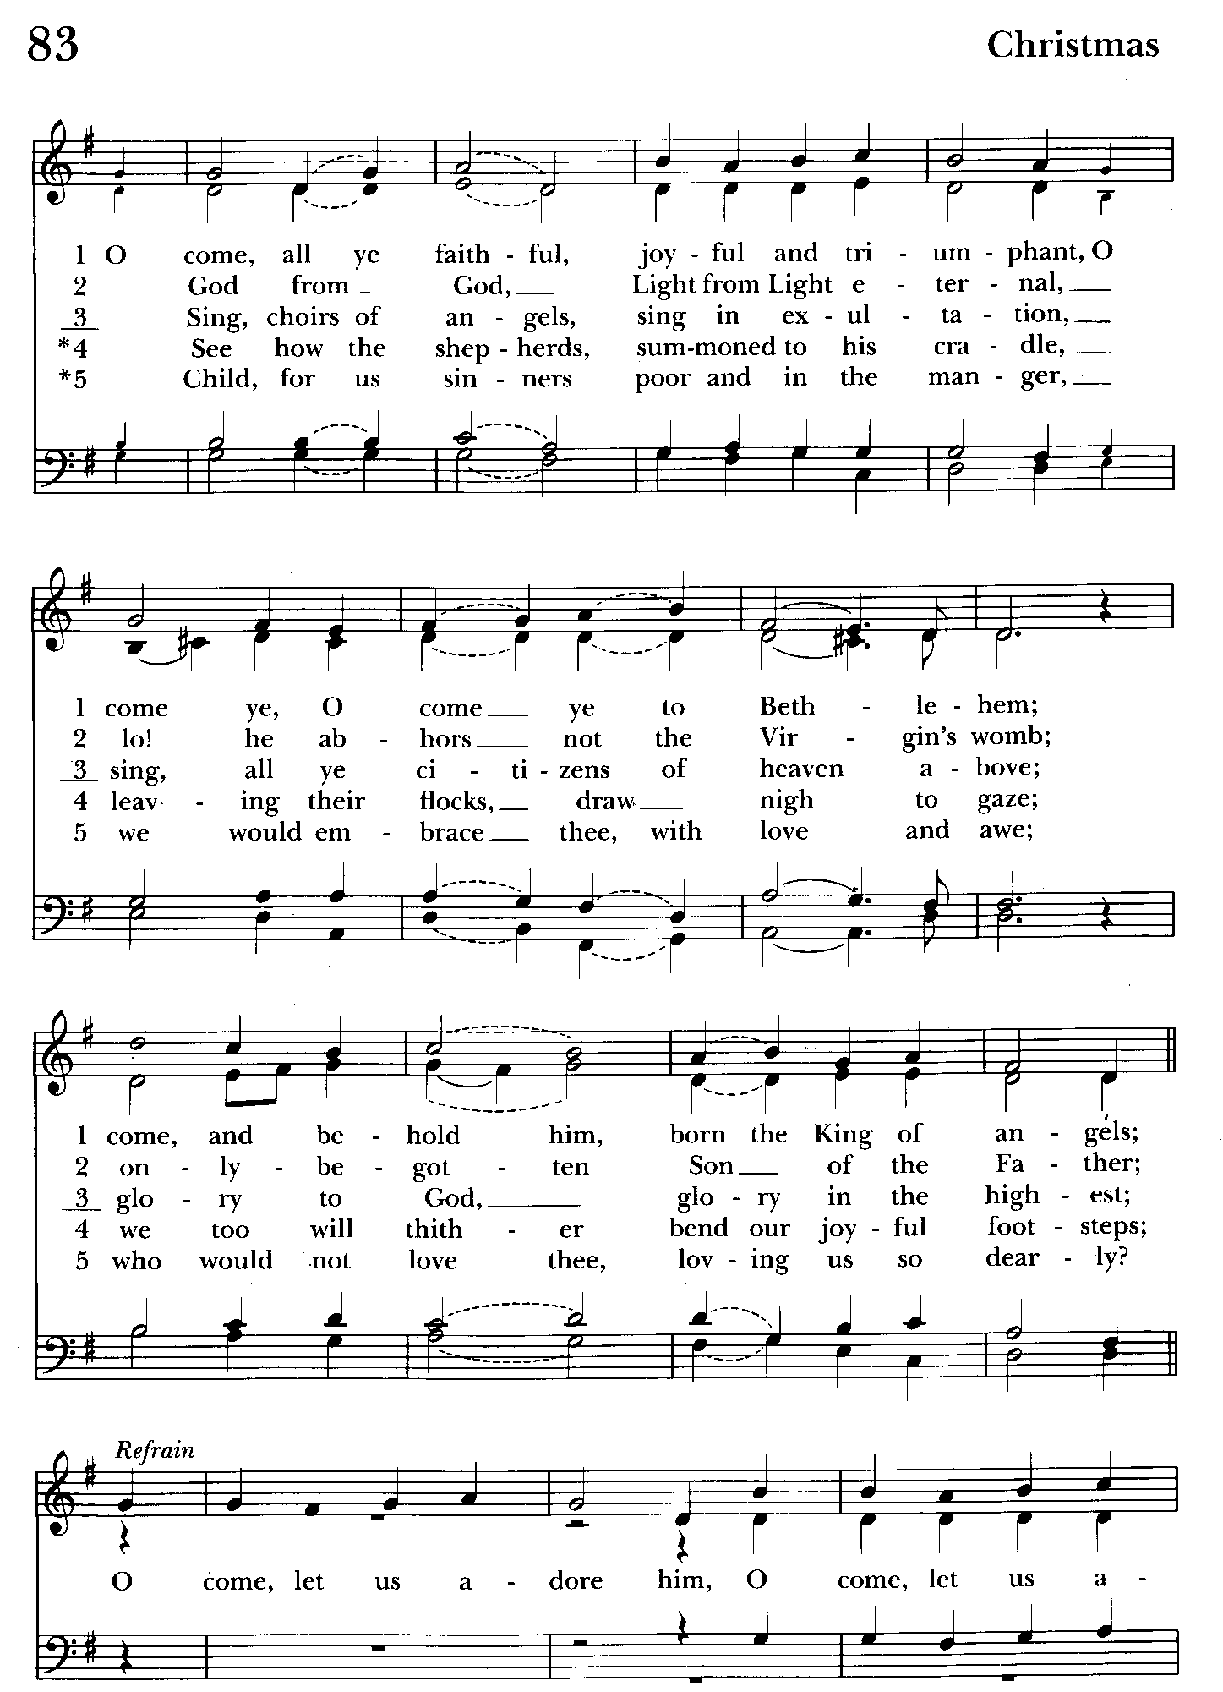

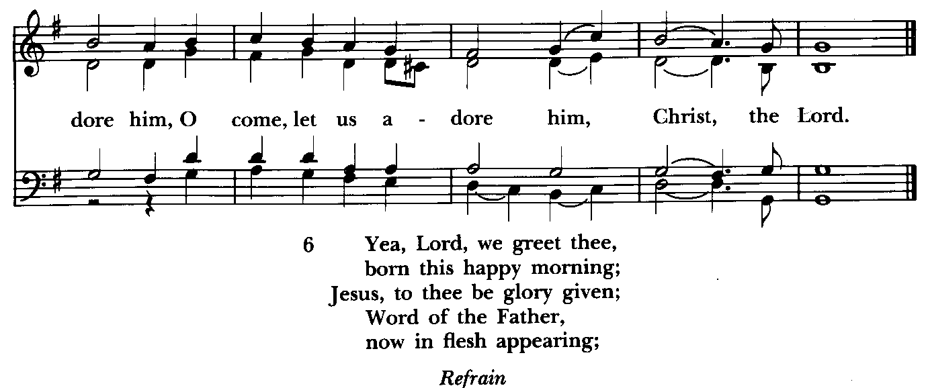

5:00 PM Family Christmas Eve Worship
The Holy Eucharist: Rite II

Prelude

Processional Hymn O Come, All Ye Faithful Hymnal # 83
(see previous and above) If you are able, please stand

Leader: Light and peace, in Jesus Christ our Lord
All: Thanks be to God

Celebrant: Blessed are you, sovereign Lord, King of peace: to you be praise and glory for ever. The new light of your incarnate Word gives gladness in our
sorrow and a presence in our isolation. Fill our lives with your light, until they overflow with gladness and praise.
People: Blessed be God for ever.

Station at the Christmas Creche

(The Infant Jesus is placed in the Creche.)

Celebrant: The glory of the Lord has been revealed:
People: And all flesh shall see the salvation of our God.

Celebrant: Let us pray. O God our Creator, to restore our fallen race you spoke the effectual word, and the Eternal Word became flesh in the womb of the Blessed Virgin Mary: Mercifully grant that as he humbled himself to be clothed with our humanity, so we may be found worthy, in him, to be clothed with his divinity; who lives and reigns for ever and ever.
All: Amen.

The Gloria in excelsis Hymnal #S-280

Glory to God in the highest,
and peace to his people on earth.

Lord God, heavenly King,
almighty God and Father,
we worship you, we give you thanks,
we praise you for your glory.
Lord Jesus Christ, only Son of the Father,
Lord God, Lamb of God,
you take away the sin of the world:
have mercy on us;
you are seated at the right hand of the Father:
receive our prayer.

For you alone are the Holy One,
you alone are the Lord,
you alone are the Most High
Jesus Christ,
with the Holy Spirit,
in the glory of God the Father. Amen.

The Collect of the Day Kneel or stand as able BCP, p. 212
O God, you make us glad by the yearly festival of the birth of your only Son Jesus Christ: Grant that we, who joyfully receive him as our Redeemer, may with sure confidence behold him when he comes to be our Judge; who lives and reigns with you and the Holy Spirit, one God, now and for ever.

All: Amen.

Please be seated.
The Word of God

A Reading from the Book of the Prophet Isaiah Isaiah 9:2-7
The people who walked in darkness have seen a great light; those who lived in a land of deep darkness--on them light has shined. You have multiplied the
nation, you have increased its joy; they rejoice before you as with joy at the
harvest, as people exult when dividing plunder. For the yoke of their burden, and the bar across their shoulders, the rod of their oppressor, you have broken as on the day of Midian. For all the boots of the tramping warriors and all the garments rolled in blood shall be burned as fuel for the fire. For a child has been born for us, a son given to us; authority rests upon his shoulders; and he is named Wonderful Counselor, Mighty God, Everlasting Father, Prince of Peace. His authority shall grow continually, and there shall be endless peace for the throne of David and his kingdom. He will establish and uphold it with justice and with righteousness from this time onward and forevermore. The zeal of the LORD of hosts will do this.

Reader: The Word of the Lord.
People: Thanks be to God.

Gradual Hymn: Go tell it on the mountain Hymnal #99
(see below and next page) Please stand as able

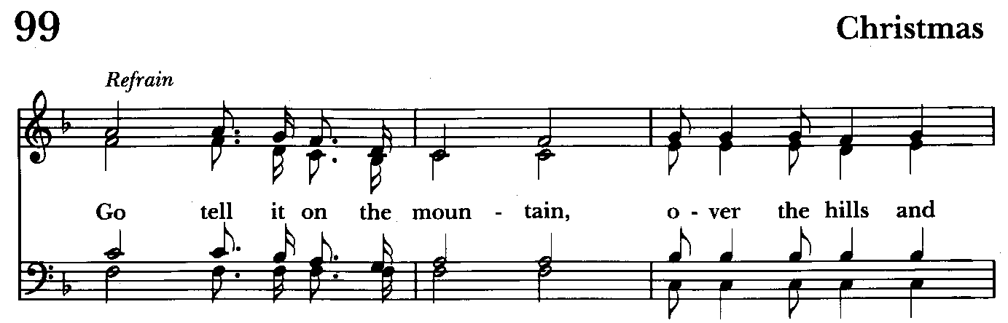

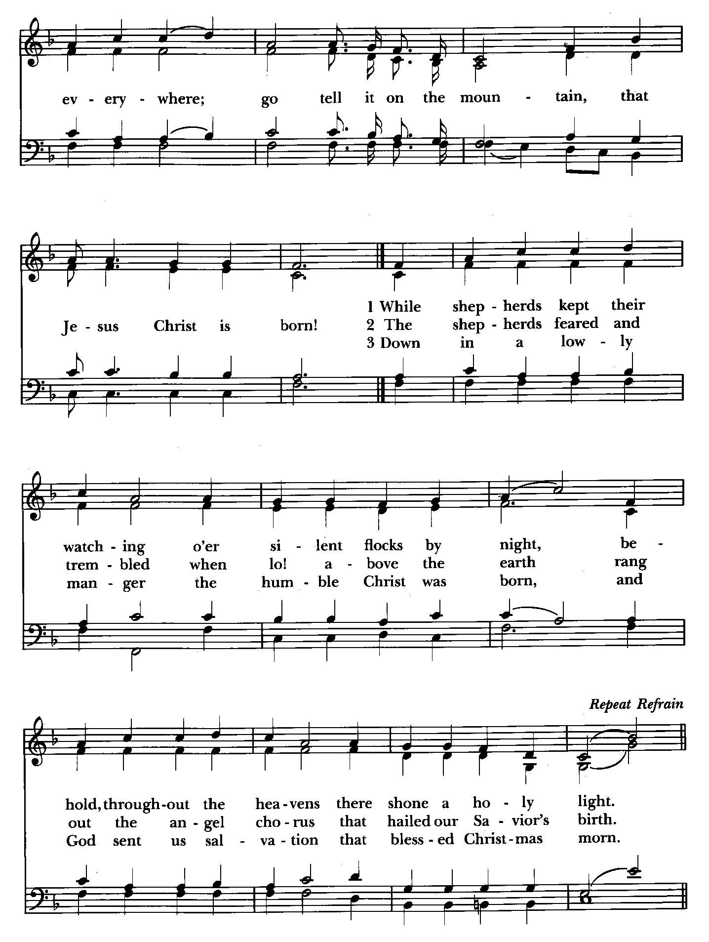

The Gospel Lesson Luke 2:1-20
Priest: The Holy Gospel of our Lord Jesus Christ according to Luke

People: Glory to you, Lord Christ.
In those days a decree went out from Emperor Augustus that all the world should be registered. This was the first registration and was taken while Quirinius was governor of Syria. All went to their own towns to be registered. Joseph also went from the town of Nazareth in Galilee to Judea, to the city of David called Bethlehem, because he was descended from the house and family of David. He went to be registered with Mary, to whom he was engaged and who was expecting a child. While they were there, the time came for her to deliver her child. And she gave birth to her firstborn son and wrapped him in bands of cloth, and laid him in a manger, because there was no place for them in the inn. In that region there were shepherds living in the fields, keeping watch over their flock by night. Then an angel of the Lord stood before them, and the glory of the Lord shone around them, and they were terrified. But the angel said to them, "Do not be afraid; for see-- I am bringing you good news of great joy for all the people: to you is born this day in the city of David a Savior, who is the Messiah, the Lord. This will be a sign for you: you will find a child wrapped in bands of cloth and lying in a manger." And suddenly there was with the angel a multitude of the heavenly host, praising God and saying, "Glory to God in the highest heaven, and on earth peace among those whom he favors!" When the angels had left them and gone into heaven, the shepherds said to one another, "Let us go now to Bethlehem and see this thing that has taken place, which the Lord has made known to us." So they went with haste and found Mary and Joseph, and the child lying in the manger. When they saw this, they made known what had been told them about this child; and all who heard it were amazed at what the shepherds told them. But Mary treasured all these words and pondered them in her heart. The shepherds returned, glorifying and praising God for all they had heard and seen, as it had been told them.

Priest: The Gospel of the Lord.
People: Praise to you, Lord Christ.
The people are seated.

Homily Rev. Mark Lobb+

The Nicene Creed Please stand as able BCP, p. 358
We believe in one God,
the Father, the Almighty,
maker of heaven and earth,
of all that is, seen and unseen.

We believe in one Lord, Jesus Christ,
the only Son of God,
eternally begotten of the Father,

God from God, Light from Light,
true God from true God,
begotten, not made,
of one Being with the Father.
Through him all things were made.
For us and for our salvation
he came down from heaven:
by the power of the Holy Spirit
he became incarnate from the Virgin Mary,
and was made man.
For our sake he was crucified under Pontius Pilate;
he suffered death and was buried.
On the third day he rose again
in accordance with the Scriptures;
he ascended into heaven
and is seated at the right hand of the Father.
He will come again in glory to judge the living and the dead,
and his kingdom will have no end.

We believe in the Holy Spirit, the Lord, the giver of life,
who proceeds from the Father and the Son.
With the Father and the Son he is worshiped and glorified.
He has spoken through the Prophets.
We believe in one holy catholic and apostolic Church.
We acknowledge one baptism for the forgiveness of sins.
We look for the resurrection of the dead,
and the life of the world to come. Amen.

Prayers of the People Form VI Please stand as able BCP 392
Litanist: In peace, we pray to you, Lord God.

Silence

Litanist: For all people in their daily life and work;
People: For our families, friends, and neighbors, and for those who
are alone.

Litanist: For this community, the nation, and the world; especially Joseph, our President, Larry, our Governor, Brandon, Nick, John and Barry, who lead our City and Counties
People: For all who work for justice, freedom, and peace.

Litanist: For the just and proper use of your creation;
People: For the victims of hunger, fear, injustice, and oppression.

Litanist: For all who are in danger, sorrow, or any kind of trouble;
People: For those who minister to the sick, the friendless, and the needy.

Litanist: For the peace and unity of the Church of God;
People: For all who proclaim the Gospel, and all who seek the Truth.

Litanist: For +Justin, Archbishop of Canterbury; for +Sean , our Presiding Bishop; for +Carrie, our Bishop; for Mark+, our Priest in Charge, for the Wardens, Vestry, Staff, and all members and friends of St. John’s Church; for this gathering; and for all ministers and people.
People: For all who serve God in his Church.

Litanist: For the special needs and concerns of this congregation. Especially DeMarino Family, Jim & Chris Carden and family, Peggie Dietz, Mike Carden, Pat Carden, Gail Landers, Sheila Jones, Gloria Millar, Marisol
Aubrey, Ross Strickler, Jim & Janice Sieracki, James Daniel Jr., Larry Betzler, Camy Schwenk, Dennis Mally, Zach Walsh, Lily John, Barbara
Miller, Nancy Barnhart, Robin Dilworth, Helen Johnson, Eileen Weimer, David Harris.
People may add their own petitions

Litanist: Hear us, Lord;
People: For your mercy is great.

Litanist: We thank you, Lord, for all the blessings of this life.

The People may add their own thanksgivings

Litanist: We will exalt you, O God our King;
People: And praise your Name for ever and ever.

Litanist: We pray for all who have died, that they may have a place in
your eternal kingdom.

Silence
Litanist: Lord, let your loving-kindness be upon them;
People: Who put their trust in you.

Litanist: We pray to you also for the forgiveness of our sins.

Silence may be kept.

Litanist and People
Have mercy upon us, most merciful Father;
in your compassion forgive us our sins,
known and unknown,
things done and left undone;
and so uphold us by your Spirit
that we may live and serve you in newness of life,
to the honor and glory of your Name;
through Jesus Christ our Lord. Amen.

Celebrant: Almighty God have mercy on you, forgive you all your sins through our Lord Jesus Christ, strengthen you in all goodness, and by the power of the Holy Spirit keep you in eternal life. Amen.

The Peace of Christ Please stand as able
Celebrant: The peace of the Lord be always with you.
People And also with you.

Welcome & Announcements All are seated

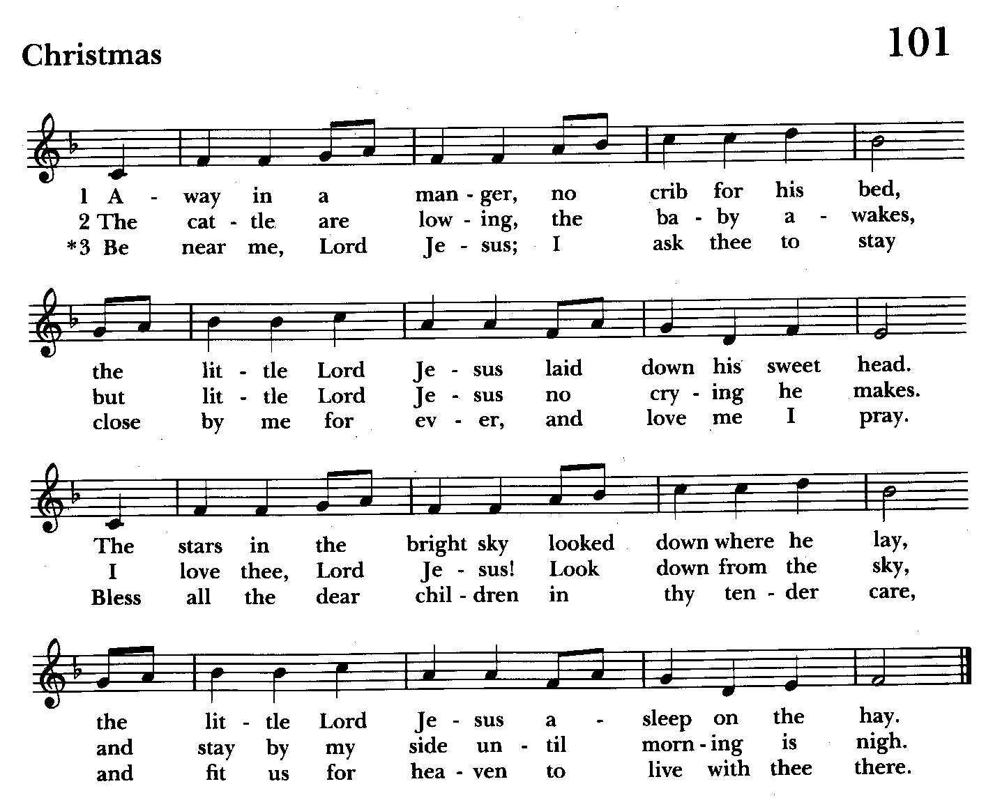

Offertory Anthem: Bring a Torch Jeanette Isabella (Bell choir)
Offertory Hymn: Away in a Manger Hymnal #101
(see above) Congregation remains seated during offering collection

Doxology Please stand as able
Praise God, from whom all blessings flow; praise him, all creatures here below; praise him above, ye heavenly host: praise Father, Son and Holy Ghost.

The Holy Communion

The Great Thanksgiving: Eucharistic Prayer B BCP, p. 367
Celebrant: The Lord be with you.
People: And also with you.
Celebrant: Lift up your hearts.
People: We lift them to the Lord.
Celebrant: Let us give thanks to the Lord our God.
People: It is right to give him thanks and praise.
Celebrant: It is right, and a good and joyful thing, always and everywhere to give thanks to you, Father Almighty, Creator of heaven and earth.

Preface
Therefore we praise you, joining our voices with Angels and Archangels and with all the company of heaven, who for ever sing this hymn to proclaim the glory of your Name:

Sanctus Hymnal # S - 129
Holy, holy, holy Lord, God of power and might,
heaven and earth are full, full of your glory.
Hosanna in the highest.
Blessed is he who comes in the name of the Lord.
Hosanna in the highest.

Please stand as able BCP 368
Celebrant: We give thanks to you, O God, for the goodness and love which you have made known to us in creation; in the calling of Israel to be your people; in your Word spoken through the prophets; and above all in the Word made flesh, Jesus, your Son. For in these last days you sent him to be incarnate from the Virgin Mary, to be the Savior and Redeemer of the world. In him, you have delivered us from evil, and made us worthy to stand before you. In him, you have brought us out of error into truth, out of sin into righteousness, out of death into life.

On the night before he died for us, our Lord Jesus Christ took bread; and when he had given thanks to you, he broke it, and gave it to his disciples, and said, “Take, eat: This is my Body, which is given for you. Do this for the remembrance of me.”
After supper he took the cup of wine; and when he had given thanks, he gave it to them, and said, “Drink this, all of you: This is my Blood of the new
Covenant, which is shed for you and for many for the forgiveness of sins.
Whenever you drink it, do this for the remembrance of me.”

Therefore, according to his command, O Father,
Celebrant and People: We remember his death, We proclaim his resurrection, We await his coming in glory;

Celebrant: And we offer our sacrifice of praise and thanksgiving to you, O Lord of all; presenting to you, from your creation, this bread and this wine.

We pray you, gracious God, to send your Holy Spirit upon these gifts that they may be the Sacrament of the Body of Christ and his Blood of the new
Covenant. Unite us to your Son in his sacrifice, that we may be acceptable through him, being sanctified by the Holy Spirit. In the fullness of time put all things in subjection under your Christ, and bring us to that heavenly country where, with St. John and all your saints, we may enter the everlasting heritage of your sons and daughters; through Jesus Christ our Lord, the firstborn of all
creation, the head of the Church, and the author of our salvation.

By him, and with him, and in him, in the unity of the Holy Spirit all honor and glory is yours, Almighty Father, now and for ever. Amen.

And now, as our Savior Christ has taught us, we are bold to say,

Our Father, who art in heaven, BCP 364
hallowed be thy Name,
thy kingdom come,
thy will be done,
on earth as it is in heaven.
Give us this day our daily bread.
And forgive us our trespasses,
as we forgive those
who trespass against us.
And lead us not into temptation,
but deliver us from evil.
For thine is the kingdom,
and the power, and the glory,
for ever and ever. Amen.

The Breaking of the Bread
Celebrant: Alleluia. Christ our Passover is sacrificed for us;
People: Therefore let us keep the feast. Alleluia.

Agnus Dei Hymnal #S-163
Jesus, Lamb of God: have mercy on us.
Jesus, bearer of our sins: have mercy on us.
Jesus, redeemer, redeemer of the world:
give us your peace, give us your peace.

Celebrant: The Gifts of God for the people of God.

Invitation to Communion BCP, p. 364
All baptized Christians are welcome to receive Holy Communion with us. If you do not wish to receive
Holy Communion, you may come to the altar rail for a blessing. Cross your arms over your heart as a sign to the priest. Guten free upon request.

Communion Hymns All sing while seated

Silent Night Hymnal #111
(see next page)

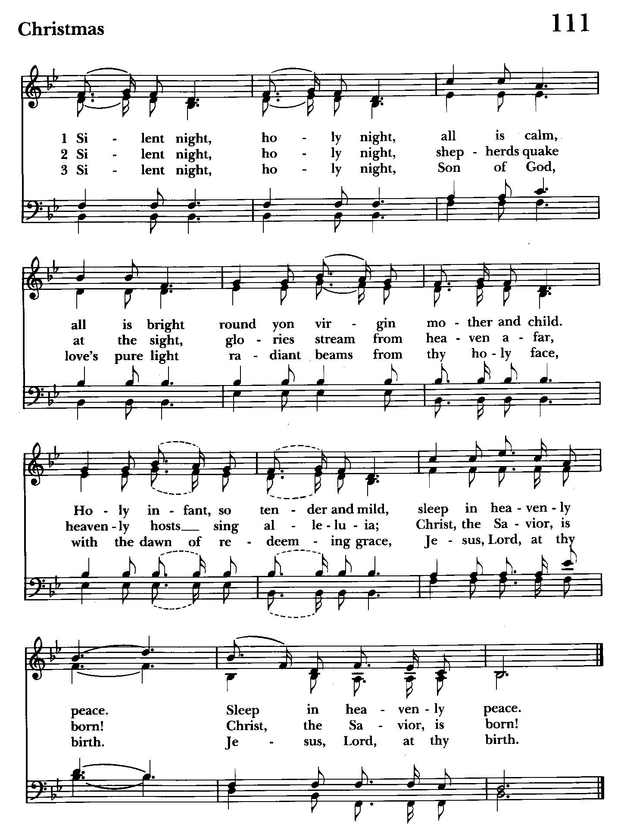

Post Communion Prayer Please kneel or stand as able BCP, p. 365
Celebrant and People: Eternal God, heavenly Father, you have graciously accepted us as living members of your Son our Savior Jesus Christ, and you have fed us with spiritual food in the Sacrament of his Body and Blood. Send us now into the world in peace, and grant us strength and courage to love and serve you with gladness and singleness of heart; through Christ our Lord. Amen.

A Christmas Blessing
Celebrant: May Christ, who by his Incarnation gathered into one things earthly and heavenly, fill you with his joy and peace; and the blessing of God Almighty, the Father, the Son, and the Holy Spirit, be among you, and remain with you always.
All: Amen.

Recessional Hymn Joy to the World Please stand Hymnal # 100
(see next 2 pages)

The Dismissal
Celebrant: Let us bless the Lord. Alleluia, Alleluia.
People: Thanks be to God. Alleluia, Alleluia.

Silent Night (Bell Choir)

Postlude

License #A-719154

Serving This Evening
Celebrant & Preacher: The Rev. Mark Lobb
Old Testament: Liz Healey
Prayers of the People: Liz Healey
Bell Choir: Nanci Rosendale, Linda Posten, Karen Smith-Manar,
Elizabeth Healey, John Stevens, Janine Stevens, Ty Schwenk
Altar Guild: John Stevens & Woodie Tingle

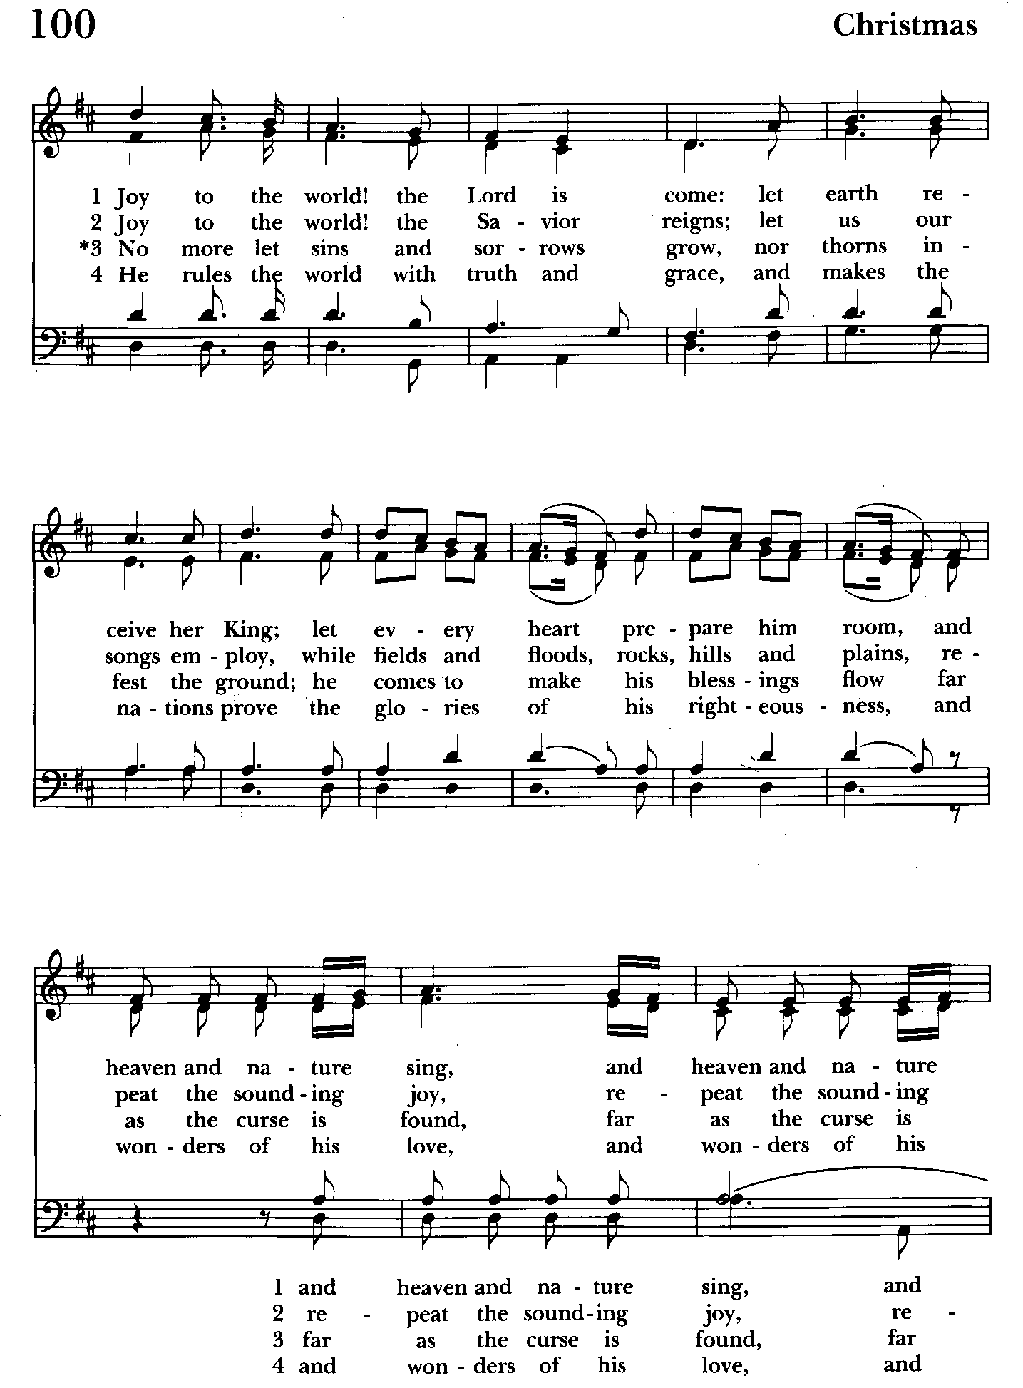

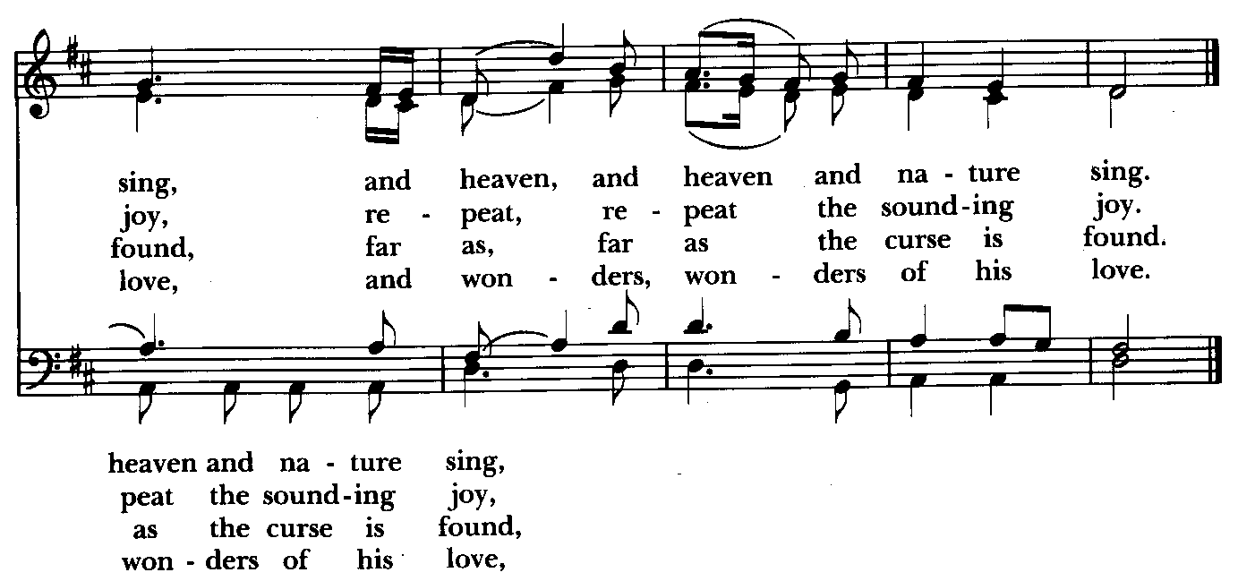

St. John’s Parish Prayer List

Additions and corrections may be made to our Parish Prayer List at any time. All names will be automatically removed from the Parish Prayer List on the 1st Sunday of each month unless you request otherwise. Please contact Angie at <office@stjohnskingsville.org> or 410-592-8570 in the church office with all changes by 10 am Thursdays. Thank you.

We Pray for Those in Need:
Names in BOLD read aloud by all.

DeMarino Family, Jim & Chris Carden and family, Peggie Dietz, Mike Carden, Pat Carden, Gail Landers, Sheila Jones, Gloria Millar, Marisol Aubrey, Ross Strickler, Jim and Janice Sieracki, James Daniel Jr, Larry Betzler, Camy Schwenk, Dennis Mally, Zach Walsh, Helen Johnson, Eileen Weimer, David Harris.

We Pray for our Homebound

Lily John, Barbara Miller, Nancy Barnhart, Robin Dilworth

We pray for the Church and the World:

For +Justin, Archbishop of Canterbury; for +Sean, our Presiding Bishop; for +Carrie, our Bishop, for Mark+, our Priest in Charge, for the Wardens, Vestry, Staff, and all members and friends of St. John’s Church.

For the leaders of all nations, especially for Joseph, our President; for Wes, our Governor; for Brandon, Zeke, John and Bob, who lead our City and Counties. We pray for all children and youth; for the homeless, the unemployed, and the hungry. We pray for the safety of our loved ones and friends serving in the Armed Forces at home and abroad, and for our enemies, that all our hearts may be turned toward peace throughout the world.

2024 Poinsettias

Linda Posten in memory of Robert Eichhorn
Stephanie & Frank Duchacek in memory of Loved Ones
Joan Salmon in memory of Captain Walter W. Salmon, Jr. (USN) and in honor of our deceased parents and siblings
Carolyn Grebe in loving memory of Elizabeth Bunch and in loving memory of Loved Ones
Woodie Tingle in honor of Dennis Mally, in honor Fr. Mark & Sharon, in honor of Angie Bosley and Nancy Heinold, in honor of Mother Jane White, in honor of 8 am worship, in memory of Mary & Woodie Tingle and Helen & Gus Mally and Aunt Ada
Laura Spadone in memory of Charles Keenan
Barbara Daniel in loving memory of Carl & Grace Pickel’s wedding
anniversary on January 1st
Liz Healey in memory of John & Lorraine Healey, Earl & May Banks, Norman & Peggy Banks, and in thanksgiving for The Holland Family

Christmas Day Service

9:30 am Spoken Service

The church office will be closed December 23rd through January 1st.



“For unto you is born this day in the city of David a Savior, which is Christ the Lord.’...That’s what Christmas is all about, Charlie Brown.”

LINUS in A Charlie Brown Christmas

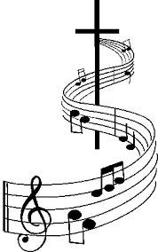
Join us Sunday, December 29th
at 10:30 for Christmas Lessons & Carols
One Service Only This Day

