St. John’s Episcopal Church
Kingsville, Maryland
Welcomes You

Our Vision Statement

We believe that together we will transform
the world with love: Come on in!



Third Sunday of Advent
December 15, 2024
8:00 and 10:30 am services

St. John’s Episcopal Church

11901 Belair Road, P. O. Box 187, Kingsville, MD 21087
Facebook: St. John’s Episcopal, Kingsville, MD
Email: office@stjohnskingsville.org
Website: www.stjohnskingsville.org
Church Phone: 410-592-8570
For Pastoral Emergencies: Fr. Mark Lobb+ 443-690-9545

Welcome to worship today! We are glad that you are with us. You are invited to participate in all parts of the service as indicated in the Book of Common Prayer and this service bulletin. If you have any questions, feel free to ask the ushers. Restrooms are located in the Parish Hall, the brick building across the parking lot.

I was glad when they said to me, “Let us go to the house of the Lord.” Psalm 122:1

Church Staff

Priest in Charge: Father Mark Lobb
Administrative Assistant: Angie Bosley
Organist/Choir Director: Nancy Heinold

The Vestry

Class of 2024 Class of 2025

Marguerite Lobb John Frost
Jacob Johnson Woodie Tingle

Officers
Ty Schwenk—Sr. Warden Terry Roe—Jr. Warden
Elizabeth Healey—Treasurer Anne Leland-Registrar

Parish Committee Chairpersons

Altar Guild: Elizabeth Healey
Auxiliary Committee: Michele Lozanski
Cemetery Committee: Terry Roe

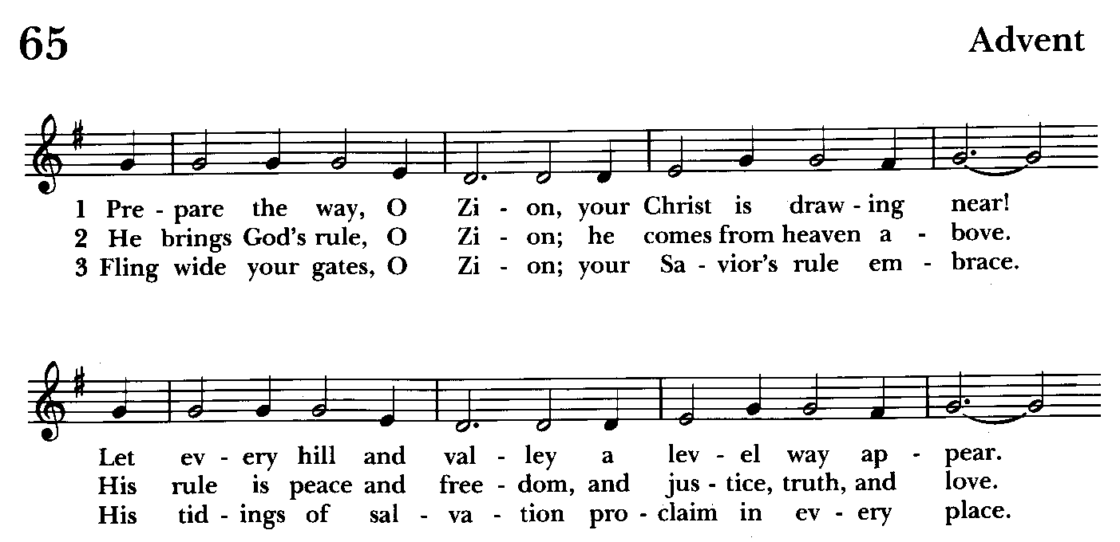

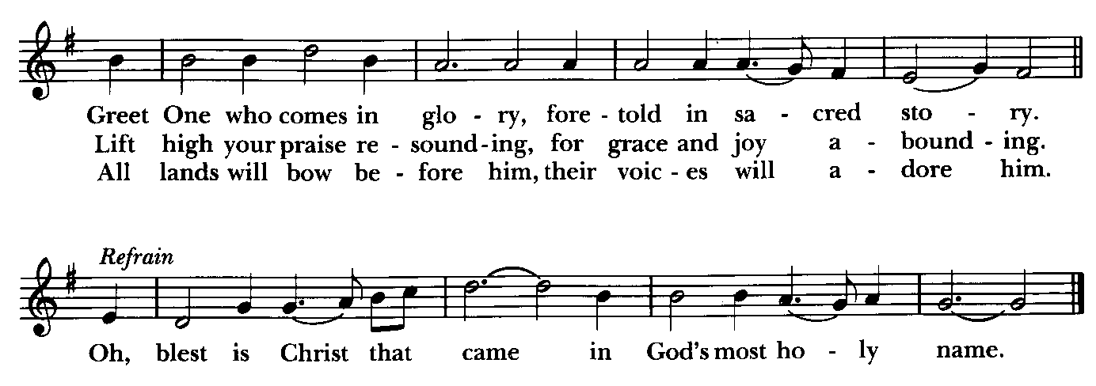

Holy Eucharist

Processional hymn: Prepare the way, O Zion Hymnal #65
(see previous page) Please stand as able

Lighting of the Advent Wreath
Celebrant: Christ our Joy, Brighten our homes with your presence. Clarify our vision so that we might see you in the people we cherish. Make every holiday activity an opportunity to spread your light and love. We await your coming with delight.
People: Amen.
Opening Acclamations

Celebrant: Blessed are you, holy and living One. BCP 355
People: You come to your people and set them free.
Celebrant: Almighty God, to you all hearts are open, all desires known, and from you no secrets are hid: Cleanse the thoughts of our hearts by the inspiration of your holy Spirit, that we may perfectly love you, and worthily magnify your holy Name; through Christ our Lord. Amen.

Trisagion Hymnal #S-100
Holy God, Holy and Mighty, Holy Immortal One,
Have mercy upon us.
Holy God, Holy and Mighty, Holy Immortal One,
Have mercy upon us.
Holy God, Holy and Mighty, Holy Immortal One,
Have mercy upon us.

Celebrant: God be with you.
People: And also with you.
Celebrant: Let us pray.

The Collect of the Day kneel or stand as able BCP 212
Stir up your power, O Lord, and with great might come among us; and, because we are sorely hindered by our sins, let your bountiful grace and mercy speedily help and deliver us; through Jesus Christ our Lord, to whom, with you and the Holy Spirit, be honor and glory, now and for ever. Amen.

The congregation is seated

A Reading from Book of Zephaniah 3:14-20
Sing aloud, O daughter Zion; shout, O Israel!
Rejoice and exult with all your heart, O daughter Jerusalem!
The Lord has taken away the judgments against you,
he has turned away your enemies.
The king of Israel, the Lord, is in your midst;
you shall fear disaster no more.
On that day it shall be said to Jerusalem:
Do not fear, O Zion; do not let your hands grow weak.
The Lord, your God, is in your midst, a warrior who gives victory;
he will rejoice over you with gladness, he will renew you in his love;
he will exult over you with loud singing as on a day of festival.
I will remove disaster from you, so that you will not bear reproach for it.
I will deal with all your oppressors at that time.
And I will save the lame and gather the outcast,
and I will change their shame into praise and renown in all the earth.
At that time I will bring you home, at the time when I gather you;
for I will make you renowned and praised
among all the peoples of the earth, when I restore your fortunes
before your eyes, says the Lord.

Reader: Hear what the Spirit is saying to God’s people
People: Thanks be to God.

Canticle 9 (Pray as directed)

The First Song of Isaiah Ecce Deus
Isaiah 12:2-6
Surely, it is God who saves me; *
I will trust in him and not be afraid.
For the Lord is my stronghold and my sure defense, *
and he will be my Savior.
Therefore you shall draw water with rejoicing *
from the springs of salvation.
And on that day you shall say, *
Give thanks to the Lord and call upon his Name;
Make his deeds known among the peoples; *
see that they remember that his Name is exalted.
Sing the praises of the Lord, for he has done great things, *
and this is known in all the world.
Cry aloud, inhabitants of Zion, ring out your joy, *
for the great one in the midst of you is the Holy One of Israel.

Glory to the Father, and to the Son, and to the Holy Spirit: *
as it was in the beginning, is now, and will be for ever. Amen.

A Reading from the Letter of St. Paul to the Philippians 4:4-7
Rejoice in the Lord always; again I will say, Rejoice. Let your gentleness be known to everyone. The Lord is near. Do not worry about anything, but in everything by prayer and supplication with thanksgiving let your requests be made known to God. And the peace of God, which surpasses all understanding, will guard your hearts and your minds in Christ Jesus.

Reader: Hear what the Spirit is saying to God’s people
People: Thanks be to God.

Gradual hymn: Comfort, comfort ye my people Hymnal #67
(see next page) Please stand as able.

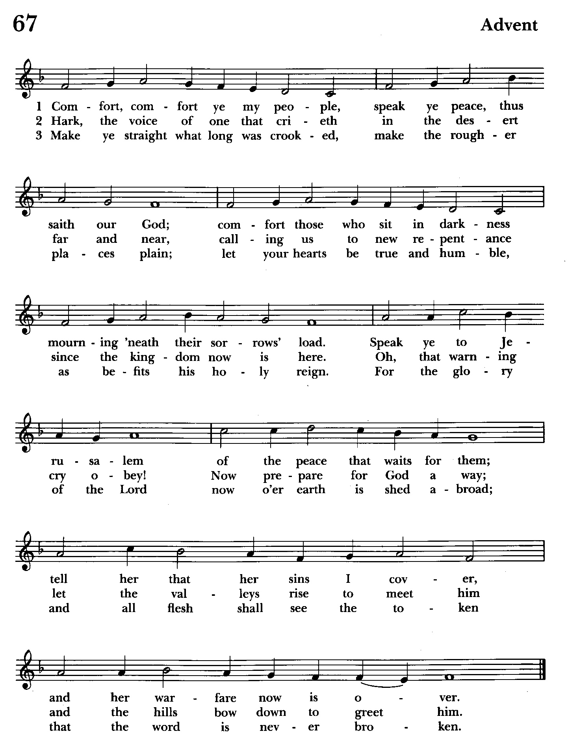

The Gospel Please remain standing
Priest: The Holy Gospel of our Lord Jesus Christ according to Luke 3:7-18
People: Glory to you, Lord Christ.
John said to the crowds that came out to be baptized by him, "You brood of vipers! Who warned you to flee from the wrath to come? Bear fruits worthy of repentance. Do not begin to say to yourselves, 'We have Abraham as our ancestor'; for I tell you, God is able from these stones to raise up children to Abraham. Even now the ax is lying at the root of the trees; every tree therefore that does not bear good fruit is cut down and thrown into the fire."
And the crowds asked him, "What then should we do?" In reply he said to them, "Whoever has two coats must share with anyone who has none; and whoever has food must do likewise." Even tax collectors came to be baptized, and they asked him, "Teacher, what should we do?" He said to them, "Collect no more than the amount prescribed for you." Soldiers also asked him, "And we, what should we do?" He said to them, "Do not extort money from anyone by threats or false accusation, and be satisfied with your wages."
As the people were filled with expectation, and all were questioning in their hearts concerning John, whether he might be the Messiah, John answered all of them by saying, "I baptize you with water; but one who is more powerful than I is coming; I am not worthy to untie the thong of his sandals. He will baptize you with the Holy Spirit and fire. His winnowing fork is in his hand, to clear his threshing floor and to gather the wheat into his granary; but the chaff he will burn with unquenchable fire."
So, with many other exhortations, he proclaimed the good news to the people.

Celebrant: The Gospel of the Lord.
People: Praise to you, Lord Christ.

Sermon The congregation is seated Rev. Mark Lobb+

The Nicene Creed Please stand as able BCP 358
Minister and People
We believe in one God,
the Father, the Almighty,
maker of heaven and earth,
of all that is, seen and unseen.
We believe in one Lord, Jesus Christ,
the only Son of God,
eternally begotten of the Father,
God from God, Light from Light,
true God from true God,
begotten, not made,
of one Being with the Father;
through him all things were made.
For us and for our salvation
he came down from heaven,
was incarnate of the Holy Spirit and the Virgin Mary
and became truly human.
For our sake he was crucified under Pontius Pilate;
he suffered death and was buried.
On the third day he rose again
in accordance with the Scriptures;
he ascended into heaven
and is seated at the right hand of the Father.
He will come again in glory to judge the living and the dead,
and his kingdom will have no end.
We believe in the Holy Spirit, the Lord, the giver of life,
who proceeds from the Father,
who with the Father and the Son is worshiped and glorified,
who has spoken through the prophets.
We believe in one holy catholic and apostolic Church.
We acknowledge one baptism for the forgiveness of sins.
We look for the resurrection of the dead,
and the life of the world to come. Amen.

Prayers of the People (Form IV, BCP p. 388) Kneel or stand as able
Deacon or other leader
Let us pray for the Church and for the world.
Grant, Almighty God, that all who confess your Name may be united in your truth, live together in your love, and reveal your glory in the world.

Silence

Lord, in your mercy
Hear our prayer.

Guide the people of this land, and of all the nations, in the ways of justice and peace; that we may honor one another and serve the common good.

Silence
Lord, in your mercy
Hear our prayer.

Give us all a reverence for the earth as your own creation, that we may use its resources rightly in the service of others and to your honor and glory.

Silence

Lord, in your mercy
Hear our prayer.

Bless all whose lives are closely linked with ours, and grant that we may serve Christ in them, and love one another as he loves us.

Silence

Lord, in your mercy
Hear our prayer.

Comfort and heal all those who suffer in body, mind, or spirit; give them courage and hope in their troubles, and bring them the joy of your salvation. Especially DeMarino Family, Jim & Chris Carden and family, Peggie Dietz, Mike Carden, Pat Carden, Gail Landers, Sheila Jones, Gloria Millar, Marisol
Aubrey, Ross Strickler, Jim & Janice Sieracki, James Daniel Jr., Larry Betzler, Camy Schwenk, Dennis Mally, Zach Walsh, Lily John, Barbara Miller, Nancy Barnhart, Robin Dilworth, Edward.

Silence

Lord, in your mercy
Hear our prayer.

We commend to your mercy all who have died, that your will for them may be fulfilled; and we pray that we may share with all your saints in your eternal kingdom. Especially remember Barb & Jim Daniel for their anniversary for whom the altar flowers are given.

Silence

Lord, in your mercy
Hear our prayer.

The Celebrant adds a concluding Collect.

Confession of Sin
The Deacon or Celebrant says
Let us confess our sins to God.
Silence may be kept.
Minister and People
God of all mercy,
we confess that we have sinned against you,
opposing your will in our lives.
We have denied your goodness in each other,
in ourselves, and in the world you have created.
We repent of the evil that enslaves us,
the evil we have done,
and the evil done on our behalf.
Forgive, restore, and strengthen us
through our Savior Jesus Christ,
that we may abide in your love
and serve only your will. Amen.

Absolution BCP 360
Almighty God have mercy on you, forgive you all your sins through the grace of Jesus Christ, Strengthen you in all goodness, and by the power of the Holy Spirit keep you in eternal life. Amen.

The Peace The congregation stands

Celebrant: The peace of Christ be always with you.
People: And also with you.

Welcome and Announcements Please be seated

Offertory anthem: Keep Your Lamps Trimmed & Burning (Choir)
Offertory Sentence
Offertory hymn: O day of God, draw nigh Hymnal #601
(see below) Please remain seated during the collection of the offertory

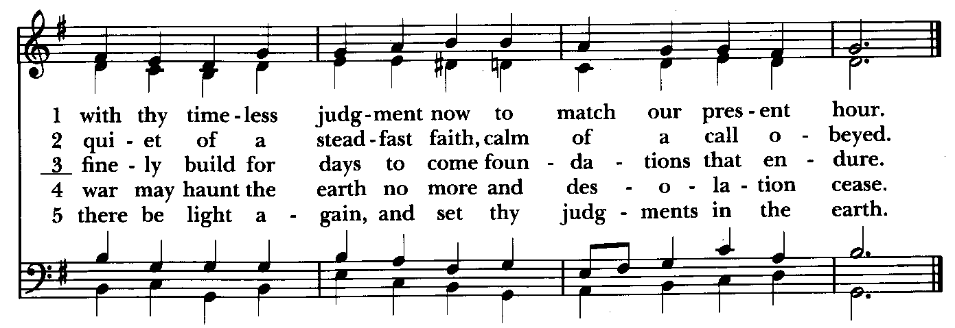
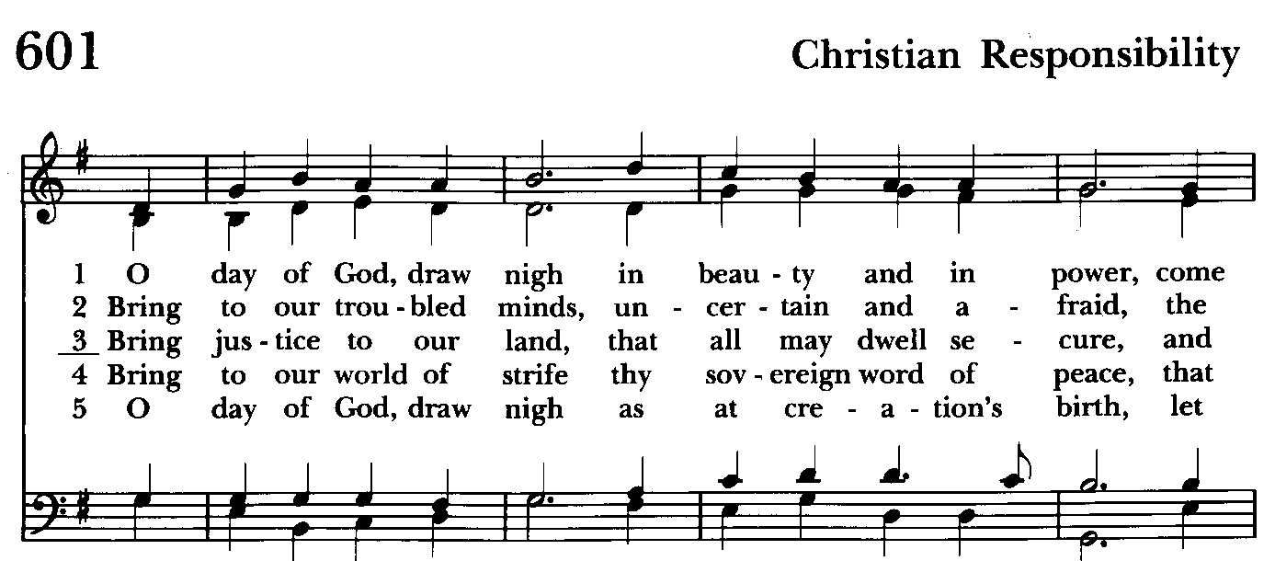

Presentation Hymn Offerings are presented Please stand as able Hymnal #43, vs. 4
Praise God, from whom all blessings flow; praise him, all creatures here below; praise him above, ye heavenly host: praise Father, Son, and Holy Ghost.

Eucharistic Prayer II
Celebrant: The Lord be with you.
People: And also with you.
Celebrant: Lift up your hearts.
People: We lift them to the Lord.
Celebrant: Let us give thanks to the Lord our God.
People: It is right to give our thanks and praise.
Celebrant: We praise you and we bless you, holy and gracious God, source of life abundant. From before time you made ready the creation. Your Spirit moved over the deep and brought all things into being: sun, moon, and stars; earth, winds, and waters; and every living thing. You made us in your image, and taught us to walk in your ways. But we rebelled against you, and wandered far away; and yet, as a mother cares for her children, you would not forget us. Time and again you called us to live in the fullness of your love.

And so this day we join with Saints and Angels in the chorus of praise that rings through eternity, lifting our voices to magnify you as we sing:

Celebrant and People
Sanctus Hymnal #S-124

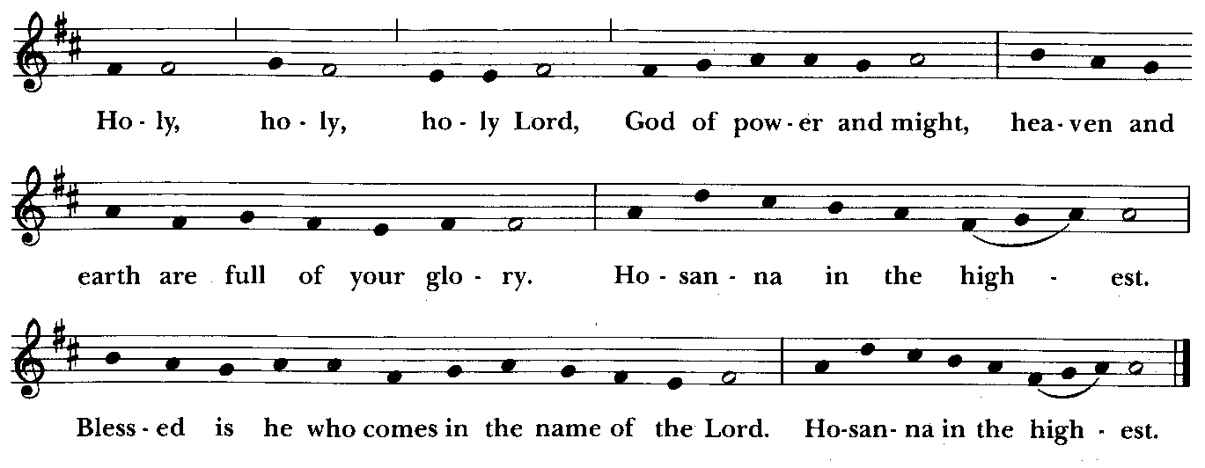

The congregation kneels or stands as able
Celebrant: Glory and honor and praise to you, holy and living God. To deliver us from the power of sin and death and to reveal the riches of your grace, you looked with favor upon Mary, your willing servant, that she might conceive and bear a son, Jesus the holy child of God.

Living among us, Jesus loved us. He broke bread with outcasts and sinners, healed the sick, and proclaimed good news to the poor. He yearned to draw all the world to himself yet we were heedless of his call to walk in love. Then, the time came for him to complete upon the cross the sacrifice of his life, and to be glorified by you.

On the night before he died for us, Jesus was at table with his friends. He took bread, gave thanks to you, broke it, and gave it to them, and said: “Take, eat: This is my Body, which is given for you. Do this for the remembrance of me.” As supper was ending, Jesus took the cup of wine. Again, he gave thanks to you, gave it to them, and said: “Drink this, all of you: This is my Blood of the new Covenant, which is poured out for you and for all for the forgiveness of sins. Whenever you drink it, do this for the remembrance of me.”

Now gathered at your table, O God of all creation, and remembering Christ, crucified and risen, who was and is and is to come, we offer to you our gifts of bread and wine, and ourselves, a living sacrifice.

Pour out your Spirit upon these gifts that they may be the Body and Blood of Christ.

Breathe your Spirit over the whole earth and make us your new creation, the Body of Christ given for the world you have made.

In the fullness of time bring us, with St. John and all your saints, from every tribe and language and people and nation, to feast at the banquet prepared from the foundation of the world.

Through Christ and with Christ and in Christ, in the unity of the Holy Spirit,
to you be honor, glory, and praise, for ever and ever. AMEN.

And now as our Savior Christ has taught us, we are bold to say,

Celebrant and People:
Our Father, who art in heaven, BCP 364
hallowed be thy Name,
thy kingdom come,
thy will be done,
on earth as it is in heaven.
Give us this day our daily bread.
And forgive us our trespasses,
as we forgive those
who trespass against us.
And lead us not into temptation,
but deliver us from evil.
For thine is the kingdom,
and the power, and the glory,
for ever and ever. Amen.

INVITATION TO COMMUNION
The Breaking of the Bread
The Celebrant breaks the consecrated Bread.
A period of silence is kept.

[Alleluia.] Christ our Passover is sacrificed for us;
Therefore let us keep the feast. [Alleluia.]

Communion hymn: Soon and Very Soon #14 LEVAS
(see next page) The people kneel or sit.

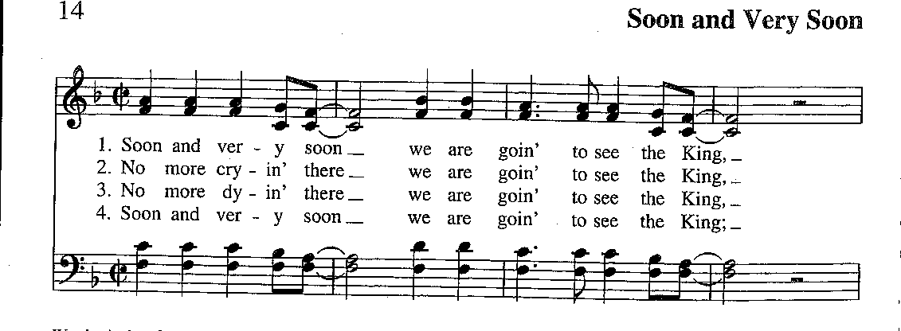

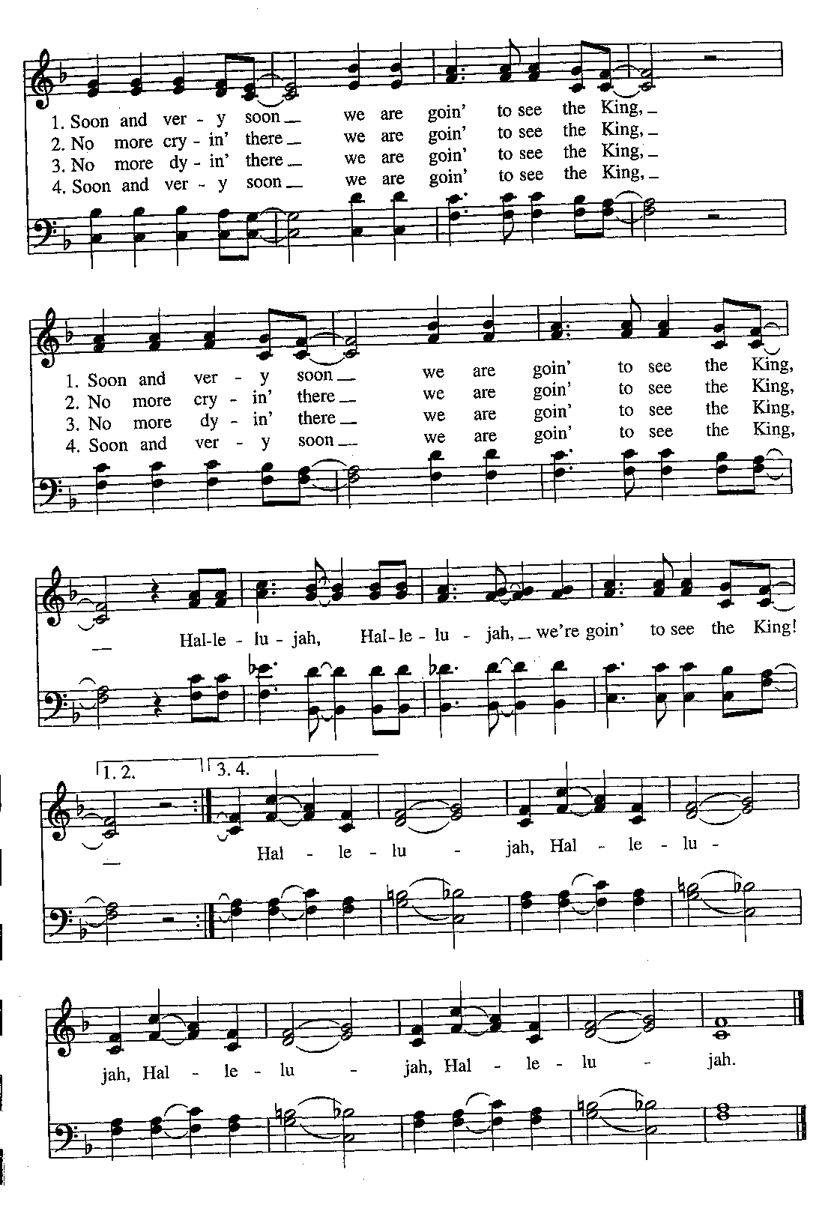

God of abundance, you have fed us with the bread of life and cup of salvation;
you have united us with Christ and one another; and you have made us one
with all your people in heaven and on earth. Now send us forth in the power of your Spirit, that we may proclaim your redeeming love to the world and continue for ever in the risen life of Christ our Savior. Amen.

or

Loving God, we give you thanks for restoring us in your image and nourishing us with spiritual food in the Sacrament of Christ’s Body and Blood. Now send us forth a people, forgiven, healed, renewed; that we may proclaim your love to the world and continue in the risen life of Christ our Savior. Amen.

Blessings
Holy eternal Majesty, Holy incarnate Word, Holy abiding Spirit, Bless you for
evermore. Amen.

May the blessing of the God of Abraham and Sarah, and of Jesus Christ born of our sister Mary, and of the Holy Spirit, who broods over the world as a mother over her children, be upon you and remain with you always. Amen.

God’s Blessing be with you, Christ’s peace be with you, the Spirit’s outpouring be with you, now and always. Amen.

The Wisdom of God the Love of God and the Grace of God strengthen you to be Christ’s hands and heart in this world, in the name of the Holy Trinity. Amen.
(source: Celtic)

Live without fear: your Creator has made you holy, has always protected you, and loves you as a mother. Go in peace to follow the good road and may God’s
blessing be with you always. Amen.

Closing hymn: Rejoice, rejoice believers Hymnal #68
(see next page)

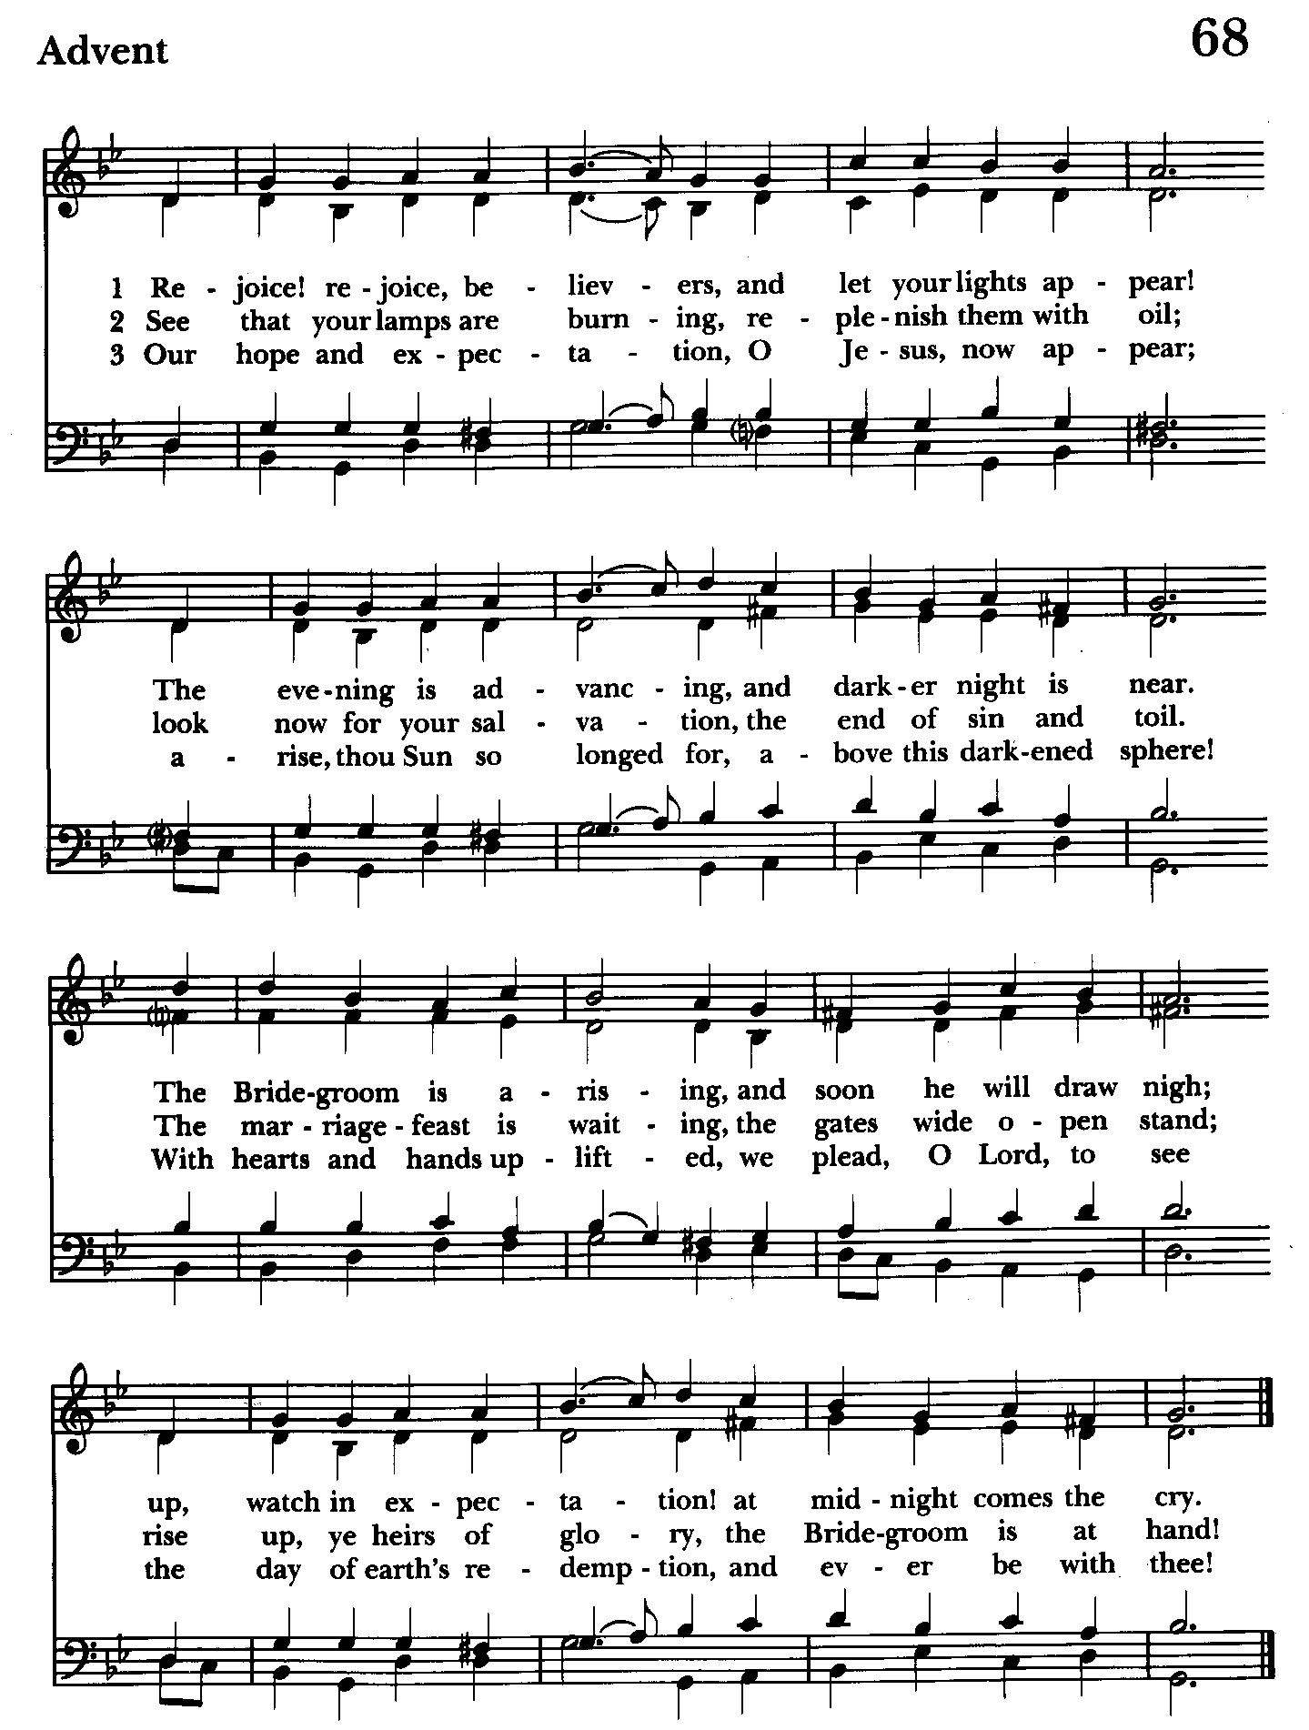

Serving Today

Celebrant and Preacher: The Rev. Mark Lobb
8:00 Reader: Woodie Tingle 10:30 1st Lesson: Liz Healey
Prayers of the People: Woodie Tingle Psalm: John Stevens
Server: Jennifer Scepaniak 2nd Lesson: Anne Leland
Prayers of the People: John Frost
Server: Marguerite Lobb
Music Director: Nancy Heinold
Choir: Anne Leland, Nancy Dellinger, Janine Stevens, Liz Healey, Karen Smith-Manar,
Jacob Johnson, Ty Schwenk
Altar Guild: John Stevens & Woodie Tingle



Altar Flowers
Given to the Glory of God by Barb Daniel
in honor of her and Jim’s Anniversary

St. John’s Parish Prayer List

Additions and corrections may be made to our Parish Prayer List at any time. All names will be automatically removed from the Parish Prayer List on the 1st Sunday of each month unless you request otherwise. Please contact Angie at <office@stjohnskingsville.org> or 410-592-8570 in the church office with all changes by 10 am Thursdays. Thank you.

We Pray for Those in Need:
Names in BOLD read aloud by all.

DeMarino Family, Jim & Chris Carden and family, Peggie Dietz, Mike Carden, Pat Carden, Gail Landers, Sheila Jones, Gloria Millar, Marisol Aubrey, Ross Strickler, Jim and Janice Sieracki, James Daniel Jr, Larry Betzler, Camy Schwenk, Dennis Mally, Zach Walsh, Edward.

We Pray for our Homebound

Lily John, Barbara Miller, Nancy Barnhart, Robin Dilworth

We pray for the Church and the World:

For +Justin, Archbishop of Canterbury; for +Sean, our Presiding Bishop; for +Carrie, our Bishop, for Mark+, our Priest in Charge, for the Wardens, Vestry, Staff, and all members and friends of St. John’s Church.

For the leaders of all nations, especially for Joseph, our President; for Wes, our Governor; for Brandon, Zeke, John and Bob, who lead our City and Counties. We pray for all children and youth; for the homeless, the unemployed, and the hungry. We pray for the safety of our loved ones and friends serving in the Armed Forces at home and abroad, and for our enemies, that all our hearts may be turned toward peace throughout the world.

From the Treasurer
December ‘24 Income vs. Expenses:

Projected December Expenses: $14,500
Monies Received as of 12/12: $11,806
Amount Needed to meet Expenses: $2,694


If you’d like to make a donation to St. John’s you can scan this QR code with your phone’s camera or tap on the link that comes up to make a contribution with either a credit or debit card, Apple Pay or Google Pay. This is a secure site provided by Clover which is a service of PNC Bank.

SUNDAY SCHOOL

10:30: Kids Sunday School- Begin in the church, ring the bell, then process over to the parish hall for a fun lesson with Mr. John and Ms. Stephanie. Note: Please seriously consider regular attendance at Sunday School so that Mr. John and Ms. Stephanie can plan good stuff.


Choral Choir and Bell Choir
Choir rehearsals Wednesdays at 7:00 pm and Bell Choir Rehearsal, Sundays after the 10:30 service. If anyone is interested in joining, see Nancy Heinold, our Music Director.



With so much going on, everyone’s help is needed to make things a success. Our volunteers make the Church function. The volunteering of time and talent is greatly appreciated.

Yoga classes on Tuesday, Wednesday and Friday evenings 6 to 7 pm and Saturday mornings 9 to 10 am in the Chapel. All experience levels are welcome.

Advent is coming! Here is what to expect. ( See what I did there?)

Book/Bible Study- On Sundays 12/15, and 12-22, we will discuss readings from Holidays and Holy Days: A Benedictine Walk through Advent by Albert Holtz, O.S.B. Sessions will be from 9:00 to 9:30. This book calls us to engage with Advent themes through the lens of Holy Scripture and the Rule of St. Benedict. Four copies have been ordered. Participants can reserve one of those or order a copy separately. Let Fr. Mark know if you need assistance obtaining a copy.

Advent Lessons and Carols- In partnership with our neighboring, and historically linked parish, Church of the Resurrection in Joppatowne, all are invited to participate in this traditional Anglican custom.
12/15- Advent Lessons and Carols- 2:30 p.m. at Church of the Resurrection.
12/22- Advent Lessons and Carols– 2:30 p.m. at St. John's, Kingsville.

Food and fellowship will be available after each event. Please join us.

Calendar Updates

Love Drops - 12/21, 10 am

Advent Lessons & Carols - 12/22, 2:30 pm

Christmas Lessons & Carols - 12/29, 10:30 am

Calendars are living documents. Every effort will be made to keep the members of the parish and community aware of any changes.


OUTREACH
WHAT A GREAT GIFT TO GIVE SOMEONE A MERRY CHRISTMAS!!

With Christmas just around the corner the Helping Hands Food Pantry is preparing for its annual Meal Distribution.

Listed below is what they need:
Yams/Sweet Potatoes (small or medium cans), Instant Potatoes (box or bag), Cranberries (canned), Sauerkraut (canned), cake mixes, cake icing (ready made)

Thank you so much!

RECYCLING!

Did you know that cat food cans are aluminum? How can you tell if a can is aluminum? Try a magnet.

By popular demand, we are recycling. Some parishioners take printed paper home where they have recycling pickup. We now have a blue container located in the Parish Hall. This will be collected and taken for recycling. Aluminum cans will be saved and taken to a recycling center for cash. The proceeds will be donated to the Outreach fund. Each recycled aluminum can also save on the electricity needed to make new aluminum from bauxite.

In our Community
Bible Studies in our area. If interested, please contact these churches to confirm.
St. Mary’s, Abingdon, (410)569-0180- Wednesdays at noon. Bring lunch. Zoom available.
Emmanuel, Bel Air, (410)838-7699- Fridays at 9:30- Zoom Available.
Holy Trinity, Churchville, (410)914-5531- Wednesdays 11:30- Zoom may be available.

Love Drops 2024 – Cookies made with Love – Calling all Cookie Makers and Volunteers
Greetings,
For the last few years during Advent, St. John’s has been making “Love Drops”, a gift of cookies (lovingly made by the congregation), candy and greetings from St. John’s. Hand delivered to our parishioners, shut-ins, local community businesses and organizations (Kingsville Fire Department, Baltimore Co. Police, our AA leaders, etc), Love Drops have become an annual outreach to those who mean so much to our parish life.
This year we are planning to assemble the packages on December 21st so that our
delivery elves (volunteers needed) can make their rounds before Christmas. About 100 Love Drops will leave the Parish Hall that day for distribution all around our community.
Of course, we’ll need your help. More cookies please! It takes a lot of cookies to fill our packages and we’re hoping that you have it in you to make one more dozen or two. Cookies should be packaged 4 to a zip lock bag and labeled if possible (no nuts please).
To recap…here’s what we need:
· Cookies, 4 to a bag, delivered to St. John’s parish hall by 10 am Saturday, 12/21. If you would like someone to come pick up your cookies just let us know and we’ll make
arrangements to do so.
· Love Drop package assemblers. We’ll meet at 10am in the hall on 12/21
· Cookie delivery elves. Packages should be ready for delivery by early afternoon on the 21st.
Thanks so much for all your help. It’s truly appreciated, and we promise that this is the last call for cookies….until the next flea market.

Sincerely,
The Love Drop Team

Christmas Services
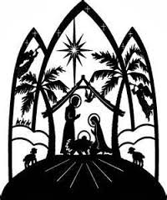
Tuesday, Christmas Eve
5:00 p.m. Family Service
9:00 p.m. Choral Holy Eucharist
Wednesday, Christmas Day
9:30 a.m. Rite I Service
Sunday, 1st Sunday after Christmas
10:30 a.m. Lessons & Carols

ANGEL TREE
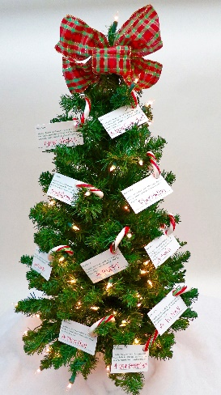
St. John’s is sponsoring 4 families that belong to Joppatowne Elementary. Please take an angel off the tree. Please sign the sheet on the table in the back of the church as to which angel you have taken. All angels need to be returned by Sunday, December 15th. If you can wrap them, that’s great, if not, we can wrap them for you. As you know, if we don’t help these families they will not have a Christmas. If you don’t feel comfortable buying an item, please consider donating a Target or Walmart gift card. Any questions, please call Michele, 443-463-6333 or Liz, 410-599-2759.

What’s Happening This Week at St. John’s

Sunday, December 15—Third Sunday of Advent
8:00am: Holy Eucharist, Said Service (Church)
10:30am: Holy Eucharist, with Music (Church)
10:30am-11:00am: Sunday School
11:30am: Coffee Hour (Parish Hall)
11:45am: Bell Choir Rehearsal (Church)

Monday, December 16
6:30-8:00pm: Spanish speaking AA group (Parish Hall)

Tuesday, December 17
6:00-7:00pm: Yoga (Chapel)
` 7:00pm: Vestry Meeting (Parish Hall)

Wednesday, December 18
6:00-7:00pm: Yoga (Chapel)
7:00pm: Choir Rehearsal(Church)
7:30pm: AA (Parish Hall)

Thursday, December 19
7:00pm: AA (Parish Hall)

Friday, December 20
6:00-7:00pm: Yoga (Chapel)

Saturday, December 21
9:00-10:00am: Yoga (Chapel)
10:00am: Love Drops
8:30pm: AA (Parish Hall)

Sunday, December 22—Fourth Sunday of Advent
8:00am: Holy Eucharist, Said Service (Church)
10:30am: Holy Eucharist, with Music (Church)
10:30am-11:00am: Sunday School
11:30am: Coffee Hour (Parish Hall)
11:45am: Bell Choir Rehearsal (Church)

Parish Office is open Monday, Wednesday and Thursday, 9:30am-1:30pm.

Potluck Luncheon on the first Sunday of the month and a Coffee Hour on all other Sundays after the 10:30 service.

AA Lunch Bunch—Monday thru Friday, Noon to 1 pm

