St. John’s Episcopal Church
Kingsville, Maryland
Welcomes You

OUR VISION STATEMENT
We believe that together we will transform the world with love: Come on in!



Last Sunday after Pentecost-Christ the King
November 24, 2024
10:30 am, Rite II

St. John’s Episcopal Church

11901 Belair Road, P. O. Box 187, Kingsville, MD 21087
Facebook: St. John’s Episcopal, Kingsville, MD
Email: office@stjohnskingsville.org
Website: www.stjohnskingsville.org
Church Phone: 410-592-8570
For Pastoral Emergencies: Fr. Mark Lobb+ 443-690-9545

Welcome to worship today! We are glad that you are with us. You are invited to participate in all parts of the service as indicated in the Book of Common Prayer and this service bulletin. If you have any questions, feel free to ask the ushers. Restrooms are located in the Parish hall, the brick building across the parking lot.

I was glad when they said to me, “Let us go to the house of the Lord.” Psalm 122:1

Church Staff

Interim Rector: Father Mark Lobb
Administrative Assistant: Angie Bosley
Organist/Choir Director: Nancy Heinold

The Vestry

Class of 2025 Class of 2026

John Frost John Stevens
Woodie Tingle
Jacob Johnson

Officers
Ty Schwenk—Sr. Warden Terry Roe—Jr. Warden
Elizabeth Healey—Treasurer Anne Leland-Registrar

Parish Committee Chairpersons

Altar Guild: Elizabeth Healey
Auxiliary Committee: Michele Lozanski
Cemetery Committee: Terry Roe

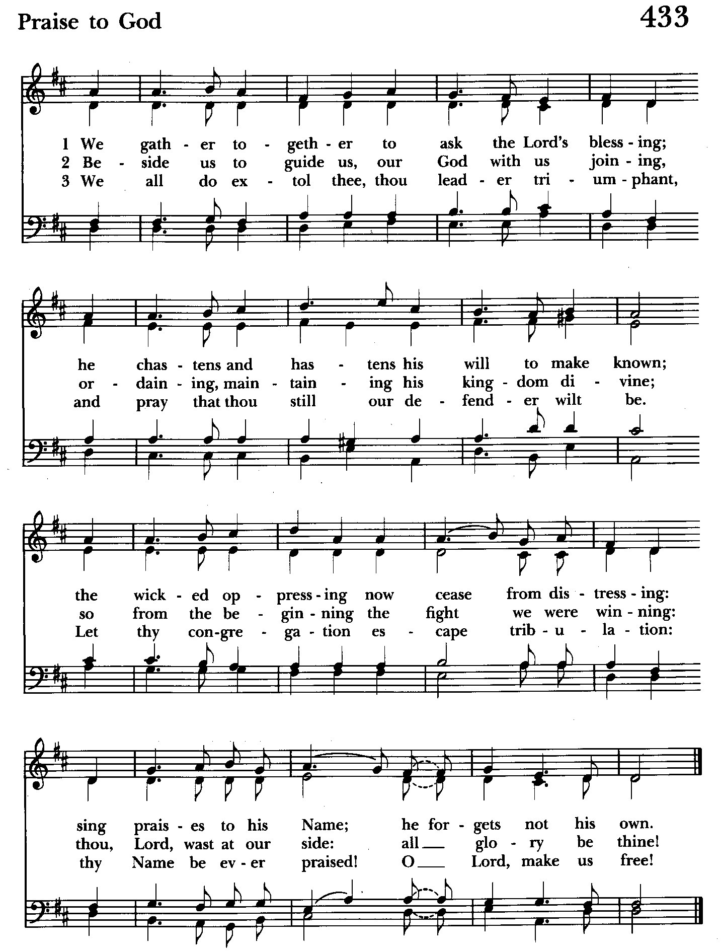

10:30 am Worship
Holy Eucharist, Rite Two

Prelude

The Word of God

Processional hymn: We gather together to ask the Lord’s blessing
Hymnal #433
(see previous page)

The congregation remains standing as able

Celebrant: Blessed be God: Father, Son, and Holy Spirit. BCP 355
People: And blessed be his kingdom, now and for ever. Amen.

Celebrant: Almighty God, to you all hearts are open, all desires known, and from you no secrets are hid: Cleanse the thoughts of our hearts by the inspiration of your Holy Spirit, that we may perfectly love you, and worthily magnify your holy Name; through Christ our Lord. Amen.

Gloria Hymnal #S-278
Glory to God in the highest,
and peace to his people on earth.
Lord God, heavenly King,
almighty God and Father,
we worship you, we give you thanks,
we praise you for your glory.
Lord Jesus Christ, only Son of the Father,
Lord God, Lamb of God,
you take away the sin of the world:
have mercy on us;
you are seated at the right hand of the Father:
receive our prayer.
For you alone are the Holy One,
you alone are the Lord,
you alone are the Most High,
Jesus Christ,
with the Holy Spirit,
in the glory of God the Father. Amen.

Celebrant: The Lord be with you.
People: And also with you.
Celebrant: Let us pray.

The Collect of the Day Kneel or stand as able BCP 236
Blessed Lord, who caused all holy Scriptures to be written for our learning: Grant us so to hear them, read, mark, learn, and inwardly digest them, that we may embrace and ever hold fast the blessed hope of everlasting life, which you have given us in our Savior Jesus Christ; who lives and reigns with you and the Holy Spirit, one God, for ever and ever. Amen.

The congregation is seated.

A Reading from the Second Book of Samuel 23:1-7
These are the last words of David:
The oracle of David, son of Jesse,
the oracle of the man whom God exalted,
the anointed of the God of Jacob,
the favorite of the Strong One of Israel:
The spirit of the Lord speaks through me,
his word is upon my tongue.
The God of Israel has spoken,
the Rock of Israel has said to me:
One who rules over people justly,
ruling in the fear of God,
is like the light of morning,
like the sun rising on a cloudless morning,
gleaming from the rain on the grassy land.
Is not my house like this with God?
For he has made with me an everlasting covenant,
ordered in all things and secure.
Will he not cause to prosper
all my help and my desire?
But the godless are all like thorns that are thrown away;
for they cannot be picked up with the hand;
to touch them one uses an iron bar
or the shaft of a spear.
And they are entirely consumed in fire on the spot.

Reader: The Word of the Lord.
People: Thanks be to God.

Psalm 132:1-13, (14-19) (Pray as directed)
1 Lord, remember David, *
and all the hardships he endured;
2 How he swore an oath to the Lord *
and vowed a vow to the Mighty One of Jacob:
3 "I will not come under the roof of my house," *
nor climb up into my bed;
4 I will not allow my eyes to sleep, *
nor let my eyelids slumber;
5 Until I find a place for the Lord, *
a dwelling for the Mighty One of Jacob."
6 "The ark! We heard it was in Ephratah; *
we found it in the fields of Jearim.
7 Let us go to God's dwelling place; *
let us fall upon our knees before his footstool."
8 Arise, O Lord, into your resting-place, *
you and the ark of your strength.
9 Let your priests be clothed with righteousness; *
let your faithful people sing with joy.
10 For your servant David's sake, *
do not turn away the face of your Anointed.
11 The Lord has sworn an oath to David; *
in truth, he will not break it:
12 "A son, the fruit of your body *
will I set upon your throne.
13 If your children keep my covenant
and my testimonies that I shall teach them, *
their children will sit upon your throne for evermore."
14 [For the Lord has chosen Zion; *
he has desired her for his habitation:
15 "This shall be my resting-place for ever; *
here will I dwell, for I delight in her.
16 I will surely bless her provisions, *
and satisfy her poor with bread.
17 I will clothe her priests with salvation, *
and her faithful people will rejoice and sing.
18 There will I make the horn of David flourish; *
I have prepared a lamp for my Anointed.
19 As for his enemies, I will clothe them with shame; *
but as for him, his crown will shine."]

A Reading from the Book of Revelation 1:4b-8
Grace to you and peace from him who is and who was and who is to come, and from the seven spirits who are before his throne, and from Jesus Christ, the faithful witness, the firstborn of the dead, and the ruler of the kings of the earth.
To him who loves us and freed us from our sins by his blood, and made us to be a kingdom, priests serving his God and Father, to him be glory and dominion forever and ever. Amen.
Look! He is coming with the clouds;
every eye will see him,
even those who pierced him;
and on his account all the tribes of the earth will wail.
So it is to be. Amen.
“I am the Alpha and the Omega,” says the Lord God, who is and who was and who is to come, the Almighty.

Reader: The Word of the Lord.
People: Thanks be to God.

Gradual hymn: Jesus shall reign where're the sun Hymnal #544
(see next page)
The congregation remains standing as able

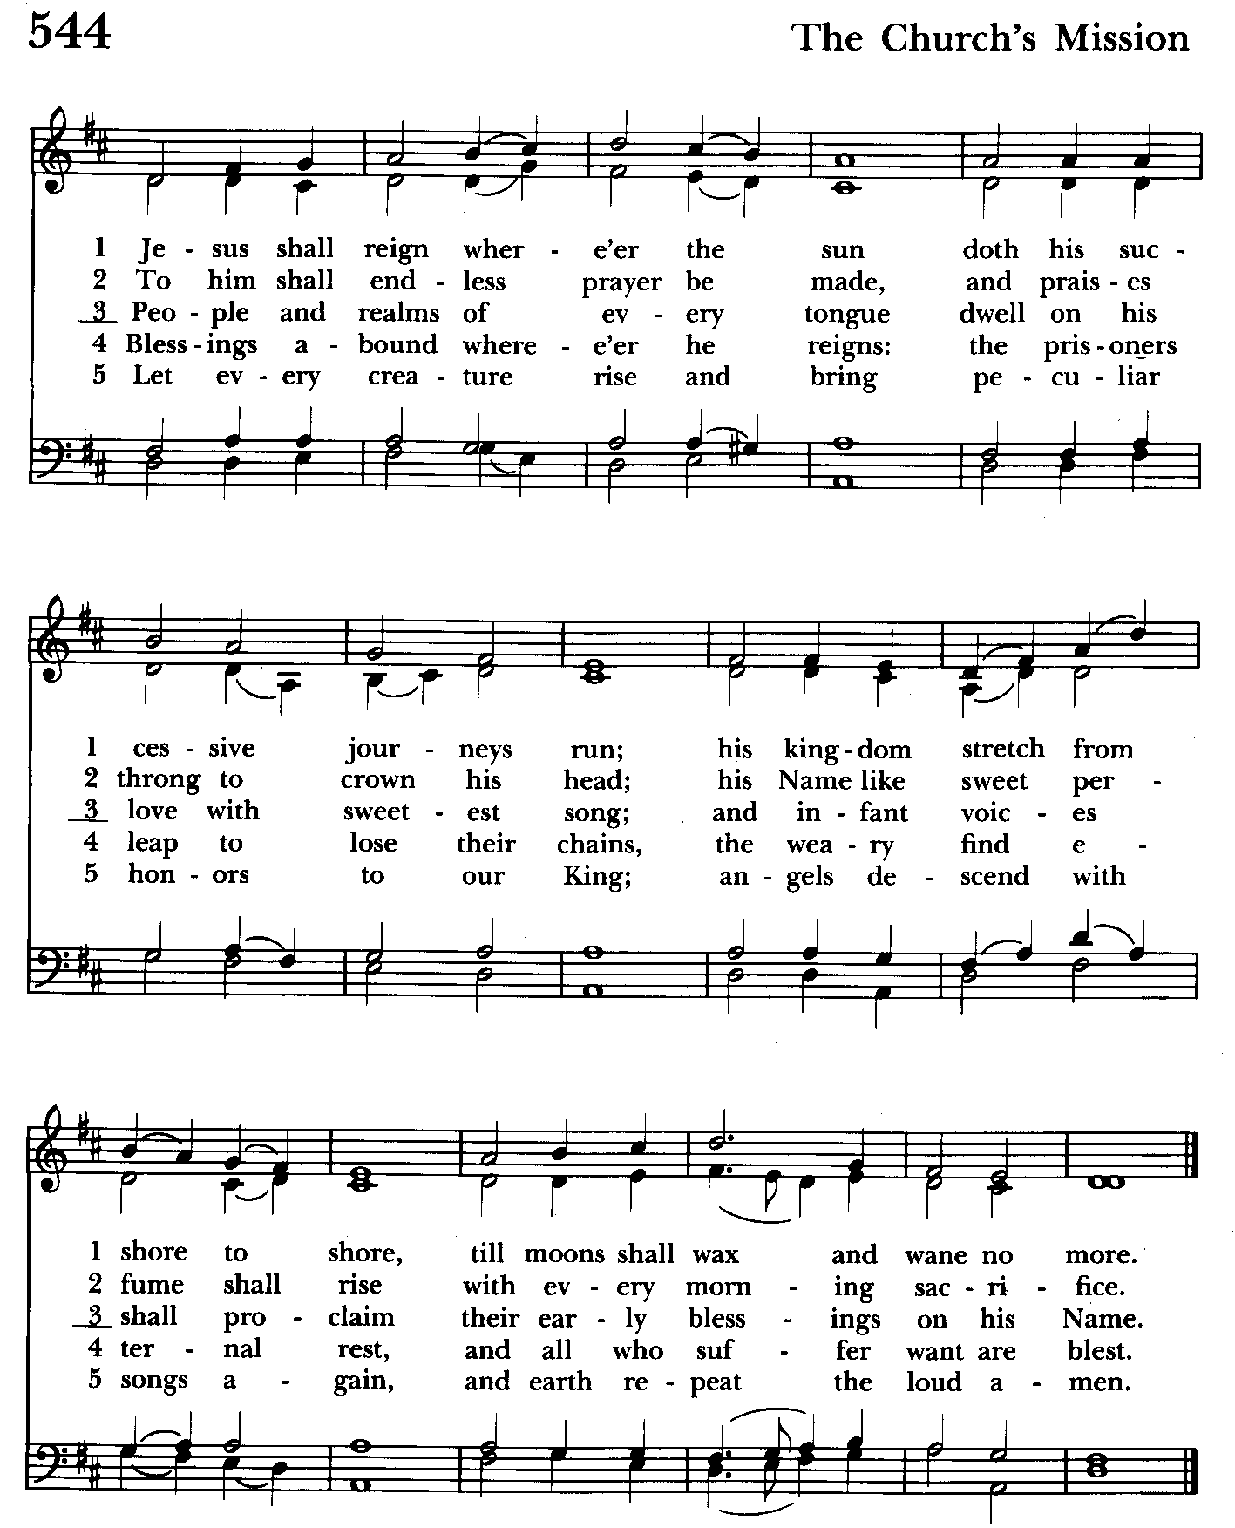

Priest: The Holy Gospel of our Lord Jesus Christ according to John 18:33-37
People: Glory to you, Lord Christ.
Pilate entered the headquarters again, summoned Jesus, and asked him, “Are you the King of the Jews?” Jesus answered, “Do you ask this on your own, or did others tell you about me?” Pilate replied, “I am not a Jew, am I? Your own nation and the chief priests have handed you over to me. What have you done?” Jesus answered, “My kingdom is not from this world. If my kingdom were from this world, my followers would be fighting to keep me from being handed over to the Jews. But as it is, my kingdom is not from here.” Pilate asked him, “So you are a king?” Jesus answered, “You say that I am a king. For this I was born, and for this I came into the world, to testify to the truth. Everyone who belongs to the truth listens to my voice.”

Priest: The Gospel of the Lord.
People: Praise to you, Lord Christ.

Sermon The congregation is seated Rev. Mark Lobb

The Nicene Creed Please stand as able BCP 358
We believe in one God,
the Father, the Almighty,
maker of heaven and earth,
of all that is, seen and unseen.
We believe in one Lord, Jesus Christ,
the only Son of God,
eternally begotten of the Father,
God from God, Light from Light,
true God from true God,
begotten, not made,
of one Being with the Father.
Through him all things were made.
For us and for our salvation
he came down from heaven:
by the power of the Holy Spirit
he became incarnate from the Virgin Mary,
and was made man.
For our sake he was crucified under Pontius Pilate;
he suffered death and was buried.
On the third day he rose again
in accordance with the Scriptures;
he ascended into heaven
and is seated at the right hand of the Father.
He will come again in glory to judge the living and the dead,
and his kingdom will have no end.
We believe in the Holy Spirit, the Lord, the giver of life,
who proceeds from the Father and the Son.
With the Father and the Son he is worshiped and glorified.
He has spoken through the Prophets.
We believe in one holy catholic and apostolic Church.
We acknowledge one baptism for the forgiveness of sins.
We look for the resurrection of the dead,
and the life of the world to come. Amen.

The Prayers of the People Form VI Kneel or stand as able BCP 392
Litanist: In peace, we pray to you, Lord God.

Litanist: For all people in their daily life and work;
People: For our families, friends, and neighbors, and for those who are alone.

Litanist: For this community, the nation, and the world;
People: For all who work for justice, freedom, and peace.

Litanist: For the just and proper use of your creation;
People: For the victims of hunger, fear, injustice, and oppression.

Litanist: For all who are in danger, sorrow, or any kind of trouble;
People: For those who minister to the sick, the friendless, and the needy.

Litanist: For the peace and unity of the Church of God;
People: For all who proclaim the Gospel, and all who seek the Truth.

Litanist: For +Justin, Archbishop of Canterbury; +Sean, our Presiding Bishop; +Carrie, our Bishop, Mark+ our Interim Rector, for the Wardens, Vestry, Staff, and all members and friends of St. John’s Church.
People: For all who serve God in his Church.

Litanist: For the special needs and concerns of this congregation. Especially remember in our prayers, DeMarino Family, Jim & Chris Carden and family, Peggie Dietz, Mike Carden, Pat Carden, Gail Landers, Sheila Jones, Gloria Millar, Marisol Aubrey, Ross Strickler, Jim & Janice Sieracki, James Daniel Jr., Larry Betzler, Camy Schwenk, Dennis Mally, Zach Walsh, Lily John, Barbara Miller, Nancy Barnhart, Robin Dilworth, Edward.
The People may add their own petitions

Litanist: Hear us, Lord;
People: For your mercy is great.
Litanist: We thank you, Lord, for all the blessings of this life.

The People may add their own thanksgivings

Litanist: We will exalt you, O God our King;
People: And praise your Name for ever and ever.

Litanist: We pray for all who have died, that they may have a place in your
eternal kingdom.

The People may add their own petitions
Litanist: Lord, let your loving-kindness be upon them;
People: Who put their trust in you.

Litanist: We pray to you also for the forgiveness of our sins.
People: Have mercy upon us, most merciful Father; in your compassion forgive us our sins, known and unknown, things done and left undone; and so uphold us by your Spirit that we may live and serve you in newness of life, to the honor and glory of your Name; through Jesus Christ our Lord. Amen.

The Celebrant gives the absolution.

The Peace Please stand as able BCP 360

Welcome & Announcements The congregation is seated.

Offertory Anthem: Communion Prayer (Choir)

Offertory Hymn: Crown him with many crowns Hymnal #494
(see below & next page)

The people remain seated while offerings are collected.

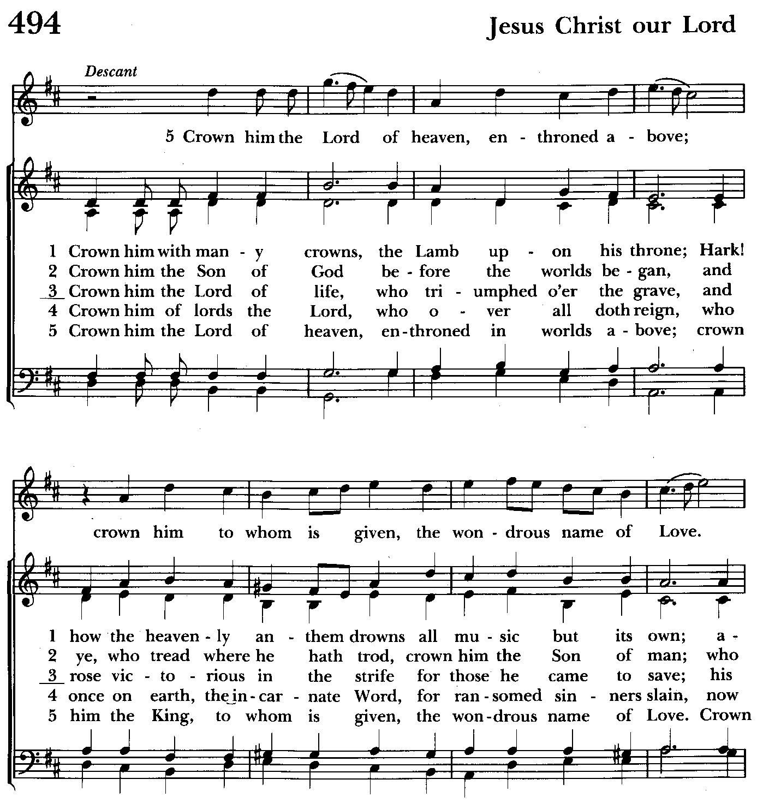

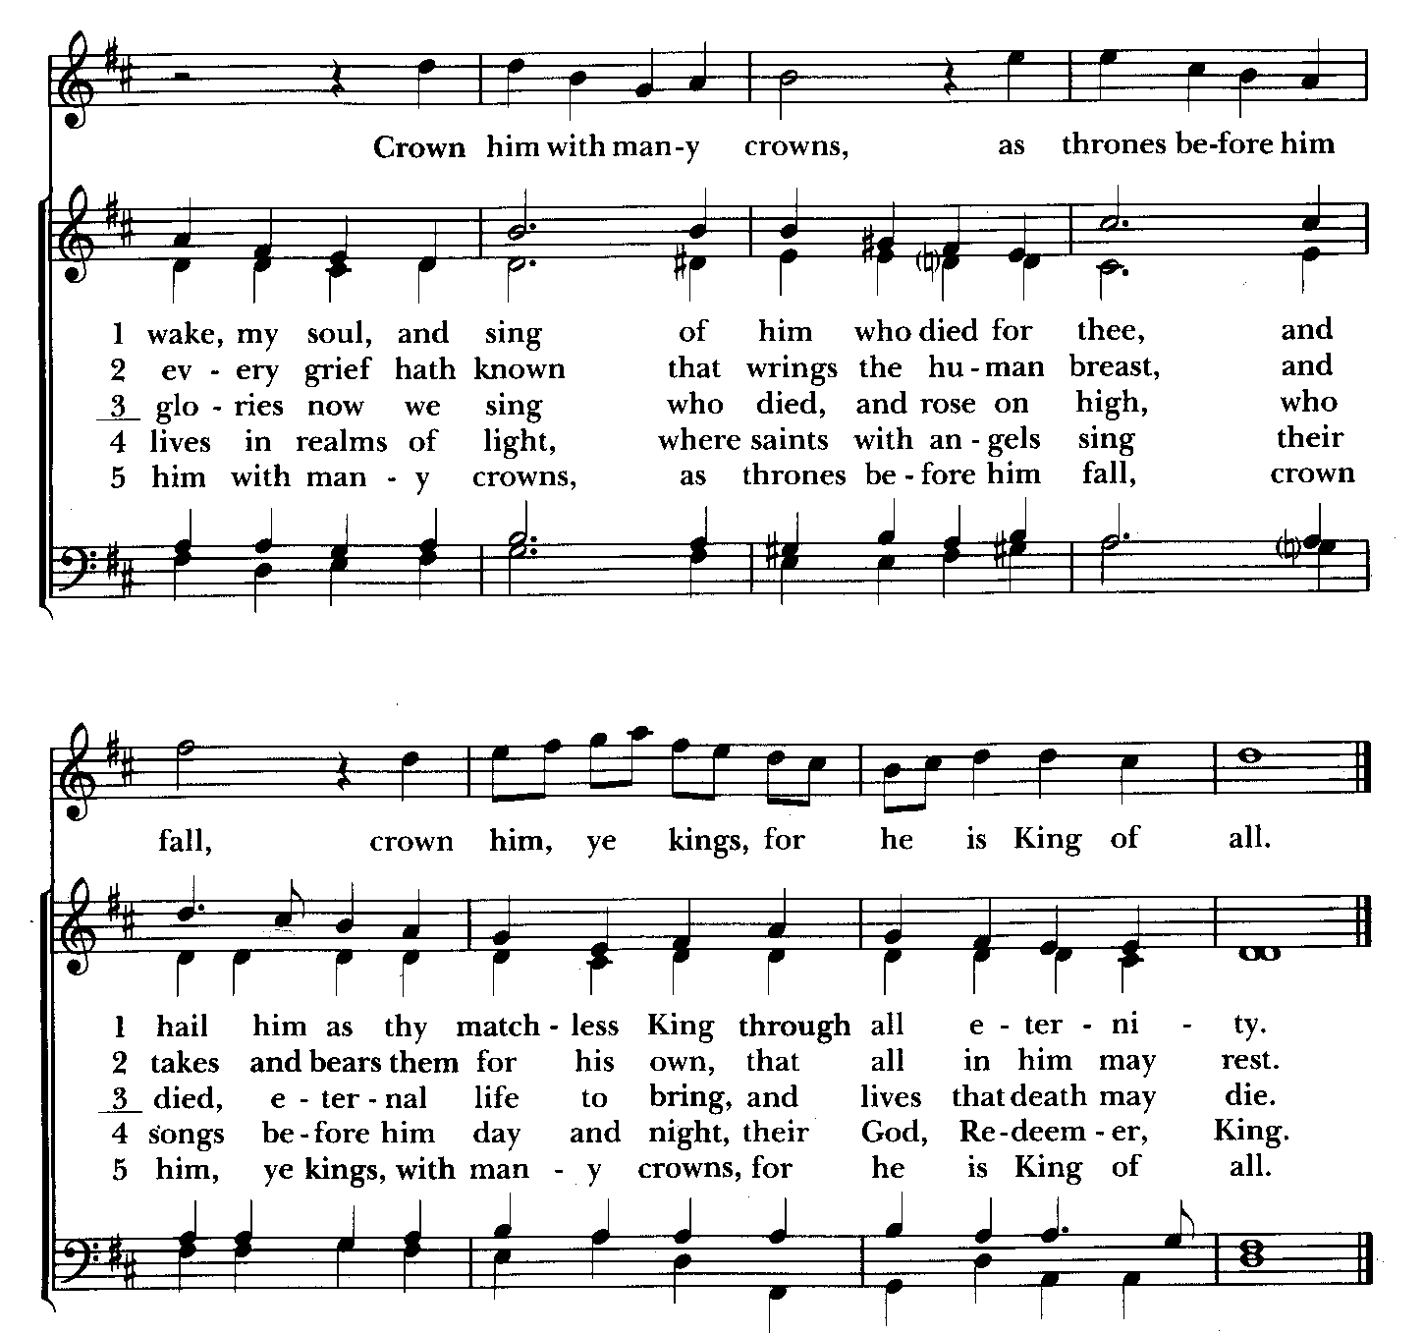

Presentation Hymn Offerings are presented Please stand as able Hymnal #43, vs. 4
Praise God, from whom all blessings flow; praise him, all creatures here below; praise him above, ye heavenly host: praise Father, Son, and Holy Ghost.

The Holy Communion

THE GREAT THANKSGIVING: Eucharistic Prayer B BCP 367
Celebrant: The Lord be with you.
People: And also with you.
Celebrant: Lift up your hearts.
People: We lift them to the Lord.
Celebrant: Let us give thanks to the Lord our God.
People: It is right to give him thanks and praise.

Then, facing the Holy Table, the Celebrant proceeds
It is right, and a good and joyful thing, always and everywhere to give thanks to you, Father Almighty, Creator of heaven and earth.

Therefore we praise you, joining our voices with Angels and Archangels and with all the company of heaven, who for ever sing this hymn to proclaim the glory of your Name:

Celebrant and People:
Holy, Holy, Holy Lord, God of power and might, Hymnal #S-129
heaven and earth are full of your glory.
Hosanna in the highest.
Blessed is he who comes in the name of the Lord.
Hosanna in the highest.
Please kneel or stand as able
Then the Celebrant continues BCP 368
We give thanks to you, O God, for the goodness and love which you have made known to us in creation; in the calling of Israel to be your people; in your Word spoken through the prophets; and above all in the Word made flesh, Jesus, your Son. For in these last days you sent him to be incarnate from the Virgin Mary, to be the Savior and Redeemer of the world. In him, you have delivered us from evil, and made us worthy to stand before you. In him, you have brought us out of error into truth, out of sin into righteousness, out of death into life.

At the following words concerning the bread, the Celebrant is to hold it, or to lay a hand upon it; and at the words concerning the cup, to hold or place a hand upon the cup and any other vessel
containing wine to be consecrated.

On the night before he died for us, our Lord Jesus Christ took bread; and when he had given thanks to you, he broke it, and gave it to his disciples, and said, "Take, eat: This is my Body, which is given for you. Do this for the remembrance of me."

After supper he took the cup of wine; and when he had given thanks, he gave it to them, and said, "Drink this, all of you: This is my Blood of the new Covenant, which is shed for you and for many for the forgiveness of sins. Whenever you drink it, do this for the remembrance of me."

Therefore, according to his command, O Father,

Celebrant and People:
We remember his death,
We proclaim his resurrection,
We await his coming in glory;

The Celebrant continues
And we offer our sacrifice of praise and thanksgiving to you, O Lord of all; presenting to you, from your creation, this bread and this wine. We pray you, gracious God, to send your Holy Spirit upon these gifts that they may be the Sacrament of the Body of Christ and his Blood of the new Covenant. Unite us to your Son in his sacrifice, that we may be acceptable through him, being sanctified by the Holy Spirit. In the fullness of time, put all things in subjection under your Christ, and bring us to that heavenly country where, with St. John and the Blessed Virgin Mary and all your saints, we may enter the everlasting heritage of your sons and daughters; through Jesus Christ our Lord, the firstborn of all creation, the head of the Church, and the author of our salvation.

By him, and with him, and in him, in the unity of the Holy Spirit all honor and glory is yours, Almighty Father, now and for ever. Amen.

And now, as our Savior Christ has taught us, we are bold to say,

Our Father, who art in heaven, BCP p. 364
hallowed be thy Name,
thy kingdom come,
thy will be done,
on earth as in heaven.
Give us this day our daily bread.
And forgive us our trespasses,
as we forgive those
who trespass against us.
And lead us not into temptation,
but deliver us from evil.
For thine is the kingdom,
and the power, and the glory,
for ever and ever. Amen.

Invitation to Communion

The Breaking of the Bread
Celebrant: Alleluia. Christ our Passover is sacrificed for us;
People: Therefore let us keep the feast. Alleluia.
Celebrant: The Gifts of God for the people of God.

The congregation is seated

Communion hymn: Let all mortal flesh keep silence Hymnal #324
(see next page)

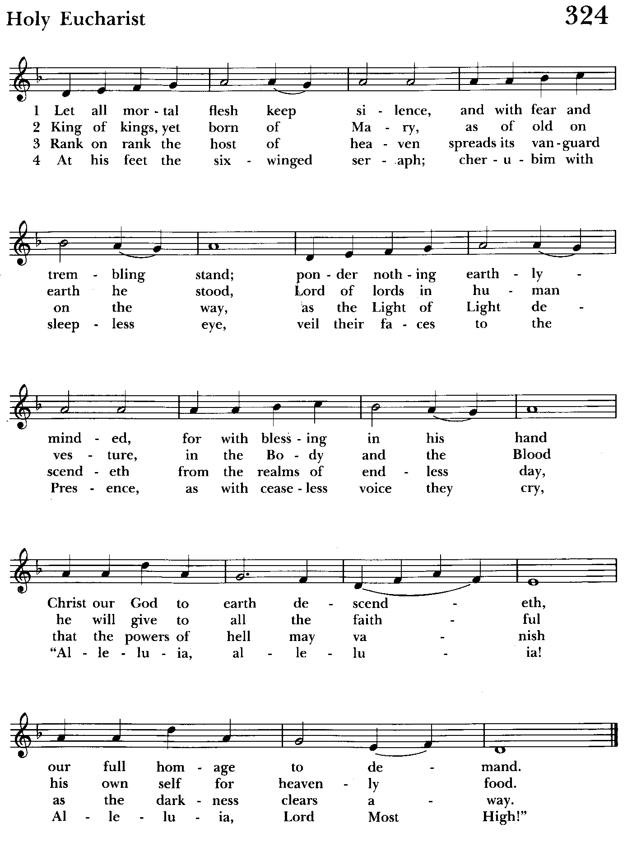

The Post Communion Prayer BCP p. 365
Eternal God, heavenly Father, you have graciously accepted us as living members of your Son our Savior Jesus Christ, and you have fed us with spiritual food in the Sacrament of his Body and Blood. Send us now into the world in peace, and grant us strength and courage to love and serve you with gladness and singleness of heart; through Christ our Lord. Amen.

Blessing

Recessional hymn: Hail to the Lord’s Anointed Hymnal #616
(see next page)

The Dismissal
Celebrant: Let us go forth in the name of the risen Lord.
People: Thanks be to God.

Postlude:

License #A-719154
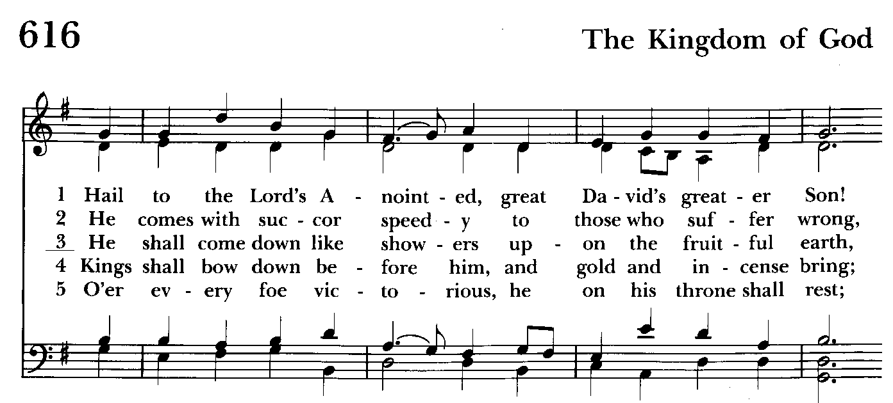

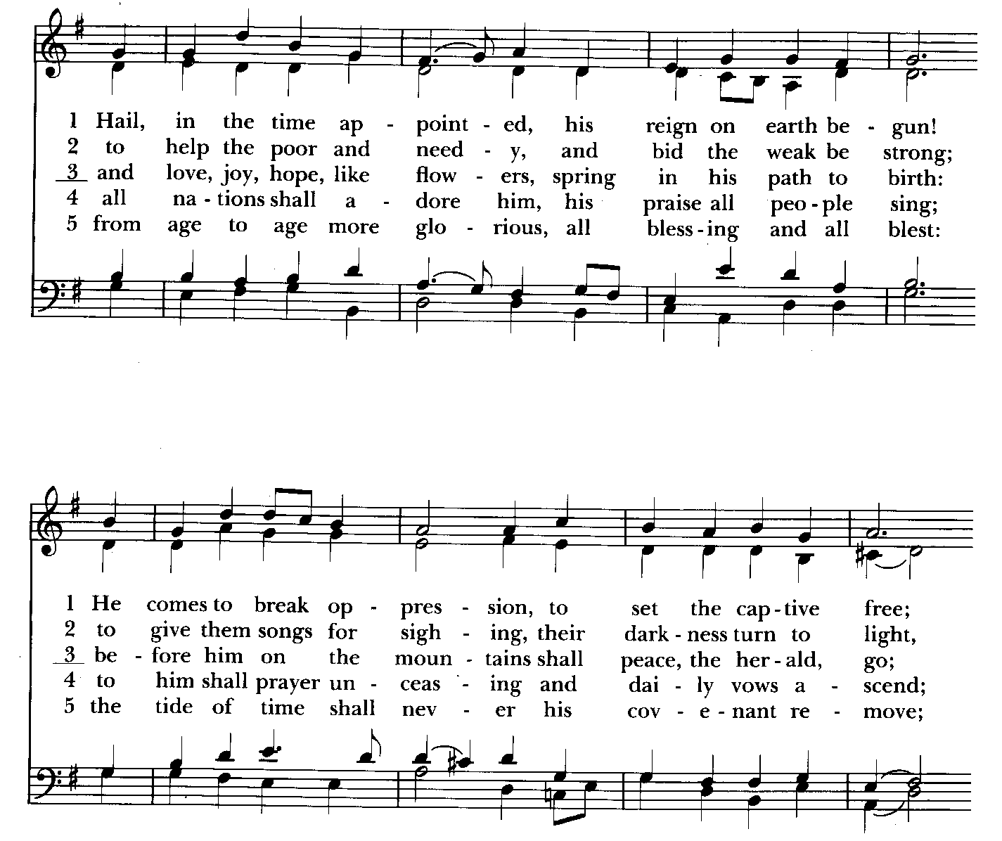

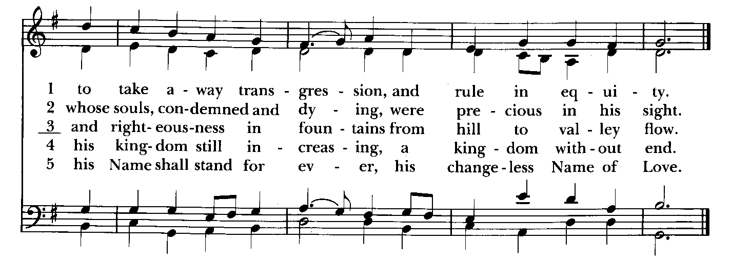

Serving Today

Celebrant and Preacher: Rev. Mark Lobb
Old Testament: Michele Lozanski
Psalm: Michele Lozanski
New Testament: Tony Rising
Prayers of the People: John Frost
Server: Marguerite Lobb
Music Director: Nancy Heinold
Bell Choir: Nanci Rosendale, Linda Posten, Karen Smith-Manar,
Liz Healey, John Stevens, Janine Stevens, Ty Schwenk
Altar Guild: Stephanie Duchacek & Sandy Roe


Time to order Poinsettias. Order forms are in the back of the church if you’d like to order. Thank you.

St. John’s Parish Prayer List

Additions and corrections may be made to our Parish Prayer List at any time. All names will be automatically removed from the Parish Prayer List on the 1st Sunday of each month unless you request otherwise. Please contact Angie at <office@stjohnskingsville.org> or 410-592-8570 in the church office with all changes by 10 am Thursdays. Thank you.

We Pray for Those in Need:
Names in BOLD read aloud by all.

DeMarino Family, Jim & Chris Carden and family, Peggie Dietz, Mike Carden, Pat Carden, Gail Landers, Sheila Jones, Gloria Millar, Marisol Aubrey, Ross Strickler, Jim and Janice Sieracki, James Daniel Jr, Larry Betzler, Camy Schwenk, Dennis Mally, Zach Walsh, Edward.

We Pray for our Homebound

Lily John, Barbara Miller, Nancy Barnhart, Robin Dilworth

We pray for the Church and the World:

For +Justin, Archbishop of Canterbury; for +Sean, our Presiding Bishop; for +Carrie, our Bishop, for Mark+, our Interim Rector, for the Wardens, Vestry, Staff, and all members and friends of St. John’s Church.

For the leaders of all nations, especially for Joseph, our President; for Wes, our Governor; for Brandon, Nick, John and Bob, who lead our City and Counties. We pray for all children and youth; for the homeless, the unemployed, and the hungry. We pray for the safety of our loved ones and friends serving in the Armed Forces at home and abroad, and for our enemies, that all our hearts may be turned toward peace throughout the world.

Calendar Updates

Community Christmas Tree Lighting and Cantata - 12/8, 7 pm

Blue Christmas/Service of Solace– 12/10, 7 pm

Christmas Lessons & Carols - 12/29, 10:30 am

Calendars are living documents. Every effort will be made to keep the members of the parish and community aware of any changes.

Advent is coming! Here is what to expect. ( See what I did there?)

Book/Bible Study- On Sundays 12/1,12/15, and 12-22, we will discuss readings from Holidays and Holy Days: A Benedictine Walk through Advent by Albert Holtz, O.S.B. Sessions will be from 9:00 to 9:30. This book calls us to engage with Advent themes through the lens of Holy Scripture and the Rule of St. Benedict. Four copies have been ordered. Participants can reserve one of those or order a copy separately. Let Fr. Mark know if you need assistance obtaining a copy.

Advent Lessons and Carols- In partnership with our neighboring, and historically linked parish, Church of the Resurrection in Joppatowne, all are invited to participate in this traditional Anglican custom.
12/1- Advent Lessons and Carols- 2:30 p.m. at Church of the Resurrection.
12/8- Kingsville Community Tree Lighting with readings and carols- 7:00 at St. John's Episcopal Church in Kingsville.
12/15- Advent Lessons and Carols- 2:30 p.m. at Church of the Resurrection.
12/22- Advent Lessons and Carols- 2:30 p.m. at St. John's, Kingsville.

Food and fellowship will be available after each event. Please join us.

Blue Christmas/Service of Solace- For some in our community, it is difficult to find joy in the holiday season. For many reasons. You are invited to join others whose pain and grief are amplified at this time to worship together in a setting of empathy and healing. Tuesday, December 10. 7:00. St. John's, Kingsville.



VOLUNTEERS!

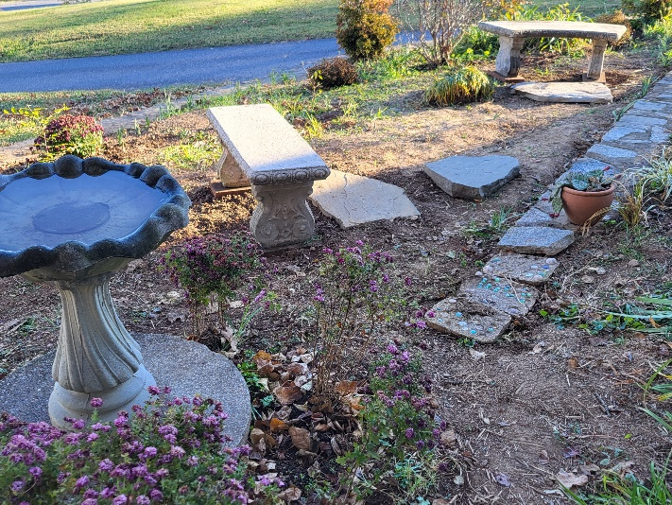
Come see the progress we’re making to Beautify our St. Francis Garden!!
For more info or to sign up to help keep our gardens looking beautiful, contact: Rita Talley (Garden Club) 443-617-1820 or Karen Smith-Manar (St. John’s) 410-746-9813 or bikenbocal@verizon.net

God’s Grace Gardens—a St. John’s, Hill & Stream Garden Club and AA collaboration


Altar Flowers
Given to the Glory of God
by Woodie Tingle
in onor of Mary & Woodie Tingle’s Heavenly Birthdays

From the Treasurer
November ‘24 Income vs. Expenses:

Projected November Expenses: $13,500
Monies Received as of 11/21: $11,112
Amount Needed to meet Expenses: $2,388


If you’d like to make a donation to St. John’s you can scan this QR code with your phone’s camera or tap on the link that comes up to make a contribution with either a credit or debit card, Apple Pay or Google Pay. This is a secure site provided by Clover which is a service of PNC Bank.

The Rev. Canon Randy Callender will be here on December 8th to celebrate and preach at both services.
Randy is the Bishop’s Canon for Mission. Please welcome him to St. John’s and bring questions about the mission of our church.


OUTREACH
WHAT A GREAT GIFT TO GIVE SOMEONE A MERRY CHRISTMAS!!

With Christmas and Thanksgiving just around the corner the Helping Hands Food Pantry is preparing for its annual Meal Distribution.

Listed below is what they need:
Yams/Sweet Potatoes (small or medium cans), Instant Potatoes (box or bag), Cranberries (canned), Sauerkraut (canned), cake mixes, cake icing (ready made)

Thank you so much!


SUNDAY SCHOOL
Kids Sunday School- Begin in the church, ring the bell, then process over to the parish hall for a fun lesson with Mr. John and Ms. Stephanie.


Choral Choir and Bell Choir
Choir rehearsals Wednesdays at 7:00 pm and Bell Choir Rehearsal, Sundays after the 10:30 service. If anyone is interested in joining, see Nancy Heinold, our Music Director.


Yoga classes on Tuesday, Wednesday and Friday evenings 6 to 7 pm and Saturday mornings 9 to 10 am in the Chapel. All experience levels are welcome.



With so much going on, everyone’s help is needed to make things a success. Our volunteers make the Church function. The volunteering of time and talent is greatly appreciated.

RECYCLING!

Feed Me!
The recycling bins are hungry for more aluminum cans.

By popular demand, we are recycling. Some parishioners take printed paper home where they have recycling pickup. We now have a blue container located in the Parish Hall. This will be collected and taken for recycling. Aluminum cans will be saved and taken to a recycling center for cash. The proceeds will be donated to the Outreach fund. Each recycled aluminum can also save on the electricity needed to make new aluminum from bauxite.

In our Community
Bible Studies in our area. If interested, please contact these churches to confirm.
St. Mary’s, Abingdon, (410)569-0180- Wednesdays at noon. Bring lunch. Zoom available.
Emmanuel, Bel Air, (410)838-7699- Fridays at 9:30- Zoom Available.
Holy Trinity, Churchville, (410)914-5531- Wednesdays 11:30- Zoom may be available.

What’s Happening This Week at St. John’s

Sunday, November 24—Last Sunday after Pentecost-Christ the King
8:00am: Holy Eucharist, Rite I (Church)
10:30am: Holy Eucharist, Rite II (Church)
11:30am: Coffee Hour (Parish Hall)
11:45am: Bell Choir Rehearsal (Church)

Monday, November 25
12:00-1:00pm: AA Lunch Bunch (Parish Hall)
7:00-8:30pm: Spanish speaking AA group (Parish Hall)

Tuesday, November 26
12:00-1:00pm: AA Lunch Bunch (Parish Hall)
6:00-7:00pm: Yoga (Chapel)
7:00pm: Choir Rehearsal (Church)

Wednesday, November 27
12:00-1:00pm: AA Lunch Bunch (Parish Hall)
6:00-7:00pm: Yoga (Chapel)

7:30pm: AA (Parish Hall)

Thursday, November 28-THANKSGIVING-OFFICE CLOSED
12:00-1:00pm: AA Lunch Bunch (Parish Hall)
7:00pm: AA (Parish Hall)

Friday, November 29
12:00-1:00pm: AA Lunch Bunch (Parish Hall)
6:00pm -7:00pm: Yoga (Chapel)

Saturday, November 30
9:00am-10:00am: Yoga (Chapel)
8:30pm: AA (Parish Hall)

Sunday, December 1—First Sunday of Advent
8:00am: Holy Eucharist, Said Service (Church)
10:30am: Holy Eucharist, with Music (Church)
11:30am: Potluck (Parish Hall)
11:45am: Bell Choir Rehearsal (Church)

Parish Office is open Monday, Wednesday and Thursday, 9:30am-1:30pm.

Potluck Luncheon on the first Sunday of the month and a Coffee Hour on all other Sundays after the 10:30 service.

