St. John’s Episcopal Church
Kingsville, Maryland
Welcomes You

OUR VISION STATEMENT
We believe that together we will transform the world with love: Come on in!



Twenty-fifth Sunday after Pentecost
November 10, 2024
10:30 am, Rite II

St. John’s Episcopal Church

11901 Belair Road, P. O. Box 187, Kingsville, MD 21087
Facebook: St. John’s Episcopal, Kingsville, MD
Email: office@stjohnskingsville.org
Website: www.stjohnskingsville.org
Church Phone: 410-592-8570
For Pastoral Emergencies: Fr. Mark Lobb+ 443-690-9545

Welcome to worship today! We are glad that you are with us. You are invited to participate in all parts of the service as indicated in the Book of Common Prayer and this service bulletin. If you have any questions, feel free to ask the ushers. Restrooms are located in the Parish hall, the brick building across the parking lot.

I was glad when they said to me, “Let us go to the house of the Lord.” Psalm 122:1

Church Staff

Interim Rector: Father Mark Lobb
Administrative Assistant: Angie Bosley
Organist/Choir Director: Nancy Heinold

The Vestry

Class of 2025 Class of 2026

John Frost John Stevens
Woodie Tingle
Jacob Johnson

Officers
Ty Schwenk—Sr. Warden Terry Roe—Jr. Warden
Elizabeth Healey—Treasurer Anne Leland-Registrar

Parish Committee Chairpersons

Altar Guild: Elizabeth Healey
Auxiliary Committee: Michele Lozanski
Cemetery Committee: Terry Roe

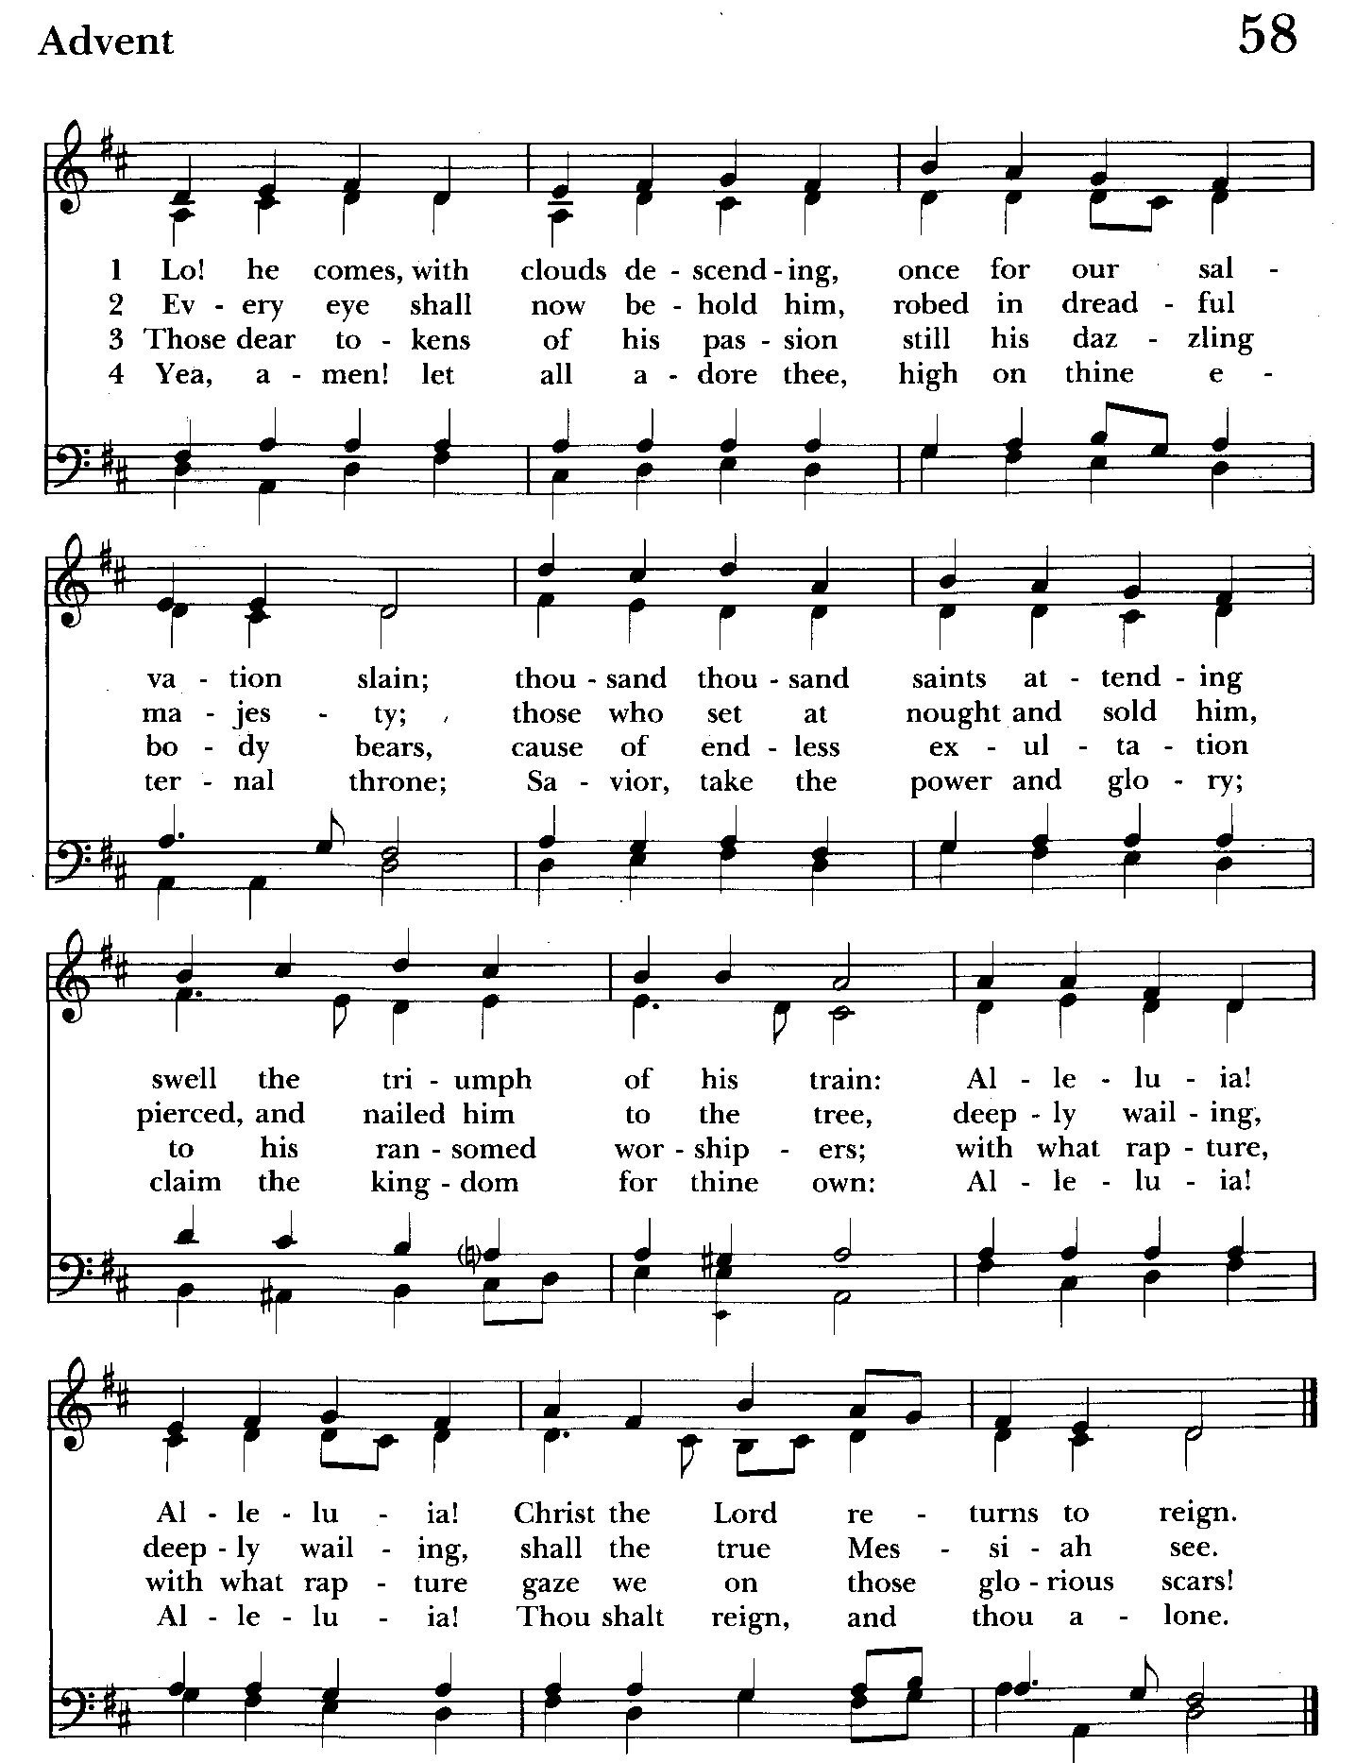

10:30 am Worship
Holy Eucharist, Rite Two

Prelude:

The Word of God

Processional hymn: Lo! He comes, with clouds descending Hymnal #58
(see previous page)

The congregation remains standing as able
Celebrant: Blessed be God: Father, Son, and Holy Spirit. BCP 355
People: And blessed be his kingdom, now and for ever. Amen.

Celebrant: Almighty God, to you all hearts are open, all desires known, and from you no secrets are hid: Cleanse the thoughts of our hearts by the inspiration of your Holy Spirit, that we may perfectly love you, and worthily magnify your holy Name; through Christ our Lord. Amen.

Gloria Hymnal #S-278
Glory to God in the highest,
and peace to his people on earth.
Lord God, heavenly King,
almighty God and Father,
we worship you, we give you thanks,
we praise you for your glory.
Lord Jesus Christ, only Son of the Father,
Lord God, Lamb of God,
you take away the sin of the world:
have mercy on us;
you are seated at the right hand of the Father:
receive our prayer.
For you alone are the Holy One,
you alone are the Lord,
you alone are the Most High,
Jesus Christ,
with the Holy Spirit,
in the glory of God the Father. Amen.

Celebrant: The Lord be with you.
People: And also with you.
Celebrant: Let us pray.

The Collect of the Day Kneel or stand as able BCP 235
O God, whose blessed Son came into the world that he might destroy the works of the devil and make us children of God and heirs of eternal life: Grant that, having this hope, we may purify ourselves as he is pure; that, when he comes again with power and great glory, we may be made like him in his eternal and glorious kingdom; where he lives and reigns with you and the Holy Spirit, one God, for ever and ever. Amen.

The congregation is seated.

A Reading from the Book of Ruth 3:1-5, 4:13-17
Naomi her mother-in-law said to Ruth, “My daughter, I need to seek some security for you, so that it may be well with you. Now here is our kinsman Boaz, with whose young women you have been working. See, he is winnowing barley tonight at the threshing floor. Now wash and anoint yourself, and put on your best clothes and go down to the threshing floor; but do not make yourself known to the man until he has finished eating and drinking. When he lies down, observe the place where he lies; then, go and uncover his feet and lie down; and he will tell you what to do.” She said to her, “All that you tell me I will do.”
So Boaz took Ruth and she became his wife. When they came together, the Lord made her conceive, and she bore a son. Then the women said to Naomi, “Blessed be the Lord, who has not left you this day without next-of-kin; and may his name be renowned in Israel! He shall be to you a restorer of life and a
nourisher of your old age; for your daughter-in-law who loves you, who is more to you than seven sons, has borne him.” Then Naomi took the child and laid him in her bosom, and became his nurse. The women of the neighborhood gave him a name, saying, “A son has been born to Naomi.” They named him Obed; he became the father of Jesse, the father of David.

Reader: The Word of the Lord.
People: Thanks be to God.

Psalm 127 (Pray as directed)
1 Unless the Lord builds the house, *
their labor is in vain who build it.
2 Unless the Lord watches over the city, *
in vain the watchman keeps his vigil.
3 It is in vain that you rise so early and go to bed so late; *
vain, too, to eat the bread of toil,
for he gives to his beloved sleep.
4 Children are a heritage from the Lord, *
and the fruit of the womb is a gift.
5 Like arrows in the hand of a warrior *
are the children of one's youth.
6 Happy is the man who has his quiver full of them! *
he shall not be put to shame
when he contends with his enemies in the gate.

A Reading from the Letter to the Hebrews 9:24-28
Christ did not enter a sanctuary made by human hands, a mere copy of the true one, but he entered into heaven itself, now to appear in the presence of God on our behalf. Nor was it to offer himself again and again, as the high priest enters the Holy Place year after year with blood that is not his own; for then he would have had to suffer again and again since the foundation of the world. But as it is, he has appeared once for all at the end of the age to remove sin by the sacrifice of himself. And just as it is appointed for mortals to die once, and after that the judgment, so Christ, having been offered once to bear the sins of many, will appear a second time, not to deal with sin, but to save those who are eagerly waiting for him.

Reader: The Word of the Lord.
People: Thanks be to God.

Gradual hymn: Take my life, and let is be Hymnal #707
(see below page) The congregation remains standing as able
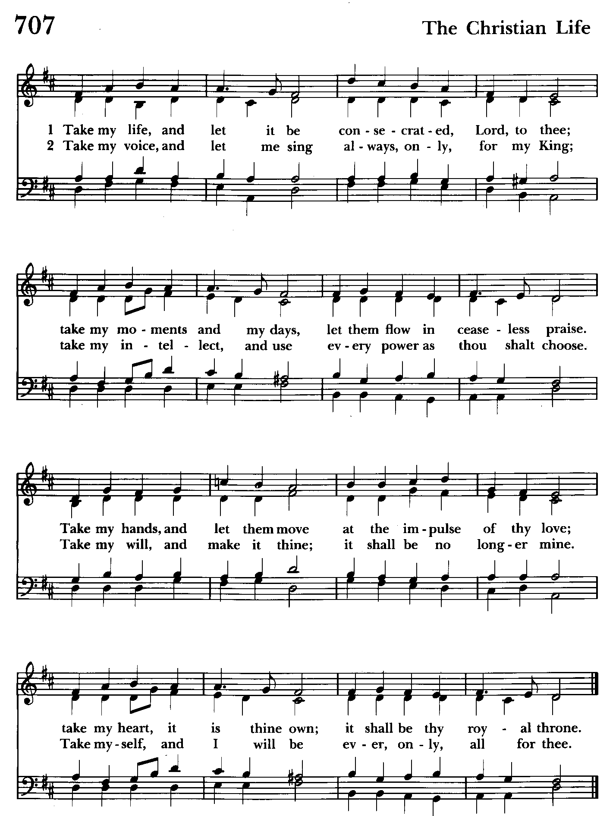

Priest: The Holy Gospel of our Lord Jesus Christ according to Mark 12:38-44

People: Glory to you, Lord Christ.
As Jesus taught, he said, “Beware of the scribes, who like to walk around in long robes, and to be greeted with respect in the marketplaces, and to have the best seats in the synagogues and places of honor at banquets! They devour widows’ houses and for the sake of appearance say long prayers. They will receive the greater condemnation.”
He sat down opposite the treasury, and watched the crowd putting money into the treasury. Many rich people put in large sums. A poor widow came and put in two small copper coins, which are worth a penny. Then he called his disciples and said to them, “Truly I tell you, this poor widow has put in more than all those who are contributing to the treasury. For all of them have contributed out of their abundance; but she out of her poverty has put in everything she had, all she had to live on.”

Priest: The Gospel of the Lord.
People: Praise to you, Lord Christ.

Sermon The congregation is seated The Rev. Canon Dina van Klaveren

The Nicene Creed Please stand as able BCP 358
We believe in one God,
the Father, the Almighty,
maker of heaven and earth,
of all that is, seen and unseen.
We believe in one Lord, Jesus Christ,
the only Son of God,
eternally begotten of the Father,
God from God, Light from Light,
true God from true God,
begotten, not made,
of one Being with the Father.
Through him all things were made.
For us and for our salvation
he came down from heaven:
by the power of the Holy Spirit
he became incarnate from the Virgin Mary,
and was made man.
For our sake he was crucified under Pontius Pilate;
he suffered death and was buried.
On the third day he rose again
in accordance with the Scriptures;
he ascended into heaven
and is seated at the right hand of the Father.
He will come again in glory to judge the living and the dead,
and his kingdom will have no end.
We believe in the Holy Spirit, the Lord, the giver of life,
who proceeds from the Father and the Son.
With the Father and the Son he is worshiped and glorified.
He has spoken through the Prophets.
We believe in one holy catholic and apostolic Church.
We acknowledge one baptism for the forgiveness of sins.
We look for the resurrection of the dead,
and the life of the world to come. Amen.

The Prayers of the People Form VI Kneel or stand as able BCP 392
Litanist: In peace, we pray to you, Lord God.

Litanist: For all people in their daily life and work;
People: For our families, friends, and neighbors, and for those who are alone.

Litanist: For this community, the nation, and the world;
People: For all who work for justice, freedom, and peace.

Litanist: For the just and proper use of your creation;
People: For the victims of hunger, fear, injustice, and oppression.

Litanist: For all who are in danger, sorrow, or any kind of trouble;
People: For those who minister to the sick, the friendless, and the needy.

Litanist: For the peace and unity of the Church of God;
People: For all who proclaim the Gospel, and all who seek the Truth.

Litanist: For +Justin, Archbishop of Canterbury; +Sean, our Presiding Bishop; +Carrie, our Bishop, Mark+ our Interim Rector, for the Wardens, Vestry, Staff, and all members and friends of St. John’s Church.
People: For all who serve God in his Church.

Litanist: For the special needs and concerns of this congregation. Especially remember in our prayers, DeMarino Family, Jim & Chris Carden and family, Peggie Dietz, Mike Carden, Pat Carden, Gail Landers, Sheila Jones, Gloria Millar, Marisol Aubrey, Ross Strickler, Jim & Janice Sieracki, James Daniel Jr., Larry Betzler, Camy Schwenk, Dennis Mally, Zach Walsh, Edward, Lily John, Barbara Miller, Nancy Barnhart, Robin Dilworth.
The People may add their own petitions

Litanist: Hear us, Lord;
People: For your mercy is great.
Litanist: We thank you, Lord, for all the blessings of this life.

The People may add their own thanksgivings

Litanist: We will exalt you, O God our King;
People: And praise your Name for ever and ever.

Litanist: We pray for all who have died, that they may have a place in your
eternal kingdom.

The People may add their own petitions
Litanist: Lord, let your loving-kindness be upon them;
People: Who put their trust in you.

Litanist: We pray to you also for the forgiveness of our sins.
People: Have mercy upon us, most merciful Father; in your compassion forgive us our sins, known and unknown, things done and left undone; and so uphold us by your Spirit that we may live and serve you in newness of life, to the honor and glory of your Name; through Jesus Christ our Lord. Amen.

The Celebrant gives the absolution.

The Peace Please stand as able BCP 360

Welcome & Announcements The congregation is seated.

Offertory Anthem: One Song (Choir)
Offertory Hymn: God himself is with us Hymnal #475
(see below & next page) The people remain seated.

Offertory: Offerings are collected

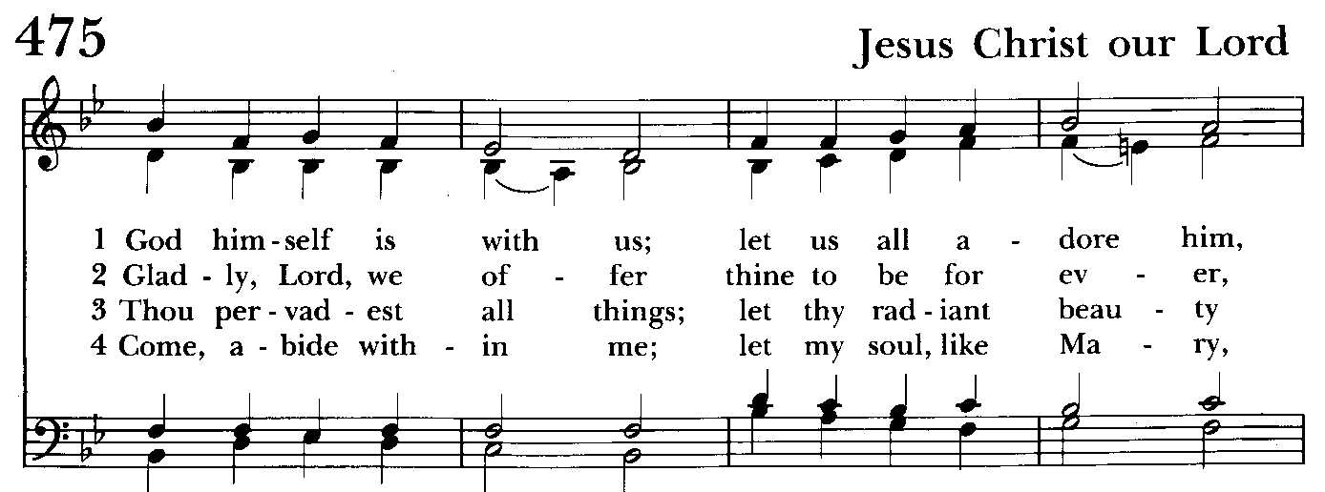

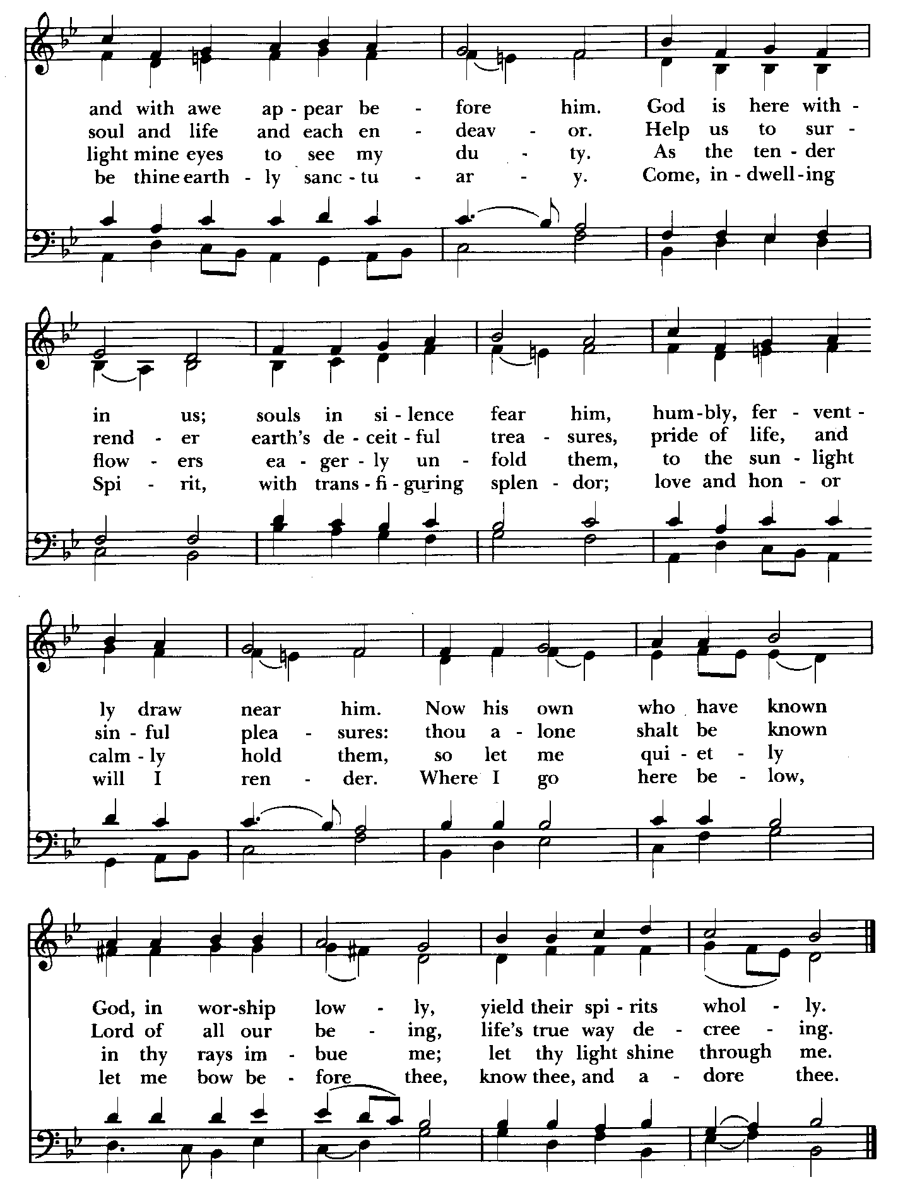

The Holy Communion

Presentation Hymn Offerings are presented Please stand as able Hymnal #43, vs. 4
Praise God, from whom all blessings flow; praise him, all creatures here below; praise him above, ye heavenly host: praise Father, Son, and Holy Ghost.

THE GREAT THANKSGIVING: Eucharistic Prayer B BCP 367
Celebrant: The Lord be with you.
People: And also with you.
Celebrant: Lift up your hearts.
People: We lift them to the Lord.
Celebrant: Let us give thanks to the Lord our God.
People: It is right to give him thanks and praise.

Then, facing the Holy Table, the Celebrant proceeds
It is right, and a good and joyful thing, always and everywhere to give thanks to you, Father Almighty, Creator of heaven and earth.

Therefore we praise you, joining our voices with Angels and Archangels and with all the company of heaven, who for ever sing this hymn to proclaim the glory of your Name:

Celebrant and People:
Holy, Holy, Holy Lord, God of power and might, Hymnal #S-129
heaven and earth are full of your glory.
Hosanna in the highest.
Blessed is he who comes in the name of the Lord.
Hosanna in the highest.
Please kneel or stand as able
Then the Celebrant continues BCP 368
We give thanks to you, O God, for the goodness and love which you have made known to us in creation; in the calling of Israel to be your people; in your Word spoken through the prophets; and above all in the Word made flesh, Jesus, your Son. For in these last days you sent him to be incarnate from the Virgin Mary, to be the Savior and Redeemer of the world. In him, you have delivered us from evil, and made us worthy to stand before you. In him, you have brought us out of error into truth, out of sin into righteousness, out of death into life.

At the following words concerning the bread, the Celebrant is to hold it, or to lay a hand upon it; and at the words concerning the cup, to hold or place a hand upon the cup and any other vessel containing wine to be consecrated.

On the night before he died for us, our Lord Jesus Christ took bread; and when he had given thanks to you, he broke it, and gave it to his disciples, and said, "Take, eat: This is my Body, which is given for you. Do this for the remembrance of me."

After supper he took the cup of wine; and when he had given thanks, he gave it to them, and said, "Drink this, all of you: This is my Blood of the new Covenant, which is shed for you and for many for the forgiveness of sins. Whenever you drink it, do this for the remembrance of me."

Therefore, according to his command, O Father,

Celebrant and People:
We remember his death,
We proclaim his resurrection,
We await his coming in glory;

The Celebrant continues
And we offer our sacrifice of praise and thanksgiving to you, O Lord of all; presenting to you, from your creation, this bread and this wine. We pray you, gracious God, to send your Holy Spirit upon these gifts that they may be the Sacrament of the Body of Christ and his Blood of the new Covenant. Unite us to your Son in his sacrifice, that we may be acceptable through him, being sanctified by the Holy Spirit. In the fullness of time, put all things in subjection under your Christ, and bring us to that heavenly country where, with St. John and the Blessed Virgin Mary and all your saints, we may enter the everlasting heritage of your sons and daughters; through Jesus Christ our Lord, the firstborn of all creation, the head of the Church, and the author of our salvation.

By him, and with him, and in him, in the unity of the Holy Spirit all honor and glory is yours, Almighty Father, now and for ever. Amen.

And now, as our Savior Christ has taught us, we are bold to say,

Our Father, who art in heaven, BCP p. 364
hallowed be thy Name,
thy kingdom come,
thy will be done,
on earth as in heaven.
Give us this day our daily bread.
And forgive us our trespasses,
as we forgive those
who trespass against us.
And lead us not into temptation,
but deliver us from evil.
For thine is the kingdom,
and the power, and the glory,
for ever and ever. Amen.

Invitation to Communion

The Breaking of the Bread
Celebrant: Alleluia. Christ our Passover is sacrificed for us;
People: Therefore let us keep the feast. Alleluia.
Celebrant: The Gifts of God for the people of God.

The congregation is seated

Communion hymn: Lord, make us servants of your peace Hymnal #593
(see next page)

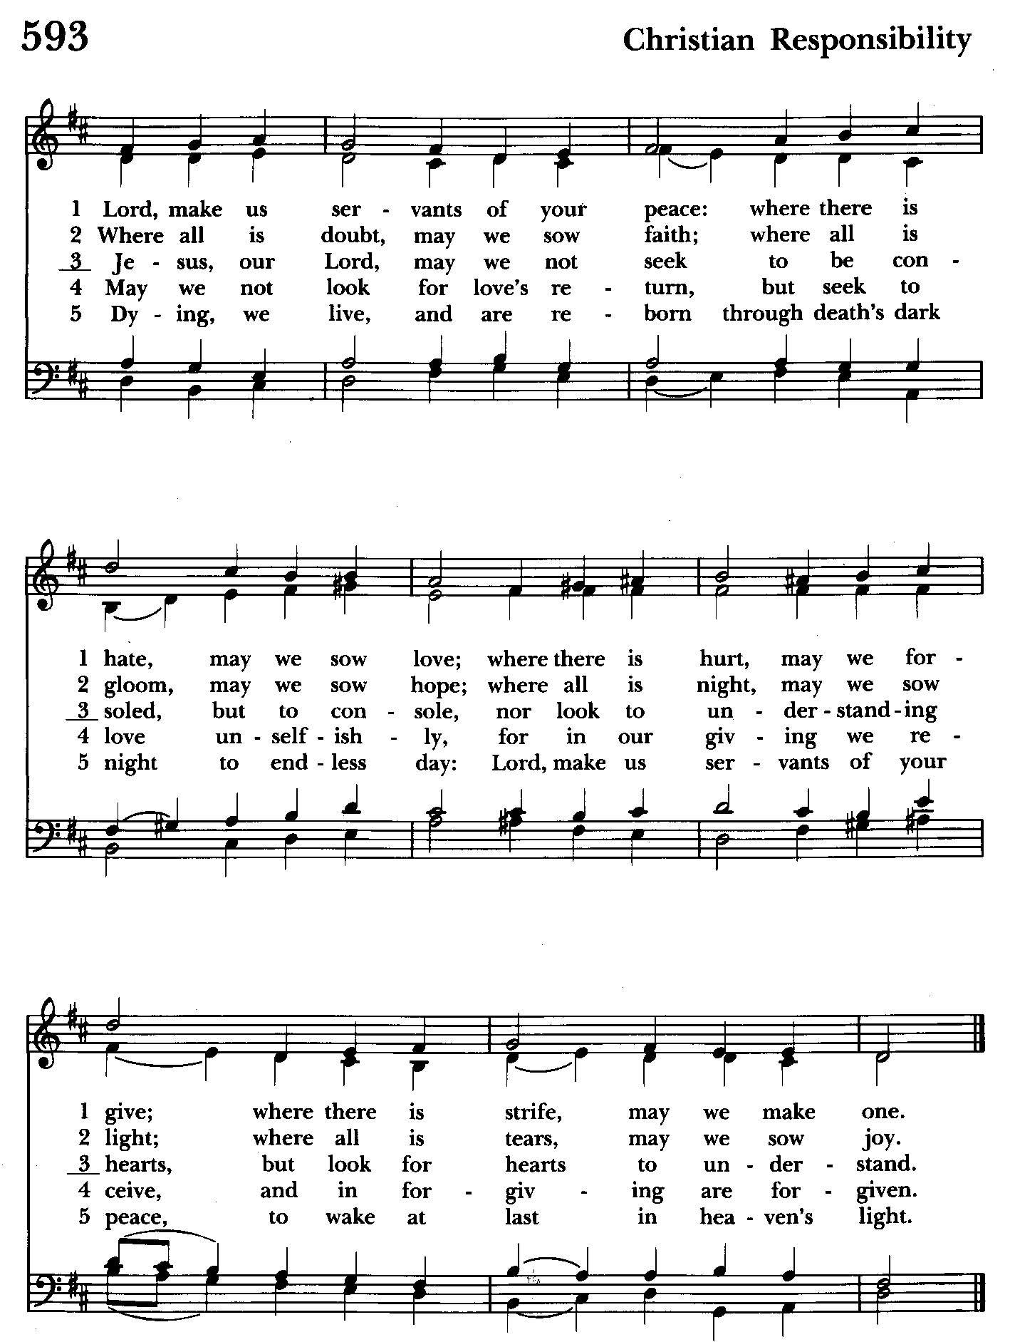

The Post Communion Prayer BCP p. 365
Eternal God, heavenly Father, you have graciously accepted us as living members of your Son our Savior Jesus Christ, and you have fed us with spiritual food in the Sacrament of his Body and Blood. Send us now into the world in peace, and grant us strength and courage to love and serve you with gladness and singleness of heart; through Christ our Lord. Amen.

Blessing

Recessional hymn: God of grace and God of glory Hymnal #594
(see next page)

The Dismissal
Celebrant: Let us go forth in the name of the risen Lord.
People: Thanks be to God.

Postlude:

License #A-719154

Serving Today

Celebrant and Preacher: The Rev Canon Dina van Klaveren
Old Testament: Liz Healey
Psalm: Liz Healey
New Testament: Anne Leland
Prayers of the People: John Frost
Server: Marguerite Lobb
Music Director: Nancy Heinold
Choir: Anne Leland, Nancy Dellinger, Janine Stevens, Liz Healey, Camy Schwenk,
Karen Smith-Manar, Jacob Johnson, Ty Schwenk
Altar Guild: Stephanie Duchacek & Sandy Roe

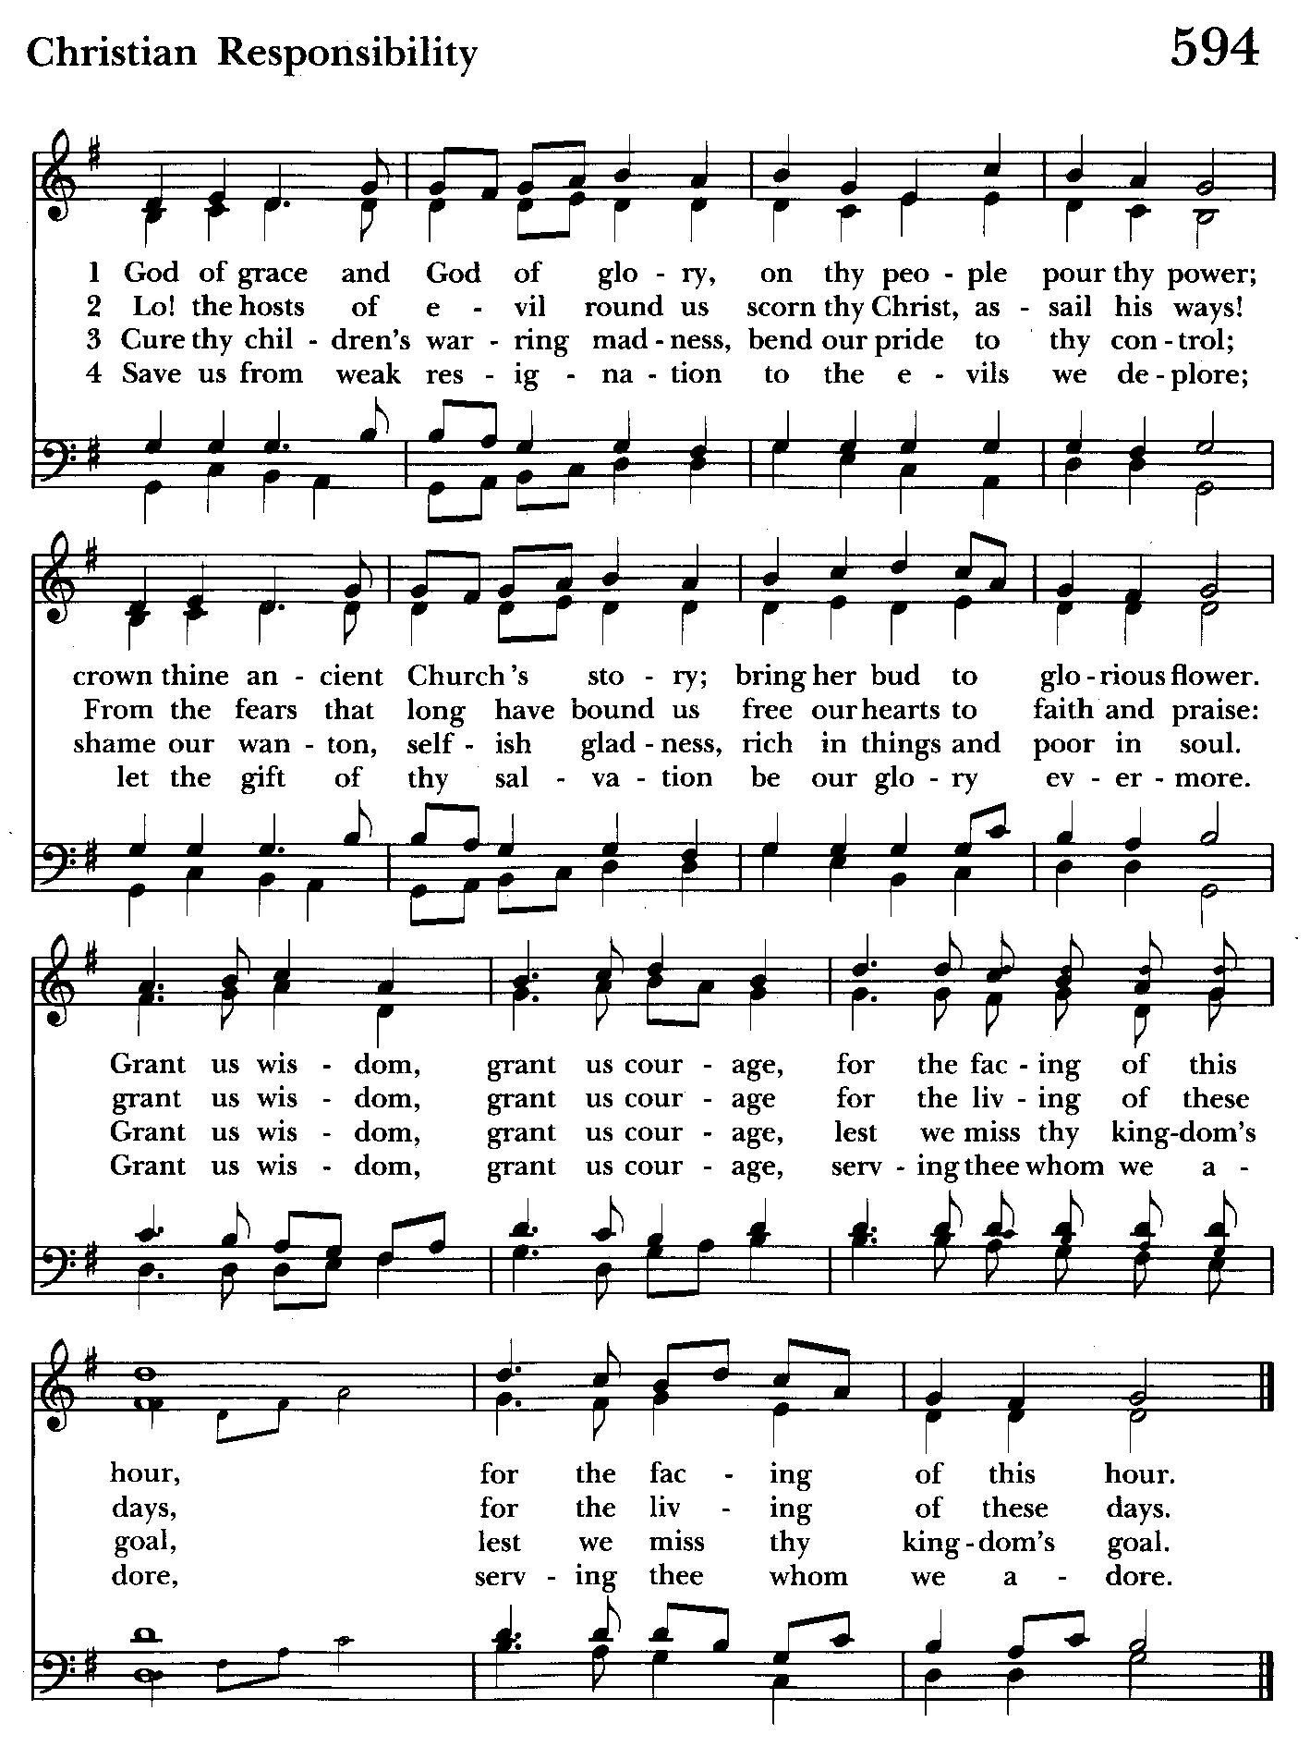


Altar Flowers
Given to the Glory of God
by Liz Healey
in memory of her father, John D. Healey, Sr.
and her aunt, Mary Holland

St. John’s Parish Prayer List

Additions and corrections may be made to our Parish Prayer List at any time. All names will be automatically removed from the Parish Prayer List on the 1st Sunday of each month unless you request otherwise. Please contact Angie at <office@stjohnskingsville.org> or 410-592-8570 in the church office with all changes by 10 am Thursdays. Thank you.

We Pray for Those in Need:
Names in BOLD read aloud by all.

DeMarino Family, Jim & Chris Carden and family, Peggie Dietz, Mike Carden, Pat Carden, Gail Landers, Sheila Jones, Gloria Millar, Marisol Aubrey, Ross Strickler, Jim and Janice Sieracki, James Daniel Jr., Larry Betzler, Camy Schwenk, Dennis Mally, Zach Walsh, Edward.

We Pray for our Homebound

Lily John, Barbara Miller, Nancy Barnhart, Robin Dilworth

We pray for the Church and the World:

For +Justin, Archbishop of Canterbury; for +Sean, our Presiding Bishop; for +Carrie, our Bishop, for Mark+, our Interim Rector; for the Wardens, Vestry, Staff, and all members and friends of St. John’s Church.

For the leaders of all nations, especially for Joseph, our President; for Wes, our Governor; for Brandon, Nick, John and Bob, who lead our City and Counties. We pray for all children and youth; for the homeless, the unemployed, and the hungry. We pray for the safety of our loved ones and friends serving in the Armed Forces at home and abroad, and for our enemies, that all our hearts may be turned toward peace throughout the world.

From the Treasurer
November ‘24 Income vs. Expenses:

Projected November Expenses: $13,500
Monies Received as of 11/7: $ 7,840
Amount Needed to meet Expenses: $ 5,660

Proceeds from October 18th Bingo: $ 3,346


If you’d like to make a donation to St. John’s you can scan this QR code with your phone’s camera or tap on the link that comes up to make a contribution with either a credit or debit card, Apple Pay or Google Pay. This is a secure site provided by Clover which is a service of PNC Bank.



With so much going on, everyone’s help is needed to make things a success. Our volunteers make the Church function. The volunteering of time and talent is greatly appreciated.

9:00- 9:30: "Confirmation Class" - for any interested in Confirmation/Reception or any just interested. Walk In Love, (copies available).
10:30: Kids Sunday School- Begin in the church, ring the bell, then process over to the parish hall for a fun lesson with Mr. John and Ms. Stephanie. Note: Please seriously consider regular attendance at Sunday School so that Mr. John and Ms. Stephanie can plan good stuff.
Wednesday Mornings- Feed the Wolf!
Our book study is held Wednesdays at 9:00 a.m. in the Parish Hall. Books are still available.

Fr. Mark is open to additional locations and times for another group. Speak up if you have a suggestion.

Choral Choir and Bell Choir
Choir rehearsals Wednesdays at 7:00 pm and Bell Choir Rehearsal on Sundays after the 10:30 service. If anyone is interested in joining, see Nancy Heinold, our Music Director.


SUNDAY SCHOOL
Kids Sunday School- Begin in the church, ring the bell, then process over to the parish hall for a fun lesson with Mr. John and Ms. Stephanie.


Yoga classes on Tuesday, Wednesday and Friday evenings 6 to 7 pm and Saturday mornings 9 to 10 am in the Chapel.
All experience levels are welcome.

Calendar Updates

Community Christmas Tree Lighting and Cantata - 12/8, 7 pm

Blue Christmas/Service of Solace- TBD

Christmas Lessons & Carols - 12/29, 10:30 am—ONE SERVICE ON THIS DAY

Calendars are living documents. Every effort will be made to keep the members of the parish and community aware of any changes.

SAVE THE DATE
Christmas Bazaar - 11/23


OUTREACH
WHAT A GREAT GIFT TO GIVE
SOMEONE A MERRY CHRISTMAS!!

With Christmas and Thanksgiving just around the corner the Helping Hands Food Pantry is preparing for its annual Meal Distribution.

Listed below is what they need:
Yams/Sweet Potatoes (small or medium cans), Instant Potatoes (box or bag), Cranberries (canned), Sauerkraut (canned), cake mixes, cake icing (ready made)

Thank you so much!


St. John's Annual Christmas Bazaar
Saturday, November 23rd, 9am-1pm
Vendors and Crafters, Bake Table, breakfast and lunch foods, soups and more.
Vendors and Crafters wanted!
Soups and desserts needed!

Anyone able to help on Bazaar day would be much appreciated.

For more information contact Michele 443-463-6333.
Sign up sheet in the back of the church.

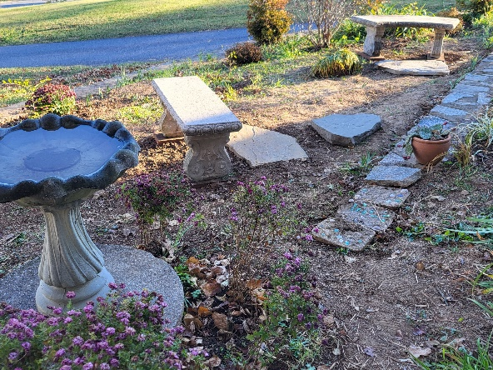
Come see the progress we’re making to Beautify our St. Francis Garden!!
For more info or to sign up to help keep our gardens looking beautiful, contact: Rita Talley-Garden Club, 443-617-1820 or Karen Smith-Manar-St. John’s 410-746-9813 or bikenbocal@verizon.net
Wish list: plant and tree food, hosta, liriope, mums, asters, shovels
God’s Grace Gardens—a St. John’s, Hill & Stream Garden Club and AA
collaboration

In our Community

Bible Studies in our area. If interested, please contact these churches to confirm.
St. Mary’s, Abingdon, (410)569-0180- Wednesdays at noon. Bring lunch. Zoom available.
Emmanuel, Bel Air, (410)838-7699- Fridays at 9:30- Zoom Available.

Holy Trinity, Churchville, (410)914-5531- Wednesdays 11:30- Zoom may be available.

RECYCLING!
Feed Me!
The recycling bins are hungry for more aluminum cans.

By popular demand, we are recycling. Some parishioners take printed paper home where they have recycling pickup. We now have a blue container located in the Parish Hall. This will be collected and taken for recycling. Aluminum cans will be saved and taken to a recycling center for cash. The proceeds will be donated to the Outreach fund. Each recycled aluminum can also save on the electricity needed to make new aluminum from bauxite.

What’s Happening This Week at St. John’s

Sunday, November 10—25th Sunday after Pentecost
8:00am: Holy Eucharist, Rite I (Church)
10:30am: Holy Eucharist, Rite II (Church)
11:30am: Coffee Hour (Parish Hall)
11:45am: Bell Choir Rehearsal (Church)

Monday, November 11
12:00-1:00pm: AA Lunch Bunch (Parish Hall)
7:00-8:30pm: Spanish speaking AA group (Parish Hall)

Tuesday, November 12
12:00-1:00pm: AA Lunch Bunch (Parish Hall)
6:00-7:00pm: Yoga (Chapel)

Wednesday, November 13
9:00am-10:00am Bible Study (Parish Hall)
12:00-1:00pm: AA Lunch Bunch (Parish Hall)
6:00-7:00pm: Yoga (Chapel)
7:00pm: Choir Rehearsal (Church)
7:30pm: AA (Parish Hall)

Thursday, November 14
12:00-1:00pm: AA Lunch Bunch (Parish Hall)
7:00pm: AA (Parish Hall)

Friday, November 15
12:00-1:00pm: AA Lunch Bunch (Parish Hall)
6:00pm -7:00pm: Yoga (Chapel)

Saturday, November 16
9:00am-10:00am: Yoga (Chapel)
8:30pm: AA (Parish Hall)

Sunday, November 17—26th Sunday after Pentecost
8:00am: Holy Eucharist, Rite I (Church)
10:30am: Holy Eucharist, Rite II (Church)
11:30am: Coffee Hour (Parish Hall)
11:45am: Bell Choir Rehearsal (Church)

Parish Office is open Monday, Wednesday and Thursday, 9:30am-1:30pm.

Potluck Luncheon on the first Sunday of the month and a Coffee Hour on all other Sundays after the 10:30 service.

