St. John’s Episcopal Church
Kingsville, Maryland
Welcomes You

Our Vision Statement

We believe that together we will transform
the world with love: Come on in!



First Sunday of Advent
December 1, 2024
8:00 and 10:30 am services

St. John’s Episcopal Church

11901 Belair Road, P. O. Box 187, Kingsville, MD 21087
Facebook: St. John’s Episcopal, Kingsville, MD
Email: office@stjohnskingsville.org
Website: www.stjohnskingsville.org
Church Phone: 410-592-8570
For Pastoral Emergencies: Fr. Mark Lobb+ 443-690-9545

Welcome to worship today! We are glad that you are with us. You are invited to participate in all parts of the service as indicated in the Book of Common Prayer and this service bulletin. If you have any questions, feel free to ask the ushers. Restrooms are located in the Parish Hall, the brick building across the parking lot.

I was glad when they said to me, “Let us go to the house of the Lord.” Psalm 122:1

Church Staff

Interim Rector: Father Mark Lobb
Administrative Assistant: Angie Bosley
Organist/Choir Director: Nancy Heinold

The Vestry

Class of 2024 Class of 2025

Marguerite Lobb John Frost
Jacob Johnson Woodie Tingle

Officers
Ty Schwenk—Sr. Warden Terry Roe—Jr. Warden
Elizabeth Healey—Treasurer Anne Leland-Registrar

Parish Committee Chairpersons

Altar Guild: Elizabeth Healey
Auxiliary Committee: Michele Lozanski
Cemetery Committee: Terry Roe

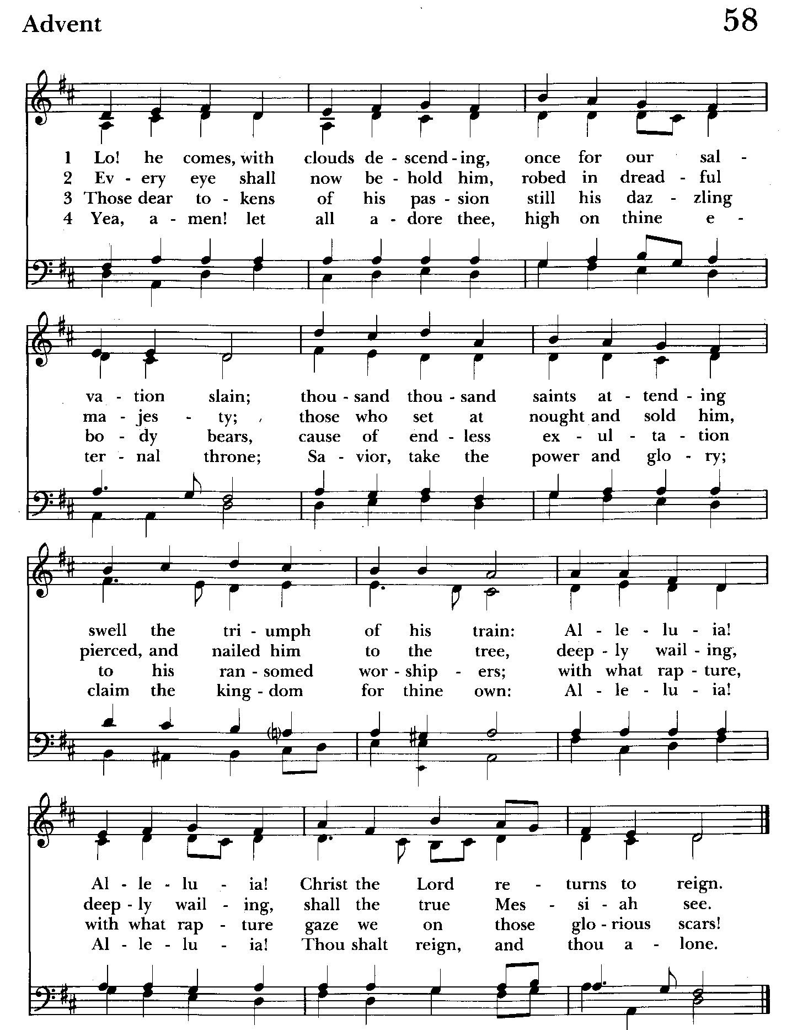

Holy Eucharist

Processional hymn: Lo! He comes with clouds descending Hymnal #58
(see previous page) Please stand as able
Opening Acclamations

Celebrant: Blessed are you, holy and living One.
People: You come to your people and set them free.
Celebrant: Almighty God, to you all hearts are open, all desires known, and from you no secrets are hid: Cleanse the thoughts of our hearts by the inspiration of your holy Spirit, that we may perfectly love you, and worthily magnify your holy Name; through Christ our Lord. Amen.

Kyrie

Celebrant: God be with you.
People: And also with you.
Celebrant: Let us pray.

The Collect of the Day kneel or stand as able BCP 211
Almighty God, give us grace to cast away the works of darkness, and put on the armor of light, now in the time of this mortal life in which your Son Jesus Christ came to visit us in great humility; that in the last day, when he shall come again in his glorious majesty to judge both the living and the dead, we may rise to the life immortal; through him who lives and reigns with you and the Holy Spirit, one God, now and for ever. Amen.

The congregation is seated

A Reading from Book of the Prophet Jeremiah 33:14-16
The days are surely coming, says the Lord, when I will fulfill the promise I made to the house of Israel and the house of Judah. In those days and at that time I will cause a righteous Branch to spring up for David; and he shall execute justice and righteousness in the land. In those days Judah will be saved and Jerusalem will live in safety. And this is the name by which it will be called: "The Lord is our righteousness."

Reader: Hear what the Spirit is saying to God’s people
People: Thanks be to God.

Psalm 25:1-9 (Pray as directed)
1 To you, O Lord, I lift up my soul;
my God, I put my trust in you; *
let me not be humiliated,
nor let my enemies triumph over me.
2 Let none who look to you be put to shame; *
let the treacherous be disappointed in their schemes.
3 Show me your ways, O Lord, *
and teach me your paths.
4 Lead me in your truth and teach me, *
for you are the God of my salvation;
in you have I trusted all the day long.
5 Remember, O Lord, your compassion and love, *
for they are from everlasting.
6 Remember not the sins of my youth and my transgressions; *
remember me according to your love
and for the sake of your goodness, O Lord.
7 Gracious and upright is the Lord; *
therefore he teaches sinners in his way.
8 He guides the humble in doing right *
and teaches his way to the lowly.
9 All the paths of the Lord are love and faithfulness *
to those who keep his covenant and his testimonies.

A Reading from the First Letter of St. Paul to the Thessalonians 3:9-13
How can we thank God enough for you in return for all the joy that we feel before our God because of you? Night and day we pray most earnestly that we may see you face to face and restore whatever is lacking in your faith.
Now may our God and Father himself and our Lord Jesus direct our way to you. And may the Lord make you increase and abound in love for one another and for all, just as we abound in love for you. And may he so strengthen your hearts in holiness that you may be blameless before our God and Father at the coming of our Lord Jesus with all his saints.

Reader: Hear what the Spirit is saying to God’s people
People: Thanks be to God.

Gradual hymn: Sleepers wake! A voice astounds us Hymnal #61
(see next 2 pages)

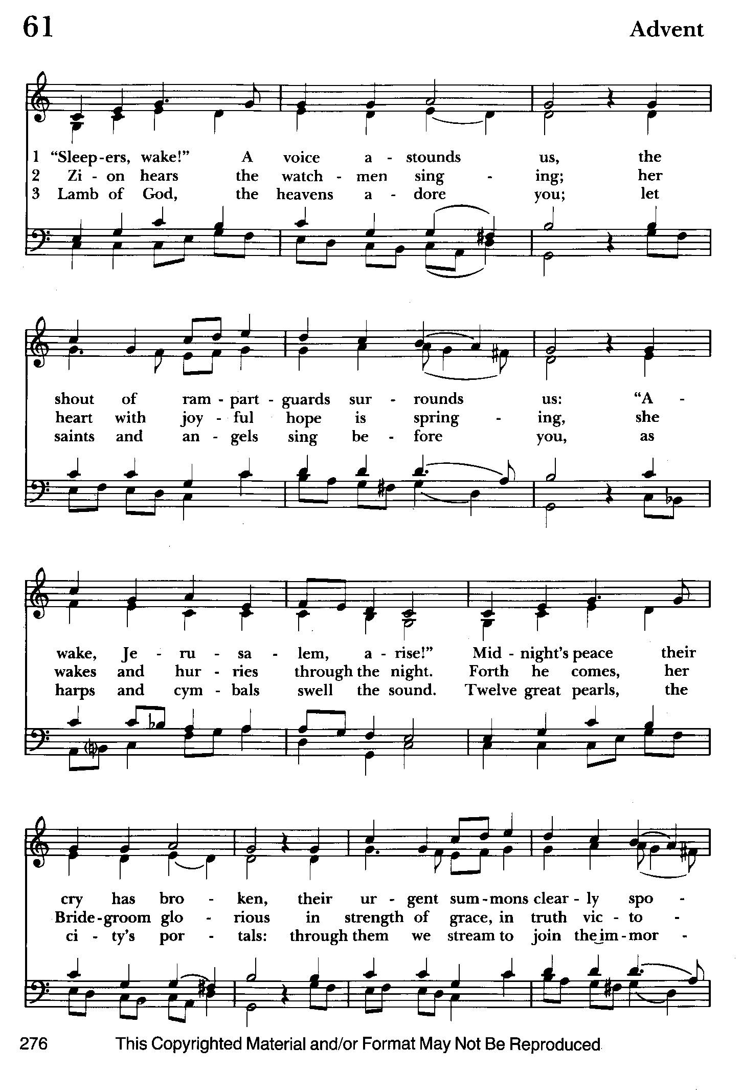

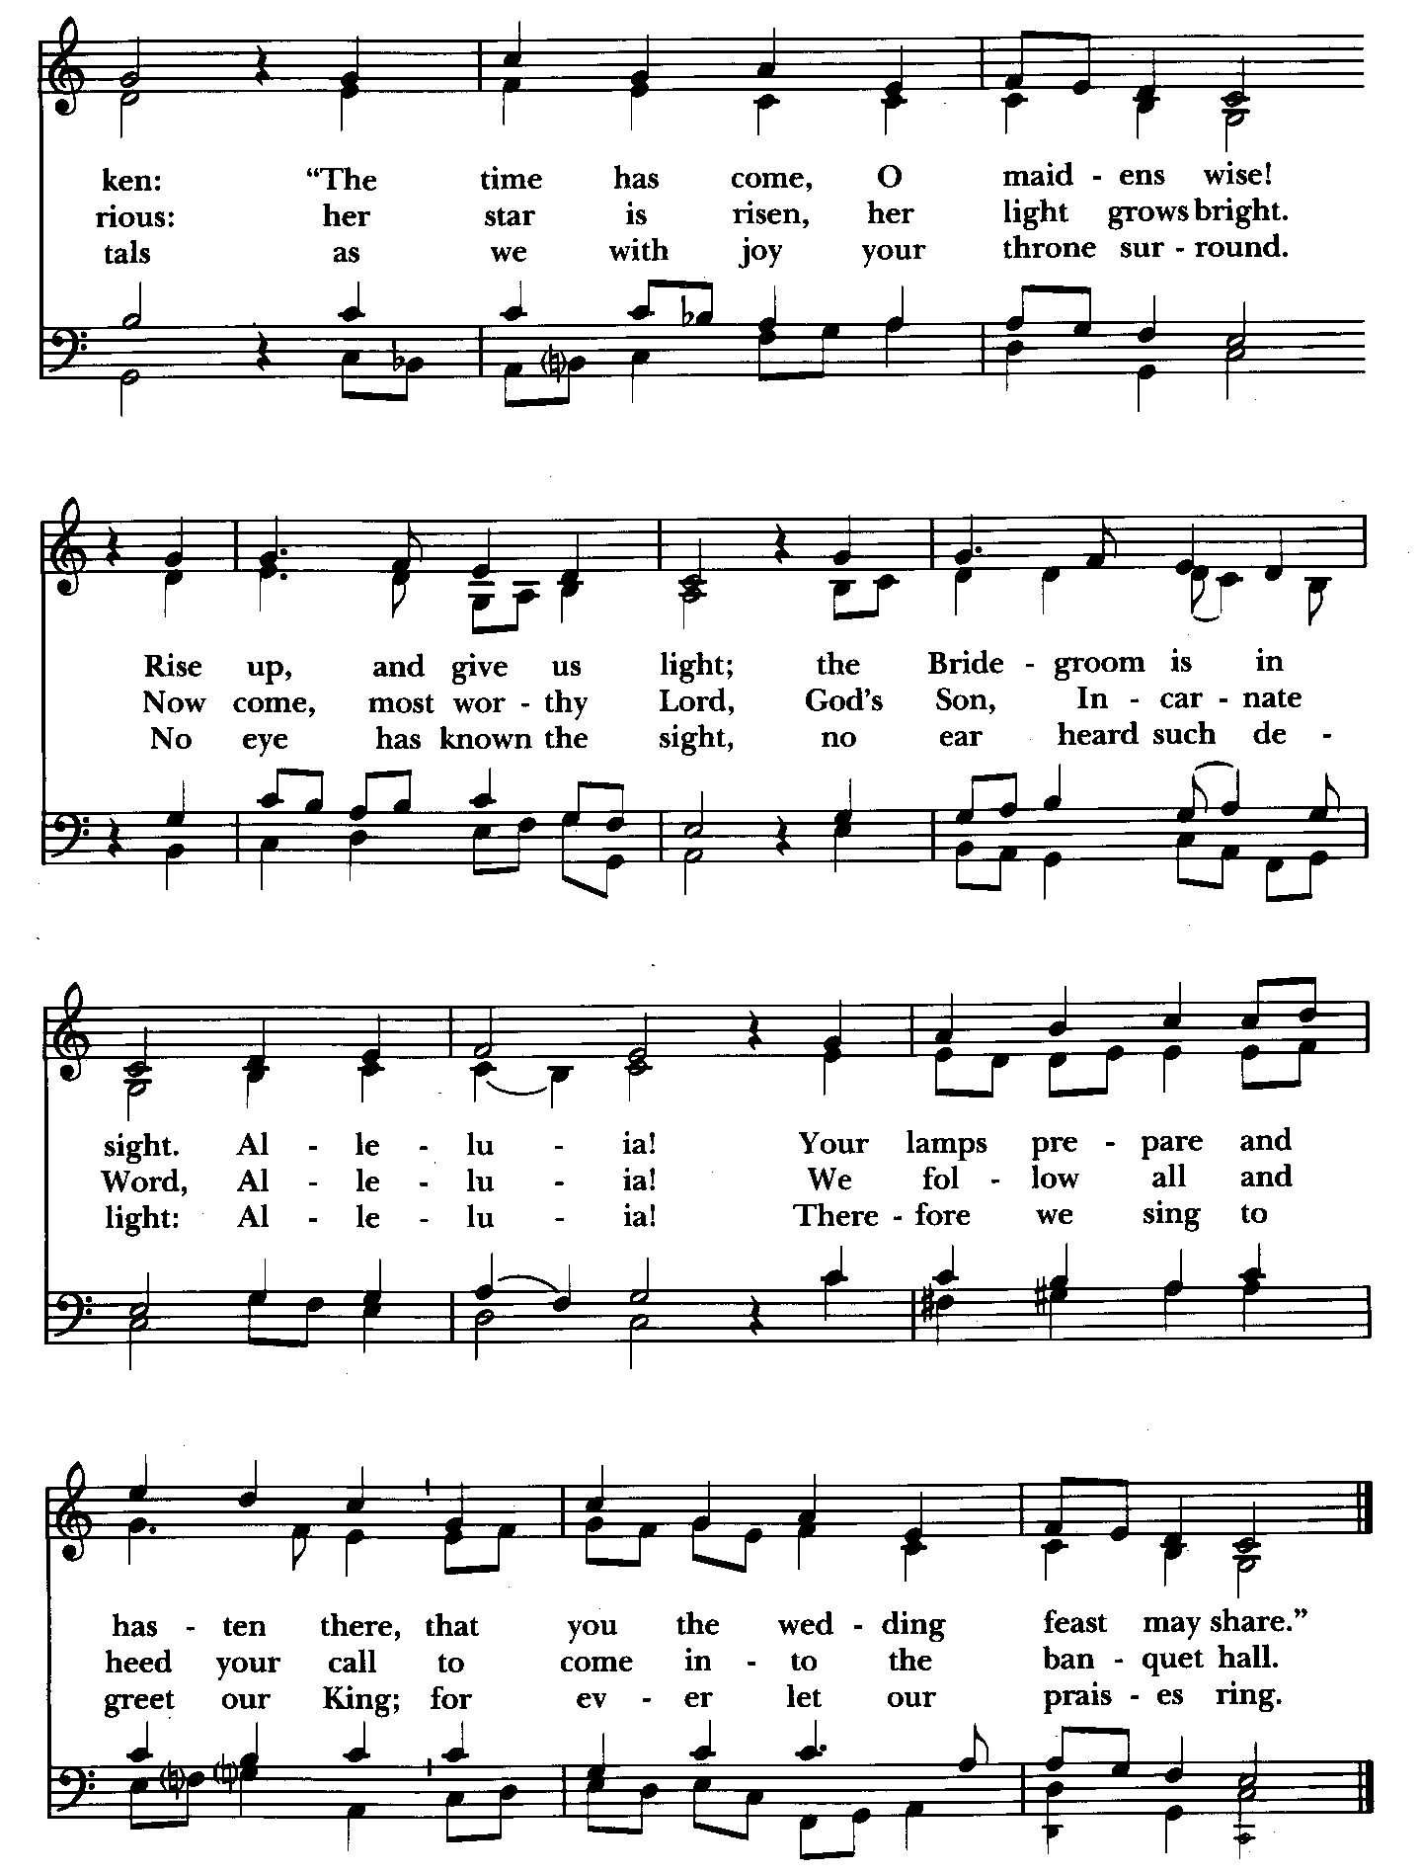

The Gospel Please remain standing
Priest: The Holy Gospel of our Lord Jesus Christ according to Luke 21:25-36
People: Glory to you, Lord Christ.
Jesus said, "There will be signs in the sun, the moon, and the stars, and on the earth distress among nations confused by the roaring of the sea and the waves. People will faint from fear and foreboding of what is coming upon the world, for the powers of the heavens will be shaken. Then they will see 'the Son of Man coming in a cloud' with power and great glory. Now when these things begin to take place, stand up and raise your heads, because your redemption is drawing near."
Then he told them a parable: "Look at the fig tree and all the trees; as soon as they sprout leaves you can see for yourselves and know that summer is already near. So also, when you see these things taking place, you know that the kingdom of God is near. Truly I tell you, this generation will not pass away until all things have taken place. Heaven and earth will pass away, but my words will not pass away.
"Be on guard so that your hearts are not weighed down with dissipation and drunkenness and the worries of this life, and that day catch you unexpectedly, like a trap. For it will come upon all who live on the face of the whole earth. Be alert at all times, praying that you may have the strength to escape all these things that will take place, and to stand before the Son of Man."

Celebrant: The Gospel of the Lord.
People: Praise to you, Lord Christ.

Sermon The congregation is seated The Rev. Mark Lobb

The Nicene Creed Please stand as able BCP 358
We believe in one God,
the Father, the Almighty,
maker of heaven and earth,
of all that is, seen and unseen.
We believe in one Lord, Jesus Christ,
the only Son of God,
eternally begotten of the Father,
God from God, Light from Light,
true God from true God,
begotten, not made,
of one Being with the Father;
through him all things were made.
For us and for our salvation
he came down from heaven,
was incarnate of the Holy Spirit and the Virgin Mary
and became truly human.
For our sake he was crucified under Pontius Pilate;
he suffered death and was buried.
On the third day he rose again
in accordance with the Scriptures;
he ascended into heaven
and is seated at the right hand of the Father.
He will come again in glory to judge the living and the dead,
and his kingdom will have no end.
We believe in the Holy Spirit, the Lord, the giver of life,
who proceeds from the Father,
who with the Father and the Son is worshiped and glorified,
who has spoken through the prophets.
We believe in one holy catholic and apostolic Church.
We acknowledge one baptism for the forgiveness of sins.
We look for the resurrection of the dead,
and the life of the world to come. Amen.

Prayers of the People (Form IV, BCP p. 388) Kneel or stand as able
Deacon or other leader
Let us pray for the Church and for the world.
Grant, Almighty God, that all who confess your Name may be united in your truth, live together in your love, and reveal your glory in the world.

Silence

Lord, in your mercy
Hear our prayer.

Guide the people of this land, and of all the nations, in the ways of justice and peace; that we may honor one another and serve the common good.
Silence

Lord, in your mercy
Hear our prayer.

Give us all a reverence for the earth as your own creation, that we may use its resources rightly in the service of others and to your honor and glory.

Silence

Lord, in your mercy
Hear our prayer.

Bless all whose lives are closely linked with ours, and grant that we may serve Christ in them, and love one another as he loves us.

Silence

Lord, in your mercy
Hear our prayer.

Comfort and heal all those who suffer in body, mind, or spirit; give them courage and hope in their troubles, and bring them the joy of your salvation. Especially DeMarino Family, Jim & Chris Carden and family, Peggie Dietz, Mike Carden, Pat Carden, Gail Landers, Sheila Jones, Gloria Millar, Marisol Aubrey, Ross Strickler, Jim & Janice Sieracki, James Daniel Jr., Larry Betzler, Camy Schwenk, Dennis Mally, Zach Walsh, Lily John,
Barbara Miller, Nancy Barnhart, Robin Dilworth, Edward.

Silence

Lord, in your mercy
Hear our prayer.

We commend to your mercy all who have died, that your will for them may be fulfilled; and we pray that we may share with all your saints in your eternal kingdom.

Silence

Lord, in your mercy
Hear our prayer.

The Celebrant adds a concluding Collect.

Confession of Sin
The Deacon or Celebrant says
Let us confess our sins to God.
Silence may be kept.
Minister and People
God of all mercy,
we confess that we have sinned against you,
opposing your will in our lives.
We have denied your goodness in each other,
in ourselves, and in the world you have created.
We repent of the evil that enslaves us,
the evil we have done,
and the evil done on our behalf.
Forgive, restore, and strengthen us
through our Savior Jesus Christ,
that we may abide in your love
and serve only your will. Amen.

Absolution BCP 360
Almighty God have mercy on you, forgive you all your sins through the grace of Jesus Christ, Strengthen you in all goodness, and by the power of the Holy Spirit keep you in eternal life. Amen.

The Peace The congregation stands

Celebrant: The peace of Christ be always with you.
People: And also with you.

Welcome and Announcements Please be seated

Offertory anthem: O Come, O Come Emmanuel (Bell choir)
Offertory Sentence

Offertory hymn: Hark! The glad sound! The Savior comes Hymnal #72
(see next page) Please remain seated during the collection of the offertory

Presentation Hymn Offerings are presented Please stand as able Hymnal #43, vs. 4
Praise God, from whom all blessings flow; praise him, all creatures here below; praise him above, ye heavenly host: praise Father, Son, and Holy Ghost.

Eucharistic Prayer II
Celebrant: The Lord be with you.
People: And also with you.
Celebrant: Lift up your hearts.
People: We lift them to the Lord.
Celebrant: Let us give thanks to the Lord our God.
People: It is right to give our thanks and praise.
Celebrant: We praise you and we bless you, holy and gracious God, source of life abundant. From before time you made ready the creation. Your Spirit moved over the deep and brought all things into being: sun, moon, and stars; earth, winds, and waters; and every living thing. You made us in your image, and taught us to walk in your ways. But we rebelled against you, and wandered far away; and yet, as a mother cares for her children, you would not forget us. Time and again you called us to live in the fullness of your love.

And so this day we join with Saints and Angels in the chorus of praise that rings through eternity, lifting our voices to magnify you as we sing:
Celebrant and People
Holy, holy, holy Lord, God of power and might, Hymnal #S-124
heaven and earth are full of your glory.
Hosanna in the highest.
Blessed is the one who comes in the name of the Lord.
Hosanna in the highest.

The congregation kneels or stand as able
Celebrant: Glory and honor and praise to you, holy and living God. To deliver us from the power of sin and death and to reveal the riches of your grace, you looked with favor upon Mary, your willing servant, that she might conceive and bear a son, Jesus the holy child of God.

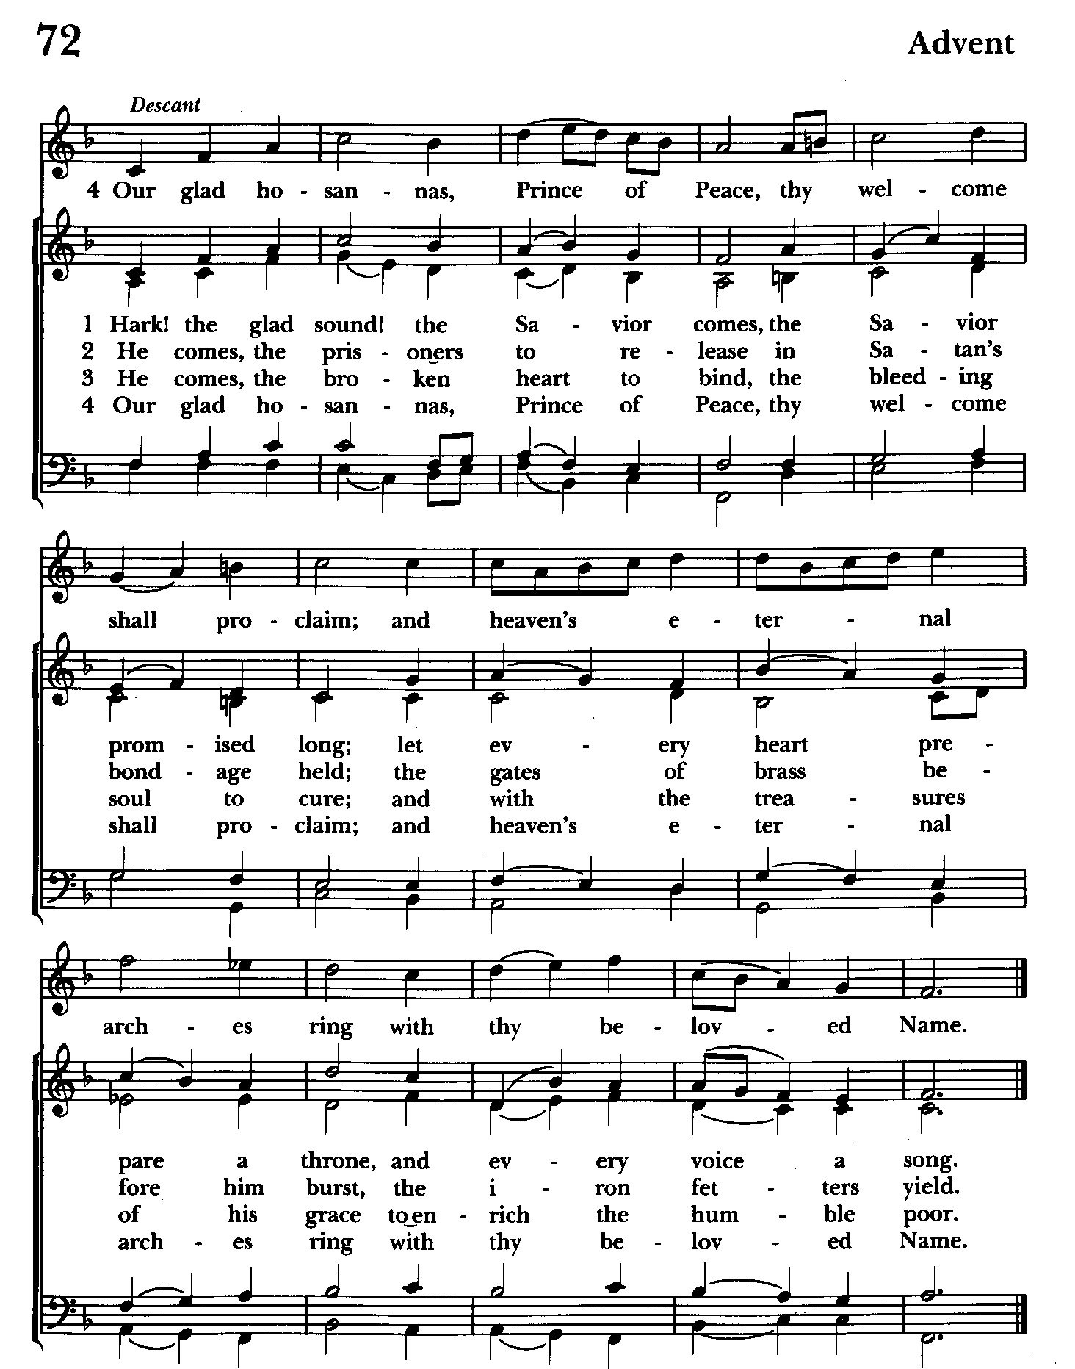

Living among us, Jesus loved us. He broke bread with outcasts and sinners, healed the sick, and proclaimed good news to the poor. He yearned to draw all the world to himself yet we were heedless of his call to walk in love. Then, the time came for him to complete upon the cross the sacrifice of his life, and to be glorified by you.

On the night before he died for us, Jesus was at table with his friends. He took bread, gave thanks to you, broke it, and gave it to them, and said: “Take, eat: This is my Body, which is given for you. Do this for the remembrance of me.” As supper was ending, Jesus took the cup of wine. Again, he gave thanks to you, gave it to them, and said: “Drink this, all of you: This is my Blood of the new Covenant, which is poured out for you and for all for the forgiveness of sins. Whenever you drink it, do this for the remembrance of me.”

Now gathered at your table, O God of all creation, and remembering Christ, crucified and risen, who was and is and is to come, we offer to you our gifts of bread and wine,
and ourselves, a living sacrifice.

Pour out your Spirit upon these gifts that they may be the Body and Blood of Christ.
Breathe your Spirit over the whole earth and make us your new creation, the Body of Christ given for the world you have made

In the fullness of time bring us, with St. John and all your saints, from every tribe and language and people and nation, to feast at the banquet prepared from the foundation of the world.

Through Christ and with Christ and in Christ, in the unity of the Holy Spirit,
to you be honor, glory, and praise, for ever and ever. AMEN.

And now as our Savior Christ has taught us, we are bold to say,

Celebrant and People:
Our Father, who art in heaven,
hallowed be thy Name,
thy kingdom come,
thy will be done,
on earth as it is in heaven.
Give us this day our daily bread.
And forgive us our trespasses,
as we forgive those
who trespass against us.
And lead us not into temptation,
but deliver us from evil.
For thine is the kingdom,
and the power, and the glory,
for ever and ever. Amen.

INVITATION TO COMMUNION
The Breaking of the Bread
The Celebrant breaks the consecrated Bread.
A period of silence is kept.

[Alleluia.] Christ our Passover is sacrificed for us;
Therefore let us keep the feast. [Alleluia.]

Communion hymn: Watchman, tell us of the night Hymnal #640
(see next page)

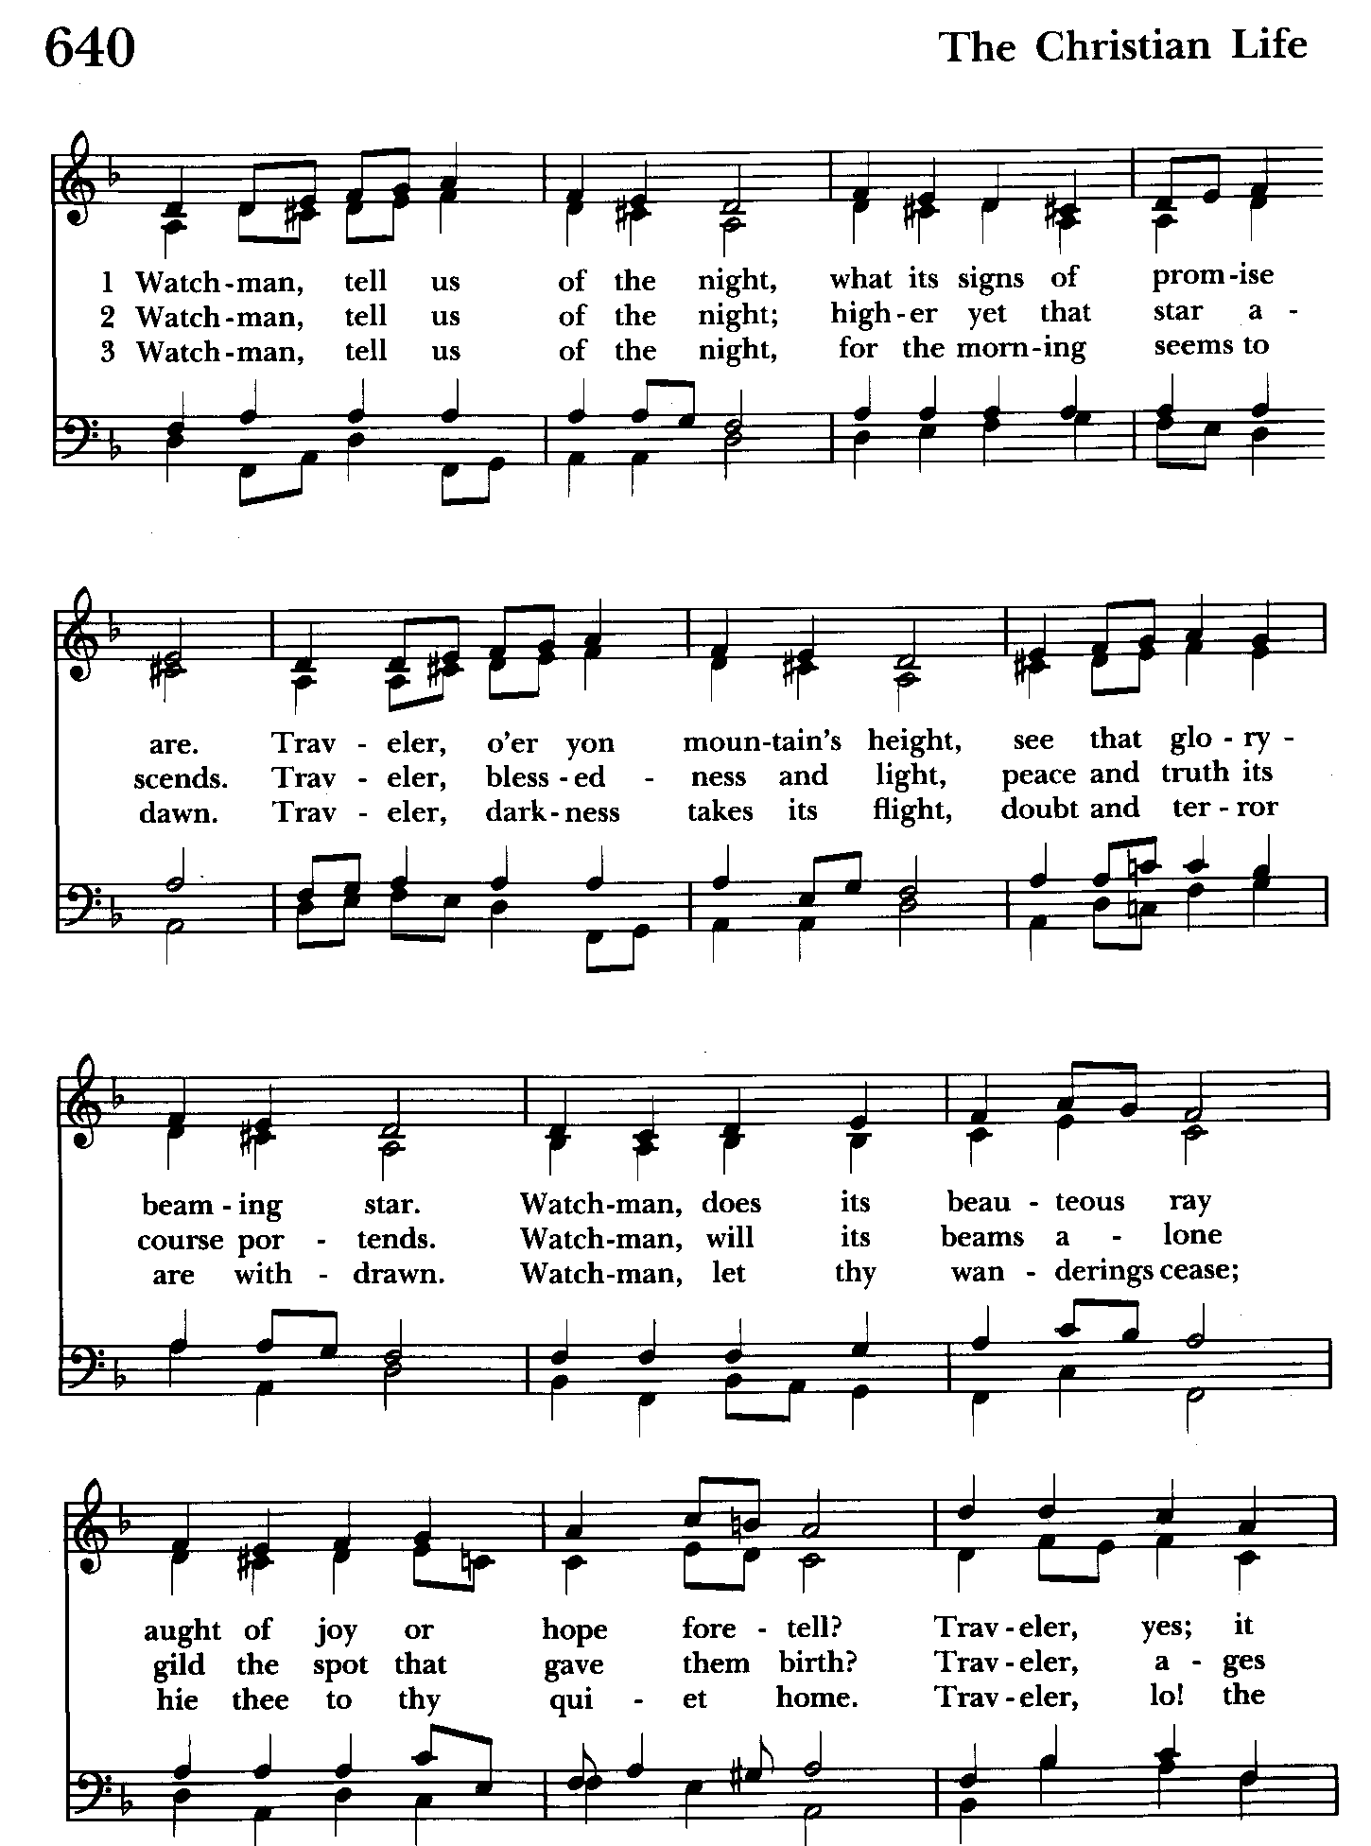

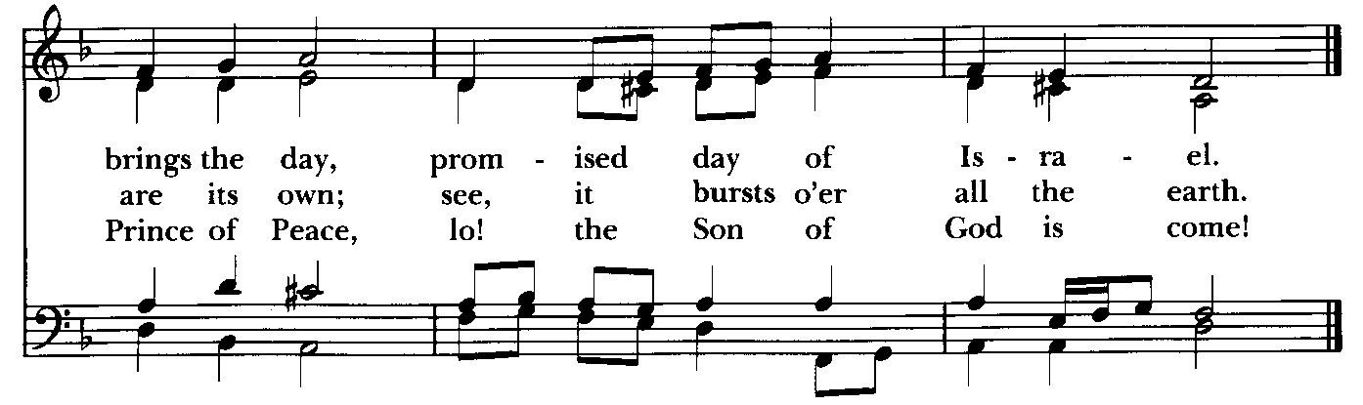

God of abundance, you have fed us with the bread of life and cup of salvation; you have united us with Christ and one another; and you have made us one with all your people in heaven and on earth. Now send us forth in the power of your Spirit, that we may proclaim your redeeming love to the world and continue for ever in the risen life of Christ our Savior. Amen.

or

Loving God, we give you thanks for restoring us in your image and nourishing us with spiritual food in the Sacrament of Christ’s Body and Blood. Now send us forth a people, forgiven, healed, renewed; that we may proclaim your love to the world and continue in the
risen life of Christ our Savior. Amen.

Blessings
Holy eternal Majesty, Holy incarnate Word, Holy abiding Spirit, Bless you for evermore. Amen.

May the blessing of the God of Abraham and Sarah, and of Jesus Christ born of our sister Mary, and of the Holy Spirit, who broods over the world as a mother over her children, be upon you and remain with you always. Amen.

God’s Blessing be with you, Christ’s peace be with you, the Spirit’s outpouring be with you, now and always. Amen.

The Wisdom of God the Love of God and the Grace of God strengthen you
to be Christ’s hands and heart in this world, in the name of the Holy Trinity. Amen.
(source: Celtic)
Live without fear: your Creator has made you holy, has always protected you, and loves you as a mother. Go in peace to follow the good road and may God’s blessing be with you always. Amen.

Closing hymn: Hail to the Lord’s Anointed Hymnal #616
(see below and next page)

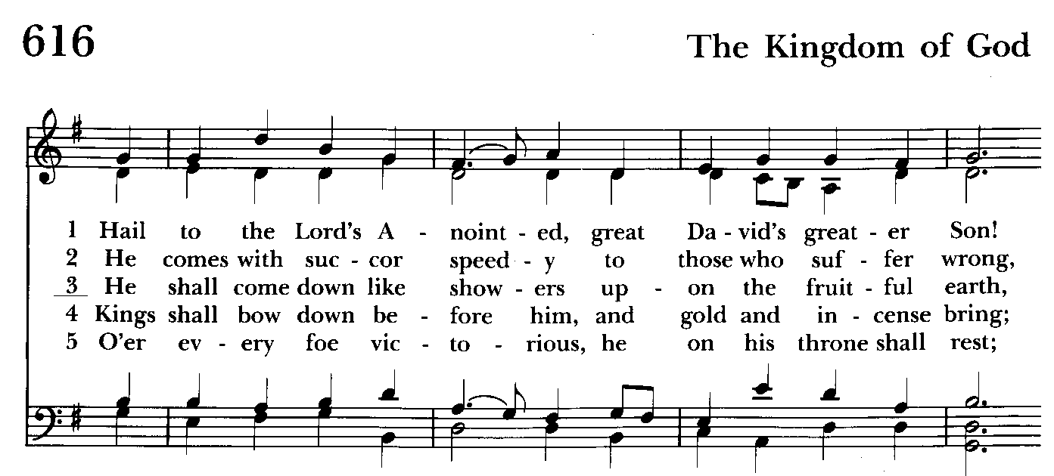

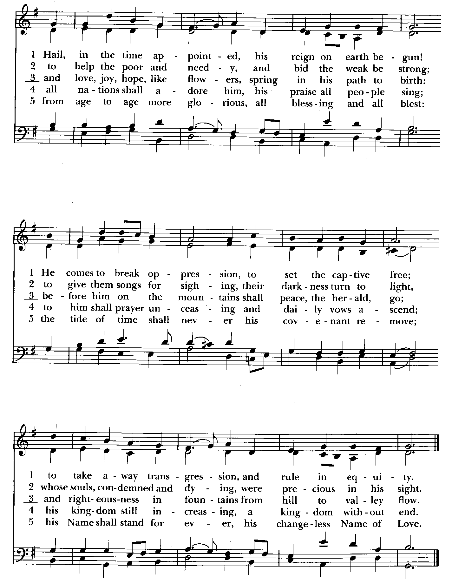

Serving Today

Celebrant and Preacher: The Rev. Mark Lobb
8:00 Reader: Woodie Tingle 10:30 1st Lesson: Barb Daniel
Prayers of the People: Woodie Tingle Psalm: Ty Schwenk
Server: Jennifer Scepaniak 2nd Lesson: Anne Leland
Prayers of the People: John Frost
Server: Terry Roe
Music Director: Nancy Heinold
Bell Choir: Nanci Rosendale, Linda Posten, Karen Smith-Manar, Liz Healey, John
Stevens, Janine Stevens, Ty Schwenk
Altar Guild: John Stevens & Woodie Tingle


Altar Flowers
Given to the Glory of God
by Frank & Stephanie Duchacek
in memory of Margaret Slitzer

St. John’s Parish Prayer List

Additions and corrections may be made to our Parish Prayer List at any time. All names will be automatically removed from the Parish Prayer List on the 1st Sunday of each month unless you request otherwise. Please contact Angie at <office@stjohnskingsville.org> or 410-592-8570 in the church office with all changes by 10 am Thursdays. Thank you.

We Pray for Those in Need:
Names in BOLD read aloud by all.

DeMarino Family, Jim & Chris Carden and family, Peggie Dietz, Mike Carden, Pat Carden, Gail Landers, Sheila Jones, Gloria Millar, Marisol Aubrey, Ross Strickler, Jim and Janice Sieracki, James Daniel Jr, Larry Betzler, Camy Schwenk, Dennis Mally, Zach Walsh, Edward.

We Pray for our Homebound

Lily John, Barbara Miller, Nancy Barnhart, Robin Dilworth

We pray for the Church and the World:

For +Justin, Archbishop of Canterbury; for +Sean, our Presiding Bishop; for +Carrie, our Bishop, for Mark+, our Interim Rector, for the Wardens, Vestry, Staff, and all members and friends of St. John’s Church.

For the leaders of all nations, especially for Joseph, our President; for Wes, our Governor; for Brandon, Nick, John and Bob, who lead our City and Counties. We pray for all children and youth; for the homeless, the unemployed, and the hungry. We pray for the safety of our loved ones and friends serving in the Armed Forces at home and abroad, and for our enemies, that all our hearts may be turned toward peace throughout the world.
From the Treasurer
November ‘24 Income vs. Expenses:

Projected November Expenses: $13,500
Monies Received as of 11/27: $12,474
Amount Needed to meet Expenses: $1,026


If you’d like to make a donation to St. John’s you can scan this QR code with your phone’s camera or tap on the link that comes up to make a contribution with either a credit or debit card, Apple Pay or Google Pay. This is a secure site provided by Clover which is a
service of PNC Bank.


Annual Christmas Tree Lighting and Carol Sing
Sunday December 8th at 7:00 p.m.

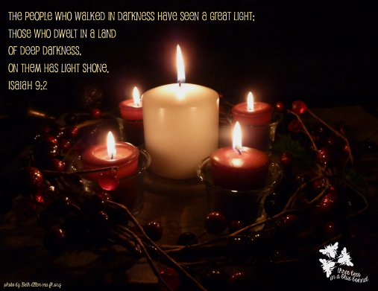
Service of Solace will be held on
Tuesday, December 10th at 7 pm


SUNDAY SCHOOL
Kids Sunday School- Begin in the church, ring the bell, then process over to the parish hall for a fun lesson with Mr. John and Ms. Stephanie.


With so much going on, everyone’s help is needed to make things a success. Our volunteers make the Church function. The volunteering of time and talent is greatly appreciated.


Choral Choir and Bell Choir
Choir rehearsals Wednesdays at 7:00 pm and Bell Choir Rehearsal, Sundays after the 10:30 service. If anyone is interested in joining, see Nancy Heinold, our Music Director.


Yoga classes on Tuesday, Wednesday and Friday evenings 6 to 7 pm and Saturday mornings 9 to 10 am in the Chapel. All experience levels are welcome.

Calendar Updates

Community Christmas Tree Lighting and Cantata - 12/8, 7 pm

Blue Christmas/Service of Solace– 12/10, 7 pm

Christmas Lessons & Carols - 12/29, 10:30 am

Calendars are living documents. Every effort will be made to keep the members of the parish and community aware of any changes.

Advent is coming! Here is what to expect. ( See what I did there?)

Book/Bible Study- On Sundays 12/1,12/15, and 12-22, we will discuss readings from Holidays and Holy Days: A Benedictine Walk through Advent by Albert Holtz, O.S.B. Sessions will be from 9:00 to 9:30. This book calls us to engage with Advent themes through the lens of Holy Scripture and the Rule of St. Benedict. Four copies have been ordered. Participants can reserve one of those or order a copy separately. Let Fr. Mark know if you need assistance obtaining a copy.

Advent Lessons and Carols- In partnership with our neighboring, and historically linked parish, Church of the Resurrection in Joppatowne, all are invited to participate in this traditional Anglican custom.
12/1- Advent Lessons and Carols- 2:30 p.m. at Church of the Resurrection.
12/8- Kingsville Community Tree Lighting with readings and carols- 7:00 pm at St. John's Episcopal Church in Kingsville.
12/15- Advent Lessons and Carols- 2:30 p.m. at Church of the Resurrection.
12/22- Advent Lessons and Carols– 2:30 p.m. at St. John's, Kingsville.

Food and fellowship will be available after each event. Please join us.

Blue Christmas/Service of Solace- For some in our community, it is difficult to find joy in the holiday season. For many reasons. You are invited to join others whose pain and grief are amplified at this time to worship together in a setting of empathy and healing. Tuesday, December 10. 7:00. St. John's, Kingsville.

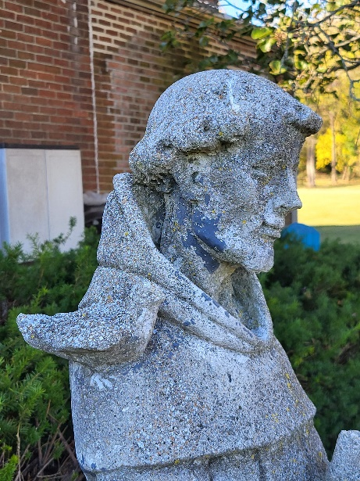
The St. Francis Garden has been put to bed for winter. But you can still enjoy God’s Grace Garden. Come sit a while!!
For more info or to sign up to help keep our gardens looking beautiful, contact: Rita Talley (Garden Club) 443-617-1820 or Karen Smith-Manar (St. John’s) 410-746-9813 or bikenbocal@verizon.net

God’s Grace Gardens—a St. John’s, Hill & Stream Garden Club and AA collaboration


Advent
Wreath
Workshop
Stay tuned
for details

10:30: Kids Sunday School- Begin in the church, ring the bell, then process over to the parish hall for a fun lesson with Mr. John and Ms. Stephanie. Note: Please seriously consider regular attendance at Sunday School so that Mr. John and Ms. Stephanie can plan good stuff.

OUTREACH

WHAT A GREAT GIFT TO GIVE SOMEONE A MERRY CHRISTMAS!!

With Christmas and Thanksgiving just around the corner the Helping Hands Food Pantry is preparing for its annual Meal Distribution.

Listed below is what they need:
Yams/Sweet Potatoes (small or medium cans), Instant
Potatoes (box or bag), Cranberries (canned), Sauerkraut (canned), cake mixes, cake icing (ready made)

Thank you so much!

RECYCLING!

Feed Me!
The recycling bins are hungry for more aluminum cans.

By popular demand, we are recycling. Some parishioners take printed paper home where they have recycling pickup. We now have a blue container located in the Parish Hall. This will be collected and taken for recycling. Aluminum cans will be saved and taken to a recycling center for cash. The proceeds will be donated to the Outreach fund. Each recycled aluminum can also save on the electricity needed to make new aluminum from bauxite.

Love Drops 2024 – Cookies made with Love – Calling all Cookie Makers and Volunteers
Greetings,
For the last few years during Advent, St. John’s has been making “Love Drops”, a gift of cookies (lovingly made by the congregation), candy and greetings from St. John’s. Hand delivered to our parishioners, shut-ins, local community businesses and organizations (Kingsville Fire Department, Baltimore Co. Police, our AA leaders, etc), Love Drops have become an annual outreach to those who mean so much to our parish life.
This year we are planning to assemble the packages on December 21st so that our delivery elves (volunteers needed) can make their rounds before Christmas. About 100 Love Drops will leave the Parish Hall that day for distribution all around our community.
Of course, we’ll need your help. More cookies please! It takes a lot of cookies to fill our packages and we’re hoping that you have it in you to make one more dozen or two. Cookies should be packaged 4 to a zip lock bag and labeled if possible (no nuts please).
To recap…here’s what we need:
· Cookies, 4 to a bag, delivered to St. John’s parish hall by 10 am Saturday, 12/21. If you would like someone to come pick up your cookies just let us know and we’ll make arrangements to do so.
· Love Drop package assemblers. We’ll meet at 10am in the hall on 12/21
· Cookie delivery elves. Packages should be ready for delivery by early afternoon on the 21st.
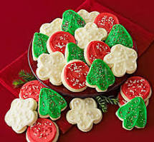
Thanks so much for all your help. It’s truly appreciated, and we promise that this is the last call for cookies….until the next flea market.
Sincerely,
The Love Drop Team

Christmas Services
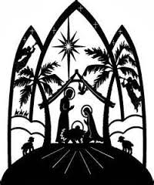
Tuesday, Christmas Eve
5:00 p.m. Family Service
9:00 p.m. Choral Holy Eucharist
Wednesday, Christmas Day
9:30 a.m. Rite I Service
Sunday, 1st Sunday after Christmas
10:30 a.m. Lessons & Carols

What’s Happening This Week at St. John’s

Sunday, December 1—First Sunday of Advent
8:00am: Holy Eucharist, Said Service (Church)
10:30am: Holy Eucharist, with Music (Church)
10:30am-11:00am: Sunday School
11:30am: Potluck (Parish Hall)

Monday, December 2
12:00-1:00pm: AA Lunch Bunch (Parish Hall)
6:30-8:00pm: Spanish speaking AA group (Parish Hall)

Tuesday, December 3
12:00-1:00pm: AA Lunch Bunch (Parish Hall)
6:00-7:00pm: Yoga (Chapel)

Wednesday, December 4
12:00-1:00pm: AA Lunch Bunch (Parish Hall)
6:00-7:00pm: Yoga (Chapel)
7:00pm: Choir Rehearsal(Church)
7:30pm: AA (Parish Hall)

Thursday, December 5
12:00-1:00pm: AA Lunch Bunch (Parish Hall)
7:00pm: AA (Parish Hall)

Friday, December 6
12:00-1:00pm: AA Lunch Bunch (Parish Hall)
6:00-7:00pm: Yoga (Chapel)

Saturday, December 7
9:00-10:00am: Yoga (Chapel)
8:30pm: AA (Parish Hall)


Sunday, December 8—Second Sunday of Advent
8:00am: Holy Eucharist, Said Service (Church)
10:30am: Holy Eucharist, with Music (Church)
10:30am-11:00am: Sunday School
11:30am: Coffee Hour (Parish Hall)
Bell Choir Rehearsal (Church)
7:00pm: Community Tree Lighting

Parish Office is open Monday, Wednesday and Thursday, 9:30am-1:30pm.

Potluck Luncheon on the first Sunday of the month and a Coffee Hour on all other Sundays after the 10:30 service.

