St. John’s Episcopal Church
Kingsville, Maryland
Welcomes You

OUR VISION STATEMENT
We believe that together we will transform the world with love: Come on in!



Twenty third Sunday after Pentecost
October 27, 2024
10:30 am, Rite II

St. John’s Episcopal Church

11901 Belair Road, P. O. Box 187, Kingsville, MD 21087
Facebook: St. John’s Episcopal, Kingsville, MD
Email: office@stjohnskingsville.org
Website: www.stjohnskingsville.org
Church Phone: 410-592-8570
For Pastoral Emergencies: Fr. Mark Lobb+ 443-690-9545

Welcome to worship today! We are glad that you are with us. You are invited to participate in all parts of the service as indicated in the Book of Common Prayer and this service bulletin. If you have any questions, feel free to ask the ushers. Restrooms are located in the Parish hall, the brick building across the parking lot.

I was glad when they said to me, “Let us go to the house of the Lord.” Psalm 122:1

Church Staff

Interim Rector: Father Mark Lobb
Administrative Assistant: Angie Bosley
Organist/Choir Director: Nancy Heinold

The Vestry

Class of 2025 Class of 2026

John Frost John Stevens
Woodie Tingle
Jacob Johnson

Officers
Ty Schwenk—Sr. Warden Terry Roe—Jr. Warden
Elizabeth Healey—Treasurer Anne Leland-Registrar

Parish Committee Chairpersons

Altar Guild: Elizabeth Healey
Auxiliary Committee: Michele Lozanski
Cemetery Committee: Terry Roe

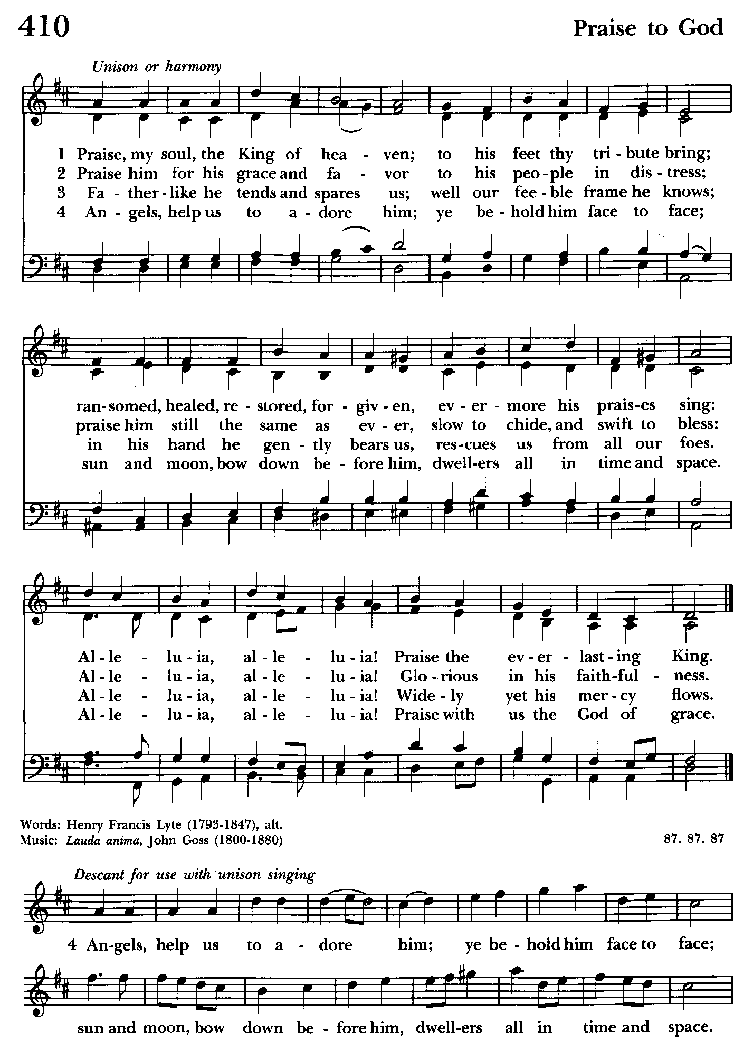

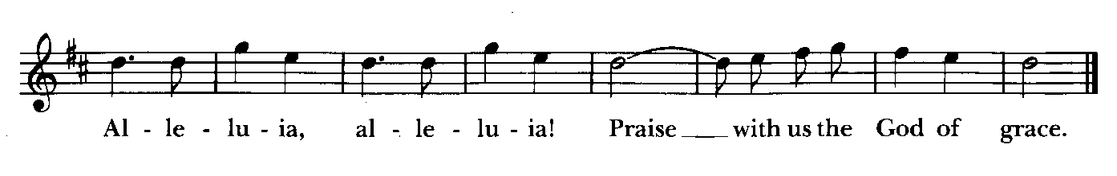

10:30 am Worship
Holy Eucharist, Rite Two

Prelude:

The Word of God

Processional hymn: Praise, my soul, the King of heaven Hymnal #410
(see previous page)

The congregation remains standing as able
Celebrant: Blessed be God: Father, Son, and Holy Spirit. BCP 355
People: And blessed be his kingdom, now and for ever. Amen.

Celebrant: Almighty God, to you all hearts are open, all desires known, and from you no secrets are hid: Cleanse the thoughts of our hearts by the inspiration of your Holy Spirit, that we may perfectly love you, and worthily magnify your holy Name; through Christ our Lord. Amen.

Gloria Hymnal #S-278
Glory to God in the highest,
and peace to his people on earth.
Lord God, heavenly King,
almighty God and Father,
we worship you, we give you thanks,
we praise you for your glory.
Lord Jesus Christ, only Son of the Father,
Lord God, Lamb of God,
you take away the sin of the world:
have mercy on us;
you are seated at the right hand of the Father:
receive our prayer.
For you alone are the Holy One,
you alone are the Lord,
you alone are the Most High,
Jesus Christ,
with the Holy Spirit,
in the glory of God the Father. Amen.

Celebrant: The Lord be with you.
People: And also with you.
Celebrant: Let us pray.

The Collect of the Day Kneel or stand as able BCP 235
Almighty and everlasting God, increase in us the gifts of faith, hope, and charity; and, that we may obtain what you promise, make us love what you command; through Jesus Christ our Lord, who lives and reigns with you and the Holy Spirit, one God, for ever and ever. Amen.

The congregation is seated.

A Reading from the Book of Job 42:1-6, 10-17
Job answered the Lord:
“I know that you can do all things,
and that no purpose of yours can be thwarted.
‘Who is this that hides counsel without knowledge?’
Therefore I have uttered what I did not understand,
things too wonderful for me, which I did not know.
‘Hear, and I will speak;
I will question you, and you declare to me.’
I had heard of you by the hearing of the ear,
but now my eye sees you;
therefore I despise myself,
and repent in dust and ashes.”

And the Lord restored the fortunes of Job when he had prayed for his friends; and the Lord gave Job twice as much as he had before. Then there came to him all his brothers and sisters and all who had known him before, and they ate bread with him in his house; they showed him sympathy and comforted him for all the evil that the Lord had brought upon him; and each of them gave him a piece of money and a gold ring. The Lord blessed the latter days of Job more than his beginning; and he had fourteen thousand sheep, six thousand camels, a thousand yoke of oxen, and a thousand donkeys. He also had seven sons and three
daughters. He named the first Jemimah, the second Keziah, and the third Keren-happuch. In all the land there were no women so beautiful as Job’s daughters; and their father gave them an inheritance along with their brothers.
After this Job lived for one hundred and forty years, and saw his children, and his children’s children, four generations. And Job died, old and full of days.

Reader: The Word of the Lord.
People: Thanks be to God.

Psalm 34:1-8, (19-22) (Pray as directed)
1 I will bless the Lord at all times; *
his praise shall ever be in my mouth.
2 I will glory in the Lord; *
let the humble hear and rejoice.
3 Proclaim with me the greatness of the Lord; *
let us exalt his Name together.
4 I sought the Lord, and he answered me *
and delivered me out of all my terror.
5 Look upon him and be radiant, *
and let not your faces be ashamed.
6 I called in my affliction and the Lord heard me *
and saved me from all my troubles.
7 The angel of the Lord encompasses those who fear him, *
and he will deliver them.
8 Taste and see that the Lord is good; *
happy are they who trust in him!
19 [Many are the troubles of the righteous, *
but the Lord will deliver him out of them all.
20 He will keep safe all his bones; *
not one of them shall be broken.
21 Evil shall slay the wicked, *
and those who hate the righteous will be punished.
22 The Lord ransoms the life of his servants, *
and none will be punished who trust in him.]

A Reading from the Letter to the Hebrews 7:23-28
The former priests were many in number, because they were prevented by death from continuing in office; but Jesus holds his priesthood permanently, because he continues forever. Consequently he is able for all time to save those who approach God through him, since he always lives to make intercession for them.
For it was fitting that we should have such a high priest, holy, blameless, undefiled, separated from sinners, and exalted above the heavens. Unlike the other high priests, he has no need to offer sacrifices day after day, first for his own sins, and then for those of the people; this he did once for all when he offered himself. For the law appoints as high priests those who are subject to weakness, but the word of the oath, which came later than the law, appoints a Son who has been made perfect forever.

Reader: The Word of the Lord.
People: Thanks be to God.

Gradual hymn: Ye servants of God, your Master proclaim Hymnal #535
(see next page)

The congregation remains standing as able

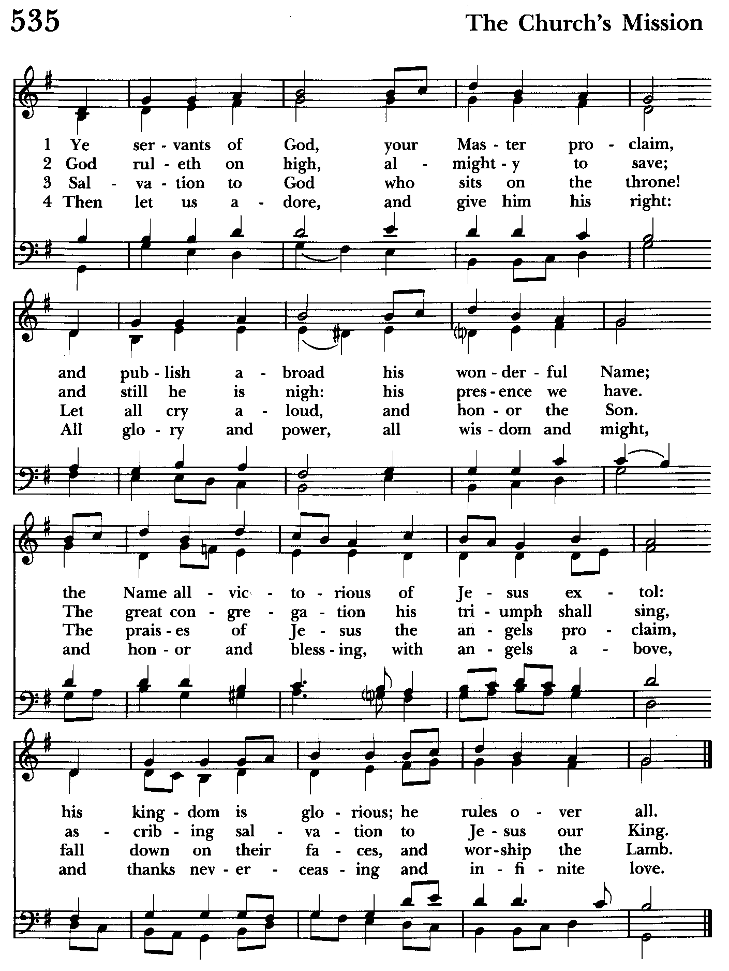

Priest: The Holy Gospel of our Lord Jesus Christ according to Mark 10:46-52

People: Glory to you, Lord Christ.
Jesus and his disciples came to Jericho. As he and his disciples and a large crowd were leaving Jericho, Bartimaeus son of Timaeus, a blind beggar, was sitting by the roadside. When he heard that it was Jesus of Nazareth, he began to shout out and say, “Jesus, Son of David, have mercy on me!” Many sternly ordered him to be quiet, but he cried out even more loudly, “Son of David, have mercy on me!” Jesus stood still and said, “Call him here.” And they called the blind man, saying to him, “Take heart; get up, he is calling you.” So throwing off his cloak, he sprang up and came to Jesus. Then Jesus said to him, “What do you want me to do for you?” The blind man said to him, “My teacher, let me see again.” Jesus said to him, “Go; your faith has made you well.” Immediately he regained his sight and followed him on the way.

Priest: The Gospel of the Lord.
People: Praise to you, Lord Christ.

Sermon The congregation is seated Nancy Dellinger

The Nicene Creed Please stand as able BCP 358
We believe in one God,
the Father, the Almighty,
maker of heaven and earth,
of all that is, seen and unseen.
We believe in one Lord, Jesus Christ,
the only Son of God,
eternally begotten of the Father,
God from God, Light from Light,
true God from true God,
begotten, not made,
of one Being with the Father.
Through him all things were made.
For us and for our salvation
he came down from heaven:
by the power of the Holy Spirit
he became incarnate from the Virgin Mary,
and was made man.

For our sake he was crucified under Pontius Pilate;
he suffered death and was buried.
On the third day he rose again
in accordance with the Scriptures;
he ascended into heaven
and is seated at the right hand of the Father.
He will come again in glory to judge the living and the dead,
and his kingdom will have no end.
We believe in the Holy Spirit, the Lord, the giver of life,
who proceeds from the Father and the Son.
With the Father and the Son he is worshiped and glorified.
He has spoken through the Prophets.
We believe in one holy catholic and apostolic Church.
We acknowledge one baptism for the forgiveness of sins.
We look for the resurrection of the dead,
and the life of the world to come. Amen.

The Prayers of the People Form VI Kneel or stand as able BCP 392
Litanist: In peace, we pray to you, Lord God.

Litanist: For all people in their daily life and work;
People: For our families, friends, and neighbors, and for those who are alone.

Litanist: For this community, the nation, and the world;
People: For all who work for justice, freedom, and peace.

Litanist: For the just and proper use of your creation;
People: For the victims of hunger, fear, injustice, and oppression.

Litanist: For all who are in danger, sorrow, or any kind of trouble;
People: For those who minister to the sick, the friendless, and the needy.

Litanist: For the peace and unity of the Church of God;
People: For all who proclaim the Gospel, and all who seek the Truth.

Litanist: For +Justin, Archbishop of Canterbury; +Michael, our Presiding Bishop; +Sean, our Presiding Bishop Elect, +Carrie, our Bishop, Mark+ our Interim Rector, for the Wardens, Vestry, Staff, and all members and friends of St. John’s Church.
People: For all who serve God in his Church.

Litanist: For the special needs and concerns of this congregation. Especially remember in our prayers, DeMarino Family, Jim & Chris Carden and family, Peggie Dietz, Mike Carden, Pat Carden, Gail Landers, Sheila Jones, Gloria Millar, Marisol Aubrey, Ross Strickler, Jim & Janice Sieracki, James Daniel, Jr., Larry Betzler, Camy Schwenk, Edward, Lily John, Barbara Miller, Nancy Barnhart, Robin Dilworth.
The People may add their own petitions

Litanist: Hear us, Lord;
People: For your mercy is great.
Litanist: We thank you, Lord, for all the blessings of this life.

The People may add their own thanksgivings

Litanist: We will exalt you, O God our King;
People: And praise your Name for ever and ever.

Litanist: We pray for all who have died, that they may have a place in your
eternal kingdom.

The People may add their own petitions
Litanist: Lord, let your loving-kindness be upon them;
People: Who put their trust in you.

Litanist: We pray to you also for the forgiveness of our sins.
People: Have mercy upon us, most merciful Father; in your compassion forgive us our sins, known and unknown, things done and left undone; and so uphold us by your Spirit that we may live and serve you in newness of life, to the honor and glory of your Name; through Jesus Christ our Lord. Amen.

The Celebrant gives the absolution.

The Peace Please stand as able BCP 360

Welcome & Announcements The congregation is seated.

Offertory Anthem: Was I Faithful (Choir)
Offertory Hymn: Amazing Grace Hymnal #671
(see next page) The people remain seated.

Offertory: Offerings are collected

Presentation Hymn Offerings are presented Please stand as able Hymnal #43, vs. 4
Praise God, from whom all blessings flow; praise him, all creatures here below; praise him above, ye heavenly host: praise Father, Son, and Holy Ghost.

The Holy Communion

THE GREAT THANKSGIVING: Eucharistic Prayer B BCP 367
Celebrant: The Lord be with you.
People: And also with you.
Celebrant: Lift up your hearts.

People: We lift them to the Lord.
Celebrant: Let us give thanks to the Lord our God.
People: It is right to give him thanks and praise.

Then, facing the Holy Table, the Celebrant proceeds
It is right, and a good and joyful thing, always and everywhere to give thanks to you, Father Almighty, Creator of heaven and earth.

Therefore we praise you, joining our voices with Angels and Archangels and with all the company of heaven, who for ever sing this hymn to proclaim the glory of your Name:

Celebrant and People:
Holy, Holy, Holy Lord, God of power and might, Hymnal #S-129
heaven and earth are full of your glory.
Hosanna in the highest.
Blessed is he who comes in the name of the Lord.
Hosanna in the highest.
Please kneel or stand as able

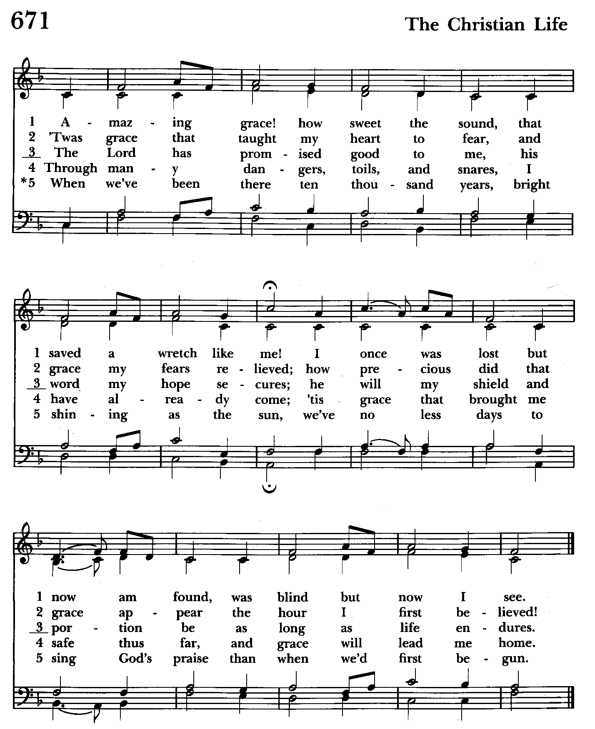

Then the Celebrant continues BCP 368
We give thanks to you, O God, for the goodness and love which you have made known to us in creation; in the calling of Israel to be your people; in your Word spoken through the prophets; and above all in the Word made flesh, Jesus, your Son. For in these last days you sent him to be incarnate from the Virgin Mary, to be the Savior and Redeemer of the world. In him, you have delivered us from evil, and made us worthy to stand before you. In him, you have brought us out of error into truth, out of sin into righteousness, out of death into life.

At the following words concerning the bread, the Celebrant is to hold it, or to lay a hand upon it; and at the words concerning the cup, to hold or place a hand upon the cup and any other vessel containing wine to be consecrated.

On the night before he died for us, our Lord Jesus Christ took bread; and when he had given thanks to you, he broke it, and gave it to his disciples, and said, "Take, eat: This is my Body, which is given for you. Do this for the remembrance of me."

After supper he took the cup of wine; and when he had given thanks, he gave it to them, and said, "Drink this, all of you: This is my Blood of the new Covenant, which is shed for you and for many for the forgiveness of sins. Whenever you drink it, do this for the remembrance of me."

Therefore, according to his command, O Father,

Celebrant and People:
We remember his death,
We proclaim his resurrection,
We await his coming in glory;

The Celebrant continues
And we offer our sacrifice of praise and thanksgiving to you, O Lord of all; presenting to you, from your creation, this bread and this wine. We pray you, gracious God, to send your Holy Spirit upon these gifts that they may be the Sacrament of the Body of Christ and his Blood of the new Covenant. Unite us to your Son in his sacrifice, that we may be acceptable through him, being sanctified by the Holy Spirit. In the fullness of time, put all things in subjection under your Christ, and bring us to that heavenly country where, with St. John and the Blessed Virgin Mary and all your saints, we may enter the everlasting heritage of your sons and daughters; through Jesus Christ our Lord, the firstborn of all creation, the head of the Church, and the author of our salvation.

By him, and with him, and in him, in the unity of the Holy Spirit all honor and glory is yours, Almighty Father, now and for ever. Amen.

And now, as our Savior Christ has taught us, we are bold to say,

Our Father, who art in heaven, BCP p. 364
hallowed be thy Name,
thy kingdom come,
thy will be done,
on earth as in heaven.
Give us this day our daily bread.
And forgive us our trespasses,
as we forgive those
who trespass against us.
And lead us not into temptation,
but deliver us from evil.
For thine is the kingdom,
and the power, and the glory, for ever and ever. Amen.

Invitation to Communion

The Breaking of the Bread
Celebrant: Alleluia. Christ our Passover is sacrificed for us;
People: Therefore let us keep the feast. Alleluia.
Celebrant: The Gifts of God for the people of God.

The congregation is seated
Communion hymn: Just as I am, without one plea Hymnal #693
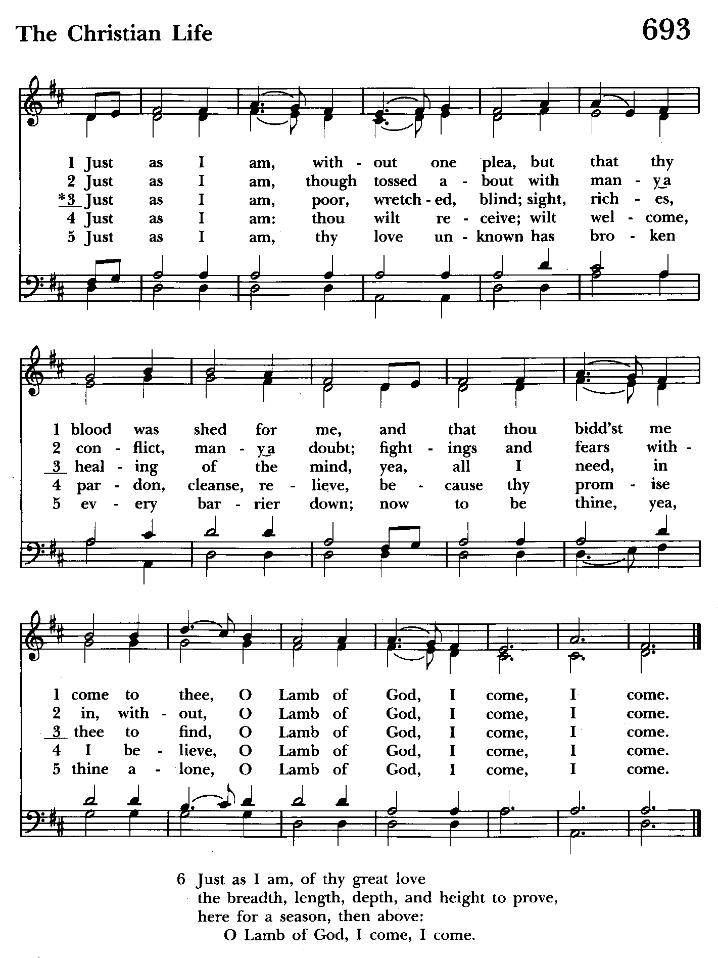

The Post Communion Prayer BCP p. 365
Eternal God, heavenly Father, you have graciously accepted us as living members of your Son our Savior Jesus Christ, and you have fed us with spiritual food in the Sacrament of his Body and Blood. Send us now into the world in peace, and grant us strength and courage to love and serve you with gladness and singleness of heart; through Christ our Lord. Amen.

Blessing

Recessional hymn: Thine arm, O Lord, in days of old Hymnal #567
(see next 2 pages)

The Dismissal
Celebrant: Let us go forth in the name of the risen Lord.
People: Thanks be to God.

Postlude:

License #A-719154

THIS IS THE LAST DAY TO ACCEPT NAMES FOR ALL SOULS LIST

Serving Today

Celebrant and Preacher: The Rev. Mark Lobb+
Old Testament: Michele Lozanski
Psalm: Michele Lozanski
New Testament: Tony Rising
Prayers of the People: John Frost
Server: Marguerite Lobb
Music Director: Nancy Heinold
Choir: Anne Leland, Nancy Dellinger, Janine Stevens, Liz Healey, Camy Schwenk,
Karen Smith-Manar, Jacob Johnson, Ty Schwenk
Altar Guild: Liz Healey & Marguerite Lobb

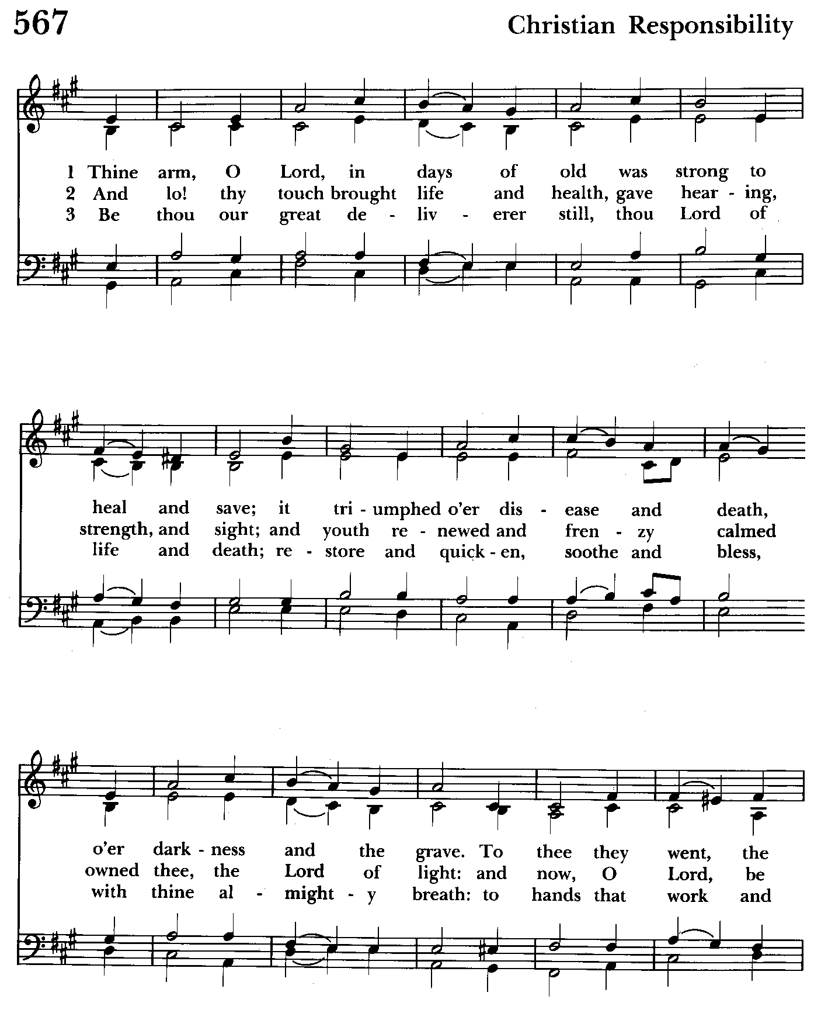

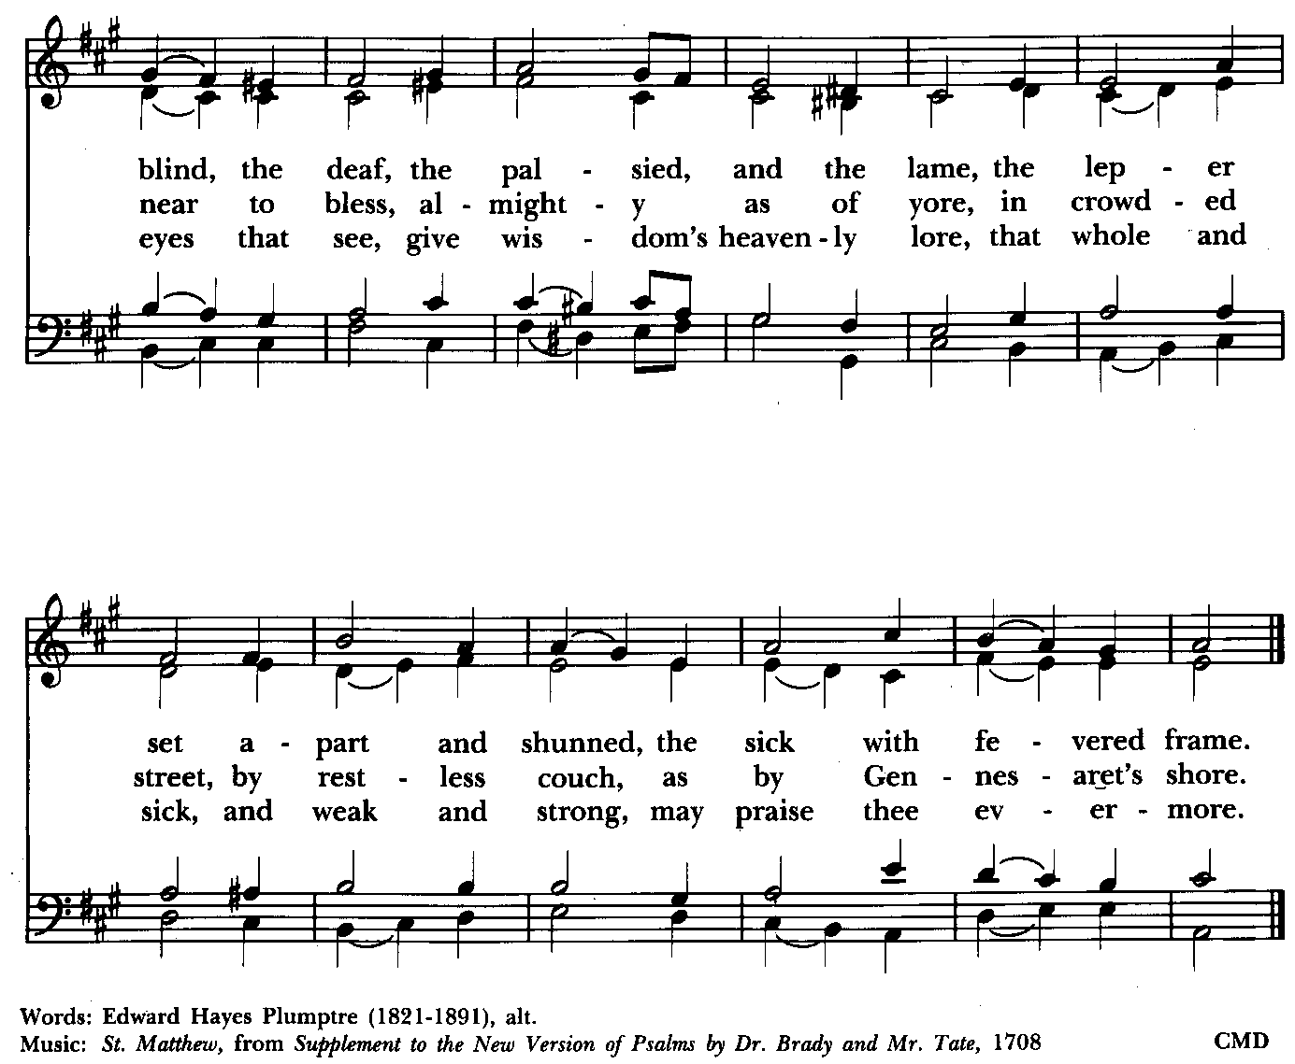

St. John’s Parish Prayer List

Additions and corrections may be made to our Parish Prayer List at any time. All names will be automatically removed from the Parish Prayer List on the 1st Sunday of each month unless you request otherwise. Please contact Angie at <office@stjohnskingsville.org> or 410-592-8570 in the church office with all changes by 10 am Thursdays. Thank you.

We Pray for Those in Need:
Names in BOLD read aloud by all.

DeMarino Family, Jim & Chris Carden and family, Peggie Dietz, Mike Carden, Pat Carden, Gail Landers, Sheila Jones, Gloria Millar, Marisol Aubrey, Ross Strickler, Jim and Janice Sieracki, James Daniel, Jr, Larry Betzler, Camy Schwenk, Edward.

We Pray for our Homebound

Lily John, Barbara Miller, Nancy Barnhart, Robin Dilworth

We pray for the Church and the World:

For +Justin, Archbishop of Canterbury; for +Michael, our Presiding Bishop; for +Sean, our Presiding Bishop Elect, for +Carrie, our Bishop, for Mark+, our Interim Rector, for the Wardens, Vestry, Staff, and all members and friends of St. John’s Church.

For the leaders of all nations, especially for Joseph, our President; for Wes, our Governor; for Brandon, Nick, John and Bob, who lead our City and Counties. We pray for all children and youth; for the homeless, the unemployed, and the hungry. We pray for the safety of our loved ones and friends serving in the Armed Forces at home and abroad, and for our enemies, that all our hearts may be turned toward peace throughout the world.

Calendar Updates
Morning Prayer- will be offered on the following Sundays: 12/29. Lay people are highly encouraged to consider helping by officiating and/or preaching of Morning Prayer. I am willing to help you prepare for this.

Would it be helpful to have an “Officiating Morning Prayer” class? Let me know.

Bishop Carrie Visits - 11/3, ONE SERVICE AT 10:30 AM (2 baptisms & confirmation during service.). Fellowship with the Bishop & Luncheon to follow.

All Souls service- Sunday evening 7:00 11/3.

Community Christmas Tree Lighting and Cantata - 12/8, 7 pm

Blue Christmas/Service of Solace- TBD

Christmas Lessons & Carols - 12/29, 10:30 am

Calendars are living documents. Every effort will be made to keep the members of the parish and community aware of any changes.

SAVE THE DATE
God’s Grace Garden Workday—11/9 @ 8:30 am (Rain date 11/16 @ 8:30 am
Christmas Bazaar - 11/23


Altar Flowers
Given to the Glory of God by Barbara Daniel
in honor of Chrissy Darling’s Birthday

From the Treasurer
October ’24 Income vs. Expenses:
Projected October Expenses: $13,500
Monies Received as of 10/24: $10,872
Amount Needed to Meet Expenses: $2,628


If you’d like to make a donation to St. John’s you can scan this QR code with your phone’s camera or tap on the link that comes up to make a contribution with either a credit or debit card, Apple Pay or Google Pay. This is a secure site provided by Clover which is a service of PNC Bank.

9:00- 9:30: "Confirmation Class" - for any interested in Confirmation/Reception or any just interested. Walk In Love, (copies available).
10:30: Kids Sunday School- Begin in the church, ring the bell, then process over to the parish hall for a fun lesson with Mr. John and Ms. Stephanie. Note: Please seriously consider regular attendance at Sunday School so that Mr. John and Ms. Stephanie can plan good stuff.
Wednesday Mornings- Feed the Wolf!
Our book study is held Wednesdays at 9:00 a.m. in the Parish Hall. Books are still available.
Fr. Mark is open to additional locations and times for another group. Speak up if you have a suggestion.


SUNDAY SCHOOL
Kid’s Sunday School- Begin in the church, ring the bell, then process over to the parish hall for a fun lesson with Mr. John and Ms. Stephanie.

Choral Choir and Bell Choir
Choir rehearsals Wednesdays at 7:00 pm and Bell Choir Rehearsal, Sundays after the 10:30 service. If anyone is interested in joining, see Nancy Heinold, our Music Director.

Yoga classes on Tuesday, Wednesday and Friday evenings 6 to 7 pm and Saturday mornings 9 to 10 am in the Chapel. All experience levels are welcome.


With so much going on, everyone’s help is needed to make things a success. Our volunteers make the Church function. The volunteering of time and talent is greatly appreciated.

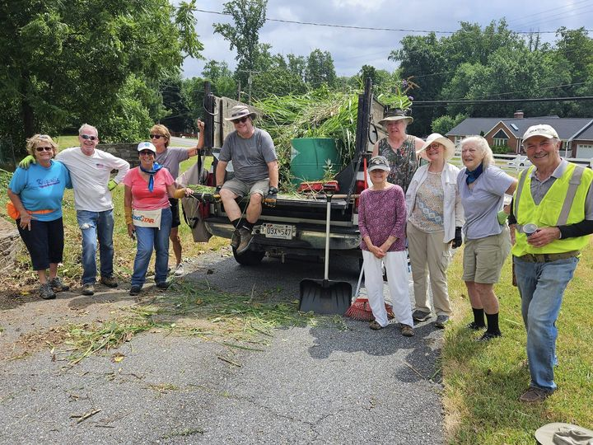
Come see the progress we’re making to Beautify our St. Francis Garden!!
For more info or to sign up to help keep our gardens looking beautiful, contact: Rita Talley-Garden Club, 443-617-1820 or Karen Smith-Manar-St. John’s 410-746-9813 or bikenbocal@verizon.net
Wish list: plant and tree food, hosta, liriope, mums, asters, shovels
Next Workday: 11/9 @ 8:30 am (Rain date: 11/16 @ 8:30 am)
God’s Grace Gardens—a St. John’s, Hill & Stream Garden Club
and AA collaboration

OUTREACH
WHAT A GREAT GIFT TO GIVE SOMEONE A MERRY CHRISTMAS!!
With Christmas and Thanksgiving just around the corner the Helping Hands Food Pantry is preparing for its annual Meal Distribution.

Listed below is what they need:
Yams/Sweet Potatoes (small or medium cans), Instant Potatoes (box or bag), Cranberries (canned), Sauerkraut (canned), cake mixes, cake icing (ready made)

Thank you so much!
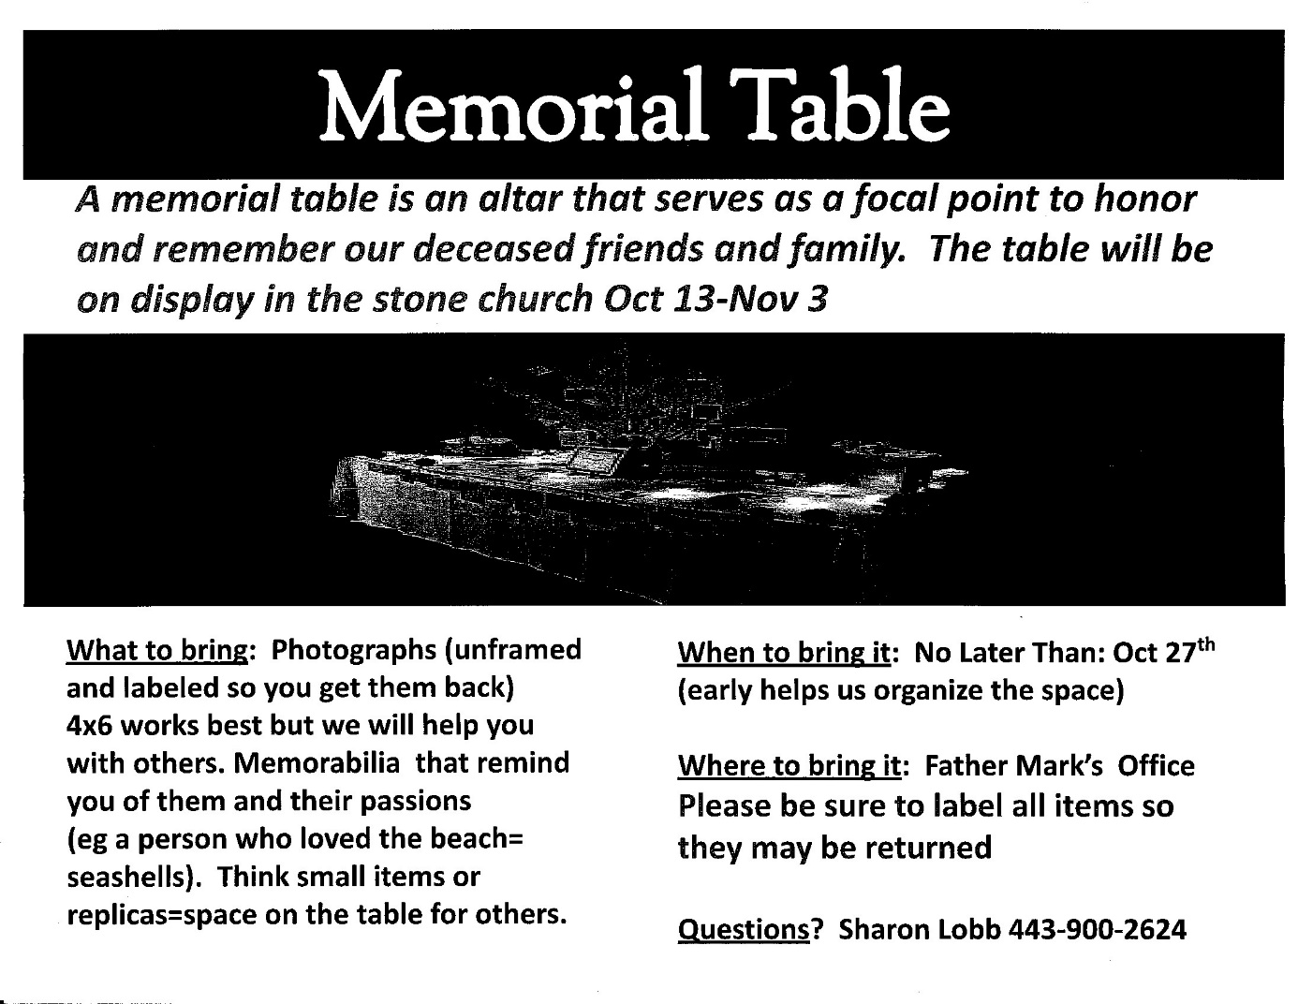

RECYCLING!
We have recycled a load aluminum cans for $8.45. Did you know that cat food cans are made from aluminum?

By popular demand, we are recycling. Some parishioners take printed paper home where they have recycling pickup. We now have a blue container located in the Parish Hall. This will be collected and taken for recycling. Aluminum cans will be saved and taken to a recycling center for cash. The proceeds will be donated to the Outreach fund. Each recycled aluminum can also save on the electricity needed to make new aluminum from bauxite.

In our Community
Bible Studies in our area. If interested, please contact these churches to confirm.
St. Mary’s, Abingdon, (410)569-0180- Wednesdays at noon. Bring lunch. Zoom available.
Emmanuel, Bel Air, (410)838-7699- Fridays at 9:30- Zoom Available.
Holy Trinity, Churchville, (410)914-5531- Wednesdays 11:30- Zoom may be available.
What’s Happening This Week at St. John’s

Sunday, October 27—23rd Sunday after Pentecost
8:00am: Holy Eucharist, Rite I (Church)
10:30am: Holy Eucharist, Rite II (Church)
11:30am: Coffee Hour (Parish Hall)
11:45am: Bell Choir Rehearsal (Church)

Monday, October 28
12:00-1:00pm: AA Lunch Bunch (Parish Hall)
7:00-8:30pm: Spanish speaking AA group (Parish Hall)

Tuesday, October 29
12:00-1:00pm: AA Lunch Bunch (Parish Hall)
6:00-7:00pm: Yoga (Chapel)

Wednesday, October 30
9:00am-10:00am Bible Study (Parish Hall)
12:00-1:00pm: AA Lunch Bunch (Parish Hall)
6:00-7:00pm: Yoga (Chapel)
7:00pm: Choir Reharsal (Church)
7:30pm: AA (Parish Hall)

Thursday, October 31
12:00-1:00pm: AA Lunch Bunch (Parish Hall)
7:00pm: AA (Parish Hall)

Friday, November 1
12:00-1:00pm: AA Lunch Bunch (Parish Hall)
6:00pm -7:00pm: Yoga (Chapel)

Saturday, November 2
9:00am-10:00am: Yoga (Chapel)
8:30pm: AA (Parish Hall)

Sunday, November 3 —All Saints Sunday (Bishop’s Visit)
10:30am: Holy Eucharist with
Holy Baptism and Confirmation, Rite II (Church)
11:30am: Bishop’s Luncheon (Parish Hall)
7:00pm: All Soul’s Service (Church)

Parish Office is open Monday, Wednesday and Thursday, 9:30am-1:30pm.

Potluck Luncheon on the first Sunday of the month and a Coffee Hour on all other Sundays after the 10:30 service.

