St. John’s Episcopal Church
Kingsville, Maryland
Welcomes You

Our Vision Statement

We believe that together we will transform
the world with love: Come on in!

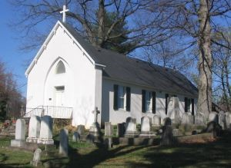

Twenty-second Sunday after Pentecost
Morning Prayer - Anglican Church of New Zealand
October 20, 2024—10:30 am

St. John’s Episcopal Church

11901 Belair Road, P. O. Box 187, Kingsville, MD 21087
Facebook: St. John’s Episcopal, Kingsville, MD
Email: office@stjohnskingsville.org
Website: www.stjohnskingsville.org
Church Phone: 410-592-8570
For Pastoral Emergencies: Fr. Mark Lobb+ 443-690-9545

Welcome to worship today! We are glad that you are with us. You are invited to participate in all parts of the service as indicated in the Book of Common Prayer and this service bulletin. If you have any questions, feel free to ask the ushers. Restrooms are located in the Parish Hall, the brick building across the parking lot.

I was glad when they said to me, “Let us go to the house of the Lord.” Psalm 122:1

Church Staff

Interim Rector: Father Mark Lobb
Administrative Assistant: Angie Bosley
Organist/Choir Director: Nancy Heinold

The Vestry

Class of 2025 Class of 2026

John Frost John Stevens
Woodie Tingle
Jacob Johnson

Officers
Ty Schwenk—Sr. Warden Terry Roe—Jr. Warden
Elizabeth Healey—Treasurer Anne Leland-Registrar

Parish Committee Chairpersons

Altar Guild: Elizabeth Healey
Auxiliary Committee: Michele Lozanski
Cemetery Committee: Terry Roe

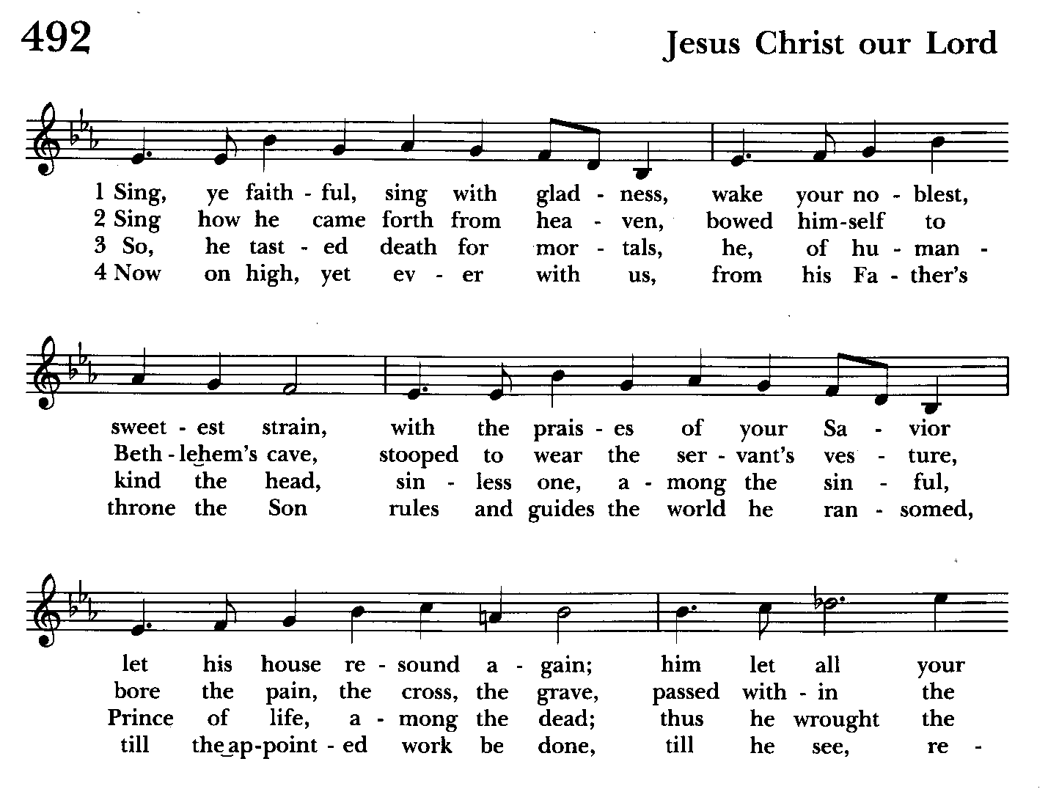

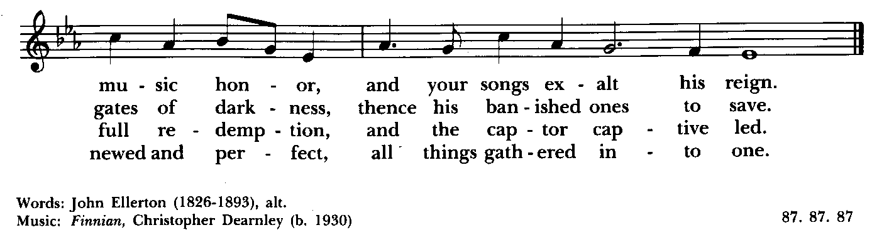

Morning Prayer—Rite II
Note:
Please feel free to remain seated during the service if unable to stand or kneel. ‘BCP’ refers to the Book of Common Prayer. The people’s responses are in bold.

Prelude

Gathering hymn: Sing ye faithful, sing with gladness Hymnal #492
(see above)

Officiant: You shall receive power when the Holy Spirit has come upon you, and you shall be my witness.
Acts 1:8

Officiant: God’s love has been poured into our hearts through the Holy Spirit which has been given to us.
Romans 5:5
Great is the Lord and worthy of all praise.

Amen! Praise and glory and wisdom,
Thanksgiving and honour, power and might
be to our God for ever and ever! Amen.

GREAT AND WONDERFUL
1 Great and wonderful are your deeds O Lord God the almighty:
Just and true are your ways O Sovereign of the nations.
2 Who shall not revere and praise your name O Lord?
For you alone are holy
3 All nations shall come and worship in y our presence:
for your just dealings have been revealed.
4 To the One who is seated on the throne and to the Lamb:
Be blessing and honour, glory and might
For ever and ever. Amen.
Revelation 15:3b-4; 5:13
Officiant: Brothers and sisters in Christ,
Let us praise and worship God who has called us together.
Let us celebrate God’s majesty,
And delight in the wonder of God’s love.
Together we shall confess our sins
And receive assurance that we are forgiven
As the scriptures are read,
We can allow God’s word to speak to us,
And ponder its meaning for our lives.
In our prayers, we give thanks for God’s goodness,
We pray for others as well as for ourselves,
And we offer our lives anew in Christ’s service.

All this we do,
Because we believe in the presence among us
Of our Saviour Jesus Christ,
And in the mighty power of the Holy Spirit.

Hear these words of scripture.

Love one another,
For love is of God,
And whoever loves is born of God and knows God
Spirit of God, search our hearts.

Officiant: Let us kneel and, in silence,
Remember our need for God’s forgiveness.

Silence

Let us confess our sins to God.

CONFESSION OF SIN
Almighty and merciful God, we have sinned against you, in thought, word and deed. We have not loved you with all our heart. We have not loved others as our Saviour Christ loves us. We are truly sorry. In your mercy forgive what we have been, help us to amend what we are, and direct what we shall be; that we may delight in your will and walk in your ways, through Jesus Christ our Saviour. Amen

Officiant: Almighty God, who pardons all who truly repent,
forgive us our sins, strengthen us by the Holy Spirit,
and keep us in life eternal; through Jesus Christ our Redeemer. Amen

The Ministry of the Word

Officiant: O come, let us sing to the lord,
Let us rejoice in the rock of our salvation

We sing to you, O God, and bless your name;
And tell of your salvation from day to day.

We proclaim your glory to the nations,
your praise to the ends of the earth.

Psalm 104:1-9, 25, 37b
1 Bless the Lord, O my soul; *
O Lord my God, how excellent is your greatness!
you are clothed with majesty and splendor.
2 You wrap yourself with light as with a cloak *
and spread out the heavens like a curtain.
3 You lay the beams of your chambers in the waters above; *
you make the clouds your chariot;
you ride on the wings of the wind.
4 You make the winds your messengers *
and flames of fire your servants.
5 You have set the earth upon its foundations, *
so that it never shall move at any time.
6 You covered it with the Deep as with a mantle; *
the waters stood higher than the mountains.
7 At your rebuke they fled; *
at the voice of your thunder they hastened away.
8 They went up into the hills and down to the valleys beneath, *
to the places you had appointed for them.
9 You set the limits that they should not pass; *
they shall not again cover the earth.
25 O Lord, how manifold are your works! *
in wisdom you have made them all;
the earth is full of your creatures.
37b Hallelujah!

Officiant and People
Glory to the Father, and to the Son, and to the Holy Spirit: as it was in the beginning, is now, and will be for ever. Amen.

Please be seated

THE FIRST READING Job 38:1-7, (34-41)
The Lord answered Job out of the whirlwind:
"Who is this that darkens counsel by words without knowledge?
Gird up your loins like a man,
I will question you, and you shall declare to me.

"Where were you when I laid the foundation of the earth?
Tell me, if you have understanding.
Who determined its measurements—surely you know!
Or who stretched the line upon it?
On what were its bases sunk,
or who laid its cornerstone
when the morning stars sang together
and all the heavenly beings shouted for joy?

[“Can you lift up your voice to the clouds,
so that a flood of waters may cover you?
Can you send forth lightnings, so that they may go
and say to you, ‘Here we are’?
Who has put wisdom in the inward parts,
or given understanding to the mind?
Who has the wisdom to number the clouds?
Or who can tilt the waterskins of the heavens,
when the dust runs into a mass
and the clods cling together?

“Can you hunt the prey for the lion,
or satisfy the appetite of the young lions,
when they crouch in their dens,
or lie in wait in their covert?
Who provides for the raven its prey,
when its young ones cry to God,
and wander about for lack of food?”]

Hear what the Spirit is saying to the Church.
Thanks be to God.

The Song of Zechariah Benedictus
Blessed are you O Lord our God:
You have come to your people and set them free.
You have raised up for us a mighty Saviour:
Born of the house of your servant David
Through your holy prophets you promised of old:
That you would save us from our enemies
From the hands of all who hate us.
You promised to show mercy to our forbears:
And to remember your holy covenant.
This was the oath you swore to our father Abraham:
To set us free from the hands of our enemies,
Free to worship you without fear:
Holy and righteous in your sight
All the days of our life.
And you, child, shall be called the prophet of the most high
For you will go before the Lord to prepare the way,
To give God’s people knowledge of salvation:
Through the forgiveness of their sins.
In the tender compassion of our God:
The dawn from on high shall break upon us,
To shine on those who dwell in darkness and the shadow of death
And guide our feet into the way of peace.

Glory to the Father and to the Son:
And to the Holy Spirit:
As it was in the beginning is now:
And shall be for ever. Amen.

THE SECOND READING Hebrews 5:1-10
Every high priest chosen from among mortals is put in charge of things pertaining to God on their behalf, to offer gifts and sacrifices for sins. He is able to deal gently with the ignorant and wayward, since he himself is subject to weakness; and because of this he must offer sacrifice for his own sins as well as for those of the people. And one does not presume to take this honor, but takes it only when called by God, just as Aaron was.
So also Christ did not glorify himself in becoming a high priest, but was appointed by the one who said to him,
“You are my Son,
today I have begotten you”;
as he says also in another place,
“You are a priest forever,
according to the order of Melchizedek.”
In the days of his flesh, Jesus offered up prayers and supplications, with loud cries and tears, to the one who was able to save him from death, and he was heard because of his reverent submission. Although he was a Son, he learned obedience through what he suffered; and having been made perfect, he became the source of eternal salvation for all who obey him, having been designated by God a high priest according to the order of Melchizedek.

Hear what the Spirit is saying to the Church.
Thanks be to God.

Canticle 21 You are God Te Deum laudamus
You are the Lord; we acclaim you;
You are the eternal Father:
All creation worships you.
To you all angels, all the powers of heaven,
Cherubim and Seraphim, sing in endless praise:
Holy, holy, holy Lord, God of power and might,
heaven and earth are full of your glory.
The glorious company of apostles praise you.
The noble fellowship of prophets praise you.
The white-robed army of martyrs praise you.
Throughout the world the holy Church acclaims you;
Father, of majesty unbounded,
your true and only Son, worthy of all worship,
and the Holy Spirit, advocate and guide.
You, Christ, are the king of glory,
the eternal Son of the Father.
When you became man to set us free
you did not shun the Virgin's womb.
You overcame the sting of death
and opened the kingdom of heaven to all believers.
You are seated at God's right hand in glory.
We believe that you will come and be our judge.
Come then, Lord, and help your people,
bought with the price of your own blood,
and bring us with your saints
to glory everlasting.

Gradual hymn: O Love of God, how strong and true Hymnal #455
(see next page)

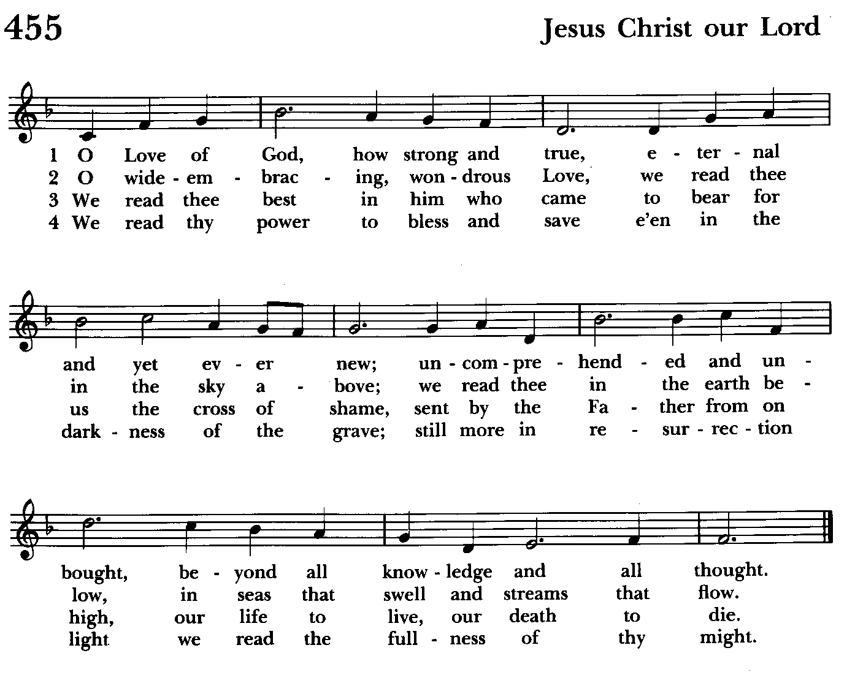

A READING FROM THE GOSPEL OF MARK 10:35-45
James and John, the sons of Zebedee, came forward to Jesus and said to him, “Teacher, we want you to do for us whatever we ask of you.” And he said to them, “What is it you want me to do for you?” And they said to him, “Grant us to sit, one at your right hand and one at your left, in your glory.” But Jesus said to them, “You do not know what you are asking. Are you able to drink the cup that I drink, or be baptized with the baptism that I am baptized with?” They replied, “We are able.” Then Jesus said to them, “The cup that I drink you will drink; and with the baptism with which I am baptized, you will be baptized; but to sit at my right hand or at my left is not mine to grant, but it is for those for whom it has been prepared.”
When the ten heard this, they began to be angry with James and John. So Jesus called them and said to them, “You know that among the Gentiles those whom they recognize as their rulers lord it over them, and their great ones are tyrants over them. But it is not so among you; but whoever wishes to become great among you must be your servant, and whoever wishes to be first among you must be slave of all. For the Son of Man came not to be served but to serve, and to give his life a ransom for many.”

The Word of the Lord.
Thanks be to God.

The Homily The congregation is seated Liz Healey & Michele Lozanski

The Peace The congregation stands as able

Announcements The people are seated

THE APOSTLES CREED BCP pg. 96
Said by all, standing as you are able.

I believe in God, the Father almighty,
creator of heaven and earth;
I believe in Jesus Christ, his only Son, our Lord.
He was conceived by the power of the Holy Spirit
and born of the Virgin Mary.
He suffered under Pontius Pilate,
was crucified, died, and was buried.
He descended to the dead.
On the third day he rose again.
He ascended into heaven,
and is seated at the right hand of the Father.
He will come again to judge the living and the dead.
I believe in the Holy Spirit,
the holy catholic Church,
the communion of saints,
the forgiveness of sins
the resurrection of the body,
and the life everlasting. Amen.
Celebrant: The Lord be with you.
People: And also with you.
Celebrant: Let us pray.
THE LORD’S PRAYER Stand or kneel as able. BCP pg. 97
Our Father, who art in heaven, hallowed be thy Name, thy kingdom come, thy will be done, on earth as it is in heaven. Give us this day our daily bread. And forgive us our trespasses, as we forgive those who trespass against us. And lead us not into temptation, but deliver us from evil. For thine is the kingdom, and the power, and the glory, for ever and ever. Amen.
People and Officiant
SUFFRAGES B BCP pg. 98
V. Save your people, Lord, and bless your inheritance;
R. Govern and uphold them, now and always.
V. Day by day we bless you;
R. We praise your Name for ever.
V. Lord, keep us from all sin today;
R. Have mercy on us, Lord, have mercy.
V. Lord, show us your love and mercy;
R. For we put our trust in you.
V. In you, Lord, is our hope;
R. And we shall never hope in vain.

THE COLLECT OF THE DAY BCP pg. 234
Almighty and everlasting God, in Christ you have revealed your glory among the nations: Preserve the works of your mercy, that your Church throughout the world may persevere with steadfast faith in the confession of your Name; through Jesus Christ our Lord, who lives and reigns with you and the Holy Spirit, one God, for ever and ever. Amen.

A COLLECT FOR MORNING
Holy and everliving God, by your power we are created and by your love we are redeemed; guide and strengthen us by your Spirit, that we may give ourselves to your service, and live each day in love to one another and to you, through Jesus Christ our Lord. Amen.

Officiant: Let us pray for our own needs and those of others.

Silence

PRAYER FOR MISSION BCP pg. 100
Almighty and everlasting God, by whose Spirit the whole body of your faithful people is governed and sanctified: Receive our supplications and prayers which we offer before you for all members of your holy Church, that in their vocation and ministry they may truly and devoutly serve you; through Lord and Savior Jesus Christ. Amen.

The people remain seated during the Offertory collection.

OFFERTORY HYMN: O Master, let me walk with thee Hymnal #660
(see below)

THE OFFERTORY The offering is collected during the singing of the hymn

DOXOLOGY Please stand as able as the offering is brought forward Hymnal #43, vs. 4
Praise God, from whom all blessings flow; praise him, all creatures here below; praise him above, ye heavenly host: praise Father, Son, and Holy Ghost.

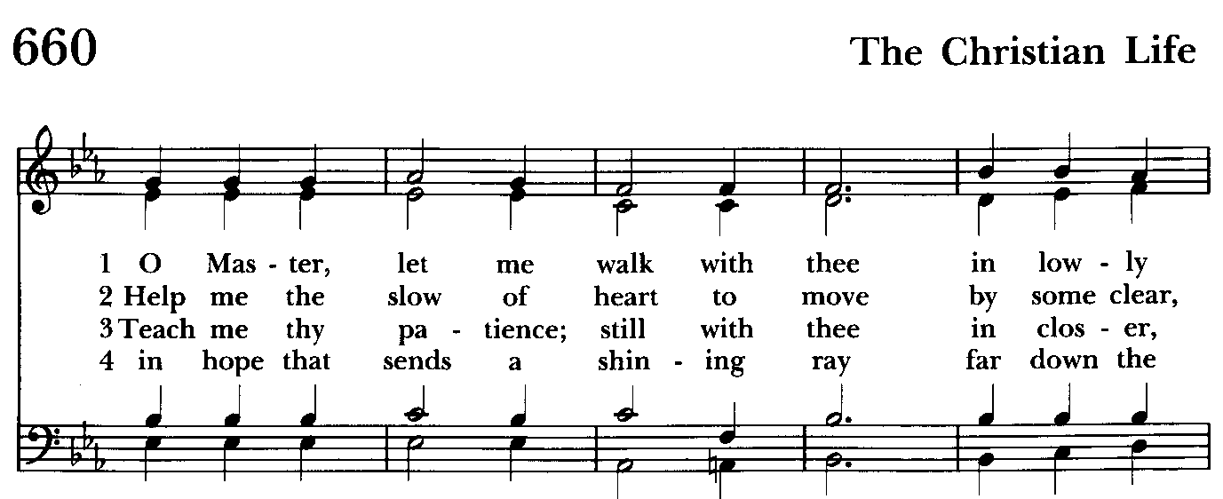

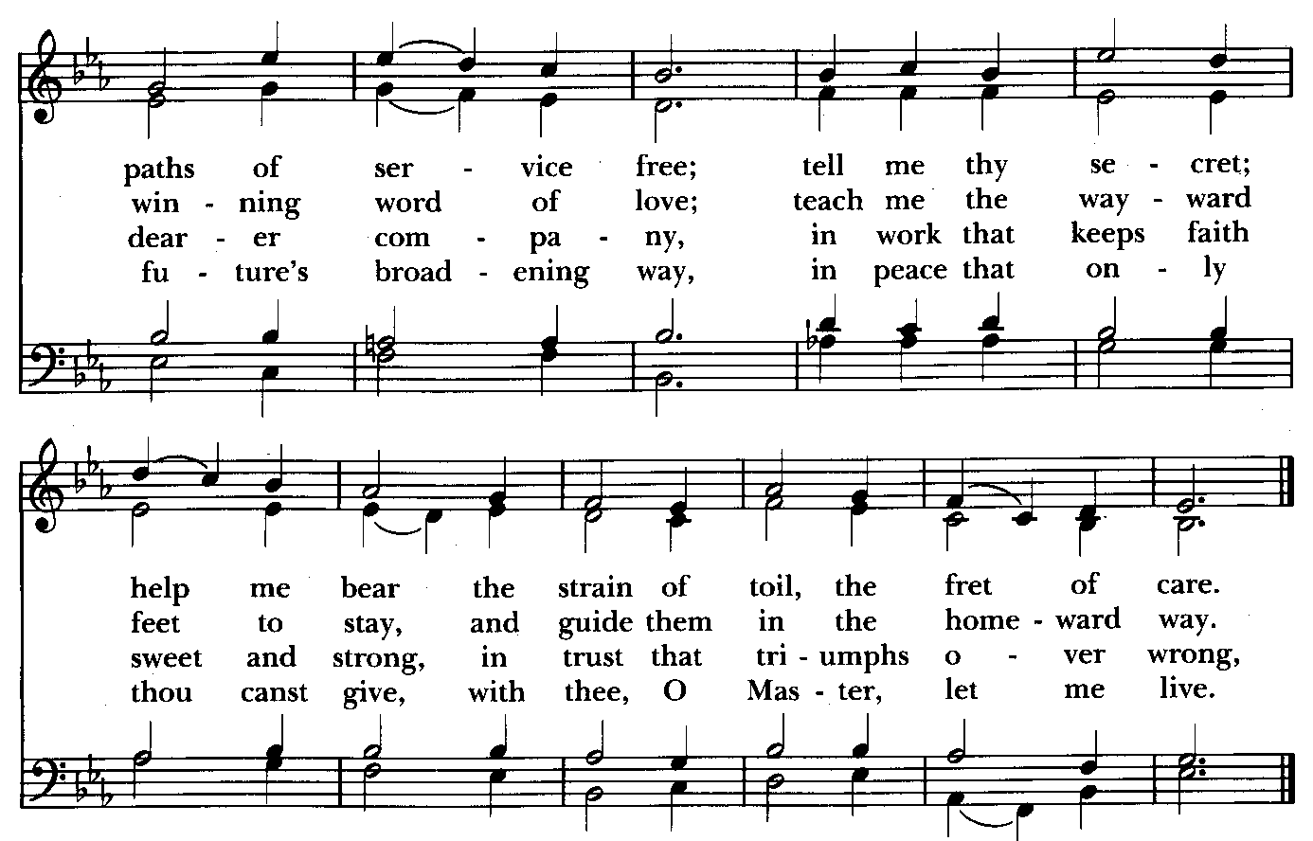

Please kneel or stand as able

THE PRAYERS OF THE PEOPLE
Make your ways known upon earth, O God.
Your saving power among all peoples.

Renew your Church in holiness.
And help us to serve you with joy.

Guide the leaders of this and every nation.
That justice may prevail throughout the world.

Let not the needy, O God, be forgotten.
Nor the hope of the poor be taken away.

Make us instruments of your peace.
And let your glory be over all the earth.

.Let us pray for our own needs and those of others.

We Pray for Those in Need:
DeMarino Family, Jim & Chris Carden and family, Peggie Dietz, Mike Carden, Pat Carden, Gail Landers, Sheila Jones, Gloria Millar, Marisol Aubrey, Ross Strickler, Jim and Janice Sieracki, James Daniel, Jr., Larry Betzler, Carol Vandergriff, Camy Schwenk, Edward,

We Pray for our Homebound

Lily John, Barbara Miller, Nancy Barnhart, Robin Dilworth

We pray for the Church and the World:

For +Justin, Archbishop of Canterbury; for +Michael, our Presiding Bishop; for +Sean, our Presiding Bishop Elect, for +Carrie, our Bishop, for Mark+, our Interim Rector, for the Wardens, Vestry, Staff, and all members and friends of St. John’s Church.

For the leaders of all nations, especially for Joseph, our President; for Wes, our Governor; for Brandon, Nick, John and Bob, who lead our City and Counties. We pray for all children and youth; for the homeless, the unemployed, and the hungry. We pray for the safety of our loved ones and friends serving in the Armed Forces at home and abroad, and for our enemies, that all our hearts may be turned toward peace throughout the world.

THE GENERAL THANKSGIVING
Let us pray.
Officiant and people BCP pg. 101
Almighty God, Father of all mercies, we your unworthy servants give you humble thanks for all your goodness and loving-kindness to us and to all whom you have made. We bless you for our creation, preservation, and all the blessings of this life; but above all for your immeasurable love in the redemption of the world by our Lord Jesus Christ; for the means of grace, and for the hope of
glory. And, we pray, give us such an awareness of your mercies, that with truly thankful hearts we may show forth your praise, not only with our lips, but in our lives, by giving up our selves to your service, and by walking before you in holiness and righteousness all our days; through Jesus Christ our Lord, to whom, with you and the Holy Spirit, be honor and glory throughout all ages. Amen.

Closing hymn: All praise to thee, for thou, O King divine Hymnal #477

THE DISMISSAL BCP pg. 102
Officiant: The grace of our Lord Jesus Christ, and the Love of God, and the fellowship of the Holy Spirit, be with us all evermore.
People: Thanks be to God.

License #A-719154

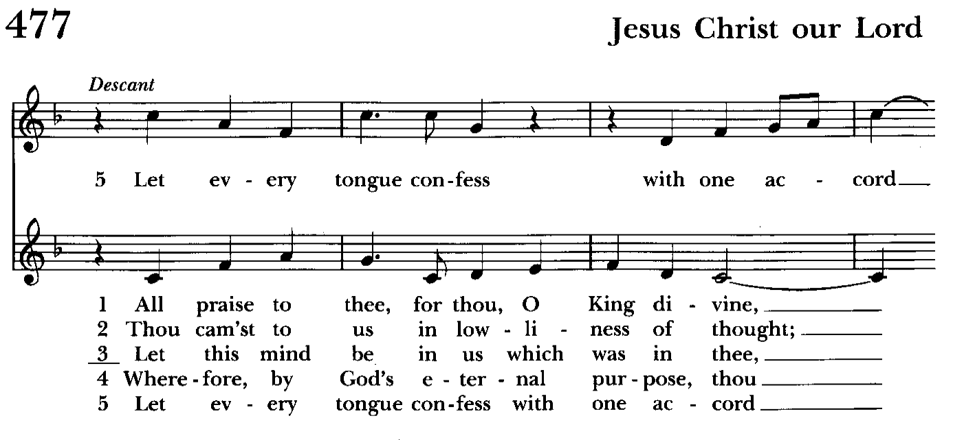

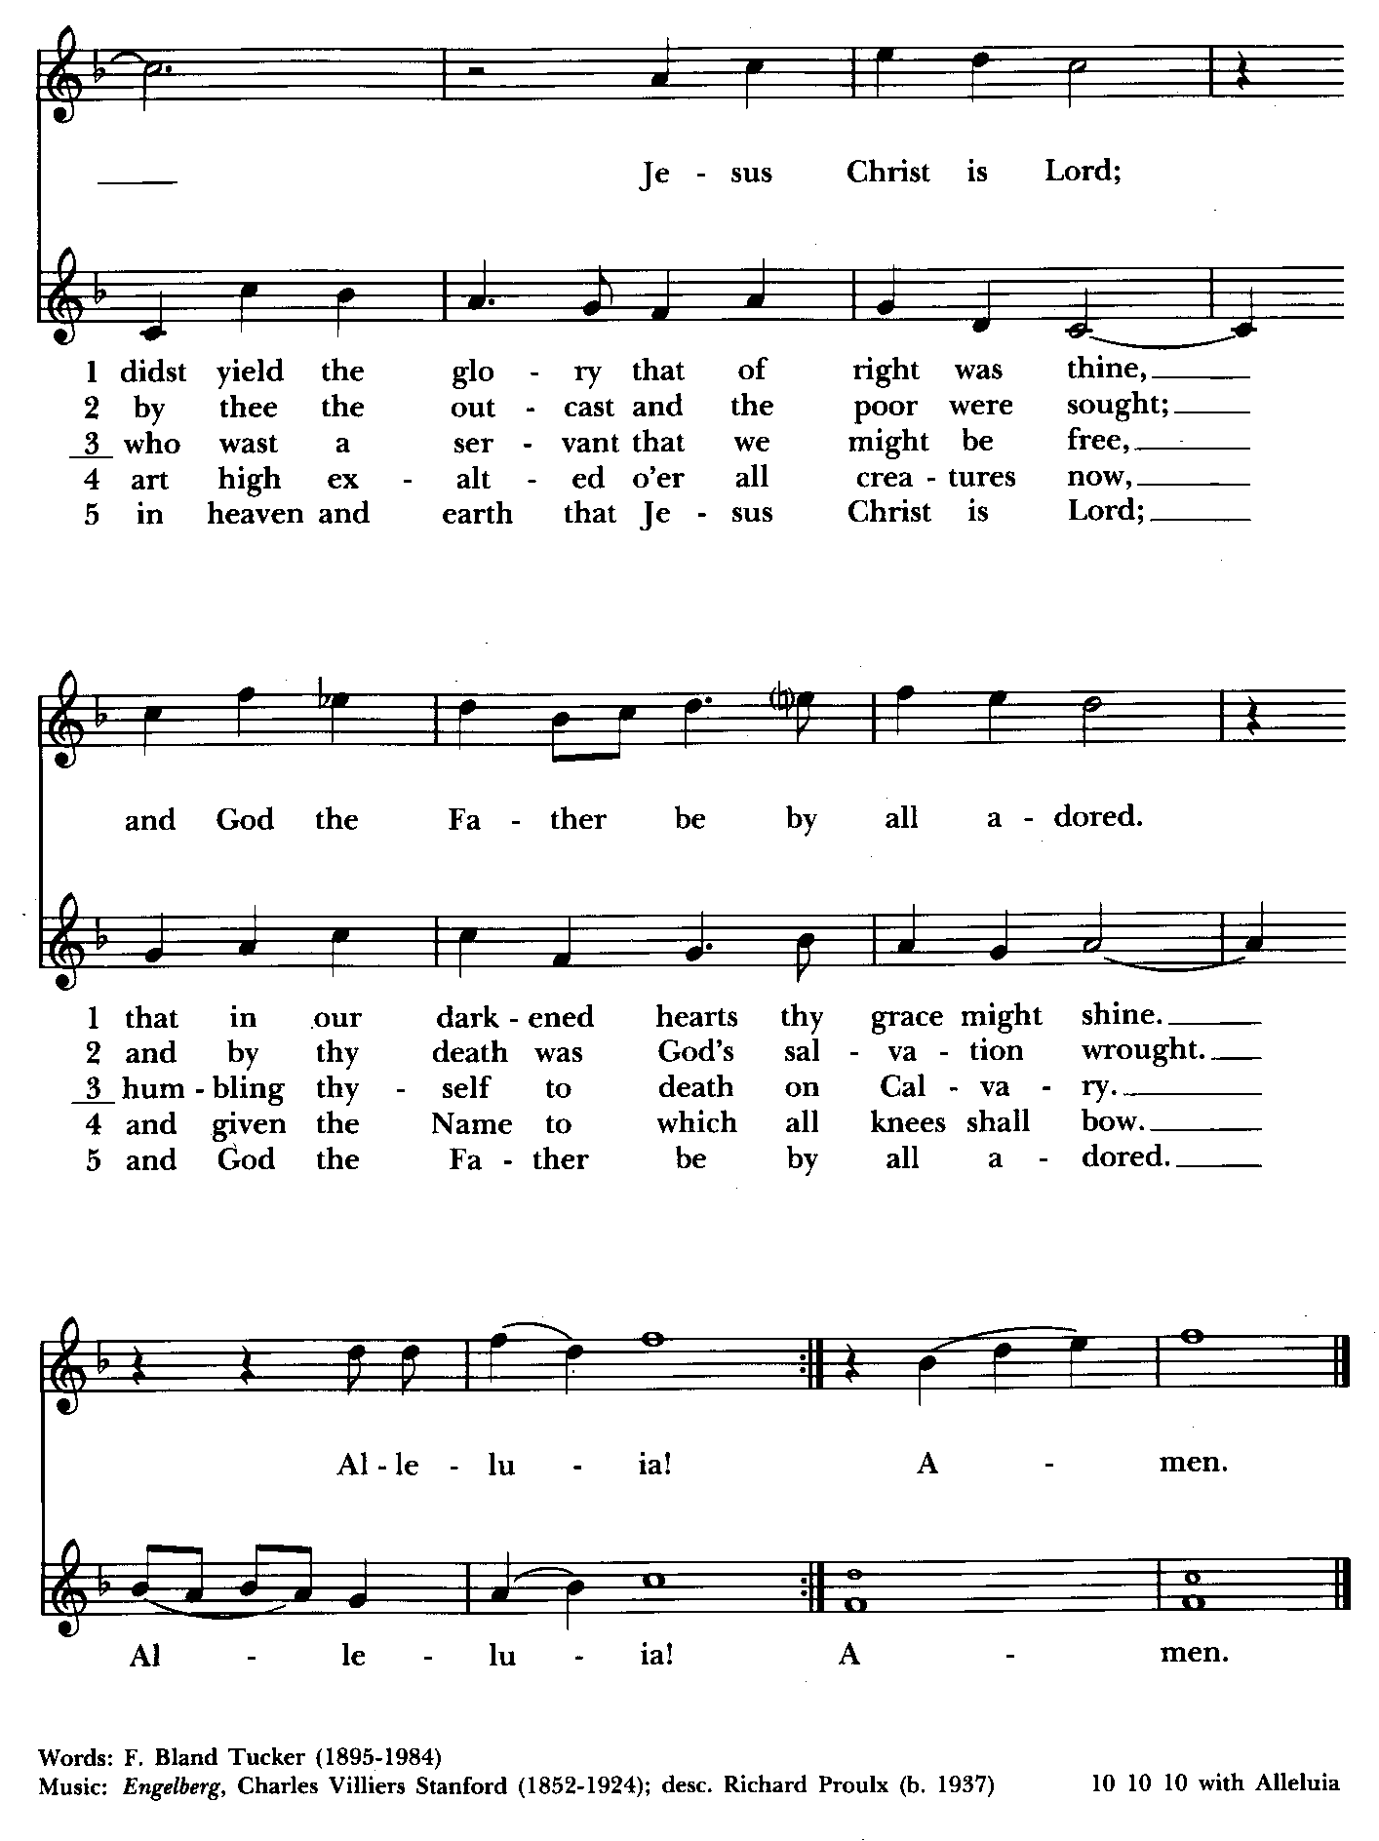

Serving Today
Officiant: Liz Healey & Michele Lozanski
Old Testament: Liz Healey
Psalm: John Stevens
New Testament: Anne Leland
Prayers of the People: Liz Healey
Music Director: Nancy Heinold
Altar Guild: Liz Healey & Marguerite Lobb


With so much going on, everyone’s help is needed to make things a success. Our volunteers make the Church function. The volunteering of time and talent is greatly appreciated.

St. John’s Parish Prayer List

Additions and corrections may be made to our Parish Prayer List at any time. All names will be automatically removed from the Parish Prayer List on the 1st Sunday of each month unless you request otherwise. Please contact Angie at <office@stjohnskingsville.org> or 410-592-8570 in the church office with all changes by 10 am Thursdays. Thank you.

We Pray for Those in Need:
Names in BOLD read aloud by all.

DeMarino Family, Jim & Chris Carden and family, Peggie Dietz, Mike Carden, Pat Carden, Gail Landers, Sheila Jones, Gloria Millar, Marisol Aubrey, Ross Strickler, Jim and Janice Sieracki, James Daniel, Jr., Larry Betzler, Carol Vandergriff, Camy Schwenk, Edward.

We Pray for our Homebound

Lily John, Barbara Miller, Nancy Barnhart, Robin Dilworth

We pray for the Church and the World:

For +Justin, Archbishop of Canterbury; for +Michael, our Presiding Bishop; for +Sean, our Presiding Bishop Elect; for +Carrie, our Bishop, for Mark+, our Interim Rector; for the Wardens, Vestry, Staff, and all members and friends of St. John’s Church.

For the leaders of all nations, especially for Joseph, our President; for Wes, our Governor; for Brandon, Nick, John and Bob, who lead our City and Counties. We pray for all children and youth; for the homeless, the unemployed, and the hungry. We pray for the safety of our loved ones and friends serving in the Armed Forces at home and abroad, and for our enemies, that all our hearts may be turned toward peace throughout the world.


Altar Flowers

Given to the Glory of God
by Woodie Tingle
in honor of his and Dennis’ 10th Wedding Anniversary

From the Treasurer

October ’24 Income vs. Expenses:

Projected October Expenses: $13,500
Monies Received as of 10/17: $10,844
Amount Needed to Meet Expenses: $2,656


If you’d like to make a donation to St. John’s you can scan this QR code with your phone’s camera or tap on the link that comes up to make a contribution with either a credit or debit card, Apple Pay or Google Pay. This is a secure site provided by Clover which is a
service of PNC Bank.

9:00- 9:30: "Confirmation Class" - for any interested in Confirmation/Reception or any just interested. Walk In Love (copies available).
10:30: Kids Sunday School- Begin in the church, ring the bell, then process over to the parish hall for a fun lesson with Mr. John and Ms. Stephanie. Note: Please seriously consider regular attendance at Sunday School so that Mr. John and Ms. Stephanie can plan good stuff.
Wednesday Mornings- Feed the Wolf!
Our book study, Wednesdays, 9:00 a.m. in the Parish Hall. Books are still available.
Fr. Mark is open to additional locations and times for another group. Speak up if you have a suggestion.


Choral Choir and Bell Choir

Choir rehearsals Wednesdays at 7:00 pm and Bell Choir Rehearsal after the 10:30 service. If anyone is interested in joining, see Nancy Heinold, our Music Director.

SUNDAY SCHOOL
Time for Sunday School. Mr. John and Miss Stephanie are back. Sunday School begins in the church during the 10:30 service and continues in the Parish Hall.


Crafters Weekend
Friday 11/1, 9am-9pm and
Saturday 11/2, 9am-5pm
in the Parish Hall, All hobbyists welcome

Calendar Updates

Morning Prayer- will be offered on the following Sundays: 10/20, 12/29. Lay people are highly encouraged to consider helping by officiating and/or preaching of Morning Prayer. I am willing to help you prepare for this.

Would it be helpful to have an “Officiating Morning Prayer” class? Let me know.

Bishop Carrie Visit - 11/3 ONE SERVICE AT 10:30 AM, Fellowship with the Bishop & Luncheon to follow. (There are 2 baptisms and a confirmation at the service.)

All Souls service- Sunday evening 7:00 11/3.

Blue Christmas/Service of Solace- TBD

Calendars are living documents. Every effort will be made to keep the members of the parish and community aware of any changes.

SAVE THE DATE
God’s Grace Garden Workday - 11/9 8:30 am (Rain date: 11/16 @ 8:30 am)
Christmas Bazaar - 11/23

OUTREACH

WHAT A GREAT GIFT TO GIVE SOMEONE A MERRY CHRISTMAS!!

With Christmas and Thanksgiving just around the corner the Helping Hands Food Pantry is preparing for its annual Meal Distribution.

Listed below is what they need:
Yams/Sweet Potatoes (small or medium cans), Instant Potatoes (box or bag), Cranberries (canned), Sauerkraut (canned), cake mixes, cake icing (ready made)

Thank you so much!

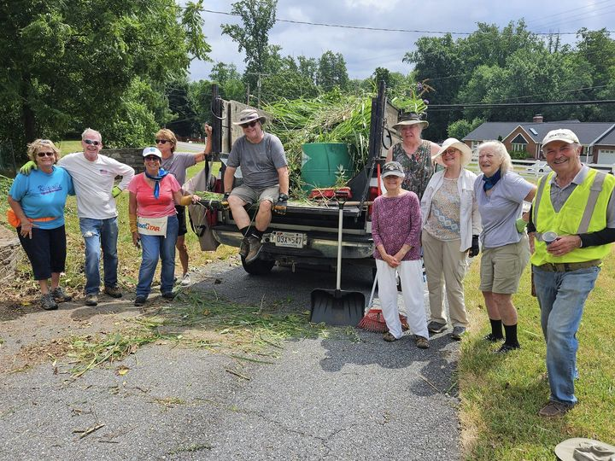
Come see the progress we’re making to Beautify our St. Francis Garden!!
For more info or to sign up to help keep our gardens looking beautiful, contact: Rita Talley-Garden Club, 443-617-1820 or Karen Smith-Manar-St. John’s 410-746-9813 or bikenbocal@verizon.net
Wish list: plant and tree food, hosta, liriope, mums, asters, shovels

God’s Grace Gardens—a St. John’s, Hill & Stream Garden Club
and AA collaboration

Next Workday: 11/9 @ 8:30 am (Rain date: 11/16 @ 8:30 am)


Yoga is now on Tuesday, Wednesday and Friday evenings 6 to 7 pm and Saturday mornings 9 to 10 am in the Chapel.
All experience levels are welcome.

RECYCLING!
The recycling bin at home is filling up and it will soon be time to take it over to the recycling center. Did you know that cat food cans are made from aluminum?

By popular demand, we are recycling. Some parishioners take printed paper home where they have recycling pickup. We now have a blue container located in the Parish Hall. This will be collected and taken for recycling. Aluminum cans will be saved and taken to a recycling center for cash. The proceeds will be donated to the Outreach fund. Each recycled aluminum can also save on the electricity needed to make new aluminum from bauxite.

In our Community

Bible Studies in our area. If interested, please contact these churches to confirm.

St. Mary’s, Abingdon, (410)569-0180- Wednesdays at noon. Bring lunch. Zoom available.

Emmanuel, Bel Air, (410)838-7699- Fridays at 9:30- Zoom Available.

Holy Trinity, Churchville, (410)914-5531- Wednesdays 11:30- Zoom may be available.

What’s Happening This Week at St. John’s

Sunday, October 20—MORNING PRAYER-22nd Sunday after Pentecost
8:00am: Morning Prayer (Church)
10:30am: Morning Prayer (Church)
11:30am: Coffee Hour (Parish Hall)
11:45am: Bell Choir Rehearsal (Church)

Monday, October 21
12:00-1:00pm: AA Lunch Bunch (Parish Hall)
7:00-8:30pm: Spanish speaking AA group (Parish Hall)

Tuesday, October 22
12:00-1:00pm: AA Lunch Bunch (Parish Hall)
6:00-7:00pm: Yoga (Chapel)

Wednesday, October 23
9:00am: Book Study (Parish Hall)
12:00-1:00pm: AA Lunch Bunch (Parish Hall)
6:00-7:00pm: Yoga (Chapel)
7:00pm: Choir Rehearsal (Church)
7:30pm: AA (Parish Hall)

Thursday, October 24
12:00-1:00pm: AA Lunch Bunch (Parish Hall)
7:00pm: AA (Parish Hall)

Friday, October 25
12:00-1:00pm: AA Lunch Bunch (Parish Hall)
6:00-7:00pm: Yoga (Chapel)

Saturday, October 26
9:00-10:00am:: Yoga (Church)
8:30pm: AA (Parish Hall)

Sunday, October 27—23rd Sunday after Pentecost
8:00am: Holy Eucharist, Rite I (Church)
10:30am: Holy Eucharist, Rite II (Church)
11:30am: Coffee Hour (Parish Hall)
11:45am: Bell Choir Rehearsal (Church)

Parish Office is open Monday, Wednesday and Thursday, 9:30am-1:30pm.

Potluck Luncheon on the first Sunday of the month and a Coffee Hour on all other Sundays after the 10:30 service.

