St. John’s Episcopal Church
Kingsville, Maryland
Welcomes You
Our Vision Statement

We believe that together we will transform
the world with love: Come on in!

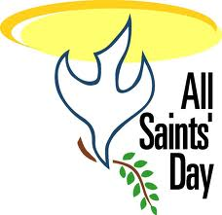

All Saints Sunday
with the Celebration of Holy Baptism and Confirmation
November 3, 2024 - 10:30 am

St. John’s Episcopal Church

11901 Belair Road, P. O. Box 187, Kingsville, MD 21087
Facebook: St. John’s Episcopal, Kingsville, MD
Email: office@stjohnskingsville.org
Website: www.stjohnskingsville.org
Church Phone: 410-592-8570
For Pastoral Emergencies: Fr. Mark Lobb+ 443-690-9545

Welcome to worship today! We are glad that you are with us. You are invited to participate in all parts of the service as indicated in the Book of Common Prayer and this service bulletin. If you have any questions, feel free to ask the ushers. Restrooms are located in the Parish hall, the brick building across the parking lot.

I was glad when they said to me, “Let us go to the house of the Lord.” Psalm 122:1

Church Staff

Interim Rector: Father Mark Lobb
Administrative Assistant: Angie Bosley
Organist/Choir Director: Nancy Heinold

The Vestry

Class of 2025 Class of 2026

John Frost John Stevens
Woodie Tingle
Jacob Johnson

Officers
Ty Schwenk—Sr. Warden Terry Roe—Jr. Warden
Elizabeth Healey—Treasurer Anne Leland-Registrar

Parish Committee Chairpersons

Altar Guild: Elizabeth Healey
Auxiliary Committee: Michele Lozanski
Cemetery Committee: Terry Roe

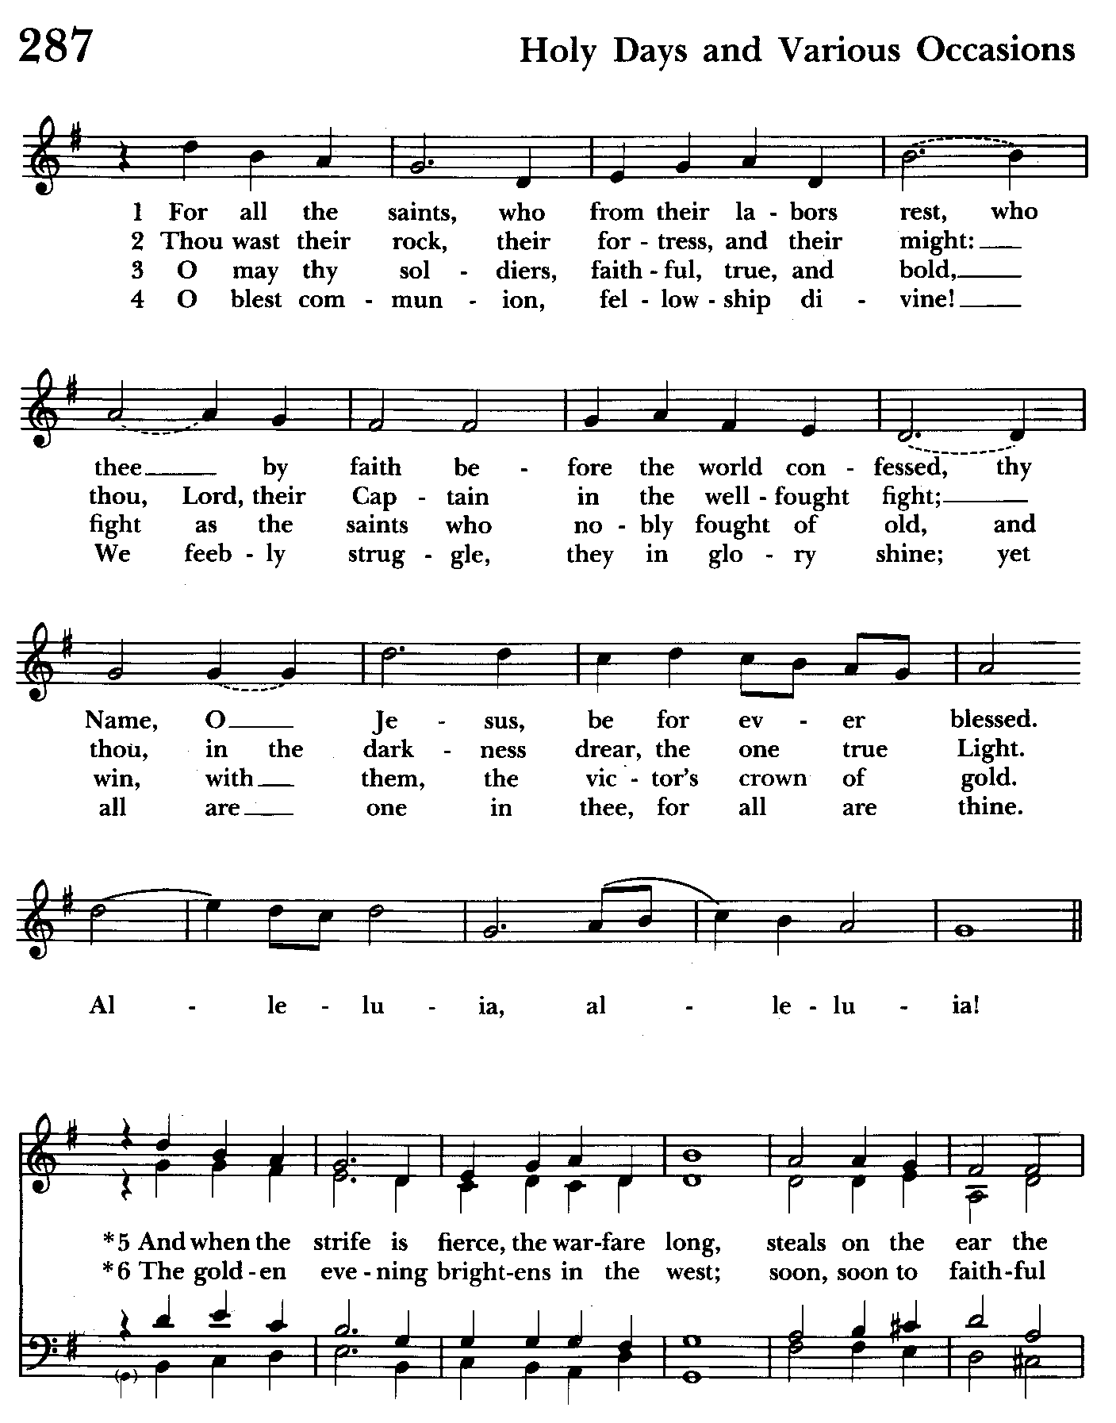

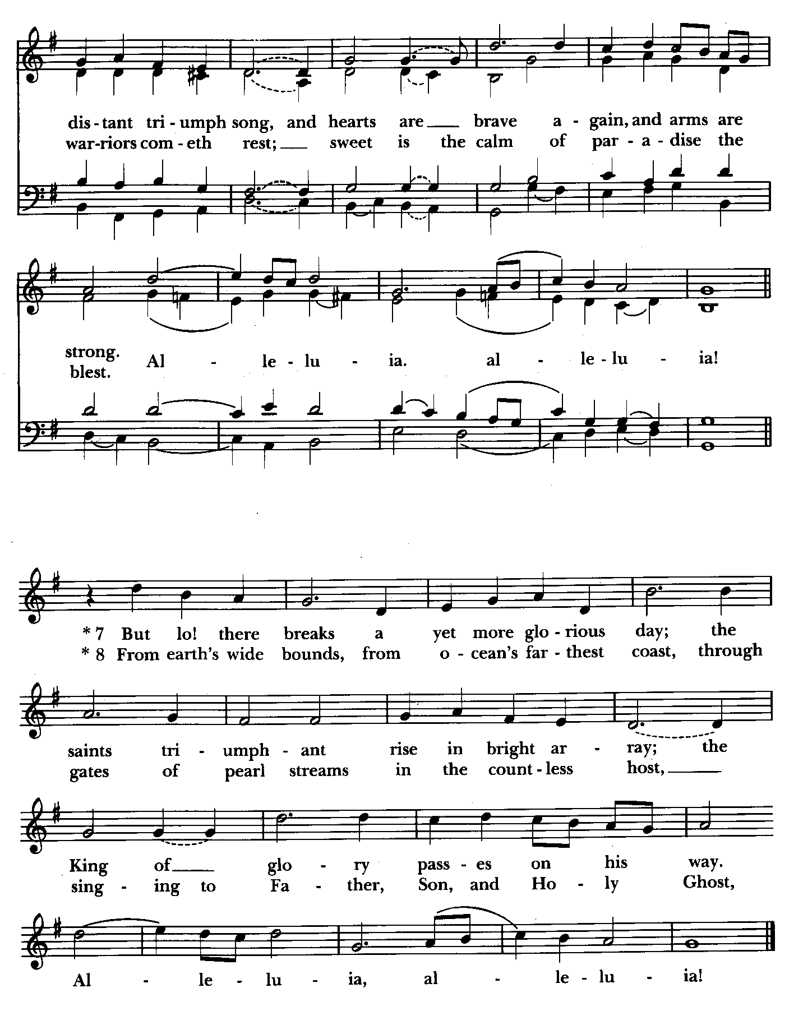

10:30 am Worship
Holy Eucharist, Rite Two

Prelude:
The Word of God

Processional hymn: For all the saints, who from their labors rest Hymnal #287
(see previous 2 pages) Please stand as able.

Celebrant: Blessed be God; Father, Son, and Holy Spirit.
People: And blessed be his kingdom, now and for ever. Amen.

Celebrant: There is one Body and one Spirit;
People: There is one hope in God’s call to us;
Celebrant: One Lord, one Faith, one Baptism;
People: One God and Father of all.

Gloria Hymnal #S-278
Glory to God in the highest,
and peace to his people on earth.
Lord God, heavenly King,
almighty God and Father,
we worship you, we give you thanks,
we praise you for your glory.
Lord Jesus Christ, only Son of the Father,
Lord God, Lamb of God,
you take away the sin of the world:
have mercy on us;
you are seated at the right hand of the Father:
receive our prayer.
For you alone are the Holy One,
you alone are the Lord,
you alone are the Most High,
Jesus Christ,
with the Holy Spirit,
in the glory of God the Father. Amen.

Celebrant: The Lord be with you.
People: And also with you.
Celebrant: Let us pray.

The Collect of the Day Kneel or stand as able BCP 245
Almighty God, you have knit together your elect in one communion and fellowship in the mystical body of your Son Christ our Lord: Give us grace so to follow your blessed saints in all virtuous and godly living, that we may come to those ineffable joys that you have prepared for those who truly love you; through Jesus Christ our Lord, who with you and the Holy Spirit lives and reigns, one God, in glory everlasting. Amen.
The congregation is seated.

A Reading from the Wisdom of Solomon 3:1-9
The souls of the righteous are in the hand of God,
and no torment will ever touch them.
In the eyes of the foolish they seemed to have died,
and their departure was thought to be a disaster,
and their going from us to be their destruction;
but they are at peace.
For though in the sight of others they were punished,
their hope is full of immortality.
Having been disciplined a little, they will receive great good,
because God tested them and found them worthy of himself;
like gold in the furnace he tried them,
and like a sacrificial burnt offering he accepted them.
In the time of their visitation they will shine forth,
and will run like sparks through the stubble.
They will govern nations and rule over peoples,
and the Lord will reign over them forever.
Those who trust in him will understand truth,
and the faithful will abide with him in love,
because grace and mercy are upon his holy ones,
and he watches over his elect.

Reader: The Word of the Lord.
People: Thanks be to God.

Psalm 24 (Prayed as directed.)
1 The earth is the Lord's and all that is in it, *
the world and all who dwell therein.
2 For it is he who founded it upon the seas *
and made it firm upon the rivers of the deep.
3 "Who can ascend the hill of the Lord? *
and who can stand in his holy place?"
4 "Those who have clean hands and a pure heart, *
who have not pledged themselves to falsehood,
nor sworn by what is a fraud.
5 They shall receive a blessing from the Lord *
and a just reward from the God of their salvation."
6 Such is the generation of those who seek him, *
of those who seek your face, O God of Jacob.
7 Lift up your heads, O gates;
lift them high, O everlasting doors; *
and the King of glory shall come in.
8 "Who is this King of glory?" *
"The Lord, strong and mighty,
the Lord, mighty in battle."
9 Lift up your heads, O gates;
lift them high, O everlasting doors; *
and the King of glory shall come in.
10 "Who is he, this King of glory?" *
"The Lord of hosts,
he is the King of glory."
A Reading from the Book of Revelation 21:1-6a
I saw a new heaven and a new earth; for the first heaven and the first earth had passed away, and the sea was no more. And I saw the holy city, the new Jerusalem, coming down out of heaven from God, prepared as a bride adorned for her husband. And I heard a loud voice from the throne saying,
"See, the home of God is among mortals.
He will dwell with them as their God;
they will be his peoples,
and God himself will be with them;
he will wipe every tear from their eyes.
Death will be no more;
mourning and crying and pain will be no more,
for the first things have passed away."
And the one who was seated on the throne said, "See, I am making all things new." Also he said, "Write this, for these words are trustworthy and true." Then he said to me, "It is done! I am the Alpha and the Omega, the beginning and the end."

Reader: The Word of the Lord.
People: Thanks be to God.

Gradual hymn: I sing a song of the saints of God Hymnal #293
(see next page) The congregation stands as able.

The Gospel Please remain standing.
Priest: The Holy Gospel of our Lord Jesus Christ according to John 11:32-44

People: Glory to you, Lord Christ.
When Mary came where Jesus was and saw him, she knelt at his feet and said to him, "Lord, if you had been here, my brother would not have died." When Jesus saw her weeping, and the Jews who came with her also weeping, he was greatly disturbed in spirit and deeply moved. He said, "Where have you laid him?" They said to him, "Lord, come and see." Jesus began to weep. So the Jews said, "See how he loved him!" But some of them said, "Could not he who opened the eyes of the blind man have kept this man from dying?"
Then Jesus, again greatly disturbed, came to the tomb. It was a cave, and a stone was lying against it. Jesus said, "Take away the stone." Martha, the sister of the dead man, said to him, "Lord, already there is a stench because he has been dead four days." Jesus said to her, "Did I not tell you that if you believed, you would see the glory of God?" So they took away the stone. And Jesus looked upward and said, "Father, I thank you for having heard me. I knew that you always hear me, but I have said this for the sake of the crowd standing here, so that they may believe that you sent me." When he had said this, he cried with a loud voice, "Lazarus, come out!" The dead man came out, his hands and feet bound with strips of cloth, and his face wrapped in a cloth. Jesus said to them, "Unbind him, and let him go."

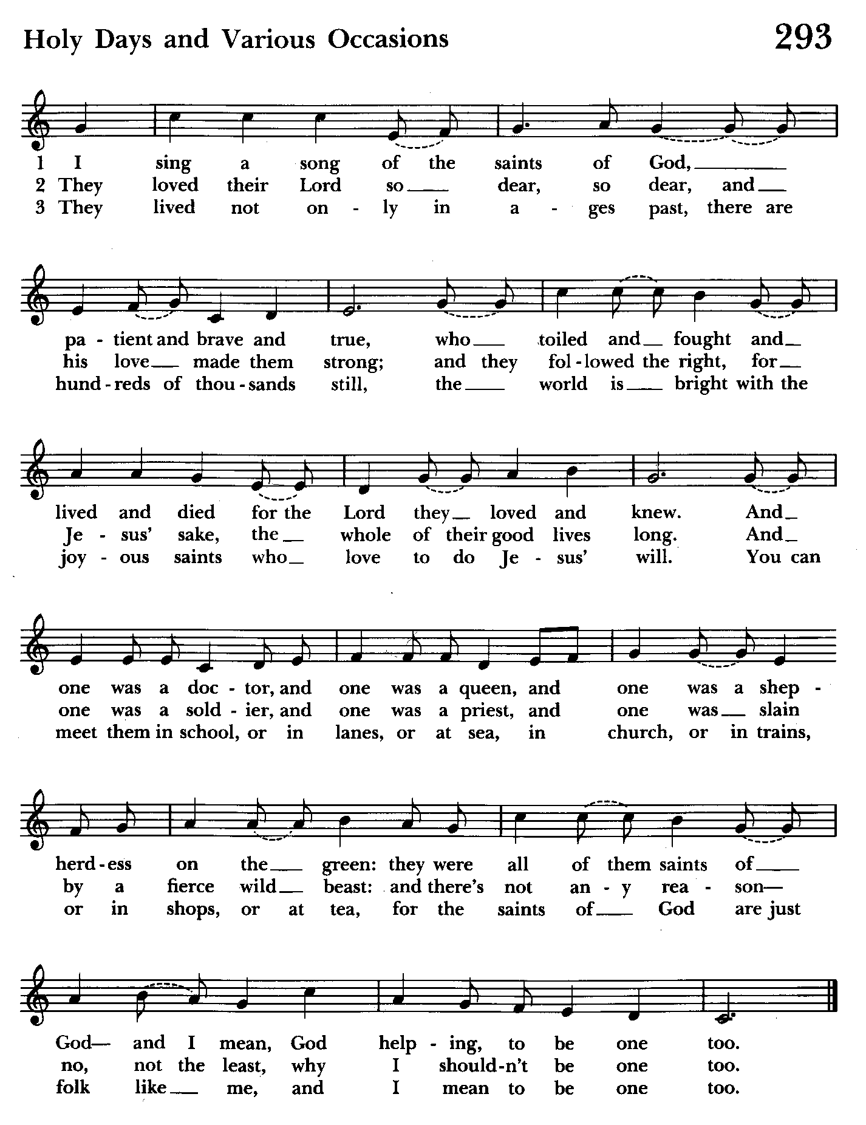

Priest: The Gospel of the Lord.
People: Praise to you, Lord Christ.

Sermon Please be seated The Rt. Rev. Carrie Schofield Broadbent

Holy Baptism Please stand as able. BCP 301
Presentation and Examination of the Candidates
The candidates for Holy Baptism will now be presented.

Parents and Godparents: I present Emma and Cade Donald to receive the
Sacrament of Baptism.

Celebrant: Will you be responsible for seeing that the children you present are brought up in the Christian faith and life?
Parents and Godparents: I will, with God’s help.

Celebrant: Will you by your prayers and witness help them to grow into the full stature of Christ?
Parents and Godparents: I will, with God’s help.

Celebrant: Do you renounce Satan and all the spiritual forces of wickedness that rebel against God?
Parents and Godparents: I renounce them.

Celebrant: Do you renounce the evil powers of this world which corrupt and
destroy the creatures of God?
Parents and Godparents: I renounce them.

Celebrant: Do you renounce all sinful desires that draw you from the love of God?
Parents and Godparents: I renounce them.

Celebrant: Do you turn to Jesus Christ and accept him as your Savior?
Parents and Godparents: I do.
Celebrant: Do you put your whole trust in his grace and love?
Parents and Godparents: I do.

Celebrant: Do you promise to follow and obey him as your Lord?
Parents and Godparents: I do.

Turning to the Congregation
Celebrant: Will you who witness these vows do all in your power to support these persons in their life in Christ?
Congregation: We will.

Celebrant: Let us join with those who are committing themselves to Christ and renew our own baptismal covenant.

Celebrant: Do you believe in God the Father?
People: I believe in God, the Father almighty, creator of heaven and earth.

Celebrant: Do you believe in Jesus Christ, the Son of God?
People: I believe in Jesus Christ, his only Son, our Lord. He was conceived by the power of the Holy Spirit and born of the Virgin Mary. He suffered under Pontius Pilate, was crucified, died, and was buried. He descended to the dead. On the third day he rose again. He ascended into heaven, and is seated at the right hand of the Father. He will come again to judge the living and the dead.

Celebrant: Do you believe in God the Holy Spirit?
People: I believe in the Holy Spirit, the holy catholic Church, the communion of saints, the forgiveness of sins, the resurrection of the body, and the life
everlasting.

Celebrant: Will you continue in the apostles’ teaching and fellowship, in the breaking of bread, and in the prayers ?
People: I will, with God’s help.

Celebrant: Will you persevere in resisting evil, and, whenever you fall into sin, repent and return to the Lord?
People: I will, with God’s help.

Celebrant: Will you proclaim by word and example the Good News of God in Christ?
People: I will, with God’s help.

Celebrant: Will you seek and serve Christ in all persons, loving your neighbor as yourself?
People: I will, with God’s help.

Celebrant: Will you strive for justice and peace among all people, and respect the dignity of every human being?
People: I will, with God’s help.

Prayers for the Candidates BCP 305
Celebrant: Let us now pray for Emma and Cade Donald who are to receive the Sacrament of new birth.

Leader: Deliver them, O Lord, from the way of sin and death.
People: Lord, hear our prayer.

Leader: Open their hearts to your grace and truth.
People: Lord, hear our prayer.

Leader: Fill them with your holy and life-giving Spirit.
People: Lord, hear our prayer.

Leader: Keep them in the faith and communion of your holy Church.
People: Lord, hear our prayer.

Leader: Teach them to love others in the power of the Spirit.
People: Lord, hear our prayer.

Leader: Send them into the world in witness to your love.
People: Lord, hear our prayer.

Leader: Bring them to the fullness of your peace and glory.
People: Lord, hear our prayer.
Celebrant: Grant, O Lord, that all who are baptized into the death of Jesus Christ your Son may live in the power of his resurrection and look for him to come again in glory; who lives and reigns now and for ever. Amen.

Thanksgiving over the water BCP 306
Celebrant: The Lord be with you.
People: And also with you.

Celebrant: Let us give thanks to the Lord our God.
People: It is right to give him thanks and praise.

Celebrant: We thank you, Almighty God, for the gift of water. Over it the Holy Spirit moved in the beginning of creation. Through it you led the children of Israel out of their bondage in Egypt into the land of promise. In it your Son Jesus received the baptism of John and was anointed by the Holy Spirit as the Messiah, the Christ, to lead us, through his death and resurrection, from the bondage of sin into everlasting life.

We thank you, Father, for the water of Baptism. In it we are buried with Christ in his death. By it we share in his resurrection. Through it we are reborn by the Holy Spirit. Therefore in joyful obedience to your Son, we bring into his fellowship those who come to him in faith, baptizing them in the Name of the Father, and of the Son, and of the Holy Spirit.

Now sanctify this water, we pray you, by the power of your Holy Spirit, that those who here are cleansed from sin and born again may continue for ever in the risen life of Jesus Christ our Savior.

To him, to you, and to the Holy Spirit, be all honor and glory, now and for ever. Amen.

The Baptism BCP 307
Celebrant: Emma and Cade Donald, I baptize you in the Name of the Father, and of the Son, and of the Holy Spirit. Amen.

Let us pray.

Heavenly Father, we thank you that by water and the Holy Spirit you have bestowed upon these your servants the forgiveness of sin, and have raised them to the new life of grace. Sustain them, O Lord, in your Holy Spirit. Give them an inquiring and discerning heart, the courage to will and to persevere, a spirit to know and to love you, and the gift of joy and wonder in all your works. Amen.

Celebrant: Emma and Cade Donald you are sealed by the Holy Spirit in Baptism and marked as Christ’s own for ever. Amen.

Celebrant: Receive the light of Christ as a sign that you have passed from darkness into life.

Celebrant: Let us welcome the newly baptized.

Celebrant and People: We receive you into the household of God. Confess the faith of Christ crucified, proclaim his resurrection, and share with us in his eternal priesthood.

Celebrant: The peace of the Lord be always with you. BCP 360
People: And also with you.

Confirmation BCP 309
Bishop: Let us now pray for Stephanie who has renewed her commitment to Christ.

Bishop: Almighty God, we thank you that by the death and resurrection of your Son Jesus Christ you have overcome sin and brought us to yourself, and that by the sealing of your Holy Spirit you have bound us to your service. Renew in these your servants the covenant you made with them at their Baptism. Send them forth in the power of that Spirit to perform the service you set before them; through Jesus Christ your Son our Lord, who lives and reigns with you and the Holy Spirit, one God, now and for ever. Amen.

Bishop: Strengthen, O Lord, your servant Stephanie, with your Holy Spirit; empower her for your service; and sustain her all the days of her life. Amen.

Prayers of the People Form III Kneel or stand as able BCP 387
Celebrant: Father, we pray for your holy Catholic Church;
People: That we all may be one.

Celebrant: Grant that every member of the Church may truly and humbly serve you;
People: That your Name may be glorified by all people.

Celebrant: We pray for all bishops, priests, and deacons;
People: That they may be faithful ministers of your Word and Sacraments.

Celebrant: We pray for all who govern and hold authority in the nations of the world;
People: That there may be justice and peace on the earth.

Celebrant: Give us grace to do your will in all that we undertake;
People: That our works may find favor in your sight.
Celebrant: Have compassion on those who suffer from any grief or trouble;
People: That they may be delivered from their distress.

Celebrant: Give to the departed eternal rest;
People: Let light perpetual shine upon them.

Celebrant: We praise you for your saints who have entered into joy;
People: May we also come to share in your heavenly kingdom.

Celebrant: Let us pray for our own needs and those of others. Especially remember in our prayers, DeMarino Family, Jim & Chris Carden and family, Peggie Dietz, Mike Carden, Pat Carden, Gail Landers, Sheila Jones, Gloria Millar, Marisol Aubrey, Ross Strickler, Jim & Janice Sieracki, James Daniel, Jr., Larry Betzler, Camy Schwenk, Edward, Lily John, Barbara Miller, Nancy Barnhart, Robin Dilworth.

For Peace Among the Nations BCP 816
Almighty God our heavenly Father, guide the nations of the world into the way of justice and truth, and establish among them that peace which is the fruit of righteousness, that they may become the kingdom of our Lord and Savior Jesus Christ. Amen.

The priest adds a concluding collect.

Confession of Sin BCP 359

The Peace The congregation stands as able BCP 360

Welcome & Announcements The congregation is seated.

The Bishop blesses the Sanctus Bells, Holy Water Fonts and Processional Cross.

Offertory anthem: We Thank You For Beloved Saints (Choir)

Offertory hymn: Rejoice, ye pure in heart Hymnal #556
(see next page) Please remain seated as the offering is collected

Presentation Hymn Please stand as able. Hymnal #43, vs. 4
Praise God, from whom all blessings flow; praise him, all creatures here below; praise him above, ye heavenly host: praise Father, Son, and Holy Ghost.

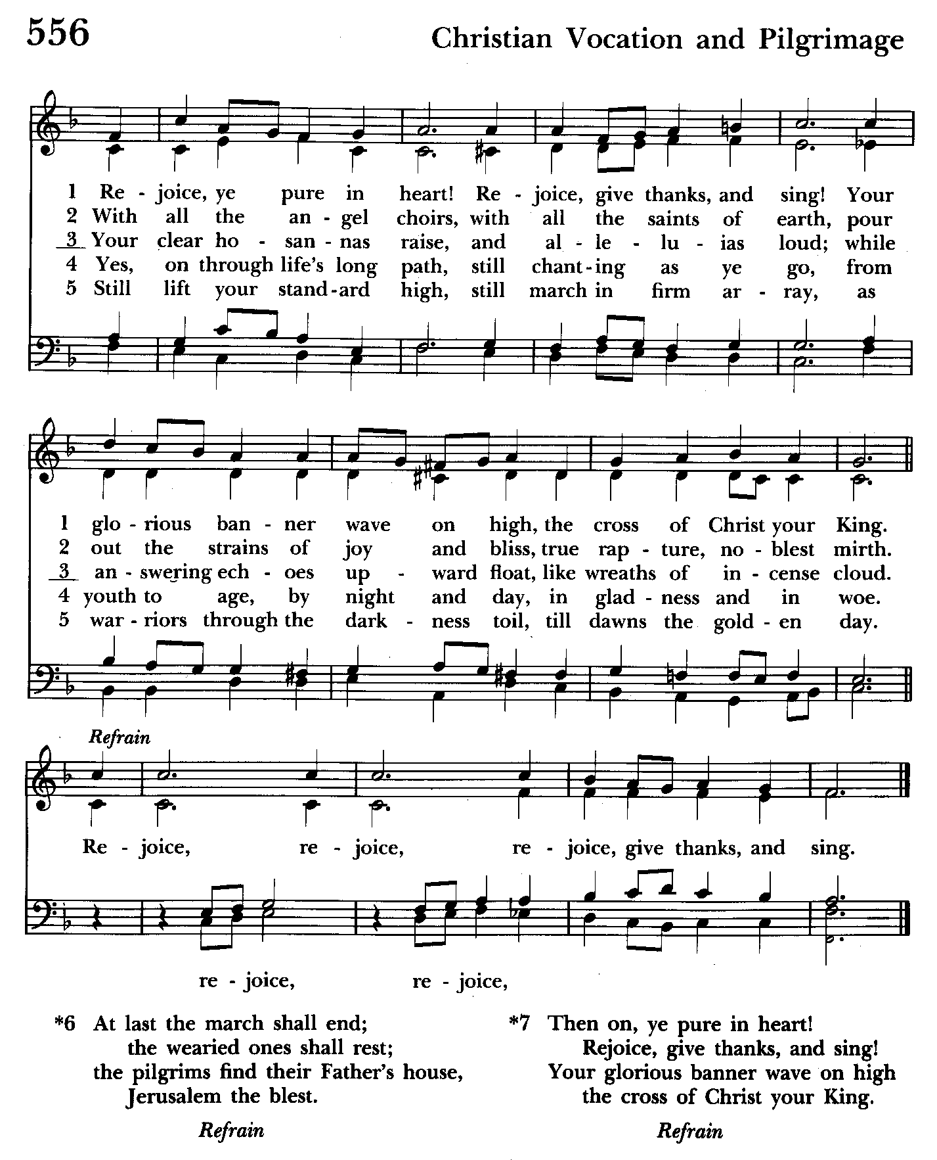

The Holy Communion

THE GREAT THANKSGIVING: Eucharistic Prayer B BCP 367

Sanctus Hymnal #S-128
Holy, Holy, Holy Lord, God of power and might,
heaven and earth are full of your glory.
Hosanna in the highest.
Blessed is he who comes in the name of the Lord.
Hosanna in the highest.

The Lord’s Prayer Please kneel or stand as able BCP 364

The Holy Communion is an “outward and visible sign” that we encounter Christ. Although some reserve this sacrament only for the baptized, at St. John’s we invite all who know Christ, seek to know Christ, or are simply curious to the altar at the Invitation. Receive the bread in cupped hands. Receive the wine by gently grasping the base of the chalice with two fingers, assisting the chalice bearer in guiding the cup to your lips. Intinction (dipping the bread in the wine) is strongly discouraged. If you do not wish to receive one or both kinds, please cross your arms in front of your chest to receive a blessing from the minister. Gluten-free wafers are available. Please indicate your desire for gluten-free sacrament by holding your hands palm down. Those participating online or otherwise unable to be present are considered to be fully engaged and receive the full benefit of the blessings of this gathering.

Invitation to Communion

The Breaking of the Bread

Communion hymn: Draw nigh and take the Body of the Lord Hymnal #328
(see next page)

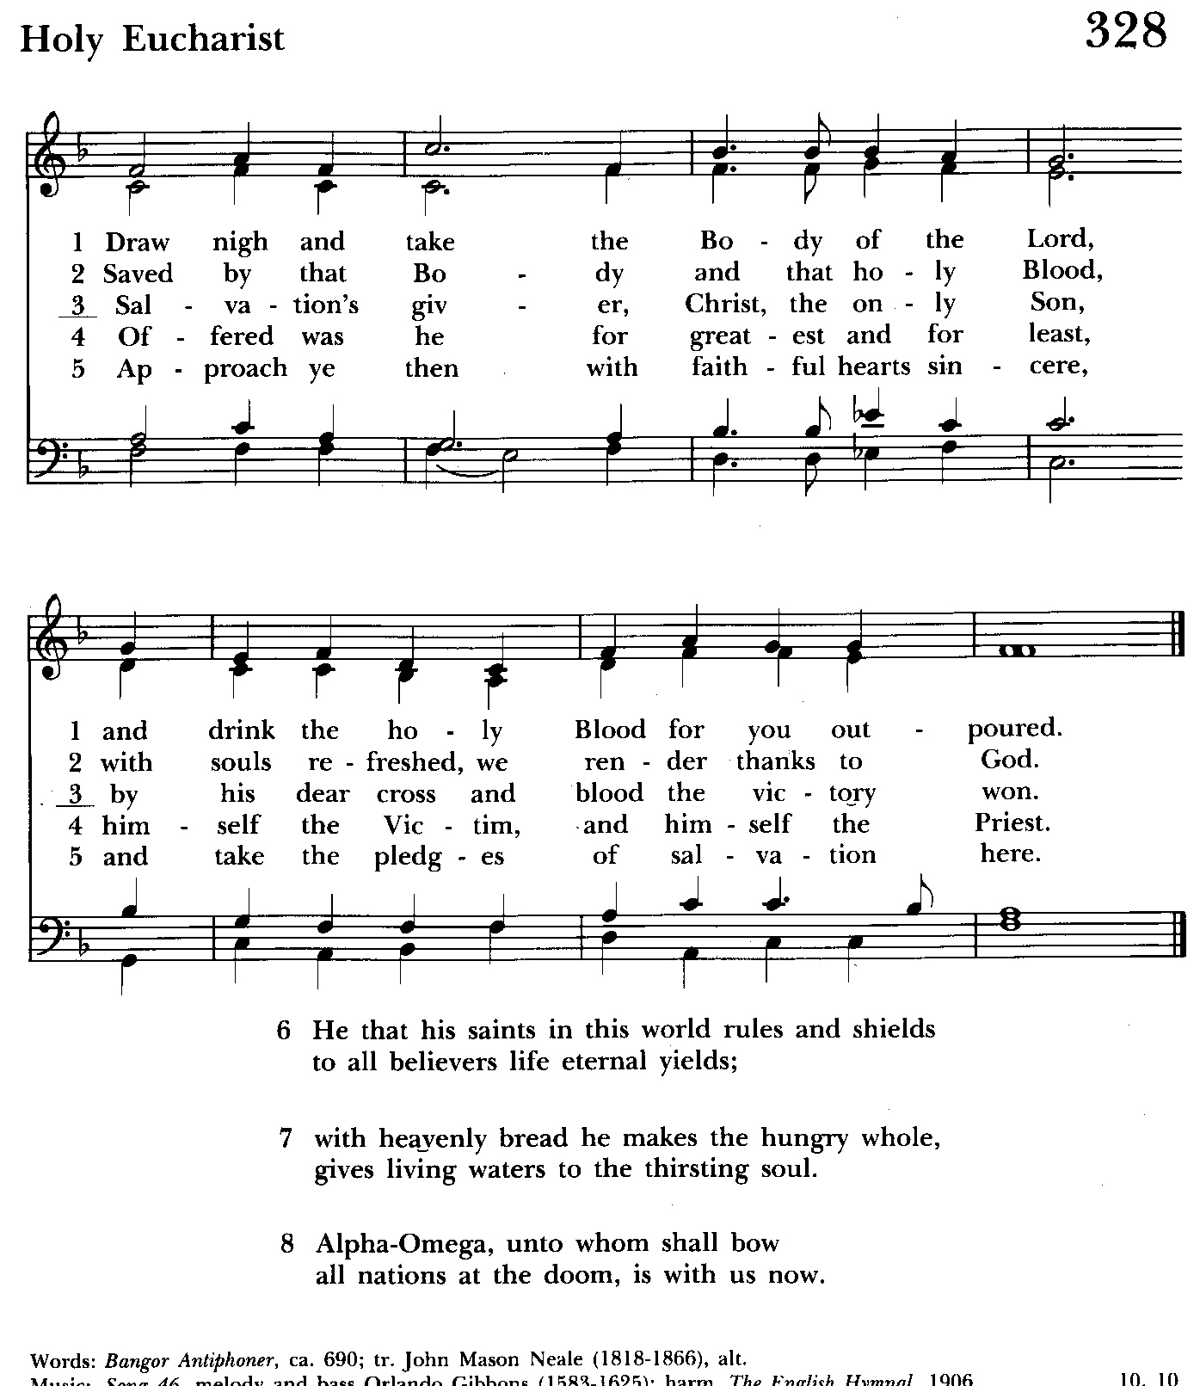

The Post Communion Prayer BCP p. 365
Eternal God, heavenly Father, you have graciously accepted us as living members of your Son our Savior Jesus Christ, and you have fed us with spiritual food in the Sacrament of his Body and Blood. Send us now into the world in peace, and grant us strength and courage to love and serve you with gladness and singleness of heart; through Christ our Lord. Amen.

Blessing

Recessional hymn: Rise up, ye saints of God Hymnal #551
(see next page)

The Dismissal
Celebrant: Let us go forth in the name of the risen Lord.
People: Thanks be to God.

Postlude:

License #A-719154

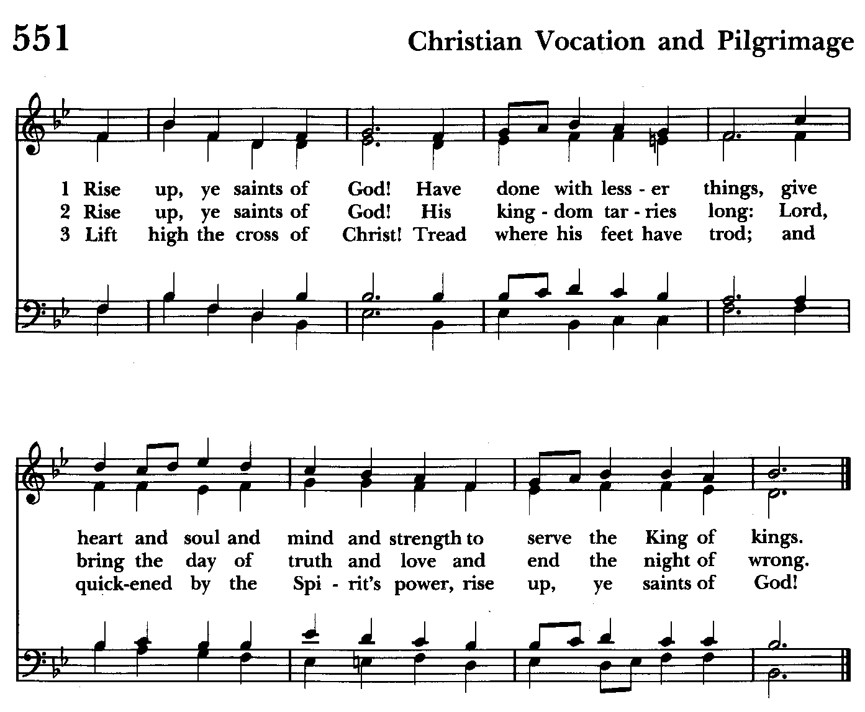



Our Stewardship Campaign has begun! Please prayerfully consider making your pledge online or by
using a pledge card that is available in the back of the church. Thank you.

Serving Today

Celebrant & Preacher: The Rt. Reverend Carrie Schofield-Broadbent
Old Testament: Barb Daniel
Psalm: Woodie Tingle
New Testament: Anne Leland
Prayers of the People: Ty Schwenk
Server: Terry Roe
Music Director: Nancy Heinold
Choir: Anne Leland, Nancy Dellinger, Janine Stevens, Liz Healey,
Camy Schwenk, Karen Smith-Manar, Jacob Johnson, Ty Schwenk
Altar Guild: Stephanie Duchacek and Sandy Roe


Altar Flowers
Given to the Glory of God
by Marsha DeMarino
in loving memory of Matthew

St. John’s Parish Prayer List

Additions and corrections may be made to our Parish Prayer List at any time. All names will be automatically removed from the Parish Prayer List on the 1st Sunday of each month unless you request otherwise. Please contact Angie at <office@stjohnskingsville.org> or 410-592-8570 in the church office with all changes by 10 am Thursdays. Thank you.

We Pray for Those in Need:
Names in BOLD read aloud by all.

DeMarino Family, Jim & Chris Carden and family, Peggie Dietz, Mike Carden, Pat Carden, Gail Landers, Sheila Jones, Gloria Millar, Marisol Aubrey, Ross Strickler, Jim and Janice Sieracki, James Daniel, Jr, Larry Betzler, Camy Schwenk, Edward.

We Pray for our Homebound

Lily John, Barbara Miller, Nancy Barnhart, Robin Dilworth

We pray for the Church and the World:

For +Justin, Archbishop of Canterbury; for +Sean, our Presiding Bishop, for +Carrie, our Bishop, for Mark+, our Interim Rector, for the Wardens, Vestry, Staff, and all members and friends of St. John’s Church.

For the leaders of all nations, especially for Joseph, our President; for Wes, our Governor; for Brandon, Nick, John and Bob, who lead our City and Counties. We pray for all children and youth; for the homeless, the unemployed, and the hungry. We pray for the safety of our loved ones and friends serving in the Armed Forces at home and abroad, and for our enemies, that all our hearts may be turned toward peace throughout the world.

From the Treasurer
October ‘24 Income vs. Expenses:

Projected October Expenses: $13,500
Monies Received as of 10/31: $14,658
Income vs. Projected Expenses: $ 1,158
THANK YOU!

November ’24 Projected Expenses: $13,500


If you’d like to make a donation to St. John’s you can scan this QR code with your phone’s camera or tap on the link that comes up to make a contribution with either a credit or debit card, Apple Pay or Google Pay. This is a secure site provided by Clover which is a service of PNC Bank.

SUNDAY SCHOOL

Time for Sunday School. Mr. John and Miss Stephanie are back. Sunday School begins during the 10:30 service and continues in the Parish Hall.

Calendar Updates

Bishop Carrie Visits - 11/3, ONE SERVICE AT 10:30 AM (2 baptisms & confirmation during service.). Fellowship with the Bishop & Luncheon to follow.

All Souls service- Sunday evening 7:00 11/3.

Community Christmas Tree Lighting and Cantata - 12/8, 7 pm

Blue Christmas/Service of Solace- TBD

Christmas Lessons & Carols - 12/29, 10:30 am

Calendars are living documents. Every effort will be made to keep the members of the parish and community aware of any changes.

Choral Choir and Bell Choir

Choir rehearsals Wednesdays at 7:00 pm and Bell Choir Rehearsal will be on Sundays after the 10:30 service. If anyone is interested in joining, see Nancy Heinold, our Music Director.

9:00- 9:30: "Confirmation Class" - for any interested in Confirmation/Reception or any just interested. Walk In Love, (copies available).
10:30: Kids Sunday School- Begin in the church, ring the bell, then process over to the parish hall for a fun lesson with Mr. John and Ms. Stephanie. Note: Please seriously consider regular attendance at Sunday School so that Mr. John and Ms. Stephanie can plan good stuff.
Wednesday Mornings- Feed the Wolf!
Our book study is held Wednesdays at 9:00 a.m. in the Parish Hall. Books are still available.
Fr. Mark is open to additional locations and times for another group. Speak up if you have a suggestion.


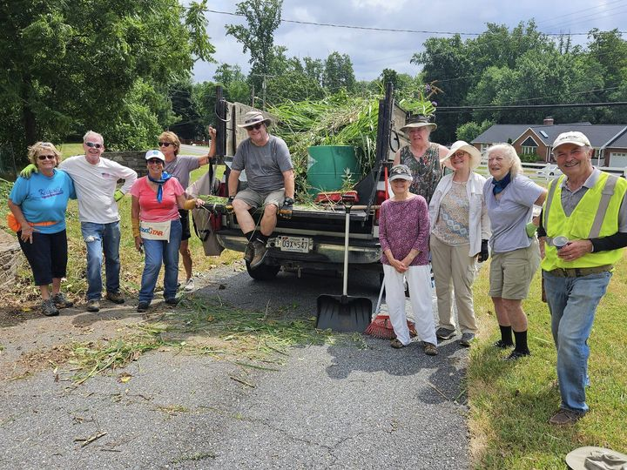
Yoga classes on Tuesday, Wednesday and Friday evenings 6 to 7 pm and Saturday mornings 9 to 10 am in the Chapel. All experience levels are welcome.
Come see the progress we’re making to Beautify our St. Francis Garden!!
For more info or to sign up to help keep our gardens looking beautiful, contact: Rita Talley-Garden Club, 443-617-1820 or Karen Smith-Manar-St. John’s 410-746-9813 or bikenbocal@verizon.net
Wish list: plant and tree food, hosta, liriope, mums, asters, shovels
Next workday: 11/9 @ 8:30 (rain date: 11/16 @ 8:30 am)
God’s Grace Gardens—a St. John’s, Hill & Stream Garden Club and AA collaboration


With so much going on, everyone’s help is needed to make things a success. Our volunteers make the Church function. The volunteering of time and talent is greatly appreciated.


If you won’t be attending the All Souls Service we would invite you to join in supporting the Heping Hands Food Pantry Community Choir Concert tonight at 7 pm at St. Paul’s.


OUTREACH
WHAT A GREAT GIFT TO GIVE SOMEONE A MERRY CHRISTMAS!!

With Christmas and Thanksgiving just around the corner the Helping Hands Food Pantry is preparing for its annual Meal Distribution.

Listed below is what they need:
Yams/Sweet Potatoes (small or medium cans), Instant Potatoes (box or bag), Cranberries (canned), Sauerkraut (canned), cake mixes, cake icing (ready made)

Thank you so much!

In our Community
Bible Studies in our area. If interested, please contact these churches to confirm.
St. Mary’s, Abingdon, (410)569-0180- Wednesdays at noon. Bring lunch. Zoom available.
Emmanuel, Bel Air, (410)838-7699- Fridays at 9:30- Zoom Available.
Holy Trinity, Churchville, (410)914-5531- Wednesdays 11:30- Zoom may be available.

What’s Happening This Week at St. John’s

Sunday, November 3—All Saints Sunday
10:30am: Holy Eucharist-Holy Baptism & Confirmation Rite II (Church)
11:30am: Luncheon with Bishop Carrie (Parish Hall)

Monday, November 4
12:00-1:00pm: AA Lunch Bunch (Parish Hall)
7:00-8:30pm: Spanish speaking AA group (Parish Hall)

Tuesday, November 5
12:00-1:00pm: AA Lunch Bunch (Parish Hall)
6:00-7:00pm: Yoga (Chapel)

Wednesday, November 6
9:00am: Bible Study (Parish Hall)
12:00-1:00pm: AA Lunch Bunch (Parish Hall)
6:00-7:00pm: Yoga (Chapel)
7:00pm: Choir Rehearsal (Church)
7:30pm: AA (Parish Hall)

Thursday, November 7
12:00-1:00pm: AA Lunch Bunch (Parish Hall)
7:00pm: AA (Parish Hall)

Friday, November 8
12:00-1:00pm: AA Lunch Bunch (Parish Hall)
6:00pm -7:00pm: Yoga (Chapel)

Saturday, November 9
9:00am-10:00am: Yoga (Chapel)
8:30pm: AA (Parish Hall)

Sunday, November 10 —25th Sunday after Pentecost
8:00am: Holy Eucharist, Rite I (Church)
10:30am: Holy Eucharist, Rite II (Church)
11:30am: Coffee Hour (Parish Hall)
11:45am: Bell Choir Rehearsal (Church)

Parish Office is open Monday, Wednesday and Thursday, 9:30am-1:30pm.

Potluck Luncheon on the first Sunday of the month and a Coffee Hour on all other Sundays after the 10:30 service.

