St. John’s Episcopal Church
Kingsville, Maryland
Welcomes You

Our Vision Statement

We believe that together we will transform
the world with love: Come on in!

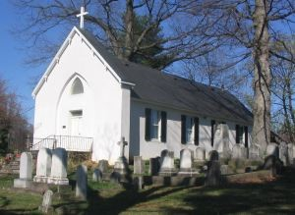

Nineteenth Sunday after Pentecost
Morning Prayer Rite II
September 29, 2024—10:30 am

St. John’s Episcopal Church

11901 Belair Road, P. O. Box 187, Kingsville, MD 21087
Facebook: St. John’s Episcopal, Kingsville, MD
Email: office@stjohnskingsville.org
Website: www.stjohnskingsville.org
Church Phone: 410-592-8570
For Pastoral Emergencies: Fr. Mark Lobb+ 443-690-9545

Welcome to worship today! We are glad that you are with us. You are invited to participate in all parts of the service as indicated in the Book of Common Prayer and this service bulletin. If you have any questions, feel free to ask the ushers. Restrooms are located in the Parish Hall, the brick building across the parking lot.

I was glad when they said to me, “Let us go to the house of the Lord.” Psalm 122:1

Church Staff

Interim Rector: Father Mark Lobb
Administrative Assistant: Angie Bosley
Organist/Choir Director: Nancy Heinold

The Vestry

Class of 2025 Class of 2026

John Frost John Stevens
Woodie Tingle
Jacob Johnson

Officers
Ty Schwenk—Sr. Warden Terry Roe—Jr. Warden
Elizabeth Healey—Treasurer Anne Leland-Registrar

Parish Committee Chairpersons

Altar Guild: Elizabeth Healey
Auxiliary Committee: Michele Lozanski
Cemetery Committee: Terry Roe

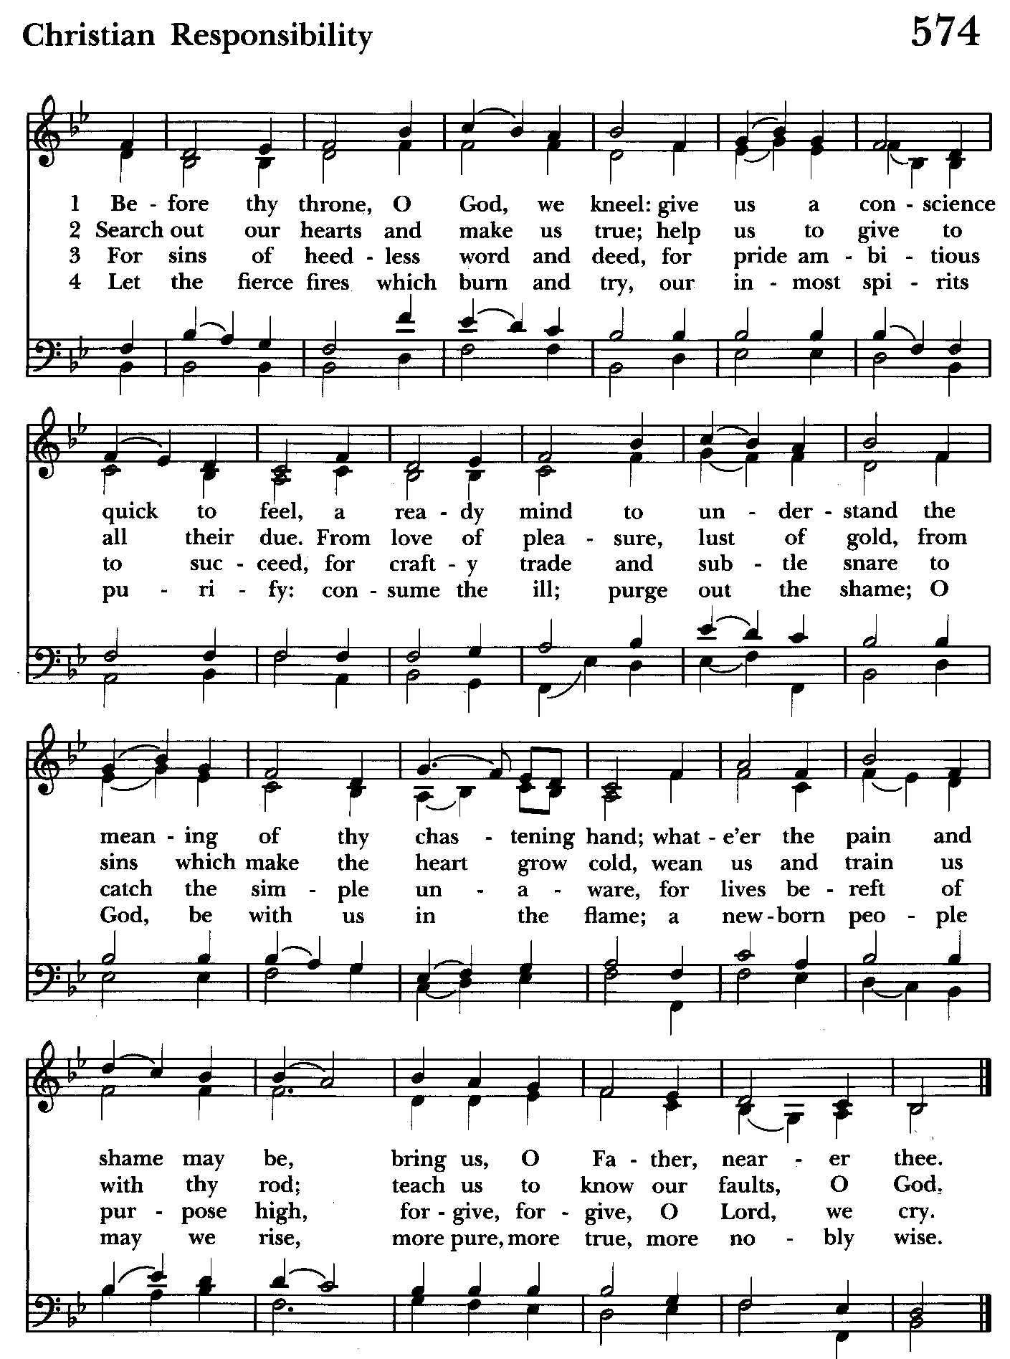

Morning Prayer—Rite II
Note:
Please feel free to remain seated during the service if unable to stand or kneel. ‘BCP’ refers to the Book of Common Prayer. The people’s responses are in bold.

Prelude

Gathering hymn: Before thy throne, O God, we kneel Hymnal #574
(see previous page)

OPENING SENTENCES BCP p. 78

Officiant: Grace to you and peace from God our Father and the Lord Jesus Christ.
Philippians 1:2

CONFESSION OF SIN BCP p. 79
Dearly beloved, we have come together in the presence of Almighty God our heavenly Father, to set forth his praise, to hear his holy Word, and to ask, for ourselves and on behalf of others, those things that are necessary for our life and our salvation. And so that we may prepare ourselves in heart and mind to worship him, let us kneel in silence, and with penitent and obedient hearts confess our sins, that we may obtain forgiveness by his infinite goodness and mercy.

Officiant and People please stand or kneel as able
Most merciful God, we confess that we have sinned against you in thought, word, and deed, by what we have done, and by what we have left undone. We have not loved you with our whole heart; we have not loved our neighbors as ourselves. We are truly sorry and we humbly repent. For the sake of your Son Jesus Christ, have mercy on us and forgive us; that we may delight in your will, and walk in your ways, to the glory of your Name. Amen.

Officiant: Almighty God have mercy on us, forgive us all our sins through our Lord Jesus Christ, strengthen you in all goodness, and by the power of the Holy Spirit keep us in eternal life. Amen.

The Invitatory and Psalter BCP pg. 80

All stand
Officiant: Lord, open our lips.
People: And our mouth shall proclaim your praise.

Officiant and People
Glory to the Father, and to the Son, and to the Holy Spirit: as it was in the beginning, is now, and will be for ever. Amen.

The mercy of the Lord is everlasting: Come let us adore him. BCP pg. 81

Venite Psalm 95:1-7 BCP. pg. 82
Come, let us sing to the Lord;*
let us shout for joy to the Rock of our salvation.
Let us come before his presence with thakisgiving*
and raise a loud shout to him with psalms.

For the Lord is a great God,*
and a great King above all gods.
In his hands are the caverns of the earth,*
and the heights of the hills are his also.
The sea is his, for he made it.*
and his hands have molded the dry land.

Come, let us bow down, and bend the knee,*
and kneel before the Lord our Maker.
For he is our God,
and we are the people of his pasture and the sheep of his hand.*
Oh, that today you would hearken to his voice!

Psalm 124
Officiant and People
1 If the Lord had not been on our side, *
let Israel now say;
2 If the Lord had not been on our side, *
when enemies rose up against us;
3 Then would they have swallowed us up alive *
in their fierce anger toward us;
4 Then would the waters have overwhelmed us *
and the torrent gone over us;
5 Then would the raging waters *
have gone right over us.
6 Blessed be the Lord! *
he has not given us over to be a prey for their teeth.
7 We have escaped like a bird from the snare of the fowler; *
the snare is broken, and we have escaped.
8 Our help is in the Name of the Lord, *
the maker of heaven and earth.

Please be seated

THE FIRST READING Esther 7:1-6, 9-10; 9:20-22
The king and Haman went in to feast with Queen Esther. On the second day, as they were drinking wine, the king again said to Esther, “What is your petition, Queen Esther? It shall be granted you. And what is your request? Even to the half of my kingdom, it shall be fulfilled.” Then Queen Esther answered, “If I have won your favor, O king, and if it pleases the king, let my life be given me-- that is my petition-- and the lives of my people-- that is my request. For we have been sold, I and my people, to be destroyed, to be killed, and to be annihilated. If we had been sold merely as slaves, men and women, I would have held my peace; but no enemy can compensate for this damage to the king.” Then King Ahasuerus said to Queen Esther, “Who is he, and where is he, who has presumed to do this?” Esther said, “A foe and enemy, this wicked Haman!” Then
Haman was terrified before the king and the queen.
Then Harbona, one of the eunuchs in attendance on the king, said, “Look, the very
gallows that Haman has prepared for Mordecai, whose word saved the king, stands at Haman's house, fifty cubits high.” And the king said, “Hang him on that.” So they hanged Haman on the gallows that he had prepared for Mordecai. Then the anger of the king abated.
Mordecai recorded these things, and sent letters to all the Jews who were in all the provinces of King Ahasuerus, both near and far, enjoining them that they should keep the fourteenth day of the month Adar and also the fifteenth day of the same month, year by year, as the days on which the Jews gained relief from their enemies, and as the month that had been turned for them from sorrow into gladness and from mourning into a holiday; that they should make them days of feasting and gladness, days for sending gifts of food to one another and presents to the poor.

The Word of the Lord.
Thanks be to God.

Canticle 16 The Song of Zechariah Benedictus Dominus Deus BCP pg. 92
Luke 1: 68-79
Blessed be the Lord, the God of Israel; *
he has come to his people and set them free.
He has raised up for us a mighty savior, *
born of the house of his servant David.
Through his holy prophets he promised of old,
that he would save us from our enemies, *
from the hands of all who hate us.
He promised to show mercy to our fathers *
and to remember his holy covenant.
This was the oath he swore to our father Abraham, *
to set us free from the hands of our enemies,
Free to worship him without fear, *
holy and righteous in his sight
all the days of our life.
You, my child, shall be called the prophet of the Most High, *
for you will go before the Lord to prepare his way,
To give his people knowledge of salvation *
by the forgiveness of their sins.
In the tender compassion of our God *
the dawn from on high shall break upon us,
To shine on those who dwell in darkness and the
shadow of death, *
and to guide our feet into the way of peace.
Glory to the Father, and to the Son, and to the Holy Spirit: *
as it was in the beginning, is now, and will be for ever. Amen.

THE SECOND READING James 5:13-20
Are any among you suffering? They should pray. Are any cheerful? They should sing songs of praise. Are any among you sick? They should call for the elders of the church and have them pray over them, anointing them with oil in the name of the Lord. The prayer of faith will save the sick, and the Lord will raise them up; and anyone who has committed sins will be forgiven. Therefore confess your sins to one another, and pray for one another, so that you may be healed. The prayer of the righteous is powerful and effective. Elijah was a human being like us, and he prayed fervently that it might not rain, and for three years and six months it did not rain on the earth. Then he prayed again, and the heaven gave rain and the earth yielded its harvest.
My brothers and sisters, if anyone among you wanders from the truth and is brought back by another, you should know that whoever brings back a sinner from wandering will save the sinner's soul from death and will cover a multitude of sins.

The Word of the Lord.
Thanks be to God.

Canticle 21 You are God Te Deum laudamus BCP pg. 95
You are the Lord; we acclaim you;
You are the eternal Father:
All creation worships you.
To you all angels, all the powers of heaven,
Cherubim and Seraphim, sing in endless praise:
Holy, holy, holy Lord, God of power and might,
heaven and earth are full of your glory.
The glorious company of apostles praise you.
The noble fellowship of prophets praise you.
The white-robed army of martyrs praise you.
Throughout the world the holy Church acclaims you;
Father, of majesty unbounded,
your true and only Son, worthy of all worship,
and the Holy Spirit, advocate and guide.
You, Christ, are the king of glory,
the eternal Son of the Father.
When you became man to set us free
you did not shun the Virgin's womb.
You overcame the sting of death
and opened the kingdom of heaven to all believers.
You are seated at God's right hand in glory.
We believe that you will come and be our judge.
Come then, Lord, and help your people,
bought with the price of your own blood,
and bring us with your saints
to glory everlasting.

Gradual hymn: Where cross the crowded ways of life Hymnal #609
(see next page)

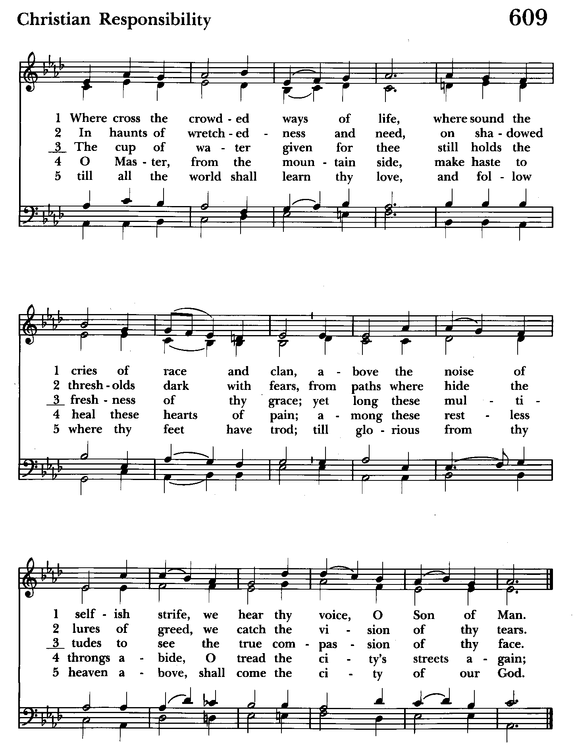

A READING FROM THE GOSPEL OF MARK People remain standing 9:38-50
John said to Jesus, “Teacher, we saw someone casting out demons in your name, and we tried to stop him, because he was not following us.” But Jesus said, “Do not stop him; for no one who does a deed of power in my name will be able soon afterward to speak evil of me. Whoever is not against us is for us. For truly I tell you, whoever gives you a cup of water to drink because you bear the name of Christ will by no means lose the reward.
“If any of you put a stumbling block before one of these little ones who believe in me, it would be better for you if a great millstone were hung around your neck and you were thrown into the sea. If your hand causes you to stumble, cut it off; it is better for you to enter life maimed than to have two hands and to go to hell, to the unquenchable fire. And if your foot causes you to stumble, cut it off; it is better for you to enter life lame than to have two feet and to be thrown into hell. And if your eye causes you to stumble, tear it out; it is better for you to enter the kingdom of God with one eye than to have two eyes and to be thrown into hell, where their worm never dies, and the fire is never quenched.
“For everyone will be salted with fire. Salt is good; but if salt has lost its saltiness, how can you season it? Have salt in yourselves, and be at peace with one another.”

The Word of the Lord.
Thanks be to God.

The Homily The congregation is seated Ty Schwenk

The Peace The congregation stands as able

Announcements The people are seated

THE APOSTLES CREED BCP pg. 96
Said by all, standing as you are able.
I believe in God, the Father almighty,
creator of heaven and earth;
I believe in Jesus Christ, his only Son, our Lord.
He was conceived by the power of the Holy Spirit
and born of the Virgin Mary.
He suffered under Pontius Pilate,
was crucified, died, and was buried.
He descended to the dead.
On the third day he rose again.
He ascended into heaven,
and is seated at the right hand of the Father.
He will come again to judge the living and the dead.
I believe in the Holy Spirit,
the holy catholic Church,
the communion of saints,
the forgiveness of sins
the resurrection of the body,
and the life everlasting. Amen.
Celebrant: The Lord be with you.
People: And also with you.
Celebrant: Let us pray.
THE LORD’S PRAYER Stand or kneel as able. BCP pg. 97
Our Father, who art in heaven, hallowed be thy Name, thy kingdom come, thy will be done, on earth as it is in heaven. Give us this day our daily bread. And forgive us our trespasses, as we forgive those who trespass against us. And lead us not into temptation, but deliver us from evil. For thine is the kingdom, and the power, and the glory, for ever and ever. Amen.
People and Officiant
SUFFRAGES B BCP pg. 98
V. Save your people, Lord, and bless your inheritance;
R. Govern and uphold them, now and always.
V. Day by day we bless you;
R. We praise your Name for ever.
V. Lord, keep us from all sin today;
R. Have mercy on us, Lord, have mercy.
V. Lord, show us your love and mercy;
R. For we put our trust in you.
V. In you, Lord, is our hope;
R. And we shall never hope in vain.

THE COLLECT OF THE DAY BCP pg. 234

O God, you declare your almighty power chiefly in showing mercy and pity: Grant us the fullness of your grace, that we, running to obtain your promises, may become partakers of your heavenly treasure; through Jesus Christ our Lord, who lives and reigns with you and the Holy Spirit, one God, for ever and ever. Amen.

A COLLECT FOR SUNDAYS BCP pg. 98
O God, you make us glad with the weekly remembrance of the glorious resurrection of your Son our Lord: Give us this day such blessing through our worship of you, that the week to come may be spent in your favor; through Jesus Christ our Lord. Amen.

Officiant: Let us pray for our own needs and those of others.

Silence

PRAYER FOR MISSION BCP pg. 100
Almighty and everlasting God, by whose Spirit the whole body of your faithful people is governed and sanctified: Receive our supplications and prayers which we offer before you for all members of your holy Church, that in their vocation and ministry they may truly and devoutly serve you; through Lord and Savior Jesus Christ. Amen.

The people remain seated.

OFFERTORY ANTHEM: Spirit Song (Choir)

THE OFFERTORY The offering is collected The offering is brought forward

DOXOLOGY Please stand as able Hymnal #43, vs. 4
Praise God, from whom all blessings flow; praise him, all creatures here below; praise him above, ye heavenly host: praise Father, Son, and Holy Ghost.

Please kneel or stand as able

THE PRAYERS OF THE PEOPLE – Form III BCP pg. 387
Father, we pray for your holy Catholic Church;
That we all may be one.

Grant that every member of the Church may truly and humbly serve you;
That your Name may be glorified by all people.

We pray for all bishops, priests, and deacons;
That they may be faithful ministers of your Word and Sacraments.

We pray for all who govern and hold authority in the nations of the world;
That there may be justice and peace on the earth.

Give us grace to do your will in all that we undertake;
That our works may find favor in your sight.

Have compassion on those who suffer from any grief or trouble;
That they may be delivered from their distress.

Give to the departed eternal rest;
Let light perpetual shine upon them.
.
We praise you for your saints who have entered into joy;
May we also come to share in your heavenly kingdom.
.
Let us pray for our own needs and those of others.

We Pray for Those in Need:
DeMarino Family, Jim & Chris Carden and family, Peggie Dietz, Mike Carden, Pat Carden, Gail Landers, Sheila Jones, Gloria Millar, Marisol Aubrey, Ross Strickler, Jim and Janice Sieracki, Edward, James Daniel, Jr., Larry Betzler, John Webb, Carol Vandergriff.

We Pray for our Homebound

Lily John, Barbara Miller, Nancy Barnhart, Robin Dilworth

We pray for the Church and the World:

For +Justin, Archbishop of Canterbury; for +Michael, our Presiding Bishop; for +Carrie, our Bishop, for Mark+, our Interim Rector, for the Wardens, Vestry, Staff, and all members and friends of St. John’s Church.

For the leaders of all nations, especially for Joseph, our President; for Wes, our Governor; for Brandon, Nick, John and Bob, who lead our City and Counties. We pray for all children and youth; for the homeless, the unemployed, and the hungry. We pray for the safety of our loved ones and friends serving in the Armed Forces at home and abroad, and for our enemies, that all our hearts may be turned toward peace throughout the world.

THE GENERAL THANKSGIVING
Let us pray.
Officiant and people BCP pg. 101
Almighty God, Father of all mercies, we your unworthy servants give you humble thanks for all your goodness and loving-kindness to us and to all whom you have made. We bless you for our creation, preservation, and all the blessings of this life; but above all for your immeasurable love in the redemption of the world by our Lord Jesus Christ; for the means of grace, and for the hope of glory. And, we pray, give us such an awareness of your mercies, that with truly thankful hearts we may show forth your praise, not only with our lips, but in our lives, by giving up our selves to your service, and by walking before you in holiness and righteousness all our days; through Jesus Christ our Lord, to whom, with you and the Holy Spirit, be honor and glory throughout all ages. Amen.

Closing hymn: Lord, dismiss us with thy blessing Hymnal #344

THE DISMISSAL BCP pg. 102
Officiant: The grace of our Lord Jesus Christ, and the Love of God, and the
fellowship of the Holy Spirit, be with us all evermore.
People: Thanks be to God.

License #A-719154

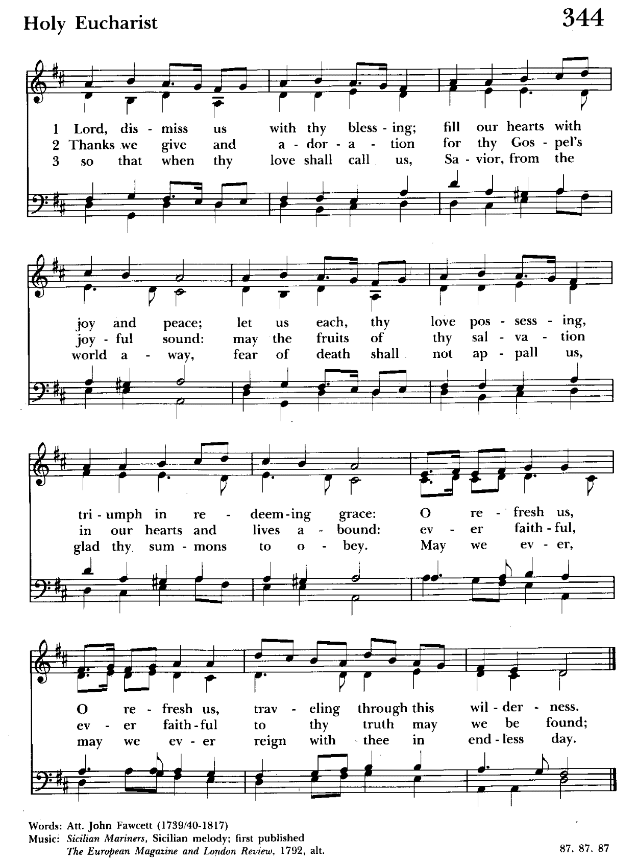

Serving Today
Officiant: Ty Schwenk
Old Testament: Anne Leland
Psalm: Liz Healey
New Testament: Anne Leland
Prayers of the People: Liz Healey
Music Director: Nancy Heinold
Choir: Anne Leland, Nancy Dellinger, Janine Stevens, Liz Healey, Camy Schwenk,
Karen Smith-Manar, Jacob Johnson, Ty Schwenk
Altar Guild: John Stevens & Woodie Tingle


With so much going on, everyone’s help is needed to make things a success. Our volunteers make the Church function. The volunteering of time and talent is greatly appreciated.

St. John’s Parish Prayer List

Additions and corrections may be made to our Parish Prayer List at any time. All names will be automatically removed from the Parish Prayer List on the 1st Sunday of each month unless you request otherwise. Please contact Angie at <office@stjohnskingsville.org> or 410-592-8570 in the church office with all changes by 10 am Thursdays. Thank you.

We Pray for Those in Need:
Names in BOLD read aloud by all.

DeMarino Family, Jim & Chris Carden and family, Peggie Dietz, Mike Carden, Pat Carden, Gail Landers, Sheila Jones, Gloria Millar, Marisol Aubrey, Ross Strickler, Jim and Janice Sieracki, Edward, James Daniel, Jr., Larry Betzler, John Webb, Carol Vandergriff.

We Pray for our Homebound

Lily John, Barbara Miller, Nancy Barnhart, Robin Dilworth

We pray for the Church and the World:

For +Justin, Archbishop of Canterbury; for +Michael, our Presiding Bishop; for +Sean, our Presiding Bishop Elect; for +Carrie, our Bishop, for Mark+, our Interim Rector; for the Wardens, Vestry, Staff, and all members and friends of St. John’s Church.

For the leaders of all nations, especially for Joseph, our President; for Wes, our Governor; for Brandon, Nick, John and Bob, who lead our City and Counties. We pray for all children and youth; for the homeless, the unemployed, and the hungry. We pray for the safety of our loved ones and friends serving in the Armed Forces at home and abroad, and for our enemies, that all our hearts may be turned toward peace throughout the world.

Altar Flowers


Given to the Glory of God
by Frank Duchacek
in celebration of Stephanie Duchacek’s Birthday

From the Treasurer

September ’24 Income vs. Expenses:

Projected September Expenses: $13,500
Monies Received as of 9/26: $11,720
Amount Needed to Meet Expenses: $1,780

Proceeds from 9/21 Flea Market: $2,131


If you’d like to make a donation to St. John’s you can scan this QR code with your phone’s camera or tap on the link that comes up to make a contribution with either a credit or debit card, Apple Pay or Google Pay. This is a secure site provided by Clover which is a service of PNC Bank.

9:00- 9:30: "Confirmation Class" - for any interested in Confirmation/Reception or any just interested. This class will not meet on September 29th but will continue on October 6th, Walk In Love, Chapters 9 and 10 (copies available).
10:30: Kids Sunday School- Begin in the church, ring the bell, then process over to the parish hall for a fun lesson with Mr. John and Ms. Stephanie. Note: Please seriously consider regular attendance at Sunday School so that Mr. John and Ms. Stephanie can plan good stuff.
Wednesday Mornings- Feed the Wolf!
Our book study begins this Wednesday 9/18, 9:00 a.m. in the Parish Hall. We will look at Chapters 4 and 5. Books are still available.
Fr. Mark is open to additional locations and times for another group. Speak up if you have a suggestion.

Our next BINGO is quickly approaching.



October 18th at 5:30 pm

Choral Choir and Bell Choir
Choir rehearsals Wednesdays at 7:00 pm and Bell Choir Rehearsal will be after the 10:30 service. If anyone is interested in joining, see Nancy Heinold, our Music Director.

SUNDAY SCHOOL
Time for Sunday School. Mr. John and Miss Stephanie are back.


Yoga is now on Tuesday, Wednesday and Friday evenings 6 to 7 pm and Saturday mornings 9 to 10 am in the Chapel.
All experience levels are welcome.

Calendar Updates

Morning Prayer- will be offered on the following Sundays: 9/29, 10/20, 12/29. Lay people are highly encouraged to consider helping by officiating and/or preaching of Morning Prayer. I am willing to help you prepare for this.

Would it be helpful to have an “Officiating Morning Prayer” class? Let me know.

Blessing of the Animals- 9:30 a.m. (between the services) on Sunday 10/6, outside or in the Parish Hall (weather permitting).

All Souls service- Sunday evening 7:00 11/3.

Blue Christmas/Service of Solace- TBD

Calendars are living documents. Every effort will be made to keep the members of the parish and community aware of any changes.

SAVE THE DATE
Bingo - 10/18
Christmas Bazaar - 11/23


OUTREACH
WHAT A GREAT GIFT TO GIVE SOMEONE A MERRY CHRISTMAS!!

With Christmas and Thanksgiving just around the corner the Helping Hands Food Pantry is preparing for its annual Meal Distribution.

Listed below is what they need:
Yams/Sweet Potatoes (small or medium cans), Instant
Potatoes (box or bag), Cranberries (canned), Sauerkraut (canned), cake mixes, cake icing (ready made)

Thank you so much!

RECYCLING!
The recycling bin at home is filling up and it will soon be time to take it over to the recycling center. Did you know that cat food cans are made from aluminum?

By popular demand, we are recycling. Some parishioners take printed paper home where they have recycling pickup. We now have a blue container located in the Parish Hall. This will be collected and taken for recycling. Aluminum cans will be saved and taken to a recycling center for cash. The proceeds will be donated to the Outreach fund. Each recycled aluminum can also save on the electricity needed to make new aluminum from bauxite.

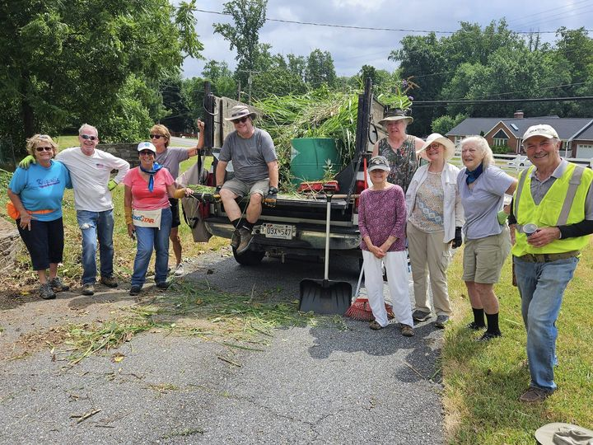
Come see the progress we’re making to Beautify our St. Francis Garden!!
For more info or to sign up to help keep our gardens looking beautiful, contact: Rita Talley-Garden Club, 443-617-1820 or Karen Smith-Manar-St. John’s 410-746-9813 or bikenbocal@verizon.net
Wish list: plant and tree food, hosta, liriope, mums, asters, shovels
Next Workday: October 3 @ 8:30 am
God’s Grace Gardens—a St. John’s, Hill & Stream Garden Club and AA collaboration

In our Community

COPLEY PARISH HISTORIC FALL FESTIVAL October 19, 2024 11 am-4 pm
Face Painting, Pony Rides, 1700’s L:iving History, Petting Zoo, Demos, Food, Vendors & More (www.copleyparish.org)

Bible Studies in our area. If interested, please contact these churches to confirm.
St. Mary’s, Abingdon, (410)569-0180- Wednesdays at noon. Bring lunch. Zoom available.
Emmanuel, Bel Air, (410)838-7699- Fridays at 9:30- Zoom Available.
Holy Trinity, Churchville, (410)914-5531- Wednesdays 11:30- Zoom may be available.

What’s Happening This Week at St. John’s

Sunday, September 29—MORNING PRAYER-19th Sunday after Pentecost
8:00am: Morning Prayer, Rite I (Church)
10:30am: Morning Prayer, Rite II (Church)
11:30am: Coffee Hour (Parish Hall)
11:45am: Bell Choir Rehearsal (Church)

Monday, September 30
12:00-1:00pm: AA Lunch Bunch (Parish Hall)
7:00-8:30pm: Spanish speaking AA group (Parish Hall)

Tuesday, October 1
12:00-1:00pm: AA Lunch Bunch (Parish Hall)
6:00-7:00pm: Yoga (Chapel)

Wednesday, October 2
12:00-1:00pm: AA Lunch Bunch (Parish Hall)
6:00-7:00pm: Yoga (Chapel)
7:00pm: Choir Rehearsal (Church)
7:30pm: AA (Parish Hall)

Thursday, October 3
8:30am: God’s Grace Gardens Workday (St. Francis Garden)
12:00-1:00pm: AA Lunch Bunch (Parish Hall)
7:00pm: AA (Parish Hall)

Friday, October 4
12:00-1:00pm: AA Lunch Bunch (Parish Hall)
6:00-7:00pm: Yoga (Chapel)

Saturday, October 5
9:00-10:00am:: Yoga (Church)
8:30pm: AA (Parish Hall)

Sunday, October 6—20th Sunday after Pentecost
8:00am: Holy Eucharist, Rite I (Church)
9:30am: Blessing of the Animals (outside or Hall-weather permitting)
10:30am: Holy Eucharist, Rite II (Church)
11:30am: Potluck (Parish Hall)
11:45am: Bell Choir Rehearsal (Church)

Parish Office is open Monday, Wednesday and Thursday, 9:30am-1:30pm.

Potluck Luncheon on the first Sunday of the month and a Coffee Hour on all other Sundays after the 10:30 service.

