St. John’s Episcopal Church
Kingsville, Maryland
Welcomes You

OUR VISION STATEMENT
We believe that together we will transform the world with love: Come on in!



Fifteenth Sunday after Pentecost
September 1, 2024
10:30 am, Rite II

St. John’s Episcopal Church

11901 Belair Road, P. O. Box 187, Kingsville, MD 21087
Facebook: St. John’s Episcopal, Kingsville, MD
Email: office@stjohnskingsville.org
Website: www.stjohnskingsville.org
Church Phone: 410-592-8570
For Pastoral Emergencies: Fr. Mark Lobb+ 443-690-9545

Welcome to worship today! We are glad that you are with us. You are invited to participate in all parts of the service as indicated in the Book of Common Prayer and this service bulletin. If you have any questions, feel free to ask the ushers. Restrooms are located in the Parish hall, the brick building across the parking lot.

I was glad when they said to me, “Let us go to the house of the Lord.” Psalm 122:1

Church Staff

Interim Rector: Father Mark Lobb
Administrative Assistant: Angie Bosley
Organist/Choir Director: Nancy Heinold

The Vestry

Class of 2025 Class of 2026

John Frost John Stevens
Woodie Tingle
Jacob Johnson

Officers
Ty Schwenk—Sr. Warden Terry Roe—Jr. Warden
Elizabeth Healey—Treasurer Anne Leland-Registrar

Parish Committee Chairpersons

Altar Guild: Elizabeth Healey
Auxiliary Committee: Michele Lozanski
Cemetery Committee: Terry Roe

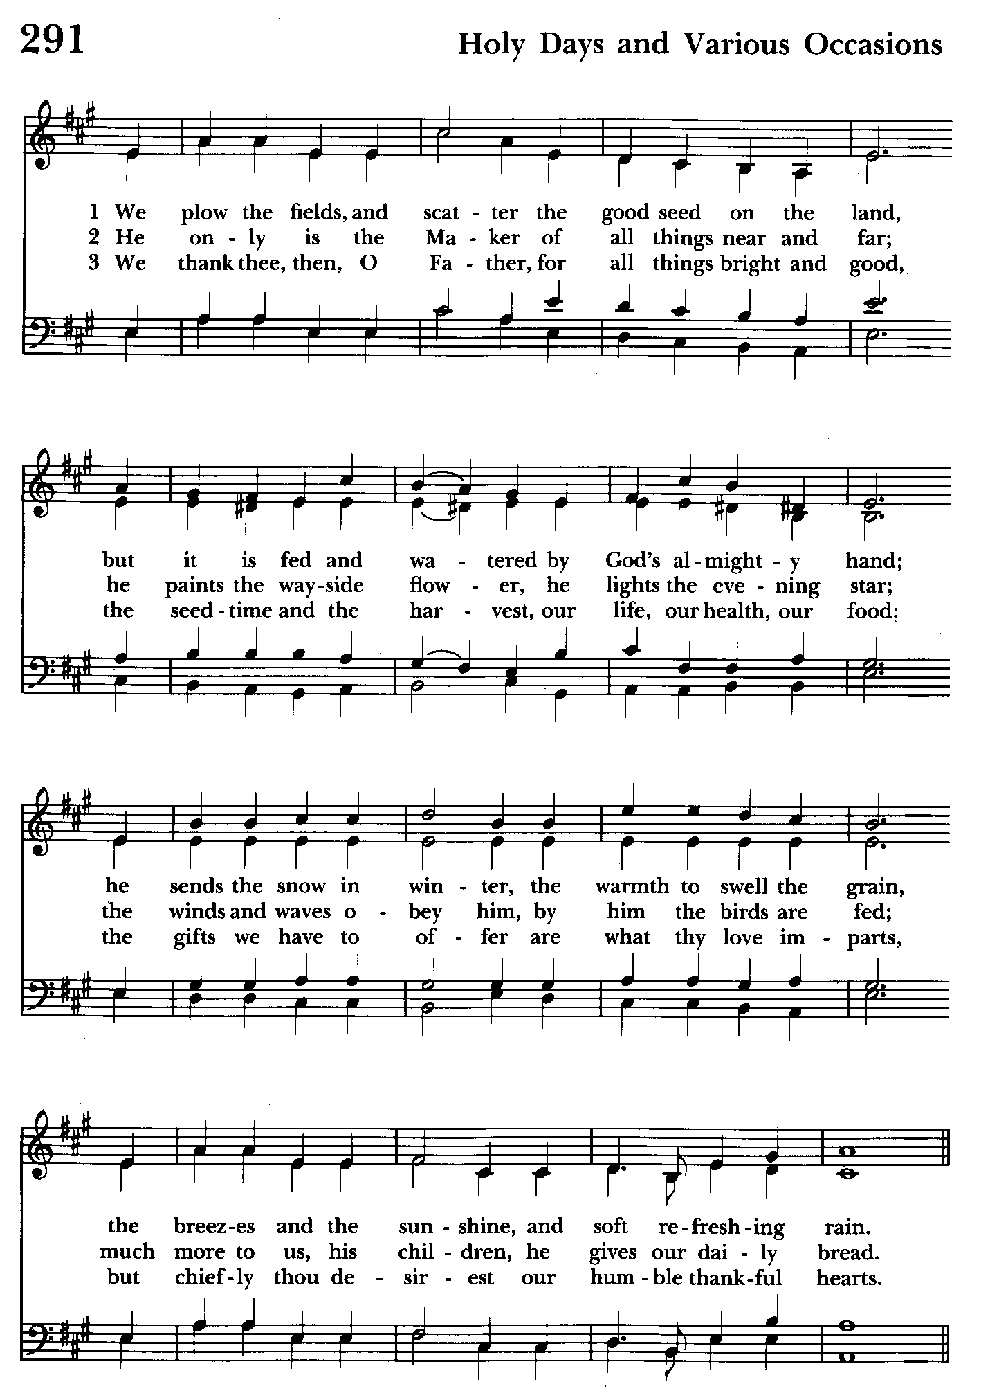

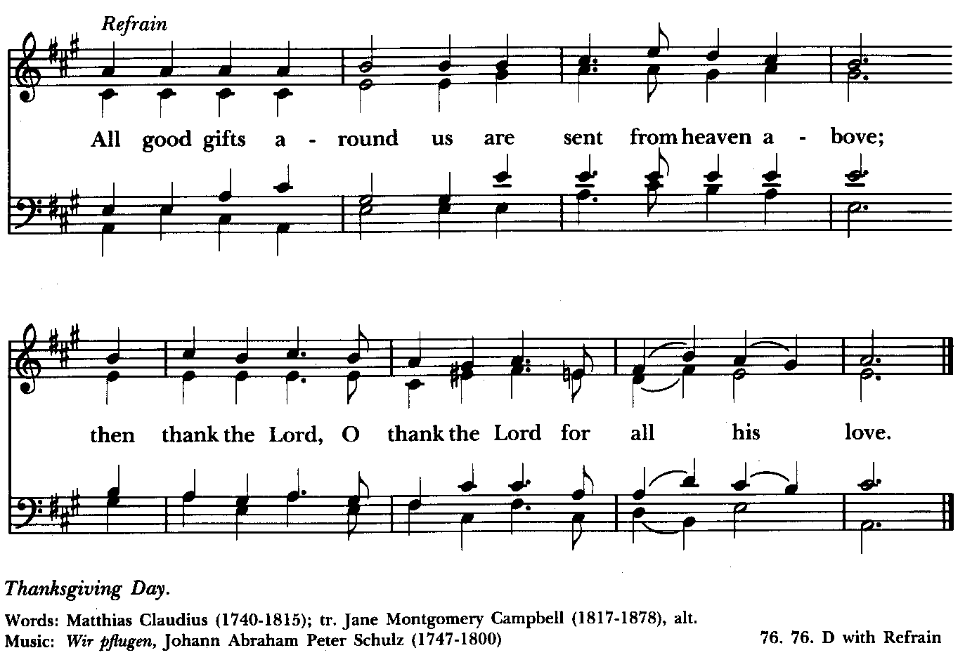

10:30 am Worship
Holy Eucharist, Rite Two

Prelude:
The Word of God

Processional hymn: We plow the fields, and scatter Hymnal #291
(see previous 2 pages)

The congregation remains standing as able
Celebrant: Blessed be God: Father, Son, and Holy Spirit. BCP 355
People: And blessed be his kingdom, now and for ever. Amen.

Celebrant: Almighty God, to you all hearts are open, all desires known, and from you no secrets are hid: Cleanse the thoughts of our hearts by the inspiration of your Holy Spirit, that we may perfectly love you, and worthily magnify your holy Name; through Christ our Lord. Amen.

Gloria Hymnal #S-278
Glory to God in the highest,
and peace to his people on earth.
Lord God, heavenly King,
almighty God and Father,
we worship you, we give you thanks,
we praise you for your glory.
Lord Jesus Christ, only Son of the Father,
Lord God, Lamb of God,
you take away the sin of the world:
have mercy on us;
you are seated at the right hand of the Father:
receive our prayer.
For you alone are the Holy One,
you alone are the Lord,
you alone are the Most High,
Jesus Christ,
with the Holy Spirit,
in the glory of God the Father. Amen.

Celebrant: The Lord be with you.
People: And also with you.
Celebrant: Let us pray.

The Collect of the Day Kneel or stand as able BCP 233
Lord of all power and might, the author and giver of all good things: Graft in our hearts the love of your Name; increase in us true religion; nourish us with all goodness; and bring forth in us the fruit of good works; through Jesus Christ our Lord, who lives and reigns with you and the Holy Spirit, one God for ever and
ever. Amen.

The congregation is seated.

A Reading from the Song of Solomon 2:8-13
The voice of my beloved!
Look, he comes,
leaping upon the mountains,
bounding over the hills.
My beloved is like a gazelle
or a young stag.
Look, there he stands
behind our wall,
gazing in at the windows,
looking through the lattice.
My beloved speaks and says to me:
"Arise, my love, my fair one,
and come away;
for now the winter is past,
the rain is over and gone.
The flowers appear on the earth;
the time of singing has come,
and the voice of the turtledove
is heard in our land.
The fig tree puts forth its figs,
and the vines are in blossom;
they give forth fragrance.
Arise, my love, my fair one,
and come away."

Reader: The Word of the Lord.
People: Thanks be to God.

Psalm 45:1-2, 7-10 (Pray as directed)
1 My heart is stirring with a noble song;
let me recite what I have fashioned for the king; *
my tongue shall be the pen of a skilled writer.
2 You are the fairest of men; *
grace flows from your lips,
because God has blessed you for ever.
7 Your throne, O God, endures for ever and ever, *
a scepter of righteousness is the scepter of your kingdom;
you love righteousness and hate iniquity.
8 Therefore God, your God, has anointed you *
with the oil of gladness above your fellows.
9 All your garments are fragrant with myrrh, aloes, and cassia, *
and the music of strings from ivory palaces makes you glad.
10 Kings' daughters stand among the ladies of the court; *
on your right hand is the queen,
adorned with the gold of Ophir.

A Reading from the Letter of James 1:17-27
Every generous act of giving, with every perfect gift, is from above, coming down from the Father of lights, with whom there is no variation or shadow due to change. In fulfillment of his own purpose he gave us birth by the word of truth, so that we would become a kind of first fruits of his creatures.
You must understand this, my beloved: let everyone be quick to listen, slow to speak, slow to anger; for your anger does not produce God's righteousness.
Therefore rid yourselves of all sordidness and rank growth of wickedness, and welcome with meekness the implanted word that has the power to save your souls. But be doers of the word, and not merely hearers who deceive themselves. For if any are hearers of the word and not doers, they are like those who look at themselves in a mirror; for they look at themselves and, on going away, immediately forget what they were like. But those who look into the perfect law, the law of liberty, and persevere, being not hearers who forget but doers who act-they will be blessed in their doing.
If any think they are religious, and do not bridle their tongues but deceive their hearts, their religion is worthless. Religion that is pure and undefiled before God, the Father, is this: to care for orphans and widows in their distress, and to keep oneself unstained by the world.

Reader: The Word of the Lord.
People: Thanks be to God.

Gradual hymn: Come away to the skies Hymnal #213

The congregation remains standing as able

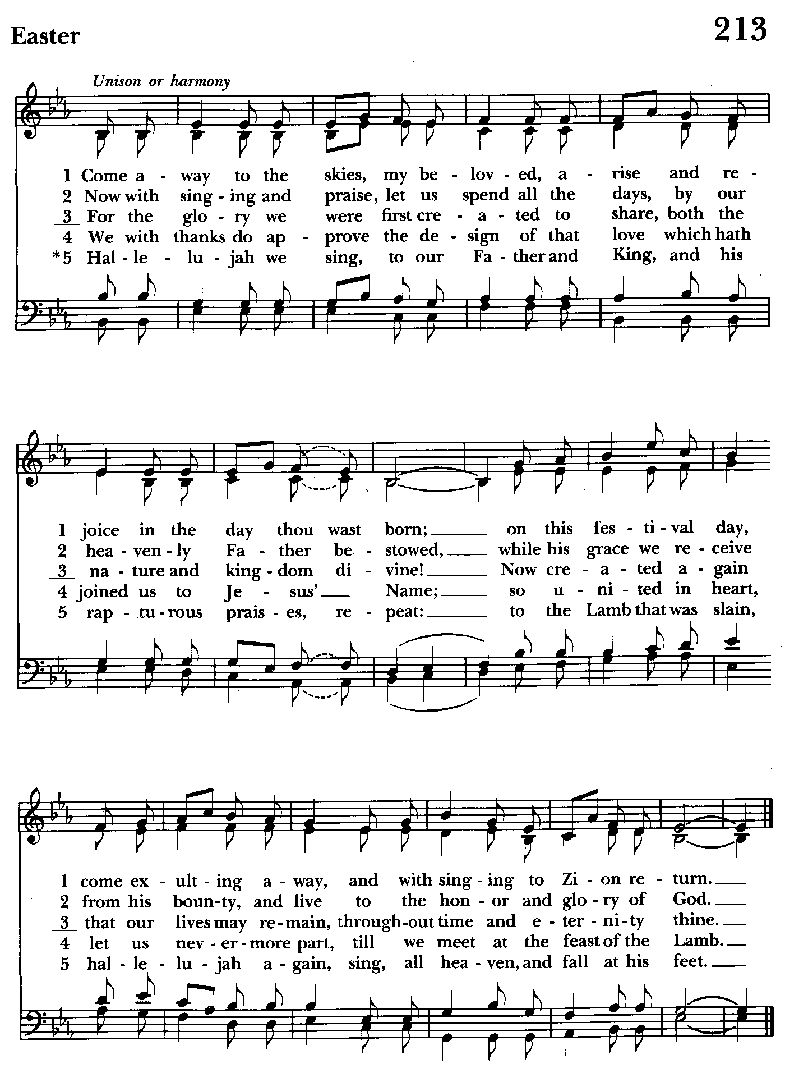

Priest: The Holy Gospel of our Lord Jesus Christ according to Mark
7:1-8, 14-15, 21-23

People: Glory to you, Lord Christ.
When the Pharisees and some of the scribes who had come from Jerusalem gathered around him, they noticed that some of his disciples were eating with defiled hands, that is, without washing them. (For the Pharisees, and all the Jews, do not eat unless they thoroughly wash their hands, thus observing the tradition of the elders; and they do not eat anything from the market unless they wash it; and there are also many other traditions that they observe, the washing of cups, pots, and bronze kettles.) So the Pharisees and the scribes asked him, “Why do your disciples not live according to the tradition of the elders, but eat with defiled hands?” He said to them, “Isaiah prophesied rightly about you hypocrites, as it is written,
‘This people honors me with their lips,
but their hearts are far from me;
in vain do they worship me,
teaching human precepts as doctrines.’
You abandon the commandment of God and hold to human tradition.”
Then he called the crowd again and said to them, “Listen to me, all of you, and understand: there is nothing outside a person that by going in can defile, but the things that come out are what defile.” For it is from within, from the human heart, that evil intentions come: fornication, theft, murder, adultery, avarice, wickedness, deceit, licentiousness, envy, slander, pride, folly. All these evil things come from within, and they defile a person.”

Priest: The Gospel of the Lord.
People: Praise to you, Lord Christ.

Sermon The congregation is seated The Rev. Mark Lobb+

The Nicene Creed Please stand as able BCP 358
We believe in one God,
the Father, the Almighty,
maker of heaven and earth,
of all that is, seen and unseen.
We believe in one Lord, Jesus Christ,
the only Son of God,
eternally begotten of the Father,
God from God, Light from Light,
true God from true God,
begotten, not made,
of one Being with the Father.
Through him all things were made.
For us and for our salvation
he came down from heaven:
by the power of the Holy Spirit
he became incarnate from the Virgin Mary,
and was made man.
For our sake he was crucified under Pontius Pilate;
he suffered death and was buried.
On the third day he rose again
in accordance with the Scriptures;
he ascended into heaven
and is seated at the right hand of the Father.
He will come again in glory to judge the living and the dead,
and his kingdom will have no end.
We believe in the Holy Spirit, the Lord, the giver of life,
who proceeds from the Father and the Son.
With the Father and the Son he is worshiped and glorified.
He has spoken through the Prophets.
We believe in one holy catholic and apostolic Church.
We acknowledge one baptism for the forgiveness of sins.
We look for the resurrection of the dead,
and the life of the world to come. Amen.

The Prayers of the People Form VI Kneel or stand as able BCP 392
Litanist: In peace, we pray to you, Lord God.

Litanist: For all people in their daily life and work;
People: For our families, friends, and neighbors, and for those who are alone.

Litanist: For this community, the nation, and the world;
People: For all who work for justice, freedom, and peace.

Litanist: For the just and proper use of your creation;
People: For the victims of hunger, fear, injustice, and oppression.

Litanist: For all who are in danger, sorrow, or any kind of trouble;
People: For those who minister to the sick, the friendless, and the needy.

Litanist: For the peace and unity of the Church of God;
People: For all who proclaim the Gospel, and all who seek the Truth.

Litanist: For +Justin, Archbishop of Canterbury; +Michael, our Presiding Bishop; +Sean, our Presiding Bishop Elect, +Carrie, our Bishop, +Mark our Interim Rector, for the Wardens, Vestry, Staff, and all members and friends of St. John’s Church.
People: For all who serve God in his Church.

Litanist: For the special needs and concerns of this congregation. Especially remember in our prayers, DeMarino Family, Jim & Chris Carden and family, Peggie Dietz, Mike Carden, Pat Carden, Gail Landers, Sheila Jones, Gloria Millar, Marisol Aubrey, Amelia Bell, Ross Strickler, Jim & Janice Sieracki, Edward, Robin Dilworth.

The People may add their own petitions

Litanist: Hear us, Lord;
People: For your mercy is great.
Litanist: We thank you, Lord, for all the blessings of this life.

The People may add their own thanksgivings

Litanist: We will exalt you, O God our King;
People: And praise your Name for ever and ever.

Litanist: We pray for all who have died, that they may have a place in your
eternal kingdom.

The People may add their own petitions
Litanist: Lord, let your loving-kindness be upon them;
People: Who put their trust in you.

Litanist: We pray to you also for the forgiveness of our sins.
People: Have mercy upon us, most merciful Father; in your compassion forgive us our sins, known and unknown, things done and left undone; and so uphold us by your Spirit that we may live and serve you in newness of life, to the honor and glory of your Name; through Jesus Christ our Lord. Amen.

The Celebrant gives the absolution.

The Peace Please stand as able BCP 360

Welcome & Announcements The congregation is seated.

Offertory Anthem: Find in Me a Thankful Heart (Choir)

Offertory: Offerings are collected

Presentation Hymn Offerings are presented Please stand as able Hymnal #43, vs. 4
Praise God, from whom all blessings flow; praise him, all creatures here below; praise him above, ye heavenly host: praise Father, Son, and Holy Ghost.

The Holy Communion

THE GREAT THANKSGIVING: Eucharistic Prayer B BCP 367
Celebrant: The Lord be with you.
People: And also with you.
Celebrant: Lift up your hearts.
People: We lift them to the Lord.
Celebrant: Let us give thanks to the Lord our God.
People: It is right to give him thanks and praise.

Then, facing the Holy Table, the Celebrant proceeds
It is right, and a good and joyful thing, always and everywhere to give thanks to you, Father Almighty, Creator of heaven and earth.

Therefore we praise you, joining our voices with Angels and Archangels and with all the company of heaven, who for ever sing this hymn to proclaim the glory of your Name:

Celebrant and People:
Holy, Holy, Holy Lord, God of power and might, Hymnal #S-129
heaven and earth are full of your glory.
Hosanna in the highest.
Blessed is he who comes in the name of the Lord.
Hosanna in the highest.

Please kneel or stand as able

Then the Celebrant continues BCP 368
We give thanks to you, O God, for the goodness and love which you have made known to us in creation; in the calling of Israel to be your people; in your Word spoken through the prophets; and above all in the Word made flesh, Jesus, your Son. For in these last days you sent him to be incarnate from the Virgin Mary, to be the Savior and Redeemer of the world. In him, you have delivered us from evil, and made us worthy to stand before you. In him, you have brought us out of error into truth, out of sin into righteousness, out of death into life.

At the following words concerning the bread, the Celebrant is to hold it, or to lay a hand upon it; and at the words concerning the cup, to hold or place a hand upon the cup and any other vessel containing wine to be consecrated.

On the night before he died for us, our Lord Jesus Christ took bread; and when he had given thanks to you, he broke it, and gave it to his disciples, and said, "Take, eat: This is my Body, which is given for you. Do this for the remembrance of me."

After supper he took the cup of wine; and when he had given thanks, he gave it to them, and said, "Drink this, all of you: This is my Blood of the new Covenant, which is shed for you and for many for the forgiveness of sins. Whenever you drink it, do this for the remembrance of me."

Therefore, according to his command, O Father,

Celebrant and People:
We remember his death,
We proclaim his resurrection,
We await his coming in glory;

The Celebrant continues
And we offer our sacrifice of praise and thanksgiving to you, O Lord of all; presenting to you, from your creation, this bread and this wine. We pray you, gracious God, to send your Holy Spirit upon these gifts that they may be the Sacrament of the Body of Christ and his Blood of the new Covenant. Unite us to your Son in his sacrifice, that we may be acceptable through him, being sanctified by the Holy Spirit. In the fullness of time, put all things in subjection under your Christ, and bring us to that heavenly country where, with St. John and the Blessed Virgin Mary and all your saints, we may enter the everlasting heritage of your sons and daughters; through Jesus Christ our Lord, the firstborn of all creation, the head of the Church, and the author of our salvation.

By him, and with him, and in him, in the unity of the Holy Spirit all honor and glory is yours, Almighty Father, now and for ever. Amen.
And now, as our Savior Christ has taught us, we are bold to say,

Our Father, who art in heaven, BCP p. 364
hallowed be thy Name,
thy kingdom come,
thy will be done,
on earth as in heaven.
Give us this day our daily bread.
And forgive us our trespasses,
as we forgive those
who trespass against us.
And lead us not into temptation,
but deliver us from evil.
For thine is the kingdom,
and the power, and the glory,
for ever and ever. Amen.

Invitation to Communion

The Breaking of the Bread
Celebrant: Alleluia. Christ our Passover is sacrificed for us;
People: Therefore let us keep the feast. Alleluia.
Celebrant: The Gifts of God for the people of God.

The congregation is seated
Communion hymn: O Master, let me walk with thee Hymnal #660

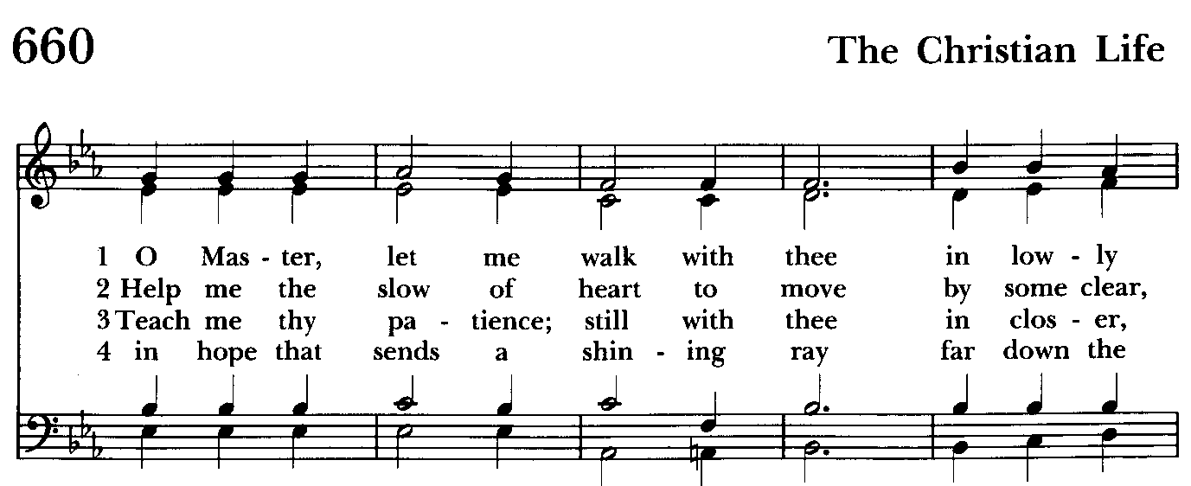

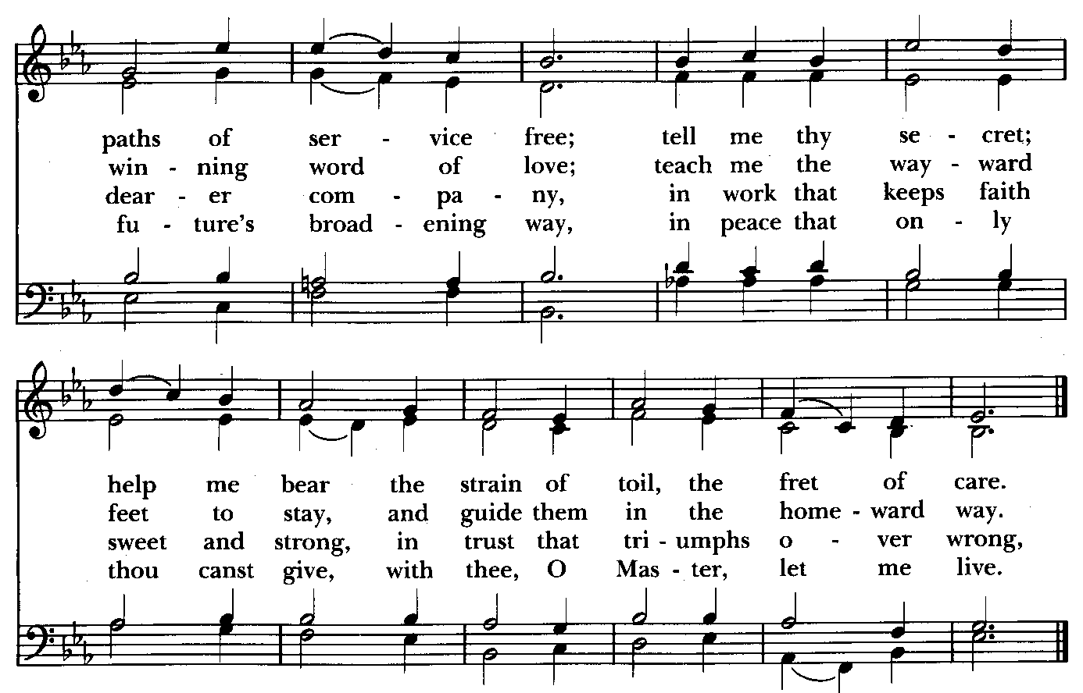

The Post Communion Prayer BCP p. 365
Eternal God, heavenly Father, you have graciously accepted us as living members of your Son our Savior Jesus Christ, and you have fed us with spiritual food in the Sacrament of his Body and Blood. Send us now into the world in peace, and grant us strength and courage to love and serve you with gladness and singleness of heart; through Christ our Lord. Amen.

Blessing

Recessional hymn: Lift up your heads, ye mighty gate Hymnal #436
(see next page)

The Dismissal (The Alleluias are back!)
Celebrant: Let us go forth in the name of the risen Lord.
People: Thanks be to God. Alleluia, alleluia!

License #A-719154

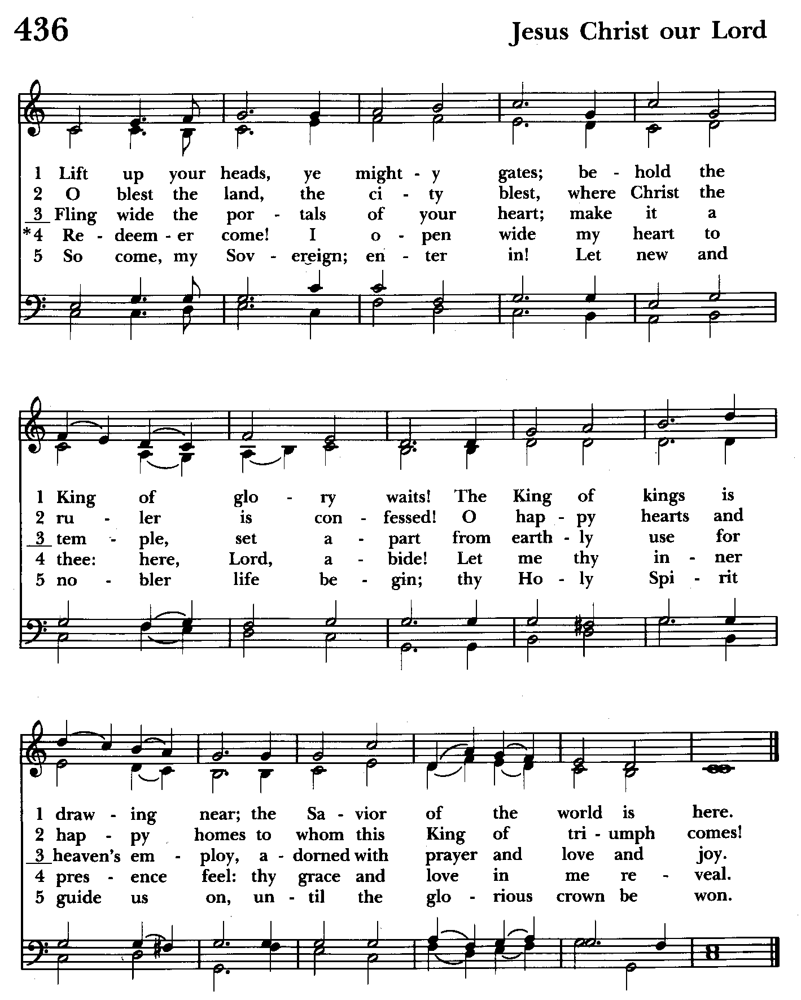

Serving Today

Celebrant and Preacher: The Rev. Mark Lobb+
Old Testament: Barbara Daniel
Psalm: John Frost
New Testament: Anne Leland
Prayers of the People: John Frost
Server: Terry Roe
Music Director: Nancy Heinold
Choir: Anne Leland, Nancy Dellinger, Janine Stevens, Liz Healey, Camy Schwenk,
Karen Smith-Manar, Jacob Johnson, Ty Schwenk
Altar Guild: John Stevens & Woodie Tingle

St. John’s Parish Prayer List

Additions and corrections may be made to our Parish Prayer List at any time. All names will be automatically removed from the Parish Prayer List on the 1st Sunday of each month unless you request otherwise. Please contact Angie at <office@stjohnskingsville.org> or 410-592-8570 in the church office with all changes by 10 am Thursdays. Thank you.

We Pray for Those in Need:
Names in BOLD read aloud by all.

DeMarino Family, Jim & Chris Carden and family, Peggie Dietz, Mike Carden, Pat Carden, Gail Landers, Sheila Jones, Gloria Millar, Marisol Aubrey, Amelia Bell, Ross Strickler, Jim and Janice Sieracki, Edward.

We Pray for our Homebound

Lily John, Barbara Miller, Nancy Barnhart, Robin Dilworth

We pray for the Church and the World:

For +Justin, Archbishop of Canterbury; for +Michael, our Presiding Bishop; for +Sean, our Presiding Bishop Elect, for +Carrie, our Bishop, for Mark+, our Interim Rector, for the Wardens, Vestry, Staff, and all members and friends of St. John’s Church.

For the leaders of all nations, especially for Joseph, our President; for Wes, our Governor; for Brandon, Nick, John and Bob, who lead our City and Counties. We pray for all children and youth; for the homeless, the unemployed, and the hungry. We pray for the safety of our loved ones and friends serving in the Armed Forces at home and abroad, and for our enemies, that all our hearts may be turned toward peace throughout the world.


Altar Flowers
Given to the Glory of God
by Karen Smith-Manar
in memory of Hugh Manar

Choral Choir and Bell Choir
Choir rehearsals Wednesdays at 7:00 pm and Bell practice will begin on Sunday September 15 after the 10:30 service. If anyone is interested in joining, see Nancy Heinold, our Music Director.

SUNDAY SCHOOL
It's almost time for Sunday School. Mr. John and Miss Stephanie will be coming back and classes begin on September 8th.


With so much going on, everyone’s help is needed to make things a success. Our volunteers make the Church function. The volunteering of time and talent is greatly appreciated.

Calendar Updates
Morning Prayer- will be offered on the following Sundays: 9/8, 9/29, 10/13, 11/10, 12/8, 12/29. Lay people are highly encouraged to consider helping by officiating and/or preaching of Morning Prayer. I am willing to help you prepare for this.

Would it be helpful to have an “Officiating Morning Prayer” class? Let me know.

God’s Grace Gardens Workday - September 14 @ 8:30 am

Blessing of the Animals- 9:30 a.m. (between the services) on Sunday 10/6.

All Souls service- Sunday evening 7:00 11/3.

Blue Christmas/Service of Solace- TBD

Calendars are living documents. Every effort will be made to keep the members of the parish and community aware of any changes.

SAVE THE DATE
God’s Grace Gardens Workday—September 14 @ 8:30 am
Flea Market 9/21
Bingo 10/18
Christmas Bazaar - 11/23

In our Community

Bible Studies in our area. If interested, please contact these churches to confirm.
St. Mary’s, Abingdon, (410)569-0180- Wednesdays at noon. Bring lunch. Zoom available.
Emmanuel, Bel Air, (410)838-7699- Fridays at 9:30- Zoom Available.
Holy Trinity, Churchville, (410)914-5531- Wednesdays 11:30- Zoom may be available.

From the Treasurer
Projected August Expenses: $13,500
Monies Received as of 8/29: $16,668
Amount OVER Projected Expenses: $ 3,168

8/16 Bingo NET Proceeds: $ 2,963

Projected September Expenses: $13,500


If you’d like to make a donation to St. John’s you can scan this QR code with your phone’s camera or tap on the link that comes up to make a contribution with either a credit or debit card, Apple Pay or Google Pay. This is a secure site provided by Clover which is a service of PNC Bank.

FLEA MARKET!
On Saturday September 21, from 8am to 1pm St. John’s will be hosting a community flea market. If you have any gently used items (no clothes), feel free to drop them off after 8/16/24 during office hours or on Sundays. If you know of anyone who might be interested in participating, invite them to contact the church for details. The office Number is 410-592-8570 email is office@stjohnskingsville.org

Calling all Bakers!
If you can, please bake cookies or brownies to sell at the flea market.
Please package 4 cookies to a bag and 2 brownies to a bag please let us know what the item is and if it has nuts. They can be dropped off on Friday 9/20 after 1pm till 8pm.

Please consider signing up to help with the flea market event. Just give us a call and let us know if you are available any time would he helpful. Michele 443-463-6333 or Angie 410-592-8570. Also a sign up sheet is in the back of the church.

Barb Daniels would like help to set up after 2 on Friday 9/20 and the day of the flea market. You can call Barb at 410-877-2962.

Please let us know if you need a flyer for the event and we will send you one.



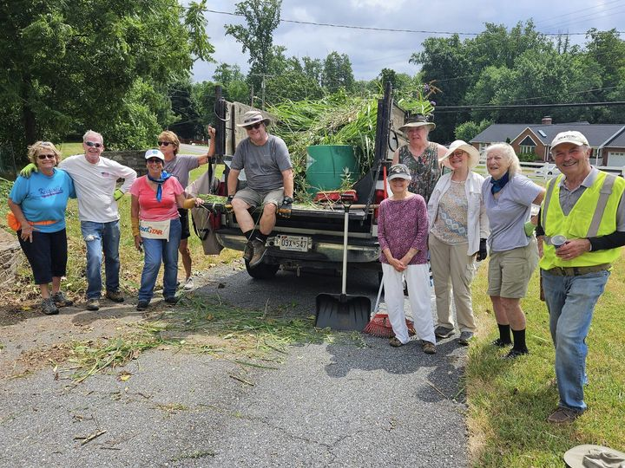
God’s Grace Gardens—a St. John’s, Hill & Stream Garden Club and AA collaboration

For more info or to sign up to help keep our gardens looking beautiful, contact: Rita Talley-Garden Club, 443-617-1820 or Karen Smith-Manar-St. John’s 410-746-9813 or bikenbocal@verizon.net

Next Workday: Sept 14th @8:30 am


Yoga classes on Tuesday, Wednesday and Friday evenings 6 to 7 pm and Saturday mornings 9 to 10 am in the Chapel. All experience levels are welcome.

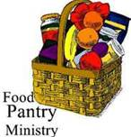
OUTREACH
The FOOD PANTRY is in need of immediate
donations. All donations welcome, food or
monetary. Thank you so much.
Needed at this time: spaghetti, spaghetti sauce, jelly/jam

RECYCLING!
By popular demand, we are recycling. Some parishioners take printed paper home where they have recycling pickup. We now have a blue container located in the Parish Hall. This will be collected and taken for recycling. Aluminum cans will be saved and taken to a recycling center for cash. The proceeds will be donated to the Outreach fund. Each recycled aluminum can also save on the electricity needed to make new aluminum from bauxite.

What’s Happening This Week at St. John’s

Sunday, September 1—15th Sunday after Pentecost
8:00am: Holy Eucharist, Rite I (Church)
10:30am: Holy Eucharist, Rite II (Church)
11:30am: Potluck (Parish Hall)

Monday, September 2-OFFICE CLOSED FOR LABOR DAY
12:00-1:00pm: AA Lunch Bunch (Parish Hall)
7:00-8:30pm: Spanish speaking AA group (Parish Hall)

Tuesday, September 3
12:00-1:00pm: AA Lunch Bunch (Parish Hall)
6:00-7:00pm: Yoga (Chapel)
7:00pm: Vestry Meeting (Parish Hall)

Wednesday, September 4
12:00-1:00pm: AA Lunch Bunch (Parish Hall)
6:00-7:00pm: Yoga (Chapel)
7:30pm: AA (Parish Hall)

Thursday, September 5
12:00-1:00pm: AA Lunch Bunch (Parish Hall)
7:00pm: AA (Parish Hall)

Friday, September 6
12:00-1:00pm: AA Lunch Bunch (Parish Hall)
6:00pm -7:00pm: Yoga (Chapel)

Saturday, September 7
9:00am-10:00am: Yoga (Chapel)
8:30pm: AA (Parish Hall)

Sunday, September 8 —16th Sunday after Pentecost
8:00am: Morning Prayert, Rite I (Church)
10:30am: Morning Prayer, Rite II (Church)
11:30am: Coffee Hour (Parish Hall)

Parish Office is open Monday, Wednesday and Thursday, 9:30am-1:30pm.

Potluck Luncheon on the first Sunday of the month and a Coffee Hour on all other Sundays after the 10:30 service.

