St. John’s Episcopal Church
Kingsville, Maryland
Welcomes You

Our Vision Statement

We believe that together we will transform
the world with love: Come on in!

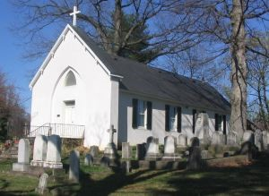

Fourteenth Sunday after Pentecost
Morning Prayer Rite II
August 25, 2024—9:30 am

St. John’s Episcopal Church

11901 Belair Road, P. O. Box 187, Kingsville, MD 21087
Facebook: St. John’s Episcopal, Kingsville, MD
Email: office@stjohnskingsville.org
Website: www.stjohnskingsville.org
Church Phone: 410-592-8570
For Pastoral Emergencies: Fr. Mark Lobb+ 443-690-9545

Welcome to worship today! We are glad that you are with us. You are invited to participate in all parts of the service as indicated in the Book of Common Prayer and this service bulletin. If you have any questions, feel free to ask the ushers. Restrooms are located in the Parish Hall, the brick building across the parking lot.

I was glad when they said to me, “Let us go to the house of the Lord.” Psalm 122:1

Church Staff

Interim Rector: Father Mark Lobb
Administrative Assistant: Angie Bosley
Organist/Choir Director: Nancy Heinold

The Vestry

Class of 2025 Class of 2026

John Frost John Stevens
Woodie Tingle
Jacob Johnson

Officers
Ty Schwenk—Sr. Warden Terry Roe—Jr. Warden
Elizabeth Healey—Treasurer Anne Leland-Registrar

Parish Committee Chairpersons

Altar Guild: Elizabeth Healey
Auxiliary Committee: Michele Lozanski
Cemetery Committee: Terry Roe

Gathering Hymn:
I will sing, I will sing - C174 in Green Come Celebrate Book

1. I will sing, I will sing a song unto the Lord
I will sing, I will sing a song unto the Lord
I will sing, I will sing a song unto the Lord
Alleluia, Glory to the Lord.

Refrain: Alleluia, Alleluia, glory to the Lord,
Alleluia, glory to the Lord.

2. We will come, we will come as one before the Lord.
Alleluia, Glory to the Lord.

Refrain

3. If the Son if the Son shall make you free
You shall be free indeed

Refrain

4. In his name in his name we have the victory
Alleluia, Glory to the Lord.

Refrain

Morning Prayer—Rite II
Note:
Please feel free to remain seated during the service if unable to stand or kneel.
‘BCP’ refers to the Book of Common Prayer. The people’s responses are in bold. Large print song sheets are available. Please see an usher if you would like to use one.

Prelude

Gathering hymn: I will sing, I will sing (see above)

OPENING SENTENCES BCP p. 78

Officiant: Grace to you and peace from God our Father and the Lord Jesus Christ.
Philippians 1:2

CONFESSION OF SIN BCP p. 79
Dearly beloved, we have come together in the presence of Almighty God our heavenly Father, to set forth his praise, to hear his holy Word, and to ask, for ourselves and on behalf of others, those things that are necessary for our life and our salvation. And so that we may prepare ourselves in heart and mind to worship him, let us kneel in silence, and with penitent and obedient hearts confess our sins, that we may obtain forgiveness by his infinite goodness and mercy.

Officiant and People please stand or kneel as able
Most merciful God, we confess that we have sinned against you in thought, word, and deed, by what we have done, and by what we have left undone. We have not loved you with our whole heart; we have not loved our neighbors as ourselves. We are truly sorry and we humbly repent. For the sake of your Son Jesus Christ, have mercy on us and forgive us; that we may delight in your will, and walk in your ways, to the glory of your Name. Amen.

Officiant: Almighty God have mercy on you, forgive us all our sins through our Lord Jesus Christ, strengthen you in all goodness, and by the power of the Holy Spirit keep us in eternal life. Amen.

The Invitatory and Psalter BCP pg. 80

All stand
Officiant: Lord, open our lips.
People: And our mouth shall proclaim your praise.

Officiant and People
Glory to the Father, and to the Son, and to the Holy Spirit: as it was in the beginning, is now, and will be for ever. Amen.

The mercy of the Lord is everlasting: Come let us adore him. BCP pg. 81

Venite Psalm 95:1-7 BCP. pg. 82
Come, let us sing to the Lord;*
let us shout for joy to the Rock of our salvation.
Let us come before his presence with thakisgiving*
and raise a loud shout to him with psalms.

For the Lord is a great God,*
and a great King above all gods.
In his hands are the caverns of the earth,*
and the heights of the hills are his also.
The sea is his, for he made it.*
and his hands have molded the dry land.

Come, let us bow down, and bend the knee,*
and kneel before the Lord our Maker.
For he is our God,
and we are the people of his pasture and the sheep of his hand.*
Oh, that today you would hearken to his voice!

Psalm 84 De profundis
Officiant and People
1 How dear to me is your dwelling, O Lord of hosts! *
My soul has a desire and longing for the courts of the Lord;
my heart and my flesh rejoice in the living God.
2 The sparrow has found her a house
and the swallow a nest where she may lay her young; *
by the side of your altars, O Lord of hosts,
my King and my God.
3 Happy are they who dwell in your house! *
they will always be praising you.
4 Happy are the people whose strength is in you! *
whose hearts are set on the pilgrims' way.
5 Those who go through the desolate valley will find it a place of springs, *
for the early rains have covered it with pools of water.
6 They will climb from height to height, *
and the God of gods will reveal himself in Zion.
7 Lord God of hosts, hear my prayer; *
hearken, O God of Jacob.
8 Behold our defender, O God; *
and look upon the face of your Anointed.
9 For one day in your courts is better than a thousand in my own room, *
and to stand at the threshold of the house of my God
than to dwell in the tents of the wicked.
10 For the Lord God is both sun and shield; *
he will give grace and glory;
11 No good thing will the Lord withhold *
from those who walk with integrity.
12 O Lord of hosts, *
happy are they who put their trust in you!

Please be seated

THE FIRST READING 1 Kings 8:[1, 6, 10-11], 22-30, 41-43
[Solomon assembled the elders of Israel and all the heads of the tribes, the leaders of the ancestral houses of the Israelites, before King Solomon in Jerusalem, to bring up the ark of the covenant of the Lord out of the city of David, which is Zion. Then the priests brought the ark of the covenant of the Lord to its place, in the inner sanctuary of the house, in the most holy place, underneath the wings of the cherubim. And when the priests came out of the holy place, a cloud filled the house of the Lord, so that the priests could not stand to minister because of the cloud; for the glory of the Lord filled the house of the Lord.]
Then Solomon stood before the altar of the Lord in the presence of all the assembly of Israel, and spread out his hands to heaven. He said, “O Lord, God of Israel, there is no God like you in heaven above or on earth beneath, keeping covenant and steadfast love for your servants who walk before you with all their heart, the covenant that you kept for your servant my father David as you declared to him; you promised with your mouth and have this day fulfilled with your hand. Therefore, O Lord, God of Israel, keep for your servant my father David that which you promised him, saying, ‘There shall never fail you a successor before me to sit on the throne of Israel, if only your children look to their way, to walk before me as you have walked before me.’
Therefore, O God of Israel, let your word be confirmed, which you promised to your servant my father David.
“But will God indeed dwell on the earth? Even heaven and the highest heaven cannot contain you, much less this house that I have built! Regard your servant’s prayer and his plea, O Lord my God, heeding the cry and the prayer that your servant prays to you today; that your eyes may be open night and day toward this house, the place of which you said, ‘My name shall be there,’ that you may heed the prayer that your
servant prays toward this place. Hear the plea of your servant and of your people Israel when they pray toward this place; O hear in heaven your dwelling place; heed and forgive.
“Likewise when a foreigner, who is not of your people Israel, comes from a distant land because of your name —for they shall hear of your great name, your mighty hand, and your outstretched arm—when a foreigner comes and prays toward this house, then hear in heaven your dwelling place, and do according to all that the foreigner calls to you, so that all the peoples of the earth may know your name and fear you, as do your people Israel, and so that they may know that your name has been invoked on this house that I have built.

The Word of the Lord.
Thanks be to God.

Canticle 16 The Song of Zechariah Benedictus Dominus Deus BCP pg. 92
Luke 1: 68-79
Blessed be the Lord, the God of Israel; *
he has come to his people and set them free.
He has raised up for us a mighty savior, *
born of the house of his servant David.
Through his holy prophets he promised of old,
that he would save us from our enemies, *
from the hands of all who hate us.
He promised to show mercy to our fathers *
and to remember his holy covenant.
This was the oath he swore to our father Abraham, *
to set us free from the hands of our enemies,
Free to worship him without fear, *
holy and righteous in his sight
all the days of our life.
You, my child, shall be called the prophet of the Most High, *
for you will go before the Lord to prepare his way,
To give his people knowledge of salvation *
by the forgiveness of their sins.
In the tender compassion of our God *
the dawn from on high shall break upon us,
To shine on those who dwell in darkness and the
shadow of death, *
and to guide our feet into the way of peace.
Glory to the Father, and to the Son, and to the Holy Spirit: *

THE SECOND READING Ephesians 6:10-20
Be strong in the Lord and in the strength of his power. Put on the whole armor of God, so that you may be able to stand against the wiles of the devil. For our struggle is not against enemies of blood and flesh, but against the rulers, against the authorities, against the cosmic powers of this present darkness, against the spiritual forces of evil in the heavenly places. Therefore take up the whole armor of God, so that you may be able to withstand on that evil day, and having done everything, to stand firm. Stand therefore, and fasten the belt of truth around your waist, and put on the breastplate of righteousness. As shoes for your feet put on whatever will make you ready to proclaim the gospel of peace. With all of these, take the shield of faith, with which you will be able to quench all the flaming arrows of the evil one. Take the helmet of salvation, and the sword of the Spirit, which is the word of God.
Pray in the Spirit at all times in every prayer and supplication. To that end keep alert and always persevere in supplication for all the saints. Pray also for me, so that when I speak, a message may be given to me to make known with boldness the mystery of the gospel, for which I am an ambassador in chains. Pray that I may declare it boldly, as I must speak.

The Word of the Lord.
Thanks be to God.

Canticle 21 You are God Te Deum laudamus BCP pg. 95
You are the Lord; we acclaim you;
You are the eternal Father:
All creation worships you.
To you all angels, all the powers of heaven,
Cherubim and Seraphim, sing in endless praise:
Holy, holy, holy Lord, God of power and might,
heaven and earth are full of your glory.
The glorious company of apostles praise you.
The noble fellowship of prophets praise you.
The white-robed army of martyrs praise you.
Throughout the world the holy Church acclaims you;
Father, of majesty unbounded,
your true and only Son, worthy of all worship,
and the Holy Spirit, advocate and guide.
You, Christ, are the king of glory,
the eternal Son of the Father.
When you became man to set us free
you did not shun the Virgin's womb.
You overcame the sting of death
and opened the kingdom of heaven to all believers.
You are seated at God's right hand in glory.
We believe that you will come and be our judge.
Come then, Lord, and help your people,
bought with the price of your own blood,
and bring us with your saints
to glory everlasting.

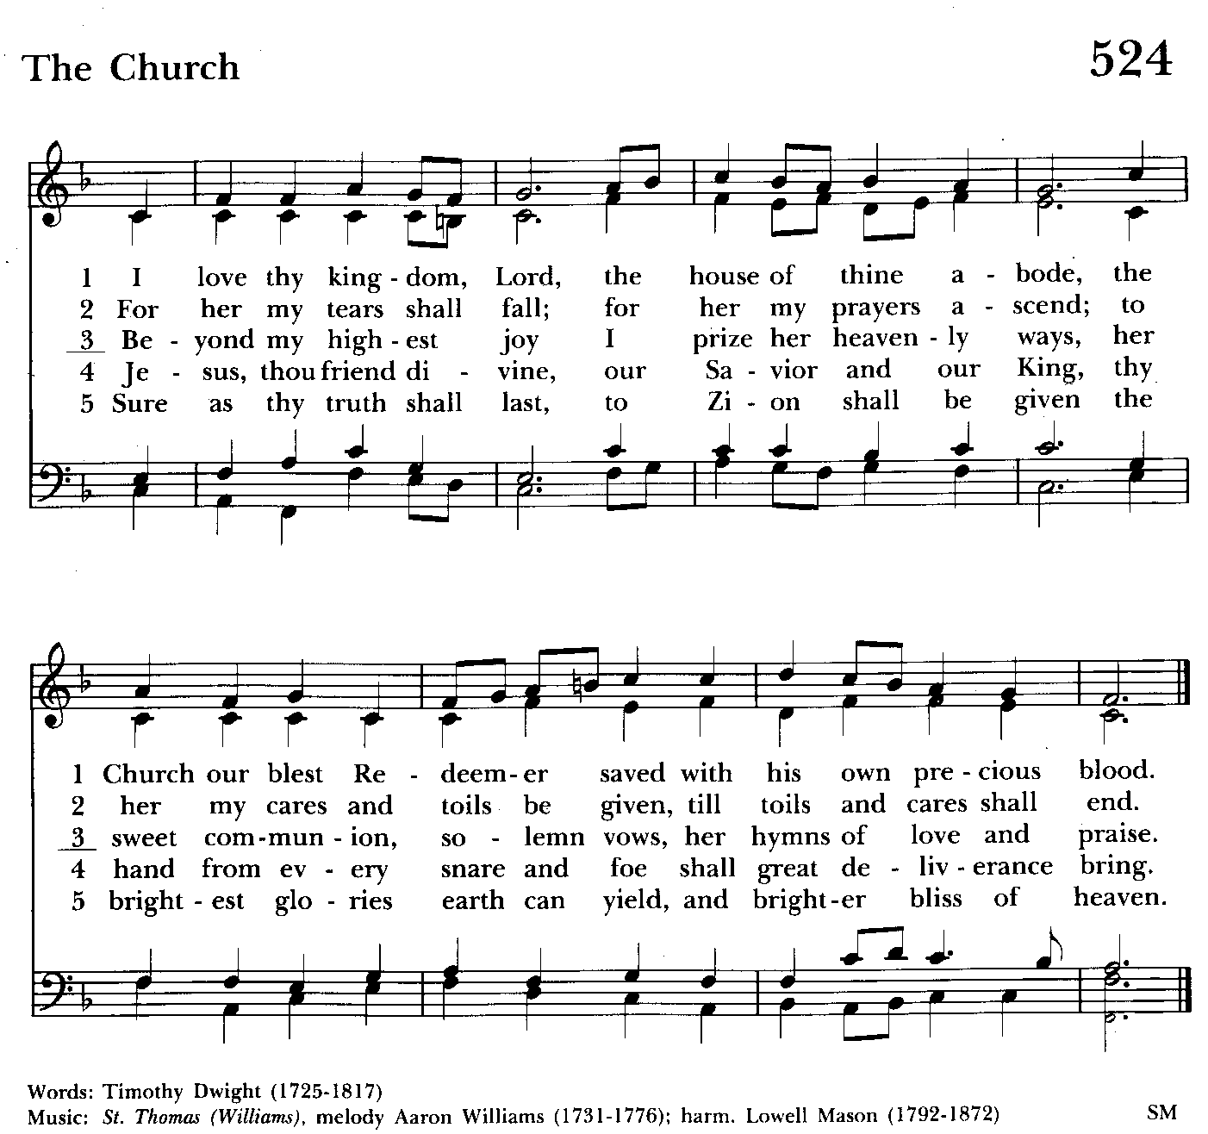

Gradual hymn: I love thy kingdom, Lord Hymnal #524
(see above)

A Reading from the Gospel according to John People remain standing 6:56-69
Jesus said, “Those who eat my flesh and drink my blood abide in me, and I in them. Just as the living Father sent me, and I live because of the Father, so whoever eats me will live because of me. This is the bread that came down from heaven, not like that which your ancestors ate, and they died. But the one who eats this bread will live forever.” He said these things while he was teaching in the synagogue at Capernaum.
When many of his disciples heard it, they said, “This teaching is difficult; who can accept it?” But Jesus, being aware that his disciples were complaining about it, said to them, “Does this offend you? Then what if you were to see the Son of Man ascending to where he was before? It is the spirit that gives life; the flesh is useless. The words that I have spoken to you are spirit and life. But among you there are some who do not believe.” For Jesus knew from the first who were the ones that did not believe, and who was the one that would betray him. And he said, “For this reason I have told you that no one can come to me unless it is granted by the Father.”
Because of this many of his disciples turned back and no longer went about with him. So Jesus asked the twelve, “Do you also wish to go away?” Simon Peter answered him, “Lord, to whom can we go? You have the words of eternal life. We have come to believe and know that you are the Holy One of God.”

The Word of the Lord.
Thanks be to God.

The Homily The congregation is seated Ty Schwenk

The Peace The congregation stands as able

Announcements The people are seated

THE APOSTLES CREED BCP pg. 96
Said by all, standing as you are able.
I believe in God, the Father almighty,
creator of heaven and earth;
I believe in Jesus Christ, his only Son, our Lord.
He was conceived by the power of the Holy Spirit
and born of the Virgin Mary.
He suffered under Pontius Pilate,
was crucified, died, and was buried.
He descended to the dead.
On the third day he rose again.
He ascended into heaven,
and is seated at the right hand of the Father.
He will come again to judge the living and the dead.
I believe in the Holy Spirit,
the holy catholic Church,
the communion of saints,
the forgiveness of sins
the resurrection of the body,
and the life everlasting. Amen.
Celebrant: The Lord be with you.
People: And also with you.
Celebrant: Let us pray.
THE LORD’S PRAYER Stand or kneel as able. BCP pg. 97
Our Father, who art in heaven, hallowed be thy Name, thy kingdom come, thy will be done, on earth as it is in heaven. Give us this day our daily bread. And forgive us our trespasses, as we forgive those who trespass against us. And lead us not into temptation, but deliver us from evil. For thine is the kingdom, and the power, and the glory, for ever and ever. Amen.
People and Officiant
SUFFRAGES B BCP pg. 98
V. Save your people, Lord, and bless your inheritance;
R. Govern and uphold them, now and always.
V. Day by day we bless you;
R. We praise your Name for ever.
V. Lord, keep us from all sin today;
R. Have mercy on us, Lord, have mercy.

V. Lord, show us your love and mercy;
R. For we put our trust in you.
V. In you, Lord, is our hope;
R. And we shall never hope in vain.

THE COLLECT OF THE DAY BCP pg. 232
Grant, O merciful God, that your Church, being gathered together in unity by your Holy Spirit, may show forth your power among all peoples, to the glory of your Name; through Jesus Christ our Lord, who lives and reigns with you and the Holy Spirit, one God, for ever and ever. Amen.

A COLLECT FOR SUNDAYS BCP pg. 98
O God, you make us glad with the weekly remembrance of the glorious resurrection of your Son our Lord: Give us this day such blessing through our worship of you, that the week to come may be spent in your favor; through Jesus Christ our Lord. Amen.

Officiant: Let us pray for our own needs and those of others.

Silence

PRAYER FOR MISSION BCP pg. 100
Almighty and everlasting God, by whose Spirit the whole body of your faithful people is governed and sanctified: Receive our supplications and prayers which we offer before you for all members of your holy Church, that in their vocation and ministry they may truly and devoutly serve you; through Lord and Savior Jesus Christ. Amen.

The people remain seated.

OFFERTORY HYMN: Pullin’ the Weeds Come Celebrate #C-182
Pullin' the weeds, Lord. Pullin' the weeds. Living for your glory. Pullin' the weeds.
Pullin' the weeds, Lord. Pullin' the weeds. Living for your glory. Pullin' the weeds.

THE OFFERTORY The offering is collected The offering is brought forward

DOXOLOGY Please stand as able Hymnal #43, vs. 4
Praise God, from whom all blessings flow; praise him, all creatures here below; praise him above, ye heavenly host: praise Father, Son, and Holy Ghost.

Please kneel or stand as able

THE PRAYERS OF THE PEOPLE – Form III BCP pg. 387
Father, we pray for your holy Catholic Church;
That we all may be one.

Grant that every member of the Church may truly and humbly serve you;
That your Name may be glorified by all people.

We pray for all bishops, priests, and deacons;
That they may be faithful ministers of your Word and Sacraments.

We pray for all who govern and hold authority in the nations of the world;
That there may be justice and peace on the earth.

Give us grace to do your will in all that we undertake;
That our works may find favor in your sight.

Have compassion on those who suffer from any grief or trouble;
That they may be delivered from their distress.

Give to the departed eternal rest;
Let light perpetual shine upon them.
.
We praise you for your saints who have entered into joy;
May we also come to share in your heavenly kingdom.

Let us pray for our own needs and those of others.

We Pray for Those in Need:
DeMarino Family, Jim & Chris Carden and family, Peggie Dietz, Mike Carden, Pat Carden, Gail Landers, Sheila Jones, Gloria Millar, Marisol Aubrey, Amelia Bell, Linda and Allan Urban, Ross Strickler, Jim and Janice Sieracki, Edward.

We Pray for our Homebound

Lily John, Barbara Miller, Nancy Barnhart, Robin Dilworth

We pray for the Church and the World:

For +Justin, Archbishop of Canterbury; for +Michael, our Presiding Bishop; for +Carrie, our Bishop, for Mark+, our Interim Rector, for the Wardens, Vestry, Staff, and all members and friends of St. John’s Church.

For the leaders of all nations, especially for Joseph, our President; for Wes, our Governor; for Brandon, Nick, John and Bob, who lead our City and Counties. We pray for all children and youth; for the homeless, the unemployed, and the hungry. We pray for the safety of our loved ones and friends serving in the Armed Forces at home and abroad, and for our enemies, that all our hearts may be turned toward peace throughout the world.

THE GENERAL THANKSGIVING
Let us pray.
Officiant and people BCP pg. 101
Almighty God, Father of all mercies, we your unworthy servants give you humble thanks for all your goodness and loving-kindness to us and to all whom you have made. We bless you for our creation, preservation, and all the blessings of this life; but above all for your immeasurable love in the redemption of the world by our Lord Jesus Christ; for the means of grace, and for the hope of glory. And, we pray, give us such an awareness of your mercies, that with truly thankful hearts we may show forth your praise, not only with our lips, but in our lives, by giving up our selves to your service, and by walking before you in
holiness and righteousness all our days; through Jesus Christ our Lord, to whom, with you and the Holy Spirit, be honor and glory throughout all ages. Amen.

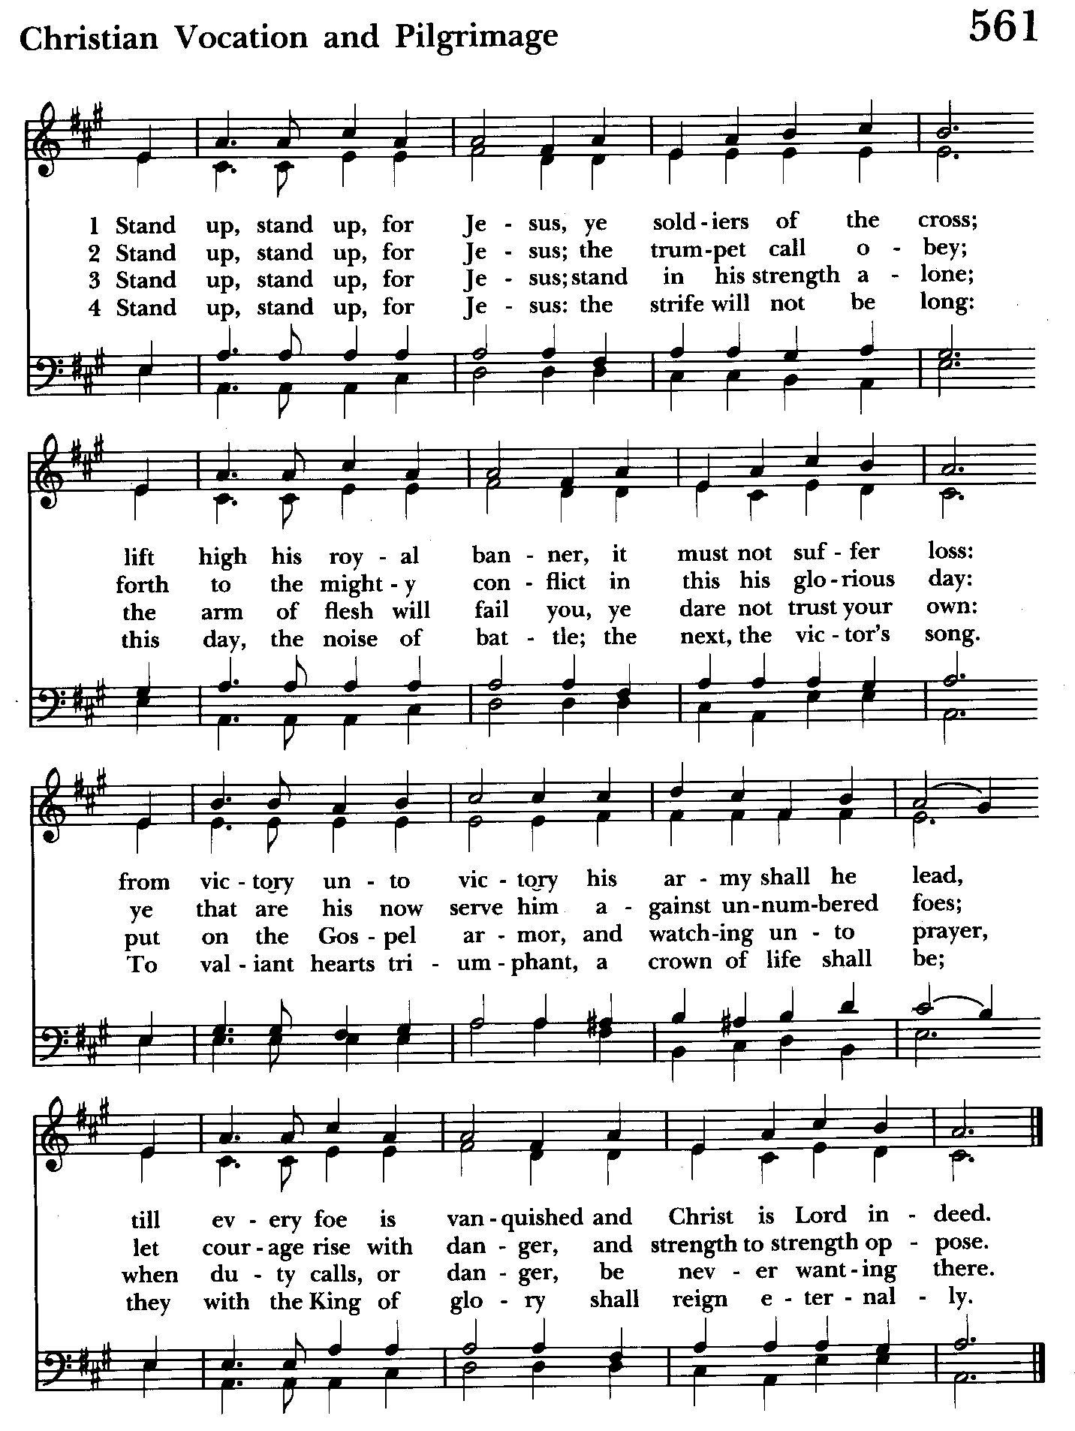

Closing hymn: Stand up, stand up, for Jesus Hymnal #561

THE DISMISSAL BCP pg. 102
Officiant: The grace of our Lord Jesus Christ, and the Love of God, and the fellowship of the Holy Spirit, be with us all evermore.
People: Thanks be to God.

License #A-719154

Serving Today
Officiant:: Ty Schwenk
Old Testament: Michele Lozanski
Psalm: Michele Lozanski
New Testament: Tony Rising
Prayers of the People: John Frost
Music Director: Nancy Heinold
Altar Guild: Stephanie Duchacek & Sandy Roe


Altar Flowers

Given to the Glory of God
by Mary Ann Pomerleau
and Karen Smith-Manar
in Praise and Thanksgiving

St. John’s Parish Prayer List

Additions and corrections may be made to our Parish Prayer List at any time. All names will be automatically removed from the Parish Prayer List on the 1st Sunday of each month unless you request otherwise. Please contact Angie at <office@stjohnskingsville.org> or 410-592-8570 in the church office with all changes by 10 am Thursdays. Thank you.

We Pray for Those in Need:
Names in BOLD read aloud by all.

DeMarino Family, Jim & Chris Carden and family, Peggie Dietz, Mike Carden, Pat Carden, Gail Landers, Sheila Jones, Gloria Millar, Marisol Aubrey, Amelia Bell, Linda and Allan Urban, Ross Strickler, Jim and Janice Sieracki, Edward.

We Pray for our Homebound

Lily John, Barbara Miller, Nancy Barnhart, Robin Dilworth

We pray for the Church and the World:

For +Justin, Archbishop of Canterbury; for +Michael, our Presiding Bishop; for +Sean, our Presiding Bishop Elect; for +Carrie, our Bishop, for Mark+, our Interim Rector; for the Wardens, Vestry, Staff, and all members and friends of St. John’s Church.

For the leaders of all nations, especially for Joseph, our President; for Wes, our Governor; for Brandon, Nick, John and Bob, who lead our City and Counties. We pray for all children and youth; for the homeless, the unemployed, and the hungry. We pray for the safety of our loved ones and friends serving in the Armed Forces at home and abroad, and for our enemies, that all our hearts may be turned toward peace throughout the world.

From the Treasurer
Projected August Expenses: $13,500
Monies Received as of 8/22: $15,903
Amount OVER Projected Expenses: $ 2,403

8/16 Bingo NET Proceeds: $ 2,927


If you’d like to make a donation to St. John’s you can scan this QR code with your phone’s camera or tap on the link that comes up to make a contribution with either a credit or debit card, Apple Pay or Google Pay. This is a secure site provided by Clover which is a
service of PNC Bank.

SUNDAY SCHOOL
It's almost time for Sunday School. Mr. John and Miss Stephanie will be coming back and classes begin on September 8th.

Choral Choir and Bell Choir
Choir rehearsals begin on Wednesday, August 28 and Bell practice will begin on Sunday September 15 after the 10:30 service. . If anyone is interested in joining, see Nancy Heinold, our Music Director.


With so much going on, everyone’s help is needed to make things a success. Our volunteers make the Church function. The volunteering of time and talent is greatly appreciated.

SAVE THE DATE
Flea Market - 9/21
Bingo - 10/18
Christmas Bazaar - 11/23

Calendar Updates

Summer services- We will temporarily go to one service on a Sunday at 9:30 a.m. from 7/7 to 8/25. Most will be Holy Eucharist.

Morning Prayer- will be offered on the following Sundays: 8/25, 9/8, 9/29, 10/13, 11/10, 12/8, 12/29. Lay people are highly encouraged to consider helping by officiating and/or preaching of Morning Prayer. I am willing to help you prepare for this.

Would it be helpful to have an “Officiating Morning Prayer” class? Let me know.

Blessing of the Animals- 9:30 a.m. (between the services) on Sunday 10/6.

All Souls service- Sunday evening 7:00 11/3.

Blue Christmas/Service of Solace- TBD

Calendars are living documents. Every effort will be made to keep the members of the parish and community aware of any changes.

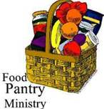
OUTREACH
The FOOD PANTRY is in need of immediate donations. All
donations welcome, food or monetary. Thank you so much.
Needed now: spaghetti, spaghetti sauce, jelly/jam


St. John’s Flea Market
is coming up!!
September 21st, 8 am-1 pm
You can now bring in your
gently used items to the Parish Hall (storage room next to the kitchen). Volunteers needed also for baking! Thank you so much!!

Brownies (2/bag) and cookies (4/bag) can be dropped off during office hours on 9/19 [9:30-1:30] or Friday 9/20 from noon to 8 pm.

We are also accepting donations of Sprite, Sunkist Orange, Water, Diet Pepsi, Diet Coke, Brisk Iced Tea for the Flea Market and other Upcoming Events.


Yoga is now on Tuesday, Wednesday and Friday evenings 6 to 7 pm and Saturday mornings 9 to 10 am in the Chapel.
All experience levels are welcome.

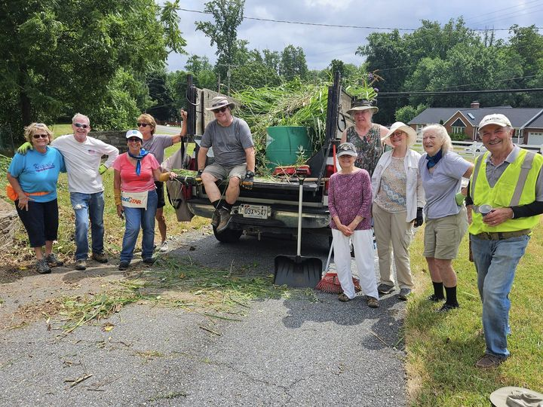
God’s Grace Gardens—a St. John’s, Hill & Stream Garden Club and AA collaboration

For more info or to sign up to help keep our gardens looking beautiful, contact: Rita Talley-Garden Club or Karen Smith-Manar-St. John’s 410-746-9813 or bikenbocal@verizon.net

RECYCLING!
By popular demand, we are recycling. Some parishioners take printed paper home where they have recycling pickup. We now have a blue container located in the Parish Hall. This will be collected and taken for recycling. Aluminum cans will be saved and taken to a recycling center for cash. The proceeds will be donated to the Outreach fund. Each recycled aluminum can also save on the electricity needed to make new aluminum from bauxite.

In our Community

Bible Studies in our area. If interested, please contact these churches to confirm.
St. Mary’s, Abingdon, (410)569-0180- Wednesdays at noon. Bring lunch. Zoom available.
Emmanuel, Bel Air, (410)838-7699- Fridays at 9:30- Zoom Available.
Holy Trinity, Churchville, (410)914-5531- Wednesdays 11:30- Zoom may be available.

Potluck next Sunday, September 1st after the 10:30 service.


St. Mary’s Fall Fried Chicken Dinner
1021 St. Marys Rd Pylesville, MD 21132
Saturday, September 7th, Noon

Dine in or Carry out—Cash, Check or Credit Card
Buffet Style-All You Can Eat
Bake, Craft, Religious and White Elephant Shoppes
Bingo / Children Games / Instant Bingo / Raffle—also Craft and Flea Market (outside vendors)

What’s Happening This Week at St. John’s

Sunday, August 25—MORNING PRAYER-14th Sunday after Pentecost
9:30am: Morning Prayer, Rite II (Church)
11:30am: Coffee Hour (Parish Hall)

Monday, August 26
12:00-1:00pm: AA Lunch Bunch (Parish Hall)
7:00-8:30pm: Spanish speaking AA group (Parish Hall)

Tuesday, August 27
12:00-1:00pm: AA Lunch Bunch (Parish Hall)
6:00-7:00pm: Yoga (Chapel)

Wednesday, August 28
12:00-1:00pm: AA Lunch Bunch (Parish Hall)
6:00-7:00pm: Yoga (Chapel)
7:30pm: AA (Parish Hall)

Thursday, August 29
12:00-1:00pm: AA Lunch Bunch (Parish Hall)
7:00pm: AA (Parish Hall)

Friday, August 30
12:00-1:00pm: AA Lunch Bunch (Parish Hall)

Saturday, August 31
8:30pm: AA (Parish Hall)

Sunday, September 1—15th Sunday after Pentecost
8:00am: Holy Eucharist, Rite I (Church)
10:30am: Holy Eucharist, Rite II (Church)
11:30am: Potluck (Parish Hall)

Parish Office is open Monday, Wednesday and Thursday, 9:30am-1:30pm.

Potluck Luncheon on the first Sunday of the month and a Coffee Hour on all other Sundays after the 10:30 service.

