St. John’s Episcopal Church
Kingsville, Maryland
Welcomes You

OUR VISION STATEMENT

We believe that together we will transform the world with love: Come on in!



12th Sunday after Pentecost
August 11, 2024
9:30 am, Rite I

St. John’s Episcopal Church
11901 Belair Road, P. O. Box 187, Kingsville, MD 21087
Facebook: St. John’s Episcopal, Kingsville, MD
Email: office@stjohnskingsville.org
Website: www.stjohnskingsville.org
Church Phone: 410-592-8570
For Pastoral Emergencies: Fr. Mark Lobb+ 443-690-9545

Welcome to worship today! We are glad that you are with us. You are invited to participate in all parts of the service as indicated in the Book of Common Prayer and this service bulletin. If you have any questions, feel free to ask the ushers. Restrooms are located in the Parish hall, the brick building across the parking lot.

I was glad when they said to me, “Let us go to the house of the Lord.” Psalm 122:1

Church Staff

Interim Rector: Father Mark Lobb
Administrative Assistant: Angie Bosley
Organist/Choir Director: Nancy Heinold

The Vestry

Class of 2025 Class of 2026

John Frost John Stevens
Woodie Tingle
Jacob Johnson

Officers
Ty Schwenk—Sr. Warden Terry Roe—Jr. Warden
Elizabeth Healey—Treasurer Anne Leland-Registrar

Parish Committee Chairpersons

Altar Guild: Elizabeth Healey
Auxiliary Committee: Michele Lozanski
Cemetery Committee: Terry Roe

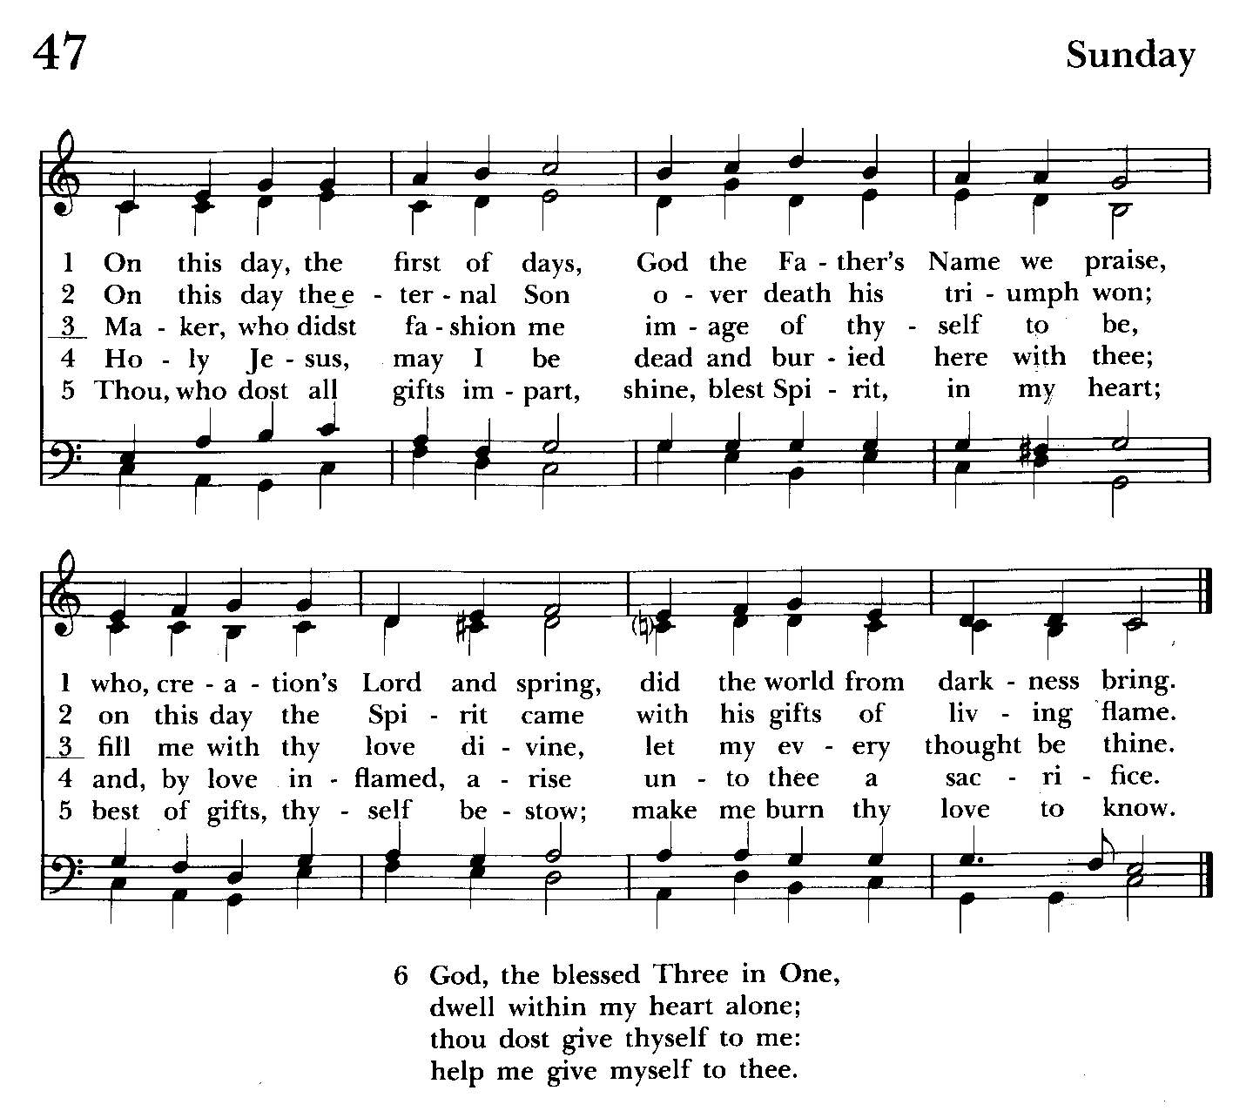

9:30 am Worship
Holy Eucharist, Rite One

9:25 am Church Bell is Rung

Processional Hymn: On this day, the first of days Hymnal #47
(see previous page)
The Word of God
Please stand as able
Worship begins BCP 323
Priest: Blessed be God: Father, Son, and Holy Spirit
People: And blessed be his kingdom, now and for ever. Amen.

The Collect for Purity
Almighty God, unto whom all hearts are open, all desires known, and from whom no secrets are hid: Cleanse the thoughts of our hearts by the inspiration of thy Holy Spirit, that we may perfectly love thee, and worthily magnify thy holy Name, through Christ our Lord. Amen.

The Gloria Celebrant and People Hymnal #S-202
Glory be to God on high,
and on earth peace, good will towards men.
We praise thee, we bless thee,
we worship thee,
we glorify thee,
we give thanks to thee for thy great glory,
O Lord God, heavenly King, God the Father Almighty.
O Lord, the only-begotten Son, Jesus Christ;
O Lord God, Lamb of God, Son of the Father,
that takest away the sins of the world,
have mercy upon us.
Thou that takest away the sins of the world,
receive our prayer.
Thou that sittest at the right hand of God the Father,
have mercy upon us.
For thou only art holy;
thou only art the Lord;
thou only, O Christ,
with the Holy Ghost,
art most high in the glory of God the Father. Amen.

Celebrant: The Lord be with you.
People: And with thy spirit.
Celebrant: Let us pray.

The Collect of the Day BCP 180
Grant to us, Lord, we beseech thee, the spirit to think and do always such things as are right, that we, who cannot exist without thee, may by thee be enabled to live according to thy will; through Jesus Christ our Lord, who liveth and reigneth with thee and the Holy Spirit, one God, for ever and ever. Amen.

The congregation is seated

A Reading from the Second Book of Samuel 18:5-9, 15, 31-33
The king, David, ordered Joab and Abishai and Ittai, saying, “Deal gently for my sake with the young man Absalom.” And all the people heard when the king gave orders to all the commanders concerning Absalom. So the army went out into the field against Israel; and the battle was fought in the forest of Ephraim. The men of Israel were defeated there by the servants of David, and the slaughter there was great on that day, twenty thousand men. The battle spread over the face of all the country; and the forest claimed more victims that day than the sword. Absalom happened to meet the servants of David.
Absalom was riding on his mule, and the mule went under the thick branches of a great oak. His head caught fast in the oak, and he was left hanging between heaven and earth, while the mule that was under him went on.
And ten young men, Joab’s armor-bearers, surrounded Absalom and struck him, and killed him.
Then the Cushite came; and the Cushite said, “Good tidings for my lord the king! For the Lord has vindicated you this day, delivering you from the power of all who rose up against you.” The king said to the Cushite, “Is it well with the young man Absalom?” The Cushite answered, “May the enemies of my lord the king, and all who rise up to do you harm, be like that young man.”
The king was deeply moved, and went up to the chamber over the gate, and wept; and as he went, he said, “O my son Absalom, my son, my son Absalom! Would I had died instead of you, O Absalom, my son, my son!”

Reader: The Word of the Lord.
People: Thanks be to God.
Psalm 130 (Pray as directed)
1 Out of the depths have I called to you, O Lord;
Lord, hear my voice; *
let your ears consider well the voice of my supplication.
2 If you, Lord, were to note what is done amiss, *
O Lord, who could stand?
3 For there is forgiveness with you; *
therefore you shall be feared.
4 I wait for the Lord; my soul waits for him; *
in his word is my hope.
5 My soul waits for the Lord,
more than watchmen for the morning, *
more than watchmen for the morning.
6 O Israel, wait for the Lord, *
for with the Lord there is mercy;
7 With him there is plenteous redemption, *
and he shall redeem Israel from all their sins.

A Reading from the Letter of St. Paul to the Ephesians 4:25-5:2
Putting away falsehood, let all of us speak the truth to our neighbors, for we are members of one another. Be angry but do not sin; do not let the sun go down on your anger, and do not make room for the devil. Thieves must give up stealing; rather let them labor and work honestly with their own hands, so as to have something to share with the needy. Let no evil talk come out of your mouths, but only what is useful for building up, as there is need, so that your words may give grace to those who hear. And do not grieve the Holy Spirit of God, with which you were marked with a seal for the day of redemption. Put away from you all bitterness and wrath and anger and wrangling and slander, together with all malice, and be kind to one another, tenderhearted, forgiving one another, as God in Christ has forgiven you. Therefore be imitators of God, as beloved children, and live in love, as Christ loved us and gave himself up for us, a fragrant offering and sacrifice to God.

Reader: The Word of the Lord.
People: Thanks be to God.

Gradual Hymn: Lord, make us servants of your peace Hymnal #593
(see next page)

Please remain standing as able

The Gospel
Priest: The Holy Gospel of our Lord Jesus Christ according to John 6:35, 41-51
People: Glory be to thee, O Lord.
Jesus said, “I am the bread of life. Whoever comes to me will never be hungry, and whoever believes in me will never be thirsty.”
Then the Jews began to complain about him because he said, “I am the bread that came down from heaven.” They were saying, “Is not this Jesus, the son of Joseph, whose father and mother we know? How can he now say, ‘I have come down from heaven’?” Jesus answered them, “Do not complain among yourselves. No one can come to me unless drawn by the Father who sent me; and I will raise that person up on the last day. It is written in the prophets, ‘And they shall all be taught by God.’ Everyone who has heard and learned from the Father comes to me. Not that anyone has seen the Father except the one who is from God; he has seen the Father. Very truly, I tell you, whoever believes has eternal life. I am the bread of life. Your ancestors ate the manna in the wilderness, and they died. This is the bread that comes down from heaven, so that one may eat of it and not die. I am the living bread that came down from heaven. Whoever eats of this bread will live forever; and the bread that I will give for the life of the world is my flesh.”

Priest: The Gospel of the Lord.
People: Praise be to thee, O Christ.

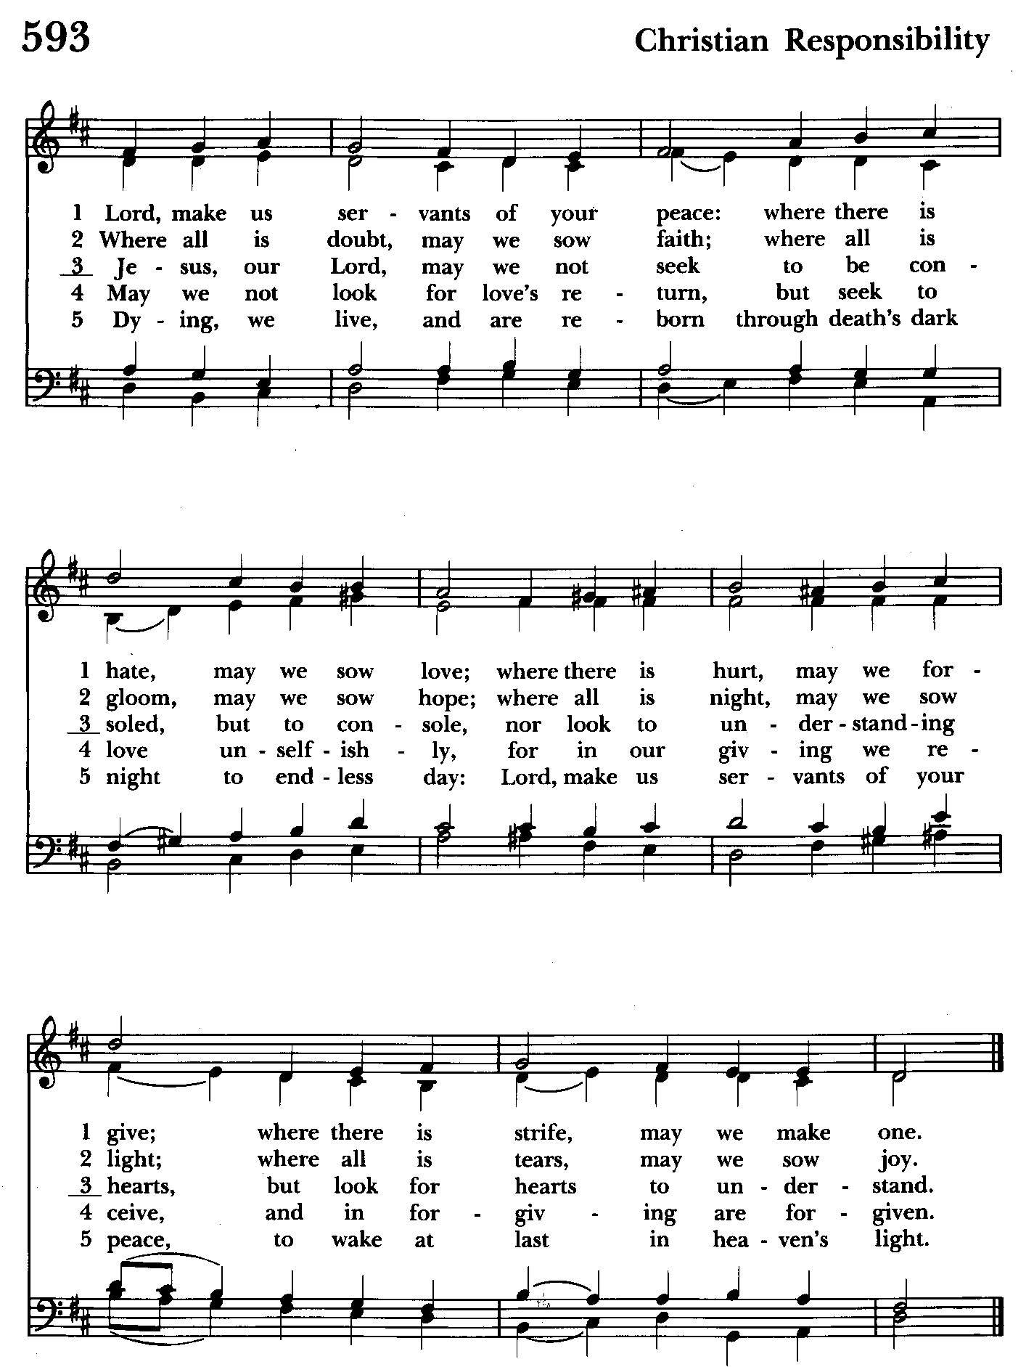

Sermon The congregation is seated The Rev. Mark Lobb+

The Nicene Creed Please stand as able BCP 326
We believe in one God,
the Father, the Almighty,
maker of heaven and earth,
of all that is, seen and unseen.
We believe in one Lord, Jesus Christ,
the only Son of God,
eternally begotten of the Father,
God from God, Light from Light,
true God from true God,
begotten, not made,
of one Being with the Father.
Through him all things were made.
For us and for our salvation
he came down from heaven:
by the power of the Holy Spirit
he became incarnate from the Virgin Mary,
and was made man.
For our sake he was crucified under Pontius Pilate;
he suffered death and was buried.
On the third day he rose again
in accordance with the Scriptures;
he ascended into heaven
and is seated at the right hand of the Father.
He will come again in glory to judge the living and the dead,
and his kingdom will have no end.
We believe in the Holy Spirit, the Lord, the giver of life,
who proceeds from the Father and the Son.
With the Father and the Son he is worshiped and glorified.
He has spoken through the Prophets.
We believe in one holy catholic and apostolic Church.
We acknowledge one baptism for the forgiveness of sins.
We look for the resurrection of the dead,
and the life of the world to come. Amen.

Prayers of the People Please kneel or stand as able. BCP 328
Celebrant: Let us pray for the whole state of Christ's Church and the world.

Almighty and everliving God, who in thy holy Word hast taught us to make prayers, and supplications, and to give thanks for all men: Receive these our prayers which we offer unto thy divine Majesty, beseeching thee to inspire continually the Universal Church with the spirit of truth, unity, and concord; and grant that all those who do confess thy holy Name may agree in the truth of thy holy Word, and live in unity and godly love. Give grace, O heavenly Father, to all bishops and other ministers. For Justin, Archbishop of Canterbury; Michael, our Presiding Bishop; Carrie, our Bishop, and Mark, our Interim Rector, that they may, both by their life and doctrine, set forth thy true and lively Word, and rightly and duly administer thy holy Sacraments. And to all thy people give thy heavenly grace, and especially to this congregation here present; that, with meek heart and due reverence, they may hear and receive thy holy Word, truly serving thee in holiness and righteousness all the days of their life. We beseech thee also so to rule the hearts of those who bear the authority of government in this and every land especially especially for Joseph, our President; for Wes, our Governor; Brandon, Nick, John and Bob, who lead our City and Counties, that they may be led to wise decisions and right actions for the welfare and peace of the world. Open, O Lord, the eyes of all people to behold thy gracious hand in all thy works, that, rejoicing in thy whole creation, they may honor thee with their substance, and be faithful stewards of thy bounty. And we most humbly beseech thee, of thy goodness, O Lord, to comfort and succor all those who in this transitory life, are in trouble, sorrow, need, sickness, or any other adversity. Especially remember in our prayers, DeMarino Family, Jim & Chris Carden and family, Peggie Dietz, Mike Carden, Pat Carden, Gail Landers, Sheila Jones, Gloria Millar, Marisol Aubrey, Amelia Bell,
Linda and Allan Urban, Ross Strickler, Jim and Janice Sieracki, Lily John.

Additional petitions and thanksgivings may be included here.
And we also bless thy holy Name for all thy servants departed this life in thy faith and fear, beseeching thee to grant them continual growth in thy love and service; and to grant us grace so to follow the good examples of St. John and of all thy saints, that with them we may be partakers of thy heavenly kingdom. Grant these our prayers, O Father, for Jesus Christ's sake, our only Mediator and Advocate. Amen.

The Confession and Absolution BCP 330
Celebrant: Let us humbly confess our sins unto Almighty God.

People: Most merciful God, we confess that we have sinned against thee in thought, word, and deed, by what we have done, and by what we have left undone. We have not loved thee with our whole heart; we have not loved our neighbors as ourselves. We are truly sorry and we humbly repent. For the sake of thy Son Jesus Christ, have mercy on us and forgive us; that we may delight in thy will, and walk in thy ways, to the glory of thy Name. Amen.

Priest: Almighty God, our heavenly Father, who of his great mercy hath promised forgiveness of sins to all those who with hearty repentance and true faith turn unto him, have mercy upon you, pardon and deliver you from all your sins, confirm and strengthen you in all goodness, and bring you to everlasting life; through Jesus Christ our Lord. Amen.

God so loved the world, that he gave his only-begotten Son, to the end that all that believe in him should not perish, but have everlasting life. John 3:16

The Peace Please stand as able BCP 332
Celebrant: The peace of the Lord be always with you.
People And with thy spirit.

The congregation is seated
Offertory Hymn: God is Love, and where true love is Hymnal #577
(see pages 12 and 13)

Offertory: Offerings are collected

Offerings are presented Please stand as able

Presentation Hymn: Hymnal #43, vs. 4
Praise God, from whom all blessings flow; praise him, all creatures here below; praise him above, ye heavenly host: praise Father, Son, and Holy Ghost.

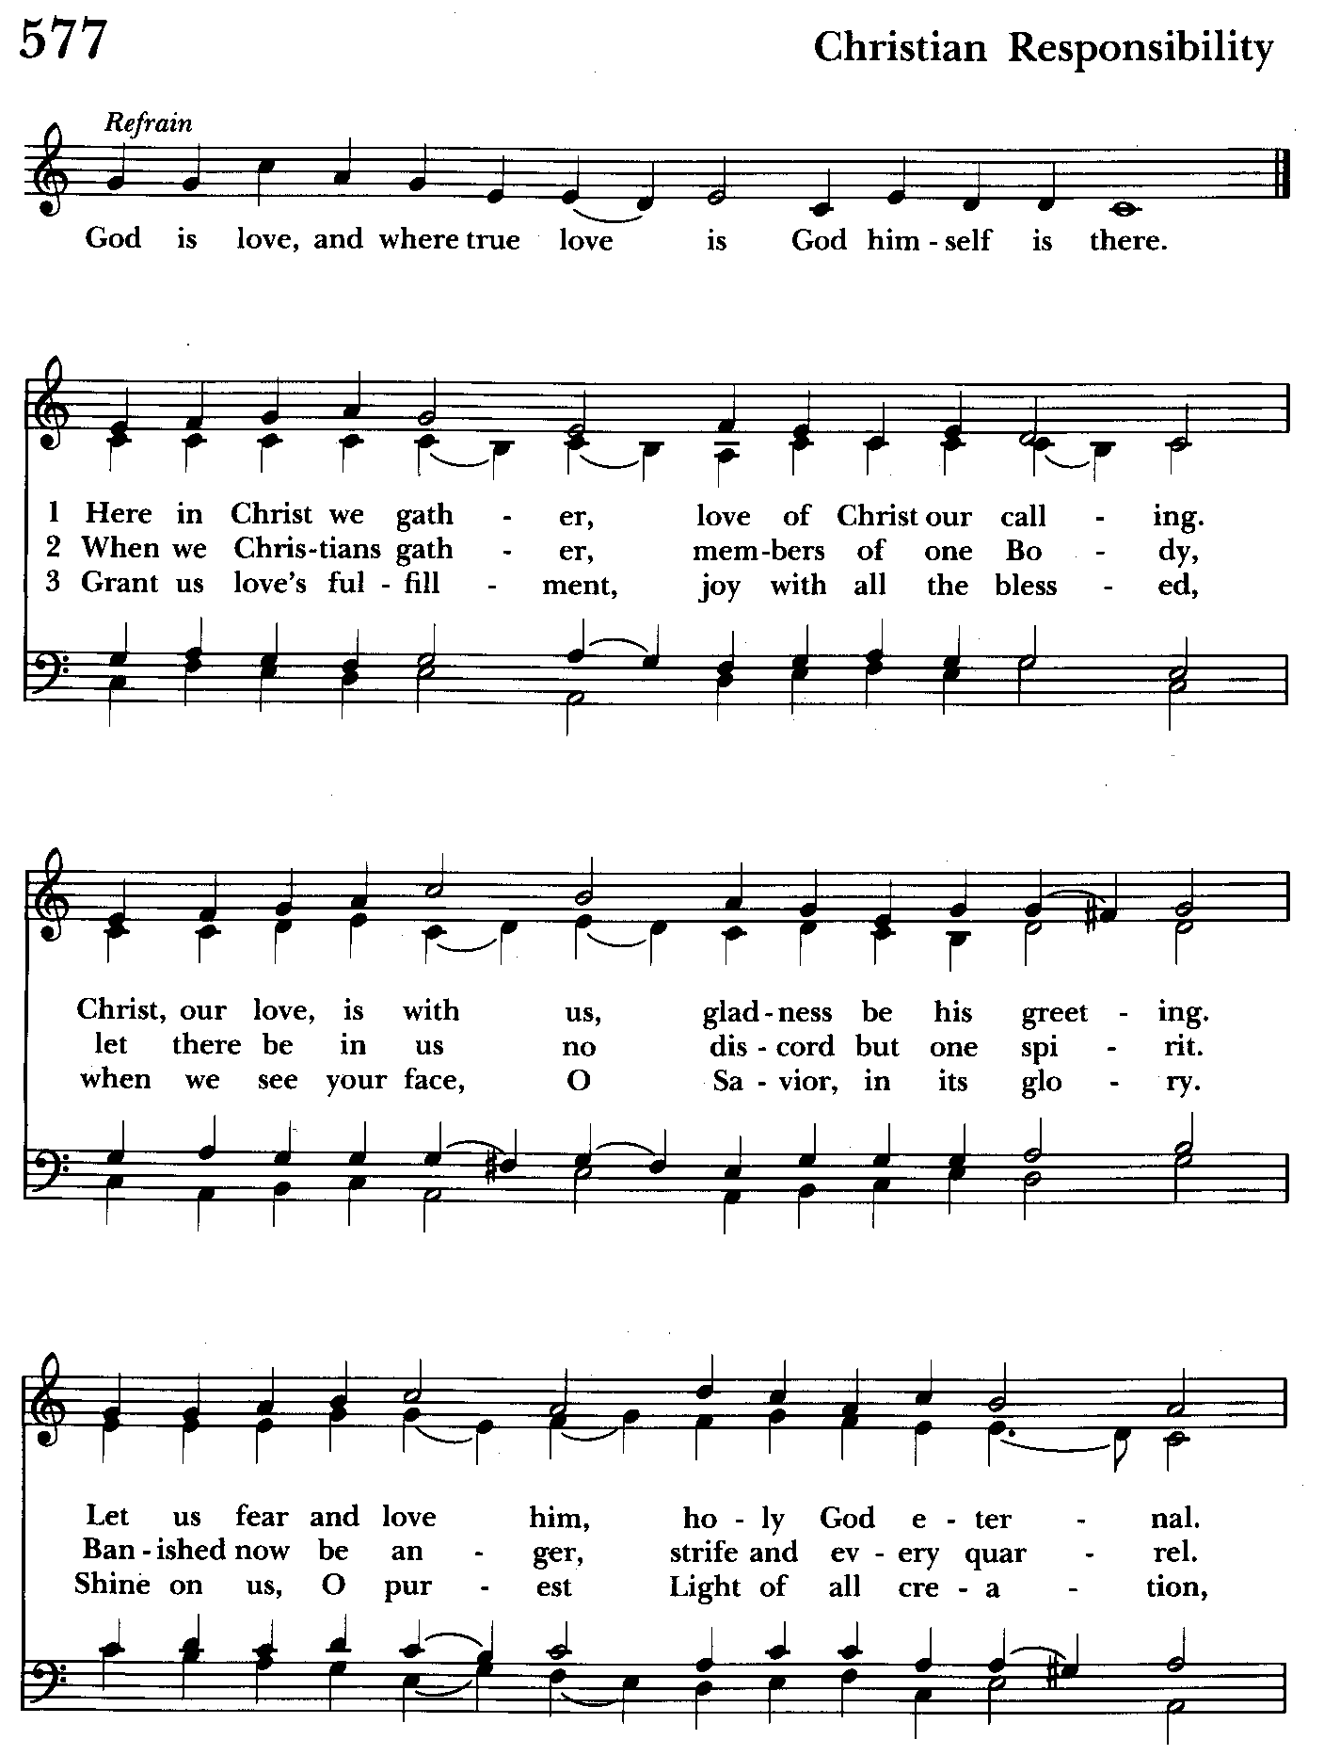

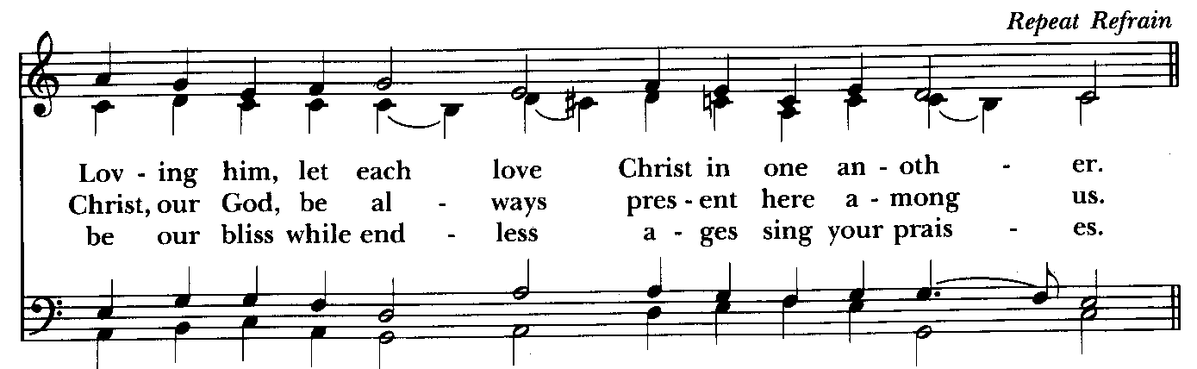

The Holy Communion—Form II
The Great Thanksgiving BCP 340
Celebrant: The Lord be with you.
People And with thy spirit.
Celebrant Lift up your hearts.
People We lift them up unto the Lord.
Celebrant Let us give thanks unto our Lord God.
People It is meet and right so to do.

Preface - The celebrant inserts a Proper Preface

Therefore with Angels and Archangels, and with all the company of heaven, we laud and magnify thy glorious Name; evermore praising thee, and saying,

Sanctus Hymnal #S-114
Holy, holy, holy, Lord God of Hosts,
heaven and earth are full of your glory.
Glory be to thee, O Lord Most High.
Blessed is he that cometh in the name of the Lord.
Hosanna in the highest.

Please kneel or stand as able

Celebrant: All glory be to thee, O Lord our God, for that thou didst create heaven and earth, and didst make us in thine own image; and, of thy tender mercy, didst give thine only Son Jesus Christ to take our nature upon him, and to suffer death upon the cross for our redemption. He made there a full and perfect sacrifice for the whole world; and did institute, and in his holy Gospel command us to continue, a perpetual memory of that his precious death and sacrifice, until his coming again.

At the following words concerning the bread, the Celebrant is to hold it, or lay a hand upon it; and at the words concerning the cup, to hold or place a hand upon the cup and any other vessel containing wine to be consecrated.

For in the night in which he was betrayed, he took bread; and when he had given thanks, he brake it, and gave it to his disciples, saying, “Take, eat, this is my Body, which is given for you. Do this in remembrance of me.”

Likewise, after supper, he took the cup; and when he had given thanks, he gave it to them, saying, “Drink ye all of this; for this is my Blood of the New Covenant, which is shed for you, and for many, for the remission of sins. Do this, as oft as ye shall drink it, in remembrance of me.”

Wherefore, O Lord and heavenly Father, we thy people do celebrate and make, with these thy holy gifts which we now offer unto thee, the memorial thy Son hath commanded us to make; having in remembrance his blessed passion and precious death, his mighty resurrection and glorious ascension; and looking for his coming again with power and great glory.

And we most humbly beseech thee, O merciful Father, to hear us, and, with thy Word and Holy Spirit, to bless and sanctify these gifts of bread and wine, that they may be unto us the body and Blood of thy dearly-beloved Son Jesus Christ.

And we earnestly desire thy fatherly goodness to accept this our sacrifice of praise and thanksgiving, whereby we offer and present unto thee, O Lord, our selves, our souls and bodies. Grant, we beseech thee, that all who partake of this Holy Communion may worthily receive the most precious Body and Blood of thy Son Jesus Christ, and be filled with thy grace and heavenly benediction; and also that we and all thy whole Church may be made one body with him, that he may dwell in us, and we in him; through the same Jesus Christ our Lord.

By whom, and with whom, and in whom, in the unity of the Holy Ghost all honor and glory be unto thee, O Father Almighty, world without end. Amen.

And now, as our Savior Christ hath taught us, we are bold to say,

Our Father, who art in heaven, hallowed be thy Name, BCP 336
thy kingdom come, thy will be done, on earth as it is in heaven.
Give us this day our daily bread. And forgive us our trespasses,
as we forgive those who trespass against us.
And lead us not into temptation, but deliver us from evil.
For thine is the kingdom, and the power, and the glory,
for ever and ever. Amen.

The Breaking of the Bread BCP 337
Celebrant: Alleluia. Christ our Passover is sacrificed for us;
People: Therefore, let us keep the feast. Alleluia.

The congregation is seated
Celebrant and People: We do not presume to come to this thy Table, O merciful Lord, trusting in our own righteousness, but in thy manifold and great mercies. We are not worthy so much as to gather up the crumbs under thy Table. But thou art the same Lord whose property is always to have mercy. Grant us therefore, gracious Lord, so to eat the flesh of thy dear Son Jesus Christ, and to drink his blood, that we may evermore dwell in him, and he in us. Amen.

Celebrant: The Gifts of God for the People of God.

Fraction Anthem: Hymnal #S-158

Communion hymn: I am the bread of life Please be seated Hymnal #335
(see next 2 pages)

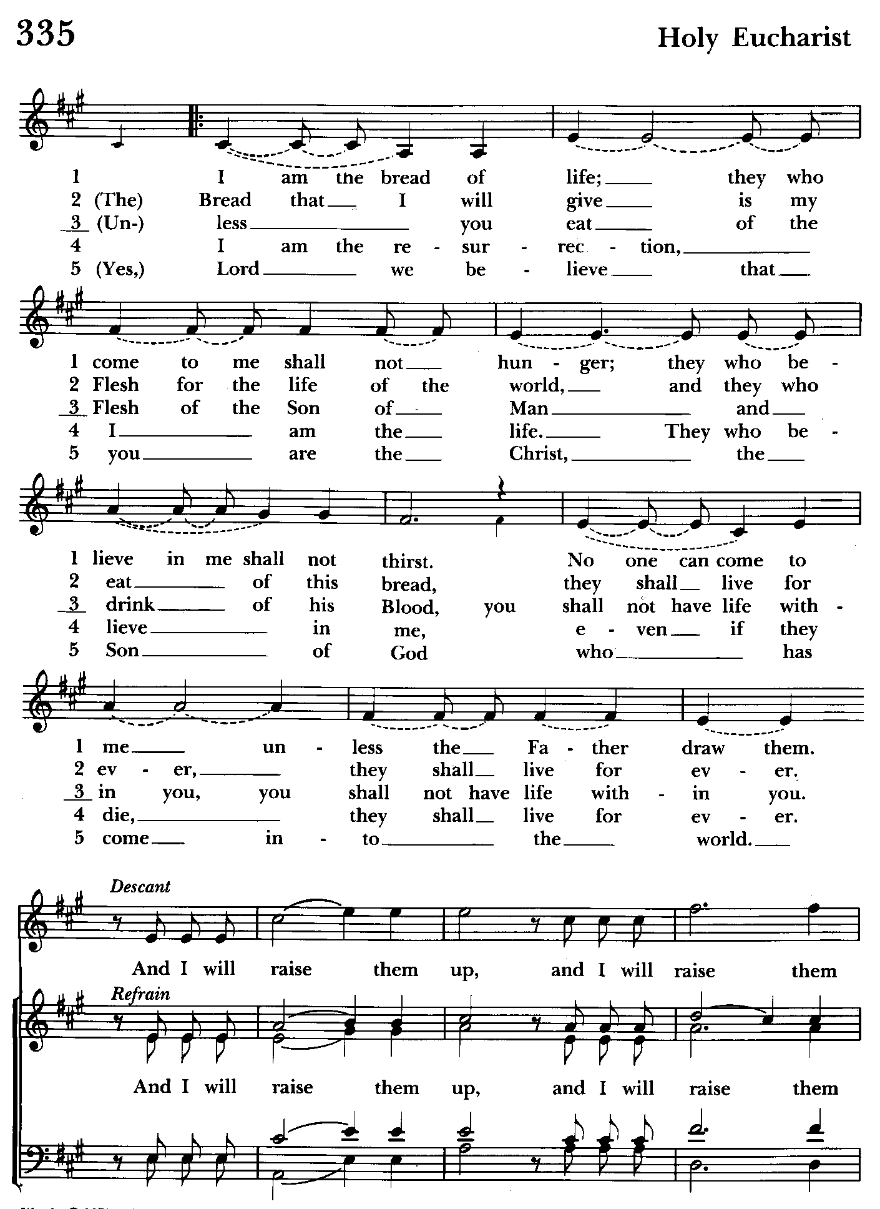

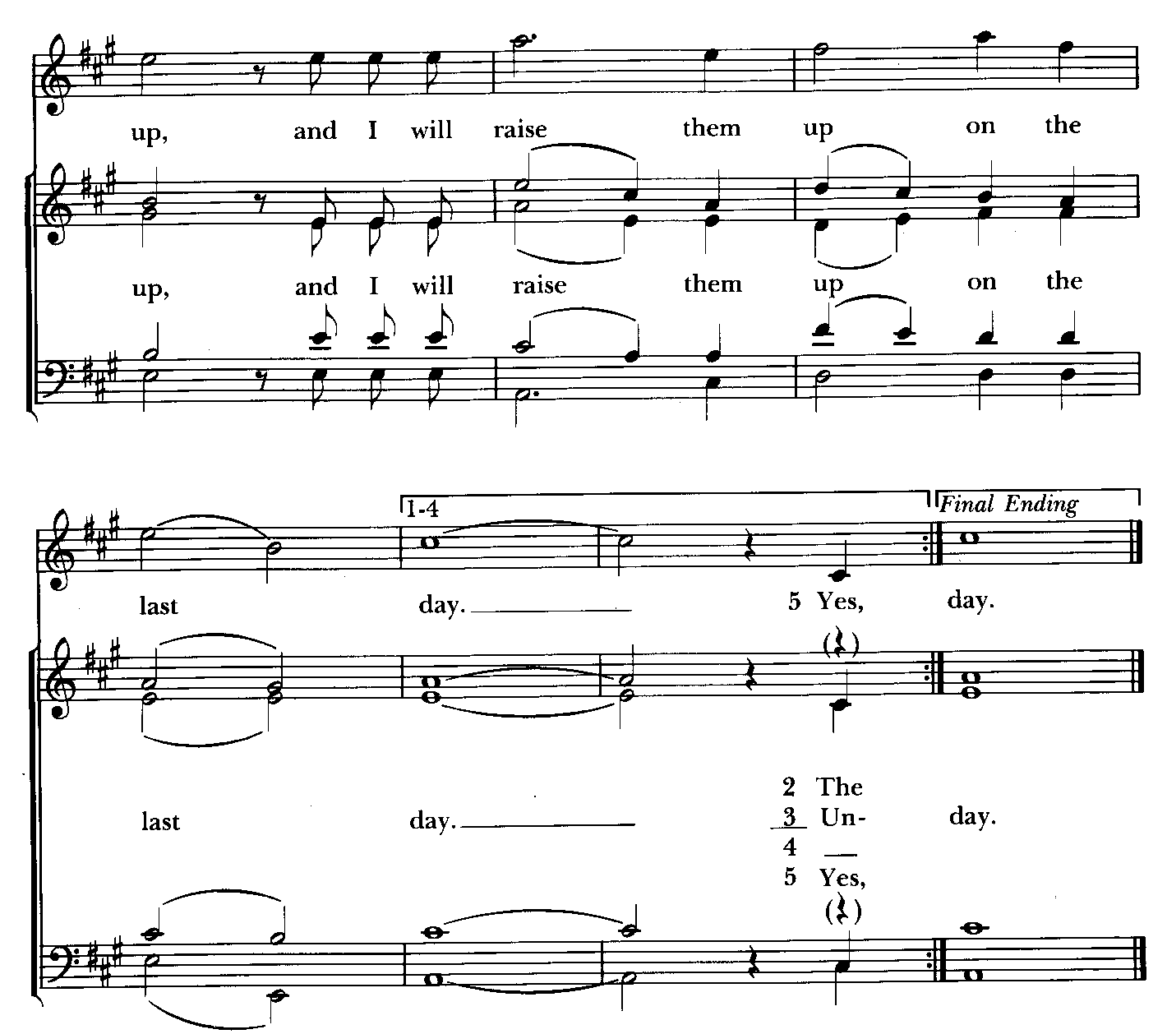

The Post Communion Prayer BCP 339
Almighty and everliving God, we most heartily thank thee for that thou dost feed us, in these holy mysteries, with the spiritual food of the most precious Body and Blood of thy Son our Savior Jesus Christ; and dost assure us thereby of thy favor and goodness towards us; and that we are very members incorporate in the mystical body of thy Son, the blessed company of all faithful people; and are also heirs, through hope, of thy everlasting kingdom. And we humbly beseech thee, O heavenly Father, so to assist us with thy grace, that we may continue in that holy fellowship, and do all such good works as thou hast prepared for us to walk in; through Jesus Christ our Lord, to whom, with thee and the Holy Ghost, be all honor and glory, world without end. Amen.

Blessing

Recessional Hymn: Deck thyself, my soul, with gladness Hymnal #339
(see next 2 pages)

The Dismissal (The Alleluias are back)
Celebrant: Let us go forth in the name of Christ..
People: Thanks be to God. Alleluia, Alleluia!

License #A-719154

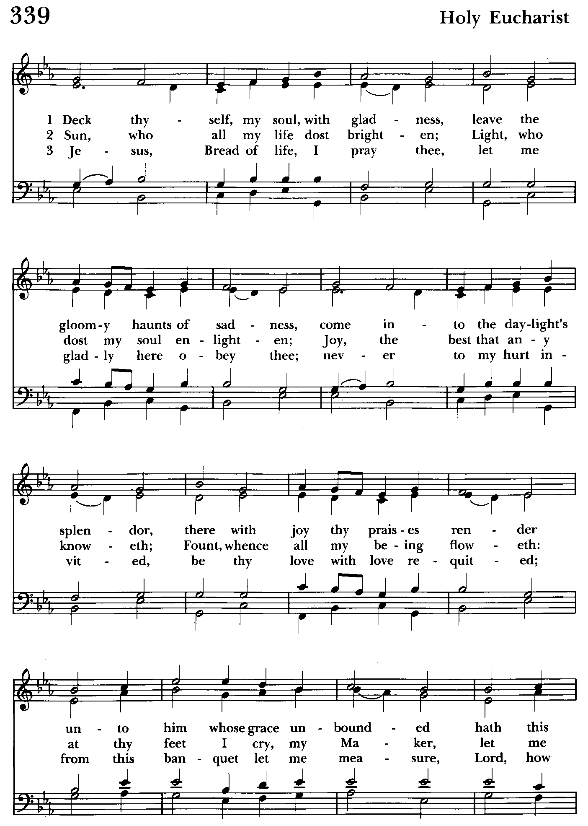

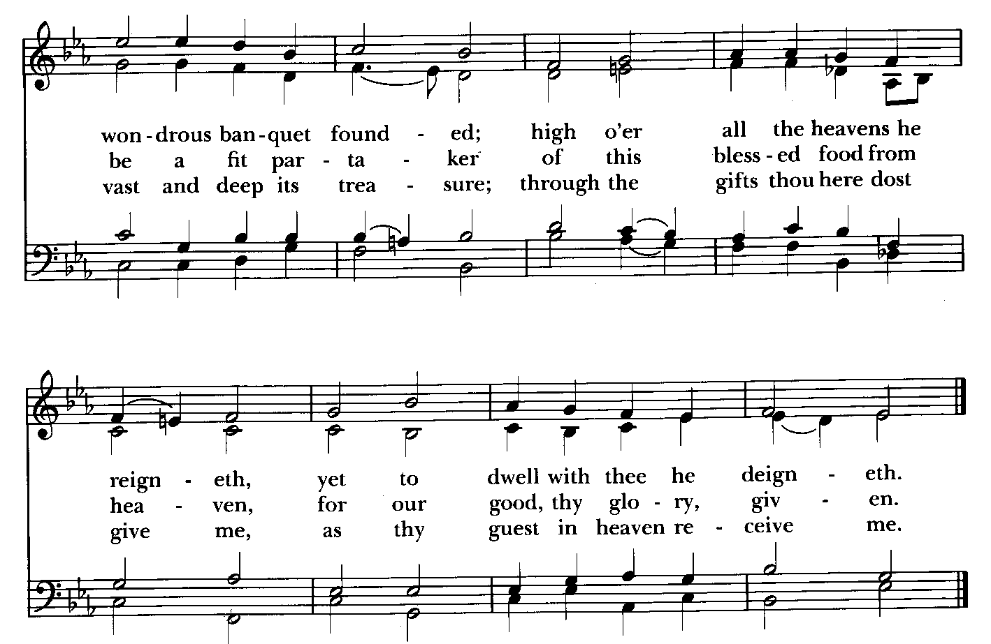

Serving Today

Celebrant & Preacher: The Rev. Mark Lobb+
Old Testament: John Stevens
Psalm: John Stevens
New Testament: Liz Healey
Prayers of the People: John Frost
Server: Jennifer Scepaniak
Altar Guild: Stephanie Duchacek & Sandy Roe

St. John’s Parish Prayer List

Additions and corrections may be made to our Parish Prayer List at any time. All names will be automatically removed from the Parish Prayer List on the 1st Sunday of each month unless you request otherwise. Please contact Angie at <office@stjohnskingsville.org> or 410-592-8570 in the church office with all changes by 10 am Thursdays. Thank you.

We Pray for Those in Need:
Names in BOLD read aloud by all.

DeMarino Family, Jim & Chris Carden and family, Peggie Dietz, Mike Carden, Pat Carden, Gail Landers, Sheila Jones, Gloria Millar, Marisol Aubrey, Amelia Bell, Linda and Allan Urban, Ross Strickler, Janice and Jim Sieracki.

We Pray for our Homebound

Lily John, Barbara Miller, Nancy Barnhart, Robin Dilworth

We pray for the Church and the World:

For +Justin, Archbishop of Canterbury; for +Michael, our Presiding Bishop; for +Sean, our Presiding Bishop Elect; for +Carrie, our Bishop, for Mark+, our Interim Rector; for the Wardens, Vestry, Staff, and all members and friends of St. John’s Church.

For the leaders of all nations, especially for Joseph, our President; for Wes, our Governor; for Brandon, Nick, John and Bob, who lead our City and Counties. We pray for all children and youth; for the homeless, the unemployed, and the hungry. We pray for the safety of our loved ones and friends serving in the Armed Forces at home and abroad, and for our enemies, that all our hearts may be turned toward peace throughout the world.


Altar Flowers
Given to the Glory of God
by a Generous Donor in
Thanksgiving for St. John’s

From the Treasurer
August ’24 Income vs. Expenses:
Projected August Expenses: $13,500
Monies Received as of 8/8: $7,088
Amount Needed to Meet Expenses: $6,412


If you’d like to make a donation to St. John’s you can scan this QR code with your phone’s camera or tap on the link that comes up to make a contribution with either a credit or debit card, Apple Pay or Google Pay. This is a secure site provided by Clover which is a service of PNC Bank.


With so much going on, everyone’s help is needed to make things a success. Our volunteers make the Church function. The volunteering of time and talent is greatly appreciated.

Choral Choir and Bell Choir
Choir and Bell Choir are off for the summer. See you in September.

SUNDAY SCHOOL
It's almost time for Sunday School. Mr. John and Miss Stephanie will be coming back and classes begin on September 8th.

BINGO-AUGUST 16TH @ 5:30 PM
We are asking for donations of water, Diet Pepsi, Regular Coke, and ice tea for the kitchen.

Calling all Bakers!
If you can, please bake cookies or brownies to sell at the
Bingo.
Please package 4 cookies to a bag and 2 brownies to a bag please let us know what the item is and if it has nuts. They can be dropped off on Friday 8/16 after 1pm.
Please consider signing up to help or donate a basket for the Bingo event. Just give us a call and let us know if you are available any time would be helpful. Michele 443-463-6333 or Angie 410-592-8570. Also a sign up sheet is in the back of the church.

Yoga classes on Tuesday, Wednesday and Friday evenings 6 to 7 pm and Saturday mornings 9 to 10 am in the Chapel.
All experience levels are welcome.

Calendar Updates
Summer services- We will temporarily go to one service on a Sunday at 9:30 a.m. from 7/7 to 8/25. Most will be Holy Eucharist.

Morning Prayer- will be offered on the following Sundays: 8/25, 9/8, 9/29, 10/13, 11/10, 12/8, 12/29. Lay people are highly encouraged to consider helping by officiating and/or preaching of Morning Prayer. I am willing to help you prepare for this.

Would it be helpful to have an “Officiating Morning Prayer” class? Let me know.

Blessing of the Animals- 9:30 a.m. (between the services) on Sunday 10/6.

All Souls service- Sunday evening 7:00 11/3.

Blue Christmas/Service of Solace- TBD

Calendars are living documents. Every effort will be made to keep the members of the parish and community aware of any changes.

SAVE THE DATE
God’s Grace Garden Workday - 8/10 @ 9 am (inclement weather date 9/7)
Bingo - 8/16
Flea Market - 9/21
Bingo - 10/18
Christmas Bazaar - 11/23

RECYCLING!
By popular demand, we are recycling. Some parishioners take printed paper home where they have recycling pickup. We now have a blue container located in the Parish Hall. This will be collected and taken for recycling. Aluminum cans will be saved and taken to a recycling center for cash. The proceeds will be donated to the Outreach fund. Each recycled aluminum can also save on the electricity needed to make new aluminum from bauxite.

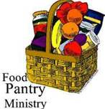
OUTREACH
The FOOD PANTRY is in need of immediate
donations. All donations welcome, food or
monetary. Thank you so much.
Needed at this time: spaghetti, spaghetti sauce
jelly/jam


Come see the progress we’re making to Beautify our St. Francis Garden!!
Next Workday
Saturday August 10th at 9 am, weather permitting.
Inclement Weather Date --- Saturday September 7th at 9 am, weather permitting.
Donation Wish List
Tarps, Topsoil (loose), Mulch, (no plastic bags please), Angle Grinder, Stainless Steel Memorial Plant Markers, Rakes, Hoe
Please let Karen or Rita know of any memorial plantings on campus so that they may be labeled and nurtured.
Thank You!
Work Plan Includes:
Selected shrub, vine and ornamental grass removal
Clear debris and apply topsoil and mulch
Install donated natural stone paver path to provide access to 2 donated small
cement benches near the St. Francis Statue

God’s Grace Gardens—a St. John’s, Hill & Stream Garden Club and AA collaboration

In our Community

Bible Studies in our area. If interested, please contact these churches to confirm.
St. Mary’s, Abingdon, (410)569-0180- Wednesdays at noon. Bring lunch. Zoom available.
Emmanuel, Bel Air, (410)838-7699- Fridays at 9:30- Zoom Available.
Holy Trinity, Churchville, (410)914-5531- Wednesdays 11:30- Zoom may be available.

Jerusalem Mill Summer Concert Series– see next page.

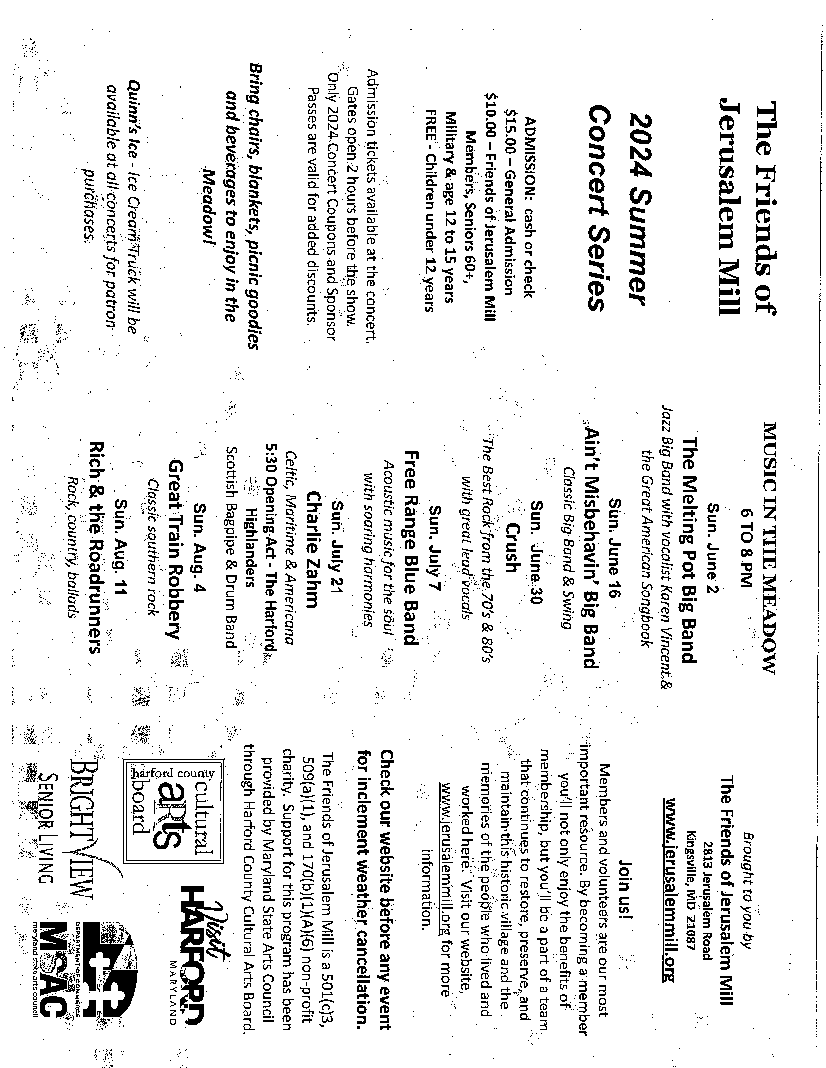

What’s Happening This Week at St. John’s

Sunday, August 11—12th Sunday after Pentecost
9:30am: Holy Eucharist, Rite I (Church)
10:45am: Coffee Hour (Parish Hall)

Monday, August 12
12:00-1:00pm: AA Lunch Bunch (Parish Hall)
7:00-8:30pm: Spanish speaking AA group (Parish Hall)

Tuesday, August 13
12:00-1:00pm: AA Lunch Bunch (Parish Hall)
6:00-7:00pm: Yoga (Chapel)

Wednesday, August 14
12:00-1:00pm: AA Lunch Bunch (Parish Hall)
6:00-7:00pm: Yoga (Chapel)
7:30pm: AA (Parish Hall)

Thursday, August 15
12:00-1:00pm: AA Lunch Bunch (Parish Hall)
7:00pm: AA (Parish Hall)

Friday, August 16
12:00-1:00pm: AA Lunch Bunch (Parish Hall)
5:00pm: BINGO (Parish Hall)
6:00-7:00pm: Yoga (Chapel)

Saturday, August 17
9:00-10:00am: Yoga (Chapel)
8:30pm: AA (Parish Hall)

Sunday, August 18—13th Sunday after Pentecost- +Kristin Krantz celebrating/preaching
9:30am: Holy Eucharist, Rite II (Church)
10:45am: Coffee Hour (Parish Hall)

Parish Office is open Monday, Wednesday and Thursday, 9:30am-1:30pm.

Potluck Luncheon on the first Sunday of the month and a Coffee Hour on all other Sundays after the 9:30 service.

FR. MARK ON VACATION BEGINNING AUGUST 12TH THROUGH
AUGUST 29TH

