St. John’s Episcopal Church
Kingsville, Maryland
Welcomes You

Our Mission Statement

We believe that together we will transform the world with love: Come on in!

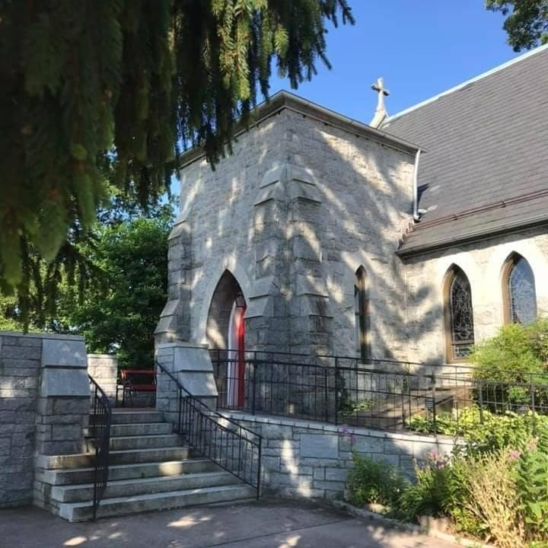

9th Sunday after Pentecost
Morning Prayer-Rite I
July 21, 2024-9:30 am

St. John’s Episcopal Church

11901 Belair Road, P. O. Box 187, Kingsville, MD 21087
Facebook: St. John’s Episcopal, Kingsville, MD
Email: office@stjohnskingsville.org
Website: www.stjohnskingsville.org
Church Phone: 410-592-8570
For Pastoral Emergencies: Fr. Mark Lobb+ 443-690-9545

Welcome to worship today! We are glad that you are with us. You are invited to participate in all parts of the service as indicated in the Book of Common Prayer and this service bulletin. If you have any questions, feel free to ask the ushers. Restrooms are located in the Parish hall, the brick building across the parking lot.

I was glad when they said to me, “Let us go to the house of the Lord.” Psalm 122:1

Church Staff

Interim Rector: Father Mark Lobb
Administrative Assistant: Angie Bosley
Organist/Choir Director: Nancy Heinold

The Vestry

Class of 2025 Class of 2026

John Frost John Stevens
Woodie Tingle
Jacob Johnson

Officers
Ty Schwenk—Sr. Warden Terry Roe—Jr. Warden
Elizabeth Healey—Treasurer Anne Leland-Registrar

Parish Committee Chairpersons

Altar Guild: Elizabeth Healey
Auxiliary Committee: Michele Lozanski
Cemetery Committee: Terry Roe

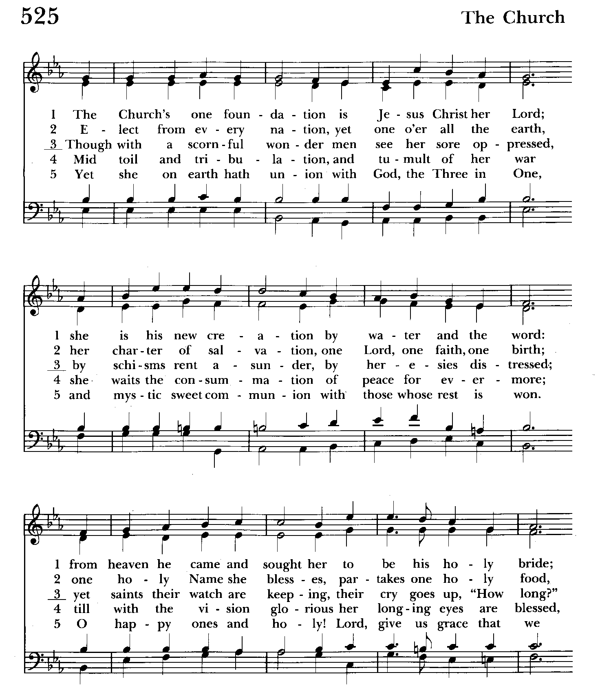

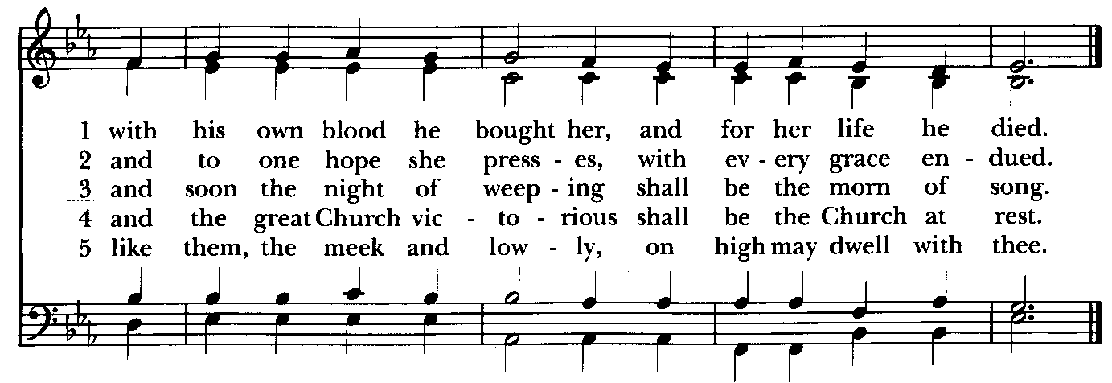

Morning Prayer, Rite I
Note:
Please feel free to remain seated during the service if unable to stand or kneel.
‘BCP’ refers to the Book of Common Prayer. The people’s responses are in bold. Large print song sheets are available. Please see an usher if you would like to use one.
DAILY MORNING PRAYER: RITE One
Prelude

Opening Hymn: The Church’s one foundation Hymnal #525
(see previous page)

Welcome and Announcements Please remain standing as you are able.

THE OPENING SENTENCES BCP pg. 42
Officiant: O Lord, open thou our lips.
People: And our mouth shall show forth thy praise.

CONFESSION OF SIN BCP. pg. 41
Let us humbly confess our sins unto Almighty God.
Silence may be kept.

Officiant and people Please kneel or stand as able
Almighty and most merciful Father,
we have erred and strayed from thy ways like lost sheep,
we have followed too much the devices and desires of our
own hearts,
we have offended against thy holy laws,
we have left undone those things which we ought to have done,
and we have done those things which we ought not to have done.
But thou, O Lord, have mercy upon us,
spare thou those who confess their faults,
restore thou those who are penitent,
according to thy promises declared unto mankind
in Christ Jesus our Lord;
and grant, O most merciful Father, for his sake,
that we may hereafter live a godly, righteous, and sober life,
to the glory of thy holy Name. Amen.

The officiant says
The Almighty and merciful Lord grant us absolution and remission of all our sins, true repentance, amendment of life, and the grace and consolation of his Holy Spirit. Amen.

THE INVITATORY AND PSALTER BCP pg. 42
Please stand as you are able
Officiant: Oh Lord, open thou our lips.
People: And our mouth shall show forth thy praise.
Glory to the Father, and to the Son, and to the Holy Spirit: as it was in the
beginning, is now, and will be forever. Amen. Alleluia.

The earth is the Lord’s for he made it: Come let us adore him.

THE VENITE – Psalm 95:1-7 BCP pg. 44
Officiant and people
O come, let us sing unto the Lord; *
let us heartily rejoice in the strength of our salvation.
Let us come before his presence with thanksgiving *
and show ourselves glad in him with psalms.
For the Lord is a great God, *
and a great King above all gods.
In his hand are all the corners of the earth, *
and the strength of the hills is his also.
The sea is his, and he made it, *
and his hands prepared the dry land.
O come, let us worship and fall down, *
and kneel before the Lord our Maker.
For he is the Lord our God, *
and we are the people of his pasture
and the sheep of his hand.
O worship the Lord in the beauty of holiness; *
let the whole earth stand in awe of him.
For he cometh, for he cometh to judge the earth, *
and with righteousness to judge the world
and the peoples with his truth.

Psalm 89:20-37
Officiant and People
20 I have found David my servant; *
with my holy oil have I anointed him.
21 My hand will hold him fast *
and my arm will make him strong.
22 No enemy shall deceive him, *
nor any wicked man bring him down.
23 I will crush his foes before him *
and strike down those who hate him.
24 My faithfulness and love shall be with him, *
and he shall be victorious through my Name.
25 I shall make his dominion extend *
from the Great Sea to the River.
26 He will say to me, 'You are my Father, *
my God, and the rock of my salvation.'
27 I will make him my firstborn *
and higher than the kings of the earth.
28 I will keep my love for him for ever, *
and my covenant will stand firm for him.
29 I will establish his line for ever *
and his throne as the days of heaven."
30 "If his children forsake my law *
and do not walk according to my judgments;
31 If they break my statutes *
and do not keep my commandments;
32 I will punish their transgressions with a rod *
and their iniquities with the lash;
33 But I will not take my love from him, *
nor let my faithfulness prove false.
34 I will not break my covenant, *
nor change what has gone out of my lips.
35 Once for all I have sworn by my holiness: *
'I will not lie to David.
36 His line shall endure for ever *
and his throne as the sun before me;
37 It shall stand fast for evermore like the moon, *
the abiding witness in the sky.' "

Please be seated

THE FIRST READING 2 Samuel 7:1-14a
When the king was settled in his house, and the Lord had given him rest from all his enemies around him, the king said to the prophet Nathan, “See now, I am living in a house of cedar, but the ark of God stays in a tent.” Nathan said to the king, “Go, do all that you have in mind; for the Lord is with you.”
But that same night the word of the Lord came to Nathan: Go and tell my servant David: Thus says the Lord: Are you the one to build me a house to live in? I have not lived in a house since the day I brought up the people of Israel from Egypt to this day, but I have been moving about in a tent and a tabernacle. Wherever I have moved about among all the people of Israel, did I ever speak a word with any of the tribal leaders of Israel, whom I commanded to shepherd my people Israel, saying, “Why have you not built me a house of cedar?” Now therefore thus you shall say to my servant David: Thus says the Lord of hosts: I took you from the pasture, from following the sheep to be prince over my people Israel; and I have been with you wherever you went, and have cut off all your enemies from before you; and I will make for you a great name, like the name of the great ones of the earth. And I will appoint a place for my people Israel and will plant them, so that they may live in their own place, and be disturbed no more; and evildoers shall afflict them no more, as formerly, from the time that I appointed judges over my people Israel; and I will give you rest from all your enemies. Moreover the Lord declares to you that the Lord will make you a house. When your days are fulfilled and you lie down with your ancestors, I will raise up your offspring after you, who shall come forth from your body, and I will establish his kingdom. He shall build a house for my name, and I will establish the throne of his kingdom forever. I will be a father to him, and he shall be a son to me.

The Word of the Lord.
Thanks be to God.

CANTICLE 4 The Song of Zechariah Benedictus Dominus Deus Luke 1:68-79
Officiant and People
Blessed be the Lord God of Israel, *
for he hath visited and redeemed his people;
And hath raised up a mighty salvation for us *
in the house of his servant David,
As he spake by the mouth of his holy prophets, *
which have been since the world began:
That we should be saved from our enemies, *
and from the hand of all that hate us;
To perform the mercy promised to our forefathers, *
and to remember his holy covenant;
To perform the oath which he sware to our forefather Abraham, *
that he would give us,
That we being delivered out of the hand of our enemies *
might serve him without fear,
In holiness and righteousness before him, *
all the days of our life.
And thou, child, shalt be called the prophet of the Highest, *
for thou shalt go before the face of the Lord
to prepare his ways;
To give knowledge of salvation unto his people *
for the remission of their sins,
Through the tender mercy of our God, *
whereby the dayspring from on high hath visited us;
To give light to them that sit in darkness
and in the shadow of death, *
and to guide our feet into the way of peace.

Glory to the Father, and to the Son, and to the Holy Spirit: *
as it was in the beginning, is now, and will be for ever. Amen.

THE SECOND READING Ephesians 2:11-22
Remember that at one time you Gentiles by birth, called “the uncircumcision” by those who are called “the circumcision” —a physical circumcision made in the flesh by human hands— remember that you were at that time without Christ, being aliens from the commonwealth of Israel, and strangers to the covenants of promise, having no hope and without God in the world. But now in Christ Jesus you who once were far off have been brought near by the blood of Christ. For he is our peace; in his flesh he has made both groups into one and has broken down the dividing wall, that is, the hostility between us. He has abolished the law with its commandments and ordinances, that he might create in himself one new humanity in place of the two, thus making peace, and might reconcile both groups to God in one body through the cross, thus putting to death that hostility through it. So he came and proclaimed peace to you who were far off and peace to those who were near; for through him both of us have access in one Spirit to the Father. So then you are no longer strangers and aliens, but you are citizens with the saints and also members of the household of God, built upon the foundation of the apostles and prophets, with Christ Jesus himself as the cornerstone. In him the whole structure is joined together and grows into a holy temple in the Lord; in whom you also are built together spiritually into a dwelling place for God.

The Word of the Lord.
Thanks be to God.

7 We Praise Thee Te Deum laudamus BCP pg. 52
Officiant and People
We praise thee, O God; we acknowledge thee to be the Lord.
All the earth doth worship thee, the Father everlasting.
To thee all Angels cry aloud,
the Heavens and all the Powers therein.
To thee Cherubim and Seraphim continually do cry:
Holy, holy, holy, Lord God of Sabaoth;
Heaven and earth are full of the majesty of thy glory.
The glorious company of the apostles praise thee.
The goodly fellowship of the prophets praise thee.
The noble army of martyrs praise thee.
The holy Church throughout all the world
doth acknowledge thee,
the Father, of an infinite majesty,
thine adorable, true, and only Son,
also the Holy Ghost the Comforter.
Thou art the King of glory, O Christ.
Thou art the everlasting Son of the Father.
When thou tookest upon thee to deliver man,
thou didst humble thyself to be born of a Virgin.
When thou hadst overcome the sharpness of death,
thou didst open the kingdom of heaven to all believers.
Thou sittest at the right hand of God, in the glory of the Father.
We believe that thou shalt come to be our judge.
We therefore pray thee, help thy servants,
whom thou hast redeemed with thy precious blood.
Make them to be numbered with thy saints,
in glory everlasting.

Gradual Hymn: My Shepherd will supply my need Hymnal #664
(see next page)

Please remain standing as able

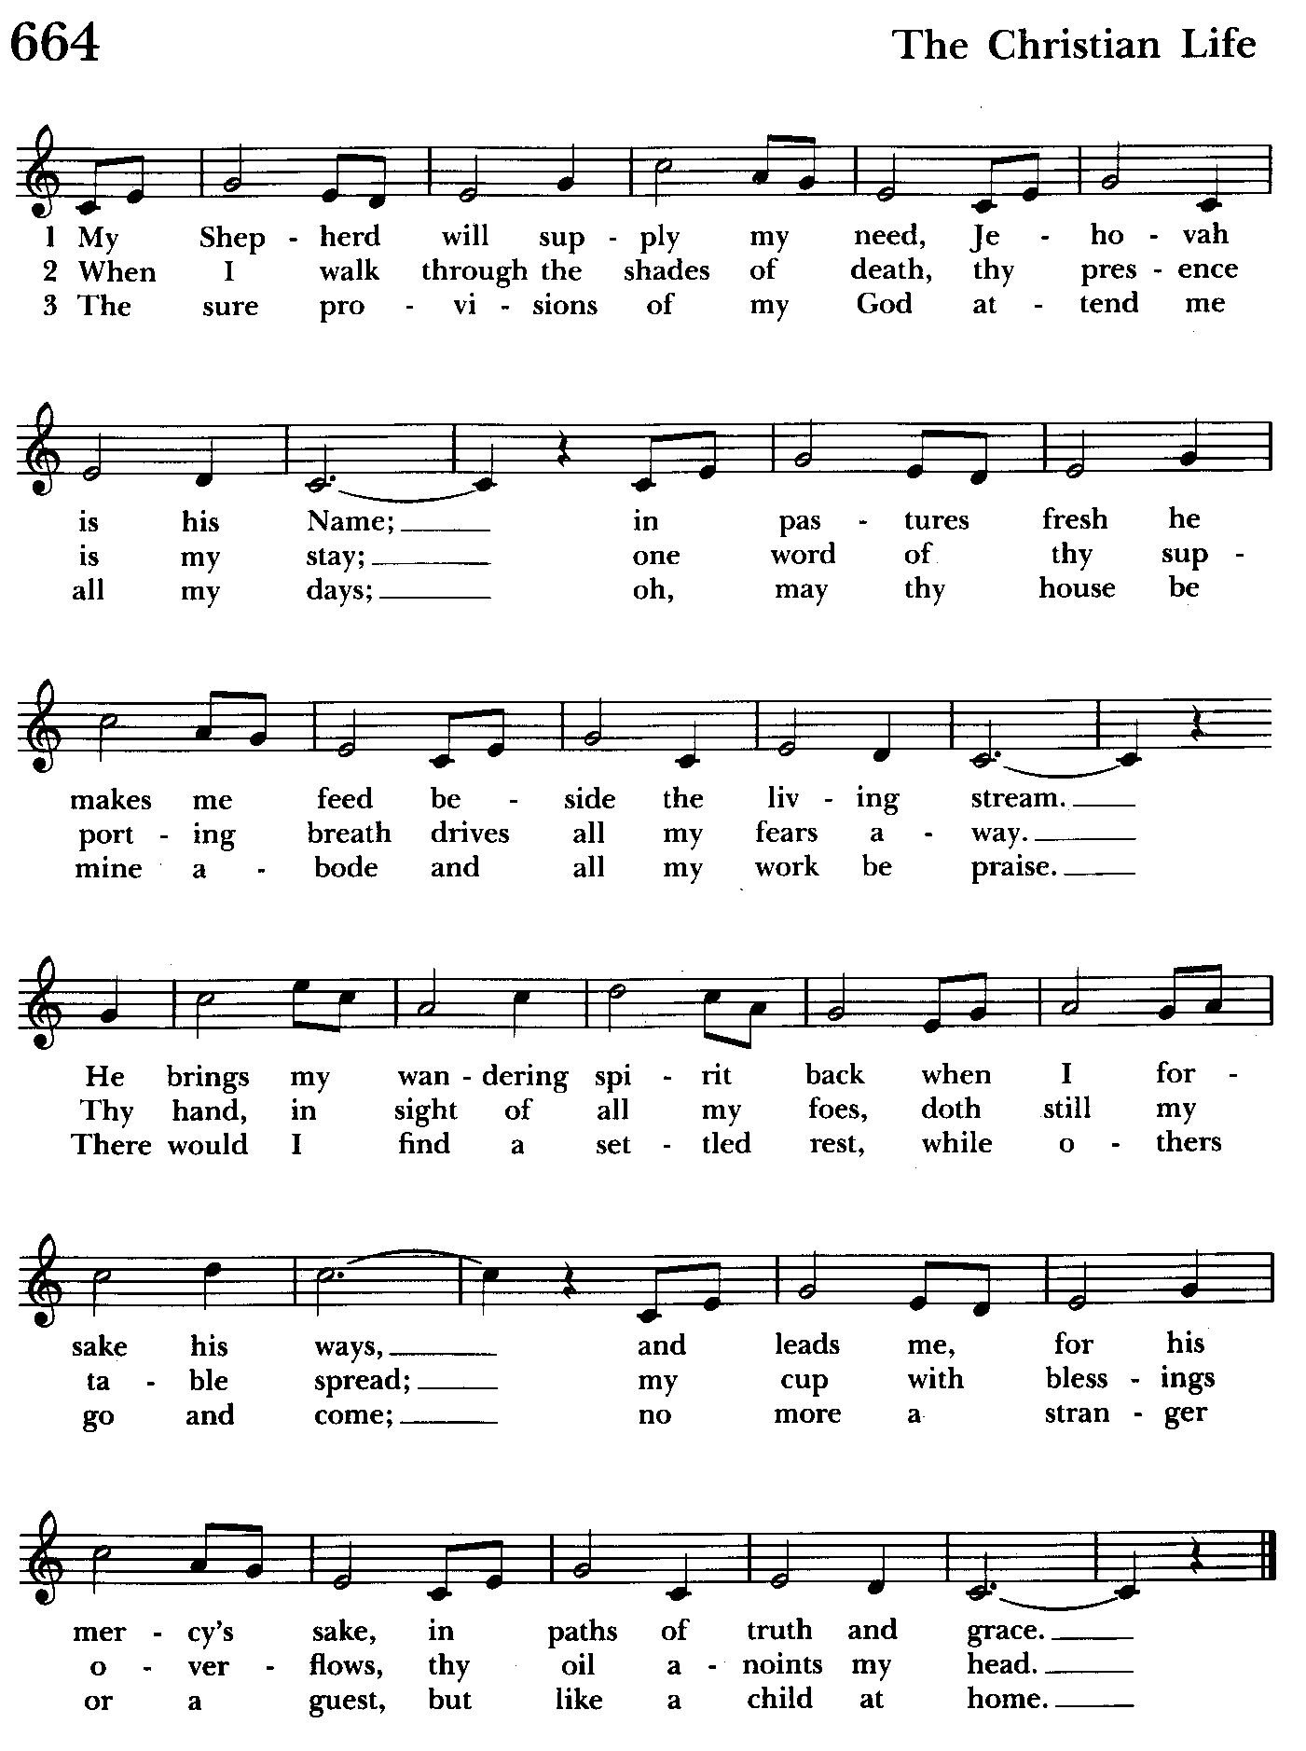

A READING FROM THE GOSPEL OF MARK 6:30-34, 53-56
The apostles gathered around Jesus, and told him all that they had done and taught. He said to them, “Come away to a deserted place all by yourselves and rest a while.” For many were coming and going, and they had no leisure even to eat. And they went away in the boat to a deserted place by themselves. Now many saw them going and recognized them, and they hurried there on foot from all the towns and arrived ahead of them. As he went ashore, he saw a great crowd; and he had compassion for them, because they were like sheep without a shepherd; and he began to teach them many things.
When they had crossed over, they came to land at Gennesaret and moored the boat. When they got out of the boat, people at once recognized him, and rushed about that whole region and began to bring the sick on mats to wherever they heard he was. And wherever he went, into villages or cities or farms, they laid the sick in the marketplaces, and begged him that they might touch even the fringe of his cloak; and all who touched it were healed.

The Word of the Lord.
Thanks be to God.

Please be seated

Homily Ty Schwenk

THE APOSTLES CREED BCP pg. 53
Said by all, standing as you are able.
I believe in God, the Father almighty,
maker of heaven and earth;
And in Jesus Christ his only Son our Lord;
who was conceived by the Holy Ghost,
born of the Virgin Mary,
suffered under Pontius Pilate,
was crucified, dead, and buried.
He descended into hell.
The third day he rose again from the dead.
He ascended into heaven,
and sitteth on the right hand of God the Father almighty.
From thence he shall come to judge the quick and the dead.
I believe in the Holy Ghost,
the holy catholic Church,
the communion of saints,
the forgiveness of sins,
the resurrection of the body,
and the life everlasting. Amen.

THE LORD’S PRAYER Stand or kneel as able BCP pg. 54

The Lord be with you.
And also with you.
Let us pray.
Officiant and People
Our Father, who art in heaven,
hallowed be thy Name,
thy kingdom come,
thy will be done,
on earth as it is in heaven.
Give us this day our daily bread.
And forgive us our trespasses,
as we forgive those who trespass against us.
And lead us not into temptation,
but deliver us from evil.
For thine is the kingdom,
and the power, and the glory,
forever and ever. Amen.

THE SUFFRAGES – Form B BCP pg. 55
O Lord, save thy people, and bless thine heritage;
Govern them and lift them up for ever.
Day by day we magnify thee;
And we worship thy Name ever, world without end.
Vouchsafe, O Lord, to keep us this day without sin
O Lord, have mercy upon us, have mercy mercy upon us.
O Lord, let thy mercy be upon us;
As our trust is in thee.
O Lord, in thee have I trusted;
Let me never be confounded.

THE COLLECT OF THE DAY BCP pg. 179
Almighty God, the fountain of all wisdom, who knowest our necessities before we ask and our ignorance in asking: Have compassion, we beseech thee, upon our infirmities, and those things which for our unworthiness we dare not, and for our blindness we cannot ask, mercifully give us for the worthiness of thy Son Jesus Christ our Lord; who liveth and reigneth with thee and the Holy Spirit, one God, now and for ever. Amen.

A COLLECT FOR SUNDAYS BCP pg. 56
O God, who makest us glad with the weekly remembrance of the glorious resurrection of thy Son our Lord: Grant us this day such blessing through our worship of thee, that the days to come may be spent in thy favor; through the same Jesus Christ our Lord. Amen.

A PRAYER FOR MISSION
Almighty and everlasting God, by whose Spirit the whole body of thy faithful people is governed and sanctified: Receive our supplications and prayers which we offer before thee for all members of thy holy Church, that in their vocation and ministry they may truly and godly serve thee; through our Lord and Savior Jesus Christ. Amen.

THE PRAYERS OF THE PEOPLE – Form III BCP pg. 387
Father, we pray for your holy Catholic Church;
That we all may be one.

Grant that every member of the Church may truly and humbly serve you;
That your Name may be glorified by all people.

We pray for all bishops, priests, and deacons;
That they may be faithful ministers of your Word and Sacraments.

We pray for all who govern and hold authority in the nations of the world;
That there may be justice and peace on the earth.

Give us grace to do your will in all that we undertake;
That our works may find favor in your sight.

Have compassion on those who suffer from any grief or trouble;
That they may be delivered from their distress.

Give to the departed eternal rest;
Let light perpetual shine upon them.
.
We praise you for your saints who have entered into joy;
May we also come to share in your heavenly kingdom.
.Let us pray for our own needs and those of others.
.
We Pray for Those in Need:
Names in BOLD read aloud by all.

DeMarino Family, Jim & Chris Carden and family, Peggie Dietz, Mike Carden, Pat Carden, Gail Landers, Sheila Jones, Gloria Millar, Marisol Aubrey, Amelia Bell, Linda and Allan Urban, Ross Strickler.

We Pray for our Homebound

Lily John, Barbara Miller, Nancy Barnhart, Robin Dilworth

We pray for the repose of the soul of Charlene Taylor Dilworth.

We pray for the Church and the World:

For +Justin, Archbishop of Canterbury; for +Michael, our Presiding Bishop, for +Carrie, our Bishop, for Mark+, our Interim Rector, for the Wardens, Vestry, Staff, and all members and friends of St. John’s Church.

For the leaders of all nations, especially for Joseph, our President; for Wes, our Governor; for Brandon, Nick, John and Bob, who lead our City and Counties. We pray for all children and youth; for the homeless, the unemployed, and the hungry. We pray for the safety of our loved ones and friends serving in the Armed Forces at home and abroad, and for our enemies, that all our hearts may be turned toward peace throughout the world.

A period of silence follows after which the officiant concludes with the following prayer
Lord, hear the prayers of your people; and what we have asked faithfully, grant that we may obtain effectually, to the glory of your Name; through Jesus Christ our Lord. Amen.

THE GENERAL THANKSGIVING
Officiant and People
Almighty God, Father of all mercies,
we thine unworthy servants
do give thee most humble and hearty thanks
for all thy goodness and loving-kindness
to us and to all men.
We bless thee for our creation, preservation,
and all the blessings of this life;
but above all for thine inestimable love
in the redemption of the world by our Lord Jesus Christ, for the means of grace, and for the hope of glory.

And, we beseech thee,
give us that due sense of all thy mercies,
that our hearts maybe unfeignedly thankful;
and that we show forth thy praise,
not only with our lips, but in our lives,
by giving up our selves to thy service,
and by walking before thee
in holiness and righteousness all our days;
through Jesus Christ our Lord,
to whom, with thee and the Holy Ghost,
be all honor and glory, world without end. Amen.

The congregation is seated

Offertory Hymn: Shepherd of souls, refresh and bless Hymnal #343
(see next page)

THE OFFERTORY
The people are seated while an offering is collected to support God’s mission here at St. John’s Church and in the world.
.
All stand. The officiant says to the people
Officiant: All things come of thee, O Lord;
People: And of thine own have we given thee. Amen.

Closing Hymn: Christ is made the sure foundation Hymnal #518
(see page 18)

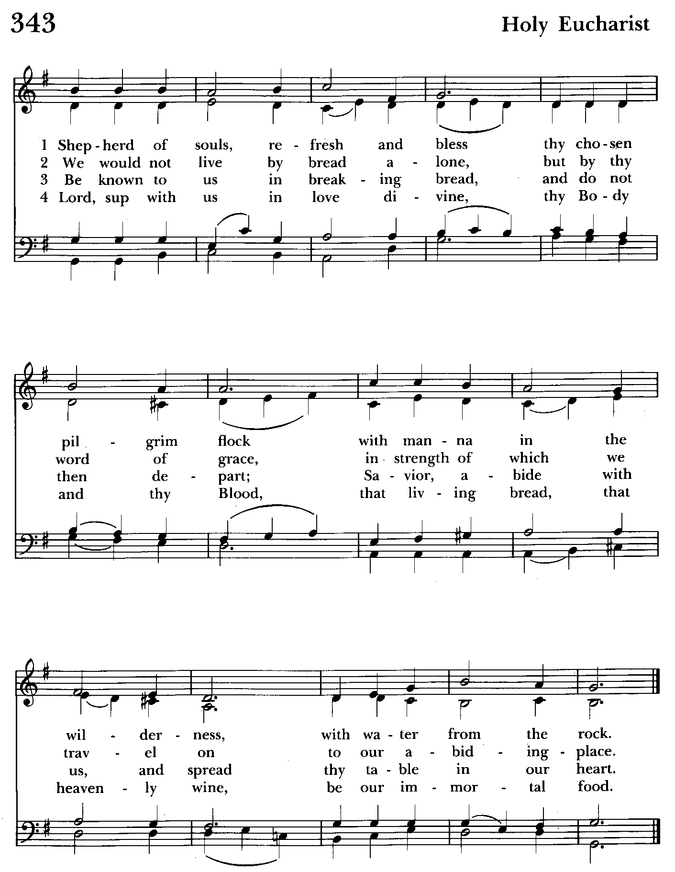

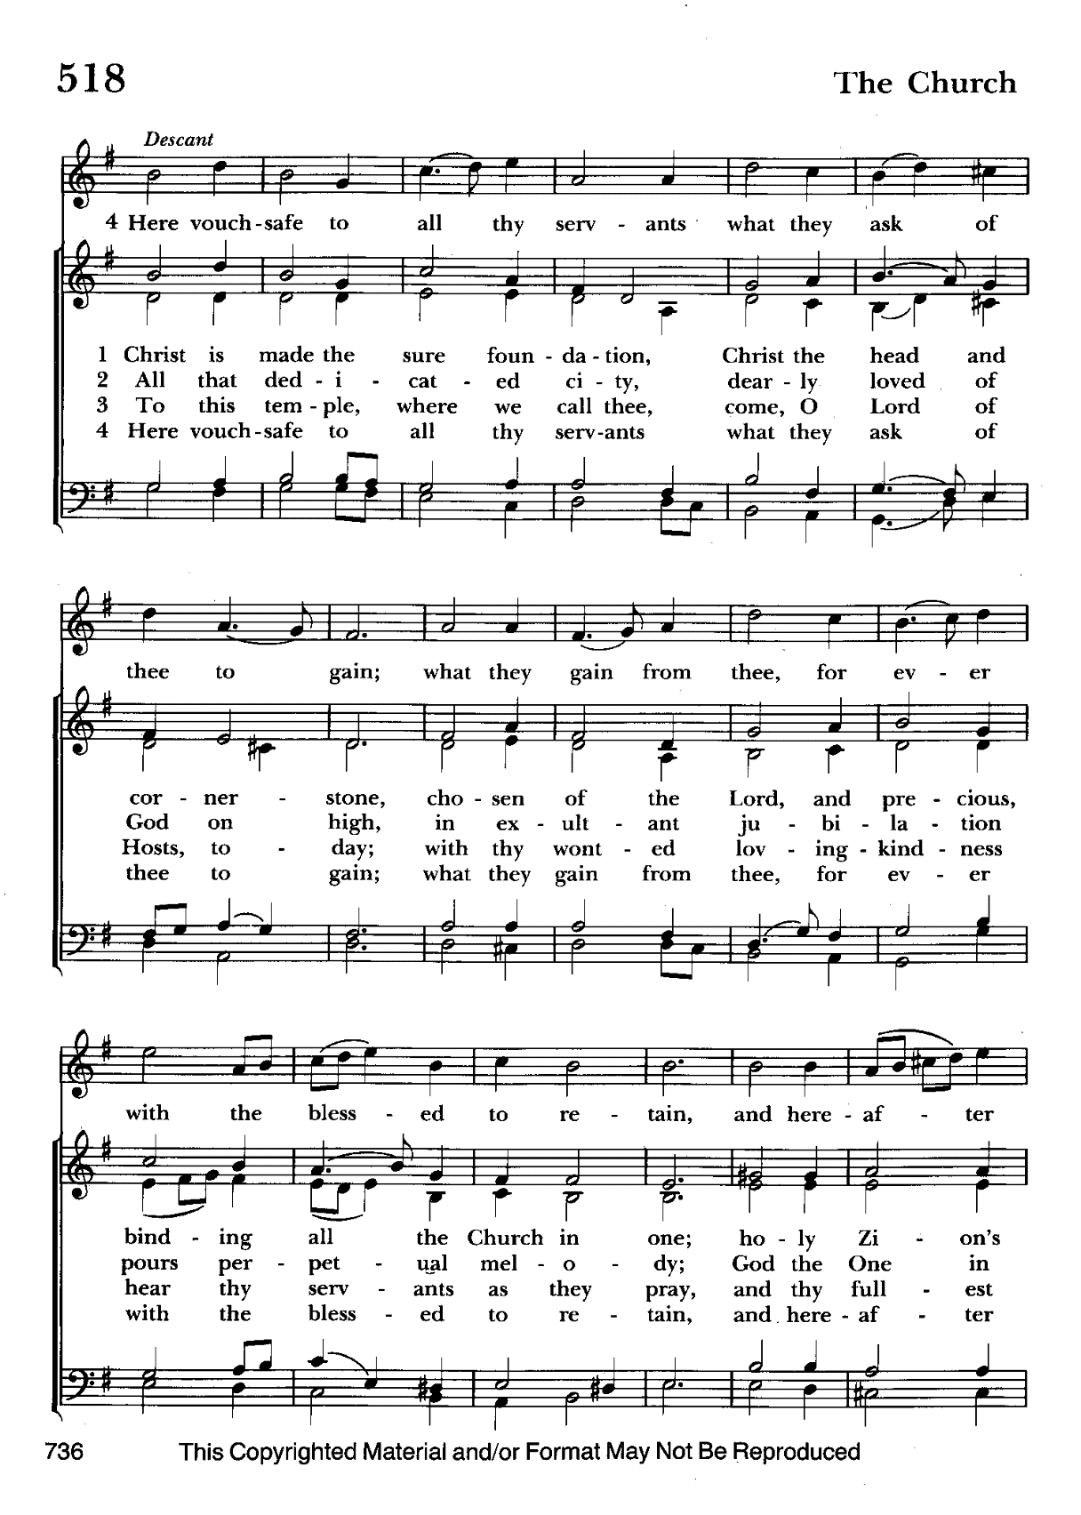

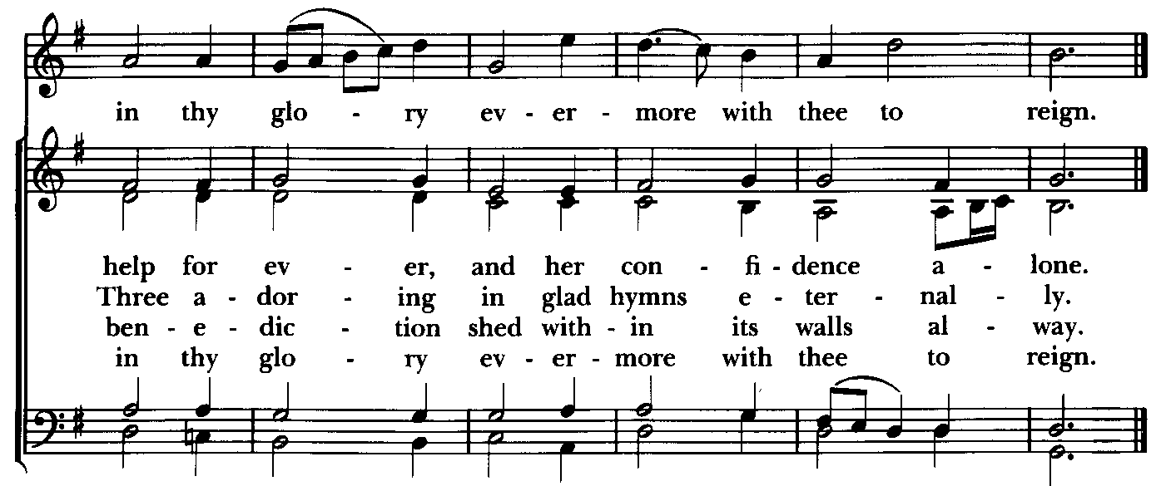

THE DISMISSAL
Let us bless the Lord.
Thanks be to God.
The grace of our Lord Jesus Christ, the love of God, and the fellowship of the Holy Ghost, be with us all evermore. Amen.

Serving Today

Officiant: Ty Schwenk
Old Testament: Woodie Tingle
Psalm: John Stevens
New Testament: Anne Leland
Prayers of the People: Debbie Weaver
Altar Guild: Liz Healey & Marguerite Lobb


Altar Flowers

Given to the Glory of God
by

From the Treasurer
July ’24 Income vs. Expenses:
Projected July Expenses: $13,500
Monies Received as of 7/18: $8,297
Amount Needed to Meet Expenses: $5,203


If you’d like to make a donation to St. John’s you can scan this QR code with your phone’s camera or tap on the link that comes up to make a contribution with either a credit or debit card, Apple Pay or Google Pay. This is a secure site provided by Clover which is a service of PNC Bank.

Choral Choir and Bell Choir
Choir and Bell Choir are off for the summer. See you in September.
SUNDAY SCHOOL
Sunday School is over for the year. We will reconvene in September.


With so much going on, everyone’s help is needed to make things a success. Our volunteers make the Church function. The volunteering of time and talent is greatly appreciated.


Yoga classes on Tuesday, Wednesday and Friday evenings 6 to 7 pm and Saturday mornings 9 to 10 am in the Chapel. All experience levels are welcome.
There will be no Yoga classes from July 5 thru 20. They will resume on July 23.

OUTREACH

The FOOD PANTRY is in need of immediate donations. All donations welcome, food or monetary. Thank you so much.
Needed at this time: spaghetti, spaghetti sauce,
jelly/jam

Calendar Updates

Vestry Meetings– The summer vestry meetings will be held on June 25 and August 6 in our parish hall at 7:00 pm.

Summer services- We will temporarily go to one service on a Sunday at 9:30 a.m. from 7/7 to 8/25. Most will be Holy Eucharist.

Morning Prayer- will be offered on the following Sundays: 7/21, 8/25, 9/8, 9/29, 10/13, 11/10, 12/8, 12/29. Lay people are highly encouraged to consider helping by officiating and/or preaching of Morning Prayer. I am willing to help you prepare for this.

Would it be helpful to have an “Officiating Morning Prayer” class? Let me know.

Blessing of the Animals- 9:30 a.m. (between the services) on Sunday 10/6.

All Souls service- Sunday evening 7:00 11/3.

Blue Christmas/Service of Solace- TBD

Calendars are living documents. Every effort will be made to keep the members of the parish and community aware of any changes.

SAVE THE DATE
Bingo - 8/16
Flea Market 9/21
Christmas Bazaar - 11/23


God’s Grace Gardens—a St. John’s and Hill & Stream
Garden Club and AA collaboration

Many thanks to the 16 volunteers who helped our first work day be such a success. Check out Councilman Mark’s Facebook page for photos!

For more info or to sign up to help keep our gardens looking beautiful, contact: Rita Talley-Garden Club or Karen Smith-Manar-St. John’s 410-746-9813 or bikenbocal@verizon.net

In our Community

Bible Studies in our area. If interested, please contact these churches to confirm.
St. Mary’s, Abingdon, (410)569-0180- Wednesdays at noon. Bring lunch. Zoom available.
Emmanuel, Bel Air, (410)838-7699- Fridays at 9:30- Zoom Available.
Holy Trinity, Churchville, (410)914-5531- Wednesdays 11:30- Zoom may be available.

Jerusalem Mill Summer Concert Series– scan QR code.

RECYCLING!
By popular demand, we are recycling. Some parishioners take printed paper home where they have recycling pickup. We now have a blue container located in the Parish Hall. This will be collected and taken for recycling. Aluminum cans will be saved and taken to a recycling center for cash. The proceeds will be donated to the Outreach fund. Each recycled aluminum can also save on the electricity needed to make new aluminum from bauxite.

What’s Happening This Week at St. John’s

Sunday, July 21—MORNING PRAYER-9th Sunday after Pentecost
9:30am: Morning Prayer, Rite I (Church)
11:30am: Coffee Hour (Parish Hall)

Monday, July 22
12:00-1:00pm: AA Lunch Bunch (Parish Hall)
7:00-8:30pm: Spanish speaking AA group (Parish Hall)

Tuesday, July 23
12:00-1:00pm: AA Lunch Bunch (Parish Hall)
6:00-7:00pm: Yoga (Chapel)

Wednesday, July 24
12:00-1:00pm: AA Lunch Bunch (Parish Hall)
6:00-7:00pm: Yoga (Chapel)
7:30pm: AA (Parish Hall)

Thursday, July 25
12:00-1:00pm: AA Lunch Bunch (Parish Hall)
7:00pm: AA (Parish Hall)

Friday, July 26
12:00-1:00pm: AA Lunch Bunch (Parish Hall)

Saturday, July 27
8:30pm: AA (Parish Hall)

Sunday, July 28—10th Sunday after Pentecost
9:30am: Holy Eucharist, Rite I (Church)
11:30am: Coffee Hour (Parish Hall)

Parish Office is open Monday, Wednesday and Thursday, 9:30am-1:30pm.

Potluck Luncheon on the first Sunday of the month and a Coffee Hour on all other Sundays after the 10:30 service.

