St. John’s Episcopal Church
Kingsville, Maryland
Welcomes You

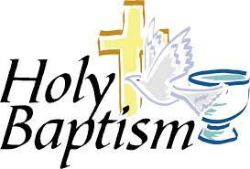

The Baptism of Reid Persing
8th Sunday after Pentecost
July 14, 2024

St. John’s Episcopal Church

11901 Belair Road, P. O. Box 187, Kingsville, MD 21087
Facebook: St. John’s Episcopal, Kingsville, MD
Email: office@stjohnskingsville.org
Website: www.stjohnskingsville.org
Church Phone: 410-592-8570
For Pastoral Emergencies: Fr. Mark Lobb+ 443-690-9545

Welcome to worship today! We are glad that you are with us. You are invited to participate in all parts of the service as indicated in the Book of Common Prayer and this service bulletin. If you have any questions, feel free to ask the ushers. Restrooms are located in the Parish hall, the brick building across the parking lot.

I was glad when they said to me, “Let us go to the house of the Lord.” Psalm 122:1

Church Staff

Interim Rector: Father Mark Lobb
Administrative Assistant: Angie Bosley
Organist/Choir Director: Nancy Heinold

The Vestry

Class of 2025 Class of 2026

John Frost John Stevens
Woodie Tingle
Jacob Johnson

Officers
Ty Schwenk—Sr. Warden Terry Roe—Jr. Warden
Elizabeth Healey—Treasurer Anne Leland-Registrar

Parish Committee Chairpersons

Altar Guild: Elizabeth Healey
Auxiliary Committee: Michele Lozanski
Cemetery Committee: Terry Roe

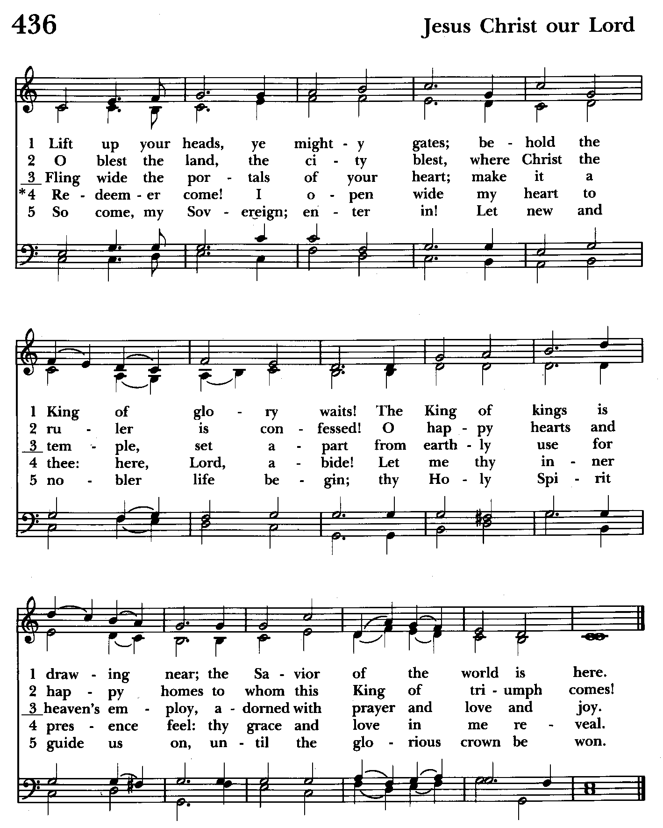

HOLY BAPTISM

Processional Hymn: Lift up your heads, ye mighty gates Hymnal #436
(see previous page)

Celebrant: Blessed be God: Father, Son, and Holy Spirit.
People: And blessed be his kingdom, now and for ever. Amen.

Celebrant: There is one Body and one Spirit;
People: There is one hope in God’s call to us;
Celebrant: One Lord, one Faith, one Baptism;
People: One God and Father of all.

Celebrant: The Lord be with you.
People: And also with you.
Celebrant: Let us pray.

The Collect of the Day BCP p. 231
O Lord, mercifully receive the prayers of your people who call upon you, and grant that they may know and understand what things they ought to do, and also may have grace and power faithfully to accomplish them; through Jesus Christ our Lord, who lives and reigns with you and the Holy Spirit, one God, now and for ever. Amen.

The Lessons
The people sit.

A Reading from the Book of the Prophet Ezekiel 36:24-28
Say to the house of Israel, Thus says the Lord God: I will take you from the nations, and gather you from all the countries, and bring you into your own land. I will sprinkle clean water upon you, and you shall be clean from all your uncleannesses, and from all your idols I will cleanse you. A new heart I will give you, and a new spirit I will put within you; and I will remove from your body the heart of stone and give you a heart of flesh. I will put my spirit within you, and make you follow my statutes and be careful to observe my ordinances. Then you shall live in the land that I gave to your ancestors; and you shall be my people, and I will be your God.

Reader: The Word of the Lord.
People: Thanks be to God.
Psalm 23
1 The Lord is my shepherd; *
I shall not be in want.
2 He makes me lie down in green pastures *
and leads me beside still waters.
3 He revives my soul *
and guides me along right pathways for his Name's sake.
4 Though I walk through the valley of the shadow of death,
I shall fear no evil; *
for you are with me;
your rod and your staff, they comfort me.
5 You spread a table before me in the presence of those who trouble me; *
you have anointed my head with oil,
and my cup is running over.
6 Surely your goodness and mercy shall follow me all the days of my life, *
and I will dwell in the house of the Lord for ever.

A Reading from the Second Letter of St. Paul to the Corinthians 5:17-20
If anyone is in Christ, there is a new creation: everything old has passed away; see, everything has become new! All this is from God, who reconciled us to himself through Christ, and has given us the ministry of reconciliation; that is, in Christ God was reconciling the world to himself, not counting their trespasses against them, and entrusting the message of reconciliation to us. So we are ambassadors for Christ, since God is making his appeal through us; we entreat you on behalf of Christ, be reconciled to God.

Reader: The Word of the Lord.
People: Thanks be to God.

Gradual Hymn: Baptized in water Hymnal #294
(see next page)

The Gospel
Celebrant: The Holy Gospel of our Lord Jesus Christ according to Mark 10:13-16
People: Glory to you, Lord Christ.
People were bringing little children to Jesus in order that he might touch them; and the disciples spoke sternly to them. But when Jesus saw this, he was indignant and said to them, “Let the little children come to me; do not stop them; for it is to such as these that the kingdom of God belongs. Truly I tell you, whoever does not receive the kingdom of God as a little child will never enter it.” And he took them up in his arms, laid his hands on them, and blessed them.

Celebrant: The Gospel of the Lord.
People: Praise to you, Lord Christ.

The Sermon The Rev. Mark Lobb+

Presentation and Examination of the Candidate BCP p. 301
Celebrant: The Candidate for Holy Baptism will now be presented.
The candidates who are unable to answer for themselves are presented individually by their Parents and Godparents, as follows

Parents and Godparents: I present Reid to receive the Sacrament of Baptism.
Celebrant: Will you be responsible for seeing that the child you present is brought up in the Christian faith and life?
Parents and Godparents: I will, with God's help.

Celebrant: Will you by your prayers and witness help this child to grow
into the full stature of Christ?
Parents and Godparents: I will, with God's help.

Celebrant: Do you renounce Satan and all the spiritual forces of wickedness that rebel against God?
Parents and Godparents: I renounce them.

Celebrant: Do you renounce the evil powers of this world which corrupt and destroy the creatures of God?
Parents and Godparents: I renounce them.

Celebrant: Do you renounce all sinful desires that draw you from the love of God?
Parents and Godparents: I renounce them.

Do you turn to Jesus Christ and accept him as your Savior:
Parents and Godparents: I do.

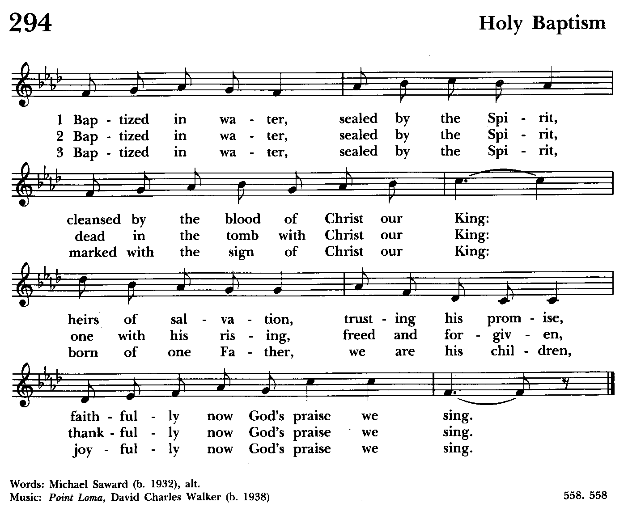

Please remain standing as able

Celebrant: Do you put your whole trust in his grace and love?
Parents and Godparents: I do.

Celebrant: Do you promise to follow and obey him as your Lord?
Parents and Godparents: I do.

Celebrant: Will you who witness these vows do all in your power to support these persons in their life in Christ?
People: We will.
Celebrant: Let us join with those who are committing themselves to Christ and renew our own baptismal covenant.

The Baptismal Covenant
Celebrant: Do you believe in God the Father?
People: I believe in God, the Father almighty, creator of heaven and earth.

Celebrant: Do you believe in Jesus Christ, the Son of God?
People: I believe in Jesus Christ, his only Son, our Lord. He was conceived by the power of the Holy Spirit and born of the Virgin Mary. He suffered under Pontius Pilate, was crucified, died, and was buried. He descended to the dead. On the third day he rose again. He ascended into heaven, and is seated at the right hand of the father. He will come again to judge the living and the dead.

Celebrant: Do you believe in God the Holy Spirit?
People: I believe in the Holy Spirit, the holy catholic Church, the communion of saints, the forgiveness of sins, the resurrection of the body, and the life everlasting.

Celebrant: Will you continue in the apostles’ teaching and fellowship, in the breaking of the bread, and in the prayers?
People: I will, with God’s help.

Celebrant: Will you persevere in resisting evil, and, whenever you fall into sin, repent and return to the Lord?
People: I will, with God’s help.

Celebrant: Will you proclaim by word and example the Good News of God in Christ?
People: I will, with God’s help.

Celebrant: Will you seek and serve Christ in all persons, loving your neighbor as yourself?
People: I will, with God’s help.

Celebrant: Will you strive for justice and peace among all people, and respect the dignity of every human being.
People: I will, with God’s help.
Prayers for the Candidates
Celebrant: Let us now pray for Reid who is to receive the Sacrament of new birth.

Leader: Deliver him, O Lord, from the way of sin and death.
People: Lord, hear our prayer.
Leader: Open his hearts to your grace and truth.
People: Lord, hear our prayer.
Leader: Fill him with your holy and life-giving Spirit.
People: Lord, hear our prayer.
Leader: Keep him in the faith and communion of your holy Church.
People: Lord, hear our prayer.
Leader: Teach him to love others in the power of the Spirit
People: Lord, hear our prayer.
Leader: Send him into the world in witness to your love.
People: Lord, hear our prayer.
Leader: Bring him to the fullness of your peace and glory.
People: Lord, hear our prayer.

Celebrant: Grant, O Lord, that all who are baptized into the death of Jesus Christ your Son may live in the power of his resurrection and look for him to come again in glory; who lives and reigns now and forever. Amen.

Thanksgiving over the Water
The Celebrant blesses the water, first saying

Celebrant: The Lord be with you.
People: And also with you.
Celebrant: Let us give thanks to the Lord our God.
People: It is right to give him thanks and praise.
Celebrant: We thank you, Almighty God, for the gift of water. Over it the Holy Spirit moved in the beginning of creation. Through it you led the children of Israel out of their bondage in Egypt into the land of promise. In it your Son Jesus received the baptism of John and was anointed by the Holy Spirit as the Messiah, the Christ, to lead us, through his death and resurrection, from the bondage of sin into everlasting life. We thank you, Father, for the water of Baptism. In it we are buried with Christ in his death. By it we share in his resurrection. Through it we are reborn by the Holy Spirit. Therefore in joyful obedience to your Son, we bring into his fellowship those who come to him in faith, baptizing them in the Name of the Father, and of the Son, and of the Holy Spirit.
At the following words, the Celebrant touches the water
Now sanctify this water, we pray you, by the power of your Holy Spirit, that those who here are cleansed from sin and born again may continue for ever in the risen life of Jesus Christ our Savior. To him, to you, and to the Holy Spirit, be all honor and glory, now and for ever. Amen.
The Baptism

The candidate is presented by name to the Celebrant, or to an assisting priest or deacon, who then immerses, or pours water upon, the candidate, saying
Reid, I baptize you in the Name of the Father, and of the Son, and of the Holy Spirit. Amen.
Celebrant: Let us pray.
Heavenly Father, we thank you that by water and the Holy Spirit you have bestowed upon him your servants the forgiveness of sin, and have raised him to the new life of grace. Sustain him, O Lord, in your Holy Spirit. Give him an inquiring and discerning heart, the courage to will and to persevere, a spirit to know and to love you, and the gift of joy and wonder in all your works. Amen.
Then the Priest places a hand on the person's head, marking on the forehead the sign of the cross [using Chrism if desired] and saying to them
Reid, you are sealed by the Holy Spirit in Baptism and marked as Christ's own for ever. Amen.

Celebrant: Let us welcome the newly baptized.
Celebrant and People: We receive you into the household of God. Confess the faith of Christ crucified, proclaim his resurrection, and share with us in his eternal priesthood.

Celebrant: The peace of the Lord be always with you.
People: And also with you.

Celebrant: All praise and thanks to you, most merciful Father, for adopting us as your own children, for incorporating us into your holy Church, and for making us worthy to share in the inheritance of the saints in light; through Jesus Christ your Son our Lord, who lives and reigns with you and the Holy Spirit, one God, for ever and ever. Amen.

Celebrant: Almighty God, the Father, of our Lord Jesus Christ, from whom every family in heaven and earth is named, grant you to be strengthened with might by his Holy Spirit, that, Christ dwelling in your hearts by faith, you may be filled with all the fullness of God. Amen.

The Prayers of the People Form VI Kneel or stand as able BCP 392
Litanist: In peace, we pray to you, Lord God.

Litanist: For all people in their daily life and work;
People: For our families, friends, and neighbors, and for those who are alone.

Litanist: For this community, the nation, and the world;
People: For all who work for justice, freedom, and peace.

Litanist: For the just and proper use of your creation;
People: For the victims of hunger, fear, injustice, and oppression.
Litanist: For all who are in danger, sorrow, or any kind of trouble;
People: For those who minister to the sick, the friendless, and the needy.

Litanist: For the peace and unity of the Church of God;
People: For all who proclaim the Gospel, and all who seek the Truth.

Litanist: For +Justin, Archbishop of Canterbury; +Michael, our Presiding Bishop; +Carrie, our Bishop, +Mark our Interim Rector, for the Wardens, Vestry, Staff, and all members and friends of St. John’s Church.

People: For all who serve God in his Church.

Litanist: For the special needs and concerns of this congregation. Especially
remember in our prayers, DeMarino Family, Jim & Chris Carden and family, Peggie Dietz, Mike Carden, Pat Carden, Gail Landers, Sheila Jones, Gloria Millar, Marisol Aubrey, Amelia Bell, Ross Strickler, Lily John.

The People may add their own petitions

Litanist: Hear us, Lord;
People: For your mercy is great.
Litanist: We thank you, Lord, for all the blessings of this life.

The People may add their own thanksgivings

Litanist: We will exalt you, O God our King;
People: And praise your Name for ever and ever.

Litanist: We pray for all who have died, that they may have a place in your
eternal kingdom.

The People may add their own petitions
Litanist: Lord, let your loving-kindness be upon them;
People: Who put their trust in you.

Litanist: We pray to you also for the forgiveness of our sins.
People: Have mercy upon us, most merciful Father; in your compassion forgive us our sins, known and unknown, things done and left undone; and so uphold us by your Spirit that we may live and serve you in newness of life, to the honor and glory of your Name; through Jesus Christ our Lord. Amen.
The Celebrant gives the absolution.

The Peace Please stand as able BCP 360

Welcome & Announcements The congregation is seated.

Offertory Anthem: This is My Beloved (Choir)

Offertory Hymn: Come thou fount of every blessing Hymnal 686
(see next page)

Offertory: Offerings are collected

Presentation Hymn Offerings are presented Please stand as able Hymnal #43, vs. 4
Praise God, from whom all blessings flow; praise him, all creatures here below; praise him above, ye heavenly host: praise Father, Son, and Holy Ghost.

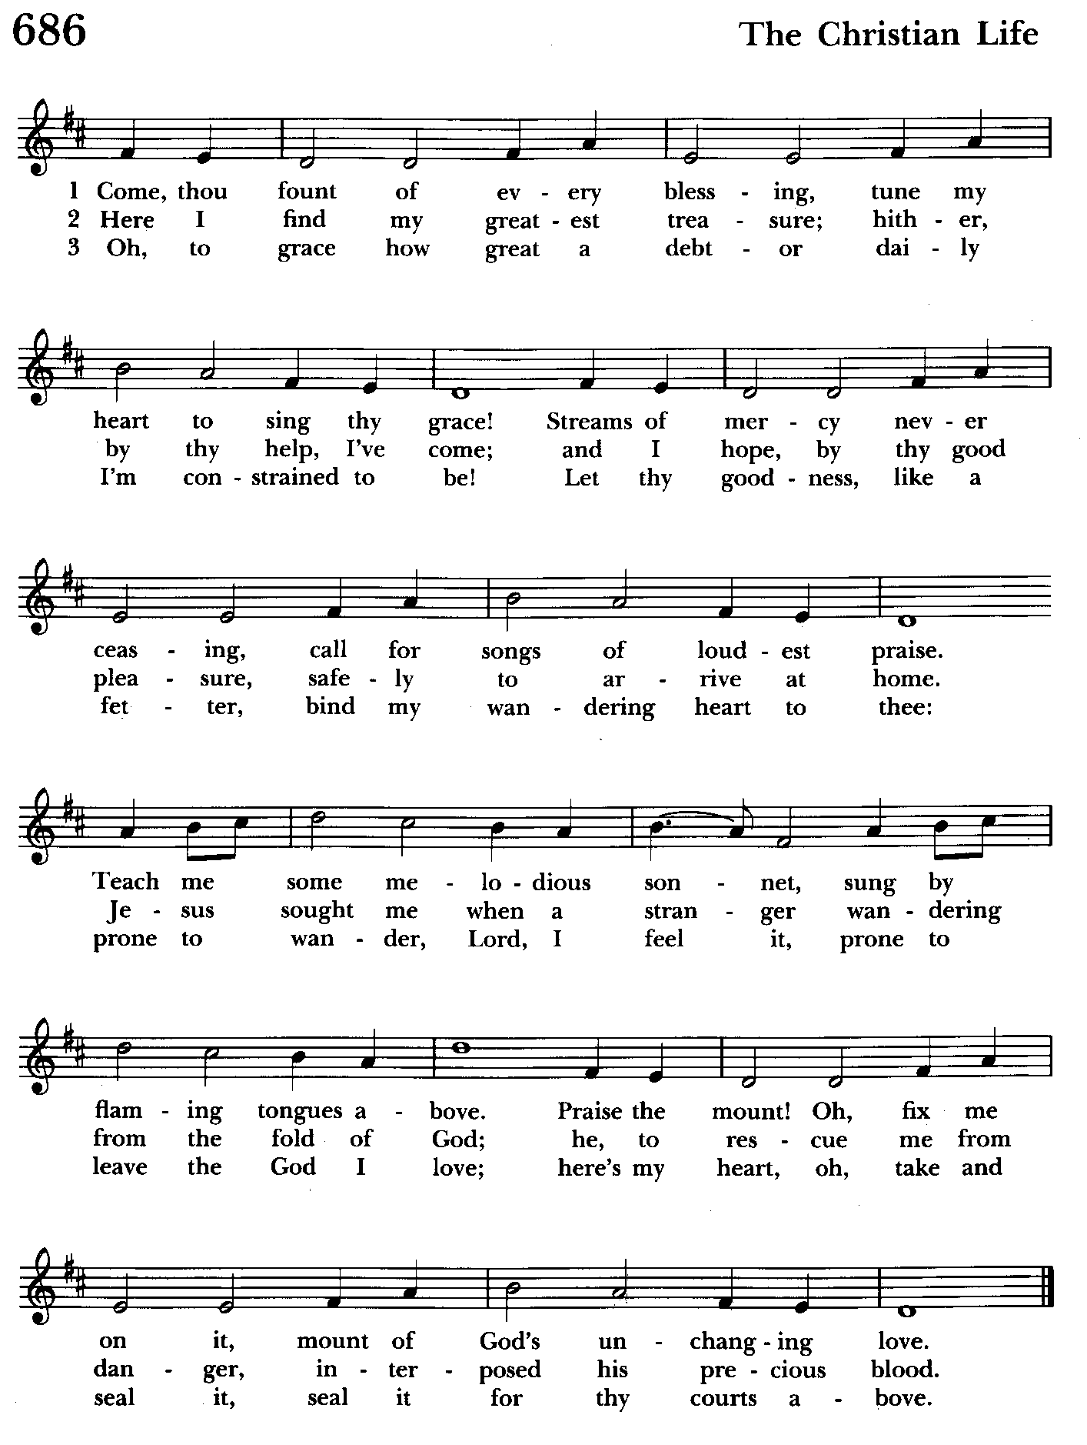

The Holy Communion

THE GREAT THANKSGIVING: Eucharistic Prayer B BCP 367
Celebrant: The Lord be with you.
People: And also with you.
Celebrant: Lift up your hearts.
People: We lift them to the Lord.
Celebrant: Let us give thanks to the Lord our God.
People: It is right to give him thanks and praise.

Then, facing the Holy Table, the Celebrant proceeds
It is right, and a good and joyful thing, always and everywhere to give thanks to you, Father Almighty, Creator of heaven and earth.

Therefore we praise you, joining our voices with Angels and Archangels and with all the company of heaven, who for ever sing this hymn to proclaim the glory of your Name:

Celebrant and People:
Holy, Holy, Holy Lord, God of power and might, Hymnal #S-129
heaven and earth are full of your glory.
Hosanna in the highest.
Blessed is he who comes in the name of the Lord.
Hosanna in the highest.

Please kneel or stand as able

Then the Celebrant continues BCP 368
We give thanks to you, O God, for the goodness and love which you have made known to us in creation; in the calling of Israel to be your people; in your Word spoken through the prophets; and above all in the Word made flesh, Jesus, your Son. For in these last days you sent him to be incarnate from the Virgin Mary, to be the Savior and Redeemer of the world. In him, you have delivered us from evil, and made us worthy to stand before you. In him, you have brought us out of error into truth, out of sin into righteousness, out of death into life.

At the following words concerning the bread, the Celebrant is to hold it, or to lay a hand upon it; and at the words concerning the cup, to hold or place a hand upon the cup and any other vessel containing wine to be consecrated.

On the night before he died for us, our Lord Jesus Christ took bread; and when he had given thanks to you, he broke it, and gave it to his disciples, and said, "Take, eat: This is my Body, which is given for you. Do this for the remembrance of me."

After supper he took the cup of wine; and when he had given thanks, he gave it to them, and said, "Drink this, all of you: This is my Blood of the new Covenant, which is shed for you and for many for the forgiveness of sins. Whenever you drink it, do this for the remembrance of me."

Therefore, according to his command, O Father,

Celebrant and People:
We remember his death,
We proclaim his resurrection,
We await his coming in glory;

The Celebrant continues
And we offer our sacrifice of praise and thanksgiving to you, O Lord of all; presenting to you, from your creation, this bread and this wine. We pray you, gracious God, to send your Holy Spirit upon these gifts that they may be the Sacrament of the Body of Christ and his Blood of the new Covenant. Unite us to your Son in his sacrifice, that we may be acceptable through him, being sanctified by the Holy Spirit. In the fullness of time, put all things in subjection under your Christ, and bring us to that heavenly country where, with St. John and the Blessed Virgin Mary and all your saints, we may enter the everlasting heritage of your sons and daughters; through Jesus Christ our Lord, the firstborn of all creation, the head of the Church, and the author of our salvation.

By him, and with him, and in him, in the unity of the Holy Spirit all honor and glory is yours, Almighty Father, now and for ever. Amen.

And now, as our Savior Christ has taught us, we are bold to say,

Our Father, who art in heaven, BCP p. 364
hallowed be thy Name,
thy kingdom come,
thy will be done,
on earth as in heaven.
Give us this day our daily bread.
And forgive us our trespasses,
as we forgive those
who trespass against us.
And lead us not into temptation,
but deliver us from evil.
For thine is the kingdom,
and the power, and the glory,
for ever and ever. Amen.
Invitation to Communion

The Breaking of the Bread
Celebrant: Alleluia. Christ our Passover is sacrificed for us;
People: Therefore let us keep the feast. Alleluia.
Celebrant: The Gifts of God for the people of God.

The congregation is seated
Communion hymn: Amazing Grace Hymnal #671
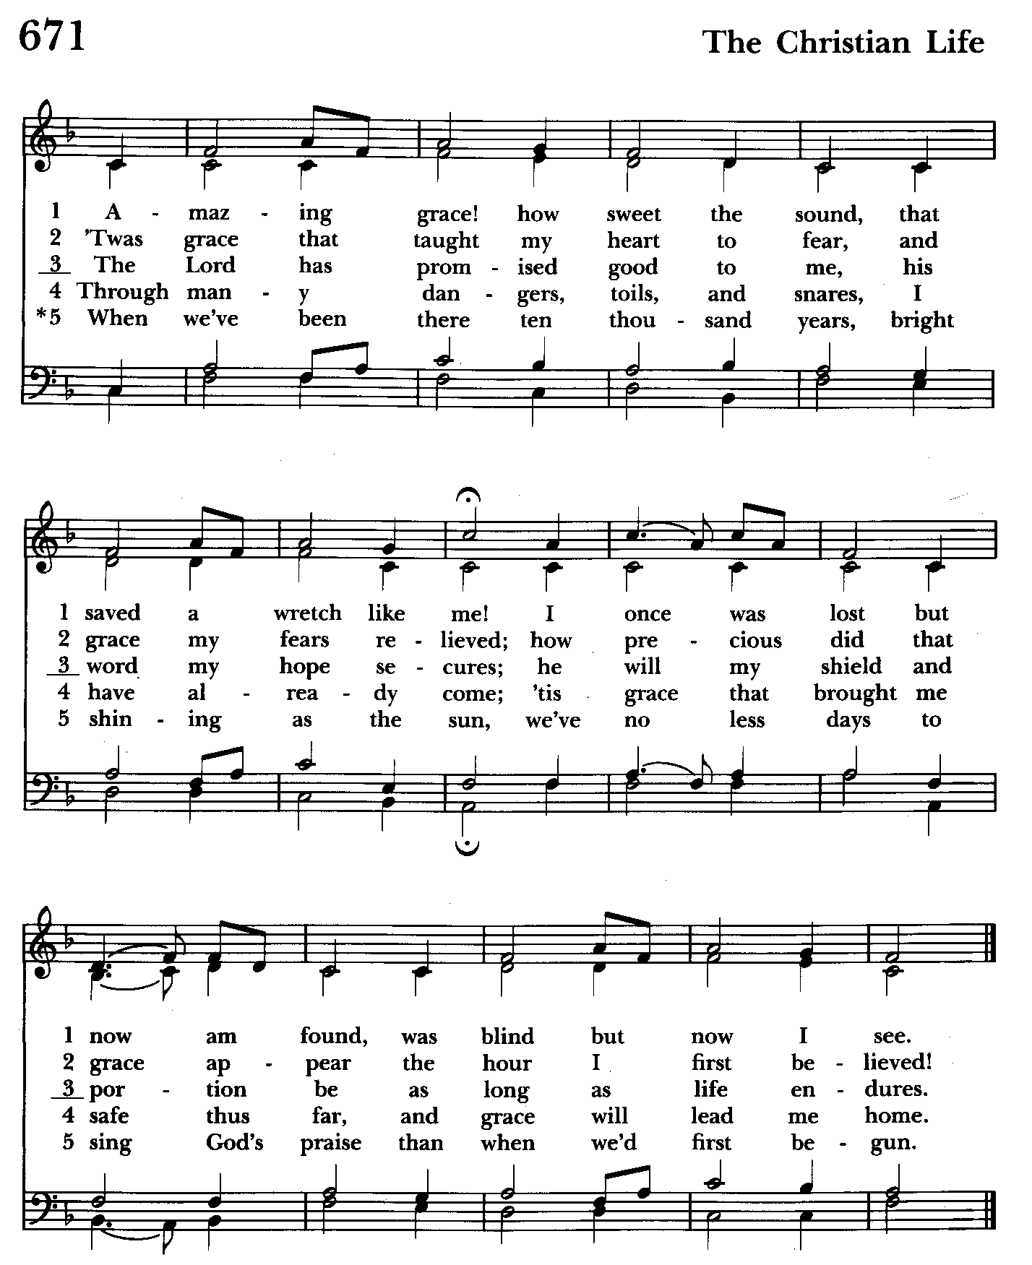

The Post Communion Prayer BCP p. 365
Eternal God, heavenly Father, you have graciously accepted us as living members of your Son our Savior Jesus Christ, and you have fed us with spiritual food in the Sacrament of his Body and Blood. Send us now into the world in peace, and grant us strength and courage to love and serve you with gladness and singleness of heart; through Christ our Lord. Amen.

Blessing

Recessional hymn: Sing ye faithful, sing with gladness Hymnal #492
(see next page)

The Dismissal (The Alleluias are back!)
Celebrant: Let us go forth in the name of the risen Lord.
People: Thanks be to God. Alleluia, alleluia!

License #A-719154

Serving Today

Celebrant and Preacher: The Rev. Mark Lobb
Old Testament: John Stevens
Psalm: John Stevens
New Testament: Liz Healey
Prayers of the People: John Frost
Choir: Anne Leland, Nancy Dellinger, Janine Stevens, Liz Healey, Camy Schwenk, Karen Smith-Manar, Ty Schwenk
Altar Guild: Liz Healey & Marguerite Lobb

Reid’s Parents:
Tyler Persing
Allison Persing

Reid’s Godparents:
Josh Persing
Katie Hogan

“Go therefore and make disciples of all nations, Baptizing them in the name of the Father and of the Son and of the Holy Spirit, and teaching them to obey everything that I have commanded you. And remember, I am with you always, to the end of the age.”

Matthew 28: 19-20

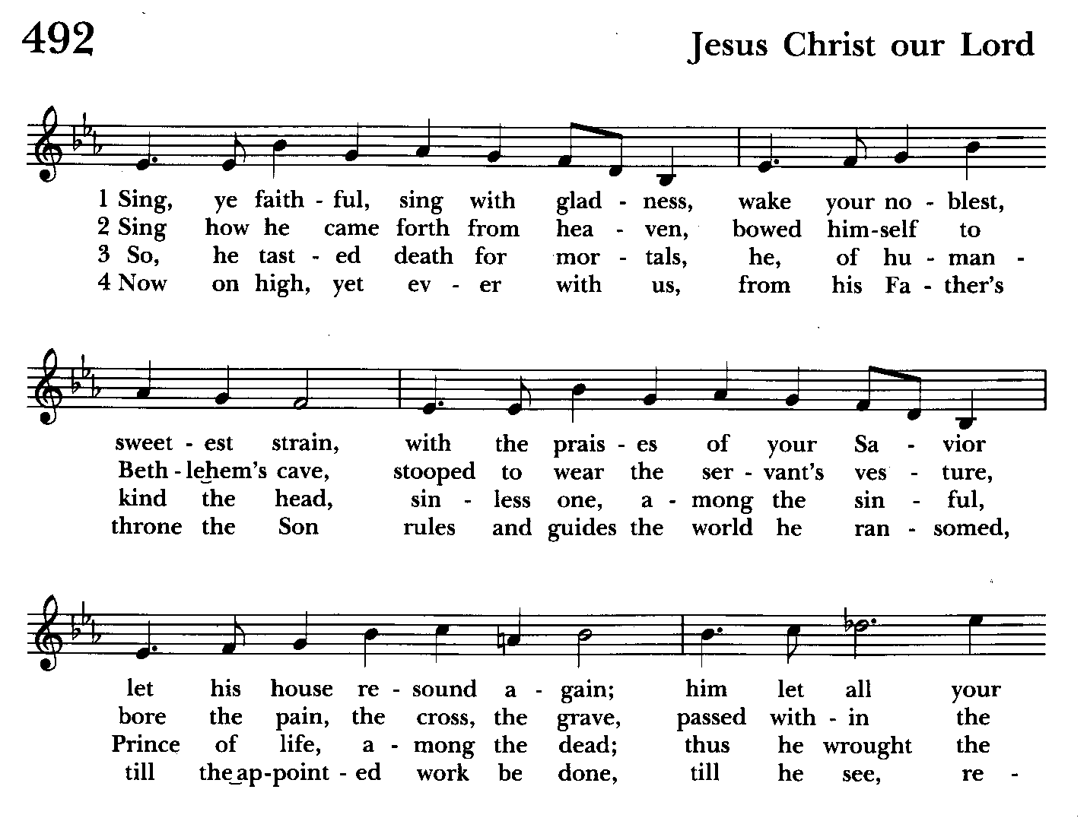

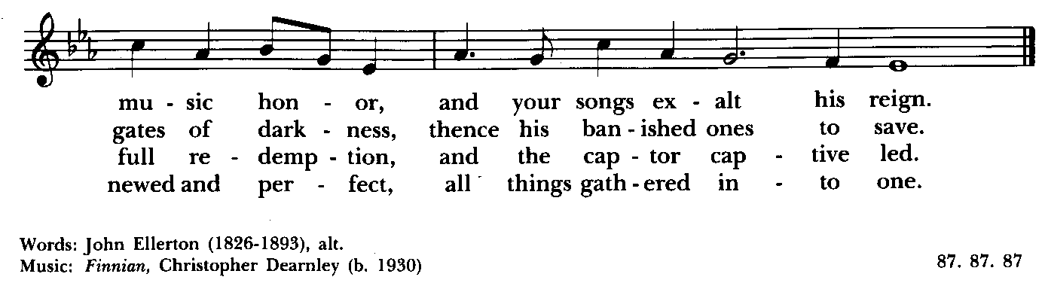

St. John’s Parish Prayer List

Additions and corrections may be made to our Parish Prayer List at any time. All names will be automatically removed from the Parish Prayer List on the 1st Sunday of each month unless you request otherwise. Please contact Angie at <office@stjohnskingsville.org> or 410-592-8570 in the church office with all changes by 10 am Thursdays. Thank you.

We Pray for Those in Need:
Names in BOLD read aloud by all.

DeMarino Family, Jim & Chris Carden and family, Peggie Dietz, Mike Carden, Pat Carden, Gail Landers, Sheila Jones, Gloria Millar, Marisol Aubrey, Amelia Bell, Linda and Allan Urban, Ross Strickler.

We Pray for our Homebound

Lily John, Barbara Miller, Nancy Barnhart, Robin Dilworth

We pray for the repose of the soul of Michael Bailey

We pray for the repose of the soul of Maria Giordano

We pray for the Church and the World:

For +Justin, Archbishop of Canterbury; for +Michael, our Presiding Bishop; for +Carrie, our Bishop, for Mark+, our Interim Rector; for the Wardens, Vestry, Staff, and all members and friends of St. John’s Church.

For the leaders of all nations, especially for Joseph, our President; for Wes, our Governor; for Brandon, Nick, John and Bob, who lead our City and Counties. We pray for all children and youth; for the homeless, the unemployed, and the hungry. We pray for the safety of our loved ones and friends serving in the Armed Forces at home and abroad, and for our enemies, that all our hearts may be turned toward peace throughout the world.


Altar Flowers
Given to the Glory of God
by a Generous Donor in thanksgiving for St. John’s

From the Treasurer
July ’24 Income vs. Expenses:
Projected July Expenses: $13,500
Monies Received as of 7/10: $7.479
Amount Needed to Meet Expenses: $6,021


If you’d like to make a donation to St. John’s you can scan this QR code with your phone’s camera or tap on the link that comes up to make a contribution with either a credit or debit card, Apple Pay or Google Pay. This is a secure site provided by Clover which is a service of PNC Bank.


With so much going on, everyone’s help is needed to make things a success. Our volunteers make the Church function. The volunteering of time and talent is greatly appreciated.


Yoga classes on Tuesday, Wednesday and Friday evenings 6 to 7 pm and Saturday mornings 9 to 10 am in the Chapel.
All experience levels are welcome.
There will be no Yoga classes from July 5 thru 20
They will resume on July 23.

Choral Choir and Bell Choir

Choir and Bell Choir are off for the summer. See you in September.

SUNDAY SCHOOL
Sunday School is over for the year. We will be back in September

Calendar Updates

Vestry Meetings– The summer vestry meeting will be held on August 6 in our parish hall at 7:00 pm.

Summer services- We will temporarily go to one service on a Sunday at 9:30 a.m. from 7/7 to 8/25. Most will be Holy Eucharist.

Morning Prayer- will be offered on the following Sundays: 7/21, 8/25, 9/8, 9/29, 10/13, 11/10, 12/8, 12/29. Lay people are highly encouraged to consider helping by officiating and/or preaching of Morning Prayer. I am willing to help you prepare for this.

Would it be helpful to have an “Officiating Morning Prayer” class? Let me know.

Blessing of the Animals- 9:30 a.m. (between the services) on Sunday 10/6.

All Souls service- Sunday evening 7:00 11/3.

Blue Christmas/Service of Solace- TBD

Calendars are living documents. Every effort will be made to keep the members of the parish and community aware of any changes.

SAVE THE DATE
Flea Market 9/21
Bingo 10/18
Christmas Bazaar - 11/23

RECYCLING!

By popular demand, we are recycling. Some parishioners take printed paper home where they have recycling pickup. We now have a blue container located in the Parish Hall. This will be collected and taken for recycling. Aluminum cans will be saved and taken to a recycling center for cash. The proceeds will be donated to the Outreach fund. Each recycled aluminum can also save on the electricity needed to make new aluminum from bauxite.

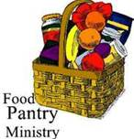
OUTREACH
The FOOD PANTRY is in need of immediate
donations. All donations welcome, food or
monetary. Thank you so much.
Needed at this time: spaghetti, spaghetti sauce
jelly/jam


God’s Grace Gardens—a St. John’s and Hill & Stream
Garden Club and AA collaboration

Many thanks to the 16 volunteers who helped our first work day be such a success. Check out Councilman Mark’s Facebook page for photos!

For more info or to sign up to help keep our gardens looking beautiful, contact: Rita Talley-Garden Club or Karen Smith-Manar-St. John’s 410-746-9813 or bikenbocal@verizon.net

In our Community

Bible Studies in our area. If interested, please contact these churches to confirm.
St. Mary’s, Abingdon, (410)569-0180- Wednesdays at noon. Bring lunch. Zoom available.
Emmanuel, Bel Air, (410)838-7699- Fridays at 9:30- Zoom Available.
Holy Trinity, Churchville, (410)914-5531- Wednesdays 11:30- Zoom may be available.

Jerusalem Mill Summer Concert Series– see next page.

THANK YOU VOLUNTEERS and CONTRIBUTORS!!

St. John’s hosted the Kingsville community for the best attended
Independence Day celebration yet! It could not have happened without our teams of 30 volunteers and many contributors.

I wish everyone could have seen:

The hundreds of thankful looks for free cold water and a cool place to rest

The kid and grownup smiles of joy as they rang our bell to celebrate
America’s freedom

The many requests to take time to pray in the peaceful 1817 Chapel

The wide-eyed wonder of visitors who took a tour of our beautiful Stone Church Stained Glass and heard the story of Jesus

The surprise and joy of the children who sat on the bench of our historic Moeller organ and heard “America” play out loud and clear.


Yes friends, it was wonderful day. And many, many visitors said that St. John’s was a wonderfully welcoming place. Thanks be to God.

Karen

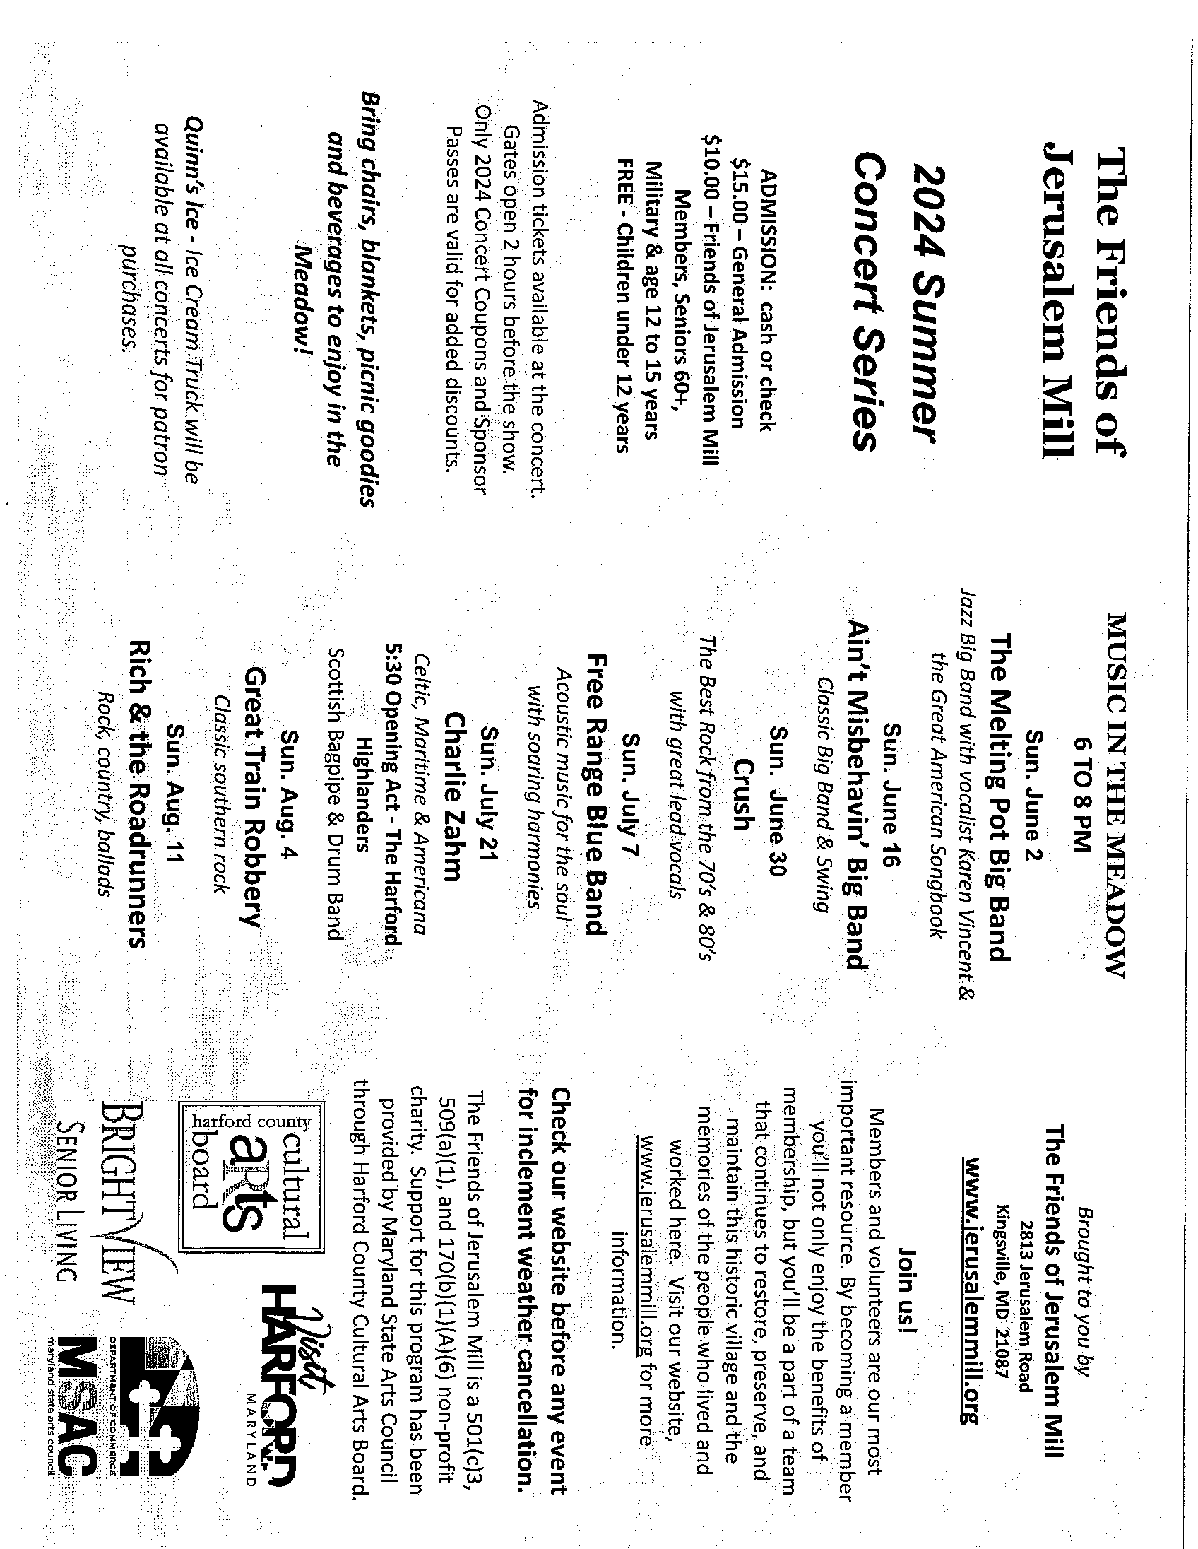

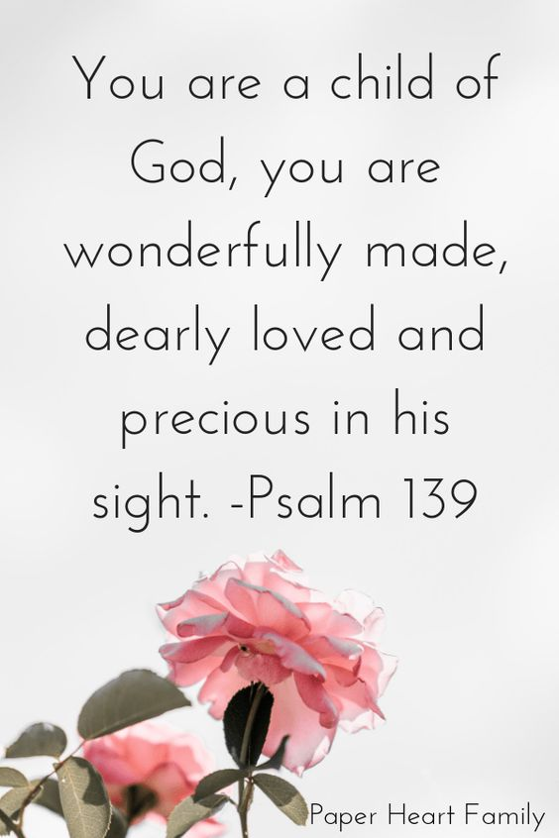
What’s Happening This Week at St. John’s

Sunday, July 14—HOLY BAPTISM and the 8th Sunday after Pentecost
9:30am: Holy Eucharist, Rite I (Church)
10:45am: Coffee Hour (Parish Hall)

Monday, July 15
12:00-1:00pm: AA Lunch Bunch (Parish Hall)
7:00-8:30pm: Spanish speaking AA group (Parish Hall)

Tuesday, July 16
12:00-1:00pm: AA Lunch Bunch (Parish Hall)

Wednesday, July 17
12:00-1:00pm: AA Lunch Bunch (Parish Hall)
7:30pm: AA (Parish Hall)

Thursday, July 18
12:00-1:00pm: AA Lunch Bunch (Parish Hall)
7:00pm: AA (Parish Hall)

Friday, July 19
12:00-1:00pm: AA Lunch Bunch (Parish Hall)

Saturday, July 20
8:30pm: AA (Parish Hall)

Sunday, July 21—9th Sunday after Pentecost
9:30am: Holy Eucharist, Rite II (Church)
10:45am: Coffee Hour (Parish Hall)

Parish Office is open Monday, Wednesday and Thursday, 9:30am-1:30pm.

Potluck Luncheon on the first Sunday of the month and a Coffee Hour on all other Sundays after the 9:30 service.

