St. John’s Episcopal Church
Kingsville, Maryland
Welcomes You

Our Vision Statement

We believe that together we will transform
the world with love: Come on in!

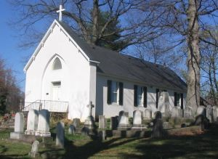

Sixth Sunday after Pentecost
Morning Prayer Rite II
June 30, 2024—10:30 am

St. John’s Episcopal Church

11901 Belair Road, P. O. Box 187, Kingsville, MD 21087
Facebook: St. John’s Episcopal, Kingsville, MD
Email: office@stjohnskingsville.org
Website: www.stjohnskingsville.org
Church Phone: 410-592-8570
For Pastoral Emergencies: Fr. Mark Lobb+ 443-690-9545

Welcome to worship today! We are glad that you are with us. You are invited to participate in all parts of the service as indicated in the Book of Common Prayer and this service bulletin. If you have any questions, feel free to ask the ushers. Restrooms are located in the Parish hall, the brick building across the parking lot.

I was glad when they said to me, “Let us go to the house of the Lord.” Psalm 122:1

Church Staff

Interim Rector: Father Mark Lobb
Administrative Assistant: Angie Bosley
Organist/Choir Director: Nancy Heinold

The Vestry

Class of 2025 Class of 2026

John Frost John Stevens
Woodie Tingle
Jacob Johnson

Officers
Ty Schwenk—Sr. Warden Terry Roe—Jr. Warden
Elizabeth Healey—Treasurer Anne Leland-Registrar

Parish Committee Chairpersons

Altar Guild: Elizabeth Healey
Auxiliary Committee: Michele Lozanski
Cemetery Committee: Terry Roe

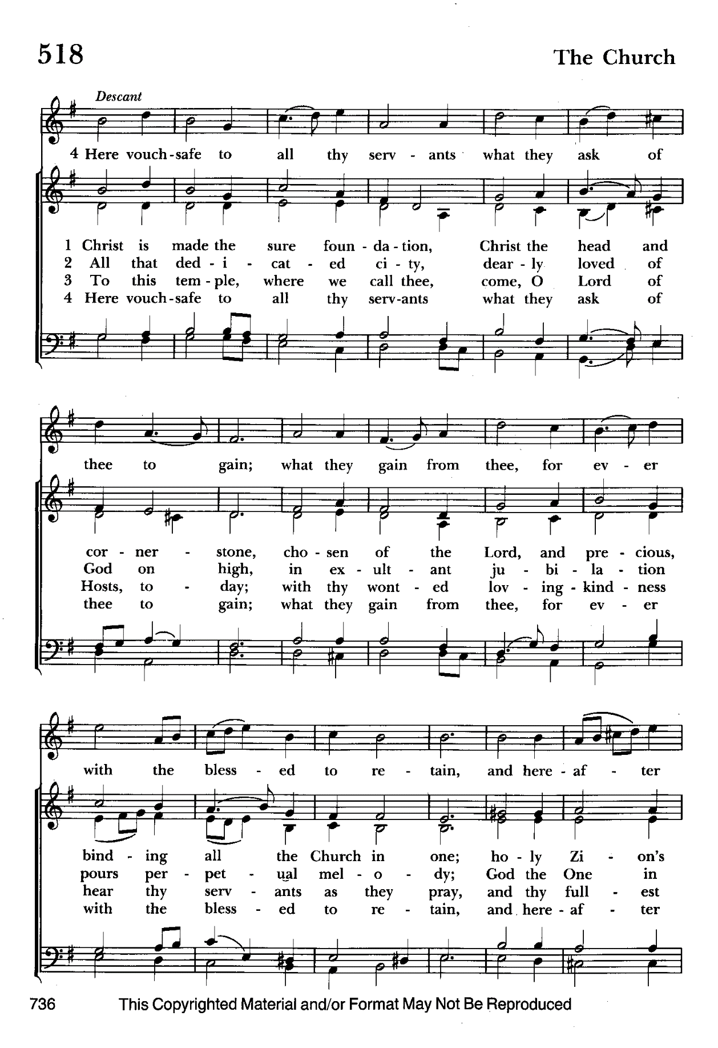

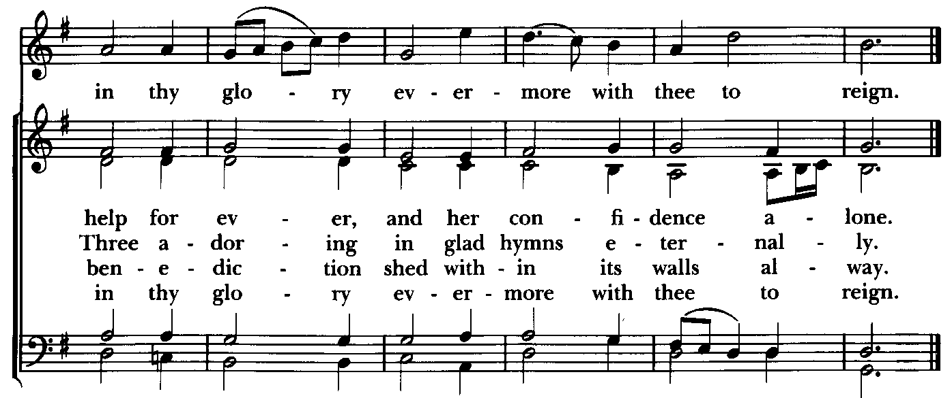

Morning Prayer—Rite II
Note:
Please feel free to remain seated during the service if unable to stand or kneel.
‘BCP’ refers to the Book of Common Prayer. The people’s responses are in bold. Large print song sheets are available. Please see an usher if you would like to use one.

Prelude

Gathering hymn: Christ is made the sure foundation Hymnal #518
(see previous page)

OPENING SENTENCES BCP p. 78

Officiant: Grace to you and peace from God our Father and the Lord Jesus Christ.
Philippians 1:2

CONFESSION OF SIN BCP p. 79
Dearly beloved, we have come together in the presence of Almighty God our heavenly Father, to set forth his praise, to hear his holy Word, and to ask, for ourselves and on behalf of others, those things that are necessary for our life and our salvation. And so that we may prepare ourselves in heart and mind to worship him, let us kneel in silence, and with penitent and obedient hearts confess our sins, that we may obtain forgiveness by his infinite goodness and mercy.

Officiant and People please stand or kneel as able
Most merciful God, we confess that we have sinned against you in thought, word, and deed, by what we have done, and by what we have left undone. We have not loved you with our whole heart; we have not loved our neighbors as ourselves. We are truly sorry and we humbly repent. For the sake of your Son Jesus Christ, have mercy on us and forgive us; that we may delight in your will, and walk in your ways, to the glory of your Name. Amen.

Officiant: Almighty God have mercy on you, forgive you all your sins through our Lord Jesus Christ, strengthen you in all goodness, and by the power of the Holy Spirit keep you in eternal life. Amen.

The Invitatory and Psalter BCP pg. 80

All stand
Officiant: Lord, open our lips.
People: And our mouth shall proclaim your praise.

Officiant and People
Glory to the Father, and to the Son, and to the Holy Spirit: as it was in the beginning, is now, and will be for ever. Amen.

The Lord is full of compassion and mercy: Come let us adore him. BCP pg. 81

Venite Psalm 95:1-7 BCP. pg. 82
Come, let us sing to the Lord;*
let us shout for joy to the Rock of our salvation.
Let us come before his presence with thakisgiving*
and raise a loud shout to him with psalms.

For the Lord is a great God,*
and a great King above all gods.
In his hands are the caverns of the earth,*
and the heights of the hills are his also.
The sea is his, for he made it.*
and his hands have molded the dry land.

Come, let us bow down, and bend the knee,*
and kneel before the Lord our Maker.
For he is our God,
and we are the people of his pasture and the sheep of his hand.*
Oh, that today you would hearken to his voice!

Psalm 130 De profundis
Officiant and People
1 Out of the depths have I called to you, O Lord;
Lord, hear my voice; *
let your ears consider well the voice of my supplication.
2 If you, Lord, were to note what is done amiss, *
O Lord, who could stand?
3 For there is forgiveness with you; *
therefore you shall be feared.
4 I wait for the Lord; my soul waits for him; *
in his word is my hope.
5 My soul waits for the Lord,
more than watchmen for the morning, *
more than watchmen for the morning.
6 O Israel, wait for the Lord, *
for with the Lord there is mercy;
7 With him there is plenteous redemption, *
and he shall redeem Israel from all their sins.

Please be seated

THE FIRST READING 2 Samuel 1:1, 17-27
After the death of Saul, when David had returned from defeating the Amalekites, David remained two days in Ziklag.
David intoned this lamentation over Saul and his son Jonathan. (He ordered that The Song of the Bow be taught to the people of Judah; it is written in the Book of Jashar.) He said: Your glory, O Israel, lies slain upon your high places! How the mighty have fallen! Tell it not in Gath, proclaim it not in the streets of Ashkelon; or the daughters of the Philistines will rejoice, the daughters of the uncircumcised will exult.
You mountains of Gilboa, let there be no dew or rain upon you, nor bounteous fields! For there the shield of the mighty was defiled, the shield of Saul, anointed with oil no more.
From the blood of the slain, from the fat of the mighty, the bow of Jonathan did not turn back, nor the sword of Saul return empty. Saul and Jonathan, beloved and lovely!
In life and in death they were not divided; they were swifter than eagles, they were stronger than lions.
O daughters of Israel, weep over Saul, who clothed you with crimson, in luxury, who put ornaments of gold on your apparel.
How the mighty have fallen in the midst of the battle!
Jonathan lies slain upon your high places. I am distressed for you, my brother Jonathan; greatly beloved were you to me; your love to me was wonderful, passing the love of women.
How the mighty have fallen, and the weapons of war perished!

The Word of the Lord.
Thanks be to God.

Canticle 16 The Song of Zechariah Benedictus Dominus Deus BCP pg. 92
Luke 1: 68-79
Blessed be the Lord, the God of Israel; *
he has come to his people and set them free.
He has raised up for us a mighty savior, *
born of the house of his servant David.
Through his holy prophets he promised of old,
that he would save us from our enemies, *
from the hands of all who hate us.
He promised to show mercy to our fathers *
and to remember his holy covenant.
This was the oath he swore to our father Abraham, *
to set us free from the hands of our enemies,
Free to worship him without fear, *
holy and righteous in his sight
all the days of our life.
You, my child, shall be called the prophet of the Most High, *
for you will go before the Lord to prepare his way,
To give his people knowledge of salvation *
by the forgiveness of their sins.
In the tender compassion of our God *
the dawn from on high shall break upon us,
To shine on those who dwell in darkness and the
shadow of death, *
and to guide our feet into the way of peace.
Glory to the Father, and to the Son, and to the Holy Spirit: *

THE SECOND READING 2 Corinthians 8:7-15
As you excel in everything-- in faith, in speech, in knowledge, in utmost eagerness, and in our love for you-- so we want you to excel also in this generous undertaking.
I do not say this as a command, but I am testing the genuineness of your love against the earnestness of others. For you know the generous act of our Lord Jesus Christ, that though he was rich, yet for your sakes he became poor, so that by his poverty you might become rich. And in this matter I am giving my advice: it is appropriate for you who began last year not only to do something but even to desire to do something-- now finish doing it, so that your eagerness may be matched by completing it according to your means. For if the eagerness is there, the gift is acceptable according to what one has-- not according to what one does not have. I do not mean that there should be relief for others and pressure on you, but it is a question of a fair balance between your present abundance and their need, so that their abundance may be for your need, in order that there may be a fair balance. As it is written, “The one who had much did not have too much, and the one who had little did not have too little.”

The Word of the Lord.
Thanks be to God.

Canticle 21 You are God Te Deum laudamus BCP pg. 95
You are the Lord; we acclaim you;
You are the eternal Father:
All creation worships you.
To you all angels, all the powers of heaven,
Cherubim and Seraphim, sing in endless praise:
Holy, holy, holy Lord, God of power and might,
heaven and earth are full of your glory.
The glorious company of apostles praise you.
The noble fellowship of prophets praise you.
The white-robed army of martyrs praise you.
Throughout the world the holy Church acclaims you;
Father, of majesty unbounded,
your true and only Son, worthy of all worship,
and the Holy Spirit, advocate and guide.
You, Christ, are the king of glory,
the eternal Son of the Father.
When you became man to set us free
you did not shun the Virgin's womb.
You overcame the sting of death
and opened the kingdom of heaven to all believers.
You are seated at God's right hand in glory.
We believe that you will come and be our judge.
Come then, Lord, and help your people,
bought with the price of your own blood,
and bring us with your saints
to glory everlasting.

Gradual hymn: O bless the Lord, my soul Hymnal #411
(see next page)

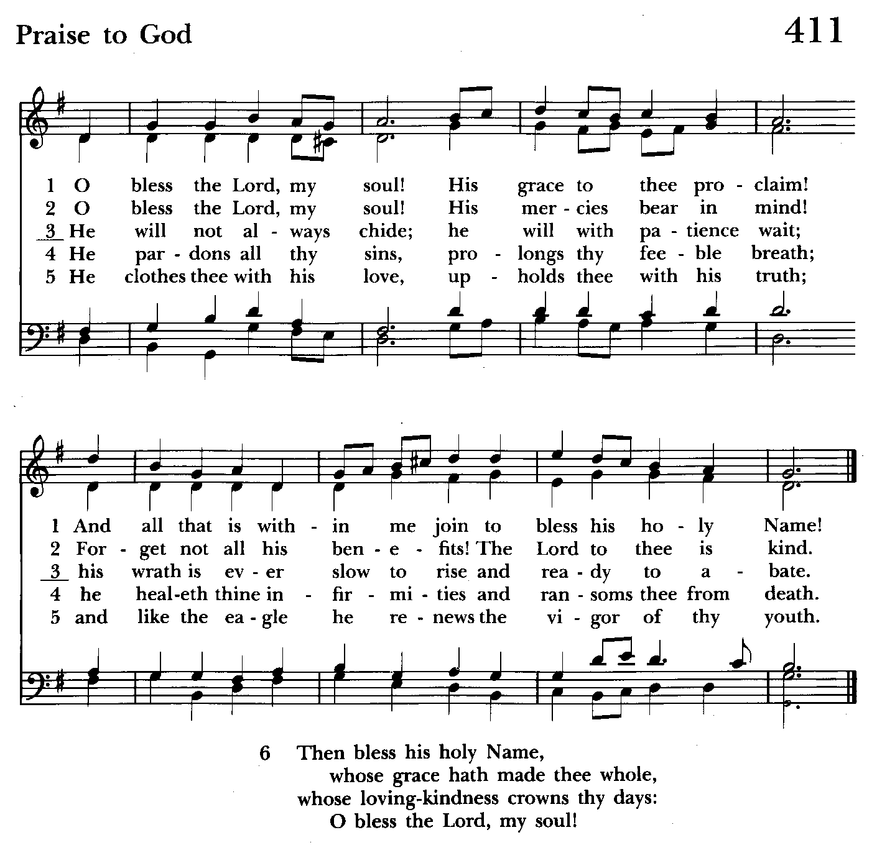

A Reading from the Gospel according to Mark People remain standing 5:21-43
When Jesus had crossed again in the boat to the other side, a great crowd gathered around him; and he was by the sea. Then one of the leaders of the synagogue named Jairus came and, when he saw him, fell at his feet and begged him repeatedly, “My little daughter is at the point of death. Come and lay your hands on her, so that she may be made well, and live.” So he went with him.
And a large crowd followed him and pressed in on him. Now there was a woman who had been suffering from hemorrhages for twelve years. She had endured much under many physicians, and had spent all that she had; and she was no better, but rather grew worse. She had heard about Jesus, and came up behind him in the crowd and touched his cloak, for she said, “If I but touch his clothes, I will be made well.” Immediately her hemorrhage stopped; and she felt in her body that she was healed of her disease. Immediately aware that power had gone forth from him, Jesus turned about in the crowd and said, “Who touched my clothes?” And his disciples said to him, “You see the crowd pressing in on you; how can you say, ‘Who touched me?’” He looked all around to see who had done it. But the woman, knowing what had happened to her, came in fear and trembling, fell down before him, and told him the whole truth. He said to her, “Daughter, your faith has made you well; go in peace, and be healed of your disease.”
While he was still speaking, some people came from the leader’s house to say, “Your daughter is dead. Why trouble the teacher any further?” But overhearing what they said, Jesus said to the leader of the synagogue, “Do not fear, only believe.” He allowed no one to follow him except Peter, James, and John, the brother of James. When they came to the house of the leader of the synagogue, he saw a commotion, people weeping and wailing loudly. When he had entered, he said to them, “Why do you make a commotion and weep? The child is not dead but sleeping.” And they laughed at him. Then he put them all outside, and took the child’s father and mother and those who were with him, and went in where the child was. He took her by the hand and said to her, “Talitha cum,” which means, “Little girl, get up!” And immediately the girl got up and began to walk about (she was twelve years of age). At this they were overcome with amazement. He strictly ordered them that no one should know this, and told them to give her something to eat.

The Word of the Lord.
Thanks be to God.

The Homily The congregation is seated Jacob Johnson

The Peace The congregation stands as able

Announcements The people are seated

THE APOSTLES CREED BCP pg. 96
Said by all, standing as you are able.
I believe in God, the Father almighty,
creator of heaven and earth;
I believe in Jesus Christ, his only Son, our Lord.
He was conceived by the power of the Holy Spirit
and born of the Virgin Mary.
He suffered under Pontius Pilate,
was crucified, died, and was buried.
He descended to the dead.
On the third day he rose again.
He ascended into heaven,
and is seated at the right hand of the Father.
He will come again to judge the living and the dead.
I believe in the Holy Spirit,
the holy catholic Church,
the communion of saints,
the forgiveness of sins
the resurrection of the body,
and the life everlasting. Amen.
Celebrant: The Lord be with you.
People: And also with you.
Celebrant: Let us pray.
THE LORD’S PRAYER Stand or kneel as able. BCP pg. 97
Our Father, who art in heaven, hallowed be thy Name, thy kingdom come, thy will be done, on earth as it is in heaven. Give us this day our daily bread. And forgive us our trespasses, as we forgive those who trespass against us. And lead us not into temptation, but deliver us from evil. For thine is the kingdom, and the power, and the glory, for ever and ever. Amen.
People and Officiant
SUFFRAGES B BCP pg. 98
V. Save your people, Lord, and bless your inheritance;
R. Govern and uphold them, now and always.
V. Day by day we bless you;
R. We praise your Name for ever.
V. Lord, keep us from all sin today;
R. Have mercy on us, Lord, have mercy.
V. Lord, show us your love and mercy;
R. For we put our trust in you.
V. In you, Lord, is our hope;
R. And we shall never hope in vain.

THE COLLECT OF THE DAY BCP pg. 230
Almighty God, you have built your Church upon the foundation of the apostles and prophets, Jesus Christ himself being the chief cornerstone: Grant us so to be joined together in unity of spirit by their teaching, that we may be made a holy temple acceptable to you; through Jesus Christ our Lord, who lives and reigns with you and the Holy Spirit, one God, for ever and ever. Amen.

A COLLECT FOR SUNDAYS BCP pg. 98
O God, you make us glad with the weekly remembrance of the glorious resurrection of your Son our Lord: Give us this day such blessing through our worship of you, that the week to come may be spent in your favor; through Jesus Christ our Lord. Amen.

Officiant: Let us pray for our own needs and those of others.

Silence

PRAYER FOR MISSION BCP pg. 100
Almighty and everlasting God, by whose Spirit the whole body of your faithful people is governed and sanctified: Receive our supplications and prayers which we offer before you for all members of your holy Church, that in their vocation and ministry they may truly and devoutly serve you; through Lord and Savior Jesus Christ. Amen.

THE OFFERTORY The offering is collected The offering is brought forward

DOXOLOGY Please stand as able Hymnal #43, vs. 4
Praise God, from whom all blessings flow; praise him, all creatures here below; praise him above, ye heavenly host: praise Father, Son, and Holy Ghost.

THE PRAYERS OF THE PEOPLE – Form III BCP pg. 387
Father, we pray for your holy Catholic Church;
That we all may be one.
Grant that every member of the Church may truly and humbly serve you;
That your Name may be glorified by all people.
We pray for all bishops, priests, and deacons;
That they may be faithful ministers of your Word and Sacraments.

We pray for all who govern and hold authority in the nations of the world;
That there may be justice and peace on the earth.

Give us grace to do your will in all that we undertake;
That our works may find favor in your sight.

Have compassion on those who suffer from any grief or trouble;
That they may be delivered from their distress.

Give to the departed eternal rest;
Let light perpetual shine upon them.
.
We praise you for your saints who have entered into joy;
May we also come to share in your heavenly kingdom.
.
Let us pray for our own needs and those of others.

We Pray for Those in Need:
DeMarino Family, Jim & Chris Carden and family, Peggie Dietz, Mike Carden, Pat Carden, Gail Landers, Sheila Jones, Gloria Millar, Marisol Aubrey, Amelia Bell, Linda and Allan Urban, Barbara Miller.

We Pray for our Homebound

Lily John, Barbara Miller, Nancy Barnhart, Robin Dilworth

We pray for the Church and the World:

For +Justin, Archbishop of Canterbury; for +Michael, our Presiding Bishop; for +Carrie, our Bishop, for Mark+, our Interim Rector, for the Wardens, Vestry, Staff, and all members and friends of St. John’s Church.

For the leaders of all nations, especially for Joseph, our President; for Wes, our Governor; for Brandon, Nick, John and Bob, who lead our City and Counties. We pray for all children and youth; for the homeless, the unemployed, and the hungry. We pray for the safety of our loved ones and friends serving in the Armed Forces at home and abroad, and for our nemies, that all our hearts may be turned toward peace throughout the world.

THE GENERAL THANKSGIVING
Let us pray.
Officiant and people BCP pg. 101
Almighty God, Father of all mercies, we your unworthy servants give you humble thanks for all your goodness and loving-kindness to us and to all whom you have made. We bless you for our creation, preservation, and all the blessings of this life; but above all for your immeasurable love in the redemption of the world by our Lord Jesus Christ; for the means of grace, and for the hope of glory. And, we pray, give us such an awareness of your mercies, that with truly thankful hearts we may show forth your praise, not only with our lips, but in our lives, by giving up our selves to your service, and by walking before you in holiness and righteousness all our days; through Jesus Christ our Lord, to whom, with you and the Holy Spirit, be honor and glory throughout all ages. Amen.

Closing hymn: Before thy throne, O God, we kneel Hymnal #574

THE DISMISSAL BCP pg. 102
Officiant: The grace of our Lord Jesus Christ, and the Love of God, and the fellowship of the Holy Spirit, be with us all evermore.
People: Thanks be to God.
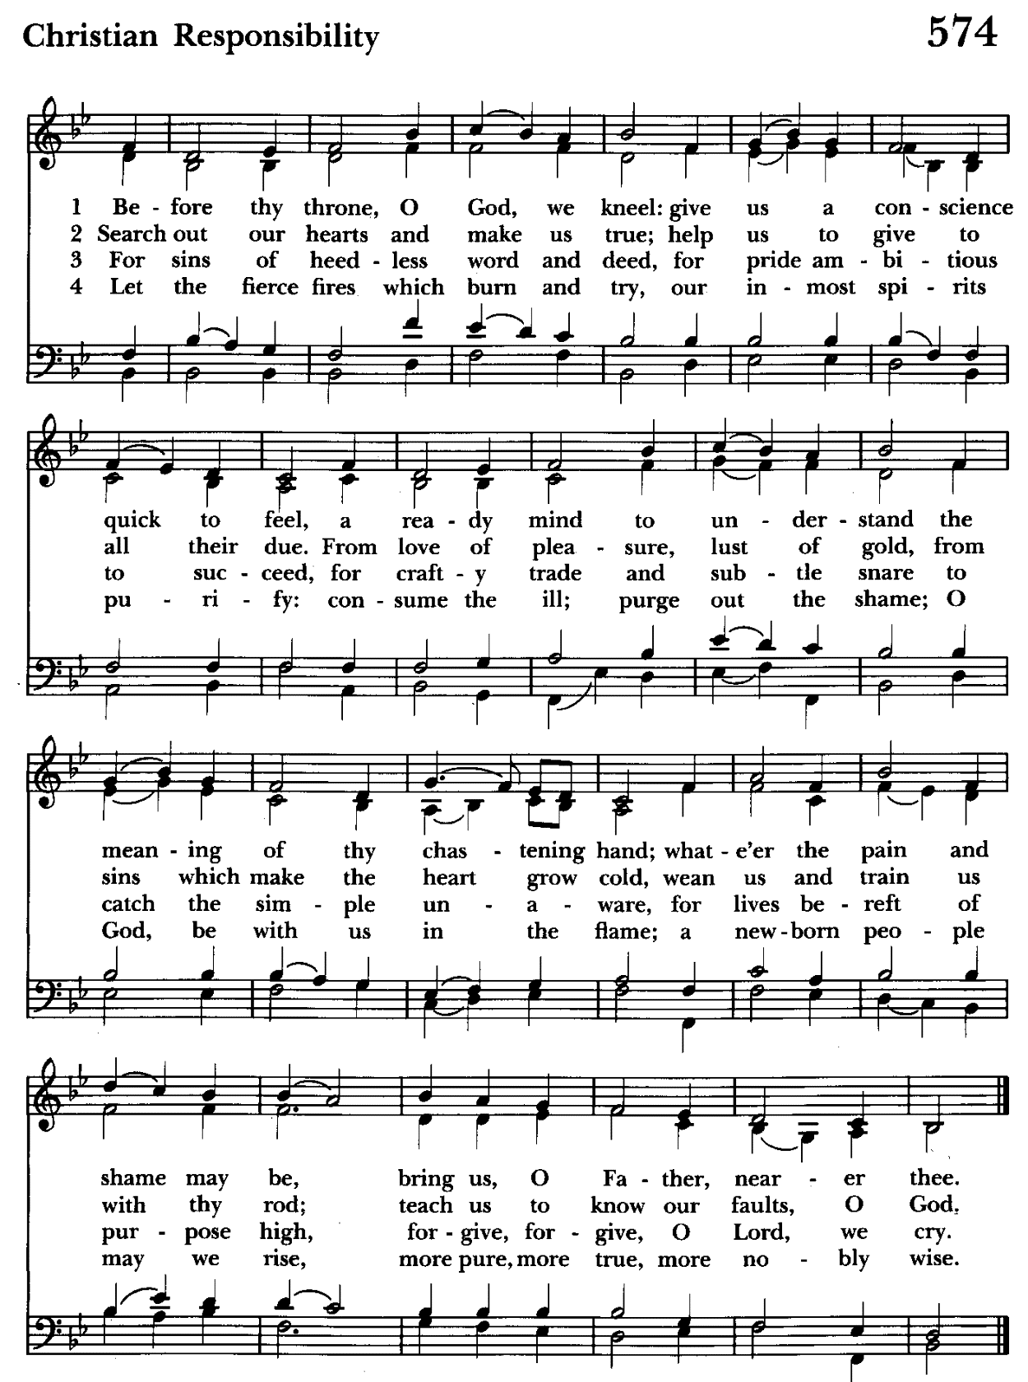

Serving Today
Officiant:: Jacob Johnson
Old Testament: Anne Leland
Psalm: Ty Schwenk
New Testament: Anne Leland
Prayers of the People: Liz Healey
Music Director: Nancy Heinold
Altar Guild: John Stevens & Woodie Tingle

St. John’s Parish Prayer List

Additions and corrections may be made to our Parish Prayer List at any time. All names will be automatically removed from the Parish Prayer List on the 1st Sunday of each month unless you request otherwise. Please contact Angie at <office@stjohnskingsville.org> or 410-592-8570 in the church office with all changes by 10 am Thursdays. Thank you.

We Pray for Those in Need:
Names in BOLD read aloud by all.

DeMarino Family, Jim & Chris Carden and family, Peggie Dietz, Mike Carden, Pat Carden, Gail Landers, Sheila Jones, Gloria Millar, Marisol Aubrey, Amelia Bell, Linda and Allan Urban.

We Pray for our Homebound

Lily John, Barbara Miller, Nancy Barnhart, Robin Dilworth

We pray for the Church and the World:

For +Justin, Archbishop of Canterbury; for our Presiding Bishop; for +Carrie, our Bishop, for Mark+, our Interim Rector, for the Wardens, Vestry, Staff, and all members and friends of St. John’s Church.

For the leaders of all nations, especially for Joseph, our President; for Wes, our Governor; for Brandon, Nick, John and Bob, who lead our City and Counties. We pray for all children and youth; for the homeless, the unemployed, and the hungry. We pray for the safety of our loved ones and friends serving in the Armed Forces at home and abroad, and for our enemies, that all our hearts may be turned toward peace throughout the world.

From the Treasurer

June ’24 Income vs. Expenses:

Projected June Expenses: $14,500
Monies Received as of 6/26: $12,647

Amount Needed to Meet Expenses: $1,853


If you’d like to make a donation to St. John’s you can scan this QR code with your phone’s camera or tap on the link that comes up to make a contribution with either a credit or debit card, Apple Pay or Google Pay. This is a secure site provided by Clover which is a
service of PNC Bank.

SUNDAY SCHOOL
Sunday School is over for the year. We will reconvene in September

Choral Choir and Bell Choir

Choir and Bell Choir are off for the summer. See you in September.


Yoga is now on Tuesday, Wednesday and Friday evenings 6 to 7 pm and Saturday mornings 9 to 10 am in the Chapel.
All experience levels are welcome.
No Yoga classes 7/5-7/20

Calendar Updates

Vestry Meetings– The summer vestry meetings will be held on June 25 and August 6 in our parish hall at 7:00 pm.

Summer services- We will temporarily go to one service on a Sunday at 9:30 a.m. from 7/7 to 8/25. Most will be Holy Eucharist.

Morning Prayer- will be offered on the following Sundays: 6/30, 7/21, 8/25, 9/8, 9/29, 10/13, 11/10, 12/8, 12/29. Lay people are highly encouraged to consider helping by officiating and/or preaching of Morning Prayer. I am willing to help you prepare for this.

Would it be helpful to have an “Officiating Morning Prayer” class? Let me know.

Blessing of the Animals- 9:30 a.m. (between the services) on Sunday 10/6.

All Souls service- Sunday evening 7:00 11/3.

Blue Christmas/Service of Solace- TBD

Calendars are living documents. Every effort will be made to keep the members of the parish and community aware of any changes.

SAVE THE DATE
Flea Market 9/21
Christmas Bazaar - 11/23


St. John’s Volunteers Needed!
Donations of bottled water and granola bars requested.

Please consider being a greeter or parking attendant to welcome the hundreds of visitors that will be enjoying the parade from our campus.

Air-conditioned assignments are available. Any amount of time volunteered is helpful. Reserved parking provided.

Contact: Karen (410)746-9813 or bikenbocal@verizon.net

Let’s show Kingsville our Christian Hospitality!!
***************************************

REMEMBER TO WEAR YOUR ST. JOHN’S SHIRT ON THE 4TH OF JULY!!


Altar Flowers

Given to the Glory of God
by a Generous Donor
in Thanksgiving for the People of St. John’s


With so much going on, everyone’s help is needed to make things a success. Our volunteers make the Church function. The volunteering of time and talent is greatly appreciated.

RECYCLING!
By popular demand, we are recycling. Some parishioners take printed paper home where they have recycling pickup. We now have a blue container located in the Parish Hall. This will be collected and taken for recycling. Aluminum cans will be saved and taken to a recycling center for cash. The proceeds will be donated to the Outreach fund. Each recycled aluminum can also save on the electricity needed to make new aluminum from bauxite.


God’s Grace Gardens—a St. John’s and Hill & Stream
Garden Club collaboration

For more info or to sign up to help keep our gardens looking beautiful, contact: Rita Talley-Garden Club or Karen Smith-Manar-St. John’s 410-746-9813 or bikenbocal@verizon.net

In our Community

Bible Studies in our area. If interested, please contact these churches to confirm.
St. Mary’s, Abingdon, (410)569-0180- Wednesdays at noon. Bring lunch. Zoom available.
Emmanuel, Bel Air, (410)838-7699- Fridays at 9:30- Zoom Available.
Holy Trinity, Churchville, (410)914-5531- Wednesdays 11:30- Zoom may be available.

Jerusalem Mill Summer Concert Series– See next page.

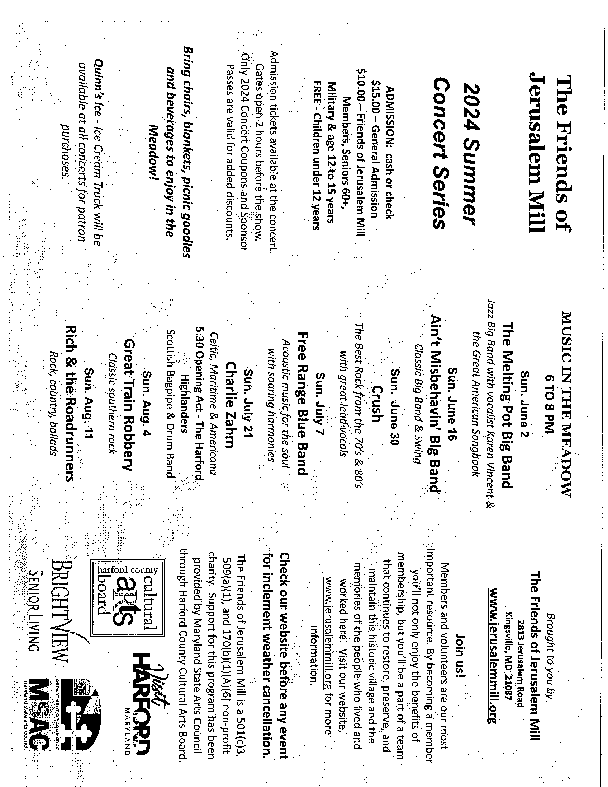


OUTREACH
The FOOD PANTRY is in need of immediate donations. All
donations welcome, food or monetary. Thank you so much.
spaghetti, spaghetti sauce, jelly/jam

What’s Happening This Week at St. John’s

Sunday, June 30—MORNING PRAYER-6th Sunday after Pentecost
8:00am: Morning Prayer, Rite I (Church)
10:30am: Morning Prayer, Rite II (Church)
11:30am: Coffee Hour (Parish Hall)

Monday, July 1
12:00-1:00pm: AA Lunch Bunch (Parish Hall)
7:00-8:30pm: Spanish speaking AA group (Parish Hall)

Tuesday, July 2
12:00-1:00pm: AA Lunch Bunch (Parish Hall)
6:00-7:00pm: Yoga (Chapel)

Wednesday, July 3
12:00-1:00pm: AA Lunch Bunch (Parish Hall)
6:00-7:00pm: Yoga (Chapel)
7:30pm: AA (Parish Hall)

Thursday, July 4—OFFICE CLOSED
12:00-1:00pm: AA Lunch Bunch (Parish Hall)
7:00pm: AA (Parish Hall)

Friday, July 5
9:00am-9:00pm Craft Group (Parish Hall)
12:00-1:00pm: AA Lunch Bunch (Parish Hall)

Saturday, July 6
9:00am-5:00pm Craft Group (Parish Hall)
8:30pm: AA (Parish Hall)

Sunday, July 7—7th Sunday after Pentecost
9:30am: Holy Eucharist, Rite I (Church)
10:30am: Potluck (Parish Hall)

Parish Office is open Monday, Wednesday and Thursday, 9:30am-1:30pm.

Potluck Luncheon on the first Sunday of the month and a Coffee Hour on all other Sundays after the 10:30 service.

