St. John’s Episcopal Church
Kingsville, Maryland
Welcomes You

OUR VISION STATEMENT
We believe that together we will transform the world with love: Come on in!

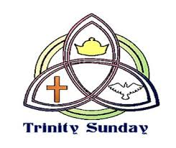

First Sunday after Pentecost-Trinity Sunday
May 26, 2024
10:30 am, Rite II

St. John’s Episcopal Church

11901 Belair Road, P. O. Box 187, Kingsville, MD 21087
Facebook: St. John’s Episcopal, Kingsville, MD
Email: office@stjohnskingsville.org
Website: www.stjohnskingsville.org
Church Phone: 410-592-8570
For Pastoral Emergencies: Fr. Mark Lobb+ 443-690-9545

Welcome to worship today! We are glad that you are with us. You are invited to participate in all parts of the service as indicated in the Book of Common Prayer and this service bulletin. If you have any questions, feel free to ask the ushers. Restrooms are located in the Parish hall, the brick building across the parking lot.

I was glad when they said to me, “Let us go to the house of the Lord.” Psalm 122:1

Church Staff

Interim Rector: Father Mark Lobb
Administrative Assistant: Angie Bosley
Organist/Choir Director: Nancy Heinold

The Vestry

Class of 2025 Class of 2026

John Frost John Stevens
Woodie Tingle
Jacob Johnson

Officers
Ty Schwenk—Sr. Warden Terry Roe—Jr. Warden
Elizabeth Healey—Treasurer Anne Leland-Registrar

Parish Committee Chairpersons

Altar Guild: Elizabeth Healey
Auxiliary Committee: Michele Lozanski
Cemetery Committee: Terry Roe

10:30 am Worship
Holy Eucharist, Rite Two

Prelude:
The Word of God

Processional hymn: Holy, holy, holy. Lord God Almighty Hymnal #362
(see next page)

The congregation remains standing as able
Celebrant: Alleluia. Christ is risen. BCP 355
People: The Lord is risen indeed. Alleluia.

Celebrant: Almighty God, to you all hearts are open, all desires known, and from you no secrets are hid: Cleanse the thoughts of our hearts by the inspiration of your Holy Spirit, that we may perfectly love you, and worthily magnify your holy Name; through Christ our Lord. Amen.

Gloria Hymnal #S-278
Glory to God in the highest,
and peace to his people on earth.
Lord God, heavenly King,
almighty God and Father,
we worship you, we give you thanks,
we praise you for your glory.
Lord Jesus Christ, only Son of the Father,
Lord God, Lamb of God,
you take away the sin of the world:
have mercy on us;
you are seated at the right hand of the Father:
receive our prayer.
For you alone are the Holy One,
you alone are the Lord,
you alone are the Most High,
Jesus Christ,
with the Holy Spirit,
in the glory of God the Father. Amen.

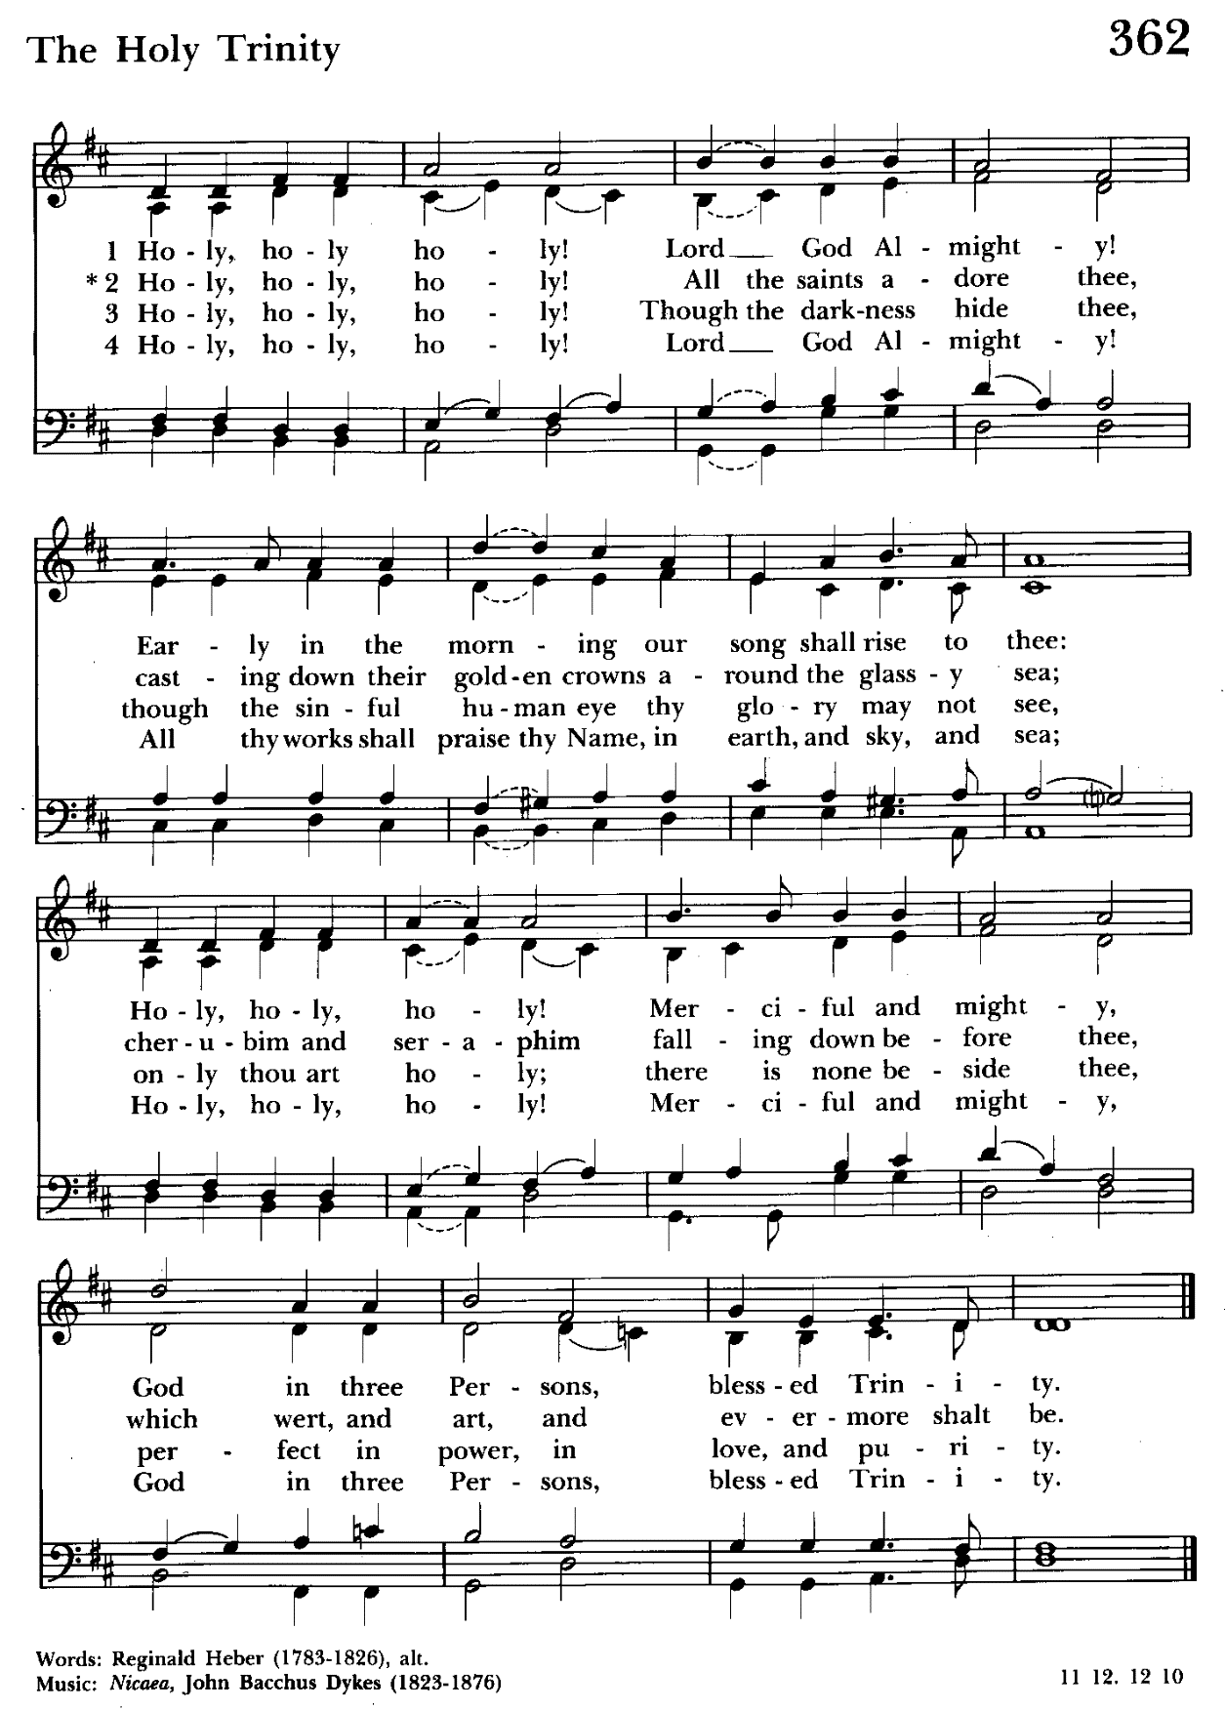

Celebrant: The Lord be with you.
People: And also with you.
Celebrant: Let us pray.

The Collect of the Day Kneel or stand as able BCP 228
Almighty and everlasting God, you have given to us your servants grace, by the confession of a true faith, to acknowledge the glory of the eternal Trinity, and in the power of your divine Majesty to worship the Unity: Keep us steadfast in this faith and worship, and bring us at last to see you in your one and eternal glory, O Father; who with the Son and the Holy Spirit live and reign, one God, for ever and ever. Amen.

The congregation is seated.

A Reading from the Book of the Prophet Isaiah 6:1-8
In the year that King Uzziah died, I saw the Lord sitting on a throne, high and lofty; and the hem of his robe filled the temple. Seraphs were in attendance above him; each had six wings: with two they covered their faces, and with two they covered their feet, and with two they flew. And one called to another and said:
“Holy, holy, holy is the Lord of hosts;
the whole earth is full of his glory.”
The pivots on the thresholds shook at the voices of those who called, and the house filled with smoke. And I said: “Woe is me! I am lost, for I am a man of unclean lips, and I live among a people of unclean lips; yet my eyes have seen the King, the Lord of hosts!”
Then one of the seraphs flew to me, holding a live coal that had been taken from the altar with a pair of tongs. The seraph touched my mouth with it and said: “Now that this has touched your lips, your guilt has departed and your sin is blotted out.” Then I heard the voice of the Lord saying, “Whom shall I send, and who will go for us?” And I said, “Here am I; send me!”

Reader: The Word of the Lord.
People: Thanks be to God.

Psalm 29 (Pray as directed)
1 Ascribe to the Lord, you gods, *
ascribe to the Lord glory and strength.
2 Ascribe to the Lord the glory due his Name; *
worship the Lord in the beauty of holiness.
3 The voice of the Lord is upon the waters;
the God of glory thunders; *
the Lord is upon the mighty waters.
4 The voice of the Lord is a powerful voice; *
the voice of the Lord is a voice of splendor.
5 The voice of the Lord breaks the cedar trees; *
the Lord breaks the cedars of Lebanon;
6 He makes Lebanon skip like a calf, *
and Mount Hermon like a young wild ox.
7 The voice of the Lord splits the flames of fire;
the voice of the Lord shakes the wilderness; *
the Lord shakes the wilderness of Kadesh.
8 The voice of the Lord makes the oak trees writhe *
and strips the forests bare.
9 And in the temple of the Lord *
all are crying, "Glory!"
10 The Lord sits enthroned above the flood; *
the Lord sits enthroned as King for evermore.
11 The Lord shall give strength to his people; *
the Lord shall give his people the blessing of peace.

A Reading from the Letter of St. Paul to the Romans 8:12-17
So then, brothers and sisters, we are debtors, not to the flesh, to live according to the flesh-- for if you live according to the flesh, you will die; but if by the Spirit you put to death the deeds of the body, you will live. For all who are led by the Spirit of God are children of God. For you did not receive a spirit of slavery to fall back into fear, but you have received a spirit of adoption. When we cry, "Abba! Father!" it is that very Spirit bearing witness with our spirit that we are children of God, and if children, then heirs, heirs of God and joint heirs with Christ-- if, in fact, we suffer with him so that we may also be glorified with him.

Reader: The Word of the Lord.
People: Thanks be to God.

Gradual hymn: Come thou almighty King Hymnal #365
(see next page)
The congregation remains standing as able

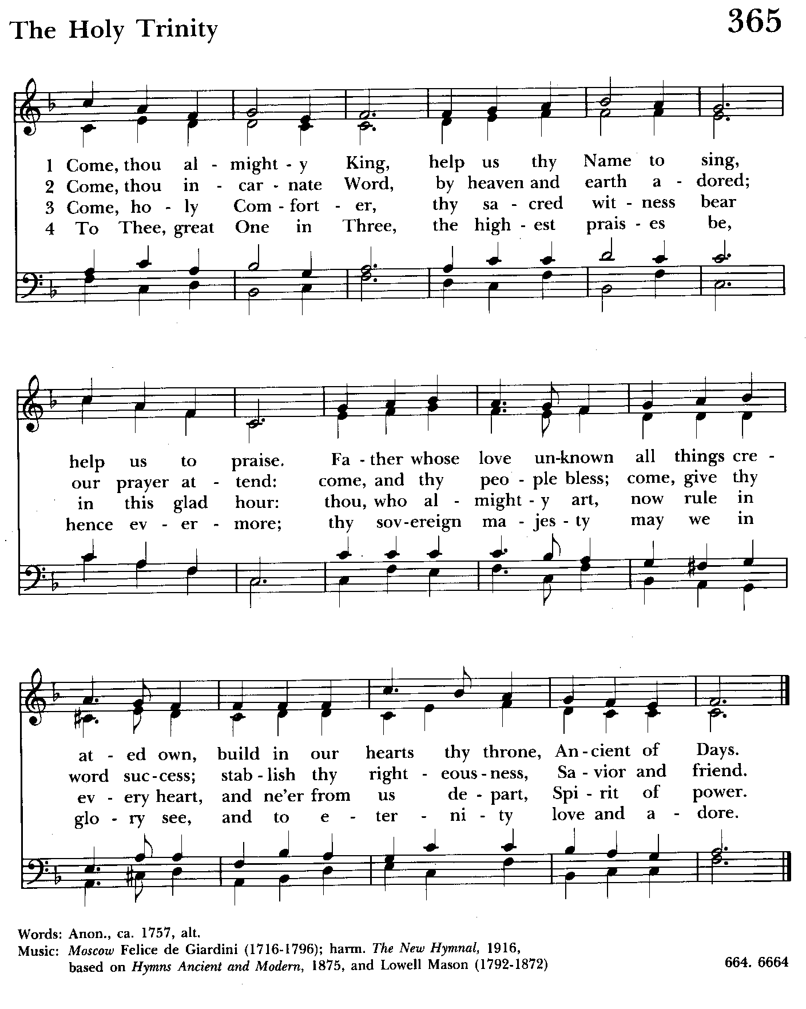

Priest: The Holy Gospel of our Lord Jesus Christ according to John 3:1-17

People: Glory to you, Lord Christ.
There was a Pharisee named Nicodemus, a leader of the Jews. He came to Jesus by night and said to him, “Rabbi, we know that you are a teacher who has come from God; for no one can do these signs that you do apart from the presence of God.” Jesus answered him, “Very truly, I tell you, no one can see the kingdom of God without being born from above.” Nicodemus said to him, “How can anyone be born after having grown old? Can one enter a second time into the mother’s womb and be born?” Jesus answered, “Very truly, I tell you, no one can enter the kingdom of God without being born of water and Spirit. What is born of the flesh is flesh, and what is born of the Spirit is spirit. Do not be astonished that I said to you, ‘You must be born from above.’ The wind blows where it chooses, and you hear the sound of it, but you do not know where it comes from or where it goes. So it is with everyone who is born of the Spirit.”
Nicodemus said to him, “How can these things be?” Jesus answered him, “Are you a teacher of Israel, and yet you do not understand these things?
“Very truly, I tell you, we speak of what we know and testify to what we have seen; yet you do not receive our testimony. If I have told you about earthly things and you do not believe, how can you believe if I tell you about heavenly things? No one has ascended into heaven except the one who descended from heaven, the Son of Man. And just as Moses lifted up the serpent in the wilderness, so must the Son of Man be lifted up, that whoever believes in him may have eternal life.
“For God so loved the world that he gave his only Son, so that everyone who believes in him may not perish but may have eternal life.
“Indeed, God did not send the Son into the world to condemn the world, but in order that the world might be saved through him.

Priest: The Gospel of the Lord.
People: Praise to you, Lord Christ.

Sermon The congregation is seated The Rev. Mark Lobb+

The Nicene Creed Please stand as able BCP 358
We believe in one God,
the Father, the Almighty,
maker of heaven and earth,
of all that is, seen and unseen.
We believe in one Lord, Jesus Christ,
the only Son of God,
eternally begotten of the Father,
God from God, Light from Light,
true God from true God,
begotten, not made,
of one Being with the Father.
Through him all things were made.
For us and for our salvation
he came down from heaven:
by the power of the Holy Spirit
he became incarnate from the Virgin Mary,
and was made man.
For our sake he was crucified under Pontius Pilate;
he suffered death and was buried.
On the third day he rose again
in accordance with the Scriptures;
he ascended into heaven
and is seated at the right hand of the Father.
He will come again in glory to judge the living and the dead,
and his kingdom will have no end.
We believe in the Holy Spirit, the Lord, the giver of life,
who proceeds from the Father and the Son.
With the Father and the Son he is worshiped and glorified.
He has spoken through the Prophets.
We believe in one holy catholic and apostolic Church.
We acknowledge one baptism for the forgiveness of sins.
We look for the resurrection of the dead,
and the life of the world to come. Amen.

The Prayers of the People Form VI Kneel or stand as able BCP 392
Litanist: In peace, we pray to you, Lord God.

Litanist: For all people in their daily life and work;
People: For our families, friends, and neighbors, and for those who are alone.

Litanist: For this community, the nation, and the world;
People: For all who work for justice, freedom, and peace.

Litanist: For the just and proper use of your creation;
People: For the victims of hunger, fear, injustice, and oppression.

Litanist: For all who are in danger, sorrow, or any kind of trouble;
People: For those who minister to the sick, the friendless, and the needy.

Litanist: For the peace and unity of the Church of God;
People: For all who proclaim the Gospel, and all who seek the Truth.

Litanist: For +Justin, Archbishop of Canterbury; +Michael, our Presiding Bishop; +Carrie, our Bishop, +Mark our Interim Rector, for the Wardens, Vestry, Staff, and all members and friends of St. John’s Church. We give you thanks for the service and leadership of +Eugene Taylor Sutton - Fourteenth Bishop of Maryland (retired).
People: For all who serve God in his Church.

Litanist: For the special needs and concerns of this congregation. Especially remember in our prayers, DeMarino Family, Jim & Chris Carden and family, Peggie Dietz, Mike Carden, Pat Carden, Gail Landers, Mary Anne Gebler, Sheila Jones, Gloria Millar, Marisol Aubrey, Robin Dilworth.

The People may add their own petitions
Litanist: Hear us, Lord;
People: For your mercy is great.
Litanist: We thank you, Lord, for all the blessings of this life.

The People may add their own thanksgivings

Litanist: We will exalt you, O God our King;
People: And praise your Name for ever and ever.

Litanist: We pray for all who have died, that they may have a place in your
eternal kingdom.

The People may add their own petitions
Litanist: Lord, let your loving-kindness be upon them;
People: Who put their trust in you.

Litanist: We pray to you also for the forgiveness of our sins.
People: Have mercy upon us, most merciful Father; in your compassion forgive us our sins, known and unknown, things done and left undone; and so uphold us by your Spirit that we may live and serve you in newness of life, to the honor and glory of your Name; through Jesus Christ our Lord. Amen.

The Celebrant gives the absolution.

The Peace Please stand as able BCP 360

Welcome & Announcements The congregation is seated.

Offertory Anthem: Cantate Canon (Choir)

Offertory: Offerings are collected

Presentation Hymn Offerings are presented Please stand as able Hymnal #43, vs. 4
Praise God, from whom all blessings flow; praise him, all creatures here below; praise him above, ye heavenly host: praise Father, Son, and Holy Ghost.

The Holy Communion

THE GREAT THANKSGIVING: Eucharistic Prayer B BCP 367
Celebrant: The Lord be with you.
People: And also with you.
Celebrant: Lift up your hearts.
People: We lift them to the Lord.
Celebrant: Let us give thanks to the Lord our God.
People: It is right to give him thanks and praise.

Then, facing the Holy Table, the Celebrant proceeds
It is right, and a good and joyful thing, always and everywhere to give thanks to you, Father Almighty, Creator of heaven and earth.
Therefore we praise you, joining our voices with Angels and Archangels and with all the company of heaven, who for ever sing this hymn to proclaim the glory of your Name:

Celebrant and People:
Holy, Holy, Holy Lord, God of power and might, Hymnal #S-129
heaven and earth are full of your glory.
Hosanna in the highest.
Blessed is he who comes in the name of the Lord.
Hosanna in the highest.

Please kneel or stand as able

Then the Celebrant continues BCP 368
We give thanks to you, O God, for the goodness and love which you have made known to us in creation; in the calling of Israel to be your people; in your Word spoken through the prophets; and above all in the Word made flesh, Jesus, your Son. For in these last days you sent him to be incarnate from the Virgin Mary, to be the Savior and Redeemer of the world. In him, you have delivered us from evil, and made us worthy to stand before you. In him, you have brought us out of error into truth, out of sin into righteousness, out of death into life.

At the following words concerning the bread, the Celebrant is to hold it, or to lay a hand upon it; and at the words concerning the cup, to hold or place a hand upon the cup and any other vessel containing wine to be consecrated.

On the night before he died for us, our Lord Jesus Christ took bread; and when he had given thanks to you, he broke it, and gave it to his disciples, and said, "Take, eat: This is my Body, which is given for you. Do this for the remembrance of me."

After supper he took the cup of wine; and when he had given thanks, he gave it to them, and said, "Drink this, all of you: This is my Blood of the new Covenant, which is shed for you and for many for the forgiveness of sins. Whenever you drink it, do this for the remembrance of me."

Therefore, according to his command, O Father,

Celebrant and People:
We remember his death,
We proclaim his resurrection,
We await his coming in glory;

The Celebrant continues
And we offer our sacrifice of praise and thanksgiving to you, O Lord of all; presenting to you, from your creation, this bread and this wine. We pray you, gracious God, to send your Holy Spirit upon these gifts that they may be the Sacrament of the Body of Christ and his Blood of the new Covenant. Unite us to your Son in his sacrifice, that we may be acceptable through him, being sanctified by the Holy Spirit. In the fullness of time, put all things in subjection under your Christ, and bring us to that heavenly country where, with St. John and the Blessed Virgin Mary and all your saints, we may enter the everlasting heritage of your sons and daughters; through Jesus Christ our Lord, the firstborn of all creation, the head of the Church, and the author of our salvation.

By him, and with him, and in him, in the unity of the Holy Spirit all honor and glory is yours, Almighty Father, now and for ever. Amen.

And now, as our Savior Christ has taught us, we are bold to say,

Our Father, who art in heaven, BCP p. 364
hallowed be thy Name,
thy kingdom come,
thy will be done,
on earth as in heaven.
Give us this day our daily bread.
And forgive us our trespasses,
as we forgive those
who trespass against us.
And lead us not into temptation,
but deliver us from evil.
For thine is the kingdom,
and the power, and the glory,
for ever and ever. Amen.
Invitation to Communion

The Breaking of the Bread
Celebrant: Alleluia. Christ our Passover is sacrificed for us;
People: Therefore let us keep the feast. Alleluia.
Celebrant: The Gifts of God for the people of God.

The congregation is seated
Communion hymn: I bind unto myself today Hymnal #370
(see next 3 pages)

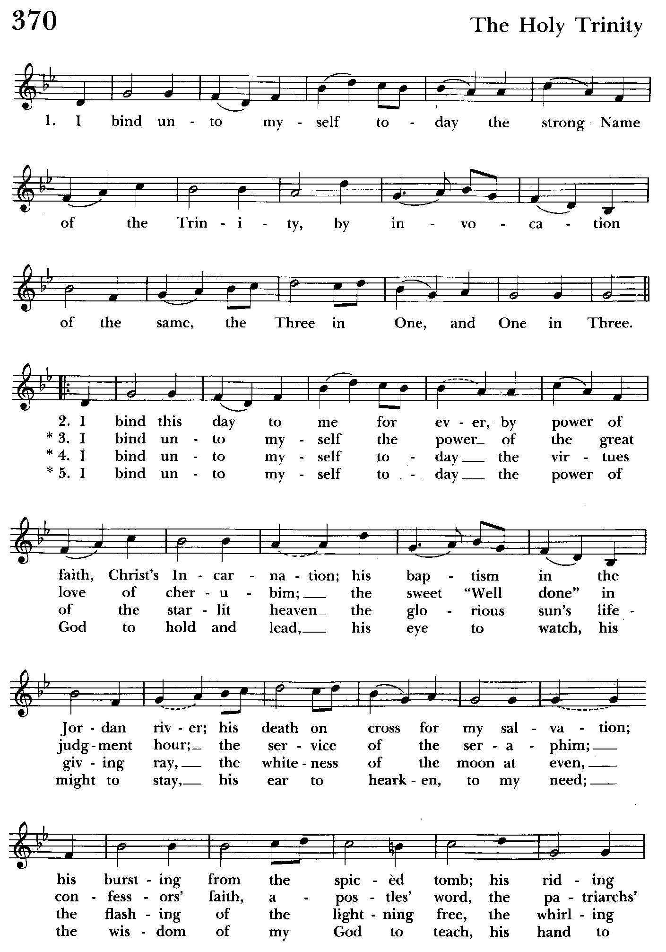

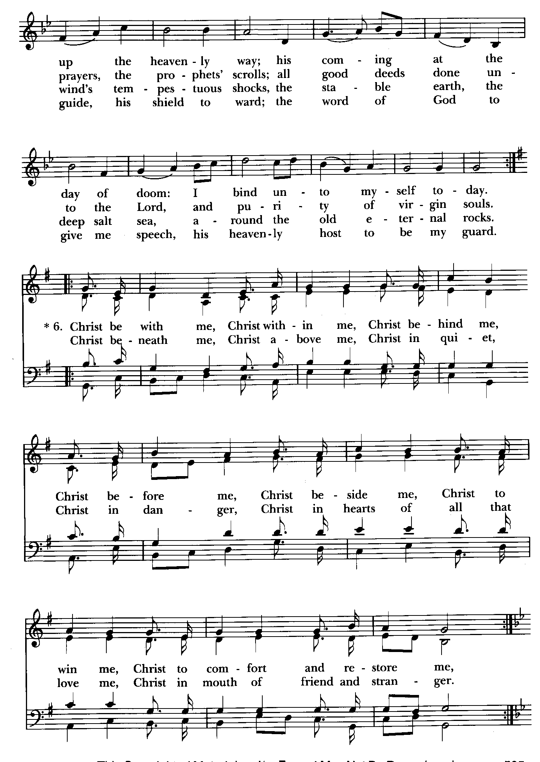

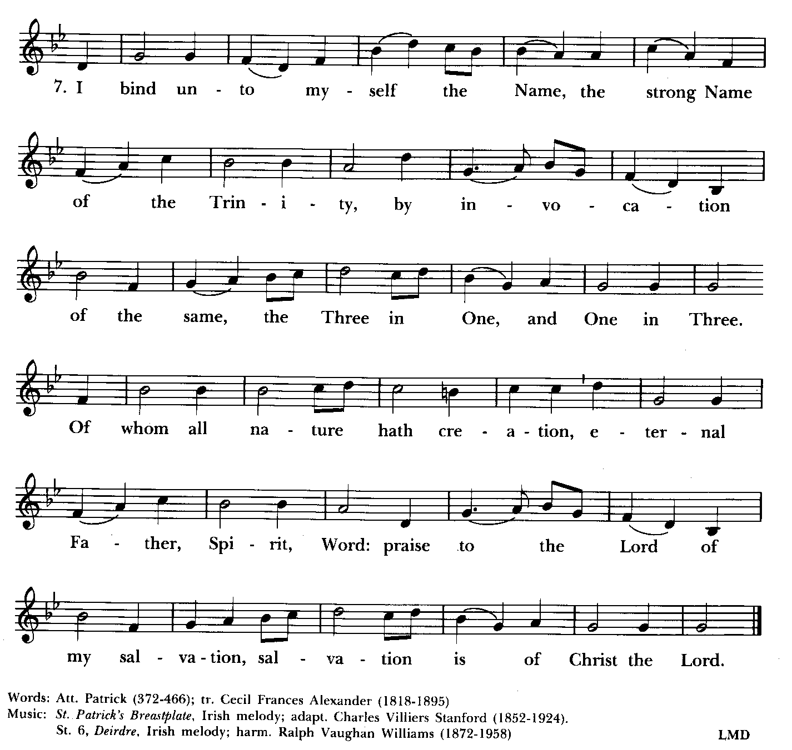

The Post Communion Prayer BCP p. 365
Eternal God, heavenly Father, you have graciously accepted us as living members of your Son our Savior Jesus Christ, and you have fed us with spiritual food in the Sacrament of his Body and Blood. Send us now into the world in peace, and grant us strength and courage to love and serve you with gladness and singleness of heart; through Christ our Lord. Amen.

Blessing

Recessional hymn: God the Omnipotent King, who ordainest Hymnal #569
(see next page)

The Dismissal (The Alleluias are back!)
Celebrant: Let us go forth in the name of the risen Lord.
People: Thanks be to God. Alleluia, alleluia!

License #A-719154

Serving Today

Celebrant and Preacher: The Rev. Mark Lobb+
Old Testament: Michele Lozanski
Psalm: Michele Lozanski
New Testament: Tony Rising
Prayers of the People: John Frost
Server: Marguerite Lobb
Music Director: Nancy Heinold
Choir: Anne Leland, Nancy Dellinger, Janine Stevens, Liz Healey,
Camy Schwenk, Karen Smith-Manar, Jacob Johnson, Ty Schwenk
Altar Guild: Stephanie Duchacek and Sandy Roe


Altar Flowers
Given to the Glory of God by a Generous Donor
in Thanksgiving for the People of St. John’s

St. John’s Parish Prayer List

Additions and corrections may be made to our Parish Prayer List at any time. All names will be automatically removed from the Parish Prayer List on the 1st Sunday of each month unless you request otherwise. Please contact Angie at <office@stjohnskingsville.org> or 410-592-8570 in the church office with all changes by 10 am Thursdays. Thank you.

We Pray for Those in Need:
Names in BOLD read aloud by all.

DeMarino Family, Jim & Chris Carden and family, Peggie Dietz, Mike Carden, Pat Carden, Gail Landers, Mary Anne Gebler, Sheila Jones, Gloria Millar, Marisol Aubrey.

We Pray for our Homebound

Lily John, Barbara Miller, Nancy Barnhart, Robin Dilworth

We pray for the Church and the World:

For +Justin, Archbishop of Canterbury; for +Michael, our Presiding Bishop; for +Carrie, our Bishop, for +Mark, our Interim Rector, for the Wardens, Vestry, Staff, and all members and friends of St. John’s Church. We give you thanks for the service and leadership of +Eugene Taylor Sutton - Fourteenth Bishop of Maryland (retired).

For the leaders of all nations, especially for Joseph, our President; for Wes, our Governor; for Brandon, Nick, John and Bob, who lead our City and Counties. We pray for all children and youth; for the homeless, the unemployed, and the hungry. We pray for the safety of our loved ones and friends serving in the Armed Forces at home and abroad, and for our enemies, that all our hearts may be turned toward peace throughout the world.

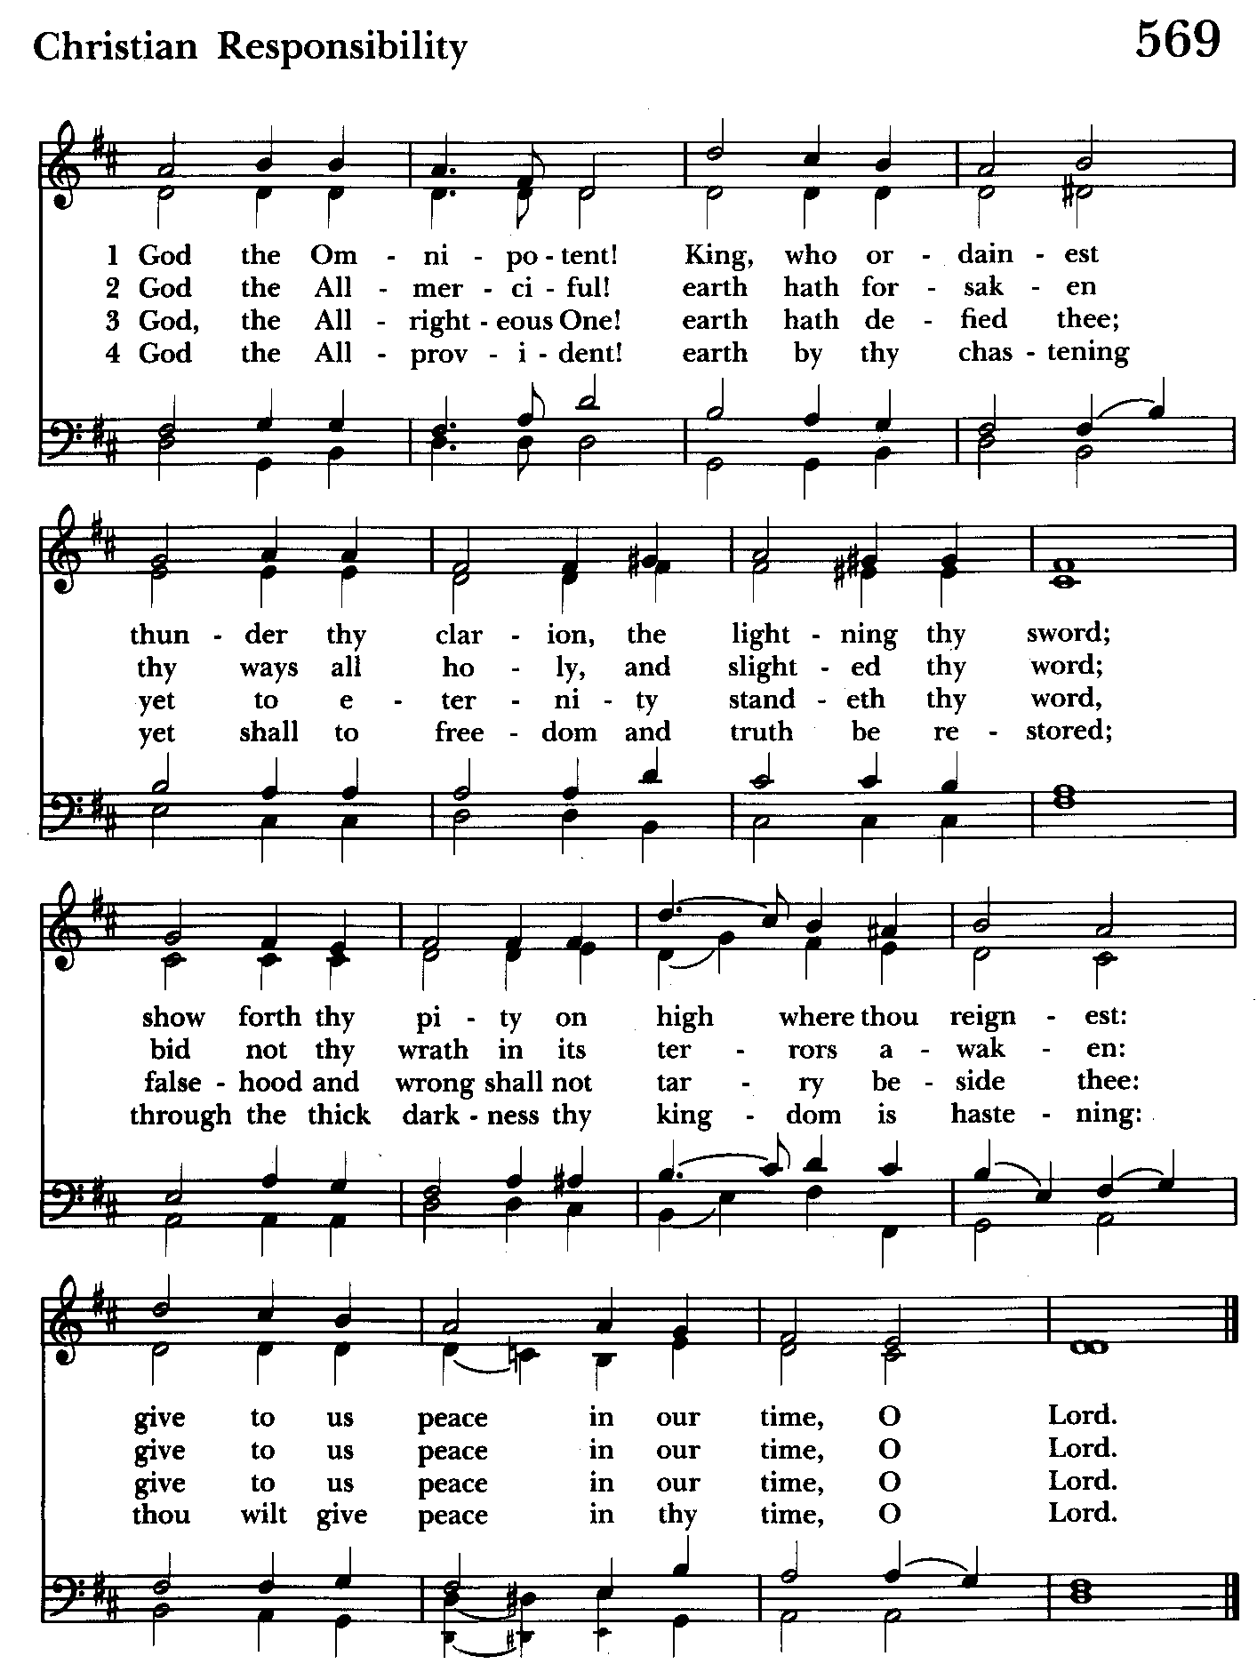

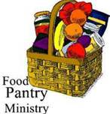
OUTREACH
The FOOD PANTRY is in need of immediate donations. All donations welcome, food or monetary. Thank you so much.
Needed at this time: spaghetti, spaghetti sauce,
jelly/jam


NEW DATE-St. John’s Flea Market
June 1st, 8 am-1 pm
You can now bring in your gently used items to the Parish Hall (storage room next to the kitchen). Volunteers needed also for baking! Thank you so much!!

Brownies (2/bag) and cookies (4/bag) can be dropped off during office hours on 5/16 [9:30-1:30] or Friday 5/17 from noon to 8 pm.

We are also accepting donations of Sprite, Sunkist Orange, Water, Diet Pepsi, Diet Coke, Brisk Iced Tea for the Flea Market and other Upcoming Events.

From the Treasurer
May ’24 Income vs. Expenses:
Projected May Expenses: $14,500
Monies Received as of 5/23: $13,324
Amount Needed to Meet Expenses: $1,176


If you’d like to make a donation to St. John’s you can scan this QR code with your phone’s camera or tap on the link that comes up to make a contribution with either a credit or debit card, Apple Pay or Google Pay. This is a secure site provided by Clover which is a service of PNC Bank.

RECYCLING!
By popular demand, we are recycling. Some parishioners take printed paper home where they have recycling pickup. We now have a blue container located in the Parish Hall. This will be collected and taken for recycling. Aluminum cans will be saved and taken to a recycling center for cash. The proceeds will be donated to the Outreach fund. Each recycled aluminum can also save on the electricity needed to make new aluminum from bauxite.


Thank you to the Dilworth family for the donation of the Marigolds for our pots out in front of the Parish Hall.


Choral Choir and Bell Choir

Choir practice, Wednesdays at 7:00 pm

Bell Choir practice, Sundays after the 10:30 service on the 2nd, 3rd and 4th Sundays


SUNDAY SCHOOL
Children’s Sunday school is held from 10:30-11:00 during our 10:30 service. Miss Stephanie and I also would like to invite all interested kids to come and be part of the group!

Mr. John


Yoga classes on Tuesday, Wednesday and Friday evenings 6 to 7 pm and Saturday mornings 9 to 10 am in the Chapel. All experience levels are welcome.

What’s Happening This Week at St. John’s

Sunday, May 26—1st Sunday after Pentecost-Trinity Sunday
8:00am: Holy Eucharist, Rite I (Church)
10:30am: Holy Eucharist, Rite II (Church)
11:30am: Coffee Hour (Parish Hall)

Monday, May 27-MEMORIAL DAY
OFFICE CLOSED
12:00-1:00pm: AA Lunch Bunch (Parish Hall)
7:00-8:30pm: Spanish speaking AA group (Parish Hall)

Tuesday, May 28
12:00-1:00pm: AA Lunch Bunch (Parish Hall)
6:00-7:00pm: Yoga (Chapel)

Wednesday, May 29
12:00-1:00pm: AA Lunch Bunch (Parish Hall)
6:00-7:00pm: Yoga (Chapel)
7:00pm: Choir Rehearsal (Church)
7:30pm: AA (Parish Hall)

Thursday, May 30
12:00-1:00pm: AA Lunch Bunch (Parish Hall)
7:00pm: AA (Parish Hall)

Friday, May 31
12:00-1:00pm: AA Lunch Bunch (Parish Hall)
6:00pm -7:00pm: Yoga (Chapel)

Saturday, June 1
9:00am-10:00am: Yoga (Chapel)
8:30pm: AA (Parish Hall)

Sunday, June 2—2nd Sunday after Pentecost
8:00am: Holy Eucharist, Rite I (Church)
10:30am: Holy Eucharist, Rite II (Church)
10:30am-11:00am: Sunday School
11:30am: Potluck (Parish Hall)

Parish Office is open Monday, Wednesday and Thursday, 9:30am-1:30pm.

Potluck Luncheon on the first Sunday of the month and a Coffee Hour on all other Sundays after the 10:30 service.

