St. John’s Episcopal Church
Kingsville, Maryland
Welcomes You

OUR VISION STATEMENT
We believe that together we will transform the world with love: Come on in!

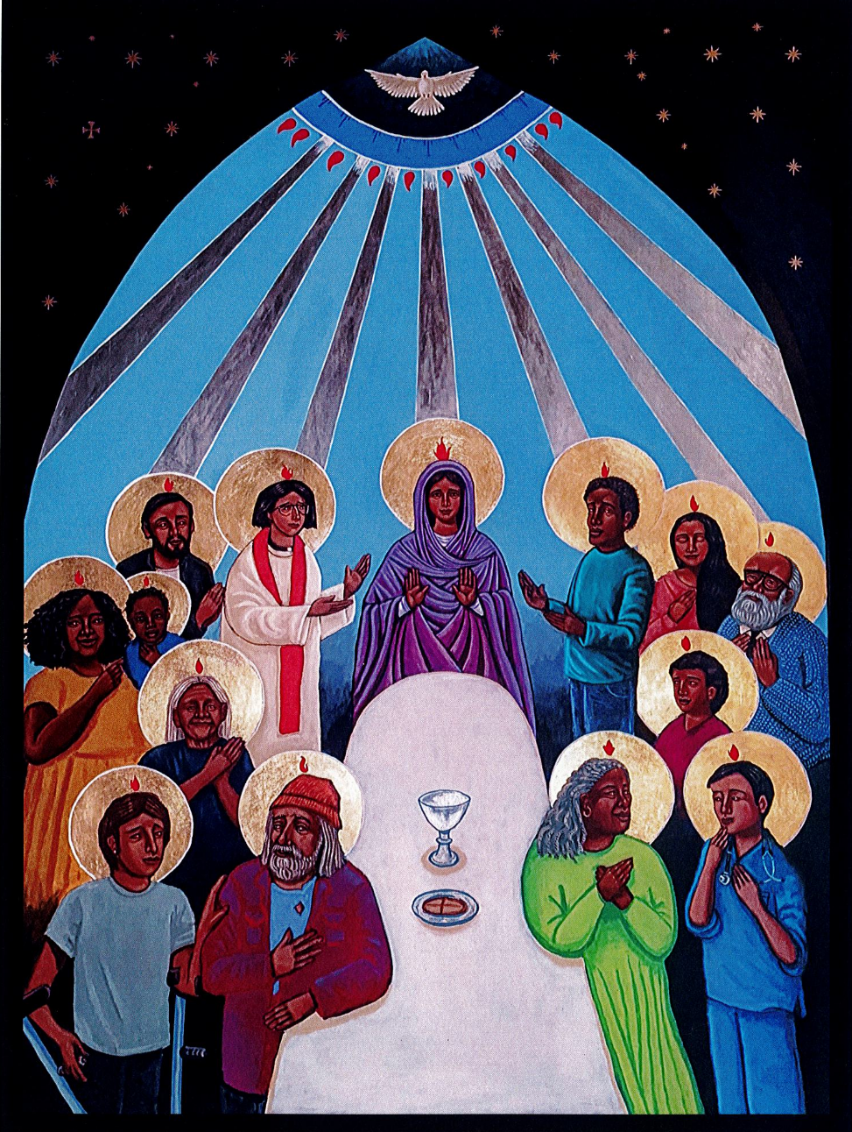

The Day of Pentecost-Whitsunday
May 19, 2024
10:30 am, Rite II

St. John’s Episcopal Church

11901 Belair Road, P. O. Box 187, Kingsville, MD 21087
Facebook: St. John’s Episcopal, Kingsville, MD
Email: office@stjohnskingsville.org
Website: www.stjohnskingsville.org
Church Phone: 410-592-8570
For Pastoral Emergencies: Fr. Mark Lobb+ 443-690-9545

Welcome to worship today! We are glad that you are with us. You are invited to participate in all parts of the service as indicated in the Book of Common Prayer and this service bulletin. If you have any questions, feel free to ask the ushers. Restrooms are located in the Parish hall, the brick building across the parking lot.

I was glad when they said to me, “Let us go to the house of the Lord.” Psalm 122:1

Church Staff

Interim Rector: Father Mark Lobb
Administrative Assistant: Angie Bosley
Organist/Choir Director: Nancy Heinold

The Vestry

Class of 2025 Class of 2026

John Frost John Stevens
Woodie Tingle
Jacob Johnson

Officers
Ty Schwenk—Sr. Warden Terry Roe—Jr. Warden
Elizabeth Healey—Treasurer Anne Leland-Registrar

Parish Committee Chairpersons

Altar Guild: Elizabeth Healey
Auxiliary Committee: Michele Lozanski
Cemetery Committee: Terry Roe

10:30 am Worship
Holy Eucharist, Rite Two

Prelude:
The Word of God

Processional hymn: Hail thee, festival day Hymnal #225
(see next page)

The congregation remains standing as able
Celebrant: Alleluia. Christ is risen. BCP 355
People: The Lord is risen indeed. Alleluia.

Celebrant: Almighty God, to you all hearts are open, all desires known, and from you no secrets are hid: Cleanse the thoughts of our hearts by the inspiration of your Holy Spirit, that we may perfectly love you, and worthily magnify your holy Name; through Christ our Lord. Amen.

Gloria Hymnal #S-278
Glory to God in the highest,
and peace to his people on earth.
Lord God, heavenly King,
almighty God and Father,
we worship you, we give you thanks,
we praise you for your glory.
Lord Jesus Christ, only Son of the Father,
Lord God, Lamb of God,
you take away the sin of the world:
have mercy on us;
you are seated at the right hand of the Father:
receive our prayer.
For you alone are the Holy One,
you alone are the Lord,
you alone are the Most High,
Jesus Christ,
with the Holy Spirit,
in the glory of God the Father. Amen.

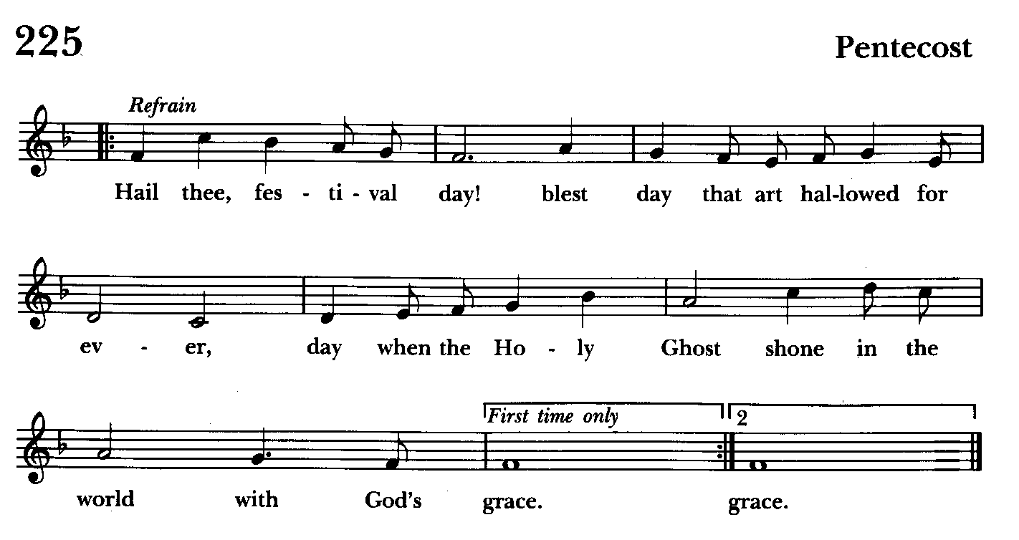

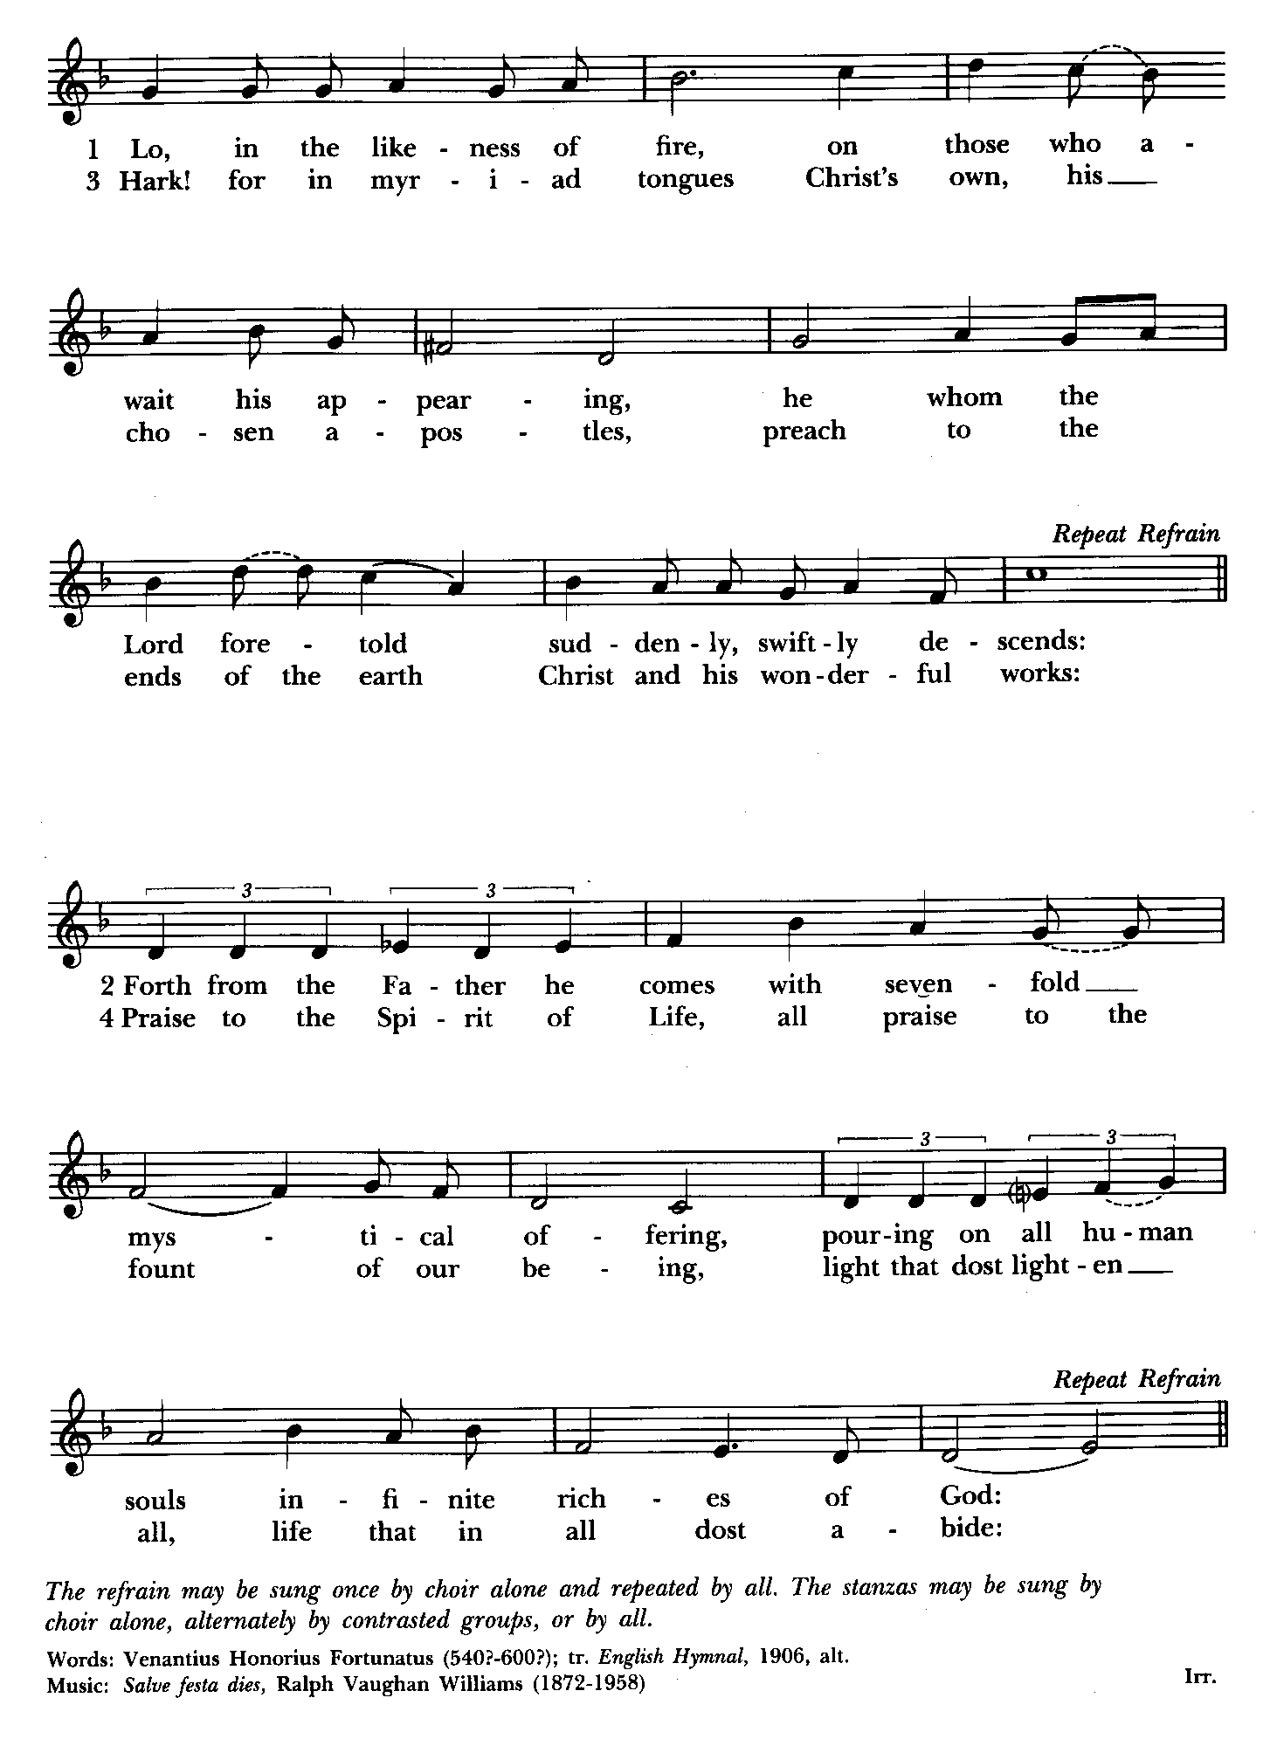
Celebrant: The Lord be with you.
People: And also with you.
Celebrant: Let us pray.

The Collect of the Day Kneel or stand as able BCP 227
Almighty God, on this day you opened the way of eternal life to every race and nation by the promised gift of your Holy Spirit: Shed abroad this gift throughout the world by the preaching of the Gospel, that it may reach to the ends of the earth; through Jesus Christ our Lord, who lives and reigns with you, in the unity of the Holy Spirit, one God, for ever and ever .Amen.

The congregation is seated.

A Reading from the Book of the Prophet Ezekiel 37:1-14
The hand of the Lord came upon me, and he brought me out by the spirit of the Lord and set me down in the middle of a valley; it was full of bones. He led me all around them; there were very many lying in the valley, and they were very dry. He said to me, “Mortal, can these bones live?” I answered, “O Lord God, you know.” Then he said to me, “Prophesy to these bones, and say to them: O dry bones, hear the word of the Lord. Thus says the Lord God to these bones: I will cause breath to enter you, and you shall live. I will lay sinews on you, and will cause flesh to come upon you, and cover you with skin, and put breath in you, and you shall live; and you shall know that I am the Lord.”
So I prophesied as I had been commanded; and as I prophesied, suddenly there was a noise, a rattling, and the bones came together, bone to its bone. I looked, and there were sinews on them, and flesh had come upon them, and skin had covered them; but there was no breath in them. Then he said to me, “Prophesy to the breath, prophesy, mortal, and say to the breath: Thus says the Lord God: Come from the four winds, O breath, and breathe upon these slain, that they may live.” I prophesied as he commanded me, and the breath came into them, and they lived, and stood on their feet, a vast multitude.
Then he said to me, “Mortal, these bones are the whole house of Israel. They say, ‘Our bones are dried up, and our hope is lost; we are cut off completely.’ Therefore prophesy, and say to them, Thus says the Lord God: I am going to open your graves, and bring you up from your graves, O my people; and I will bring you back to the land of Israel. And you shall know that I am the Lord, when I open your graves, and bring you up from your graves, O my people. I will put my spirit within you, and you shall live, and I will place you on your own soil; then you shall know that I, the Lord, have spoken and will act,” says the Lord.

Reader: The Word of the Lord.
People: Thanks be to God.

Psalm 104:25-35, 37 (Prayed as directed.)
25 O Lord, how manifold are your works! *
in wisdom you have made them all;
the earth is full of your creatures.
26 Yonder is the great and wide sea
with its living things too many to number, *
creatures both small and great.
27 There move the ships,
and there is that Leviathan, *
which you have made for the sport of it.
28 All of them look to you *
to give them their food in due season.
29 You give it to them; they gather it; *
you open your hand, and they are filled with good things.
30 You hide your face, and they are terrified; *
you take away their breath,
and they die and return to their dust.
31 You send forth your Spirit, and they are created; *
and so you renew the face of the earth.
32 May the glory of the Lord endure for ever; *
may the Lord rejoice in all his works.
33 He looks at the earth and it trembles; *
he touches the mountains and they smoke.
34 I will sing to the Lord as long as I live; *
I will praise my God while I have my being.
35 May these words of mine please him; *
I will rejoice in the Lord.
37 Bless the Lord, O my soul. *
Hallelujah!

A Reading from the Acts of the Apostles 2:1-21
When the day of Pentecost had come, the disciples were all together in one place. And suddenly from heaven there came a sound like the rush of a violent wind, and it filled the entire house where they were sitting. Divided tongues, as of fire, appeared among them, and a tongue rested on each of them. All of them were filled with the Holy Spirit and began to speak in other languages, as the Spirit gave them ability.
Now there were devout Jews from every nation under heaven living in Jerusalem. And at this sound the crowd gathered and was bewildered, because each one heard them speaking in the native language of each. Amazed and astonished, they asked, "Are not all these who are speaking Galileans? And how is it that we hear, each of us, in our own native language? Parthians, Medes, Elamites, and residents of Mesopotamia, Judea and Cappadocia, Pontus and Asia, Phrygia and Pamphylia, Egypt and the parts of Libya belonging to Cyrene, and visitors from Rome, both Jews and proselytes, Cretans and Arabs-- in our own languages we hear them speaking about God's deeds of power." All were amazed and perplexed, saying to one another, "What does this mean?" But others sneered and said, "They are filled with new wine."
But Peter, standing with the eleven, raised his voice and addressed them, "Men of Judea and all who live in Jerusalem, let this be known to you, and listen to what I say. Indeed, these are not drunk, as you suppose, for it is only nine o'clock in the morning. No, this is what was spoken through the prophet Joel:
`In the last days it will be, God declares,
that I will pour out my Spirit upon all flesh,
and your sons and your daughters shall prophesy,
and your young men shall see visions,
and your old men shall dream dreams.
Even upon my slaves, both men and women,
in those days I will pour out my Spirit;
and they shall prophesy.
And I will show portents in the heaven above
and signs on the earth below,
blood, and fire, and smoky mist.
The sun shall be turned to darkness
and the moon to blood,
before the coming of the Lord's great and glorious day.
Then everyone who calls on the name of the Lord shall be saved.' "

Reader: The Word of the Lord.
People: Thanks be to God.

Gradual hymn: Holy Spirit, font of light Hymnal #228
(see next page)
The congregation remains standing as able

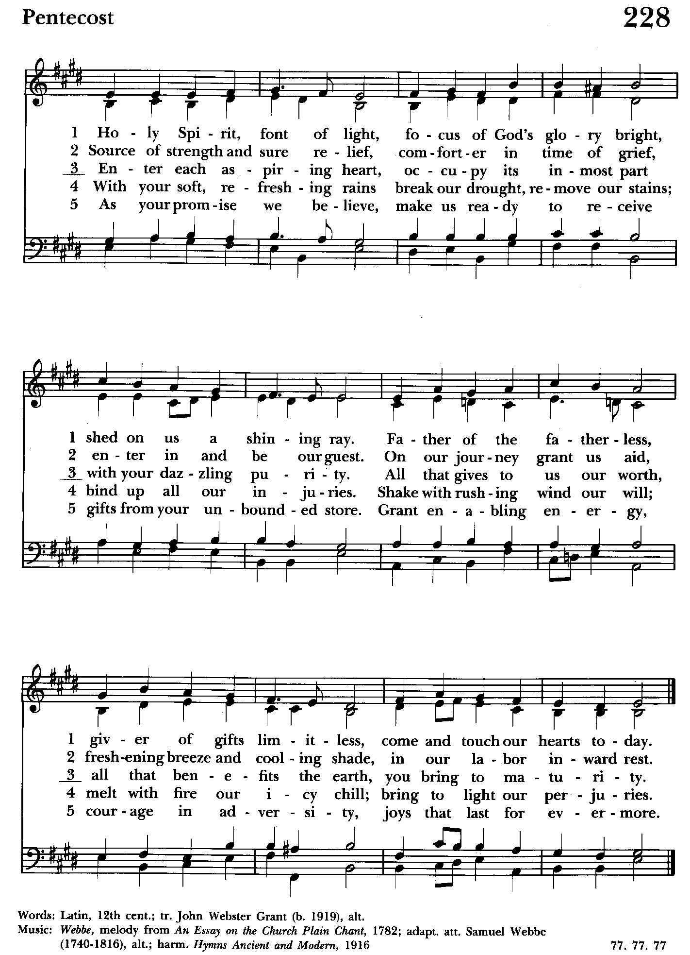

Priest: The Holy Gospel of our Lord Jesus Christ according to John
15:26-27; 16:4b-15

People: Glory to you, Lord Christ.
Jesus said to his disciples, ”When the Advocate comes, whom I will send to you from the Father, the Spirit of truth who comes from the Father, he will testify on my behalf. You also are to testify because you have been with me from the beginning.
“I did not say these things to you from the beginning, because I was with you. But now I am going to him who sent me; yet none of you asks me, ‘Where are you going?’ But because I have said these things to you, sorrow has filled your hearts. Nevertheless I tell you the truth: it is to your advantage that I go away, for if I do not go away, the Advocate will not come to you; but if I go, I will send him to you. And when he comes, he will prove the world wrong about sin and righteousness and judgment: about sin, because they do not believe in me; about righteousness, because I am going to the Father and you will see me no longer; about judgment, because the ruler of this world has been condemned.
“I still have many things to say to you, but you cannot bear them now. When the Spirit of truth comes, he will guide you into all the truth; for he will not speak on his own, but will speak whatever he hears, and he will declare to you the things that are to come. He will glorify me, because he will take what is mine and declare it to you. All that the Father has is mine. For this reason I said that he will take what is mine and declare it to you.

Priest: The Gospel of the Lord.
People: Praise to you, Lord Christ.

Sermon The congregation is seated The Rev. Mark Lobb+

The Nicene Creed Please stand as able BCP 358
We believe in one God,
the Father, the Almighty,
maker of heaven and earth,
of all that is, seen and unseen.
We believe in one Lord, Jesus Christ,
the only Son of God,
eternally begotten of the Father,
God from God, Light from Light,
true God from true God,
begotten, not made,
of one Being with the Father.
Through him all things were made.
For us and for our salvation
he came down from heaven:
by the power of the Holy Spirit
he became incarnate from the Virgin Mary,
and was made man.
For our sake he was crucified under Pontius Pilate;
he suffered death and was buried.
On the third day he rose again
in accordance with the Scriptures;
he ascended into heaven
and is seated at the right hand of the Father.
He will come again in glory to judge the living and the dead,
and his kingdom will have no end.
We believe in the Holy Spirit, the Lord, the giver of life,
who proceeds from the Father and the Son.
With the Father and the Son he is worshiped and glorified.
He has spoken through the Prophets.
We believe in one holy catholic and apostolic Church.
We acknowledge one baptism for the forgiveness of sins.
We look for the resurrection of the dead,
and the life of the world to come. Amen.

The Prayers of the People Form VI Kneel or stand as able BCP 392
Litanist: In peace, we pray to you, Lord God.

Litanist: For all people in their daily life and work;
People: For our families, friends, and neighbors, and for those who are alone.

Litanist: For this community, the nation, and the world;
People: For all who work for justice, freedom, and peace.

Litanist: For the just and proper use of your creation;
People: For the victims of hunger, fear, injustice, and oppression.

Litanist: For all who are in danger, sorrow, or any kind of trouble;
People: For those who minister to the sick, the friendless, and the needy.

Litanist: For the peace and unity of the Church of God;
People: For all who proclaim the Gospel, and all who seek the Truth.

Litanist: For +Justin, Archbishop of Canterbury; +Michael, our Presiding Bishop; +Carrie, our Bishop, +Mark our Interim Rector, for the Wardens, Vestry, Staff, and all members and friends of St. John’s Church. We give you thanks for the service and leadership of +Eugene Taylor Sutton - Fourteenth Bishop of Maryland (retired).
People: For all who serve God in his Church.

Litanist: For the special needs and concerns of this congregation. Especially remember in our prayers, DeMarino Family, Jim & Chris Carden and family, Peggie Dietz, Mike Carden, Pat Carden, Gail Landers, Mary Anne Gebler, Sheila Jones, Gloria Millar, Marisol Aubrey, Nancy Barnhart.

The People may add their own petitions

Litanist: Hear us, Lord;
People: For your mercy is great.
Litanist: We thank you, Lord, for all the blessings of this life.

The People may add their own thanksgivings

Litanist: We will exalt you, O God our King;
People: And praise your Name for ever and ever.

Litanist: We pray for all who have died, that they may have a place in your
eternal kingdom.

The People may add their own petitions
Litanist: Lord, let your loving-kindness be upon them;
People: Who put their trust in you.

Litanist: We pray to you also for the forgiveness of our sins.
People: Have mercy upon us, most merciful Father; in your compassion forgive us our sins, known and unknown, things done and left undone; and so uphold us by your Spirit that we may live and serve you in newness of life, to the honor and glory of your Name; through Jesus Christ our Lord. Amen.

The Celebrant gives the absolution.

The Peace Please stand as able BCP 360

Welcome & Announcements The congregation is seated.

Offertory Anthem: Spirit of God (Choir)

Offertory: Offerings are collected

Presentation Hymn Offerings are presented Please stand as able Hymnal #43, vs. 4
Praise God, from whom all blessings flow; praise him, all creatures here below; praise him above, ye heavenly host: praise Father, Son, and Holy Ghost.

The Holy Communion

THE GREAT THANKSGIVING: Eucharistic Prayer B BCP 367
Celebrant: The Lord be with you.
People: And also with you.
Celebrant: Lift up your hearts.
People: We lift them to the Lord.
Celebrant: Let us give thanks to the Lord our God.
People: It is right to give him thanks and praise.

Then, facing the Holy Table, the Celebrant proceeds
It is right, and a good and joyful thing, always and everywhere to give thanks to you, Father Almighty, Creator of heaven and earth.

Therefore we praise you, joining our voices with Angels and Archangels and with all the company of heaven, who for ever sing this hymn to proclaim the glory of your Name:

Celebrant and People:
Holy, Holy, Holy Lord, God of power and might, Hymnal #S-129
heaven and earth are full of your glory.
Hosanna in the highest.
Blessed is he who comes in the name of the Lord.
Hosanna in the highest.

Please kneel or stand as able

Then the Celebrant continues BCP 368
We give thanks to you, O God, for the goodness and love which you have made known to us in creation; in the calling of Israel to be your people; in your Word spoken through the prophets; and above all in the Word made flesh, Jesus, your Son. For in these last days you sent him to be incarnate from the Virgin Mary, to be the Savior and Redeemer of the world. In him, you have delivered us from evil, and made us worthy to stand before you. In him, you have brought us out of error into truth, out of sin into righteousness, out of death into life.

At the following words concerning the bread, the Celebrant is to hold it, or to lay a hand upon it; and at the words concerning the cup, to hold or place a hand upon the cup and any other vessel containing wine to be consecrated.

On the night before he died for us, our Lord Jesus Christ took bread; and when he had given thanks to you, he broke it, and gave it to his disciples, and said, "Take, eat: This is my Body, which is given for you. Do this for the remembrance of me."

After supper he took the cup of wine; and when he had given thanks, he gave it to them, and said, "Drink this, all of you: This is my Blood of the new Covenant, which is shed for you and for many for the forgiveness of sins. Whenever you drink it, do this for the remembrance of me."

Therefore, according to his command, O Father,

Celebrant and People:
We remember his death,
We proclaim his resurrection,
We await his coming in glory;

The Celebrant continues
And we offer our sacrifice of praise and thanksgiving to you, O Lord of all; presenting to you, from your creation, this bread and this wine. We pray you, gracious God, to send your Holy Spirit upon these gifts that they may be the Sacrament of the Body of Christ and his Blood of the new Covenant. Unite us to your Son in his sacrifice, that we may be acceptable through him, being sanctified by the Holy Spirit. In the fullness of time, put all things in subjection under your Christ, and bring us to that heavenly country where, with St. John and the Blessed Virgin Mary and all your saints, we may enter the everlasting heritage of your sons and daughters; through Jesus Christ our Lord, the firstborn of all creation, the head of the Church, and the author of our salvation.

By him, and with him, and in him, in the unity of the Holy Spirit all honor and glory is yours, Almighty Father, now and for ever. Amen.

And now, as our Savior Christ has taught us, we are bold to say,

Our Father, who art in heaven, BCP p. 364
hallowed be thy Name,
thy kingdom come,
thy will be done,
on earth as in heaven.
Give us this day our daily bread.
And forgive us our trespasses,
as we forgive those
who trespass against us.
And lead us not into temptation,
but deliver us from evil.
For thine is the kingdom,
and the power, and the glory,
for ever and ever. Amen.

Invitation to Communion

The Breaking of the Bread
Celebrant: Alleluia. Christ our Passover is sacrificed for us;
People: Therefore let us keep the feast. Alleluia.
Celebrant: The Gifts of God for the people of God.

The congregation is seated
Communion hymn: Come down, O Love divine Hymnal #516
(see next page)

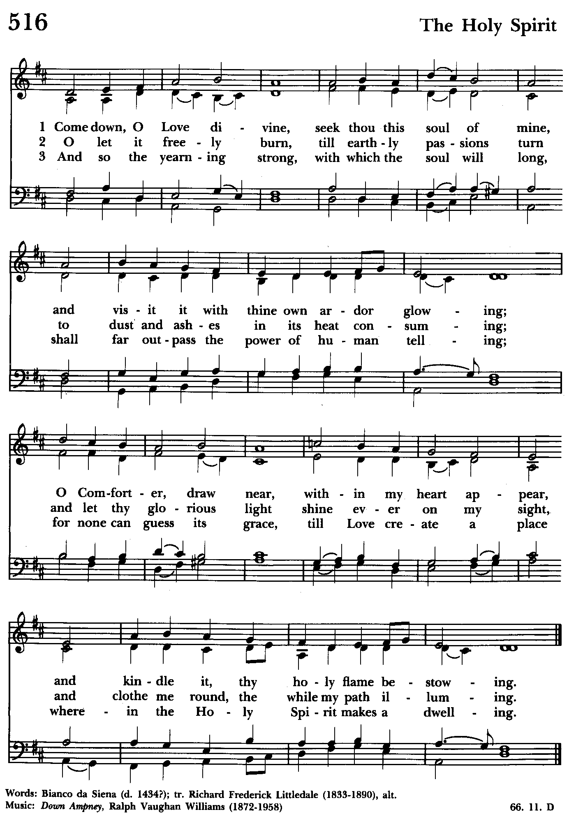

The Post Communion Prayer BCP p. 365
Eternal God, heavenly Father, you have graciously accepted us as living members of your Son our Savior Jesus Christ, and you have fed us with spiritual food in the Sacrament of his Body and Blood. Send us now into the world in peace, and grant us strength and courage to love and serve you with gladness and singleness of heart; through Christ our Lord. Amen.

Blessing

Recessional hymn: O Spirit of Life, O Spirit of God Hymnal #505
(see next page)

The Dismissal (The Alleluias are back!)
Celebrant: Let us go forth in the name of the risen Lord.
People: Thanks be to God. Alleluia, alleluia!

License #A-719154

Serving Today

Celebrant and Preacher: The Rev. Mark Lobb+
Old Testament: Debbie Weaver
Psalm: John Stevens
New Testament: Anne Leland
Prayers of the People: Debbie Weaver
Server: Terry Roe
Music Director: Nancy Heinold
Choir: Anne Leland, Nancy Dellinger, Janine Stevens, Liz Healey,
Camy Schwenk, Karen Smith-Manar, Jacob Johnson, Ty Schwenk
Altar Guild: Stephanie Duchacek and Sandy Roe


Altar Flowers
Given to the Glory of God
by a Generous Donor
in Thanksgiving for the People of St. John’s

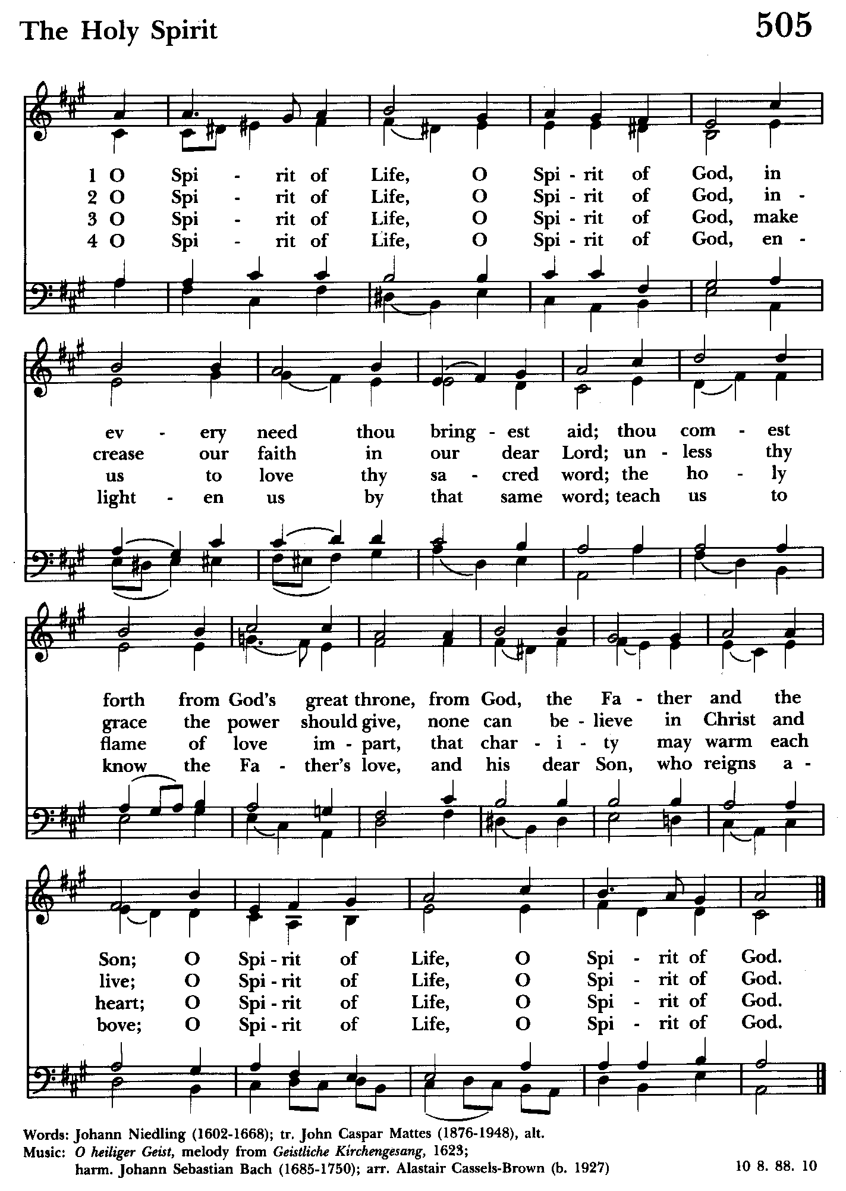

St. John’s Parish Prayer List

Additions and corrections may be made to our Parish Prayer List at any time. All names will be automatically removed from the Parish Prayer List on the 1st Sunday of each month unless you request otherwise. Please contact Angie at <office@stjohnskingsville.org> or 410-592-8570 in the church office with all changes by 10 am Thursdays. Thank you.

We Pray for Those in Need:
Names in BOLD read aloud by all.

DeMarino Family, Jim & Chris Carden and family, Peggie Dietz, Mike Carden, Pat Carden, Gail Landers, Mary Anne Gebler, Sheila Jones, Gloria Millar, Marisol Aubrey.

We Pray for our Homebound

Lily John, Barbara Miller, Nancy Barnhart, Robin Dilworth

We pray for the Church and the World:

For +Justin, Archbishop of Canterbury; for +Michael, our Presiding Bishop; for +Carrie, our Bishop, for +Mark, our Interim Rector, for the Wardens, Vestry, Staff, and all members and friends of St. John’s Church. We give you thanks for the service and leadership of +Eugene Taylor Sutton - Fourteenth Bishop of Maryland (retired).

For the leaders of all nations, especially for Joseph, our President; for Wes, our Governor; for Brandon, Nick, John and Bob, who lead our City and Counties. We pray for all children and youth; for the homeless, the unemployed, and the hungry. We pray for the safety of our loved ones and friends serving in the Armed Forces at home and abroad, and for our enemies, that all our hearts may be turned toward peace throughout the world.

OUTREACH

The FOOD PANTRY is in need of immediate donations. All donations welcome, food or monetary. Thank you so much.
Needed at this time: spaghetti, spaghetti sauce,
jelly/jam


Thank you to the Dilworth family for the donation of the Marigolds for our pots out in front of the Parish Hall.

From the Treasurer
May ’24 Income vs. Expenses:
Projected May Expenses: $14,500
Monies Received as of 5/16: $10,515
Amount Needed to Meet Expenses: $3,985


If you’d like to make a donation to St. John’s you can scan this QR code with your phone’s camera or tap on the link that comes up to make a contribution with either a credit or debit card, Apple Pay or Google Pay. This is a secure site provided by Clover which is a service of PNC Bank.

RECYCLING!

By popular demand, we are recycling. Some parishioners take printed paper home where they have recycling pickup. We now have a blue container located in the Parish Hall. This will be collected and taken for recycling. Aluminum cans will be saved and taken to a recycling center for cash. The proceeds will be donated to the Outreach fund. Each recycled aluminum can also save on the electricity needed to make new aluminum from bauxite.

Choral Choir and Bell Choir


Choir practice, Wednesdays at 7:00 pm

Bell Choir practice, Sundays after the 10:30 service on the 2nd, 3rd and 4th Sundays


SUNDAY SCHOOL
Children’s Sunday school is held from 10:30-11:00 during our 10:30 service. Miss Stephanie and I also would like to invite all interested kids to come and be part of the group!
Mr. John


Yoga classes on Tuesday and Friday evenings 6 to 7 pm and Saturday mornings 9 to 10 am in the Chapel. All experience levels are welcome.

With so much going on, everyone’s help is needed to make things a success. Our volunteers make the Church function. The volunteering of time and talent is greatly appreciated.

We have a Potluck Luncheon on the first Sunday of the month and a Coffee Hour on all other Sundays after the 10:30 service.

What’s Happening This Week at St. John’s

Sunday, May 19—Day of Pentecost-Whitsunday
8:00am: Holy Eucharist, Rite I (Church)
10:30am: Holy Eucharist, Rite II (Church)
10:30am-11:00am: Sunday School
11:30am: Coffee Hour (Parish Hall)

Monday, May 20
12:00-1:00pm: AA Lunch Bunch (Parish Hall)
7:00-8:30pm: Spanish speaking AA group (Parish Hall)

Tuesday, May 21
12:00-1:00pm: AA Lunch Bunch (Parish Hall)
6:00-7:00pm: Yoga (Chapel)

Wednesday, May 22
12:00-1:00pm: AA Lunch Bunch (Parish Hall)
7:00pm: Choir Rehearsal (Church)
7:30pm: AA (Parish Hall)

Thursday, May 23
12:00-1:00pm: AA Lunch Bunch (Parish Hall)
7:00pm: AA (Parish Hall)

Friday, May 24
12:00-1:00pm: AA Lunch Bunch (Parish Hall)
6:00pm -7:00pm: Yoga (Chapel)

Saturday, May 25
9:00am-10:00am: Yoga (Chapel)
8:30pm: AA (Parish Hall)

Sunday, May 26—Trinity Sunday
8:00am: Holy Eucharist, Rite I (Church)
10:30am: Holy Eucharist, Rite II (Church)
10:30am-11:00am: Sunday School
11:30am: Coffee Hour (Parish Hall)

Parish Office is open Monday, Wednesday and Thursday, 9:30am-1:30pm.

