St. John’s Episcopal Church
Kingsville, Maryland
Welcomes You

OUR VISION STATEMENT
We believe that together we will transform the world with love: Come on in!



Seventh Sunday of Easter
May 12, 2024
10:30 am, Rite II

St. John’s Episcopal Church

11901 Belair Road, P. O. Box 187, Kingsville, MD 21087
Facebook: St. John’s Episcopal, Kingsville, MD
Email: office@stjohnskingsville.org
Website: www.stjohnskingsville.org
Church Phone: 410-592-8570
For Pastoral Emergencies: Fr. Mark Lobb+ 443-690-9545

Welcome to worship today! We are glad that you are with us. You are invited to participate in all parts of the service as indicated in the Book of Common Prayer and this service bulletin. If you have any questions, feel free to ask the ushers. Restrooms are located in the Parish hall, the brick building across the parking lot.

I was glad when they said to me, “Let us go to the house of the Lord.” Psalm 122:1

Church Staff

Interim Rector: Father Mark Lobb
Administrative Assistant: Angie Bosley
Organist/Choir Director: Nancy Heinold

The Vestry

Class of 2025 Class of 2026

John Frost John Stevens
Woodie Tingle
Jacob Johnson

Officers
Ty Schwenk—Sr. Warden Terry Roe—Jr. Warden
Elizabeth Healey—Treasurer Anne Leland-Registrar

Parish Committee Chairpersons

Altar Guild: Elizabeth Healey
Auxiliary Committee: Michele Lozanski
Cemetery Committee: Terry Roe

10:30 am Worship
Holy Eucharist, Rite Two

Prelude:
The Word of God

Processional hymn: Hail the day that sees him rise, Alleluia Hymnal #214
(see next page)

The congregation remains standing as able
Celebrant: Alleluia. Christ is risen. BCP 355
People: The Lord is risen indeed. Alleluia.

Celebrant: Almighty God, to you all hearts are open, all desires known, and from you no secrets are hid: Cleanse the thoughts of our hearts by the inspiration of your Holy Spirit, that we may perfectly love you, and worthily magnify your holy Name; through Christ our Lord. Amen.

Gloria Hymnal #S-278
Glory to God in the highest,
and peace to his people on earth.
Lord God, heavenly King,
almighty God and Father,
we worship you, we give you thanks,
we praise you for your glory.
Lord Jesus Christ, only Son of the Father,
Lord God, Lamb of God,
you take away the sin of the world:
have mercy on us;
you are seated at the right hand of the Father:
receive our prayer.
For you alone are the Holy One,
you alone are the Lord,
you alone are the Most High,
Jesus Christ,
with the Holy Spirit,
in the glory of God the Father. Amen.

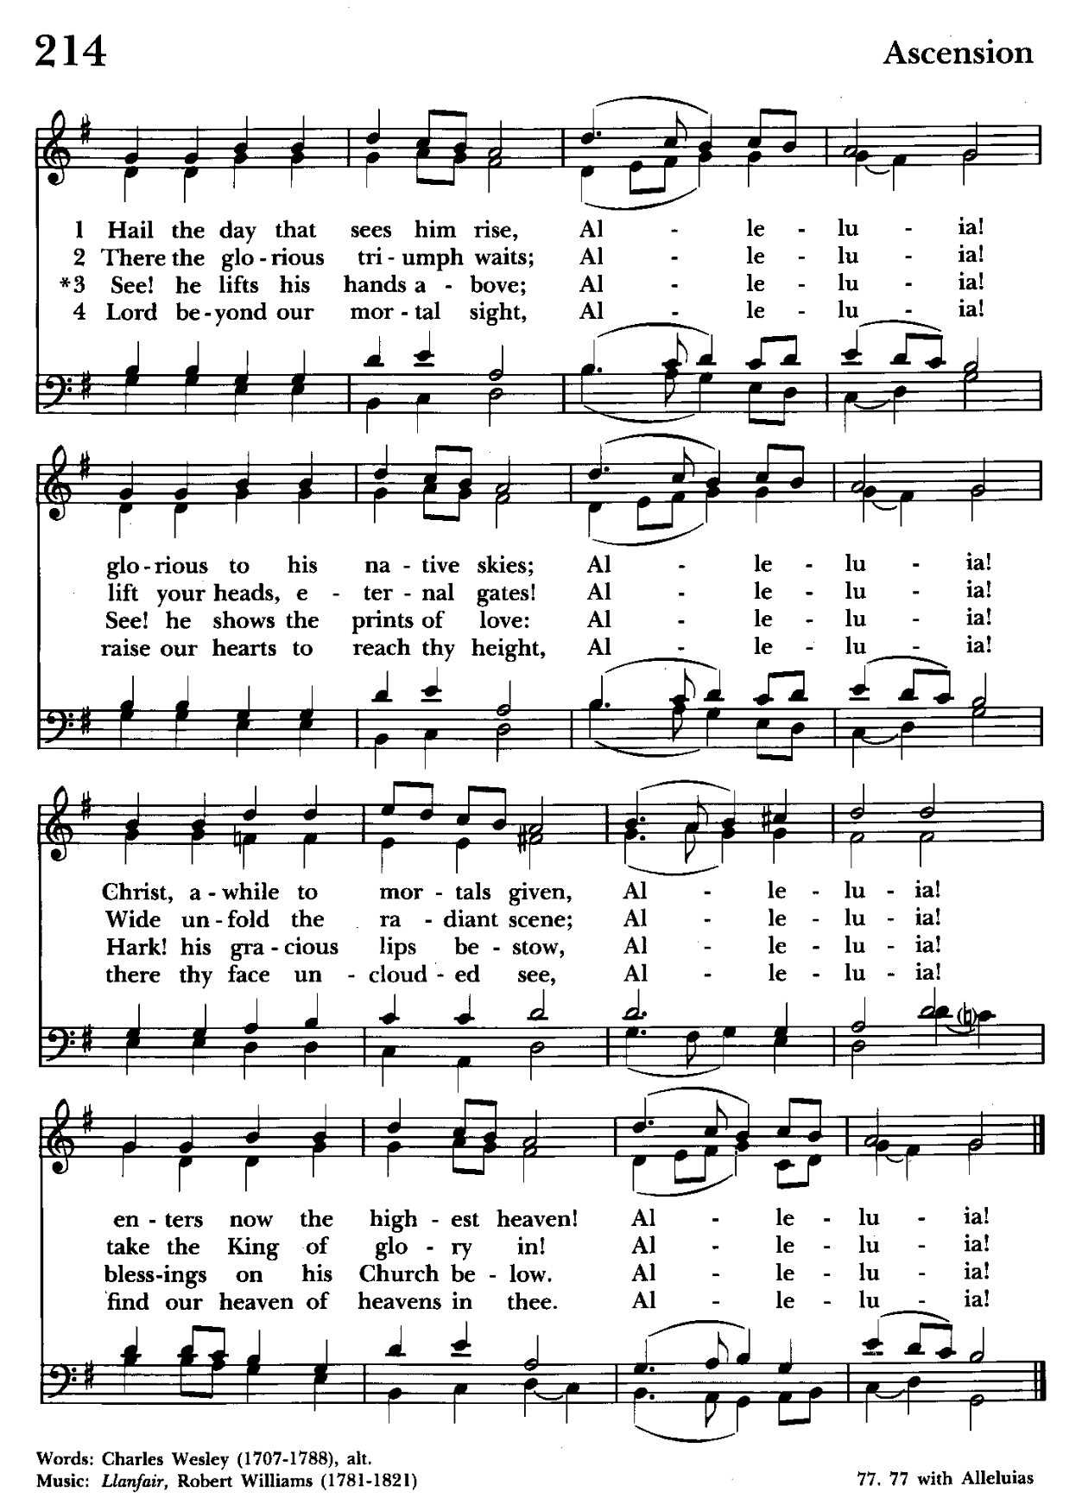

Celebrant: The Lord be with you.
People: And also with you.
Celebrant: Let us pray.

The Collect of the Day Kneel or stand as able BCP 226
O God, the King of glory, you have exalted your only Son Jesus Christ with great triumph to your kingdom in heaven: Do not leave us comfortless, but send us your Holy Spirit to strengthen us, and exalt us to that place where our Savior Christ has gone before; who lives and reigns with you and the Holy Spirit, one God, in glory everlasting. Amen.

The congregation is seated.

A Reading from the Acts of the Apostles 1:15-17, 21-26
In those days Peter stood up among the believers (together the crowd numbered about one hundred twenty persons) and said, "Friends, the scripture had to be fulfilled, which the Holy Spirit through David foretold concerning Judas, who became a guide for those who arrested Jesus-- for he was numbered among us and was allotted his share in this ministry. So one of the men who have accompanied us during all the time that the Lord Jesus went in and out among us, beginning from the baptism of John until the day when he was taken up from us-- one of these must become a witness with us to his resurrection." So they proposed two, Joseph called Barsabbas, who was also known as Justus, and Matthias. Then they prayed and said, "Lord, you know everyone's heart. Show us which one of these two you have chosen to take the place in this ministry and apostleship from which Judas turned aside to go to his own place." And they cast lots for them, and the lot fell on Matthias; and he was added to the eleven apostles.

Reader: The Word of the Lord.
People: Thanks be to God.

Psalm 1 (Prayed as directed.)
1 Happy are they who have not walked in the counsel of the wicked, *
nor lingered in the way of sinners,
nor sat in the seats of the scornful!
2 Their delight is in the law of the Lord, *
and they meditate on his law day and night.
3 They are like trees planted by streams of water,
bearing fruit in due season, with leaves that do not wither; *
everything they do shall prosper.
4 It is not so with the wicked; *
they are like chaff which the wind blows away.
5 Therefore the wicked shall not stand upright when judgment comes, *
nor the sinner in the council of the righteous.
6 For the Lord knows the way of the righteous, *
but the way of the wicked is doomed.

A Reading from the First Letter of John 5:9-13
If we receive human testimony, the testimony of God is greater; for this is the testimony of God that he has testified to his Son. Those who believe in the Son of God have the testimony in their hearts. Those who do not believe in God have made him a liar by not believing in the testimony that God has given concerning his Son. And this is the testimony: God gave us eternal life, and this life is in his Son. Whoever has the Son has life; whoever does not have the Son of God does not have life. I write these things to you who believe in the name of the Son of God, so that you may know that you have eternal life.

Reader: The Word of the Lord.
People: Thanks be to God.

Gradual hymn: The Lord ascendeth up on high Hymnal #219
(see next page)
The congregation remains standing as able

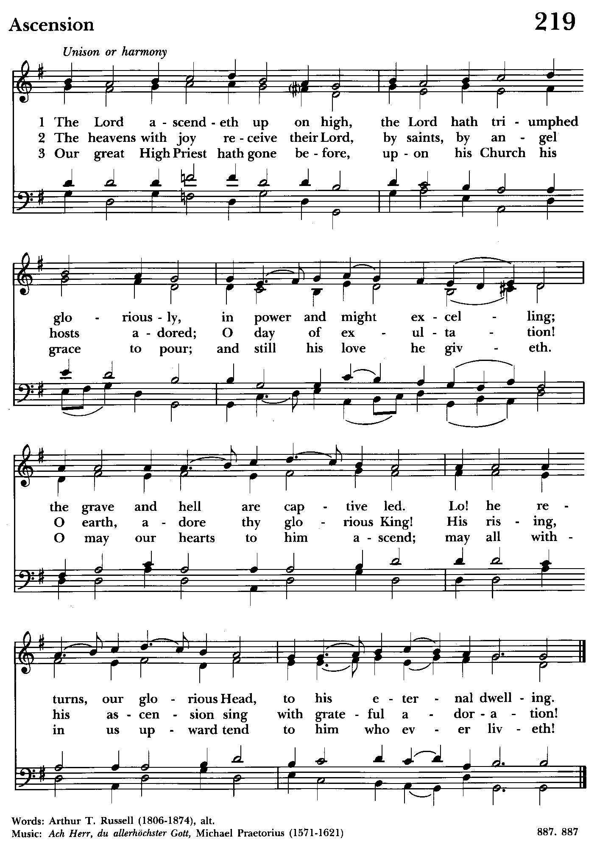

Priest: The Holy Gospel of our Lord Jesus Christ according to John 17:6-19

People: Glory to you, Lord Christ.
Jesus prayed for his disciples, “I have made your name known to those whom you gave me from the world. They were yours, and you gave them to me, and they have kept your word. Now they know that everything you have given me is from you; for the words that you gave to me I have given to them, and they have received them and know in truth that I came from you; and they have believed that you sent me. I am asking on their behalf; I am not asking on behalf of the world, but on behalf of those whom you gave me, because they are yours. All mine are yours, and yours are mine; and I have been glorified in them. And now I am no longer in the world, but they are in the world, and I am coming to you. Holy Father, protect them in your name that you have given me, so that they may be one, as we are one. While I was with them, I protected them in your name that you have given me. I guarded them, and not one of them was lost except the one destined to be lost, so that the scripture might be fulfilled. But now I am coming to you, and I speak these things in the world so that they may have my joy made complete in themselves. I have
given them your word, and the world has hated them because they do not belong to the world, just as I do not belong to the world. I am not asking you to take them out of the world, but I ask you to protect them from the evil one. They do not
belong to the world, just as I do not belong to the world. Sanctify them in the truth; your word is truth. As you have sent me into the world, so I have sent them into the world. And for their sakes I sanctify myself, so that they also may be sanctified in truth.”

Priest: The Gospel of the Lord.
People: Praise to you, Lord Christ.

Sermon The congregation is seated The Rev. Mark Lobb+

The Nicene Creed Please stand as able BCP 358
We believe in one God,
the Father, the Almighty,
maker of heaven and earth,
of all that is, seen and unseen.
We believe in one Lord, Jesus Christ,
the only Son of God,
eternally begotten of the Father,
God from God, Light from Light,
true God from true God,
begotten, not made,
of one Being with the Father.
Through him all things were made.
For us and for our salvation
he came down from heaven:
by the power of the Holy Spirit
he became incarnate from the Virgin Mary,
and was made man.
For our sake he was crucified under Pontius Pilate;
he suffered death and was buried.
On the third day he rose again
in accordance with the Scriptures;
he ascended into heaven
and is seated at the right hand of the Father.
He will come again in glory to judge the living and the dead,
and his kingdom will have no end.
We believe in the Holy Spirit, the Lord, the giver of life,
who proceeds from the Father and the Son.
With the Father and the Son he is worshiped and glorified.
He has spoken through the Prophets.
We believe in one holy catholic and apostolic Church.
We acknowledge one baptism for the forgiveness of sins.
We look for the resurrection of the dead,
and the life of the world to come. Amen.

The Prayers of the People Form VI Kneel or stand as able BCP 392
Litanist: In peace, we pray to you, Lord God.

Litanist: For all people in their daily life and work;
People: For our families, friends, and neighbors, and for those who are alone.

Litanist: For this community, the nation, and the world;
People: For all who work for justice, freedom, and peace.

Litanist: For the just and proper use of your creation;
People: For the victims of hunger, fear, injustice, and oppression.

Litanist: For all who are in danger, sorrow, or any kind of trouble;
People: For those who minister to the sick, the friendless, and the needy.

Litanist: For the peace and unity of the Church of God;
People: For all who proclaim the Gospel, and all who seek the Truth.

Litanist: For +Justin, Archbishop of Canterbury; +Michael, our Presiding Bishop; +Carrie, our Bishop, +Mark our Interim Rector, for the Wardens, Vestry, Staff, and all members and friends of St. John’s Church. We give you thanks for the service and leadership of +Eugene Taylor Sutton - Fourteenth Bishop of Maryland (retired).
People: For all who serve God in his Church.

Litanist: For the special needs and concerns of this congregation. Especially remember in our prayers, DeMarino Family, Jim & Chris Carden and family, Peggie Dietz, Mike Carden, Pat Carden, Gail Landers, Mary Anne Gebler, Sheila Jones, Gloria Millar, Barbara Miller.

The People may add their own petitions

Litanist: Hear us, Lord;
People: For your mercy is great.
Litanist: We thank you, Lord, for all the blessings of this life.

The People may add their own thanksgivings

Litanist: We will exalt you, O God our King;
People: And praise your Name for ever and ever.

Litanist: We pray for all who have died, that they may have a place in your
eternal kingdom.

The People may add their own petitions
Litanist: Lord, let your loving-kindness be upon them;
People: Who put their trust in you.

Litanist: We pray to you also for the forgiveness of our sins.
People: Have mercy upon us, most merciful Father; in your compassion forgive us our sins, known and unknown, things done and left undone; and so uphold us by your Spirit that we may live and serve you in newness of life, to the honor and glory of your Name; through Jesus Christ our Lord. Amen.

The Celebrant gives the absolution.

The Peace Please stand as able BCP 360

Welcome & Announcements The congregation is seated.

Offertory Hymn: Alleluia! Sing to Jesus Hymnal #460
(see next 2 pages)

Offertory: Offerings are collected

Presentation Hymn Offerings are presented Please stand as able Hymnal #43, vs. 4
Praise God, from whom all blessings flow; praise him, all creatures here below; praise him above, ye heavenly host: praise Father, Son, and Holy Ghost.

The Holy Communion

THE GREAT THANKSGIVING: Eucharistic Prayer B BCP 367
Celebrant: The Lord be with you.
People: And also with you.
Celebrant: Lift up your hearts.
People: We lift them to the Lord.
Celebrant: Let us give thanks to the Lord our God.
People: It is right to give him thanks and praise.

Then, facing the Holy Table, the Celebrant proceeds
It is right, and a good and joyful thing, always and everywhere to give thanks to you, Father Almighty, Creator of heaven and earth.

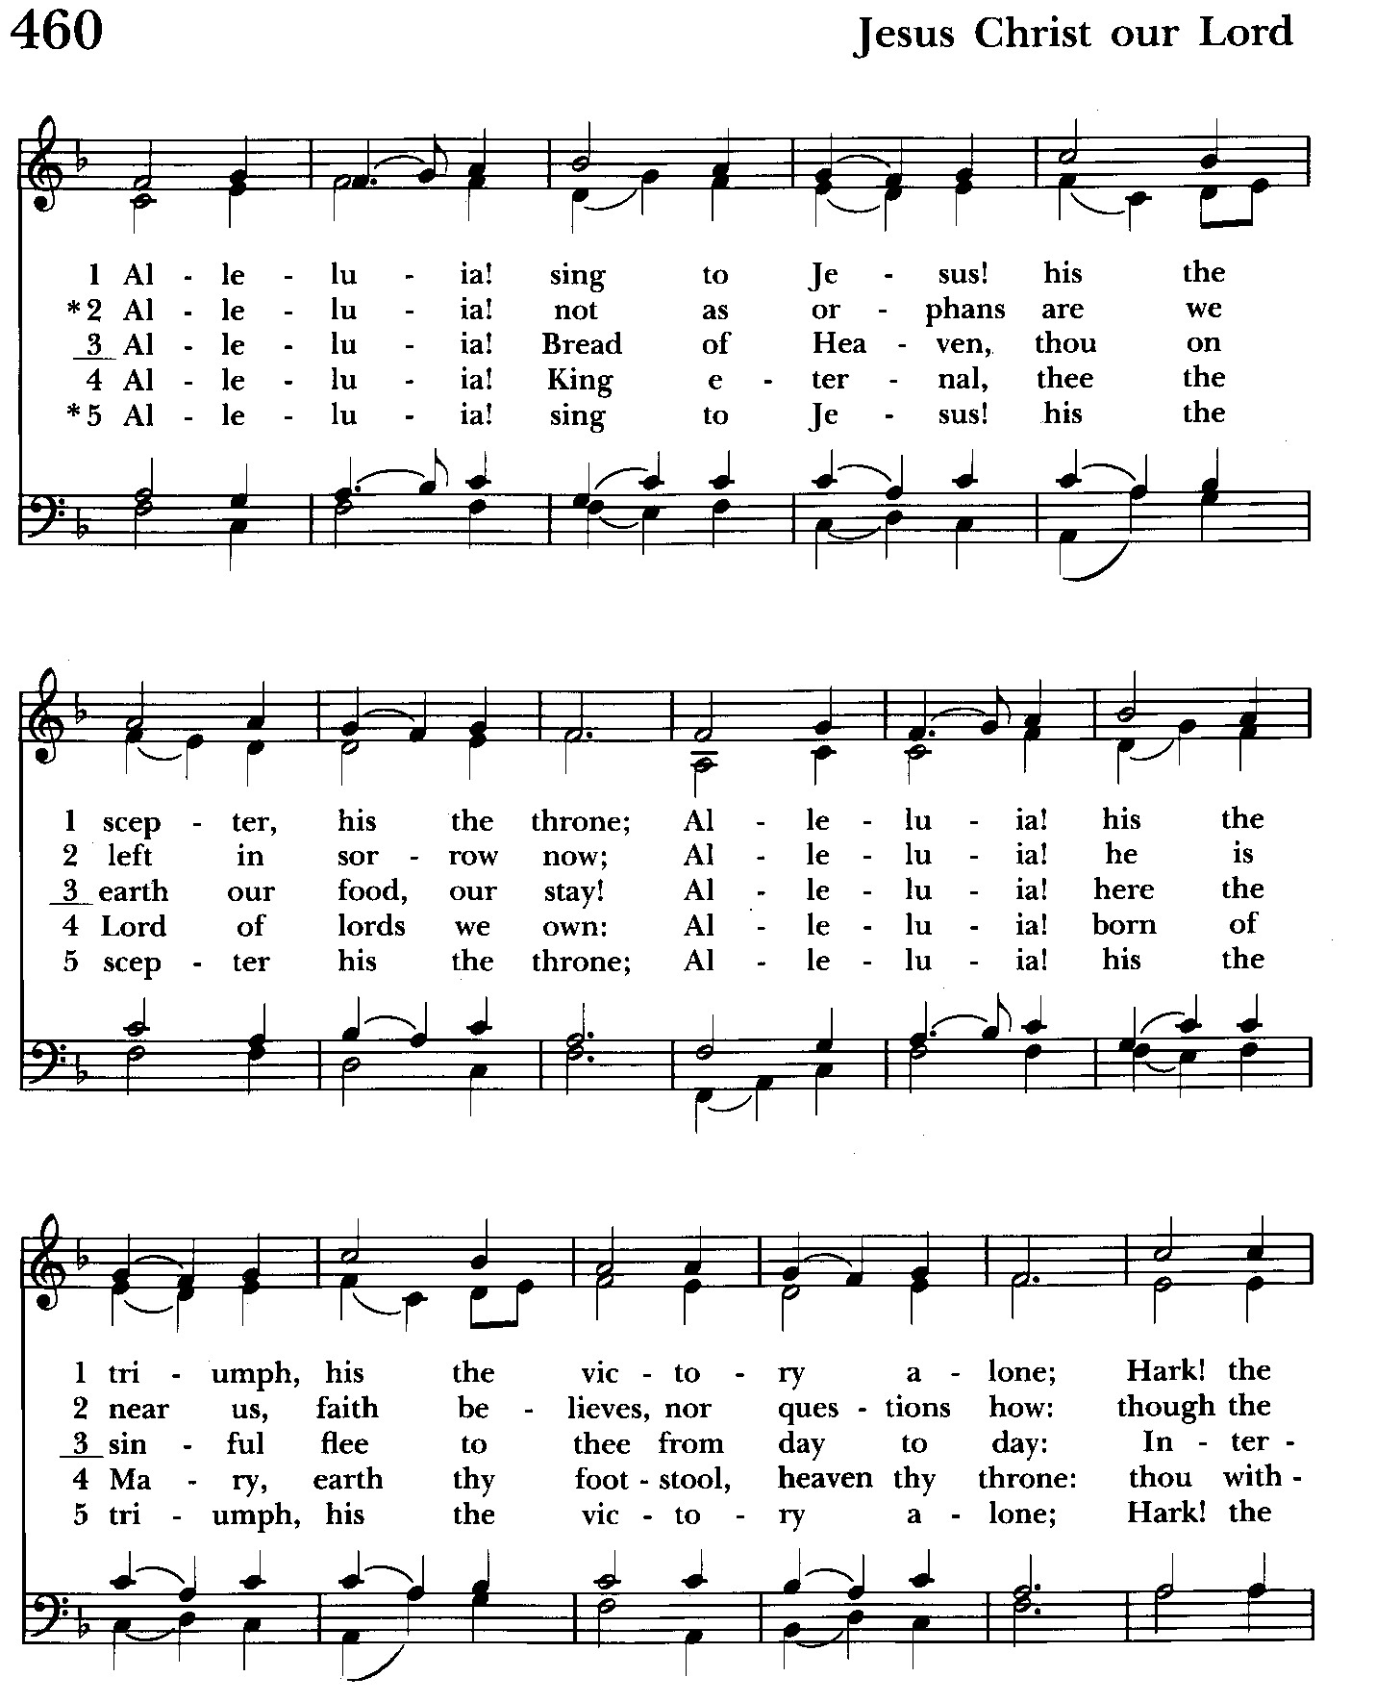

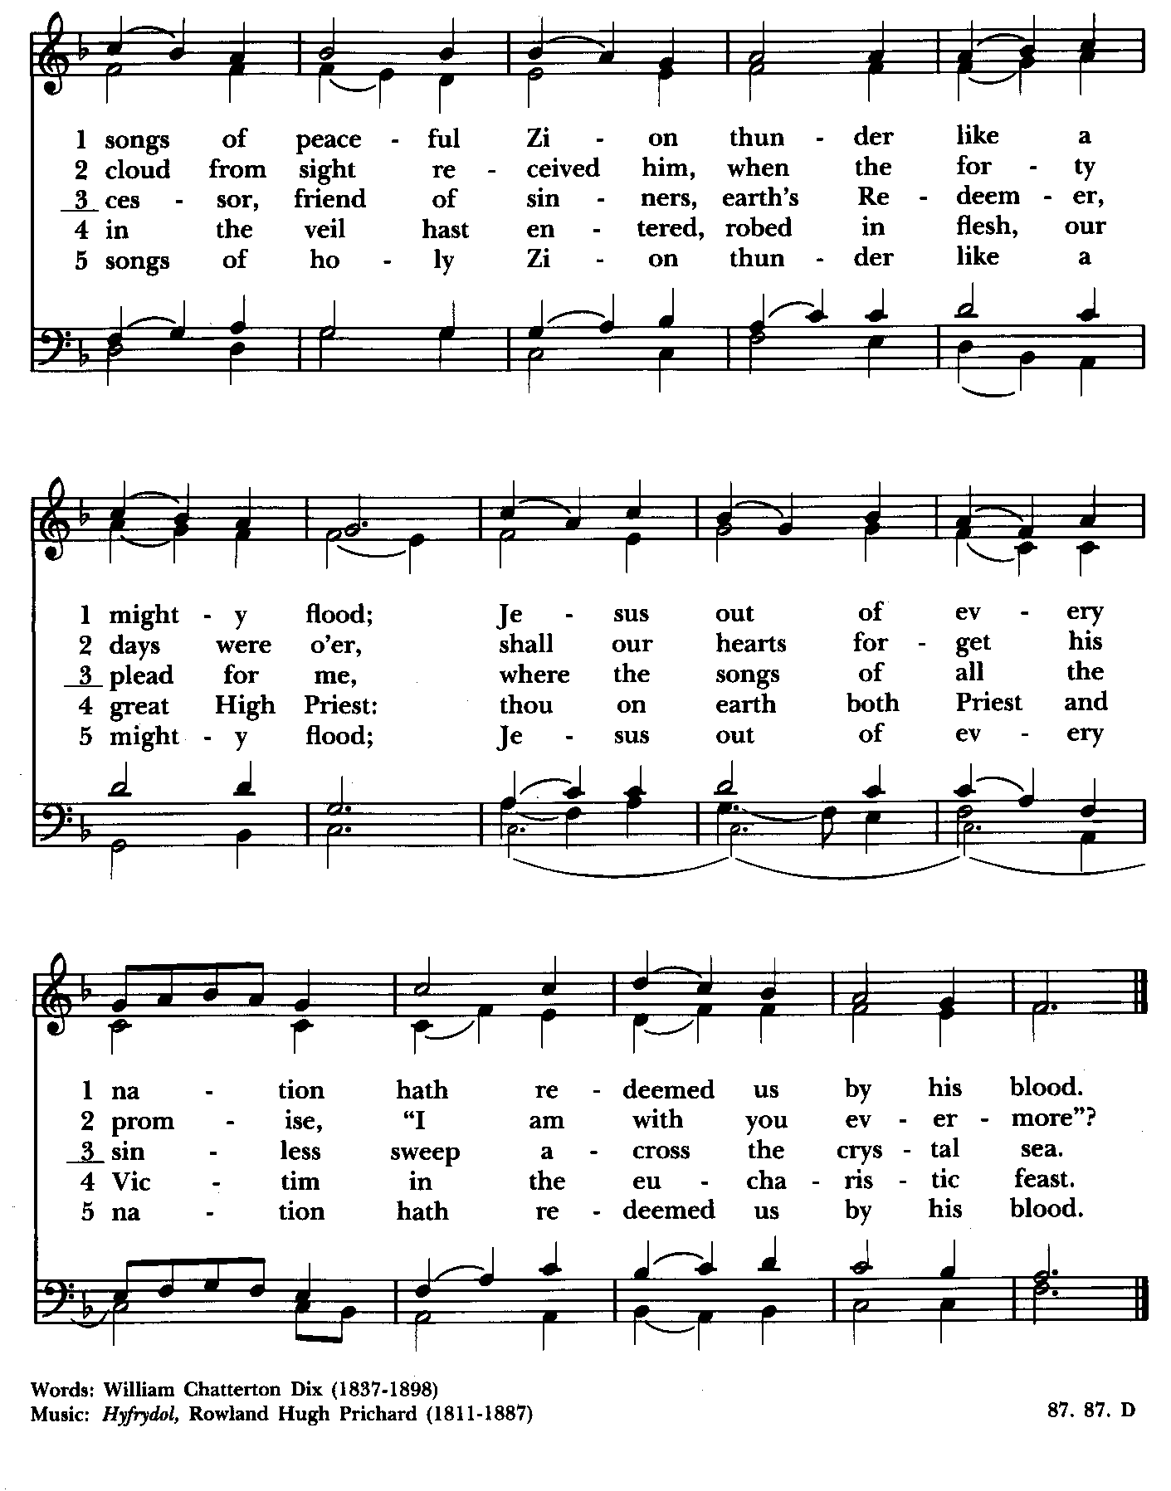

Therefore we praise you, joining our voices with Angels and Archangels and with all the company of heaven, who for ever sing this hymn to proclaim the glory of your Name:

Celebrant and People:
Holy, Holy, Holy Lord, God of power and might, Hymnal #S-129
heaven and earth are full of your glory.
Hosanna in the highest.
Blessed is he who comes in the name of the Lord.
Hosanna in the highest.

Please kneel or stand as able

Then the Celebrant continues BCP 368
We give thanks to you, O God, for the goodness and love which you have made known to us in creation; in the calling of Israel to be your people; in your Word spoken through the prophets; and above all in the Word made flesh, Jesus, your Son. For in these last days you sent him to be incarnate from the Virgin Mary, to be the Savior and Redeemer of the world. In him, you have delivered us from evil, and made us worthy to stand before you. In him, you have brought us out of error into truth, out of sin into righteousness, out of death into life.

At the following words concerning the bread, the Celebrant is to hold it, or to lay a hand upon it; and at the words concerning the cup, to hold or place a hand upon the cup and any other vessel containing wine to be consecrated.

On the night before he died for us, our Lord Jesus Christ took bread; and when he had given thanks to you, he broke it, and gave it to his disciples, and said, "Take, eat: This is my Body, which is given for you. Do this for the remembrance of me."

After supper he took the cup of wine; and when he had given thanks, he gave it to them, and said, "Drink this, all of you: This is my Blood of the new Covenant, which is shed for you and for many for the forgiveness of sins. Whenever you drink it, do this for the remembrance of me."

Therefore, according to his command, O Father,

Celebrant and People:
We remember his death,
We proclaim his resurrection,
We await his coming in glory;

The Celebrant continues
And we offer our sacrifice of praise and thanksgiving to you, O Lord of all; presenting to you, from your creation, this bread and this wine. We pray you, gracious God, to send your Holy Spirit upon these gifts that they may be the Sacrament of the Body of Christ and his Blood of the new Covenant. Unite us to your Son in his sacrifice, that we may be acceptable through him, being sanctified by the Holy Spirit. In the fullness of time, put all things in subjection under your Christ, and bring us to that heavenly country where, with St. John and the Blessed Virgin Mary and all your saints, we may enter the everlasting heritage of your sons and daughters; through Jesus Christ our Lord, the firstborn of all creation, the head of the Church, and the author of our salvation.

By him, and with him, and in him, in the unity of the Holy Spirit all honor and glory is yours, Almighty Father, now and for ever. Amen.

And now, as our Savior Christ has taught us, we are bold to say,

Our Father, who art in heaven, BCP p. 364
hallowed be thy Name,
thy kingdom come,
thy will be done,
on earth as in heaven.
Give us this day our daily bread.
And forgive us our trespasses,
as we forgive those
who trespass against us.
And lead us not into temptation,
but deliver us from evil.
For thine is the kingdom,
and the power, and the glory,
for ever and ever. Amen.

Invitation to Communion

The Breaking of the Bread
Celebrant: Alleluia. Christ our Passover is sacrificed for us;
People: Therefore let us keep the feast. Alleluia.
Celebrant: The Gifts of God for the people of God.

The congregation is seated
Communion hymn: Draw nigh and take the Body of the Lord Hymnal #328

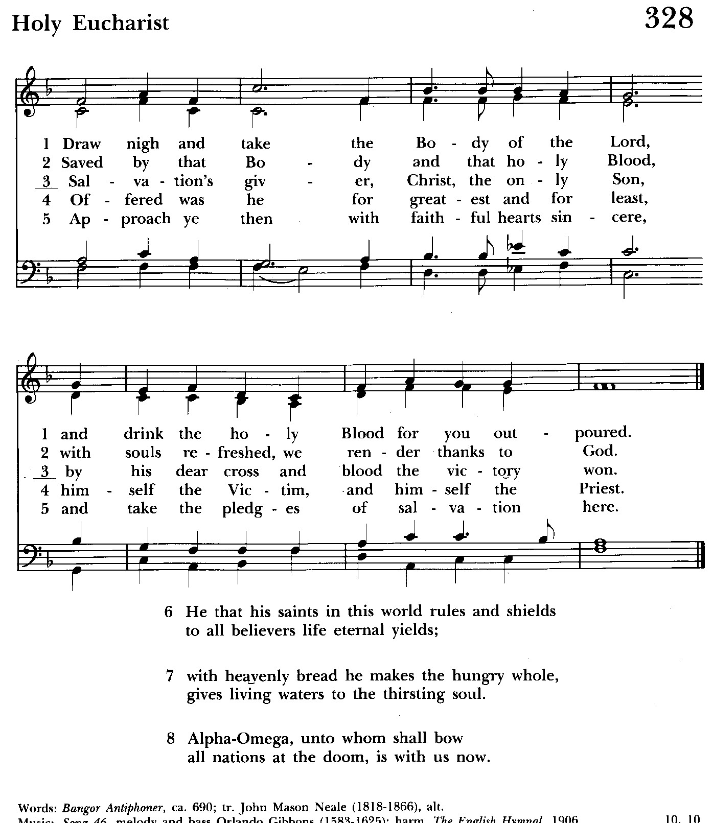

The Post Communion Prayer BCP p. 365
Eternal God, heavenly Father, you have graciously accepted us as living members of your Son our Savior Jesus Christ, and you have fed us with spiritual food in the Sacrament of his Body and Blood. Send us now into the world in peace, and grant us strength and courage to love and serve you with gladness and singleness of heart; through Christ our Lord. Amen.

Blessing

Recessional hymn: All praise to thee, for thou, O King divine Hymnal #477
The Dismissal (The Alleluias are back!)
Celebrant: Let us go forth in the name of the risen Lord.
People: Thanks be to God. Alleluia, alleluia!

License #A-719154

Serving Today

Celebrant and Preacher: The Rev. Mark Lobb+
Old Testament: John Stevens
Psalm: John Stevens
New Testament: Liz Healey
Prayers of the People: John Frost
Server: Marguerite Lobb
Music Director: Nancy Heinold
Altar Guild: Stephanie Duchacek and Sandy Roe

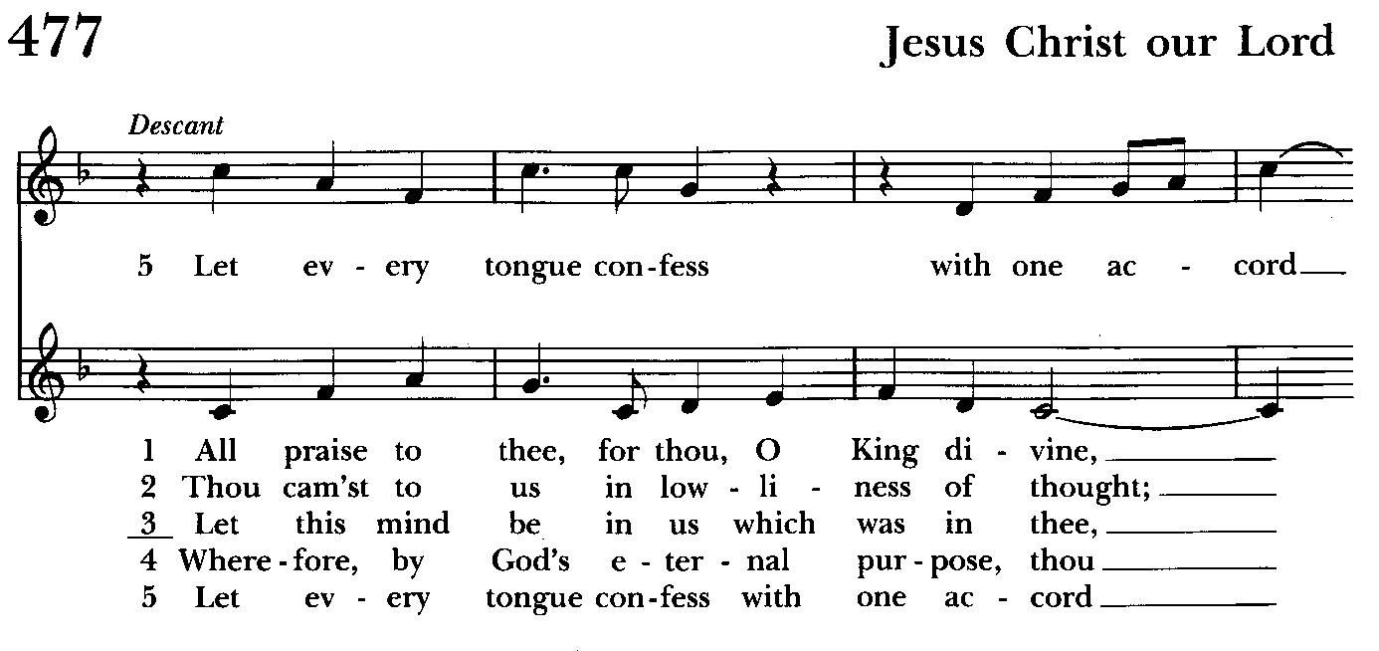

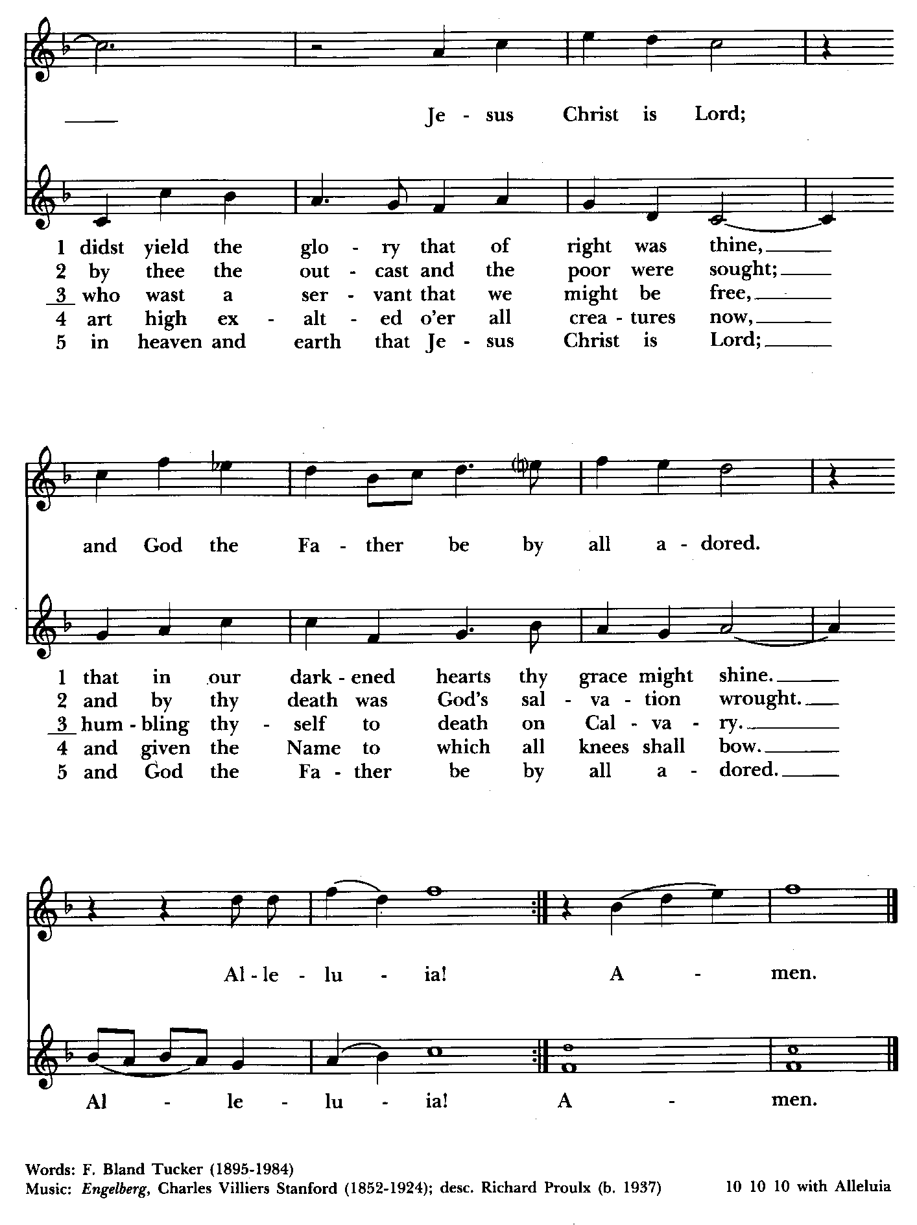


Altar Flowers
Given to the Glory of God
by Liz Healey
in memory of Lorraine Healey and May Banks

From the Treasurer
May ’24 Income vs. Expenses:
Projected May Expenses: $14,500
Monies Received as of 5/9: $9,114
Amount Needed to Meet Expenses: $5,386

St. John’s Parish Prayer List

Additions and corrections may be made to our Parish Prayer List at any time. All names will be automatically removed from the Parish Prayer List on the 1st Sunday of each month unless you request otherwise. Please contact Angie at <office@stjohnskingsville.org> or 410-592-8570 in the church office with all changes by 10 am Thursdays. Thank you.

We Pray for Those in Need:
Names in BOLD read aloud by all.

DeMarino Family, Jim & Chris Carden and family, Peggie Dietz, Mike Carden, Pat Carden, Gail Landers, Mary Anne Gebler, Sheila Jones, Gloria Millar.

We Pray for our Homebound

Lily John, Barbara Miller, Nancy Barnhart, Robin Dilworth

We pray for the Church and the World:

For +Justin, Archbishop of Canterbury; for +Michael, our Presiding Bishop; for +Carrie, our Bishop, for +Mark, our Interim Rector, for the Wardens, Vestry, Staff, and all members and friends of St. John’s Church. We give you thanks for the service and leadership of +Eugene Taylor Sutton - Fourteenth Bishop of Maryland (retired).

For the leaders of all nations, especially for Joseph, our President; for Wes, our Governor; for Brandon, Nick, John and Bob, who lead our City and Counties. We pray for all children and youth; for the homeless, the unemployed, and the hungry. We pray for the safety of our loved ones and friends serving in the Armed Forces at home and abroad, and for our enemies, that all our hearts may be turned toward peace throughout the world.

OUTREACH

The FOOD PANTRY is in need of immediate donations. All donations welcome, food or monetary. Thank you so much.
Needed at this time: spaghetti, spaghetti sauce,
jelly/jam


If you’d like to make a donation to St. John’s you can scan this QR code with your phone’s camera or tap on the link that comes up to make a contribution with either a credit or debit card, Apple Pay or Google Pay. This is a secure site provided by Clover which is a service of PNC Bank.



St. John’s Flea Market is coming up!!
May 18th, 8 am-1 pm
You can now bring in your gently used items to the Parish Hall (storage room next to the kitchen). Volunteers needed also for baking! Thank you so much!!

Brownies (2/bag) and cookies (4/bag) can be dropped off during
office hours on 5/16 [9:30-1:30] or Friday 5/17 from noon to 8 pm.

We are also accepting donations of Sprite, Sunkist Orange, Water, Diet Pepsi, Diet Coke, Brisk Iced Tea for the Flea Market and other Upcoming Events.

RECYCLING!

By popular demand, we are recycling. Some parishioners take printed paper home where they have recycling pickup. We now have a blue container located in the Parish Hall. This will be collected and taken for recycling. Aluminum cans will be saved and taken to a recycling center for cash. The proceeds will be donated to the Outreach fund. Each recycled aluminum can also saves on the electricity needed to make new aluminum from bauxite.

Choral Choir and Bell Choir

Choir practice, Wednesdays at 7:00 pm

Bell Choir practice, Sundays after the 10:30 service on the 2nd, 3rd and 4th Sundays

SUNDAY SCHOOL

Children’s Sunday school is held from 10:30-11:00 during our 10:30 service. Miss Stephanie and I also would like to invite all interested kids to come and be part of the group!

Mr. John


Yoga classes on Tuesday and Friday evenings 6 to 7 pm and Saturday mornings 9 to 10 am in the Chapel. All experience levels are welcome.


Dates to put in your calendar:
Saturday, May 18th, Flea Market. 8am-1pm. Baked goods needed and volunteers needed. Also, you may bring in gently used items for St. John’s table.

We have St. John’s shirts available for a nominal charge.
With so much going on, everyone’s help is needed to make things a success. Our volunteers make the Church function. The volunteering of time and talent is greatly appreciated.

We have a Potluck Luncheon on the first Sunday of the month and a Coffee Hour on all other Sundays after the 10:30 service.

What’s Happening This Week at St. John’s

Sunday, May 12—Seventh Sunday of Easter
8:00am: Holy Eucharist, Rite I (Church)
10:30am: Holy Eucharist, Rite II (Church)
10:30am-11:00am: Sunday School
11:30am: Coffee Hour (Parish Hall)

Monday, May 13
12:00-1:00pm: AA Lunch Bunch (Parish Hall)
7:00-8:30pm: Spanish speaking AA group (Parish Hall)

Tuesday, May 14
12:00-1:00pm: AA Lunch Bunch (Parish Hall)
6:00-7:00pm: Yoga (Chapel)

Wednesday, May 15
12:00-1:00pm: AA Lunch Bunch (Parish Hall)
7:00pm: Choir Rehearsal (Church)
7:30pm: AA (Parish Hall)

Thursday, May 16
12:00-1:00pm: AA Lunch Bunch (Parish Hall)
7:00pm: AA (Parish Hall)

Friday, May 17
12:00-1:00pm: AA Lunch Bunch (Parish Hall)
6:00pm -7:00pm: Yoga (Chapel)

Saturday, May 18
8:00am-1:00pm: Flea Market
9:00am-10:00am: Yoga (Chapel)
8:30pm: AA (Parish Hall)

Sunday, May 19-Day of Pentecost-Whitsunday
8:00am: Holy Eucharist, Rite I (Church)
10:30am: Holy Eucharist, Rite II (Church)
10:30am-11:00am: Sunday School
11:30am: Coffee Hour (Parish Hall)

Parish Office is open Monday, Wednesday and Thursday, 9:30am-1:30pm.

