St. John’s Episcopal Church
Kingsville, Maryland
Welcomes You

OUR VISION STATEMENT
We believe that together we will transform the world with love: Come on in!



Fifth Sunday of Easter
April 28, 2024
10:30 am, Rite II

St. John’s Episcopal Church

11901 Belair Road, P. O. Box 187, Kingsville, MD 21087
Facebook: St. John’s Episcopal, Kingsville, MD
Email: office@stjohnskingsville.org
Website: www.stjohnskingsville.org
Church Phone: 410-592-8570
For Pastoral Emergencies: Fr. Mark Lobb+ 443-690-9545

Welcome to worship today! We are glad that you are with us. You are invited to participate in all parts of the service as indicated in the Book of Common Prayer and this service bulletin. If you have any questions, feel free to ask the ushers. Restrooms are located in the Parish hall, the brick building across the parking lot.

I was glad when they said to me, “Let us go to the house of the Lord.” Psalm 122:1

Church Staff

Interim Rector: Father Mark Lobb
Administrative Assistant: Angie Bosley
Organist/Choir Director: Nancy Heinold

The Vestry

Class of 2025 Class of 2026

John Frost John Stevens
Woodie Tingle
Jacob Johnson

Officers
Ty Schwenk—Sr. Warden Terry Roe—Jr. Warden
Elizabeth Healey—Treasurer Anne Leland-Registrar

Parish Committee Chairpersons

Altar Guild: Elizabeth Healey
Auxiliary Committee: Michele Lozanski
Cemetery Committee: Terry Roe

10:30 am Worship
Holy Eucharist, Rite Two

Prelude:
The Word of God

Processional hymn: God is Love, let heaven adore him Hymnal #379
(see next page)

The congregation remains standing as able
Celebrant: Alleluia. Christ is risen. BCP 355
People: The Lord is risen indeed. Alleluia.

Celebrant: Almighty God, to you all hearts are open, all desires known, and from you no secrets are hid: Cleanse the thoughts of our hearts by the inspiration of your Holy Spirit, that we may perfectly love you, and worthily magnify your holy Name; through Christ our Lord. Amen.

Gloria Hymnal #S-278
Glory to God in the highest,
and peace to his people on earth.
Lord God, heavenly King,
almighty God and Father,
we worship you, we give you thanks,
we praise you for your glory.
Lord Jesus Christ, only Son of the Father,
Lord God, Lamb of God,
you take away the sin of the world:
have mercy on us;
you are seated at the right hand of the Father:
receive our prayer.
For you alone are the Holy One,
you alone are the Lord,
you alone are the Most High,
Jesus Christ,
with the Holy Spirit,
in the glory of God the Father. Amen.

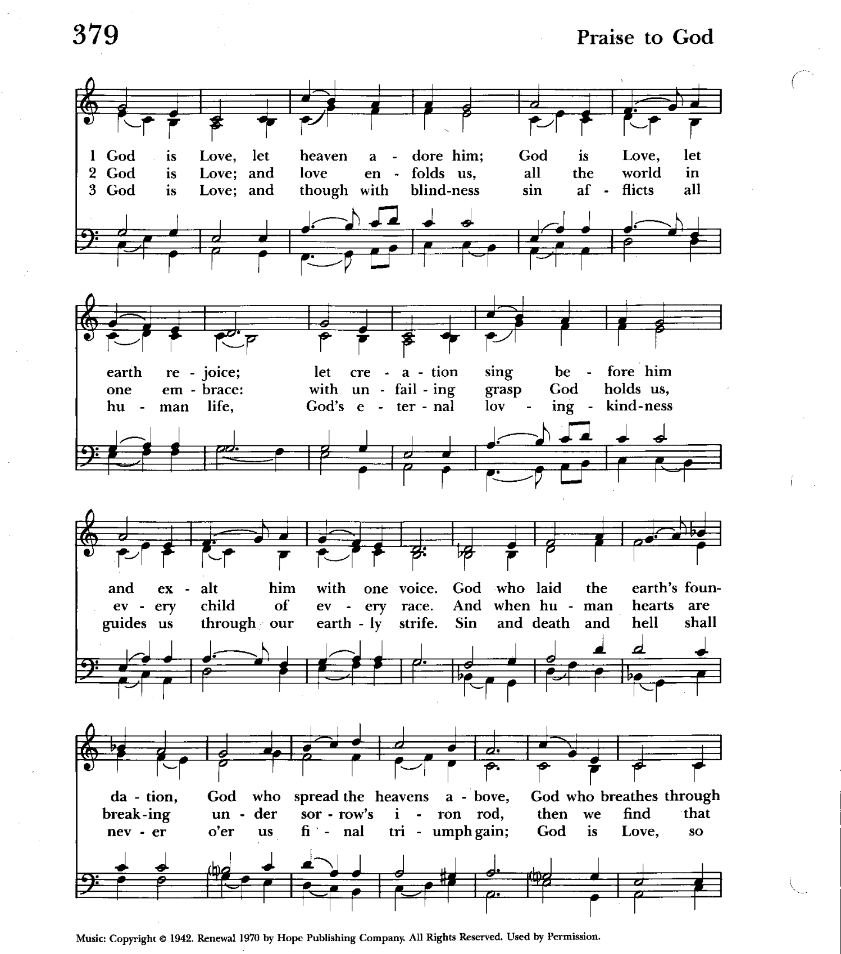

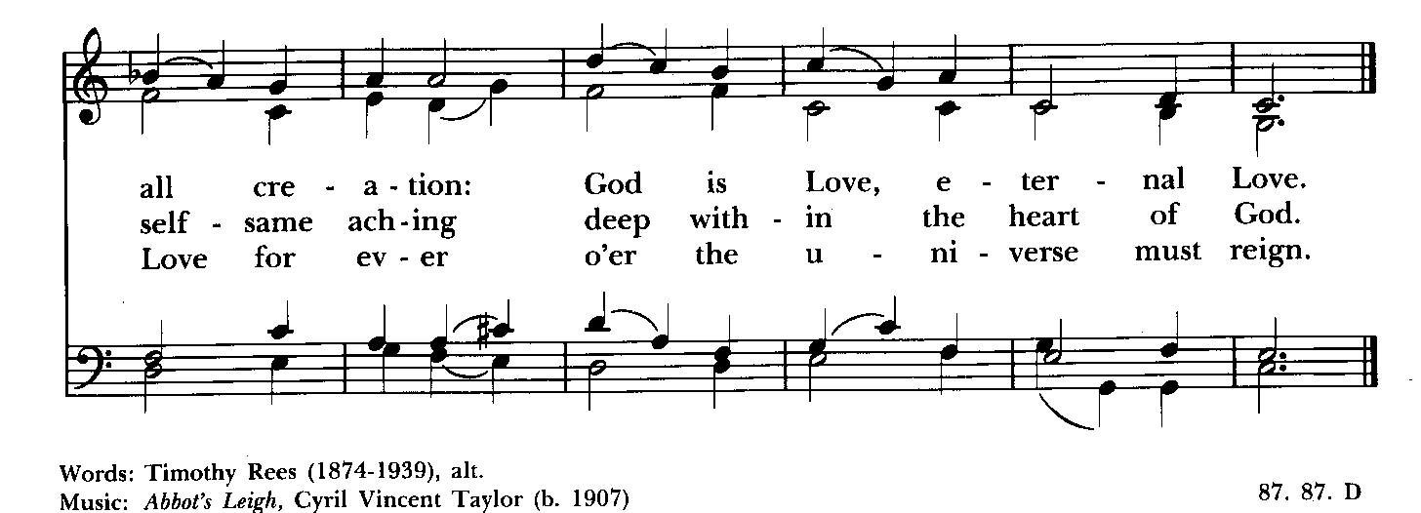

Celebrant: The Lord be with you.
People: And also with you.
Celebrant: Let us pray.

The Collect of the Day Kneel or stand as able BCP 225
Almighty God, whom truly to know is everlasting life: Grant us so perfectly to know your Son Jesus Christ to be the way, the truth, and the life, that we may steadfastly follow his steps in the way that leads to eternal life; through Jesus Christ your Son our Lord, who lives and reigns with you, in the unity of the Holy Spirit, one God, for ever and ever. Amen.

The congregation is seated.

A Reading from the Acts of the Apostles 8:26-40
An angel of the Lord said to Philip, “Get up and go toward the south to the road that goes down from Jerusalem to Gaza.” (This is a wilderness road.) So he got up and went. Now there was an Ethiopian eunuch, a court official of the Candace, queen of the Ethiopians, in charge of her entire treasury. He had come to Jerusalem to worship and was returning home; seated in his chariot, he was reading the prophet Isaiah. Then the Spirit said to Philip, “Go over to this chariot and join it.” So Philip ran up to it and heard him reading the prophet Isaiah. He asked, “Do you understand what you are reading?” He replied, “How can I, unless someone guides me?” And he invited Philip to get in and sit beside him. Now the passage of the scripture that he was reading was this:

“Like a sheep he was led to the slaughter,
and like a lamb silent before its shearer,
so he does not open his mouth.
In his humiliation justice was denied him.
Who can describe his generation?
For his life is taken away from the earth.”
The eunuch asked Philip, “About whom, may I ask you, does the prophet say this, about himself or about someone else?” Then Philip began to speak, and starting with this scripture, he proclaimed to him the good news about Jesus. As they were going along the road, they came to some water; and the eunuch said, “Look, here is water! What is to prevent me from being baptized?” He commanded the chariot to stop, and both of them, Philip and the eunuch, went down into the water, and Philip baptized him. When they came up out of the
water, the Spirit of the Lord snatched Philip away; the eunuch saw him no more, and went on his way rejoicing. But Philip found himself at Azotus, and as he was passing through the region, he proclaimed the good news to all the towns until he came to Caesarea.

Reader: The Word of the Lord.
People: Thanks be to God.

Psalm 22:24-30 (Prayed as directed.)
24 My praise is of him in the great assembly; *
I will perform my vows in the presence of those who worship him.
25 The poor shall eat and be satisfied,
and those who seek the Lord shall praise him: *
"May your heart live for ever!"
26 All the ends of the earth shall remember and turn to the Lord, *
and all the families of the nations shall bow before him.
27 For kingship belongs to the Lord; *
he rules over the nations.
28 To him alone all who sleep in the earth bow down in worship; *
all who go down to the dust fall before him.
29 My soul shall live for him;
my descendants shall serve him; *
they shall be known as the Lord's for ever.
30 They shall come and make known to a people yet unborn *
the saving deeds that he has done.

A Reading from the First Letter of John 4:7-21
Beloved, let us love one another, because love is from God; everyone who loves is born of God and knows God. Whoever does not love does not know God, for God is love. God's love was revealed among us in this way: God sent his only Son into the world so that we might live through him. In this is love, not that we loved God but that he loved us and sent his Son to be the atoning sacrifice for our sins. Beloved, since God loved us so much, we also ought to love one another. No one has ever seen God; if we love one another, God lives in us, and his love is perfected in us.
By this we know that we abide in him and he in us, because he has given us of his Spirit. And we have seen and do testify that the Father has sent his Son as the Savior of the world. God abides in those who confess that Jesus is the Son of God, and they abide in God. So we have known and believe the love that God has for us.
God is love, and those who abide in love abide in God, and God abides in them. Love has been perfected among us in this: that we may have boldness on the day of judgment, because as he is, so are we in this world. There is no fear in love, but perfect love casts out fear; for fear has to do with punishment, and whoever fears has not reached perfection in love. We love because he first loved us. Those who say, "I love God," and hate their brothers or sisters, are liars; for those who do not love a brother or sister whom they have seen, cannot love God whom they have not seen. The commandment we have from him is this: those who love God must love their brothers and sisters also.

Reader: The Word of the Lord.
People: Thanks be to God.

Gradual hymn: In Christ there is no East or West Hymnal #529

The congregation remains standing as able

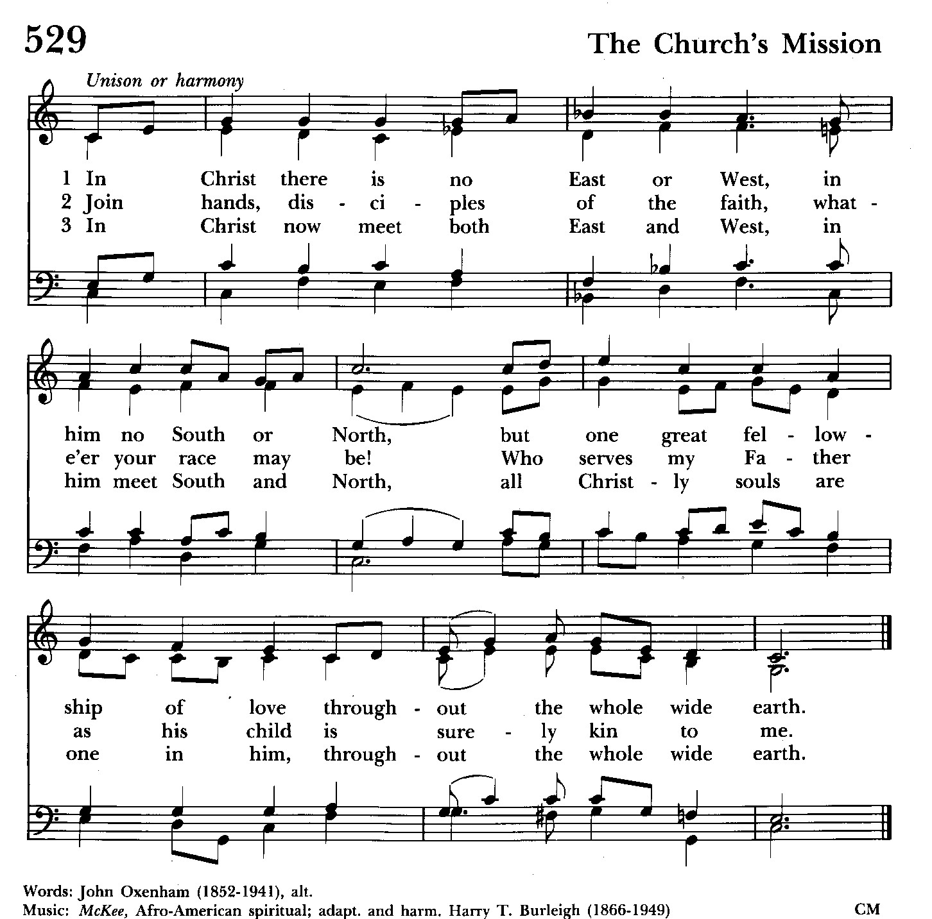

Priest: The Holy Gospel of our Lord Jesus Christ according to John 15:1-8

People: Glory to you, Lord Christ.
Jesus said to his disciples, ”I am the true vine, and my Father is the vinegrower. He removes every branch in me that bears no fruit. Every branch that bears fruit he prunes to make it bear more fruit. You have already been cleansed by the word that I have spoken to you. Abide in me as I abide in you. Just as the branch cannot bear fruit by itself unless it abides in the vine, neither can you unless you abide in me. I am the vine, you are the branches. Those who abide in me and I in them bear much fruit, because apart from me you can do nothing. Whoever does not abide in me is thrown away like a branch and withers; such branches are gathered, thrown into the fire, and burned. If you abide in me, and my words abide in you, ask for whatever you wish, and it will be done for you. My Father is glorified by this, that you bear much fruit and become my disciples.”

Priest: The Gospel of the Lord.
People: Praise to you, Lord Christ.

Sermon The congregation is seated The Rev. Mark Lobb+

The Nicene Creed Please stand as able BCP 358
We believe in one God,
the Father, the Almighty,
maker of heaven and earth,
of all that is, seen and unseen.
We believe in one Lord, Jesus Christ,
the only Son of God,
eternally begotten of the Father,
God from God, Light from Light,
true God from true God,
begotten, not made,
of one Being with the Father.
Through him all things were made.
For us and for our salvation
he came down from heaven:
by the power of the Holy Spirit
he became incarnate from the Virgin Mary,
and was made man.
For our sake he was crucified under Pontius Pilate;
he suffered death and was buried.
On the third day he rose again
in accordance with the Scriptures;
he ascended into heaven
and is seated at the right hand of the Father.
He will come again in glory to judge the living and the dead,
and his kingdom will have no end.
We believe in the Holy Spirit, the Lord, the giver of life,
who proceeds from the Father and the Son.
With the Father and the Son he is worshiped and glorified.
He has spoken through the Prophets.
We believe in one holy catholic and apostolic Church.
We acknowledge one baptism for the forgiveness of sins.
We look for the resurrection of the dead,
and the life of the world to come. Amen.

The Prayers of the People Form VI Kneel or stand as able BCP 392
Litanist: In peace, we pray to you, Lord God.

Litanist: For all people in their daily life and work;
People: For our families, friends, and neighbors, and for those who are alone.

Litanist: For this community, the nation, and the world;
People: For all who work for justice, freedom, and peace.

Litanist: For the just and proper use of your creation;
People: For the victims of hunger, fear, injustice, and oppression.

Litanist: For all who are in danger, sorrow, or any kind of trouble;
People: For those who minister to the sick, the friendless, and the needy.

Litanist: For the peace and unity of the Church of God;
People: For all who proclaim the Gospel, and all who seek the Truth.

Litanist: For +Justin, Archbishop of Canterbury; +Michael, our Presiding Bishop; +Carrie, our Bishop, +Mark our Interim Rector, for the Wardens, Vestry, Staff, and all members and friends of St. John’s Church. We give you thanks for the service and leadership of +Eugene Taylor Sutton - Fourteenth Bishop of Maryland (retired).

People: For all who serve God in his Church.

Litanist: For the special needs and concerns of this congregation. Especially
remember in our prayers, DeMarino Family, Jim & Chris Carden and family,
Peggie Dietz, Mike Carden, Pat Carden, Gail Landers, Travis Manar, Mary Anne Gebler, Sheila Jones, the Dilworth and Lozanski families, Robin Dilworth.

The People may add their own petitions

Litanist: Hear us, Lord;
People: For your mercy is great.
Litanist: We thank you, Lord, for all the blessings of this life.

The People may add their own thanksgivings

Litanist: We will exalt you, O God our King;
People: And praise your Name for ever and ever.

Litanist: We pray for all who have died, that they may have a place in your
eternal kingdom.

The People may add their own petitions
Litanist: Lord, let your loving-kindness be upon them;
People: Who put their trust in you.

Litanist: We pray to you also for the forgiveness of our sins.
People: Have mercy upon us, most merciful Father; in your compassion forgive us our sins, known and unknown, things done and left undone; and so uphold us by your Spirit that we may live and serve you in newness of life, to the honor and glory of your Name; through Jesus Christ our Lord. Amen.

The Celebrant gives the absolution.

The Peace Please stand as able BCP 360

Welcome & Announcements The congregation is seated.

Offertory Anthem : Ascribe to the Lord (Choir)

Offertory: Offerings are collected

Presentation Hymn Offerings are presented Please stand as able Hymnal #43, vs. 4
Praise God, from whom all blessings flow; praise him, all creatures here below; praise him above, ye heavenly host: praise Father, Son, and Holy Ghost.

The Holy Communion

THE GREAT THANKSGIVING: Eucharistic Prayer B BCP 367
Celebrant: The Lord be with you.
People: And also with you.
Celebrant: Lift up your hearts.
People: We lift them to the Lord.
Celebrant: Let us give thanks to the Lord our God.
People: It is right to give him thanks and praise.

Then, facing the Holy Table, the Celebrant proceeds
It is right, and a good and joyful thing, always and everywhere to give thanks to you, Father Almighty, Creator of heaven and earth.

Therefore we praise you, joining our voices with Angels and Archangels and with all the company of heaven, who for ever sing this hymn to proclaim the glory of your Name:

Celebrant and People:
Holy, Holy, Holy Lord, God of power and might, Hymnal #S-129
heaven and earth are full of your glory.
Hosanna in the highest.
Blessed is he who comes in the name of the Lord.
Hosanna in the highest.
Please kneel or stand as able

Then the Celebrant continues BCP 368
We give thanks to you, O God, for the goodness and love which you have made known to us in creation; in the calling of Israel to be your people; in your Word spoken through the prophets; and above all in the Word made flesh, Jesus, your Son. For in these last days you sent him to be incarnate from the Virgin Mary, to be the Savior and Redeemer of the world. In him, you have delivered us from evil, and made us worthy to stand before you. In him, you have brought us out of error into truth, out of sin into righteousness, out of death into life.

At the following words concerning the bread, the Celebrant is to hold it, or to lay a hand upon it; and at the words concerning the cup, to hold or place a hand upon the cup and any other vessel containing wine to be consecrated.

On the night before he died for us, our Lord Jesus Christ took bread; and when he had given thanks to you, he broke it, and gave it to his disciples, and said, "Take, eat: This is my Body, which is given for you. Do this for the remembrance of me."

After supper he took the cup of wine; and when he had given thanks, he gave it to them, and said, "Drink this, all of you: This is my Blood of the new Covenant, which is shed for you and for many for the forgiveness of sins. Whenever you drink it, do this for the remembrance of me."

Therefore, according to his command, O Father,
Celebrant and People:
We remember his death,
We proclaim his resurrection,
We await his coming in glory;

The Celebrant continues
And we offer our sacrifice of praise and thanksgiving to you, O Lord of all; presenting to you, from your creation, this bread and this wine. We pray you, gracious God, to send your Holy Spirit upon these gifts that they may be the Sacrament of the Body of Christ and his Blood of the new Covenant. Unite us to your Son in his sacrifice, that we may be acceptable through him, being sanctified by the Holy Spirit. In the fullness of time, put all things in subjection under your Christ, and bring us to that heavenly country where, with St. John and the Blessed Virgin Mary and all your saints, we may enter the everlasting heritage of your sons and daughters; through Jesus Christ our Lord, the firstborn of all creation, the head of the Church, and the author of our salvation.

By him, and with him, and in him, in the unity of the Holy Spirit all honor and glory is yours, Almighty Father, now and for ever. Amen.

And now, as our Savior Christ has taught us, we are bold to say,

Our Father, who art in heaven, BCP p. 364
hallowed be thy Name,
thy kingdom come,
thy will be done,
on earth as in heaven.
Give us this day our daily bread.
And forgive us our trespasses,
as we forgive those
who trespass against us.
And lead us not into temptation,
but deliver us from evil.
For thine is the kingdom,
and the power, and the glory,
for ever and ever. Amen.

Invitation to Communion

The Breaking of the Bread
Celebrant: Alleluia. Christ our Passover is sacrificed for us;
People: Therefore let us keep the feast. Alleluia.
Celebrant: The Gifts of God for the people of God.

The congregation is seated
Communion hymn: O love, how deep, how broad, how high Hymnal #448

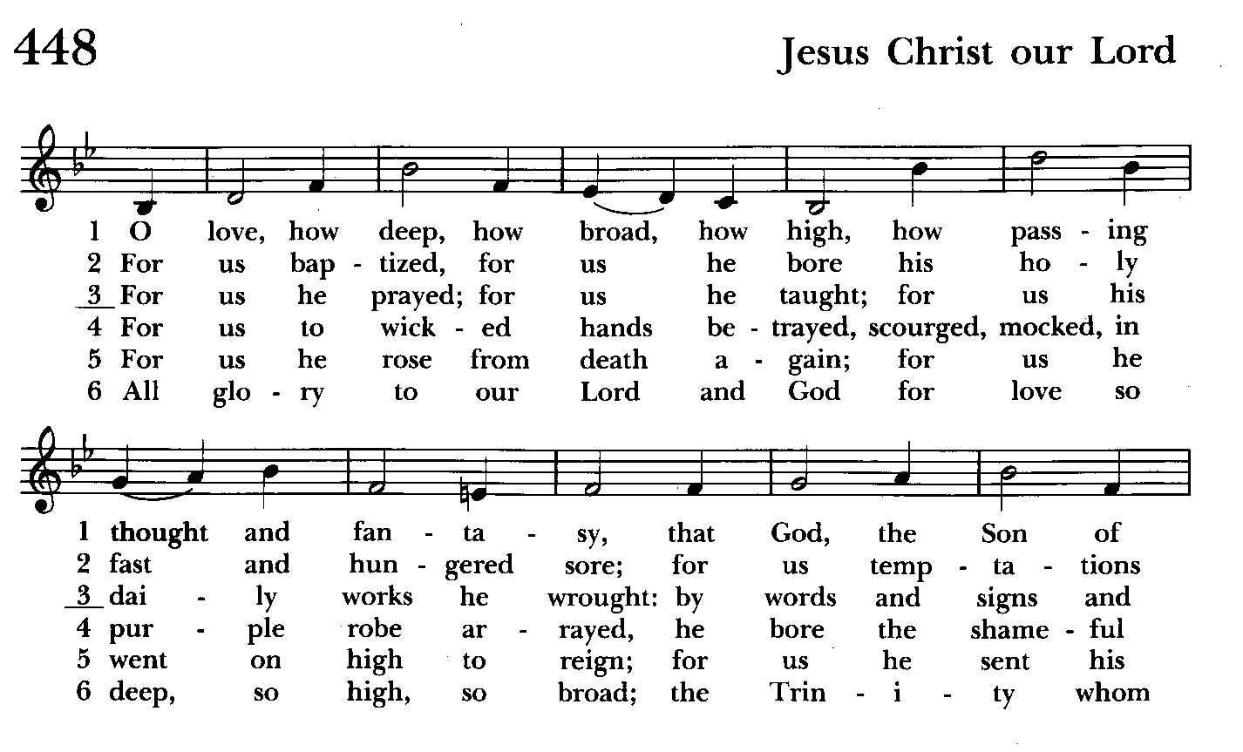

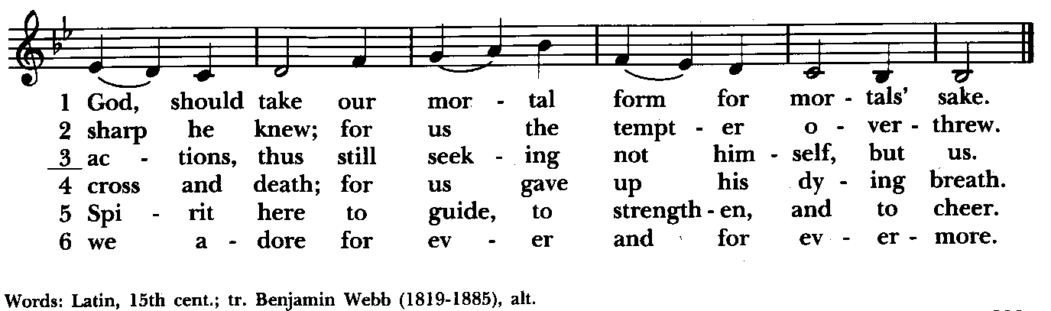

The Post Communion Prayer BCP p. 365
Eternal God, heavenly Father, you have graciously accepted us as living members of your Son our Savior Jesus Christ, and you have fed us with spiritual food in the Sacrament of his Body and Blood. Send us now into the world in peace, and grant us strength and courage to love and serve you with gladness and singleness of heart; through Christ our Lord. Amen.

Blessing

Recessional hymn: Lord, dismiss us with thy blessing Hymnal #344

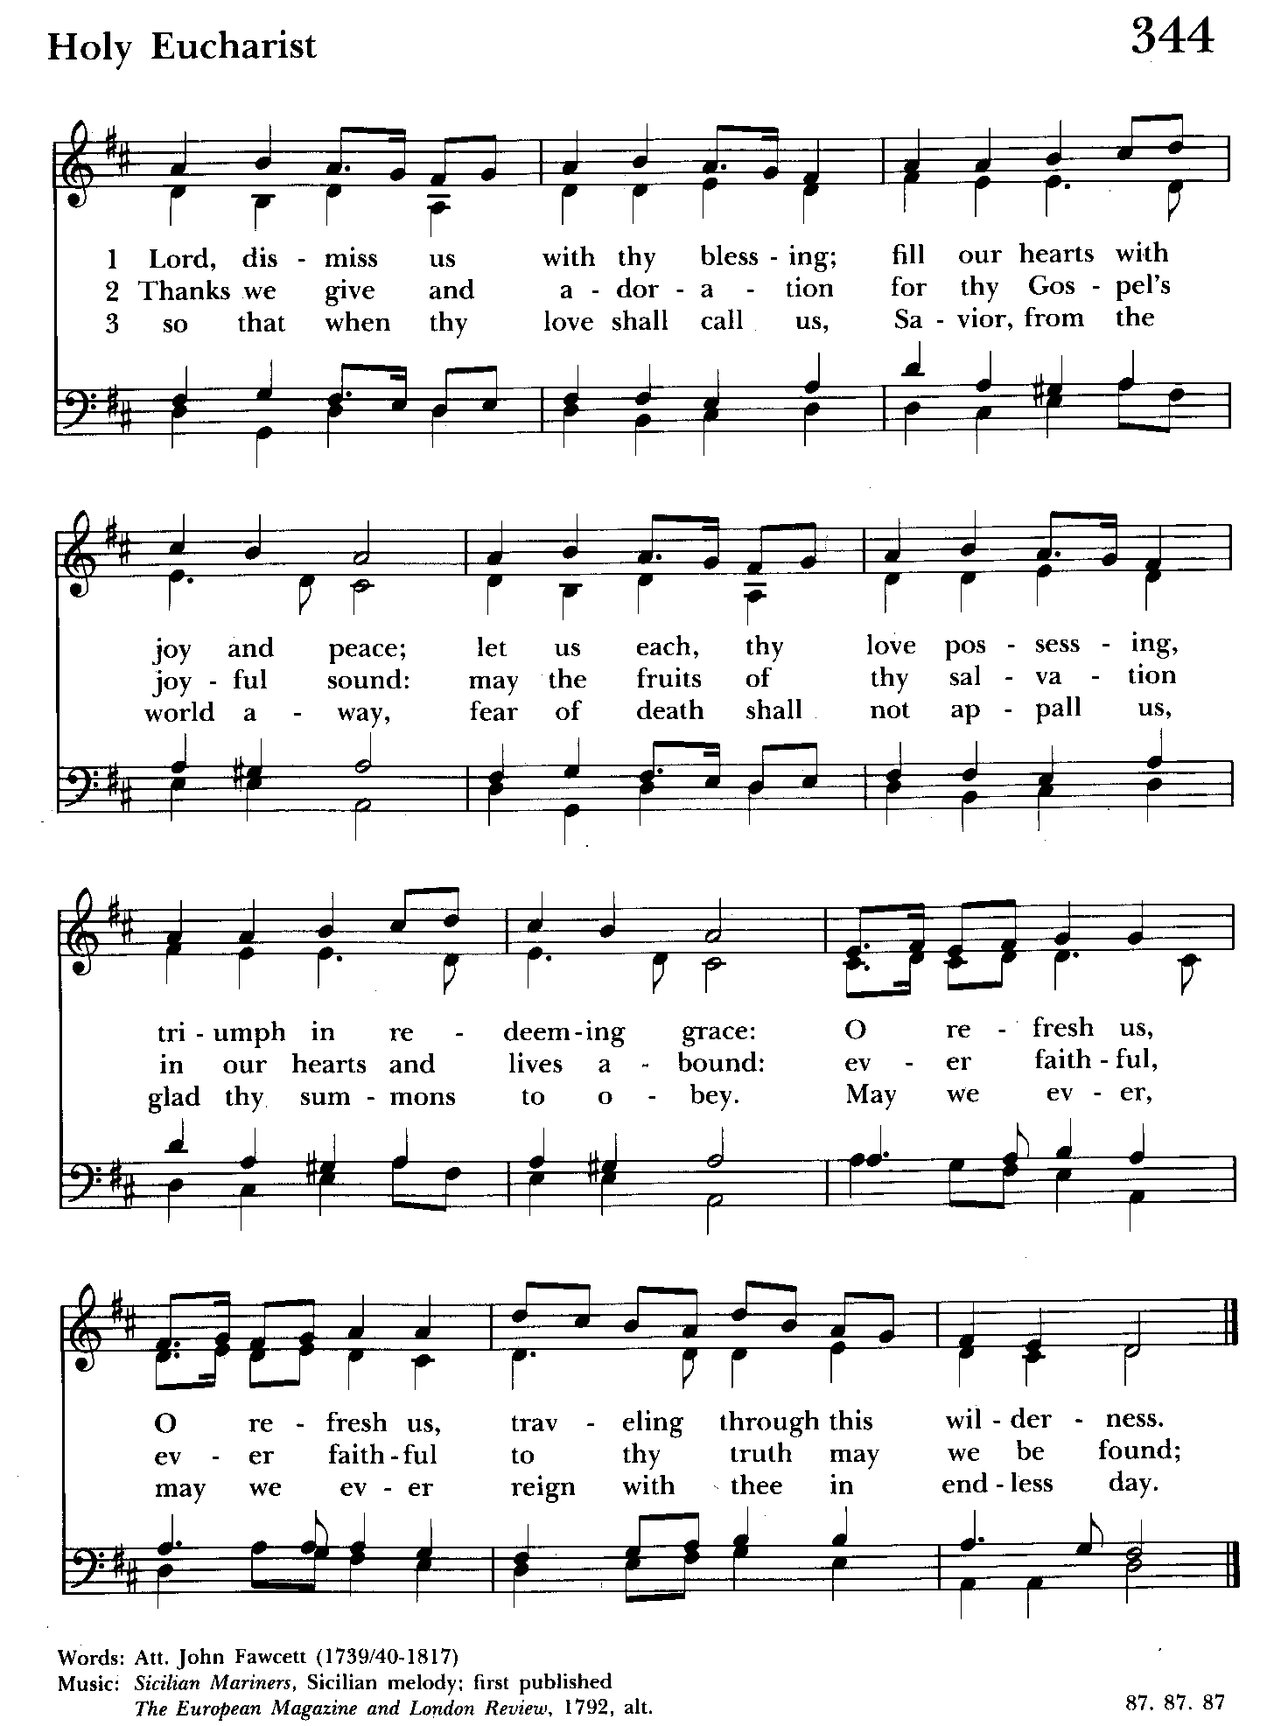

The Dismissal (The Alleluias are back!)
Celebrant: Let us go forth in the name of the risen Lord.
People: Thanks be to God. Alleluia, alleluia!

Serving Today

Celebrant and Preacher: The Rev. Mark Lobb+
Old Testament: Liz Healey
Psalm: Liz Healey
New Testament: Tony Rising
Prayers of the People: John Frost
Server: Marguerite Lobb
Music Director: Nancy Heinold
Choir: Anne Leland, Nancy Dellinger, Janine Stevens, Liz Healey, Camy Schwenk,
Karen Smith-Manar, Jacob Johnson, Ty Schwenk
Altar Guild: Liz Healey & Marguerite Lobb

St. John’s Parish Prayer List

Additions and corrections may be made to our Parish Prayer List at any time. All names will be automatically removed from the Parish Prayer List on the 1st Sunday of each month unless you request otherwise. Please contact Angie at <office@stjohnskingsville.org> or 410-592-8570 in the church office with all changes by 10 am Thursdays. Thank you.

We Pray for Those in Need:
Names in BOLD read aloud by all.

DeMarino Family, Jim & Chris Carden and family, Peggie Dietz, Mike Carden, Pat Carden, Gail Landers, Travis Manar, Mary Anne Gebler, Sheila Jones, the Dilworth and Lozanski families.

We Pray for our Homebound

Lily John, Barbara Miller, Nancy Barnhart, Robin Dilworth

We pray for the Church and the World:

For +Justin, Archbishop of Canterbury; for + Michael, our Presiding Bishop; for +Carrie, our Bishop; for +Mark, our Interim Rector, for the Wardens, Vestry, Staff, and all members and friends of St. John’s Church. We give you thanks for the service and leadership of +Eugene Taylor Sutton - Fourteenth Bishop of Maryland (retired).

For the leaders of all nations, especially for Joseph, our President; for Wes, our Governor; for Brandon, Nick, John and Bob, who lead our City and Counties. We pray for all children and youth; for the homeless, the unemployed, and the hungry. We pray for the safety of our loved ones and friends serving in the Armed Forces at home and abroad, and for our enemies, that all our hearts may be turned toward peace throughout the world.


Altar Flowers
Given to the Glory of God
by the People of St. John’s
in honor of Administrative Professionals Day and in gratitude for the work of Angie Bosley.

We have many open weeks between now and the end of August for flowers. Please sign up. Thank you.



St. John’s Flea Market is coming up!!
May 18th, 8 am-1 pm
You can now bring in your gently used items to the Parish Hall. Volunteers needed also for baking! Thank you so much!!

From the Treasurer
April ‘24 Income vs. Expenses:
Projected April Expenses: $14,500
Monies Received as of 4/25: $16,775

Amount Needed to Meet Expenses: $2,275


If you’d like to make a donation to St. John’s you can scan this QR code with your phone’s camera or tap on the link that comes up to make a contribution with either a credit or debit card, Apple Pay or Google Pay. This is a secure site provided by Clover which is a service of PNC Bank.

Baptism, Confirmation, Reception
The Day of Pentecost, also known as Whitsunday, is May 19th this year. It is a day especially appropriate for Baptisms. In addition, Bishop Carrie is Receiving and Confirming those so called at the Cathedral of the Incarnation that Sunday. If you are interested in baptism here at St. John's or reception or confirmation at the cathedral, please let Fr. Mark know.


Choral Choir and Bell Choir

Choir practice, Wednesdays at 7:00 pm

Bell Choir practice, Sundays after the 10:30 service on the 2nd, 3rd and 4th Sundays


SUNDAY SCHOOL
Children’s Sunday school is held from 10:30-11:00 during our 10:30 service. Miss Stephanie and I also would like to invite all interested kids to come and be part of the group!

Mr. John

ATTENTION!
During our cleanup day on October 7th of last year, there was a bad auto accident at the intersection of Belair Rd and Sunshine Ave, right outside our campus. One of the victims is asking if any witnesses could contact him. Fr. Mark will give you the contact information. Thanks.


Yoga classes on Tuesday and Friday evenings 6 to 7 pm and Saturday mornings 9 to 10 am in the Chapel.
All experience levels are welcome.

OUTREACH

The FOOD PANTRY is in need of immediate donations. All donations welcome, food or monetary. Thank you so much.
Needed at this time: jelly and syrup

Dates to put in your calendar:
Saturday, May 18th, Flea Market. 8am-1pm. Baked goods needed and volunteers needed.

Also, you may bring in gently used items for St. John’s table.

We have St. John’s shirts available for a nominal charge.
With so much going on, everyone’s help is needed to make things a success. Our volunteers make the Church function. The volunteering of time and talent is greatly appreciated.

We have a Potluck Luncheon on the first Sunday of the month and a Coffee Hour on all other Sundays after the 10:30 service.

Spiritual Communion prayer for those unable to participate in person.

I believe that you are truly present in the Holy Sacrament, and, since I cannot at this time receive communion, I pray you to come into my heart. I unite myself with you and embrace you with all my heart, my soul, and my mind. Let nothing separate me from you; let me serve you in this life until, by your grace, I come to your glorious kingdom and unending peace. Amen.

(St. Augustine’s Prayer Book, p.192)

Best Practices for Communion
Although intinction, the dipping of the bread in the cup, may seem to be more sanitary, multiple studies have determined the opposite.
Sharing the common cup, in keeping with ancient traditions, is actually much safer given our practice of wiping and rotating the chalice between each communicant. Our bishops and diocesan staff strongly discourage the practice of intinction. Other options include sharing the common cup in the traditional way or abstaining from the cup altogether. Both options are
considered full participation in the Eucharist. Please speak to Father Mark with any questions.

What’s Happening This Week at St. John’s

Sunday, April 28—Fifth Sunday of Easter
8:00am: Holy Eucharist, Rite I (Church)
10:30am: Holy Eucharist, Rite II (Church)
10:30am-11:00am: Sunday School
11:30am: Coffee Hour (Parish Hall)

Monday, April 29
12:00-1:00pm: AA Lunch Bunch (Parish Hall)
7:00-8:30pm: Spanish speaking AA group (Parish Hall)

Tuesday, April 30
12:00-1:00pm: AA Lunch Bunch (Parish Hall)
6:00-7:00pm: Yoga (Chapel)

Wednesday, May 1
12:00-1:00pm: AA Lunch Bunch (Parish Hall)
7:00pm: Choir Practice (Church)
7:30pm: AA (Parish Hall)

Thursday, May 2
12:00-1:00pm: AA Lunch Bunch (Parish Hall)
7:00pm: AA (Parish Hall)

Friday, May 3
12:00-1:00pm: AA Lunch Bunch (Parish Hall)
6:00pm -7:00pm: Yoga (Chapel)

Saturday, May 4
9:00am-10:00am: Yoga (Chapel)
8:30pm: AA (Parish Hall)

Sunday, May 5-Sixth Sunday of Easter
8:00am: Holy Eucharist, Rite I (Church)
10:30am: Holy Eucharist, Rite II (Church)
10:30am-11:00am: Sunday School
11:30am: Potluck (Parish Hall)

Parish Office is open Monday, Wednesday and Thursday, 9:30am-1:30pm.

