St. John’s Episcopal Church
Kingsville, Maryland
Welcomes You

OUR VISION STATEMENT
We believe that together we will transform the world with love: Come on in!



Third Sunday of Easter
April 14, 2024
10:30 am, Rite II

St. John’s Episcopal Church

11901 Belair Road, P. O. Box 187, Kingsville, MD 21087
Facebook: St. John’s Episcopal, Kingsville, MD
Email: office@stjohnskingsville.org
Website: www.stjohnskingsville.org
Church Phone: 410-592-8570
For Pastoral Emergencies: Fr. Mark Lobb+ 443-690-9545

Welcome to worship today! We are glad that you are with us. You are invited to participate in all parts of the service as indicated in the Book of Common Prayer and this service bulletin. If you have any questions, feel free to ask the ushers. Restrooms are located in the Parish hall, the brick building across the parking lot.

I was glad when they said to me, “Let us go to the house of the Lord.” Psalm 122:1

Church Staff

Interim Rector: Father Mark Lobb
Administrative Assistant: Angie Bosley
Organist/Choir Director: Nancy Heinold

The Vestry

Class of 2025 Class of 2026

John Frost John Stevens
Woodie Tingle
Jacob Johnson

Officers
Ty Schwenk—Sr. Warden Terry Roe—Jr. Warden
Elizabeth Healey—Treasurer Anne Leland-Registrar

Parish Committee Chairpersons

Altar Guild: Elizabeth Healey
Auxiliary Committee: Michele Lozanski
Cemetery Committee: Terry Roe

10:30 am Worship
Holy Eucharist, Rite Two

Prelude:
The Word of God

Processional hymn: He is risen, he is risen Hymnal #180
(see next page)

The congregation remains standing as able
Celebrant: Alleluia. Christ is risen.
People: The Lord is risen indeed. Alleluia.

Celebrant: Almighty God, to you all hearts are open, all desires known, and from you no secrets are hid: Cleanse the thoughts of our hearts by the inspiration of your Holy Spirit, that we may perfectly love you, and worthily magnify your holy Name; through Christ our Lord. Amen.

Gloria Hymnal #S-278
Glory to God in the highest,
and peace to his people on earth.
Lord God, heavenly King,
almighty God and Father,
we worship you, we give you thanks,
we praise you for your glory.
Lord Jesus Christ, only Son of the Father,
Lord God, Lamb of God,
you take away the sin of the world:
have mercy on us;
you are seated at the right hand of the Father:
receive our prayer.
For you alone are the Holy One,
you alone are the Lord,
you alone are the Most High,
Jesus Christ,
with the Holy Spirit,
in the glory of God the Father. Amen.

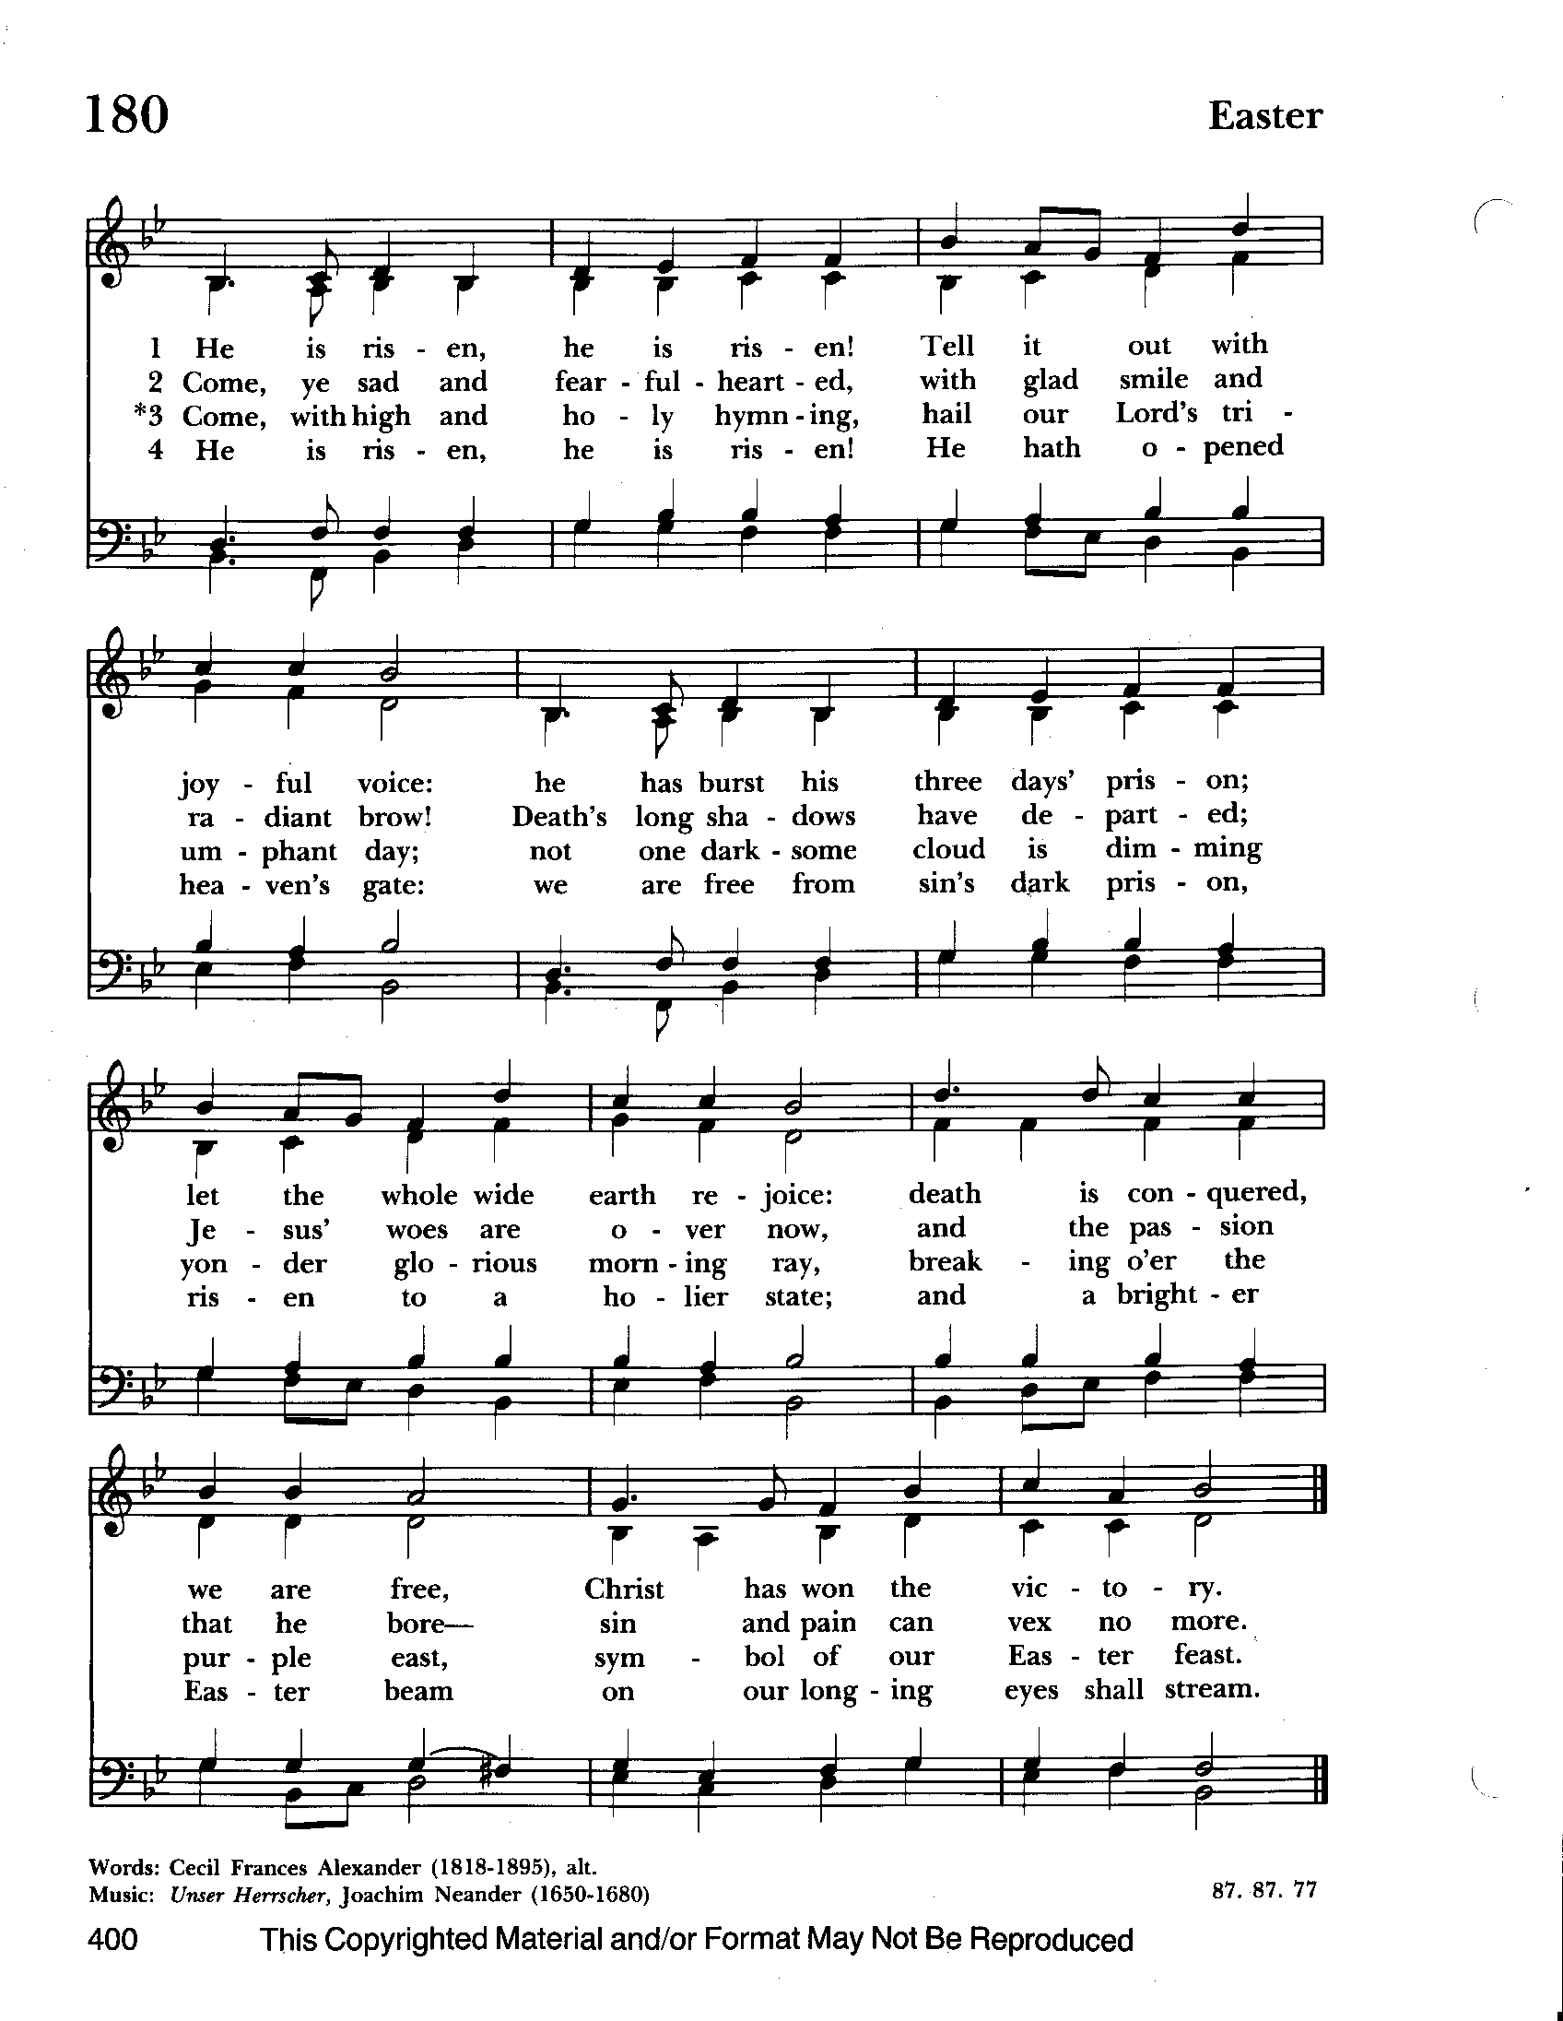

Celebrant: The Lord be with you.
People: And also with you.
Celebrant: Let us pray.

The Collect of the Day Kneel or stand as able BCP 224
O God, whose blessed Son made himself known to his disciples in the breaking of bread: Open the eyes of our faith, that we may behold him in all his redeeming work; who lives and reigns with you, in the unity of the Holy Spirit, one God, now and for ever. Amen.

The congregation is seated.

A Reading from the Acts of the Apostles 3:12-19
Peter addressed the people, “You Israelites, why do you wonder at this, or why do you stare at us, as though by our own power or piety we had made him walk? The God of Abraham, the God of Isaac, and the God of Jacob, the God of our ancestors has glorified his servant Jesus, whom you handed over and rejected in the presence of Pilate, though he had decided to release him. But you rejected the Holy and Righteous One and asked to have a murderer given to you, and you killed the Author of life, whom God raised from the dead. To this we are witnesses. And by faith in his name, his name itself has made this man strong, whom you see and know; and the faith that is through Jesus has given him this perfect health in the presence of all of you.
“And now, friends, I know that you acted in ignorance, as did also your rulers. In this way God fulfilled what he had foretold through all the prophets, that his Messiah would suffer. Repent therefore, and turn to God so that your sins may be wiped out.”

Reader: The Word of the Lord.
People: Thanks be to God.

Psalm 4 (Prayed as directed.)
1 Answer me when I call, O God, defender of my cause; *
`you set me free when I am hard-pressed;
have mercy on me and hear my prayer.
2 "You mortals, how long will you dishonor my glory; *
how long will you worship dumb idols
and run after false gods?"
3 Know that the Lord does wonders for the faithful; *
when I call upon the Lord, he will hear me.
4 Tremble, then, and do not sin; *
speak to your heart in silence upon your bed.
5 Offer the appointed sacrifices *
and put your trust in the Lord.
6 Many are saying, "Oh, that we might see better times!" *
Lift up the light of your countenance upon us, O Lord.
7 You have put gladness in my heart, *
more than when grain and wine and oil increase.
8 I lie down in peace; at once I fall asleep; *
for only you, Lord, make me dwell in safety.

A Reading from the First Letter of John 3:1-7
See what love the Father has given us, that we should be called children of God; and that is what we are. The reason the world does not know us is that it did not know him. Beloved, we are God's children now; what we will be has not yet been revealed. What we do know is this: when he is revealed, we will be like him, for we will see him as he is. And all who have this hope in him purify themselves, just as he is pure.
Everyone who commits sin is guilty of lawlessness; sin is lawlessness. You know that he was revealed to take away sins, and in him there is no sin. No one who abides in him sins; no one who sins has either seen him or known him. Little children, let no one deceive you. Everyone who does what is right is righteous, just as he is righteous.

Reader: The Word of the Lord.
People: Thanks be to God.

Gradual hymn: Good Christians all, rejoice and sing Hymnal #205

Priest: The Holy Gospel of our Lord Jesus Christ according to Luke 24:36b-48

People: Glory to you, Lord Christ.
Jesus himself stood among the disciples and said to them, “Peace be with you.” They were startled and terrified, and thought that they were seeing a ghost. He said to them, “Why are you frightened, and why do doubts arise in your hearts? Look at my hands and my feet; see that it is I myself. Touch me and see; for a ghost does not have flesh and bones as you see that I have.” And when he had said this, he showed them his hands and his feet. While in their joy they were disbelieving and still wondering, he said to them, “Have you anything here to eat?” They gave him a piece of broiled fish, and he took it and ate in their presence. Then he said to them, “These are my words that I spoke to you while I was still with you—that everything written about me in the law of Moses, the prophets, and the psalms must be fulfilled.” Then he opened their minds to understand the scriptures, and he said to them, “Thus it is written, that the Messiah is to suffer and to rise from the dead on the third day, and that repentance and forgiveness of sins is to be proclaimed in his name to all nations, beginning from Jerusalem. You are witnesses of these things.

Priest: The Gospel of the Lord.
People: Praise to you, Lord Christ.

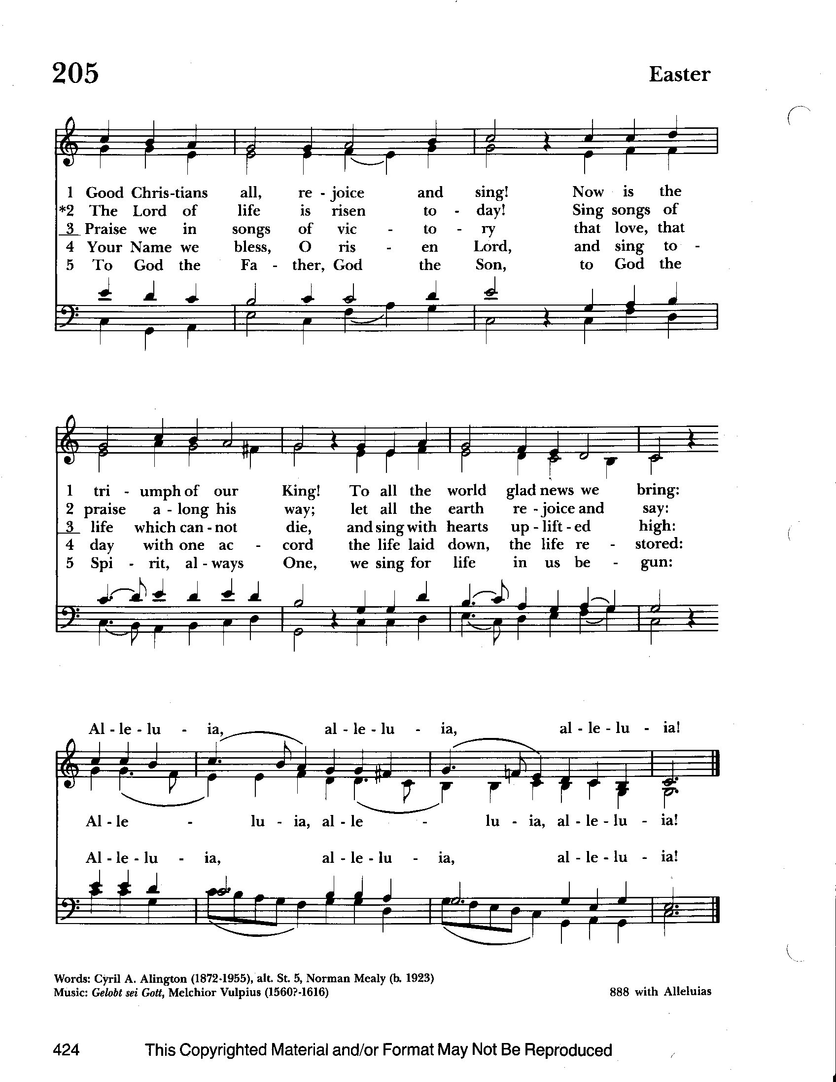

The congregation remains standing as able

Sermon The congregation is seated The Rev. Mark Lobb+

The Nicene Creed BCP 358
We believe in one God,
the Father, the Almighty,
maker of heaven and earth,
of all that is, seen and unseen.
We believe in one Lord, Jesus Christ,
the only Son of God,
eternally begotten of the Father,
God from God, Light from Light,
true God from true God,
begotten, not made,
of one Being with the Father.
Through him all things were made.
For us and for our salvation
he came down from heaven:
by the power of the Holy Spirit
he became incarnate from the Virgin Mary,
and was made man.
For our sake he was crucified under Pontius Pilate;
he suffered death and was buried.
On the third day he rose again
in accordance with the Scriptures;
he ascended into heaven
and is seated at the right hand of the Father.
He will come again in glory to judge the living and the dead,
and his kingdom will have no end.
We believe in the Holy Spirit, the Lord, the giver of life,
who proceeds from the Father and the Son.
With the Father and the Son he is worshiped and glorified.
He has spoken through the Prophets.
We believe in one holy catholic and apostolic Church.
We acknowledge one baptism for the forgiveness of sins.
We look for the resurrection of the dead,
and the life of the world to come. Amen.

The Prayers of the People Form VI BCP 392
Litanist: In peace, we pray to you, Lord God.

Litanist: For all people in their daily life and work;
People: For our families, friends, and neighbors, and for those who are alone.

Litanist: For this community, the nation, and the world;
People: For all who work for justice, freedom, and peace.

Litanist: For the just and proper use of your creation;
People: For the victims of hunger, fear, injustice, and oppression.

Litanist: For all who are in danger, sorrow, or any kind of trouble;
People: For those who minister to the sick, the friendless, and the needy.

Litanist: For the peace and unity of the Church of God;
People: For all who proclaim the Gospel, and all who seek the Truth.

Litanist: For Justin, Archbishop of Canterbury; Michael, our Presiding Bishop; Eugene and Carrie Schofield Broadbent, our Bishops, Mark our Interim Rector, for the Wardens, Vestry, Staff, and all members and friends of St. John’s Church.
People: For all who serve God in his Church.

Litanist: For the special needs and concerns of this congregation. Especially remember in our prayers, DeMarino Family, Jim & Chris Carden and family, Peggie Dietz, Mike Carden, Pat Carden, Gail Landers, Travis Manar, Marie Dilworth, Barbara Miller.

The People may add their own petitions

Litanist: Hear us, Lord;
People: For your mercy is great.
Litanist: We thank you, Lord, for all the blessings of this life.

The People may add their own thanksgivings

Litanist: We will exalt you, O God our King;
People: And praise your Name for ever and ever.

Litanist: We pray for all who have died, that they may have a place in your
eternal kingdom.

The People may add their own petitions
Litanist: Lord, let your loving-kindness be upon them;
People: Who put their trust in you.

Litanist: We pray to you also for the forgiveness of our sins.
People: Have mercy upon us, most merciful Father; in your compassion forgive us our sins, known and unknown, things done and left undone; and so uphold us by your Spirit that we may live and serve you in newness of life, to the honor and glory of your Name; through Jesus Christ our Lord. Amen.

The Celebrant gives the absolution.

The Peace Please stand as able BCP 360

Welcome & Announcements The congregation is seated.

Offertory Anthem : The Strife is O’er (Bell Choir)

Offertory: Offerings are collected

Presentation Hymn Offerings are presented Please stand as able Hymnal #43, vs. 4
Praise God, from whom all blessings flow; praise him, all creatures here below; praise him above, ye heavenly host: praise Father, Son, and Holy Ghost.

The Holy Communion

THE GREAT THANKSGIVING: Eucharistic Prayer B BCP 367
Celebrant: The Lord be with you.
People: And also with you.
Celebrant: Lift up your hearts.
People: We lift them to the Lord.
Celebrant: Let us give thanks to the Lord our God.
People: It is right to give him thanks and praise.

Then, facing the Holy Table, the Celebrant proceeds
It is right, and a good and joyful thing, always and everywhere to give thanks to you, Father Almighty, Creator of heaven and earth.

Therefore we praise you, joining our voices with Angels and Archangels and with all the company of heaven, who for ever sing this hymn to proclaim the glory of your Name:

Celebrant and People:
Holy, Holy, Holy Lord, God of power and might, Hymnal #S-129
heaven and earth are full of your glory.
Hosanna in the highest.
Blessed is he who comes in the name of the Lord.
Hosanna in the highest.

Please kneel or stand as able

Then the Celebrant continues BCP 368
We give thanks to you, O God, for the goodness and love which you have made known to us in creation; in the calling of Israel to be your people; in your Word spoken through the prophets; and above all in the Word made flesh, Jesus, your Son. For in these last days you sent him to be incarnate from the Virgin Mary, to be the Savior and Redeemer of the world. In him, you have delivered us from evil, and made us worthy to stand before you. In him, you have brought us out of error into truth, out of sin into righteousness, out of death into life.

At the following words concerning the bread, the Celebrant is to hold it, or to lay a hand upon it; and at the words concerning the cup, to hold or place a hand upon the cup and any other vessel containing wine to be consecrated.

On the night before he died for us, our Lord Jesus Christ took bread; and when he had given thanks to you, he broke it, and gave it to his disciples, and said, "Take, eat: This is my Body, which is given for you. Do this for the remembrance of me."

After supper he took the cup of wine; and when he had given thanks, he gave it to them, and said, "Drink this, all of you: This is my Blood of the new Covenant, which is shed for you and for many for the forgiveness of sins. Whenever you drink it, do this for the remembrance of me."

Therefore, according to his command, O Father,
Celebrant and People:
We remember his death,
We proclaim his resurrection,
We await his coming in glory;

The Celebrant continues
And we offer our sacrifice of praise and thanksgiving to you, O Lord of all; presenting to you, from your creation, this bread and this wine. We pray you, gracious God, to send your Holy Spirit upon these gifts that they may be theSacrament of the Body of Christ and his Blood of the new Covenant. Unite us to your Son in his sacrifice, that we may be acceptable through him, being sanctified by the Holy Spirit. In the fullness of time, put all things in subjection under your Christ, and bring us to that heavenly country where, with St. John and the Blessed Virgin Mary and all your saints, we may enter the everlasting heritage of your sons and daughters; through Jesus Christ our Lord, the firstborn of all creation, the head of the Church, and the author of our salvation.

By him, and with him, and in him, in the unity of the Holy Spirit all honor and
glory is yours, Almighty Father, now and for ever. Amen.

And now, as our Savior Christ has taught us, we are bold to say,

Our Father, in heaven, BCP p. 363
hallowed be your Name,
your kingdom come,
your will be done,
on earth as in heaven.
Give us this day our daily bread.
And forgive us our sins,
as we forgive those
who sin against us.
Save us from the time of trial,
and deliver us from evil.
For the kingdom,
the power, and the glory are yours,
now and for ever. Amen.

Invitation to Communion

The Breaking of the Bread
Celebrant: Alleluia. Christ our Passover is sacrificed for us;
People: Therefore let us keep the feast. Alleluia.
Celebrant: The Gifts of God for the people of God.

The congregation is seated
Communion hymn: Shepherd of souls, refresh and bless Hymnal #343
(see next page)

The Post Communion Prayer BCP p. 365
Eternal God, heavenly Father, you have graciously accepted us as living members of your Son our Savior Jesus Christ, and you have fed us with spiritual food in the Sacrament of his Body and Blood. Send us now into the world in peace, and grant us strength and courage to love and serve you with gladness and singleness of heart; through Christ our Lord. Amen.

Blessing

Recessional hymn: Sing ye faithful, sing with gladness Hymnal #492
(see next page)
The Dismissal (The Alleluias are back!)

Celebrant: Let us go forth in the name of the risen Lord.
People: Thanks be to God. Alleluia, alleluia!

Serving Today

Celebrant and Preacher: The Rev. Mark Lobb+
Old Testament: John Stevens
Psalm: John Stevens
New Testament: Liz Healey
Prayers of the People: John Frost
Server: Terry Roe
Music Director: Nancy Heinold
Bell Choir: Nanci Rosendale, Karen Smith-Manar, Liz Healey,
John Stevens, Janine Stevens, Camy Schwenk, Ty Schwenk

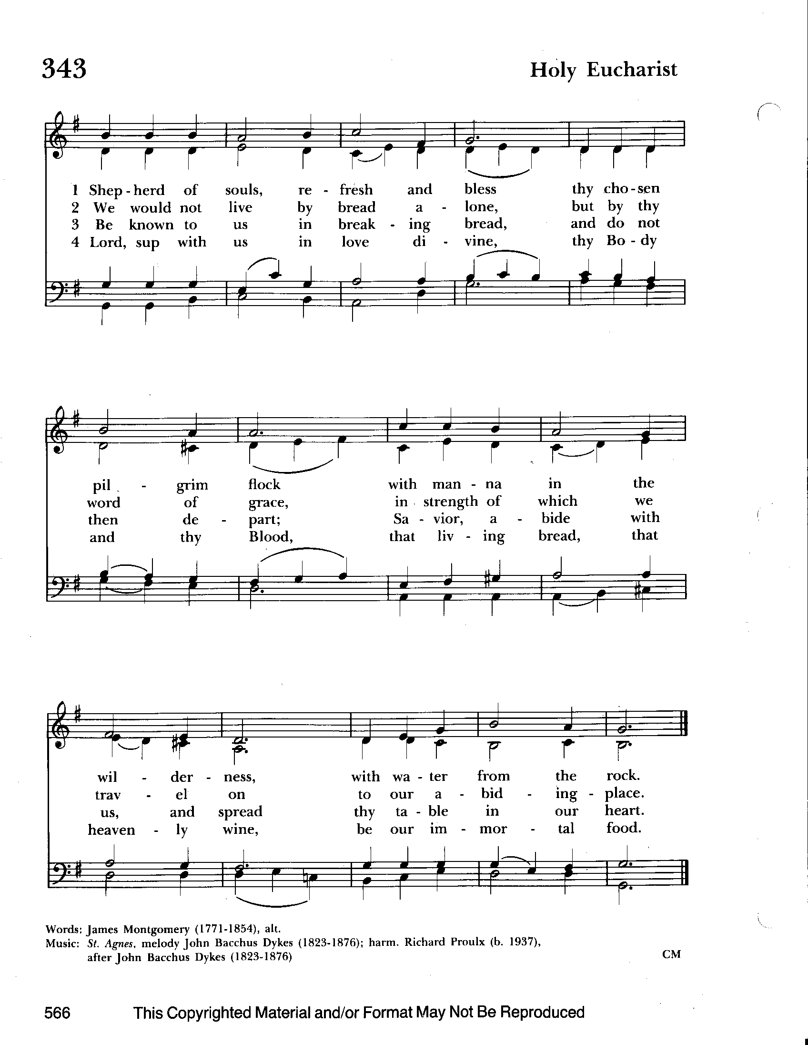


Altar Flowers
Given to the Glory of God
by Frank & Stephanie Duchacek
in memory of Stephen Slitzer

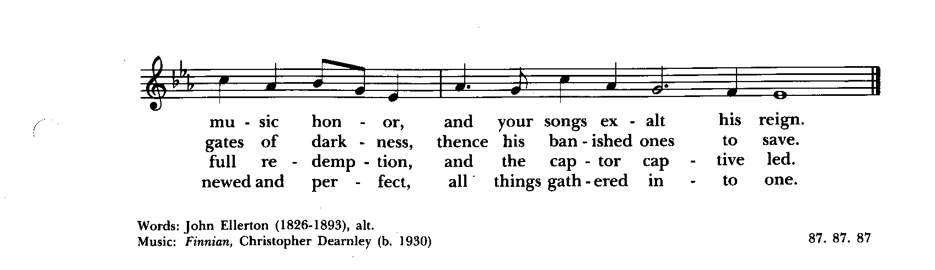
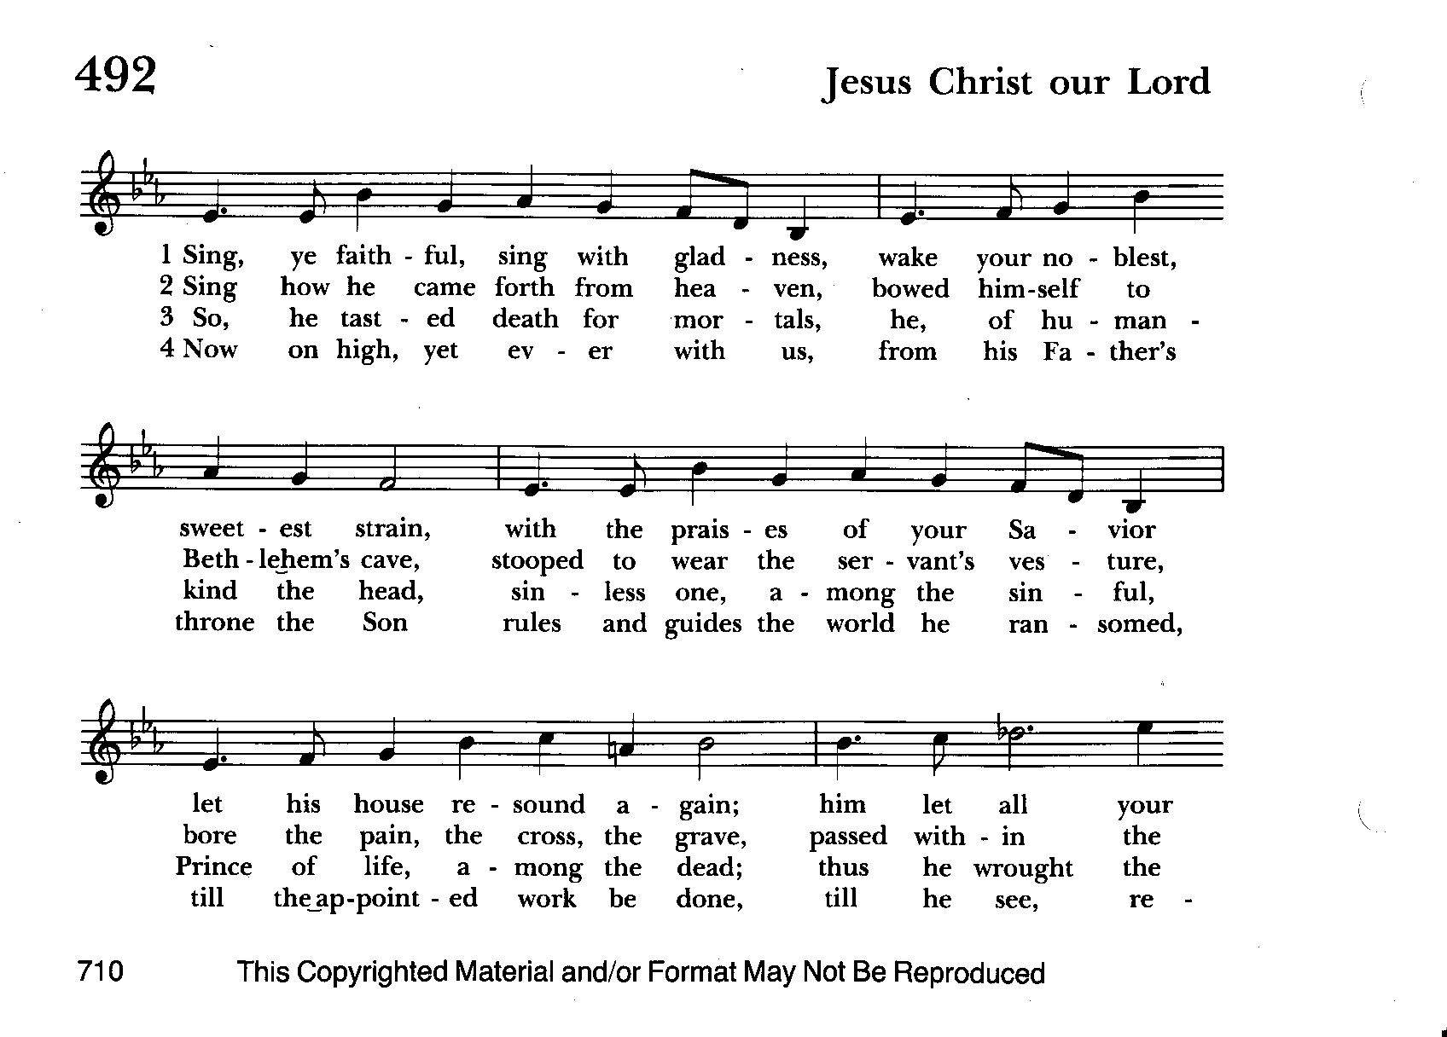

From the Treasurer
April ‘24 Income vs. Expenses:
Projected April Expenses: $14,500
Monies Received as of 4/11: $10,188
Amount Needed to Meet Expenses: $4,312


If you’d like to make a donation to St. John’s you can scan this QR code with your phone’s camera or tap on the link that comes up to make a contribution with either a credit or debit card, Apple Pay or Google Pay. This is a secure site provided by Clover which is a service of PNC Bank.

Dates to put in your calendar:

Friday, April 19th, Bingo. Doors open at 5pm, Bingo starts at 7
Saturday, May 18th, Flea Market. More details to follow

We have St. John’s shirts available for a nominal charge.
With so much going on, everyone’s help is needed to make things a success. Our volunteers make the Church function. The volunteering of time and talent is greatly appreciated.

We have a Potluck Luncheon on the first Sunday of the month and a Coffee Hour on all other Sundays after the 10:30 service.

St. John’s Parish Prayer List

Additions and corrections may be made to our Parish Prayer List at any time. All names will be automatically removed from the Parish Prayer List on the 1st Sunday of each month unless you request otherwise. Please contact Angie at <office@stjohnskingsville.org> or 410-592-8570 in the church office with all changes by 10 am Thursdays. Thank you.

We Pray for Those in Need:
Names in BOLD read aloud by all.

DeMarino Family, Jim & Chris Carden and family, Peggie Dietz, Mike Carden, Pat Carden, Gail Landers, Travis Manar, Marie Dilworth.

We Pray for our Homebound

Lily John, Barbara Miller, Nancy Barnhart, Robin Dilworth

We pray for the Church and the World:

For Most Rev’d. Justin Welby, Archbishop of Canterbury; for The Most Rev’d. Michael Curry, our Presiding Bishop; for Right Rev’d. Eugene Sutton, our Bishop; for our Bishop Co-Adjutor, Carrie Schofield Broadbent, for our Interim Rector, Rev. Mark Lobb, for the Wardens, Vestry, Staff, and all members and friends of St. John’s Church.

For the leaders of all nations, especially for Joseph, our President; for Wes, our Governor; for Brandon, Nick, John and Bob, who lead our City and Counties. We pray for all children and youth; for the homeless, the unemployed, and the hungry. We pray for the safety of our loved ones and friends serving in the Armed Forces at home and abroad, and for our enemies, that all our hearts may be turned toward peace throughout the world.

Baptism, Confirmation, Reception
The Day of Pentecost, also known as Whitsunday, is May 19th this year. It is a day especially appropriate for Baptisms. In addition, Bishop Carrie is Receiving and Confirming those so called at the Cathedral of the Incarnation that Sunday. If you are interested in baptism here at St. John's or reception or confirmation at the cathedral, please let Fr. Mark know.

Choral Choir and Bell Choir


Choir practice, Wednesdays at 7:00 pm

Bell Choir practice, Sundays after the 10:30 service on the 2nd, 3rd and 4th Sundays


SUNDAY SCHOOL
Children’s Sunday school is held from 10:30-11:00 during our 10:30 service. Miss Stephanie and I also would like to invite all interested kids to come and be part of the group!

Mr. John

HAPPINESS IS YELLING


FRIDAY, APRIL 19TH
St. John’s Episcopal Church, Belair Road, Kingsville, MD
Doors open at 5pm - Bingo starts at 7pm
Tickets are $25 Each
Includes 24 game starter pack
Cash and Basket Prizes, 50/50 Raffles, Special Bingos and More!
To reserve tickets in advance call Michele at 443-463-6333

ATTENTION!
During our cleanup day on October 7th of last year, there was a bad auto accident at the intersection of Belair Rd and Sunshine Ave, right outside our campus. One of the victims is asking if any witnesses could contact him. Fr. Mark will give you the contact information. Thanks.

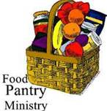
OUTREACH
The FOOD PANTRY is in need of immediate donations. All
donations welcome, food or monetary. Thank you so much.
Needed at this time: jelly and syrup


Yoga classes on Tuesday and Friday evenings 6 to 7 pm and Saturday mornings 9 to 10 am in the Chapel.
All experience levels are welcome.



Earlier this week, I sent out the cost of the Small Parish Retreat. That amount
includes meals and program. Knowing that, if cost is the only barrier to participation, please note the policy below.

Scholarships
No person will be denied the opportunity to participate in a Claggett Center program due to inadequate finances. Financial assistance through the Rev. Bill Fallowfield Scholarship Fund and/or payment arrangements will be made available to those who are in need. Please contact Rosie Alger to receive a Scholarship Request Form.

Contact Information and Directions
Claggett Center
3035 Buckeystown Pike
Adamstown, MD 21710
P: 301-874-5147
info@claggettcenter.org
Rosie Alger
Programs/Camp Director
ralger@claggettcenter.org

Spiritual Communion prayer for those unable to participate in person.

I believe that you are truly present in the Holy Sacrament, and, since I cannot at this time receive communion, I pray you to come into my heart. I unite myself with you and embrace you with all my heart, my soul, and my mind. Let nothing separate me from you; let me serve you in this life until, by your grace, I come to your glorious kingdom and unending peace. Amen.

(St. Augustine’s Prayer Book, p.192)


Social Media and St. John's
If social media is your thing, please consider following or "friending" St. John's Episcopal, Kingsville, MD. Not only will you be able to keep up with happenings in our community, but there are posts from a wide variety of Anglican and Episcopal sources that inform, inspire, and amuse.

Best Practices for Communion
Although intinction, the dipping of the bread in the cup, may seem to be more sanitary, multiple studies have determined the opposite.
Sharing the common cup, in keeping with ancient traditions, is actually much safer given our practice of wiping and rotating the chalice between each communicant. Our bishops and diocesan staff strongly discourage the practice of intinction. Other options include sharing the common cup in the traditional way or abstaining from the cup altogether. Both options are considered full participation in the Eucharist. Please speak to Father Mark with any questions.

What’s Happening This Week at St. John’s

Sunday, April 14—Third Sunday of Easter
8:00am: Holy Eucharist, Rite I (Church)
10:30am: Holy Eucharist, Rite II (Church)
10:30am-11:00am: Sunday School
11:30am: Coffee Hour(Parish Hall)

Monday, April 15
12:00-1:00pm: AA Lunch Bunch (Parish Hall)
7:00-8:30pm: Spanish speaking AA group (Parish Hall)

Tuesday, April 16
12:00-1:00pm: AA Lunch Bunch (Parish Hall)
6:00-7:00pm: Yoga (Chapel)

Wednesday, April 17
12:00-1:00pm: AA Lunch Bunch (Parish Hall)
7:00pm: Choir Practice (Church)
7:30pm: AA (Parish Hall)

Thursday, April 18
12:00-1:00pm: AA Lunch Bunch (Parish Hall)
7:00pm: AA (Parish Hall)

Friday, April 19
12:00-1:00pm: AA Lunch Bunch (Parish Hall)
5:00pm: BINGO NIGHT AT ST. JOHN’S
6:00pm -7:00pm: Yoga (Chapel)

Saturday, April 20
9:00am-10:00am: Yoga (Chapel)
8:30pm: AA (Parish Hall)

Sunday, April 21-Fourth Sunday of Easter
8:00am: Holy Eucharist, Rite I (Church)
10:30am: Holy Eucharist, Rite II (Church)
10:30am-11:00am: Sunday School
11:30am: Coffee Hour (Parish Hall)

Parish Office is open Monday, Wednesday and Thursday, 9:30am-1:30pm.

