St. John’s Episcopal Church
Kingsville, Maryland
Welcomes You

Our Vision Statement

We believe that together we will transform
the world with love: Come on in!

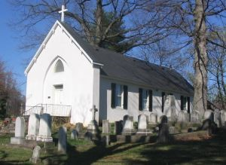

Morning Prayer Rite II
1st Sunday in Lent
February 18, 2024, 10:30 am
Morning Prayer—Rite II

Gathering hymn: The glory of these forty days Hymnal #143

OPENING SENTENCES

Jesus said “If anyone would come after me, let him deny himself and take up his cross BCP pg. 76
and follow me.” Mark 8:34

Grace to you and peace from God our Father and from the Lord Jesus Christ. BCP pg. 78
Philippians 1:2

CONFESSION OF SIN BCP p. 79
Dearly beloved, we have come together in the presence of Almighty God our heavenly Father, to set forth his praise, to hear his holy Word, and to ask, for ourselves and on behalf of others, those things that are necessary for our life and our salvation. And so that we may prepare ourselves in heart and mind to worship him, let us kneel in silence, and with penitent and obedient hearts confess our sins, that we may obtain forgiveness by his infinite goodness and mercy.

Officiant and People please stand or kneel as able
Most merciful God, we confess that we have sinned against you in thought, word, and deed, by what we have done, and by what we have left undone. We have not loved you with our whole heart; we have not loved our neighbors as ourselves. We are truly sorry and we humbly repent. For the sake of your Son Jesus Christ, have mercy on us and forgive us; that we may delight in your will, and walk in your ways, to the glory of your Name. Amen.

The Invitatory and Psalter BCP pg. 80

All stand
Officiant: Lord, open our lips.
People: And our mouth shall proclaim your praise.

Officiant and People
Glory to the Father, and to the Son, and to the Holy Spirit: as it was in the
beginning, is now, and will be for ever. Amen.

The Lord is full of compassion and mercy: Come let us adore him. BCP pg. 81

Venite Psalm 95:1-7 BCP. pg. 82
Come, let us sing to the Lord;*
let us shout for joy to the Rock of our salvation.
Let us come before his presence with thakisgiving*
and raise a loud shout to him with psalms.

For the Lord is a great God,*
and a great King above all gods.
In his hands are the caverns of the earth,*
and the heights of the hills are his also.
The sea is his, for he made it.*
and his hands have molded the dry land.

Come, let us bow down, and bend the knee,*
and kneel before the Lord our Maker.
For he is our God,
and we are the people of his pasture and the sheep of his hand.*
Oh, that today you would hearken to his voice!

Psalm 25:1-9 Ad te, Domine, levavi The congregation is seated
1 To you, O Lord, I lift up my soul;
my God, I put my trust in you; *
let me not be humiliated,
nor let my enemies triumph over me.
2 Let none who look to you be put to shame; *
let the treacherous be disappointed in their schemes.
3 Show me your ways, O Lord, *
and teach me your paths.
4 Lead me in your truth and teach me, *
for you are the God of my salvation;
in you have I trusted all the day long.
5 Remember, O Lord, your compassion and love, *
for they are from everlasting.
6 Remember not the sins of my youth and my transgressions; *
remember me according to your love
and for the sake of your goodness, O Lord.
7 Gracious and upright is the Lord; *
therefore he teaches sinners in his way.
8 He guides the humble in doing right *
and teaches his way to the lowly.
9 All the paths of the Lord are love and faithfulness *
to those who keep his covenant and his testimonies.

A Reading from Genesis 9:8-17
In the beginning when God created the heavens and the earth, the earth was a formless void and darkness covered the face of the deep, while a wind from God swept over the face of the waters. Then God said, “Let there be light”; and there was light. And God saw that the light was good; and God separated the light from the darkness. God called the light Day, and the darkness he called Night. And there was evening and there was morning, the first day.
And God said, “Let there be a dome in the midst of the waters, and let it separate the waters from the waters.” So God made the dome and separated the waters that were under the dome from the waters that were above the dome. And it was so. God called

the dome Sky. And there was evening and there was morning, the second day. And God said, “Let the waters under the sky be gathered together into one place, and let the dry land appear.” And it was so. God called the dry land Earth, and the waters that were gathered together he called Seas. And God saw that it was good. Then God said, “Let the earth put forth vegetation: plants yielding seed, and fruit trees of every kind on earth that bear fruit with the seed in it.” And it was so. The earth brought forth vegetation: plants yielding seed of every kind, and trees of every kind bearing fruit with the seed in it. And God saw that it was good. And there was evening and there was morning, the third day.
And God said, “Let there be lights in the dome of the sky to separate the day from the night; and let them be for signs and for seasons and for days and years, and let them be lights in the dome of the sky to give light upon the earth.” And it was so. God made the two great lights—the greater light to rule the day and the lesser light to rule the night—and the stars. God set them in the dome of the sky to give light upon the earth, to rule over the day and over the night, and to separate the light from the darkness. And God saw that it was good. And there was evening and there was morning, the fourth day.
And God said, “Let the waters bring forth swarms of living creatures, and let birds fly above the earth across the dome of the sky.” So God created the great sea monsters and every living creature that moves, of every kind, with which the waters swarm, and every winged bird of every kind. And God saw that it was good. God blessed them, saying, “Be fruitful and multiply and fill the waters in the seas, and let birds multiply on the earth.” And there was evening and there was morning, the fifth day.
And God said, “Let the earth bring forth living creatures of every kind: cattle and creeping things and wild animals of the earth of every kind.” And it was so. God made the wild animals of the earth of every kind, and the cattle of every kind, and everything that creeps upon the ground of every kind. And God saw that it was good.
Then God said, “Let us make humankind in our image, according to our likeness; and let them have dominion over the fish of the sea, and over the birds of the air, and over the cattle, and over all the wild animals of the earth, and over every creeping thing that creeps upon the earth.” So God created humankind in his image, in the image of God he created them; male and female he created them. God blessed them, and God said to them, “Be fruitful and multiply, and fill the earth and subdue it; and have dominion over the fish of the sea and over the birds of the air and over every living thing that moves upon the earth.” God said, “See, I have given you every plant yielding seed that is upon the face of all the earth, and every tree with seed in its fruit; you shall have them for food. And to every beast of the earth, and to every bird of the air, and to everything that creeps on the earth, everything that has the breath of life, I have given every green plant for food.” And it was so. God saw everything that he had made, and indeed, it was very good. And there was evening and there was morning, the sixth day.
Thus the heavens and the earth were finished, and all their multitude. And on the seventh day God finished the work that he had done, and he rested on the seventh day from all the work that he had done. So God blessed the seventh day and hallowed it, because on it God rested from all the work that he had done in creation. These are the generations of the heavens and the earth when they were created.

The Word of the Lord.
Thanks be to God.

Canticle 14 A Song of Penitence Kyrie Pantokrator
Prayer of Manasseh, 102, 4, 6-7, 11-15
O Lord and Ruler of the hosts of heaven, *
God of Abraham, Isaac, and Jacob,
and of all their righteous offspring:
You made the heavens and the earth, *
with all their vast array.

All things quake with fear at your presence; *
they tremble because of your power.
But your merciful promise is beyond all measure; *
it surpasses all that our minds can fathom.
O Lord, you are full of compassion, *
long-suffering, and abounding in mercy.
You hold back your hand; *
you do not punish as we deserve.
In your great goodness, Lord,
you have promised forgiveness to sinners, *
that they may repent of their sin and be saved.
And now, O Lord, I bend the knee of my heart, *
and make my appeal, sure of your gracious goodness.
I have sinned, O Lord, I have sinned, *
and I know my wickedness only too well.
Therefore I make this prayer to you: *
Forgive me, Lord, forgive me.
Do not let me perish in my sin, *
nor condemn me to the depths of the earth.
For you, O Lord, are the God of those who repent, *
and in me you will show forth your goodness.
Unworthy as I am, you will save me,
in accordance with your great mercy, *
and I will praise you without ceasing all the days of my life.
For all the powers of heaven sing your praises, *
and yours is the glory to ages of ages. Amen.

A Reading from the First Letter of Peter 3:18-22
Christ also suffered for sins once for all, the righteous for the unrighteous, in order to bring you to God. He was put to death in the flesh, but made alive in the spirit, in which also he went and made a proclamation to the spirits in prison, who in former times did not obey, when God waited patiently in the days of Noah, during the building of the ark, in which a few, that is, eight persons, were saved through water. And baptism, which this prefigured, now saves you-- not as a removal of dirt from the body, but as an appeal to God for a good conscience, through the resurrection of Jesus Christ, who has gone into heaven and is at the right hand of God, with angels, authorities, and powers made subject to him.

The Word of the Lord.
Thanks be to God.

Gradual hymn: Christ, when for us you were baptized Hymnal #121

The Holy Gospel of Our Lord according to Mark 1:9-15
In those days Jesus came from Nazareth of Galilee and was baptized by John in the Jordan. And just as he was coming up out of the water, he saw the heavens torn apart and the Spirit descending like a dove on him. And a voice came from heaven, “You are my Son, the Beloved; with you I am well pleased.”
And the Spirit immediately drove him out into the wilderness. He was in the wilderness forty days, tempted by Satan; and he was with the wild beasts; and the angels waited on him. Now after John was arrested, Jesus came to Galilee, proclaiming the good news of God, and saying, “The time is fulfilled, and the kingdom of God has come near; repent, and believe in the good news.”

The Word of the Lord.
Thanks be to God.

The Homily The congregation is seated Jacob Johnson

The Peace

Announcements

THE APOSTLES CREED BCP pg. 96
Said by all, standing as you are able.
I believe in God, the Father almighty,
creator of heaven and earth;
I believe in Jesus Christ, his only Son, our Lord.
He was conceived by the power of the Holy Spirit
and born of the Virgin Mary.
He suffered under Pontius Pilate,
was crucified, died, and was buried.
He descended to the dead.
On the third day he rose again.
He ascended into heaven,
and is seated at the right hand of the Father.
He will come again to judge the living and the dead.
I believe in the Holy Spirit,
the holy catholic Church,
the communion of saints,
the forgiveness of sins
the resurrection of the body,
and the life everlasting. Amen.
Celebrant: The Lord be with you.
People: And also with you.
Celebrant: Let us pray.
THE LORD’S PRAYER Stand or kneel as able. BCP pg. 97
Our Father, who art in heaven, hallowed be thy Name, thy kingdom come, thy will be done, on earth as it is in heaven. Give us this day our daily bread. And forgive us our trespasses, as we forgive those who trespass against us. And lead us not into temptation, but deliver us from evil. For thine is the kingdom, and the power, and the glory, for ever and ever. Amen.

People and Officiant
SUFFRAGES B BCP pg. 98
V. Save your people, Lord, and bless your inheritance;
R. Govern and uphold them, now and always.
V. Day by day we bless you;
R. We praise your Name for ever.
V. Lord, keep us from all sin today;
R. Have mercy on us, Lord, have mercy.
V. Lord, show us your love and mercy;
R. For we put our trust in you.
V. In you, Lord, is our hope;
R. And we shall never hope in vain.

THE COLLECT OF THE DAY
Almighty God, whose blessed Son was led by the Spirit to be tempted by Satan: Come quickly to help us who are assaulted by many temptations; and, as you know the weaknesses of each of us, let each one find you mighty to save; through Jesus Christ your Son our Lord, who lives and reigns with you and the Holy Spirit, one God, now and for ever. Amen.

COLLECT FOR GRACE BCP pg. 100
Lord God, almighty and everlasting Father, you have brought us in safety to this new day: Preserve us with your mighty power, that we may not fall into sin, nor be overcome by adversity; and in all we do, direct us to the fulfilling of your purpose; through Jesus Christ our Lord. Amen.

Officiant: Let us pray for our own needs and those of others.

Silence

PRAYER FOR MISSION BCP pg. 100
Almighty and everlasting God, by whose Spirit the whole body of your faithful people is governed and sanctified: Receive our supplications and prayers which we offer before you for all members of your holy Church, that in their vocation and ministry they may truly and devoutly serve you; through Lord and Savior Jesus Christ. Amen.

DOXOLOGY Please stand as able Hymnal #43, vs. 4
Praise God, from whom all blessings flow; praise him, all creatures here below; praise him above, ye heavenly host: praise Father, Son, and Holy Ghost.

We Pray for Those in Need:
Lisa, Peter, Sarah Sutherland, Melissa Heaver, Liz Rawl.

We pray for our Homebound
Lily John

We pray for the Church and the World:
For Most Rev’d. Justin Welby, Archbishop of Canterbury; for The Most Rev’d. Michael Curry, our Presiding Bishop; for Right Rev’d. Eugene Sutton, our Bishop; for our Bishop Co-Adjutor, Carrie Schofield Broadbent, for our Interim Rector, Rev. Mark Lobb, for the Wardens, Vestry, Staff, and all members and friends of St. John’s Church.

For the leaders of all nations, especially for Joseph, our President; for Wes, our Governor; for Brandon, Nick, John and Bob, who lead our City and Counties. We pray for all children and youth; for the homeless, the unemployed, and the hungry. We pray for the safety of our loved ones and friends serving in the Armed Forces at home and abroad, and for our enemies, that all our hearts may be turned toward peace throughout the world.

THE GENERAL THANKSGIVING
Let us pray.
Officiant and people BCP pg. 101
Almighty God, Father of all mercies, we your unworthy servants give you
humble thanks for all your goodness and loving-kindness to us and to all whom you have made. We bless you for our creation, preservation, and all the blessings of this life; but above all for your immeasurable love in the redemption of the world by our Lord Jesus Christ; for the means of grace, and for the hope of glory. And, we pray, give us such an awareness of your mercies, that with truly thankful hearts we may show forth your praise, not only with our lips, but in our lives, by giving up our selves to your service, and by walking before you in holiness and righteousness all our days; through Jesus Christ our Lord, to whom, with you and the Holy Spirit, be honor and glory throughout all ages. Amen.

Closing hymn: Lead us, heavenly Father, lead us Hymnal #559

THE DISMISSAL BCP pg. 102
Officiant: The grace of our Lord Jesus Christ, and the Love of God, and the fellowship of the Holy Spirit, be with us all evermore.
People: Thanks be to God.

BISHOP CARRIE—SUCH A TIME AS THIS

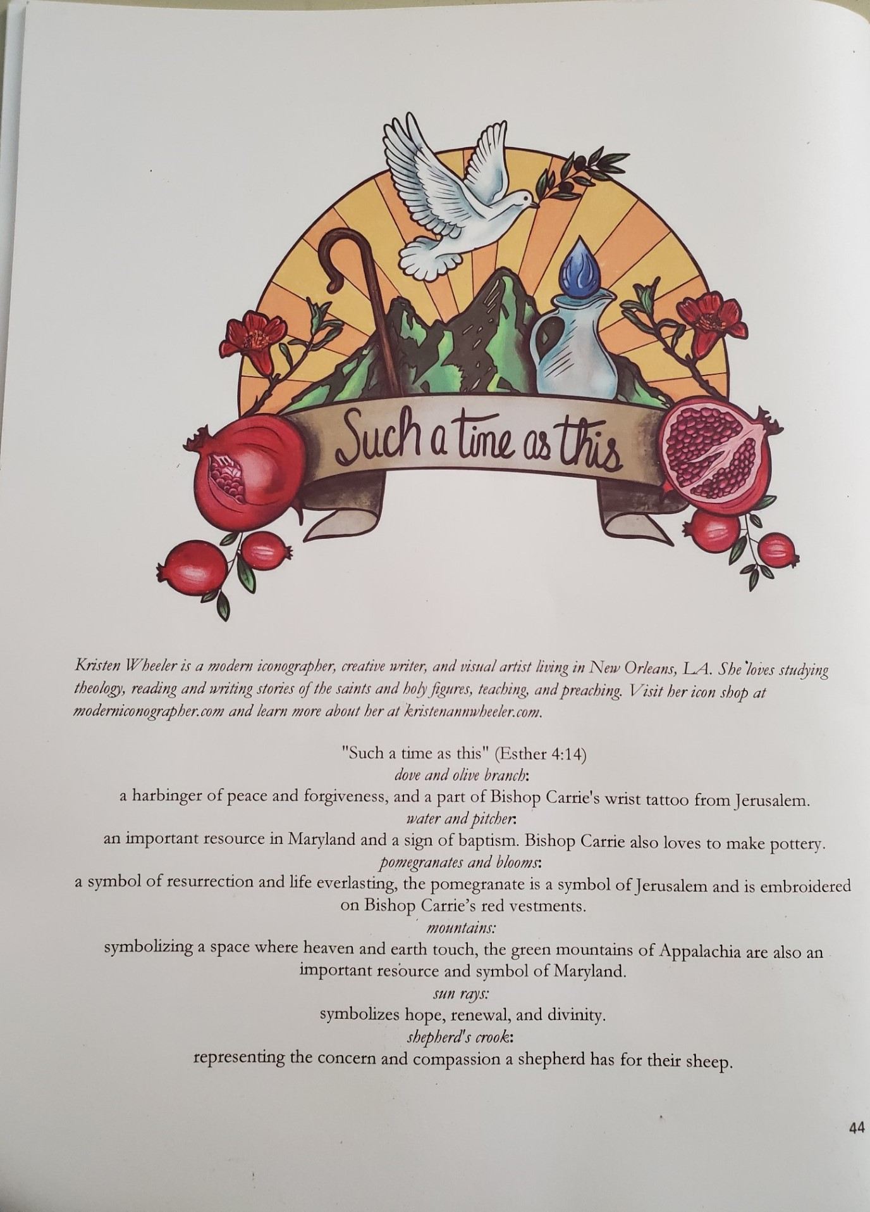

St. John’s Parish Prayer List

Additions and corrections may be made to our Parish Prayer List at any time. All names will be automatically removed from the Parish Prayer List on the 1st Sunday of each month unless you request otherwise. Please contact Angie at <office@stjohnskingsville.org> or 410-592-8570 in the church office with all changes by 10 am Thursdays. Thank you.

We Pray for Those in Need:
Names in BOLD read aloud by all.

Ivan, Lisa, Peter, Sarah Sutherland, Melissa Heaver, Liz Rawl, Ricky Carter, Marilyn Stephenson, Cleo Collins, Sid & Joan Pyle, Karen Sugden, DeMarino Family, Jenny, Lisa, Jennifer, Dylan, Gary, Paul Edwards, James Kneussl, Kim Collins-Appel, Ronnee Congleton (pancreatic cancer), Stephanie Payton, Jim & Chris Carden and family, Peggie Dietz, Barnabas & Sarah, Thomas Proctor, Mike Carden, Pat Carden, Gail Landers, Alisha Erion, Marie Dilworth, Larry Betzler, Anne Leland, Linda Urban.

We Pray for our Homebound

Lily John, Barbara Miller, Nancy Barnhart, Robin Dilworth

We pray for the Church and the World:

For Most Rev’d. Justin Welby, Archbishop of Canterbury; for The Most Rev’d. Michael Curry, our Presiding Bishop; for Right Rev’d. Eugene Sutton, our Bishop; for our Bishop Co-Adjutor, Carrie Schofield Broadbent, for our Interim Rector, Rev. Mark Lobb, for the Wardens, Vestry, Staff, and all members and friends of St. John’s Church.

For the leaders of all nations, especially for Joseph, our President; for Wes, our Governor; for Brandon, Nick, John and Bob, who lead our City and Counties. We pray for all children and youth; for the homeless, the unemployed, and the hungry. We pray for the safety of our loved ones and friends serving in the Armed Forces at home and abroad, and for our enemies, that all our hearts may be turned toward peace throughout the world.

Serving Today

Officiant:: Jacob Johnson
Old Testament: Debbie Weaver
Psalm: John Stevens
New Testament: Anne Leland
Prayers of the People: Debbie Weaver
Music Director: Nancy Heinold
Altar Guild: Stephanie Duchacek & Sandy Roe

From the Treasurer

February ’24 Income vs. Expenses:

Projected February Expenses: $13,500
Monies Received as of 2/15: $10,517

Amount Needed to Meet Expenses: $2,983


If you’d like to make a donation to St. John’s you can scan this QR code with your phone’s camera or tap on the link that comes up to make a contribution with either a credit or debit card, Apple Pay or Google Pay. This is a secure site provided by Clover which is a
service of PNC Bank.

Choral Choir and Bell Choir

Choir practice, Wednesdays at 7:00 pm

Bell Choir practice, Sundays after the 10:30 service on the 2nd, 3rd and 4th Sundays

SUNDAY SCHOOL
Children’s Sunday school is held from 10:30-11:00 during our 10:30 service. Miss Stephanie and I also would like to invite all interested kids to come and be part of the group!

Mr. John

Yoga is now on Tuesday and Friday evenings 6 to 7 pm and Saturday mornings 9 to 10 am in the Chapel.
All experience levels are welcome.


INCLEMENT WEATHER—Be careful coming to church in inclement weather. If you don’t feel safe coming out—stay home. God will understand. You can also participate on line. Follow Baltimore County Public Schools schedule.

We have St. John’s shirts available for a nominal charge.
With so much going on, everyone’s help is needed to make things a success. Our volunteers make the Church function. The volunteering of time and talent is greatly appreciated.

There is a Potluck Luncheon on the first Sunday of the month and a Coffee Hour on all other Sundays after service.

Spiritual Communion prayer for those unable to participate in person.

I believe that you are truly present in the Holy Sacrament, and, since I cannot at this time receive communion, I pray you to come into my heart. I unite myself with you and embrace you with all my heart, my soul, and my mind. Let nothing separate me from you; let me serve you in this life until, by your grace, I come to your glorious kingdom and unending peace. Amen.

(St. Augustine’s Prayer Book, p.192)

Best Practices for Communion
Although intinction, the dipping of the bread in the cup, may seem to be more sanitary, multiple studies have determined the opposite.
Sharing the common cup, in keeping with ancient traditions, is actually much safer given our practice of wiping and rotating the chalice between each communicant. Our bishops and diocesan staff strongly discourage the practice of intinction. Other options include sharing the common cup in the traditional way or abstaining from the cup altogether. Both options are considered full participation in the Eucharist. Please speak to Father Mark with any questions.

OUTREACH
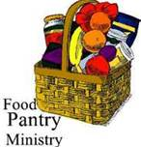
The FOOD PANTRY is in need of immediate donations. All donations welcome, food or monetary. Thank you so much.
Needed at this time: Jelly and Syrup

Social Media and St. John's

If social media is your thing, please consider following or "friending" St. John's Episcopal, Kingsville, MD. Not only will you be able to keep up with happenings in our community, but there are posts from a wide variety of Anglican and Episcopal sources that inform, inspire, and amuse.


Lent Friday Nights
In keeping with St. John’s tradition, we are all invited to a time of fellowship and formation on the Friday evenings in the season of Lent. We gather for a simple meal and then will watch together episodes of The Chosen. This is a well-regarded series that tells the story of Jesus and will provide entertainment, discussion, and discernment. Each episode is about an hour long.
We gather at 6:30 p.m. Feb. 23, Mar. 1, 8, 15, 22 in the Parish Hall.

See the author introduce the book. Click the link below.
https://youtube.com/watch?v=1T-d9uEyg_0&si=at14I6wElpNB4k0q

Our current Book Study. Looking for God in Messy Places is an excellent commentary and narrative by +Jake Owensby, Bishop of the Diocese of Western Louisiana and Chancellor of the University of the South. Our conversations will be in the same format as before. Each class will begin with a devotion, then discussion on assigned readings. The Group meets Wednesday mornings at 9:00. We will begin on 1/9-10 and go to 3/12-13 Copies are available on Amazon. Please let Fr. Mark know if you have any questions.

What’s Happening This Week at St. John’s

Sunday, February 18—First Sunday in Lent
8:00am: MORNING PRAYER, Rite I (Church)
10:30am: MORNING PRAYER, Rite II (Church)
10:30am-11:00am: Sunday School
11:30am: Coffee Hour (Parish Hall)
11:45am: Bell Choir Practice (Church)

Monday, February 19
12:00-1:00pm: AA Lunch Bunch (Parish Hall)
7:00-8:30pm: Spanish speaking AA group (Parish Hall)

Tuesday, February 20
12:00-1:00pm: AA Lunch Bunch (Parish Hall)
6:00pm-7:00pm: Yoga (Chapel)

Wednesday, February 21
9:00-10:00am: Morning Prayer and Book Study (Counseling Room)
12:00-1:00pm: AA Lunch Bunch (Parish Hall)
7:00pm: Choir Practice (Church)
7:30pm: AA (Parish Hall)

Thursday, February 22
12:00-1:00pm: AA Lunch Bunch (Parish Hall)
7:00pm: AA (Parish Hall)

Friday, February 23
12:00-1:00pm: AA Lunch Bunch (Parish Hall)
6:00pm -7:00pm: Yoga (Chapel)
6:30pm: Lent Friday Nights

Saturday, February 24
9:00am-10:00am Yoga (Chapel)
8:30pm: AA (Parish Hall)

Sunday, February 25
8:00am: Holy Eucharist, Rite I (Church)
10:30am: Holy Eucharist, Rite II (Church)
10:30am-11:00am: Sunday School
11:30am: Coffee Hour (Parish Hall)
11:45am: Bell Choir Practice (Church)

Father Mark is away February 18– February 23.
Parish Office is open Monday, Wednesday and Thursday, 9:30am-1:30pm.

