St. John’s Episcopal Church
In Kingsville, Maryland
welcomes you

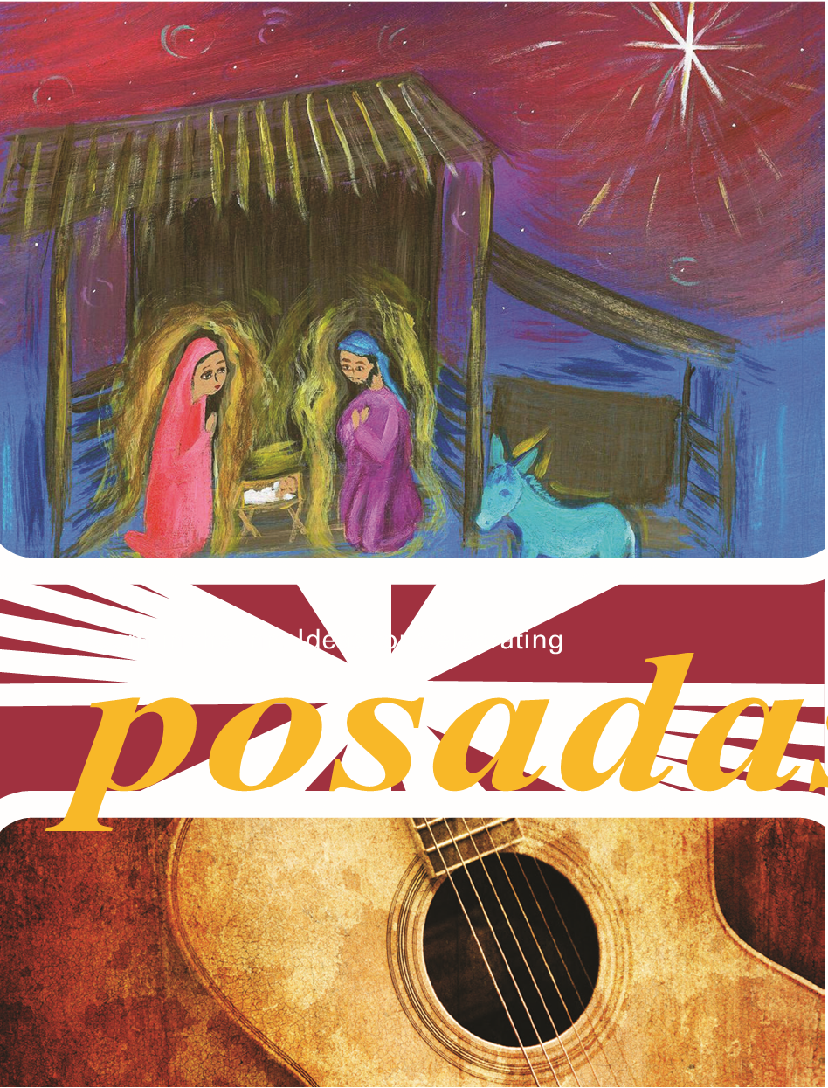

5:00 p.m. Family Christmas Eve Worship
December 24, 2023

St. John’s Episcopal Church

11901 Belair Road, P. O. Box 187, Kingsville, MD 21087
Facebook: St. John’s Episcopal, Kingsville, MD
Email: office@stjohnskingsville.org
Website: www.stjohnskingsville.org
Church Phone: 410-592-8570
For Pastoral Emergencies: Fr. Mark Lobb+ 443-690-9545

Welcome to worship today! We are glad that you are with us. You are invited to participate in all parts of the service as indicated in this service bulletin. If you have any questions, feel free to ask the ushers. Bathrooms are located in the Parish Hall, the brick building across the parking lot.

I was glad when they said to me, “Let us go to the house of the Lord.” Psalm 122:1

Church Staff

Interim Rector: Father Mark Lobb
Administrative Assistant: Angie Bosley
Organist/Choir Director: Nancy Heinold

The Vestry

Class of 2024 Class of 2025

Marguerite Lobb John Frost
Jacob Johnson Woodie Tingle

Officers
Ty Schwenk—Sr. Warden Terry Roe—Jr. Warden
Elizabeth Healey—Treasurer Anne Leland-Registrar

Parish Committee Chairpersons

Altar Guild: Elizabeth Healey
Auxiliary Committee: Michele Lozanski
Cemetery Committee: Terry Roe

5:00 PM Family Christmas Eve Worship
The Holy Eucharist: Rite II

Las Posadas is an Advent and Christmas celebration originating in Latin America. Traditional versions involve outdoor processions from house to house over a series of days. Children and adults reenact the Joseph and Mary’s search for lodging and a safe place for Jesus to be born (Luke 2:1-7), but in this case, room is found at an inn. “We learn from the Posadas that by welcoming the poor and the needy, we are
welcoming Jesus into our midst. (See Matthew 25:40¹)

Participants are given an electric candle and maybe a musical instrument such as a maraca or tambourine.

Prelude

4:55 PM The Church Bell is Rung
If you are able, please stand

The Processional Hymn O come, all ye faithful Hymnal # 83

Please be seated.
Leader: Light and peace, in Jesus Christ our Lord
All: Thanks be to God
Leader: Today is Christmas Eve , in which we recall the hope we have in Christ. Today we light again the candles of hope, peace, love and joy.
(Each candle will be lit as the reader speaks)
First Candle We speak of hope - because God keeps his promises to us.
Second Candle We work for peace - because Jesus is the ‘Prince of Peace’ and he calls his children to work for peace in his name.
Third Candle We share joy - because the Holy Spirit fills our hearts and minds with the presence the God
Fourth Candle We show love - because Jesus gave everything for us and led us to know the forgiveness of God.
Christ Candle Now we light our last candle to remember the birth of our Lord and Saviour Jesus Christ. As the prophets promised so long ago, you have come to us once again; and with the shepherds, we are filled with wonder and amazement.

(Light the white Christ candle now.)
Lord, you come as a tiny, fragile baby; yet we know that you are God and you are with us. May the flame of this candle remind us that you are the light of the world and that if we follow you, we will never walk in darkness, but will have the true light of life.
All: Come, Lord Jesus, come. Amen.

Celebrant: The glory of the Lord has been revealed:
People: And all flesh shall see the salvation of our God.

Celebrant: Let us pray. O God our Creator, to restore our fallen race you spoke the effectual word, and the Eternal Word became flesh in the womb of the Blessed Virgin Mary: Mercifully grant that as he humbled himself to be clothed with our humanity, so we may be found worthy, in him, to be clothed with his divinity; who lives and reigns for ever and ever.

All: Amen.

Hark the herald angels sing Hymnal # 87

The Collect of the Day Stand or kneel as able BCP, p. 212
O God, you make us glad by the yearly festival of the birth of your only Son Jesus Christ: Grant that we, who joyfully receive him as our Redeemer, may with sure confidence behold him when he comes to be our Judge; who lives and reigns with you and the Holy Spirit, one God, now and for ever.
All: Amen.

The Word of God

Please be seated.
A Reading from the Book of the Prophet Isaiah Isaiah 9:2-7
The people who walked in darkness have seen a great light; those who lived in a land of deep darkness--on them light has shined. You have multiplied the nation, you have increased its joy; they rejoice before you as with joy at the harvest, as people exult when dividing plunder. For the yoke of their burden, and the bar across their shoulders, the rod of their oppressor, you have broken as on the day of Midian. For all the boots of the tramping warriors and all the garments rolled in blood shall be burned as fuel for the fire. For a child has been born for us, a son given to us; authority rests upon his shoulders; and he is named Wonderful Counselor, Mighty God, Everlasting Father, Prince of Peace. His authority shall grow continually, and there shall be endless peace for the throne of David and his kingdom. He will establish and uphold it with justice and with righteousness from this time onward and forevermore. The zeal of the LORD of hosts will do this.

Reader: The Word of the Lord.
People: Thanks be to God.

Stand as able

Gradual Hymn Angels we have heard on high” Hymnal #96

The Gospel Lesson
We pray:
Emmanuel-God with us: We remember tonight the journey that our mother took as she and Joseph searched for lodging- a warm, safe place where she could give birth to you. We know that in our world, this very night, there are men, women, and children who are searching for lodging. We pray that
hospitable doors will be opened to them. In Christ’s name. Amen.

The Holy Gospel of Our Lord Jesus Christ according to Luke Luke 2: 1-7
In those days a decree went out from Emperor Augustus that all the world should be registered. This was the first registration and was taken while Quirinius was governor of Syria. All went to their own towns to be registered. Joseph also went from the town of Nazareth in Galilee to Judea, to the city of David called Bethlehem, because he was descended from the house and family of David. He went to be registered with Mary, to whom he was engaged and who was expecting a child. While they were there, the time came for her to deliver her child. And she gave birth to her firstborn son and wrapped him in bands of cloth, and laid him in a manger, because there was no place for them in the inn.

Let us enact this human drama Congregation may be seated

At this point, there is a procession around the nave, stopping where directed at a station designated as an “inn”.

Station 1
Pilgrims sing- In the name of heaven, can you give us lodging? My dear wife’s
exhausted after hours of walking.

Innkeeper sings- This is not an inn, I don’t take strangers. You might be a robber. I can’t risk that danger

Process to next station

Station 2
Pilgrims sing- We have come from Nazareth, walking all the way. I am a poor woodworker, Joseph is my name.

Innkeeper 2 sings- Knowing what your name is does not change my answer. Go and let me sleep. Stop this useless banter.

Process to next station

Station 3
Pilgrims sing- Please, sir, all we ask is one night of lodging for the queen of heaven. Can you offer nothing?

Innkeeper 3 sings- I’ve heard many stories; this beats every one. Since when does a queen walk at night alone?

Process to next station

Station 4
Pilgrims sing- Truly my wife Mary is a queen most bless’d. She will be the mother of the Word made flesh.

Innkeeper 4 sings- Is that you, Saint Joseph? And the Virgin too? I would have opened sooner if I’d recognized you.

Then all sing together:
Enter, enter, holy pilgrims, holy pilgrims. Welcome to my humble home. Though it’s little I can offer all I have, please call your own.

Mary, Joseph, and our Savior, and our Savior, what a joy to have you here! We are honored to receive you, to receive you. May you stay through all the year!

THE PINATA IS BROKEN! MERRY CHRISTMAS! FELIZ NAVIDAD!
The Gospel Reading Continues: In that region were shepherds living in the fields, keeping watch over their flock by night. Then an angel of the Lord stood before them, and the glory of the Lord shone around them, and they were terrified. But the angel said to them, “Do not be afraid; for see—I a bringing you good news of great joy for all the people: to you is born this day in the city of David a Savior, who is the Messiah, the Lord. This will be a sign for you: you will find a child wrapped in bands of cloth and lying in a manger.” And suddenly there was with the angel a multitude of heavenly host, praising God and saying, “Glory to God in the highest heaven, and on earth peace among those whom he favors!”

The Gospel of the Lord.
Praise to you, Lord Christ.

Homily Rev. Mark Lobb+

The Nicene Creed Please stand as able BCP, p. 358

Prayers of the People: Form VI Please stand or kneel as able BCP, p. 392

The Peace of Christ

Welcome & Announcements All are seated

The Holy Communion

Offertory Anthem Chants Noel Bell Choir
Offertory Hymn: Away in a manger Hymnal #101

Presentation Hymn: Hymnal #43, vs. 4

The Great Thanksgiving: Eucharistic Prayer B BCP, p. 367

Sanctus Hymnal # S - 129

Worship continues Please stand or kneel as able BCP, p. 368

The Lord’s Prayer BCP, p. 364

The Breaking of the Bread BCP, p. 364

Invitation to Communion BCP, p. 364

All baptized Christians are welcome to receive Holy Communion with us. You may receive both the Bread and the Wine, or carefully dip the bread in the wine. If you do not wish to receive Holy Communion, you may come to the altar rail for a blessing. Cross your arms over your heart as a sign to the priest.
Gluten-free available upon request.

Communion Hymn: The first Nowell Hymnal #109

Post Communion Prayer BCP p. 365

Christmas Devotion: Silent night, holy night Hymnal #111
(Lights are dimmed, congregational candles are lit and carol is sung, kneeling.)

A Christmas Blessing
Celebrant: May Christ, who by his Incarnation gathered into one thing earthly and heavenly, fill you with his joy and peace; and the blessing of God Almighty, the Father, the Son, and the Holy Spirit, be among you, and remain with you always.
All: Amen.

Recessional Hymn: Joy to the world Hymnal #100

The Dismissal

Postlude

Merry Christmas!

Join us next Sunday at 9:30 for
Christmas Lessons & Carols

The church office will be closed from

December 25-January 2nd

2023 Poinsettias
Barbara Daniel in memory of Loved Ones
Sharon & Mark Lobb in memory of Michael T. Kellogg, Don Thomas, Sr., Thomas Lobb, Susan Kellogg, Robert Kellogg
Ross & Darlene Strickler in honor of Ethel D. Ay, Gustav A. Ay, Katherine F. Lowman and Morris Lowman, Kathleen E. McKelvey and Thomas E. McKelvey
Debbie Puzzuto in memory of Michael, Anna and Dennis Debonis,
Patricia Gray
Susan Cumming in thanksgiving for St. John’s Church
Susan Cumming in memory of Ben Cumming IV
Stephanie & Frank Duchacek in memory of Loved Ones
Liz Healey in memory of John & Lorraine Healey, Earl & May Banks, The Holland Family, Norman & Peggy Banks
Karen Smith-Manar in memory of Hugh Manar
Laura Spadone in memory of Charlie Keenan
Duane & Debbie Weaver in memory of David Joho
Joan Salmon in memory of Captain Walter W. Salmon, Jr., USN
Woodie Tingle in honor of Dennis Mally, in honor of Jane White, in honor of Nancy Heinold, in honor of Angie Bosley
Woodie Tingle in memory of Mary & Woodie Tingle and Helen & Gus Mally

St. John’s Parish Prayer List

Additions and corrections may be made to our Parish Prayer List at any time. All names will be automatically removed from the Parish Prayer List on the 1st Sunday of each month unless you request otherwise. Please contact Angie at <office@stjohnskingsville.org> or 410-592-8570 in the church office with all changes by 10 am Thursdays. Thank you.

We Pray for Those in Need:

Ivan, Lisa, Peter, Sarah Sutherland, Melissa Heaver, Liz Rawl, Ricky Carter, Marilyn Stephenson, Cleo Collins, Sid & Joan Pyle, Karen Sugden, DeMarino Family, Jenny, Lisa, Jennifer, Dylan, Gary, Paul Edwards, James Kneussl, Kim Collins-Appel, Ronnee Congleton (pancreatic cancer), Stephanie Payton, Jim & Chris Carden and family, Peggie Dietz, Barnabas & Sarah, Thomas Proctor, Mike Carden, Pat Carden, Gail Landers, Alisha Erion, Marie Dilworth, Larry Betzler, Anne Leland, Morgan Thomas, Barbara Miller.

We Pray for our Homebound

Lily John, Barbara Miller, Nancy Barnhart, Robin Dilworth

We pray for the Church and the World:

For Most Rev’d. Justin Welby, Archbishop of Canterbury; for The Most Rev’d. Michael Curry, our Presiding Bishop; for Right Rev’d. Eugene Sutton, our Bishop; for our Bishop Co-Adjutor, Carrie Schofield Broadbent, for our Interim Rector, Rev. Mark Lobb, for the Wardens, Vestry, Staff, and all members and friends of St. John’s Church.

For the leaders of all nations, especially for Joseph, our President; for Wes, our Governor; for Brandon, Nick, John and Bob, who lead our City and Counties. We pray for all children and youth; for the homeless, the unemployed, and the hungry. We pray for the safety of our loved ones and friends serving in the Armed Forces at home and abroad, and for our enemies, that all our hearts may be turned toward peace throughout the world.



“For unto you is born this day in the city of David a Savior, which is Christ the Lord.’...That’s what Christmas is all about, Charlie Brown.”

LINUS in A Charlie Brown Christmas

