St. John’s Episcopal Church
Kingsville, Maryland
Welcomes You

Our Vision Statement

We believe that together we will transform
the world with love: Come on in!

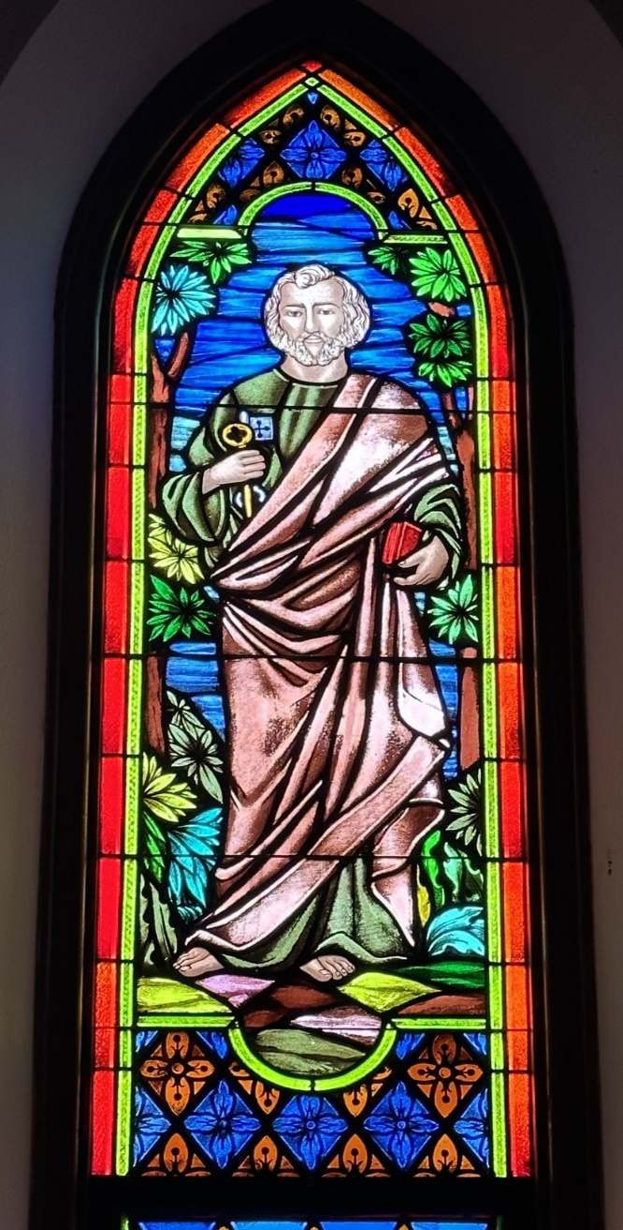

Thirteenth Sunday after Pentecost
August 27, 2023 - 9:30 am

St. John’s Episcopal Church

11901 Belair Road, P. O. Box 187, Kingsville, MD 21087
FaceBook: St. John’s Episcopal, Kingsville, MD
Email: office@stjohnskingsville.org
Website: www.stjohnskingsville.org
Church Phone: 410-592-8570
For Pastoral Emergencies: Fr. Mark Lobb+ 443-690-9545

Welcome to worship today! We are glad that you are with us. You are invited to participate in all parts of the service as indicated in the Book of Common Prayer and this service bulletin. If you have any questions, feel free to ask the ushers. Bathrooms are located in the Parish hall, the brick building across the parking lot.

I was glad when they said to me, “Let us go to the house of the Lord.” Psalm 122:1

Church Staff

Interim Rector: Father Mark Lobb
Administrative Assistant: Angie Bosley
Organist/Choir Director: Nancy Heinold

The Vestry

Class of 2024 Class of 2025

Marguerite Lobb John Frost
Jacob Johnson Woodie Tingle

Officers
Ty Schwenk—Sr. Warden Terry Roe—Jr. Warden
Elizabeth Healey—Treasurer Anne Leland-Registrar

Parish Committee Chairpersons

Altar Guild: Elizabeth Healey
Auxiliary Committee: Michele Lozanski
Cemetery Maintenance Committee: Terry Roe

9:30 am Worship
Holy Eucharist, Rite Two

Prelude:
The Word of God

Processional hymn: The Church’s one foundation Hymnal #525

Worship begins BCP 355

Gloria Hymnal #S-278
Glory to God in the highest,
and peace to his people on earth.
Lord God, heavenly King,
almighty God and Father,
we worship you, we give you thanks,
we praise you for your glory.
Lord Jesus Christ, only Son of the Father,
Lord God, Lamb of God,
you take away the sin of the world:
have mercy on us;
you are seated at the right hand of the Father:
receive our prayer.
For you alone are the Holy One,
you alone are the Lord,
you alone are the Most High,
Jesus Christ,
with the Holy Spirit,
in the glory of God the Father. Amen.

Celebrant: The Lord be with you.
People: And also with you.
Celebrant: Let us pray.

The Collect of the Day Kneel or stand as able BCP 232
Grant, O merciful God, that your Church, being gathered together in unity by your Holy Spirit, may show forth your power among all peoples, to the glory of your Name; through Jesus Christ our Lord, who lives and reigns with you and the Holy Spirit, one God, for ever and ever. Amen.

The congregation is seated.

A Reading from the Book of Exodus 1:8-2:10
Now a new king arose over Egypt, who did not know Joseph. He said to his
people, “Look, the Israelite people are more numerous and more powerful than we. Come, let us deal shrewdly with them, or they will increase and, in the event of war, join our enemies and fight against us and escape from the land.”
Therefore they set taskmasters over them to oppress them with forced labor. They built supply cities, Pithom and Rameses, for Pharaoh. But the more they were oppressed, the more they multiplied and spread, so that the Egyptians came to dread the Israelites. The Egyptians became ruthless in imposing tasks on the Israelites, and made their lives bitter with hard service in mortar and brick and in every kind of field labor. They were ruthless in all the tasks that they imposed on them.
The king of Egypt said to the Hebrew midwives, one of whom was named Shiphrah and the other Puah, “When you act as midwives to the Hebrew women, and see them on the birthstool, if it is a boy, kill him; but if it is a girl, she shall live.” But the midwives feared God; they did not do as the king of Egypt
commanded them, but they let the boys live. So the king of Egypt summoned the midwives and said to them, “Why have you done this, and allowed the boys to live?” The midwives said to Pharaoh, “Because the Hebrew women are not like the Egyptian women; for they are vigorous and give birth before the midwife comes to them.” So God dealt well with the midwives; and the people multiplied and became very strong. And because the midwives feared God, he gave them families. Then Pharaoh commanded all his people, “Every boy that is born to the Hebrews you shall throw into the Nile, but you shall let every girl live.”
Now a man from the house of Levi went and married a Levite woman. The woman conceived and bore a son; and when she saw that he was a fine baby, she hid him three months. When she could hide him no longer she got a papyrus
basket for him, and plastered it with bitumen and pitch; she put the child in it and placed it among the reeds on the bank of the river. His sister stood at a distance, to see what would happen to him.
The daughter of Pharaoh came down to bathe at the river, while her attendants walked beside the river. She saw the basket among the reeds and sent her maid to bring it. When she opened it, she saw the child. He was crying, and she took pity on him, “This must be one of the Hebrews’ children,” she said. Then his sister said to Pharaoh’s daughter, “Shall I go and get you a nurse from the
Hebrew women to nurse the child for you?” Pharaoh’s daughter said to her, “Yes.” So the girl went and called the child’s mother. Pharaoh’s daughter said to her, “Take this child and nurse it for me, and I will give you your wages.” So the woman took the child and nursed it. When the child grew up, she brought him to Pharaoh’s daughter, and she took him as her son. She named him Moses, “because,” she said, “I drew him out of the water.”

Reader: The Word of the Lord.
People: Thanks be to God.

Psalm 124
1 If the Lord had not been on our side, *
let Israel now say;
2 If the Lord had not been on our side, *
when enemies rose up against us;
3 Then would they have swallowed us up alive *
in their fierce anger toward us;
4 Then would the waters have overwhelmed us *
and the torrent gone over us;
5 Then would the raging waters *
have gone right over us.
6 Blessed be the Lord! *
he has not given us over to be a prey for their teeth.
7 We have escaped like a bird from the snare of the fowler; *
the snare is broken, and we have escaped.
8 Our help is in the Name of the Lord, *
the maker of heaven and earth.

A Reading from the Letter of St. Paul to the Romans 12:1-8
I appeal to you therefore, brothers and sisters, by the mercies of God, to present your bodies as a living sacrifice, holy and acceptable to God, which is your
spiritual worship. Do not be conformed to this world, but be transformed by the renewing of your minds, so that you may discern what is the will of God-- what is good and acceptable and perfect.
For by the grace given to me I say to everyone among you not to think of
yourself more highly than you ought to think, but to think with sober judgment, each according to the measure of faith that God has assigned. For as in one body we have many members, and not all the members have the same function, so we, who are many, are one body in Christ, and individually we are members one of another. We have gifts that differ according to the grace given to us: prophecy, in proportion to faith; ministry, in ministering; the teacher, in teaching; the exhorter, in exhortation; the giver, in generosity; the leader, in diligence; the compassionate, in cheerfulness.

Reader: The Word of the Lord.
People: Thanks be to God.

Gradual hymn: God is Love, and where true love is Hymnal #577

The Gospel
Priest: The Holy Gospel of our Lord Jesus Christ according to Matthew 16:13-20
People: Glory to you, Lord Christ.
When Jesus came into the district of Caesarea Philippi, he asked his disciples, “Who do people say that the Son of Man is?” And they said, “Some say John the Baptist, but others Elijah, and still others Jeremiah or one of the prophets.” Jesus said to them, “But who do you say that I am?” Simon Peter answered, “You are the Messiah, the Son of the living God.” And Jesus answered him, “Blessed are you, Simon son of Jonah! For flesh and blood has not revealed this to you, but my Father in heaven. And I tell you, you are Peter, and on this rock I will build my church, and the gates of Hades will not prevail against it. I will give you the keys of the kingdom of heaven, and whatever you bind on earth will be bound in
heaven, and whatever you loose on earth will be loosed in heaven.” Then Jesus
sternly ordered the disciples not to tell anyone that he was the Messiah.

Priest: The Gospel of the Lord.
People: Praise to you, Lord Christ.

Please be seated.

Sermon The Rev. Mark Lobb

The Nicene Creed Please stand as able BCP 358
We believe in one God,
the Father, the Almighty,
maker of heaven and earth,
of all that is, seen and unseen.
We believe in one Lord, Jesus Christ,
the only Son of God,
eternally begotten of the Father,
God from God, Light from Light,
true God from true God,
begotten, not made,
of one Being with the Father.
Through him all things were made.
For us and for our salvation
he came down from heaven:
by the power of the Holy Spirit
he became incarnate from the Virgin Mary,
and was made man.
For our sake he was crucified under Pontius Pilate;
he suffered death and was buried.
On the third day he rose again
in accordance with the Scriptures;
he ascended into heaven
and is seated at the right hand of the Father.
He will come again in glory to judge the living and the dead,
and his kingdom will have no end.
We believe in the Holy Spirit, the Lord, the giver of life,
who proceeds from the Father and the Son.
With the Father and the Son he is worshiped and glorified.
He has spoken through the Prophets.
We believe in one holy catholic and apostolic Church.
We acknowledge one baptism for the forgiveness of sins.
We look for the resurrection of the dead,
and the life of the world to come. Amen.

Prayers of the People Form III Kneel or stand as able BCP 387

Confession of Sin BCP 359

The Peace BCP 360

Welcome & Announcements The congregation is seated.

The Holy Communion is an “outward and visible sign” that we encounter Christ. Although some reserve this sacrament only for the baptized, at St. John’s we invite all who know Christ, seek to know Christ, or are simply curious to the altar at the Invitation. Receive the bread in cupped hands. Receive the wine by gently grasping the base of the chalice with two fingers, guiding the cup to your lips. Intinction (dipping the bread in the wine) is strongly discouraged. If you do not wish to receive one or both kinds, please cross your arms in front of your chest to receive a blessing from the minister. Gluten-free wafers are available. Please indicate your desire for gluten-free sacrament by holding your hands palm down. Those participating online or otherwise unable to be present are considered to be fully engaged and receive the full benefit of the blessings of this gathering.

Welcome to Communion

Please stand as able
Offertory hymn: Come risen Lord, and deign to be our guest Hymnal #305

Presentation Hymn Hymnal #43, vs. 4
Praise God, from whom all blessings flow; praise him, all creatures here below; praise him above, ye heavenly host: praise Father, Son, and Holy Ghost.

The Holy Communion

THE GREAT THANKSGIVING: Eucharistic Prayer B BCP 367

Sanctus Hymnal #S-128
Holy, Holy, Holy Lord, God of power and might,
heaven and earth are full of your glory.
Hosanna in the highest.
Blessed is he who comes in the name of the Lord.
Hosanna in the highest.

The Lord’s Prayer The people remain standing or kneel BCP 364

Invitation to Communion

The Breaking of the Bread The congregation is seated
Communion hymn: I come with joy to meet my Lord Hymnal #304

The Post Communion Prayer BCP 365

Blessing

Recessional hymn: Glorious things of thee are spoken Hymnal #522

The Dismissal

We welcome Father Mark Lobb as our Interim Rector

Serving Today

Celebrant & Preacher: The Rev. Mark Lobb+
Old Testament: Michele Lozanski
Psalm: Anne Leland
New Testament: Tony Rising
Prayers of the People: John Frost
Server: Terry Roe
Music Director: Nancy Heinold
Altar Guild: Stephanie Duchacek & Sandy Roe

St. John’s Parish Prayer List

Additions and corrections may be made to our Parish Prayer List at any time. All names will be automatically removed from the Parish Prayer List on the 1st Sunday of each month unless you request otherwise. Please contact Angie at <office@stjohnskingsville.org> or 410-592-8570 in the church office with all changes by 10 am Thursdays. Thank you.

We Pray for Those in Need:

Ivan, Lisa, Peter, Sarah Sutherland, Melissa Heaver, Liz Rawl, Ricky Carter, Marilyn Stephenson, Charlotte Williams (small child), Cleo Collins, Sid & Joan Pyle, Karen Sugden, DeMarino Family, Jenny, Lisa, Jennifer, Dylan, Gary, Barbara Goldsmith, Thelma, Paul Edwards, James Kneussl, Kim Collins-Appel, Ronnee Congleton (pancreatic cancer), Stephanie Payton, Jim & Chris Carden and family, Terry Barrett, Rev. Tony and Deacon Linda Hollis, Anne Leland, Peggie Dietz, Barnabas & Sarah, Stacey Bell, Thomas Proctor, Mike Carden, Pat Carden, Gail Landers, Alisha Erion, Marie Dilworth, Andy Grau, In thanksgiving for August 28, 2014 for Mary Ann Pomerleau.

We Pray for our Homebound

Lily John, Barbara Miller, Nancy Barnhart, Robin Dilworth

We pray for the Church and the World:

For Most Rev’d. Justin Welby, Archbishop of Canterbury; for The Most Rev’d. Michael Curry, our Presiding Bishop; for Right Rev’d. Eugene Sutton, our Bishop; for our Bishop Co-Adjutor Elect, Carrie Schofield Broadbent, for our Interim Rector, Rev. Mark Lobb, for the Wardens, Vestry, Staff, and all members and friends of St. John’s Church.

For the leaders of all nations, especially for Joseph, our President; for Wes, our Governor; for Brandon, Nick, John and Bob, who lead our City and Counties. We pray for all children and youth; for the homeless, the unemployed, and the hungry. We pray for the safety of our loved ones and friends serving in the Armed Forces at home and abroad, and for our enemies, that all our hearts may be turned toward peace throughout the world.


Altar Flowers
Given to the Glory of God
by Joan Salmon
in thanksgiving for Our Families

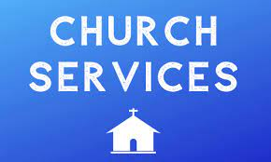
We will have a single Sunday Service for the month of August at 9:30 a.m. The
Sunday service for Labor Day weekend will also be at 9:30 a.m. followed by
Potluck. We will resume regular service times of 8:00 and 10:30 a.m. on Sunday, September 10th.

From the Treasurer
August ’23 Income vs. Expenses:

Projected August Expenses: $13,050
Monies received as of 8/24: $8,949
Amount needed to meet expenses: $4,101


POTLUCK
SUNDAY
Sunday, September 3 after the service at 9:30 a.m.

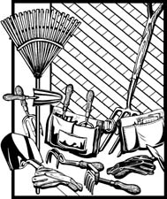
Mark Your Calendars!!
Cemetery Clean-Up
September 9th, 8 am-12 Noon
Rain Date: September 10th after the 10:30 svc.


SUNDAY SCHOOL
Children’s Sunday school will start Sunday, September 10th, from 10:30-11:00 during our 10:30 service. Miss Stephanie and I are looking forward to seeing everyone after summer break and also would like to invite all interested kids to come and be part of the group.

Mr. John


St. John’s Fall Flea Market
September 16th, 8am-1pm
Gently used items may be brought in now. Thank you.


Choral Choir and Bell Choir

Choir practice begins on Thursday, 9/14 at 7 pm and will continues on Thursdays

Bell Choir practice will begin after the 10:30 service on 9/10 and 9/17

Education for Ministry
St. John’s is offering an opportunity to engage in Education for Ministry. Our Senior Warden, Ty Schwenk, is a certified Mentor and is eager to begin a cohort.

As you know, Education for Ministry is an internationally well-known and respected program of theological education designed for lay people. A link to the program is below.

For more information about the program and to register, contact:

Ty Schwenk- Camyandty@aol.com. 443-876-5199. Or
The Rev. Mark Lobb- interim@stjohnskingsville.org 443-690-9545, or
St. John's, Kingsville- office@stjohnskingsville.org 410-592-8570.

https://theology.sewanee.edu/education-for-ministry/

A few dates to put in your calendar:

September 10th - Sunday School begins
September 16th - Flea Market
October 13th - Bingo Night
November 18th - Christmas Bazaar
We have St. John’s shirts available for a nominal charge.
With so much going on, everyone’s help is needed to make things a
success. Our volunteers make the Church function. The volunteering of time and talent is greatly appreciated.

We have a Potluck Luncheon on the first Sunday of the month and a
Coffee Hour on all other Sundays after service.



St. Mary, Pylesville–Fall Fried Chicken Dinner
September 9, 2023 - Noon to 5:30 pm (rain or shine)
1021 St. Marys Rd, Pylesville, MD www.stmaryspylesville.org

