St. John’s Episcopal Church
Kingsville, Maryland

Our Vision Statement
We believe that together we will transform
the world with love: Come on in!

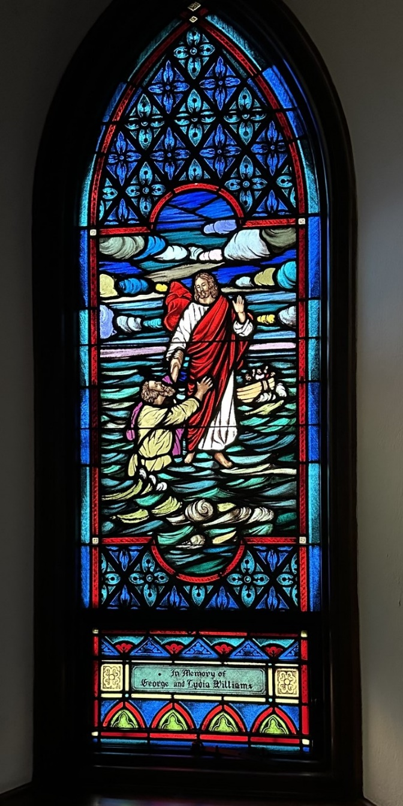

Eleventh Sunday after Pentecost
August 13, 2023, 9:30 am

St. John’s Episcopal Church

11901 Belair Road, P. O. Box 187, Kingsville, MD 21087
FaceBook: St. John’s Episcopal, Kingsville, MD
Email: office@stjohnskingsville.org
Website: www.stjohnskingsville.org
Church Phone: 410-592-8570
For Pastoral Emergencies: Fr. Mark Lobb+ 443-690-9545

Church Staff

Interim Rector: Father Mark Lobb
Administrative Assistant: Angie Bosley
Organist/Choir Director: Nancy Heinold

The Vestry

Class of 2024 Class of 2025

Marguerite Lobb John Frost
Jacob Johnson Woodie Tingle

Officers
Ty Schwenk—Sr. Warden Terry Roe—Jr. Warden
Elizabeth Healey—Treasurer Anne Leland-Registrar

Parish Committee Chairpersons

Altar Guild: Elizabeth Healey
Auxiliary Committee: Michele Lozanski
Cemetery Maintenance Committee: Terry Roe

9:30 am Worship
Holy Eucharist, Rite Two

Prelude:
The Word of God

Processional hymn: O worship the King, all glorious above Hymnal #388

Worship begins BCP 355

Gloria Hymnal #S-278
Glory to God in the highest,
and peace to his people on earth.
Lord God, heavenly King,
almighty God and Father,
we worship you, we give you thanks,
we praise you for your glory.
Lord Jesus Christ, only Son of the Father,
Lord God, Lamb of God,
you take away the sin of the world:
have mercy on us;
you are seated at the right hand of the Father:
receive our prayer.
For you alone are the Holy One,
you alone are the Lord,
you alone are the Most High,
Jesus Christ,
with the Holy Spirit,
in the glory of God the Father. Amen.

Celebrant: The Lord be with you.
People: And also with you.
Celebrant: Let us pray.

The Collect of the Day Kneel or stand as able BCP 232
Grant to us, Lord, we pray, the spirit to think and do always those things that are right, that we, who cannot exist without you, may by you be enabled to live according to your will; through Jesus Christ our Lord, who lives and reigns with you and the Holy Spirit, one God, for ever and ever. Amen.

The congregation is seated.

A Reading from the Book of Genesis 37:1-4, 12-28
Jacob settled in the land where his father had lived as an alien, the land of Canaan. This is the story of the family of Jacob.
Joseph, being seventeen years old, was shepherding the flock with his brothers; he was a helper to the sons of Bilhah and Zilpah, his father’s wives; and Joseph brought a bad report of them to their father. Now Israel loved Joseph more than any other of his children, because he was the son of his old age; and he had made him a long robe with sleeves. But when his brothers saw that their father loved him more than all his brothers, they hated him, and could not speak peaceably to him.
Now his brothers went to pasture their father’s flock near Shechem. And Israel said to Joseph, “Are not your brothers pasturing the flock at Shechem? Come, I will send you to them.” He answered, “Here I am.” So he said to him, “Go now, see if it is well with your brothers and with the flock; and bring word back to me.” So he sent him from the valley of Hebron.
He came to Shechem, and a man found him wandering in the fields; the man asked him, “What are you seeking?” “I am seeking my brothers,” he said; “tell me, please, where they are pasturing the flock.” The man said, “They have gone away, for I heard them say, ‘Let us go to Dothan.’” So Joseph went after his brothers, and found them at Dothan. They saw him from a distance, and before he came near to them, they conspired to kill him. They said to one another, “Here comes this dreamer. Come now, let us kill him and throw him into one of the pits; then we shall say that a wild animal has devoured him, and we shall see what will
become of his dreams.” But when Reuben heard it, he delivered him out of their hands, saying, “Let us not take his life.” Reuben said to them, “Shed no blood; throw him into this pit here in the wilderness, but lay no hand on him” —that he might rescue him out of their hand and restore him to his father. So when Joseph came to his brothers, they stripped him of his robe, the long robe with sleeves that he wore; and they took him and threw him into a pit. The pit was empty; there was no water in it.
Then they sat down to eat; and looking up they saw a caravan of Ishmaelites coming from Gilead, with their camels carrying gum, balm, and resin, on their way to carry it down to Egypt. Then Judah said to his brothers, “What profit is it if we kill our brother and conceal his blood? Come, let us sell him to the Ishmaelites, and not lay our hands on him, for he is our brother, our own flesh.” And his brothers agreed. When some Midianite traders passed by, they drew Joseph up, lifting him out of the pit, and sold him to the Ishmaelites for twenty pieces of silver. And they took Joseph to Egypt.

Reader: The Word of the Lord.
People: Thanks be to God.

Psalm 105: 1-6, 16-22, 45b
1 Give thanks to the Lord and call upon his Name; *
make known his deeds among the peoples.
2 Sing to him, sing praises to him, *
and speak of all his marvelous works.
3 Glory in his holy Name; *
let the hearts of those who seek the Lord rejoice.
4 Search for the Lord and his strength; *
continually seek his face.
5 Remember the marvels he has done, *
his wonders and the judgments of his mouth,
6 O offspring of Abraham his servant, *
O children of Jacob his chosen.
16 Then he called for a famine in the land *
and destroyed the supply of bread.
17 He sent a man before them, *
Joseph, who was sold as a slave.
18 They bruised his feet in fetters; *
his neck they put in an iron collar.
19 Until his prediction came to pass, *
the word of the Lord tested him.
20 The king sent and released him; *
the ruler of the peoples set him free.
21 He set him as a master over his household,
as a ruler over all his possessions,
22 To instruct his princes according to his will
and to teach his elders wisdom.
45 Hallelujah!

A Reading from the Letter of St. Paul to the Romans 10:5-15
Moses writes concerning the righteousness that comes from the law, that “the person who does these things will live by them.” But the righteousness that comes from faith says, “Do not say in your heart, ‘Who will ascend into heaven?’” (that is, to bring Christ down) “or ‘Who will descend into the abyss?’” (that is, to bring Christ up from the dead). But what does it say?
“The word is near you, on your lips and in your heart” (that is, the word of faith that we proclaim); because if you confess with your lips that Jesus is Lord and believe in your heart that God raised him from the dead, you will be saved. For one believes with the heart and so is justified, and one confesses with the mouth and so is saved. The scripture says, “No one who believes in him will be put to shame.” For there is no distinction between Jew and Greek; the same Lord is Lord of all and is generous to all who call on him. For, “Everyone who calls on the name of the Lord shall be saved.”
But how are they to call on one in whom they have not believed? And how are they to believe in one of whom they have never heard? And how are they to hear without someone to proclaim him? And how are they to proclaim him unless they are sent? As it is written, “How beautiful are the feet of those who bring good news!”

Reader: The Word of the Lord.
People: Thanks be to God.

Gradual hymn: Praise my soul, the King of heaven Hymnal #410

The Gospel
Priest: The Holy Gospel of our Lord Jesus Christ according to Matthew 14:22-33

People: Glory to you, Lord Christ.
Jesus made the disciples get into the boat and go on ahead to the other side, while he dismissed the crowds. And after he had dismissed the crowds, he went up the mountain by himself to pray. When evening came, he was there alone, but by this time the boat, battered by the waves, was far from the land, for the wind was against them. And early in the morning he came walking toward them on the sea. But when the disciples saw him walking on the sea, they were terrified, saying, “It is a ghost!” And they cried out in fear. But immediately Jesus spoke to them and said, “Take heart, it is I; do not be afraid.”
Peter answered him, “Lord, if it is you, command me to come to you on the water.” He said, “Come.” So Peter got out of the boat, started walking on the water, and came toward Jesus. But when he noticed the strong wind, he became frightened, and beginning to sink, he cried out, “Lord, save me!” Jesus immediately reached out his hand and caught him, saying to him, “You of little faith, why did you doubt?” When they got into the boat, the wind ceased. And those in the boat worshiped him, saying, “Truly you are the Son of God.”

Priest: The Gospel of the Lord.
People: Praise to you, Lord Christ.

Please be seated.

Sermon The Rev. Mark Lobb+

The Nicene Creed Please stand as able BCP 358
We believe in one God,
the Father, the Almighty,
maker of heaven and earth,
of all that is, seen and unseen.
We believe in one Lord, Jesus Christ,
the only Son of God,
eternally begotten of the Father,
God from God, Light from Light,
true God from true God,
begotten, not made,
of one Being with the Father.
Through him all things were made.
For us and for our salvation
he came down from heaven:
by the power of the Holy Spirit
he became incarnate from the Virgin Mary,
and was made man.
For our sake he was crucified under Pontius Pilate;
he suffered death and was buried.
On the third day he rose again
in accordance with the Scriptures;
he ascended into heaven
and is seated at the right hand of the Father.
He will come again in glory to judge the living and the dead,
and his kingdom will have no end.
We believe in the Holy Spirit, the Lord, the giver of life,
who proceeds from the Father and the Son.
With the Father and the Son he is worshiped and glorified.
He has spoken through the Prophets.
We believe in one holy catholic and apostolic Church.
We acknowledge one baptism for the forgiveness of sins.
We look for the resurrection of the dead,
and the life of the world to come. Amen.

Prayers of the People Form III Kneel or stand as able BCP 387

Confession of Sin BCP 359

The Peace BCP 360

Welcome & Announcements The congregation is seated.

Welcome to Communion

Offertory Anthem: Precious Lord Take My Hand (Choir)
Offertory hymn: At the Name of Jesus Hymnal #435

Presentation Hymn Please stand as able Hymnal #43, vs. 4
Praise God, from whom all blessings flow; praise him, all creatures here below; praise him above, ye heavenly host: praise Father, Son, and Holy Ghost.

The Holy Communion

THE GREAT THANKSGIVING: Eucharistic Prayer B BCP 367

Sanctus Hymnal #S-128
Holy, Holy, Holy Lord, God of power and might,
heaven and earth are full of your glory.
Hosanna in the highest.
Blessed is he who comes in the name of the Lord.
Hosanna in the highest.

The Lord’s Prayer The people remain standing or kneel BCP 364

Invitation to Communion

The Breaking of the Bread The congregation is seated

Communion hymn: Jesus, Lover of my soul Hymnal #699

The Post Communion Prayer BCP 365

Blessing

Recessional hymn: How firm a foundation, ye saints of the Lord Hymnal#637

The Dismissal

Serving Today

Celebrant & Preacher: The Rev. Mark Lobb+
Old Testament: John Stevens
Psalm: Liz Healey
New Testament: Marguerite Lobb
Prayers of the People: John Frost
Server: Jennifer Scepaniak
Music Director: Nancy Heinold
Altar Guild: Stephanie Duchacek & Sandy Roe
Choir: Anne Leland, Nancy Dellinger, Janine Stevens, Liz Healey, Camy Schwenk
Karen Smith-Manar, Jacob Johnson, Ty Schwenk

We welcome Father Mark Lobb
as our Interim Rector


Altar Flowers
Given to the Glory of God
by Joan Salmon
in Thanksgiving for Our Families

St. John’s Parish Prayer List

Additions and corrections may be made to our Parish Prayer List at any time. All names will be automatically removed from the Parish Prayer List on the 1st Sunday of each month unless you request otherwise. Please contact Angie at <office@stjohnskingsville.org> or 410-592-8570 in the church office with all changes by 10 am Thursdays. Thank you.

We Pray for Those in Need:

Ivan, Lisa, Peter, Sarah Sutherland, Melissa Heaver, Liz Rawl, Ricky Carter, Marilyn Stephenson, Charlotte Williams (small child), Cleo Collins, Sid & Joan Pyle, Karen Sugden, DeMarino Family, Jenny, Lisa, Jennifer, Dylan, Gary, Barbara Goldsmith, Thelma, Paul Edwards, James Kneussl, Kim Collins-Appel, Ronnee Congleton (pancreatic cancer), Stephanie Payton, Jim & Chris Carden and family, Terry Barrett, Rev. Tony and Deacon Linda Hollis, Anne Leland, Peggie Dietz, Barnabas & Sarah, Stacey Bell, Thomas Proctor, Mike Carden, Pat Carden, Gail Landers, Alisha Erion, Marie Dilworth, Andy Grau.

We Pray for our Homebound

Lily John, Barbara Miller, Nancy Barnhart, Robin Dilworth

We pray for the Church and the World:

For Most Rev’d. Justin Welby, Archbishop of Canterbury; for The Most Rev’d. Michael Curry, our Presiding Bishop; for Right Rev’d. Eugene Sutton, our Bishop; for our Bishop Co-Adjutor Elect, Carrie Schofield Broadbent, for our Interim Rector, Rev. Mark Lobb, for the Wardens, Vestry, Staff, and all members and friends of St. John’s Church.

For the leaders of all nations, especially for Joseph, our President; for Wes, our Governor; for Brandon, Nick, John and Bob, who lead our City and Counties. We pray for all children and youth; for the homeless, the unemployed, and the hungry. We pray for the safety of our loved ones and friends serving in the Armed Forces at home and abroad, and for our enemies, that all our hearts may be turned toward peace throughout the world.

From the Treasurer
August ’23 Income vs. Expenses:

Projected August Expenses: $13,050

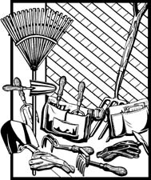
Mark Your Calendars!!
Cemetery Clean-Up
September 9th, 8 am-12 Noon
Rain Date: September 10th after the 10:30 svc.

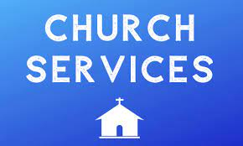
We will have a single Sunday Service for the month of August at 9:30 a.m.


St. John’s Fall Flea Market
September 16th, 8am-1pm
Gently used items may be brought in now. Thank you.

A few dates to put in your calendar:

September 10th - Sunday School begins
September 16th - Flea Market
October 13th - Bingo Night
November 18th - Christmas Bazaar
We have St. John’s shirts available for a nominal charge.
With so much going on, everyone’s help is needed to make things a success. Our volunteers make the Church function. The volunteering of time and talent is greatly appreciated.

We have a Potluck Luncheon on the first Sunday of the month and a Coffee Hour on all other Sundays after service.

