Celebration of Life



Charles B. Keenan, Jr.
March 24, 1940—July 1, 2023

Friday, July 14, 2023 1:30 pm

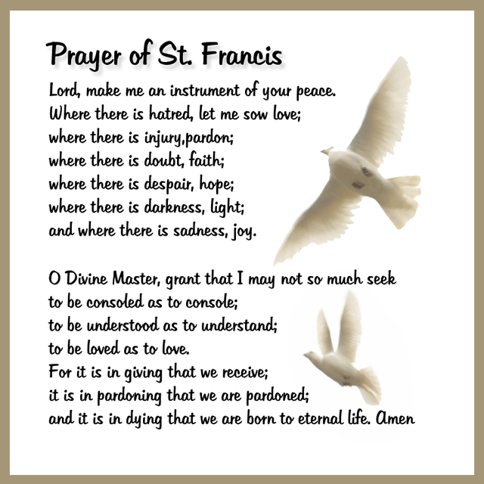

The Burial of the Dead: Rite II

Prelude: My Way Ty Schwenk

Opening hymn: A mighty fortress is our God Hymnal #687

Welcome Remarks

I am Resurrection and I am Life, says the Lord.
Whoever has faith in me shall have life,
even thou he die.
And everyone who has life,
and has committed himself to me in faith,
shall not die for ever.

As for me, I know that my Redeemer lives
and that at the last he will stand upon the earth.
After my awaking, he will raise me up;
and in my body I shall see God.
I myself shall see, and my eyes behold him
who is my friend and not a stranger.

For none of us has life in himself,
and none becomes his own master when he dies.
For if we have life, we are alive in the Lord,
and if we die, we die in the Lord.
So, then, whether we live or die,
we are the Lord’s possession.

Happy from now on are those who die in the Lord!
So it is, says the Spirit, for they rest from their labors.

Celebrant: The Lord be with you.
People: And also with you.
Celebrant: Let us pray.

The Collect
O God, who by the glorious resurrection of your Son Jesus Christ destroyed death, and brought life and immortality to light: Grant that your servant Charles, being raised with him, may know the strength of his presence, and rejoice in his eternal glory; who with you and the Holy Spirit lives and reigns, one God, for ever and ever. Amen.

The Liturgy of the Word

Ecclesiastes 3:1-8
There is a time for everything, and a season for every activity under the heavens: a time to be born and a time to die, a time to plant and a time to uproot, a time to kill and a time to heal, a time to tear down and a time to build, a time to weep and a time to laugh, a time to mourn and a time to dance, a time to scatter stones and a time to gather them, a time to embrace and a time to refrain from embracing, a time to search and a time to give up, a time to keep and a time to throw away, a time to tear and a time to mend, a time to be silent and a time to speak, a time to love and a time to hate, a time for war and a time for peace.

Psalm 23
We will read Psalm 23 responsively by full verse.

1 The Lord is my shepherd;
I shall not want.
2 He maketh me to lie down in green pastures:
he leadeth me beside the still waters.
3 He restoreth my soul:
he leadeth me in the paths of righteousness for his name's sake.
4 Yea, though I walk through the valley of the shadow of death,
I will fear no evil:
for thou art with me; thy rod and thy staff they comfort me.
5 Thou preparest a table before me in the presence of mine enemies:
thou anointest my head with oil; my cup runneth over.
6 Surely goodness and mercy shall follow me all the days of my life:
and I will dwell in the house of the Lord for ever.

John 11:21-27
“Lord,” Martha said to Jesus, “if you had been here, my brother would not have died. But I know that even now God will give you whatever you ask.”
Jesus said to her, “Your brother will rise again.”
Martha answered, “I know he will rise again in the resurrection at the last day.”
Jesus said to her, “I am the resurrection and the life. The one who believes in me will live, even though they die; and whoever lives by believing in me will never die. Do you believe this?”
“Yes, Lord,” she replied, “I believe that you are the Messiah, the Son of God, who is to come into the world.”

Gradual hymn: Lord of all hopefulness, Lord of all joy Hymnal #482

The Gospel
Priest: The Holy Gospel of our Lord Jesus Christ according to Matthew 11:25-30
People: Glory to you, Lord Christ.
At that time Jesus said, “I praise you, Father, Lord of heaven and earth, because you have hidden these things from the wise and learned, and revealed them to little children. Yes, Father, for this is what you were pleased to do.
“All things have been committed to me by my Father. No one knows the Son
except the Father, and no one knows the Father except the Son and those to whom the Son chooses to reveal him.
“Come to me, all you who are weary and burdened, and I will give you rest. Take my yoke upon you and learn from me, for I am gentle and humble in heart, and you will find rest for your souls. For my yoke is easy and my burden is light.”

Priest: The Gospel of the Lord.
People: Praise to you, Lord Christ.

Homily

Family Testimonials
Tom Keenan
John Keenan
Laura Spadone
Greg Carson
Kate Howard Perri - “Home” by Margery Kelly

Apostles Creed
I believe in God, the Father almighty, creator of heaven and earth.

I believe in Jesus Christ, his only Son, our Lord.
He was conceived by the power of the Holy Spirit
and born of the Virgin Mary.
He suffered under Pontius Pilate,
was crucified, died, and was buried.
He descended to the dead.
On the third day he rose again.
He ascended into heaven,
and is seated at the right hand of the Father.
He will come again to judge the living and the dead.
I believe in the Holy Spirit
the holy catholic Church,
the communion of saints,
the forgiveness of sins,
the resurrection of the body,
and the life everlasting. Amen.

Prayers of the People
For our brother, Charles, let us pray to our Lord Jesus Christ who said, “I am
Resurrection and I am Life.”

Lord, you consoled Martha and Mary in their distress; draw near to us who mourn for Charles, and dry the tears of those who weep.
Hear us, Lord.

You wept at the grave of Lazarus, your friend; comfort us in our sorrow.
Hear us, Lord.

You promised paradise to the thief who repented; bring our brother to the joys of heaven.
Hear us, Lord.

Our brother was washed in Baptism and anointed with the Holy Spirit; give him fellowship with all your saints.
Hear us, Lord.
He was nourished with your Body and Blood; grant him a place at the table in your heavenly kingdom.
Hear us, Lord.

Comfort us in our sorrows at the death of our brother; let our faith be our
consolation, and eternal life our hope.

Lord Jesus Christ, we commend to you our brother, Charles, who was reborn by water and the Spirit in Holy Baptism. Grant that his death may recall to us your
victory over death, and be an occasion for us to renew our trust in your Father’s love. Give us, we pray, the faith to follow where you have led the way; and where you live and reign with the Father and the Holy Spirit, to the ages of ages. Amen.

Celebrant: May the Peace of the Lord be always with you.
People: And also with you.

Hymn: Amazing Grace Hymnal #671

The Commendation

Give rest, O Christ, to your servant with your saints, where sorrow and pain are no more, neither sighing, but life everlasting.

You only are immortal, the creator and maker of mankind; and we are mortal, formed of the earth, and to earth shall we return. For so did you ordain when you created me, saying, “You are dust, and to dust you shall return.” All of us go down to the dust; yet even at the grave we make our song: Alleluia, alleluia, alleluia.

Give rest, O Christ, to your servant with your saints, where sorrow and pain are no more, neither sighing, but life everlasting.

The Officiant then says

Into your hands, O merciful Savior, we commend your servant Charles. . Acknowledge, we humbly beseech you, a sheep of your own fold, a lamb of your own flock, a sinner of your own redeeming. Receive him into the arms of your
mercy, into the blessed rest of everlasting peace, and into the glorious company of the saints in light. Amen.

Blessing

The Dismissal

Priest: Let us go forth in the Name of Christ.
People: Thanks be to God.

Closing hymn: O God, our help in ages past Hymnal #680

Postlude: Ode to Joy (Beethoven)

Officiant: Rev. Joshua Messick+
Old Testament: Ben Keenan
Psalm: Sarah Lord
New Testament: Jim Keenan
Prayers of the People: Rev. Joshua Messick+
Gospel: Rev. Joshua Messick+
Music Director: Nancy Heinold
Piper: Baltimore City Pipe Major Megan Amoss

ST JOHN’S EPISCOPAL CHURCH
PO BOX 187
11901 BELAIR ROAD
KINGSVILLE, MD 21087
(410)592-8570
office@stjohnskingsville.org
Www.stjohnskingsville.org

Service Times
Sundays 8:00 a.m. and 10:30 a.m.
July & August 9:30 a.m.

